WEEK – 4

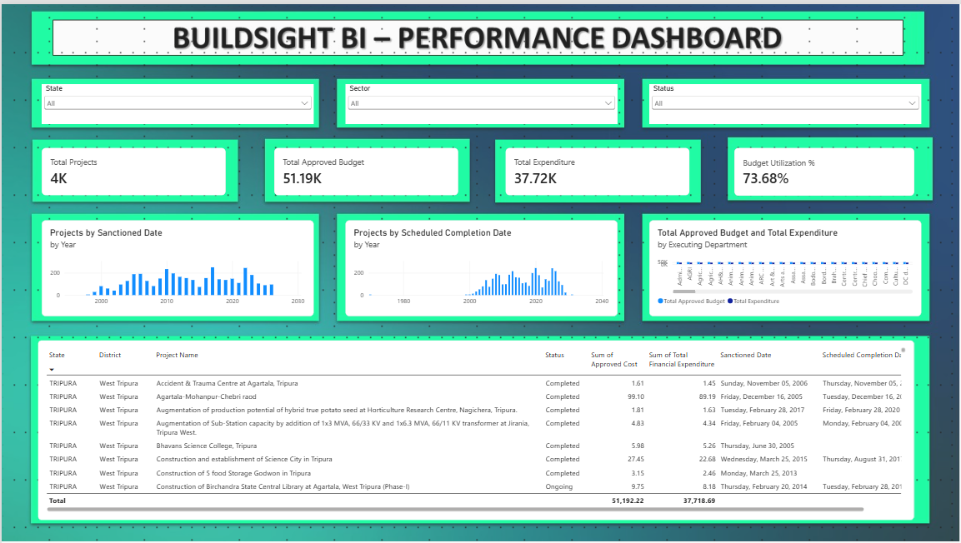
Figure 1: Performance Dashboard

Total Projects: 3744 (~4K)
Total Approved Budget: 51.19K
Total Expenditure: 37.72K
Budget Utilization %: 73.68%

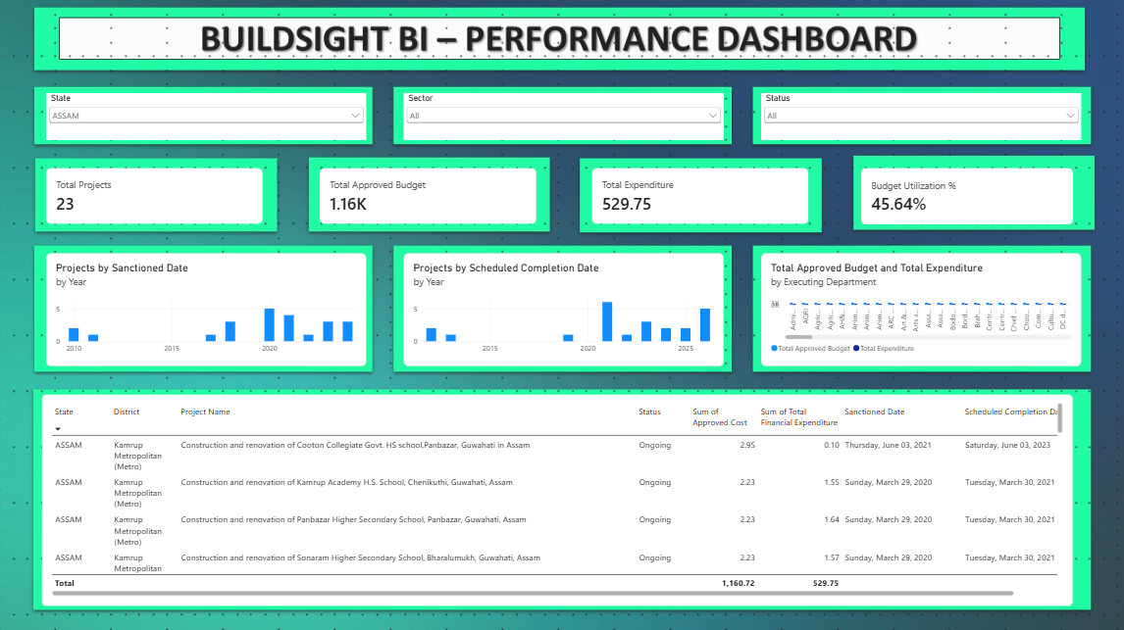
Figure 2: State Filter Interaction

Selected State: Assam
Total Projects: 23
Total Approved Budget: 1.16K
Total Expenditure: 529.75
Budget Utilization %: 45.64%

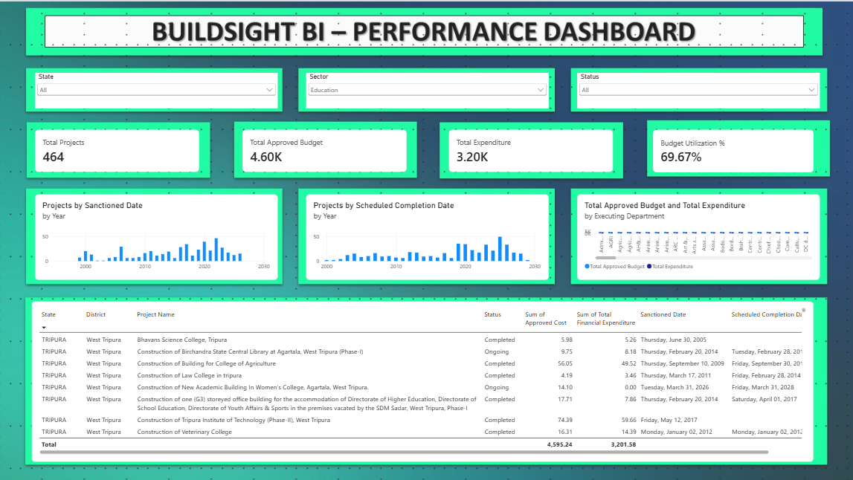
Figure 3: Sector Filter Interaction

Selected Sector: Education
Total Projects: 464
Total Approved Budget: 4.60K
Total Expenditure: 3.20K
Budget Utilization %: 69.67%

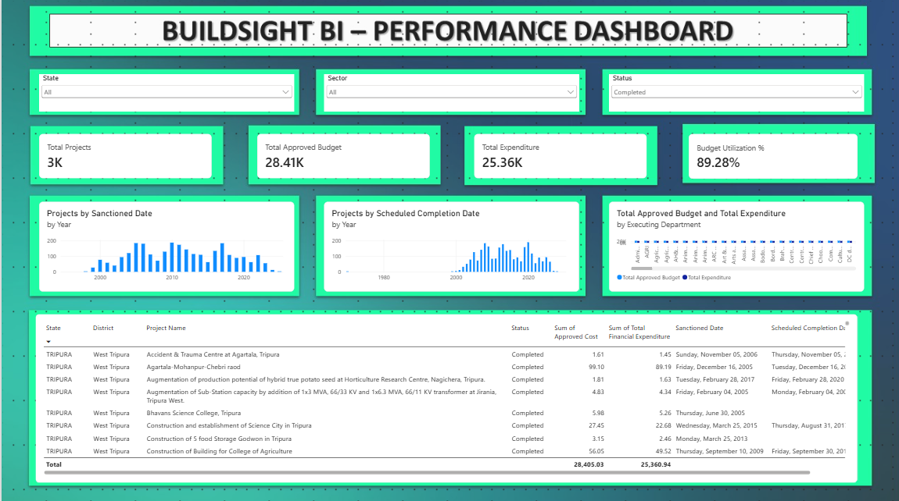
Figure 4: Status Filter Interaction

Selected Status: Assam
Total Projects: 23
Total Approved Budget: 1.16K
Total Expenditure: 529.75
Budget Utilization %: 89.28%

