WEEK 3 INTERNSHIP REPORT (REVISED SUBMISSION)
BuildSight BI
Week 3: Building Advanced Data Models and DAX Calculations
A Power BI-Based Business Intelligence Framework for Construction Project Performance

Internship | Virtual Construction Business Intelligence Internship
Programme | YuvaIntern / NSDC YuvaIntern
Student name | Shalvi Atul Surve
Institution | Vellore Institute of Technology (VIT), Vellore
Dataset | MDoNER NESetu project list, North Eastern Region
Tool | Microsoft Power BI Desktop
Submission date | 12.10.2026

Table of Contents
1. Executive Summary 1
1.1 How this revision responds to the evaluator's feedback 1
2. Assignment Objectives and Scope 3
3. Dataset and Source Overview 4
3.1 Source and scope 4
3.2 Fields and their use 4
3.3 Date coverage 4
3.4 What the dataset cannot show 5
4. Data Model Design 6
4.1 Why a star schema 6
4.2 FactProjects and its grain 6
4.3 Model view 7
4.4 Conceptual diagram 7
4.5 The measure container 8
5. Dimension Design and Key Normalization 10
5.1 DimSector and DimScheme 10
5.2 DimStatus 10
5.3 DimDepartment and DepartmentKey 11
5.4 DimGeography and GeographyKey 12
5.5 DimDate 13
6. Relationship Architecture 15
6.1 Relationship matrix 15
6.2 Single-direction filtering 16
6.3 Why one date relationship is inactive 16
6.4 Geography: the relationship depends on key coverage 16
6.5 Department relationship 16
6.6 Assumptions 17
7. DAX Measures and KPI Development 18
7.1 Core financial and count measures 18
7.2 Advanced measure 1: Projects by Scheduled Completion Date 19
7.3 Advanced measure 2: Cumulative Approved Budget 20
7.4 Advanced measures 3 and 4: conditional counts of expenditure 21
7.5 Advanced measure 5: Overdue Projects (scheduled-date screening) 21
7.6 Additional measures 22
7.7 Correctness and efficiency review 23
7.8 How the measures work with the model 23
8. Worked Examples, KPI Results and Business Interpretation 24
8.1 Validation page 25
8.2 Project overview page 27
8.3 Arithmetic reconciliation 29
8.4 Record-level worked example 29
8.5 Business questions and the measures that answer them 30
9. Validation and Testing Results 32
9.1 Status vocabulary 32
9.2 Validation matrix 32
9.3 Date-quality investigation 34
9.4 Summary of validation 35
10. Implementation Evidence 36
11. Strengths, Limitations and Risk Mitigation 37
11.1 Strengths 37
11.2 Limitations and risks 37
12. Conclusion and Recommendations 39
References 40
Appendix A: DAX Formula Reference 41
Appendix B: Relationship Matrix and Key Definitions 42
Appendix C: Screenshot Evidence Index 43
Appendix D: Validation Checklist for the Author 44

If entries or page numbers appear blank, right-click the table in Word and choose Update Field.

1. Executive Summary
This report documents the data model and DAX calculations built for the BuildSight BI project in Microsoft Power BI Desktop. The model is based on one public dataset: the project list of the Ministry of Development of North Eastern Region (MDoNER) NESetu dashboard, which covers projects in India's North Eastern Region and is not a national dataset. Monetary values are in ₹ crore, as stated in the source worksheet header.
The implemented model has a central project-level table, FactProjects, six dimension tables (DimDate, DimDepartment, DimGeography, DimScheme, DimSector, DimStatus) and a measure container, shown in the Data pane as Placeholder, which holds 13 DAX measures. The report documents each table, key and relationship, explains five advanced DAX measures line by line, and tests the model against nine screenshots taken from the working file.

Results confirmed by the screenshots
- The validation page shows 3,774 project records (card label 3.774K), a total approved budget of ₹51,192.22 crore and a total recorded expenditure of ₹37,718.69 crore (table totals, Fig-08). The same totals appear on the overview page (Fig-09).
- Budget Balance is 51,192.22 − 37,718.69 = ₹13,473.53 crore (card 13.47K), and Budget Utilization % is 37,718.69 ÷ 51,192.22 = 73.68% (card 73.68%).
- 3,629 projects have recorded expenditure and 145 do not; 3,629 + 145 = 3,774, which matches Total Projects.

Problems the evidence exposed
- `DimGeography` holds 11 rows, one per State (Fig-04), not one per State–District pair. The Week 2 profile showed 183 distinct districts, so most fact rows cannot match a geography row. The State chart in Fig-09 is dominated by a (Blank) category. This is a defect to correct, not a pending query.
- A scheduled completion date of 1 January 1970 stretches DimDate to 22,645 rows and distorts the scheduled-date chart axis (Fig-09). It precedes every sanctioned date in the data, which starts on 1 April 1998.
- `DimStatus` contains three labels: Ongoing, Completed and Foreclosed (Fig-02). The label "Completed" used by Overdue Projects matches exactly, but the measure also counts Foreclosed records, which needs a business decision.
- The Department relationship was inactive when Fig-06 was captured. The author reports it was activated afterwards; an updated screenshot is still needed.
The report makes no claim about physical progress, actual completion, labour productivity or forecasting, because the source data cannot support them.

1.1 How this revision responds to the evaluator's feedback
The earlier submission was judged generic and lacking concrete examples and evidence. This revision responds as follows.
Table 1. Evaluator concern and the revision
Concern | What this report does | Where
Generic | Uses real field names, real labels (Ongoing, Completed, Foreclosed), real department keys and real records from the Tripura rows in the validation page | Sections 5, 8
Lacking evidence | Embeds all nine screenshots beside the claims they support, with a stated limitation for each | Sections 4 to 9
Advanced DAX not shown to work | Explains five advanced measures line by line, with hypothetical and record-level worked examples and arithmetic checked against the screenshots | Sections 7, 8
Inconsistent validation | Uses one status vocabulary; no check is marked as passed unless the evidence shows it | Section 9
Outdated claims | Corrects the geography row count, the _Measures table description and the status-label question | Sections 5, 6, 9
Source: Prepared by the author.

2. Assignment Objectives and Scope
The Week 3 assignment (Building Advanced Data Models and DAX Calculations) asks for an advanced Power BI data model relating project dimensions such as timelines and budgets, a diagram of the model, at least three advanced DAX formulas for construction KPIs, documentation of relationships and assumptions, an explanation of how DAX integrates with the model, and a critical review of strengths and limitations. The objectives below restate these for the BuildSight BI dataset.
- Structure the project records as a star schema, with FactProjects at the centre.
- Separate descriptive attributes (sector, scheme, department, status, geography, dates) into dimension tables joined by explicit keys.
- Model two date roles, sanctioned and scheduled completion, from one calendar table.
- Write reusable DAX measures for budget, expenditure, project counts, date-based counts and a cumulative total.
- Verify the model against screenshots and document each discrepancy.
- State what the data cannot show.
Table 2. Assignment requirements and where they are met
Requirement | Where addressed | Principal evidence
Advanced data model | Sections 4, 5 | Fig-01, Fig-02 to Fig-05
Relationships between timeline, budget and other dimensions | Section 6 | Fig-06, Fig-01
Entity-relationship diagram | Section 4.4 | Figure 2 (conceptual), Fig-01
At least three advanced DAX formulas | Section 7 | Fig-07; worked examples in Sections 7 and 8
Documentation of cardinality, direction, active status, assumptions | Sections 6.1 to 6.5 | Fig-06
Integration of DAX with the model | Section 7.8 | Fig-08, Fig-09
Critical review of strengths and limitations | Section 11 | All figures
Source: Prepared by the author.

Scope
In scope: the table design, keys, relationships and measures, and their checks against the evidence. Out of scope: dashboard design (Week 4) and predictive analysis (Week 5). Two report pages exist in the evidence, a validation page and an overview page; they are used here only to test the model.

3. Dataset and Source Overview

3.1 Source and scope
The data comes from the MDoNER Projects Dashboard on the NESetu portal (https://www.nesetu.mdoner.gov.in/projects/project-list), which lists projects in India's North Eastern Region. The raw workbook was mdoner_projects_raw.xlsx, worksheet overall-schemes-2026-08-31, titled "All Schemes Projects, as on 2026-08-31". The model therefore describes the projects represented in that source only.
WEEK 2 EVIDENCE Week 2 Screenshot 02 shows the worksheet header "All Amount in Rs. Crore". All monetary measures in this report are in ₹ crore. No conversion was applied.

3.2 Fields and their use
Table 3. Source fields as used in the model
Role | Field(s) | Observed example (Fig-08 / Fig-09)
Identification | Serial Number; Project Name | Project names such as Birchandra State Central Library, Agartala (Phase-I)
Geography | State; District | TRIPURA; West Tripura
Classification | Sector; Scheme; Executing Department | Department values such as Dept. of Power, PWD, Not specified (Fig-03)
Budget | Approved Cost | 9.75 (₹ crore) for the library record
Expenditure | Total Financial Expenditure | 8.18 (₹ crore) for the same record
Timeline | Sanctioned Date; Scheduled Completion Date | 20 Feb 2014; 28 Feb 2017
Status | Status | Ongoing; Completed; Foreclosed (Fig-02)
Source: MDoNER NESetu; values read from Fig-02, Fig-03 and Fig-08.

3.3 Date coverage
AUTHOR-REPORTED The date ranges and blank counts below come from the author's inspection of the loaded data. They are not visible in the screenshots, except that Fig-05 shows the DimDate row count and Fig-08/Fig-09 show some blank scheduled dates.
Table 4. Observed date coverage
Column | Earliest non-blank | Latest non-blank | Blank records
FactProjects[Sanctioned Date] | 1 April 1998 | 20 August 2026 | 1
FactProjects[Scheduled Completion Date] | 1 January 1970 (anomaly, Section 9.3) | 12 June 2031 | 12
DimDate[Date] | 1 January 1970 | 31 December 2031 | 22,645 rows (Fig-05)
Source: author inspection; row count from Fig-05.
With 3,774 records, one blank sanctioned date is 0.03% and 12 blank scheduled dates are 0.32% (author's arithmetic). These are consistent with the Week 2 profile, which showed 0% empty and under 1% empty respectively.

3.4 What the dataset cannot show
The source is a project-level administrative and financial list. It does not establish physical construction progress, actual completion dates, labour productivity, actual resource consumption, or a monthly expenditure history. The scheduled completion date is a planned date. Recorded financial expenditure is not physical progress. These limits determine how every measure below is interpreted.

4. Data Model Design

4.1 Why a star schema
A star schema keeps one table of measurable records (the fact table) and joins it to small tables of descriptive values (dimensions). Microsoft's guidance on Power BI model design recommends this layout (Microsoft, n.d.-a). For this dataset the alternative is one flat table with 3,774 rows and several repeated text columns. The star schema gives three practical advantages here.
- Complete, consistent filter lists. A slicer on DimStatus[Status] always offers Ongoing, Completed and Foreclosed, even when a filter leaves no rows with one of them.
- One calendar, two date roles. A flat table has two date columns and no shared timeline, so "projects sanctioned in 2014" and "projects scheduled to finish in 2017" cannot sit on the same axis. A single DimDate table, with one active and one inactive relationship, allows both.
- Definitions written once. Measures such as Total Approved Budget are defined once and reused by every visual and by other measures.

4.2 FactProjects and its grain
FactProjects holds one row per project record as listed by the source. It is created as a referenced query from the original query overall-schemes-2026-08-31, which stays in Power Query with Enable Load switched off. Only FactProjects and the dimensions are loaded, so the model does not hold a second copy of the same 3,774 rows.
Table 5. FactProjects columns used by the model
Column | Role | Note
Serial Number | Candidate record identifier | Week 2 profile: 3,774 distinct and 3,774 unique. Uniqueness in the loaded table is not yet tested
Project Name | Description | Not a key: Week 2 profile showed 3,745 distinct but 3,731 unique names
State; District | Geography attributes | District is visible in Fig-01
Sector; Scheme; Status | Foreign keys to DimSector, DimScheme, DimStatus | Text keys
Executing Department | Display text | Null replaced with Not specified
DepartmentKey | Foreign key to DimDepartment | Text.Upper(Text.Trim(Text.Clean([Executing Department])))
GeographyKey | Foreign key to DimGeography | Text.Trim([State]) & "|" & Text.Trim([District])
Sanctioned Date; Scheduled Completion Date | Foreign keys to DimDate | Converted from text with Using Locale, English (United Kingdom)
Approved Cost | Measure source | ₹ crore
Total Financial Expenditure | Measure source | ₹ crore
Financial Expenditure (as of 31 Aug 2026); Financial Expenditure (FY 2025-26 to Aug 2026) | Other expenditure columns (visible in Fig-01) | Not used by any measure; labels under review (Section 11)
Source: Fig-01; Week 2 and Week 3 notes.
The intended grain is one row per project record. Total Projects counts rows, so this report calls it a project-record count. It treats the figure as a count of distinct projects only after the checks in Section 9 are done. Project names repeat, so records that look alike are not assumed to be duplicates.

4.3 Model view
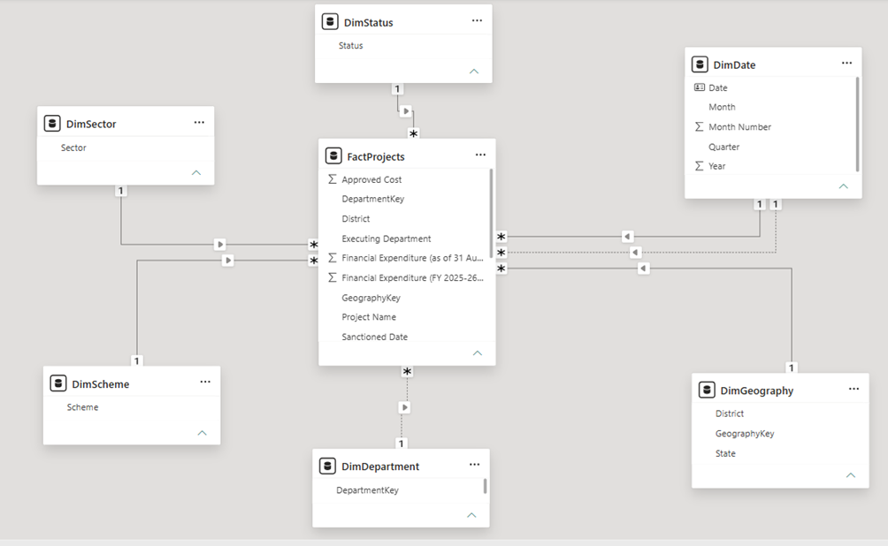
Figure 1. Model view of the BuildSight BI star schema (Evidence Fig-01)
What is visible. Seven tables: FactProjects in the centre and DimStatus, DimSector, DimScheme, DimDepartment, DimGeography and DimDate around it. Every line has 1 at the dimension and * at FactProjects, with a single arrowhead pointing toward the fact table. DimDate has two lines to the fact table, one solid and one dotted. The DimDepartment line is dotted.
What it demonstrates. A star schema with six dimensions, one-to-many relationships, single-direction filtering, and an active and an inactive date relationship. The dotted DimDepartment line means that relationship was inactive when this screenshot was taken.
Why it matters. It is the primary evidence for the model structure required by the assignment.
Limitation of the evidence. It predates the Department activation and does not show cardinality or column names for all relationships; Fig-06 gives those. The fact-table field list is scrolled, so not all columns are visible.

4.4 Conceptual diagram
Figure 2 redraws the model from Fig-01 and Fig-06 with keys, cardinality and active or inactive status. It is a conceptual representation, not a Power BI screenshot. It shows the Department relationship as active, following the author's report of the current state, and marks the geography coverage problem described in Section 6.4.
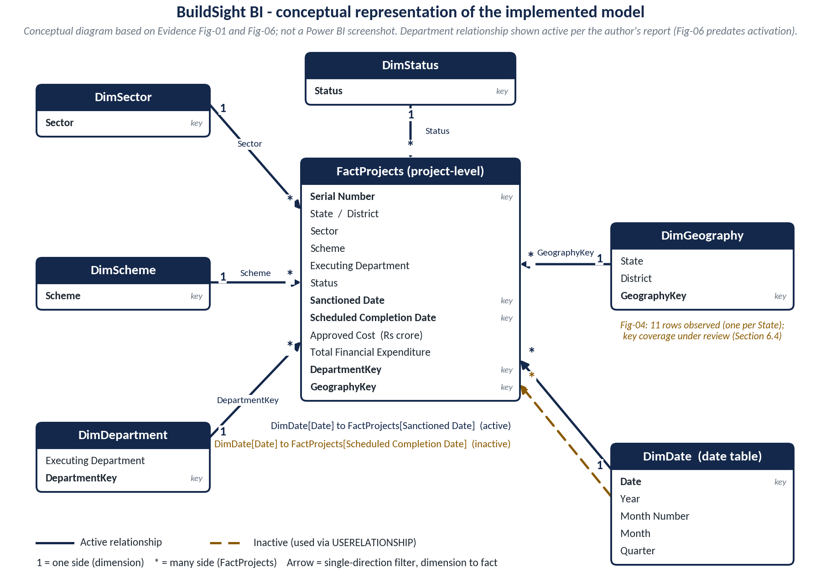
Figure 2. Conceptual representation of the implemented BuildSight BI model
Source: Prepared by the author from Evidence Fig-01 and Fig-06. Not a Power BI screenshot.

4.5 The measure container
The Data pane in Fig-02 to Fig-05 lists a table named Placeholder with a measure-table icon, and Fig-07 shows it holding a hidden field _Measures and 13 measures. This report therefore calls it the measure container, shown as Placeholder in the current implementation. It does not appear in the Model view of Fig-01, which may have been captured with it outside the visible canvas; this is not verified.
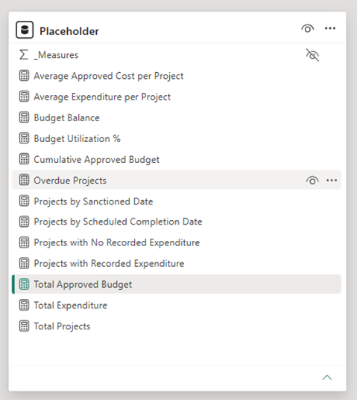
Figure 3. Measure container (Placeholder) with its hidden _Measures field and 13 measures (Evidence Fig-07)
What is visible. A table named Placeholder with an eye-slash on _Measures, followed by 13 measures: Average Approved Cost per Project, Average Expenditure per Project, Budget Balance, Budget Utilization %, Cumulative Approved Budget, Overdue Projects, Projects by Sanctioned Date, Projects by Scheduled Completion Date, Projects with No Recorded Expenditure, Projects with Recorded Expenditure, Total Approved Budget, Total Expenditure and Total Projects.
What it demonstrates. All 13 documented measures exist in the model, in one container, and the hidden helper field is not shown to report users.
Why it matters. Measures grouped in one place are easier to find, document and reuse. It also corrects the earlier report, which could not confirm the container.
Limitation of the evidence. The screenshot shows measure names, not their formulas. The formulas in Section 7 are the author's documentation and need a formula-bar screenshot (Appendix D).

5. Dimension Design and Key Normalization
Each dimension is created by referencing the prepared data in Power Query, keeping the descriptive column or columns, and removing duplicate rows. The table below summarises them; the sections after it explain the details and show the data views.
Table 6. Dimension design summary
Dimension | Source fields | Transformation | Key | Analytical purpose | Validation status
DimSector | Sector | Reference; keep Sector; remove duplicates; no blanks found | Sector | Group and filter by type of work | Relationship active in Fig-06; row count not captured
DimScheme | Scheme | Reference; keep Scheme; remove duplicates; no blanks found | Scheme | Compare funding schemes | Relationship active in Fig-06; row count not captured
DimStatus | Status | Reference; keep Status; remove duplicates; no blanks found | Status | Group by project status | Verified: three labels visible (Fig-02)
DimDepartment | Executing Department | Null replaced by Not specified; DepartmentKey added; duplicates removed on the key (242 to 235 rows) | DepartmentKey | Compare responsible departments | Verified: 235 rows (Fig-03). Activation after Fig-06 is author-reported
DimGeography | State; District | Keep State and District; GeographyKey added; duplicates removed | GeographyKey | Analyse by State and District | Issue identified: 11 rows, one per State (Fig-04)
DimDate | Sanctioned Date; Scheduled Completion Date (range only) | Continuous calendar from the minimum to maximum non-null date; Year, Month Number, Month, Quarter added | Date | Calendar analysis in two date roles | Row count verified (Fig-05); 1970 anomaly (Section 9.3)
Source: Week 3 modelling notes and Fig-02 to Fig-05.

5.1 DimSector and DimScheme
Both are single-column dimensions listing each distinct sector or scheme label once. The fact table's Sector and Scheme columns join to them directly. The notes record no blank values in either column. Their row counts were not captured, so they are not quoted here.

5.2 DimStatus
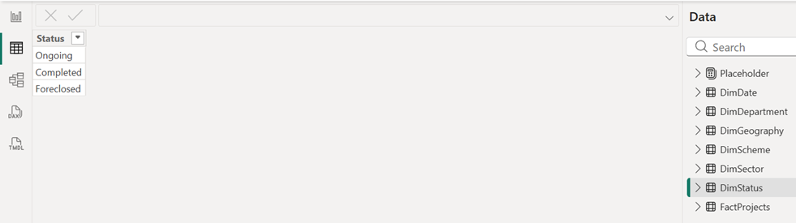
Figure 4. DimStatus in Data view (Evidence Fig-02)
What is visible. A single column Status with three rows: Ongoing, Completed, Foreclosed. The Data pane on the right lists Placeholder, DimDate, DimDepartment, DimGeography, DimScheme, DimSector, DimStatus and FactProjects.
What it demonstrates. The exact status labels in the model. The text "Completed" in the Overdue Projects formula matches one of them exactly. The Data pane lists all eight tables.
Why it matters. The screening measure depends on this label, and the previous report could not confirm it. It also shows that Foreclosed is a separate label from Ongoing.
Limitation of the evidence. It does not show how many records carry each label, and no Overdue Projects value appears anywhere in the evidence.

ISSUE IDENTIFIED Overdue Projects tests Status <> "Completed", so records labelled Foreclosed are treated the same as Ongoing records. Whether a foreclosed project should appear in an overdue screen is a business decision that the source does not answer. Section 7.5 sets out the options.

5.3 DimDepartment and DepartmentKey
The source column is Executing Department. A null value was replaced with the text Not specified in both FactProjects and DimDepartment, so every fact row has a department. The relationship key is built with three Power Query functions:
DepartmentKey (Power Query M)
Text.Upper(Text.Trim(Text.Clean([Executing Department])))

Table 7. What each function does to a department name
Step | Function | Effect | Illustration (hypothetical string)
1 | Text.Clean | Removes non-printable characters such as line breaks | Dept. of Power + hidden line break becomes Dept. of Power
2 | Text.Trim | Removes leading and trailing spaces | Dept. of Power becomes Dept. of Power
3 | Text.Upper | Makes capitalisation uniform | Dept. of Power becomes DEPT. OF POWER
Source: Prepared by the author. The illustration strings are hypothetical; the final key for `Dept. of Power` is observed in Fig-03.
The key is needed because a relationship's one side must hold unique values, and text matching in the Power BI model is generally not sensitive to capitalisation. Names that differ only by case, spaces or hidden characters would otherwise sit in the dimension as apparent duplicates. According to the notes, the dimension had 242 rows before and 235 after removing duplicates on DepartmentKey, so seven rows were merged. De-duplicating the dimension does not remove any fact record: every fact row keeps its own DepartmentKey, and each key still exists once in the dimension. The original Executing Department text is kept for display, because the upper-case key is not suited to reading.
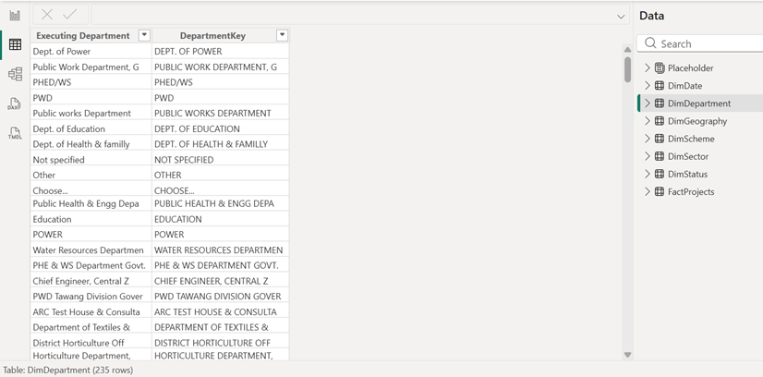
Figure 5. DimDepartment: Executing Department and DepartmentKey (Evidence Fig-03)
What is visible. Two columns, Executing Department and DepartmentKey, and the status bar reading "Table: DimDepartment (235 rows)". Example pairs: Dept. of Power and DEPT. OF POWER; Not specified and NOT SPECIFIED; Public works Department and PUBLIC WORKS DEPARTMENT.
What it demonstrates. The key formula works as intended (upper case, trimmed), the null replacement exists, and the dimension has 235 rows after de-duplication.
Why it matters. It evidences the normalised key and the 235-row result, which the earlier report only asserted.
Limitation of the evidence. The 242-row starting figure is not visible. The screenshot cannot show that keys are unique across all 235 rows or that the fact table keys all match.

What the normalisation does not do
Fig-03 shows that the key standardises text form, not meaning. PWD, Public works Department and Public Work Department, G are three different keys, as are POWER and Dept. of Power. Several source values are truncated (Public Health & Engg Depa, Water Resources Departmen, Chief Engineer, Central Z), and entries such as Choose... and Other appear as department labels. The 235 keys therefore overstate the number of real departments, and department comparisons will split the same body across several rows. This is a limitation of the source text, not an error in the key (see Section 11).

5.4 DimGeography and GeographyKey
The geography dimension was intended to hold one row for each State–District pair. A relationship connects one column to one column, so the pair is combined into a single key:
GeographyKey (Power Query M)
Text.Trim([State]) & "|" & Text.Trim([District])

For example, the key for a Tripura record in West Tripura is TRIPURA|West Tripura. Fact rows whose key has no match in the dimension fall into a blank category in any visual that uses DimGeography fields.
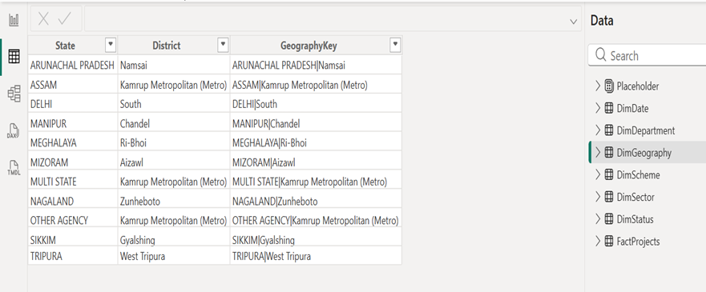
Figure 6. DimGeography in Data view (Evidence Fig-04)
What is visible. Columns State, District and GeographyKey, with 11 rows: ARUNACHAL PRADESH|Namsai, ASSAM|Kamrup Metropolitan (Metro), DELHI|South, MANIPUR|Chandel, MEGHALAYA|Ri-Bhoi, MIZORAM|Aizawl, MULTI STATE|Kamrup Metropolitan (Metro), NAGALAND|Zunheboto, OTHER AGENCY|Kamrup Metropolitan (Metro), SIKKIM|Gyalshing and TRIPURA|West Tripura.
What it demonstrates. The GeographyKey formula is applied, and the table has exactly one row per State, each with a single district. The source also uses MULTI STATE and OTHER AGENCY as State values.
Why it matters. It resolves the row-count question the earlier report left open: 11 is the number of States, not of State–District pairs. This is the evidence that the dimension is not built as intended.
Limitation of the evidence. It shows no row-count footer, so 11 is the number of rows visible with no further rows. The screenshot does not show how many fact keys are unmatched.

ISSUE IDENTIFIED Issue identified. The Week 2 profile showed 183 distinct districts, so a State–District dimension should hold at least 183 rows. With 11, the dimension appears to have been de-duplicated on State alone, which keeps one arbitrary district per State. A fact record keyed TRIPURA|West Tripura matches, but a record from any other district has no match. Section 6.4 describes the effect on visuals and Section 9 the corrective action.

5.5 DimDate
DimDate is a continuous calendar generated in Power Query with the columns Date, Year, Month Number, Month and Quarter. Its range runs from the minimum to the maximum non-null value across both fact date columns, rounded to whole years. DimDate[Date] is marked as the date table. A continuous calendar matters for the cumulative measure, which must see every date, including days with no sanctioned projects.
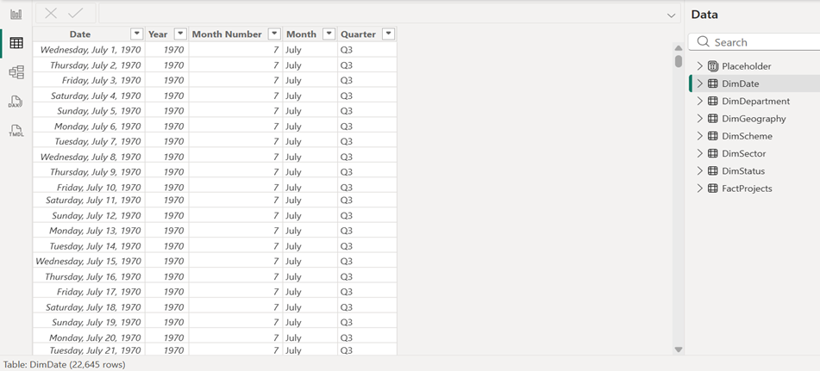
Figure 7. DimDate in Data view (Evidence Fig-05)
What is visible. Columns Date, Year, Month Number, Month and Quarter, showing consecutive days from July 1970 (Wednesday, July 1, 1970 onward, Quarter Q3), and the footer "Table: DimDate (22,645 rows)".
What it demonstrates. The calendar has the documented columns and 22,645 rows. 22,645 equals the number of days from 1 January 1970 to 31 December 2031, which agrees with the author-reported range.
Why it matters. The calendar underpins both date relationships and the time-based measures.
Limitation of the evidence. The screenshot shows 1970 rows, which are not relevant to any sanctioned date (earliest 1 April 1998). It does not show the Mark as date table setting.

ISSUE IDENTIFIED The calendar starts in 1970 only because one scheduled completion date is 1 January 1970. Without it, a calendar beginning on 1 January 1998 would hold 12,418 rows (author's arithmetic, assuming whole-year boundaries), so the anomaly adds 10,227 rows, about 45% of the table. Section 9.3 covers the investigation.

6. Relationship Architecture

6.1 Relationship matrix
Table 8. Relationships in the model
Join (dimension to fact) | Cardinality and filter direction | In Fig-06 (earlier capture) | Current state | Business purpose | Evidence and note
DimSector[Sector] to FactProjects[Sector] | One-to-many; single | Active | Active | Filter by sector | Fig-06, Fig-01
DimScheme[Scheme] to FactProjects[Scheme] | One-to-many; single | Active | Active | Filter by scheme | Fig-06, Fig-01
DimDepartment[DepartmentKey] to FactProjects[DepartmentKey] | One-to-many; single | Inactive | Active (author-reported) | Filter by executing department | Fig-06 predates activation. Updated screenshot needed
DimStatus[Status] to FactProjects[Status] | One-to-many; single | Active | Active | Filter by status | Fig-06, Fig-01
DimGeography[GeographyKey] to FactProjects[GeographyKey] | One-to-many; single | Active | Active, but see 6.4 | Filter by State–District | Fig-06. Coverage issue
DimDate[Date] to FactProjects[Sanctioned Date] | One-to-many; single | Active | Active | Default date role | Fig-06, Fig-01 (solid line)
DimDate[Date] to FactProjects[Scheduled Completion Date] | One-to-many; single | Inactive | Inactive (intended) | Alternative date role, used by USERELATIONSHIP | Fig-06, Fig-01 (dotted line)
Source: Fig-06 and Fig-01; current state as reported by the author. All filters flow from the dimension (1) to the fact table (*).
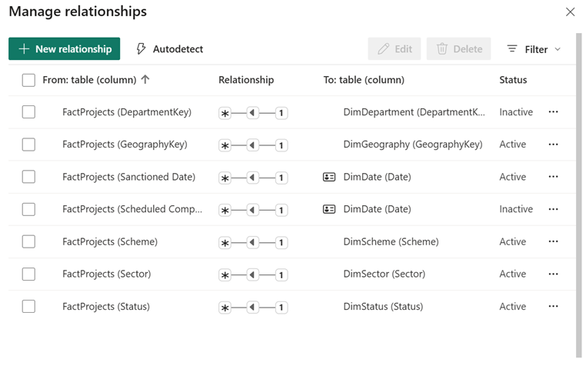
Figure 8. Manage relationships dialog (Evidence Fig-06)
What is visible. Seven relationships from FactProjects columns to dimension columns. Each shows * at the fact side, 1 at the dimension side and a single arrow pointing toward the fact side. Status column: DepartmentKey Inactive, GeographyKey Active, Sanctioned Date Active, Scheduled Completion Date Inactive, Scheme Active, Sector Active, Status Active.
What it demonstrates. Cardinality and filter direction for every relationship, and which are active. It proves the date roles: sanctioned active, scheduled completion inactive.
Why it matters. Cardinality, direction and status are core deliverables, and this is the model's own record of them.
Limitation of the evidence. It was captured before the Department relationship was activated and must not be used as proof of the current Department status. Column names are partly truncated.

6.2 Single-direction filtering
All seven relationships filter from the dimension to the fact table. Selecting Completed in a DimStatus slicer restricts the FactProjects rows seen by every measure. The reverse does not happen: filtering the fact table does not shrink a dimension's list. This keeps results predictable and avoids ambiguous filter paths in a model with six dimensions.

6.3 Why one date relationship is inactive
DimDate and FactProjects are joined twice, by Sanctioned Date and by Scheduled Completion Date. Power BI allows only one active relationship between the same pair of tables, since two active paths would make a date filter ambiguous. The sanctioned date is the active role, so a visual with DimDate[Year] on its axis counts projects by sanction year by default. The scheduled-completion relationship stays in the model, inactive, and a measure switches to it with USERELATIONSHIP inside CALCULATE (Microsoft, n.d.-c). The switch lasts only for that calculation, and a second copy of the calendar table is not needed.

6.4 Geography: the relationship depends on key coverage
A one-to-many relationship needs the one side, DimGeography[GeographyKey], to hold unique values. Fig-04 suggests that condition is met, because the 11 keys are distinct. The relationship also needs the dimension to contain the keys the fact table uses. With one district per State, it does not. Records whose key is not in the dimension are grouped under (Blank) when a visual uses DimGeography[State] or DimGeography[District].
OBSERVATION In Fig-09 the chart "Total Approved Budget and Total Expenditure by State" shows a (Blank) category as its visible bar, extending past the 40K axis label, which is most of the 51K total. A chart by State drawn from the fact table's own State column would not produce a blank category, because the Week 2 profile showed State 100% valid. This is consistent with a relationship that leaves most records unmatched. The chart cannot confirm which field it uses, so the finding is marked for verification.
RECOMMENDATION (NOT IMPLEMENTED) Rebuild DimGeography by selecting State and District together and removing duplicates, then check that its row count equals the number of distinct GeographyKey values in FactProjects and that no fact key is missing from the dimension. Not implemented in the evidence.
Recommended Power Query step (not implemented)
= Table.Distinct(PreparedData, {"State", "District"})

6.5 Department relationship
Fig-06 shows the DepartmentKey relationship as inactive. The author reports that it was activated afterwards. Because the relationship needs unique keys on the dimension side, which the 235-row de-duplication on DepartmentKey provides by construction, it can be active. The next test is whether a DimDepartment slicer changes Total Projects. Until an updated Fig-06 is captured, this report treats the activation as author-reported.

6.6 Assumptions
Table 9. Modelling assumptions
Topic | Assumption or treatment
Grain | One row of FactProjects is one project record. Uniqueness of Serial Number in the loaded table is not yet tested.
Approved Cost | The approved cost in the source, in ₹ crore.
Total Financial Expenditure | Recorded financial expenditure in the source, in ₹ crore; not physical progress.
Missing department | Null replaced with Not specified; the record stays in the model.
Department text | The key standardises case, spaces and hidden characters only. Original text is kept for display.
Geography key | State and District joined with |; State and District remain available as columns.
Blank dates | Retained. A blank date has no calendar match, so it appears under (Blank) in date visuals and is excluded from date-based counts.
Status | Used as recorded in the source: Ongoing, Completed, Foreclosed.
Scale | A small analytical model for one public dataset. It has no resource, labour or progress tables and is not a data warehouse.
Source: Prepared by the author.

7. DAX Measures and KPI Development
The 13 measures below were created in the measure container (Fig-07 confirms their names). The formulas are the author's documentation, reproduced exactly; the screenshots do not show formula text, so each formula should be compared with the formula bar before submission. No implemented formula has been altered. Recommended changes are shown separately and labelled. Monetary measures are in ₹ crore.

7.1 Core financial and count measures
Total Approved Budget
Total Approved Budget =
SUM(FactProjects[Approved Cost])

Total Expenditure
Total Expenditure =
SUM(FactProjects[Total Financial Expenditure])

Budget Balance
Budget Balance =
[Total Approved Budget] - [Total Expenditure]

Budget Utilization %
Budget Utilization % =
DIVIDE([Total Expenditure], [Total Approved Budget], 0)

Total Projects
Total Projects =
COUNTROWS(FactProjects)

Table 10. Core measures: evaluation and interpretation
Measure | How it is evaluated | Interpretation | Caveat
Total Approved Budget | Sums Approved Cost over the FactProjects rows left by the current filters | Approved cost of the projects in view (₹ crore) | Approved cost, not money spent
Total Expenditure | Sums Total Financial Expenditure over the same rows | Recorded financial expenditure (₹ crore) | Not physical progress
Budget Balance | Subtracts one measure from the other, each evaluated in the same filter context | Positive: recorded expenditure is below approved cost. Negative: it exceeds approved cost | A financial difference, not a verified spendable balance
Budget Utilization % | DIVIDE returns expenditure ÷ budget, or the alternate result 0 if the denominator is zero (Microsoft, n.d.-b). Formatted as a percentage with two decimals | Share of approved cost with recorded expenditure | A financial ratio, not a completion percentage. At any grouping it equals the group's total expenditure ÷ total budget, so large projects weigh more
Total Projects | Counts rows of FactProjects in the current context | Number of project records | Records, not confirmed distinct projects. Normally returns blank, not 0, when no row is in view
Source: Prepared by the author; DIVIDE behaviour per Microsoft (n.d.-b).
Filter context is what makes one definition give different answers. With no filters, Total Projects counts all records. In a table with DimSector[Sector] as rows, each row's context contains one sector, which flows to FactProjects through the relationship, so Total Projects counts only that sector's records. A DimStatus slicer set to Completed adds a second condition to every such row.

7.2 Advanced measure 1: Projects by Scheduled Completion Date
Projects by Scheduled Completion Date
Projects by Scheduled Completion Date =
CALCULATE(
[Total Projects],
USERELATIONSHIP(
DimDate[Date],
FactProjects[Scheduled Completion Date]
)
)

Table 11. Line-by-line explanation
Part | Role
CALCULATE( | Evaluates its first argument after changing the filter context with the later arguments
[Total Projects] | The expression to evaluate, which counts FactProjects rows
USERELATIONSHIP(DimDate[Date], FactProjects[Scheduled Completion Date]) | Makes the inactive relationship between these columns the one used for this calculation, and sets aside the active sanctioned-date relationship between the same two tables
Source: Prepared by the author; function behaviour per Microsoft (n.d.-c).
When a chart places DimDate[Year] on its axis, each bar's year filters DimDate, and the measure carries that filter to FactProjects[Scheduled Completion Date]. The result is the number of records scheduled to finish in that year. [Total Projects] on the same axis counts records by sanctioned year. This is a distribution of planned dates, not of actual completions.
Records with a blank scheduled completion date have no date to match. They do not fall in any year, and they appear under (Blank) on a date axis. With 12 blanks reported, the counts across all dates should add to 3,774 − 12 = 3,762, plus a blank group of 12. This expected result has not yet been tested (Section 9).
HYPOTHETICAL EXAMPLE Three projects, hypothetical. P1: sanctioned 2015, scheduled 2018. P2: sanctioned 2015, scheduled 2019. P3: sanctioned 2016, scheduled date blank.
Table 12. Same records, two date roles (hypothetical)
Year | Total Projects (sanctioned role) | Projects by Scheduled Completion Date
2015 | 2 (P1, P2) | 0
2016 | 1 (P3) | 0
2018 | 0 | 1 (P1)
2019 | 0 | 1 (P2)
(Blank) | 0 | 1 (P3)
Source: hypothetical illustration prepared by the author. A record-level example from the evidence is in Section 8.
Fig-09 shows the effect in real data: the chart "Projects by Scheduled Completion Date by Year" spans roughly 2000 to 2031, while the sanctioned-year chart spans 1998 to 2026. The two charts have different shapes, so the measure is using a different date column.

7.3 Advanced measure 2: Cumulative Approved Budget
Cumulative Approved Budget
Cumulative Approved Budget =
CALCULATE(
[Total Approved Budget],
FILTER(
ALLSELECTED(DimDate[Date]),
DimDate[Date] <= MAX(DimDate[Date])
)
)

Table 13. Line-by-line explanation
Part | Role
MAX(DimDate[Date]) | The latest date in the current visual cell, for example 20 February 2014 on a daily axis. It is evaluated in the cell's filter context
ALLSELECTED(DimDate[Date]) | All dates that remain after outer selections such as slicers and page filters, with the axis's own single-date filter removed
FILTER(..., DimDate[Date] <= MAX(...)) | Keeps only the dates up to and including the cell's date
CALCULATE([Total Approved Budget], ...) | Sums approved cost for the records related to those dates. The sanctioned-date relationship is the active one, so the result is the approved cost of projects sanctioned up to that date
Source: Prepared by the author.
HYPOTHETICAL EXAMPLE Three projects, hypothetical amounts in ₹ crore. X: sanctioned 10 Jan, 10. Y: sanctioned 10 Jan, 5. Z: sanctioned 15 Mar, 20.
Table 14. Running total, evaluated date by date (hypothetical)
Date in the cell | Total Approved Budget on that date | Dates kept by FILTER | Cumulative Approved Budget
10 Jan | 15 | dates up to 10 Jan | 15
12 Feb (no sanction) | blank | dates up to 12 Feb | 15
15 Mar | 20 | dates up to 15 Mar | 35
20 Apr (no sanction) | blank | dates up to 20 Apr | 35
Source: hypothetical illustration prepared by the author.
The total is flat after the last sanction date because no new approved cost enters the set of dates. A slicer, for example on DimSector, filters FactProjects before the sum, so the cumulative line then shows only that sector. A date slicer narrows the ALLSELECTED set, so the running total starts again from the first selected date, not from 1998. A record with a blank sanctioned date never enters any date, so the final cumulative value should equal Total Approved Budget minus that record's approved cost. The measure is a historical accumulation, not a forecast.

7.4 Advanced measures 3 and 4: conditional counts of expenditure
Projects with Recorded Expenditure
Projects with Recorded Expenditure =
CALCULATE(
[Total Projects],
FILTER(
FactProjects,
FactProjects[Total Financial Expenditure] > 0
)
)

Projects with No Recorded Expenditure
Projects with No Recorded Expenditure =
CALCULATE(
[Total Projects],
FILTER(
FactProjects,
ISBLANK(FactProjects[Total Financial Expenditure])
|| FactProjects[Total Financial Expenditure] = 0
)
)

FILTER walks through the FactProjects rows that are in the current filter context and keeps those meeting the test. CALCULATE then evaluates [Total Projects] on that reduced set. A sector slicer therefore changes both measures, but the expenditure test is applied to each row individually. The second measure tests for a blank or zero value; in DAX a blank compares equal to zero, so the ISBLANK clause is probably redundant, though harmless and clearer.
VERIFIED IN EVIDENCE Fig-08 shows 3.629K and 145. The card label 3.629K has four significant figures, so the count is 3,629, and 3,629 + 145 = 3,774, equal to Total Projects. The two measures therefore split the records with no overlap and no remainder (display values; Section 9).
Positive expenditure shows that spending was recorded, not that construction progressed. A blank or zero value shows nothing is recorded; the source does not say why (not started, not yet reported, or another reason). In the evidence, 145 of 3,774 records, or 3.84%, have no recorded expenditure (author's arithmetic). These are the records a financial reviewer would look at first.

7.5 Advanced measure 5: Overdue Projects (scheduled-date screening)
Overdue Projects
Overdue Projects =
CALCULATE(
[Total Projects],
FILTER(
FactProjects,
NOT ISBLANK(FactProjects[Scheduled Completion Date])
&& FactProjects[Scheduled Completion Date] < TODAY()
&& FactProjects[Status] <> "Completed"
)
)

Table 15. The three conditions
Condition | Purpose | Consequence
NOT ISBLANK(Scheduled Completion Date) | Excludes records with no scheduled date | The 12 blank-date records can never be flagged
Scheduled Completion Date < TODAY() | The planned date has passed | The result changes every day; the data is a snapshot as on 31 August 2026
Status <> "Completed" | Excludes finished projects | Matches a label that exists in DimStatus (Fig-02), so the comparison is valid. Ongoing and Foreclosed records both pass
Source: Prepared by the author; labels from Fig-02.
The measure is a scheduled-date screening indicator. A project whose planned date is in the past may be delayed, or may be finished and not yet updated, or may have a wrong date, and the data has no actual completion date or physical-progress field to tell these apart. No value of this measure appears in the evidence, so it counts as documented but not tested.
RECOMMENDATION (NOT IMPLEMENTED) Options, none implemented. (a) Keep the formula and describe it as it is. (b) Restrict to FactProjects[Status] = "Ongoing", if foreclosed projects should be excluded. (c) Compare against a fixed snapshot date, for example DATE(2026, 8, 31) held in a variable, so the result does not drift after the data snapshot. The choice between (a) and (b) is a business decision.

7.6 Additional measures
Average Approved Cost per Project
Average Approved Cost per Project =
DIVIDE([Total Approved Budget], [Total Projects], 0)

Average Expenditure per Project
Average Expenditure per Project =
DIVIDE([Total Expenditure], [Total Projects], 0)

Projects by Sanctioned Date
Projects by Sanctioned Date =
CALCULATE(
[Total Projects],
USERELATIONSHIP(
DimDate[Date],
FactProjects[Sanctioned Date]
)
)

The two averages are per project record, matching the measure names only if each row is one project. From the card values, they would be about 51,192.22 ÷ 3,774 = ₹13.56 crore and 37,718.69 ÷ 3,774 = ₹9.99 crore for the whole portfolio (author's arithmetic; the measure outputs are not shown in the evidence). Projects by Sanctioned Date names the relationship that is already active, so it returns the same result as Total Projects on a date axis and is redundant; its only value is that the name states which date is counted. It is not counted among the advanced measures in this report.

7.7 Correctness and efficiency review
Table 16. Review of implementation choices
Aspect | Observation | Possible change (not implemented)
Reuse | Averages, balance and utilization all call Total Approved Budget, Total Expenditure or Total Projects, so each rule is defined once | None needed
Safe division | Three ratio measures use DIVIDE with alternate result 0, so an empty selection shows 0 rather than an error | Use blank as the alternate result if an empty selection should show no value
Row filters | FILTER(FactProjects, ...) evaluates 3,774 rows per cell, which is not a practical cost at this size, and respects other filters on the table | A Boolean filter such as FactProjects[Total Financial Expenditure] > 0 is shorter, but it replaces any filter on that column, so the implemented form is kept
Running total | ALLSELECTED over DimDate[Date] iterates every selected date. The 1970 start adds 10,227 unneeded calendar rows | Correct the 1970 date (Section 9.3) to shorten the calendar
TODAY() | Makes Overdue Projects time-dependent | Fixed snapshot date variable (Section 7.5)
Redundancy | Projects by Sanctioned Date duplicates Total Projects; the ISBLANK clause is redundant | Remove or keep for clarity
Source: Prepared by the author.

7.8 How the measures work with the model
A measure is calculated when a visual is drawn, using the filter context of that visual, so it follows slicers and axes. A calculated column is calculated once per row at refresh and stored; it suits row-level values. In this model the row-level values DepartmentKey and GeographyKey are created earlier, as Power Query columns, because they are needed for the relationships. All 13 KPI figures are measures, because they must change with filters.
Table 17. Measure dependencies and the model paths they use
Measure | Depends on | Relationship used
Total Approved Budget; Total Expenditure; Total Projects | FactProjects columns | Any active relationship carrying a filter
Budget Balance; Budget Utilization % | Total Approved Budget; Total Expenditure | As above
Average Approved Cost per Project; Average Expenditure per Project | Totals and Total Projects | As above
Cumulative Approved Budget | Total Approved Budget; DimDate | DimDate to Sanctioned Date (active)
Projects by Scheduled Completion Date | Total Projects; DimDate | DimDate to Scheduled Completion Date (inactive, switched on)
Projects by Sanctioned Date | Total Projects; DimDate | DimDate to Sanctioned Date (active)
Projects with / with No Recorded Expenditure; Overdue Projects | Total Projects; row filters on FactProjects | Any active relationship carrying a filter
Source: Prepared by the author.

8. Worked Examples, KPI Results and Business Interpretation
This section uses the two report pages in the evidence to test the measures against real values. The cards use K-formatting, so each reading below states how much precision the display allows.

8.1 Validation page
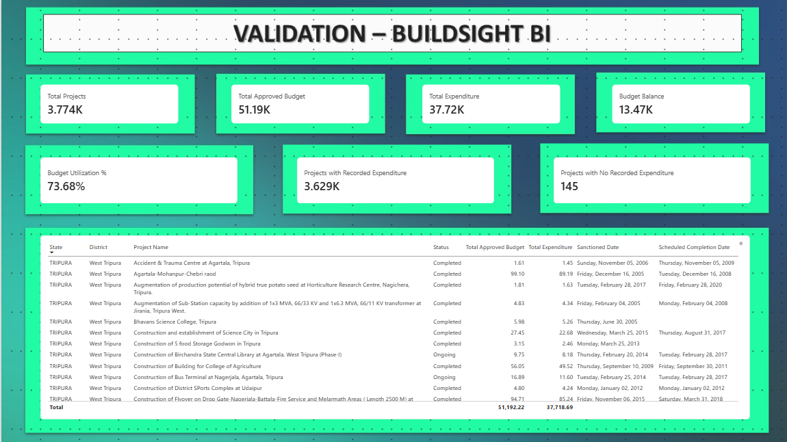
Figure 9. Validation page: core KPI cards and a project detail table (Evidence Fig-08)
What is visible. Seven cards: Total Projects 3.774K, Total Approved Budget 51.19K, Total Expenditure 37.72K, Budget Balance 13.47K, Budget Utilization % 73.68%, Projects with Recorded Expenditure 3.629K, Projects with No Recorded Expenditure 145. Below them, a table of TRIPURA / West Tripura records with Status, Total Approved Budget, Total Expenditure, Sanctioned Date and Scheduled Completion Date, and a total row of 51,192.22 and 37,718.69.
What it demonstrates. Core measures return values, the cards are consistent with each other (Section 8.3), and records can be read at row level. Two visible rows have a blank scheduled completion date, and one row has the same sanctioned and scheduled date.
Why it matters. It is the page-level proof that the measures calculate, and it supplies the real values used in the worked examples.
Limitation of the evidence. The cards are rounded to K units. The table shows only the first rows of one State, so it is not a full reconciliation. No card for Overdue Projects, Cumulative Approved Budget or the two date-role measures appears.

Table 18. Reading the validation cards
Card | Displayed | Precision of the display | Value used in this report
Total Projects | 3.774K | Four significant figures, so 3,773.5 to 3,774.5 and the integer is 3,774 | 3,774 project records
Total Approved Budget | 51.19K | Rounded to 10 ₹ crore | ₹51,192.22 crore (table total row)
Total Expenditure | 37.72K | Rounded to 10 ₹ crore | ₹37,718.69 crore (table total row)
Budget Balance | 13.47K | Rounded to 10 ₹ crore | ₹13,473.53 crore (derived, Section 8.3)
Budget Utilization % | 73.68% | Two decimals | 73.68%
Projects with Recorded Expenditure | 3.629K | Four significant figures, so 3,629 | 3,629
Projects with No Recorded Expenditure | 145 | Integer | 145
Source: Fig-08; author's reading of the display precision. The table totals are the most precise values visible.

8.2 Project overview page
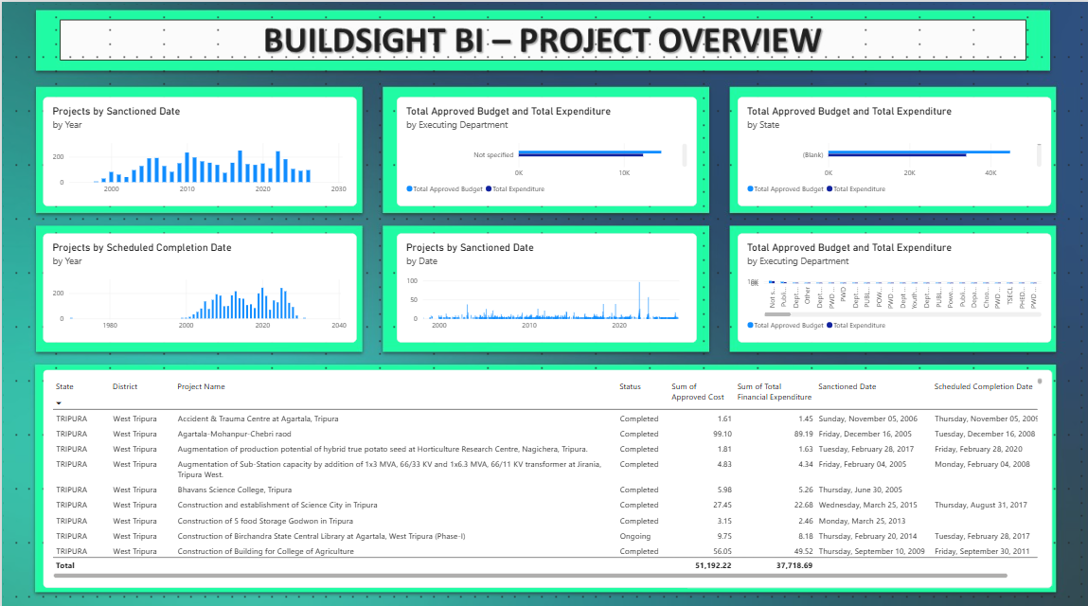
Figure 10. Project overview page: six charts and a project detail table (Evidence Fig-09)
What is visible. Six charts: Projects by Sanctioned Date by Year; Total Approved Budget and Total Expenditure by Executing Department (two charts); Projects by Scheduled Completion Date by Year; Projects by Sanctioned Date by Date; and Total Approved Budget and Total Expenditure by State. Below them, a table with the columns Sum of Approved Cost and Sum of Total Financial Expenditure and the same totals, 51,192.22 and 37,718.69.
What it demonstrates. The date-role measures work in charts, and the table totals agree with the validation page even though this table uses plain column sums and not the DAX measures. The charts also expose three model issues.
Why it matters. It shows the model in use and gives evidence for the geography and date problems.
Limitation of the evidence. Charts carry no data labels, so values are read from axes only. It does not show which table's field each chart uses, and it was captured around the earlier relationship state.

Observations from the charts (qualitative)
- Sanctioned by year. Bars run from about 1998 to 2026. Sanction counts cluster between roughly 2005 and 2022, with higher bars around 2010 and the late 2010s and lower bars at both ends.
- Scheduled completion by year. Bars run from about 2000 to 2031. The axis labels start near 1980 and a small isolated mark sits at the far left. This is consistent with the 1970 scheduled completion date and is the visible effect of the anomaly (Section 9.3).
- Sanctioned by date. Most days are low, with a few tall spikes, one close to 100 on the vertical axis. Many records share a sanction date, which suggests bulk sanctions or default dates. This needs checking against the source before it is interpreted.
- By State. The visible category is (Blank), with a bar extending past the 40K label. This is consistent with the geography key problem (Section 6.4).
- By Executing Department. The first category in one chart is Not specified, with a bar that passes the 10K label, so a large share of approved budget carries no department. The second department chart has so many categories that its bars and labels cannot be read.

8.3 Arithmetic reconciliation
The numbers on the validation page can be checked by hand. The table uses the exact totals from the table rows, not the rounded cards.
Table 19. Checks on the displayed KPI values
Check | Arithmetic | Displayed | Result
Budget Balance | 51,192.22 − 37,718.69 = 13,473.53 | 13.47K | Consistent (13,473.53 rounds to 13.47K)
Budget Utilization % | 37,718.69 ÷ 51,192.22 = 0.736805, or 73.6805% | 73.68% | Consistent to two decimals
Count split | 3,629 + 145 = 3,774 | 3.774K | Consistent: no overlap or remainder
Page totals | Fig-08 total row 51,192.22 and 37,718.69; Fig-09 total row 51,192.22 and 37,718.69 | Both pages | Identical to two decimals
Records without expenditure | 145 ÷ 3,774 = 3.84% | 145 | Derived share
Average approved cost per record | 51,192.22 ÷ 3,774 = 13.56 | not shown | Derived; measure output not in evidence
Source: author's arithmetic from Fig-08 and Fig-09.
VERIFIED IN EVIDENCE The two pages agree on both totals. Fig-08 uses the DAX measures and Fig-09 uses implicit column sums, so the agreement shows that Total Approved Budget and Total Expenditure equal a plain sum of the fact columns when unfiltered.
PENDING VALIDATION Because the cards are K-rounded, these are consistency checks at display precision. An exact reconciliation needs the cards set to show full values (Appendix D).

8.4 Record-level worked example
Four records are read from the Tripura rows in Fig-08. They are used as a small illustrative subset, not as a sample of the dataset: every figure below applies only if these four rows were the rows in view. Project names are as in the source, including its spelling.
Table 20. Four records from Fig-08 (₹ crore)
 | Project (State: TRIPURA, District: West Tripura) | Status | Approved | Expenditure | Balance | Utilization | Sanctioned | Scheduled
A | Construction of Birchandra State Central Library at Agartala (Phase-I) | Ongoing | 9.75 | 8.18 | 1.57 | 83.9% | 20 Feb 2014 | 28 Feb 2017
B | Construction of Bus Terminal at Nagerjala, Agartala | Ongoing | 16.89 | 11.60 | 5.29 | 68.7% | 25 Feb 2014 | 28 Feb 2017
C | Bhavans Science College | Completed | 5.98 | 5.26 | 0.72 | 88.0% | 30 Jun 2005 | blank
D | Agartala-Mohanpur-Chebri raod | Completed | 99.10 | 89.19 | 9.91 | 90.0% | 16 Dec 2005 | 16 Dec 2008
Source: Fig-08. Balance and utilization are the author's arithmetic.
Subset totals. Approved 9.75 + 16.89 + 5.98 + 99.10 = 131.72. Expenditure 8.18 + 11.60 + 5.26 + 89.19 = 114.23. Budget Balance = 17.49 and Budget Utilization % = 114.23 ÷ 131.72 = 86.72%. The simple average of the four record ratios is 82.63%. The two differ because the measure divides totals, so record D (99.10) weighs far more than record A (9.75). This is why the measure should not be read as the average completion of projects.
Table 21. What each measure would return for the four-record subset
Measure | Result | Reasoning
Total Projects | 4 | Four rows in view
Projects with Recorded Expenditure | 4 | All four have expenditure above 0
Projects with No Recorded Expenditure | 0 | None is blank or zero
Projects by Sanctioned Date, by year | 2005: 2 (C, D); 2014: 2 (A, B) | Active relationship on Sanctioned Date
Projects by Scheduled Completion Date, by year | 2008: 1 (D); 2017: 2 (A, B); (Blank): 1 (C) | USERELATIONSHIP on Scheduled Completion Date. C has no scheduled date
Overdue Projects | 2 (A and B) | Both are Ongoing with a scheduled date of 28 Feb 2017, which is before any date after that day. C has no scheduled date and is Completed. D is Completed
Cumulative Approved Budget, by sanctioned date | 30 Jun 2005: 5.98; 16 Dec 2005: 105.08; 20 Feb 2014: 114.83; 25 Feb 2014: 131.72 | Running sum in date order; the last value equals the subset's total approved cost, 131.72
Source: author's evaluation of the documented formulas on the four Fig-08 records. These values were not produced by Power BI for this subset.
The example shows three behaviours the model must get right. Records A and B have the same scheduled date, which shows how scheduled workload concentrates. Record C shows how a blank scheduled date drops a record from the scheduled count and from the overdue screen while it still counts under the sanctioned role. Records A and B are flagged by a screen based only on a planned date and status; whether the library or the bus terminal is physically late cannot be known from this data.

8.5 Business questions and the measures that answer them
Table 22. Construction-business use of the measures
Business question | Measure | What the result tells the analyst | Possible management action | Limitation
How much of the approved budget has recorded spending? | Budget Utilization % | Portfolio utilization is 73.68% on the validation page | Review groups with unusually low or high utilization | Financial ratio, not progress
How large is the gap between approved cost and recorded spending? | Budget Balance | ₹13,473.53 crore overall | Ask whether the gap is committed, pending or unreported | Not a spendable balance
Which sectors, schemes or departments hold the most budget and spending? | Total Approved Budget; Total Expenditure by a dimension | Where money is concentrated | Focus monitoring there | Department names are fragmented (5.3); State grouping is broken (6.4)
Which projects have no recorded expenditure? | Projects with No Recorded Expenditure | 145 records (3.84%) | Ask executing departments to confirm status and reporting | Reason for absence unknown
How many projects have recorded spending? | Projects with Recorded Expenditure | 3,629 records | Use as the base for utilization review | Not physical progress
How has sanction activity varied over time? | Projects by Sanctioned Date | Years with more sanctions (Fig-09) | Understand sanction cycles and backlog | Sanction volume is not construction activity; shared sanction dates need checking
When are projects scheduled to finish? | Projects by Scheduled Completion Date | Planned years with more completions (Fig-09) | Plan review capacity for those years | Planned dates only; 12 blanks excluded; 1970 anomaly
How has approved cost accumulated? | Cumulative Approved Budget | Growth of approved commitments by sanction date | Compare growth across sectors or schemes | Historical, not a forecast; one blank sanctioned date excluded
Which records need schedule follow-up? | Overdue Projects | Records past their planned date and not Completed | Review those records first | Not proof of delay; includes Foreclosed; TODAY()
How do states, sectors, schemes or departments compare? | Utilization and totals by dimension | Relative financial positions | Prioritise outliers | Valid only once geography and department keys are corrected
Source: Prepared by the author; values from Fig-08.

9. Validation and Testing Results

9.1 Status vocabulary
Every check uses one of six statuses. A check is not marked verified because a formula exists or a screenshot looks plausible.
Table 23. Validation statuses
Status | Meaning
Verified in current Power BI evidence | A supplied screenshot shows the result directly, or the result follows by arithmetic from values it shows
Observed in an older screenshot | Shown in a screenshot or profile that may predate later changes
Confirmed by author; updated screenshot needed | The author reports the current state; the supplied screenshot shows something older
Documented implementation; formula not independently tested | The design is recorded, but no evidence shows the result or the formula text
Pending validation | No evidence exists yet; the procedure is given
Issue identified; corrective action required | The evidence shows a defect or an anomaly
Source: Prepared by the author.

9.2 Validation matrix
Table 24. Validation matrix (16 checks)
# | Check | Procedure and expected outcome | Evidence available | Status | Corrective action
1 | All model tables present | Model view and Data pane list FactProjects, six dimensions and the measure container | Fig-01 shows seven tables; Data panes in Fig-02 to Fig-05 and Fig-07 list Placeholder and the seven tables | Verified in current Power BI evidence | Optionally capture Model view with the measure container visible
2 | Fact row count and Serial Number uniqueness | Row count of FactProjects; distinct Serial Numbers equal row count | Total Projects card 3.774K (Fig-08), so 3,774 at display precision. Week 2 profile: 3,774 distinct and 3,774 unique | Observed in an older screenshot | Run a column profile on the loaded FactProjects; report row count and distinct count
3 | Dimension-key uniqueness | Distinct count equals row count for each dimension key | Fig-02: three distinct labels. Fig-03: 235 rows, unique by construction. Fig-04: 11 distinct keys. Sector and Scheme counts not captured | Documented implementation; formula not independently tested | Capture a column profile for each key
4 | Department relationship active | Manage relationships shows DepartmentKey Active; a DimDepartment slicer changes Total Projects | Fig-06 shows Inactive (earlier capture). Author reports it was activated afterwards | Confirmed by author; updated screenshot needed | Recapture Fig-06; run the slicer test
5 | Geography relationship completeness | Every distinct GeographyKey in FactProjects exists once in DimGeography | Fig-04: 11 rows, one per State. Week 2: 183 distinct districts. Fig-09: (Blank) State category | Issue identified; corrective action required | Rebuild DimGeography on distinct State and District (Section 6.4); recount; repeat the State chart
6 | Date relationship configuration | Sanctioned Date relationship Active; Scheduled Completion Date relationship Inactive | Fig-06 and Fig-01 (solid and dotted lines). Author reports no change | Observed in an older screenshot | Recapture Manage relationships to show the current state
7 | Date-table marking and range | Table tools shows Mark as date table on DimDate[Date]; min and max dates correct | Fig-05: 22,645 rows. Range author-reported. Marking not shown | Pending validation | Capture Table tools; resolve the 1970 start (check 15)
8 | Budget Balance arithmetic | Total Approved Budget minus Total Expenditure | 51,192.22 − 37,718.69 = 13,473.53; card 13.47K (Fig-08) | Verified in current Power BI evidence | Show the card with full decimals for an exact match
9 | Budget Utilization % arithmetic | Expenditure divided by approved budget | 37,718.69 ÷ 51,192.22 = 73.6805%; card 73.68% | Verified in current Power BI evidence | None
10 | Approved and expenditure totals reconcile | Same totals on both pages | Fig-08 and Fig-09 total rows are both 51,192.22 and 37,718.69 | Verified in current Power BI evidence | None
11 | Conditional expenditure counts | Recorded plus No Recorded equals Total Projects | 3.629K + 145 = 3,774 (Fig-08) | Verified in current Power BI evidence | Set display units to None to show 3,629 exactly
12 | Scheduled-date measure behaviour | Counts across all dates add to 3,762 plus a (Blank) group of 12; distribution differs from the sanctioned role | Fig-09 shows different shapes for the two year charts. Sums not tested; formula text not shown | Documented implementation; formula not independently tested | Build a table by DimDate[Year], total the column and compare with 3,762 and 12
13 | Cumulative Approved Budget behaviour | Values never fall on a date axis; last value equals Total Approved Budget minus the approved cost of the record with a blank sanctioned date | No cumulative visual in the evidence | Pending validation | Build a monthly line chart and compare its last value
14 | Status label for the screening measure | DimStatus contains exactly Completed | Fig-02 shows Ongoing, Completed, Foreclosed. The label matches. The measure's value is not shown and Foreclosed records pass the <> "Completed" test | Verified in current Power BI evidence | Add an Overdue Projects card; decide whether Foreclosed is excluded (Section 7.5)
15 | Blank dates and the 1970 date | Count blanks; list records where scheduled date precedes sanctioned date | Author-reported 1 and 12 blanks. Blank scheduled dates visible in Fig-08. 1970 axis effect visible in Fig-09. The record itself is not shown | Issue identified; corrective action required | Follow the steps in Section 9.3
16 | Validation page and overview page agree | Same totals; charts consistent with cards | Totals agree (check 10). Charts have no data labels. State chart shows (Blank) | Verified in current Power BI evidence | Add data labels. Totals only; see checks 5 and 15 for the charts
Source: Prepared by the author from Fig-01 to Fig-09 and the author's reported state. Status counts: Verified 7; Observed in an older screenshot 2; Confirmed by author 1; Documented, not tested 2; Pending 2; Issue identified 2.

9.3 Date-quality investigation
Table 25. Date observations
Observation | Source | Interpretation
Sanctioned dates run from 1 April 1998 to 20 August 2026; one is blank | Author inspection | The latest date is before the 31 August 2026 snapshot, which is plausible
Scheduled completion dates run from 1 January 1970 to 12 June 2031; 12 are blank | Author inspection | A 1970 date is implausible for a sanctioned project
DimDate runs from 1 January 1970 to 31 December 2031, 22,645 rows | Fig-05 and author | The range follows the minimum and maximum of both columns
The scheduled-completion chart axis starts near 1980 with a small mark at the far left | Fig-09 | Visible effect of the 1970 value
Some records have a scheduled date exactly three years after the sanctioned date (for example 16 Dec 2005 and 16 Dec 2008) | Fig-08 | Suggests some schedules may be derived from a standard duration
One record has the same sanctioned and scheduled date (2 January 2012, District Sports Complex at Udaipur) | Fig-08 | Implausible as a project schedule; to be checked
Source: author inspection, Fig-05, Fig-08 and Fig-09.

Why the 1970 date matters
The earliest sanctioned date in the data is 1 April 1998, so a scheduled completion date of 1 January 1970 falls at least 28 years before the sanction of the same project. A project cannot be scheduled to finish before it is sanctioned, so the value is an error or a placeholder. It also coincides with the start of Unix time, a default date in some systems, which is one explanation to test, not a conclusion. The cause is not established here.
The effects on the model are concrete. (1) DimDate is about 45% longer than needed, from 12,418 to 22,645 rows (author's arithmetic, assuming whole-year bounds). (2) Any chart of scheduled dates has its axis stretched back to 1970 (Fig-09). (3) Overdue Projects would flag the record, because 1970 is before today, unless its status is Completed. (4) ALLSELECTED in the cumulative measure iterates the extra dates.

Procedure
- In Power Query, filter FactProjects for Scheduled Completion Date < Sanctioned Date and list the rows. This finds the 1970 record and any other inverted dates. The number of 1970 records is not known and may be more than one.
- Open the same project on the NESetu dashboard and compare the source value.
- Choose, from the evidence: correct the date, keep it with a documented explanation, or exclude it from date analysis by setting it to null in a documented step. If it is nulled, DimDate should shrink to start in 1998.
- Check the same-day and three-year patterns with the source before drawing conclusions about schedule quality.

Blank dates
One blank sanctioned date and 12 blank scheduled dates were retained. A blank has no calendar match, so the record appears under (Blank) in a date visual and is excluded from date-based counts. For the unfiltered data, the expected totals are 3,773 for Projects by Sanctioned Date and 3,762 for Projects by Scheduled Completion Date, plus the blank groups of 1 and 12. These are derived from the author's blank counts and have not yet been observed.

9.4 Summary of validation
Of the 16 checks, seven are verified by the current evidence at display precision, two are observed in earlier captures, one awaits an updated screenshot, two are documented but untested, two are pending, and two identify defects to correct. The verified checks cover the arithmetic of the financial KPIs and the consistency of the two report pages. The unresolved checks concern the geography key, the dates, and the formulas themselves.

10. Implementation Evidence
All nine screenshots are used in the sections shown below. The table states what each proves and what it does not, and which need refreshing.
Table 26. Evidence summary
Figure | Evidence | Section | Proves | Does not prove | Refresh
1 | Fig-01 Model view | 4.3 | Star schema, 1-to-many, single direction, dotted date and Department lines | Current Department status | Recapture after the Department activation
2 | Conceptual diagram | 4.4 | Model structure with keys (conceptual) | Anything not in Fig-01 and Fig-06 | None
3 | Fig-07 Measures | 4.5 | 13 measures in the container | Formula text | Add formula-bar captures
4 | Fig-02 DimStatus | 5.2 | Three labels incl. Completed | Counts per label | None
5 | Fig-03 DimDepartment | 5.3 | Key formula applied; 235 rows | 242 start; key matches in fact | None
6 | Fig-04 DimGeography | 5.4 | 11 rows, one per State | Unmatched key count | Recapture after the rebuild, with row count
7 | Fig-05 DimDate | 5.5 | Columns; 22,645 rows | Date-table marking | Add Table tools capture
8 | Fig-06 Manage relationships | 6.1 | Cardinality, direction, date roles | Current Department status | Recapture
9 | Fig-08 Validation page | 8.1 | KPI values and arithmetic | Exact values; Overdue; cumulative | Show full-precision cards; add Overdue card
10 | Fig-09 Overview page | 8.2 | Date-role charts; matching totals; geography and date anomalies | Chart values | Add data labels; recapture after fixes
Source: Prepared by the author. Appendix C maps figure numbers to the original screenshot labels.
The project files are kept in the BuildSight BI repository (https://github.com/Shalvi-Surve/BuildSight-BI). The repository link is given for access to the files; the figures above are the evidence for this report.

11. Strengths, Limitations and Risk Mitigation

11.1 Strengths
Table 27. Strengths and the evidence for them
Strength | Evidence
Star-schema organisation: one fact table and six dimensions with one-to-many, single-direction relationships | Fig-01, Fig-06
Reusable measures: ratios and averages call base measures, so each rule is defined once | Fig-07; Section 7.8
Normalised department key that reduces duplicates caused by case, spaces and hidden characters | Fig-03 (235 rows)
Composite State–District key design, which lets a pair join through one column | Fig-04 (key formula applied); coverage needs correction
One calendar serving two date roles through an active and an inactive relationship, with a measure switching roles | Fig-06; Fig-09
Explicit filter-context behaviour, checked on a record-level example | Section 8.4
Consistent financial KPI definitions, reconciled across two report pages | Section 8.3; Fig-08, Fig-09
Source: Prepared by the author.

11.2 Limitations and risks
Table 28. Limitations, consequences and actions
Limitation or risk | Practical consequence | Corrective or preventive action | Type
DimGeography has one row per State | Most records fall under (Blank) in geographic visuals; state and district analysis is unreliable | Rebuild on distinct State and District; recount; add an unmatched-key check | Proposed (defect)
1970 scheduled date | Stretches the calendar and charts; may be flagged as overdue | Investigate, then correct, document or exclude | Proposed
Blank dates (1 sanctioned, 12 scheduled) | Excluded from date counts and cumulative totals | Keep, and report the (Blank) group beside date visuals | Implemented (retained); report group proposed
Department names fragmented and truncated | 235 keys overstate real departments; splits budgets | Add a mapping table that groups variants; do not rely on the key alone | Proposed
Large Not specified group (Fig-09) | Department comparisons cover only part of the budget | Show the share of Not specified beside department charts | Proposed
Project-record count, not confirmed unique projects | Counts may include repeats | Profile Serial Number in the loaded table | Proposed
No actual completion date or physical progress | Delay and completion cannot be measured | Source additional data | Future work
Expenditure is financial, not physical | Utilization must not be read as completion | Keep the label "recorded financial expenditure" | Implemented (wording)
TODAY() in Overdue Projects | Results change daily | Use a fixed snapshot date | Proposed
Foreclosed status counted as not Completed | May inflate the overdue count | Decide whether to restrict to Ongoing | Proposed
Expenditure column labels changed in Week 2 ("as on 31-03-2025" shown as "as of 31 Aug 2026") | Wrong labels would mislead anyone using those columns; the measures use Total Financial Expenditure and are unaffected | Check the source definition and relabel | Proposed
Source covers only North Eastern Region projects | Results do not describe India as a whole | State the scope on every report page | Implemented (wording)
Department relationship evidence is older | Current state unproven | Recapture Manage relationships | Proposed
Source: Prepared by the author. "Implemented" refers to work in the current model or wording; "Proposed" and "Future work" are not yet done.

12. Conclusion and Recommendations
The Week 3 work delivers an advanced data model for the MDoNER project dataset: a fact table of 3,774 project records, six dimensions, normalised department and geography keys, a calendar with an active and an inactive date role, and 13 DAX measures including five advanced ones. The relationships, the date-role switching and the financial KPIs are demonstrated by the screenshots, and the validation page and the overview page agree on the totals (₹51,192.22 crore approved, ₹37,718.69 crore recorded, 73.68% utilization).
The evidence also shows where the model needs work. The geography dimension does not cover the districts in the data, the 1970 scheduled date distorts the calendar and the scheduled-date chart, the screening measure includes foreclosed projects, and several checks are still pending. These findings are part of the result, since each comes with the evidence and a corrective step. The model supports descriptive questions about budgets, expenditure and planned dates; it does not measure physical progress, actual delay, labour productivity or resource use, and it makes no forecast.

Recommended next steps, in order
- Rebuild DimGeography on distinct State and District; recount; confirm no unmatched keys.
- Investigate the 1970 record; decide, document and rebuild DimDate.
- Recapture Manage relationships with the Department relationship active.
- Add cards for Overdue Projects and a full-precision count and totals; add a cumulative line chart and a scheduled-year table with the (Blank) group.
- Decide the treatment of Foreclosed and a fixed snapshot date for the screening measure.
- Capture formula bars for the advanced measures and the Mark as date table setting.
- Profile Serial Number in the loaded table before describing records as unique projects.
- Review the Week 2 expenditure column labels against the source.

References
Ministry of Development of North Eastern Region. (n.d.). NESetu: Projects dashboard [Public project list]. Government of India. https://www.nesetu.mdoner.gov.in/projects/project-list
Microsoft. (n.d.-a). Understand star schema and the importance for Power BI. Microsoft Learn. https://learn.microsoft.com/power-bi/guidance/star-schema
Microsoft. (n.d.-b). DIVIDE function (DAX). Microsoft Learn. https://learn.microsoft.com/en-us/dax/divide-function-dax
Microsoft. (n.d.-c). USERELATIONSHIP function (DAX). Microsoft Learn. https://learn.microsoft.com/en-us/dax/userelationship-function-dax

Appendix A: DAX Formula Reference
Table 29. The 13 measures
Measure | Formula (as documented) | Concepts | Status
Total Approved Budget | SUM(FactProjects[Approved Cost]) | SUM | Documented; name in Fig-07; value in Fig-08
Total Expenditure | SUM(FactProjects[Total Financial Expenditure]) | SUM | Documented; value in Fig-08
Budget Balance | [Total Approved Budget] - [Total Expenditure] | Measure arithmetic | Value consistent (8.3)
Budget Utilization % | DIVIDE([Total Expenditure], [Total Approved Budget], 0) | DIVIDE | Value consistent (8.3)
Total Projects | COUNTROWS(FactProjects) | COUNTROWS | Value in Fig-08
Projects by Scheduled Completion Date | CALCULATE([Total Projects], USERELATIONSHIP(DimDate[Date], FactProjects[Scheduled Completion Date])) | CALCULATE, USERELATIONSHIP | Chart in Fig-09; sums untested
Cumulative Approved Budget | CALCULATE([Total Approved Budget], FILTER(ALLSELECTED(DimDate[Date]), DimDate[Date] <= MAX(DimDate[Date]))) | CALCULATE, FILTER, ALLSELECTED, MAX | Not yet shown in a visual
Projects with Recorded Expenditure | CALCULATE([Total Projects], FILTER(FactProjects, FactProjects[Total Financial Expenditure] > 0)) | CALCULATE, FILTER | Value in Fig-08
Projects with No Recorded Expenditure | CALCULATE([Total Projects], FILTER(FactProjects, ISBLANK(FactProjects[Total Financial Expenditure]) || FactProjects[Total Financial Expenditure] = 0)) | CALCULATE, FILTER, ISBLANK | Value in Fig-08
Average Approved Cost per Project | DIVIDE([Total Approved Budget], [Total Projects], 0) | DIVIDE | Output not shown
Average Expenditure per Project | DIVIDE([Total Expenditure], [Total Projects], 0) | DIVIDE | Output not shown
Projects by Sanctioned Date | CALCULATE([Total Projects], USERELATIONSHIP(DimDate[Date], FactProjects[Sanctioned Date])) | CALCULATE, USERELATIONSHIP | Chart in Fig-09; redundant
Overdue Projects | CALCULATE([Total Projects], FILTER(FactProjects, NOT ISBLANK([Scheduled Completion Date]) && [Scheduled Completion Date] < TODAY() && [Status] <> "Completed")) | CALCULATE, FILTER, TODAY | Output not shown
Source: author's documentation; formula text is not visible in the screenshots. Column references in the last row are shortened for space.

Appendix B: Relationship Matrix and Key Definitions
Table 30. Relationships (compact)
Dimension key | Fact key | Cardinality | Direction | Status
DimSector[Sector] | FactProjects[Sector] | 1:* | Single | Active
DimScheme[Scheme] | FactProjects[Scheme] | 1:* | Single | Active
DimDepartment[DepartmentKey] | FactProjects[DepartmentKey] | 1:* | Single | Active (author-reported); Inactive in Fig-06
DimStatus[Status] | FactProjects[Status] | 1:* | Single | Active
DimGeography[GeographyKey] | FactProjects[GeographyKey] | 1:* | Single | Active; coverage issue
DimDate[Date] | FactProjects[Sanctioned Date] | 1:* | Single | Active
DimDate[Date] | FactProjects[Scheduled Completion Date] | 1:* | Single | Inactive
Key definitions (Power Query M)
DepartmentKey = Text.Upper(Text.Trim(Text.Clean([Executing Department])))
GeographyKey = Text.Trim([State]) & "|" & Text.Trim([District])

Appendix C: Screenshot Evidence Index
Table 31. Screenshot index
Report figure | Original label | Content | Section
1 | Fig-01 Star-Schema Model View | Model view | 4.3
2 | (conceptual diagram) | Redrawn from Fig-01 and Fig-06 | 4.4
3 | Fig-07 Measures | Measure container | 4.5
4 | Fig-02 DimStatus Data View | DimStatus labels | 5.2
5 | Fig-03 DimDepartment and DepartmentKey Data View | Department key; 235 rows | 5.3
6 | Fig-04 DimGeography Data View | 11 geography rows | 5.4
7 | Fig-05 DimDate Data View | Calendar; 22,645 rows | 5.5
8 | Fig-06 Relationship Matrix | Manage relationships | 6.1
9 | Fig-08 Validation Page | KPI cards and table | 8.1
10 | Fig-09 Product Overview Page | Overview charts and table | 8.2
Source: Week-3-Draft.docx. Figure 2 is a conceptual diagram.

Appendix D: Validation Checklist for the Author
Table 32. Actions before submission
Done | Action | Check
[ ] | Recapture Manage relationships with the Department relationship active | 4, 6
[ ] | Rebuild DimGeography on distinct State and District; capture row count and Data view | 5
[ ] | Find the 1970 record (Scheduled Completion Date < Sanctioned Date); decide and document | 15
[ ] | Add cards: Overdue Projects; Total Projects, Total Approved Budget and Total Expenditure with display units None | 8, 9, 11, 14
[ ] | Add a table by DimDate[Year] with both date-role measures and the (Blank) group; compare with 3,773 and 3,762 | 12
[ ] | Add a monthly line chart for Cumulative Approved Budget; compare its last value | 13
[ ] | Capture formula bars for the three advanced measures | Appendix A
[ ] | Capture Table tools showing Mark as date table | 7
[ ] | Run a column profile on loaded FactProjects for Serial Number | 2
[ ] | Decide treatment of Foreclosed; update the report text if the formula changes | 14
[ ] | Review the Week 2 expenditure column labels against the source | 11.2
Source: Prepared by the author. Update the matrix statuses in Section 9.2 after each action.

