WEEK – 3

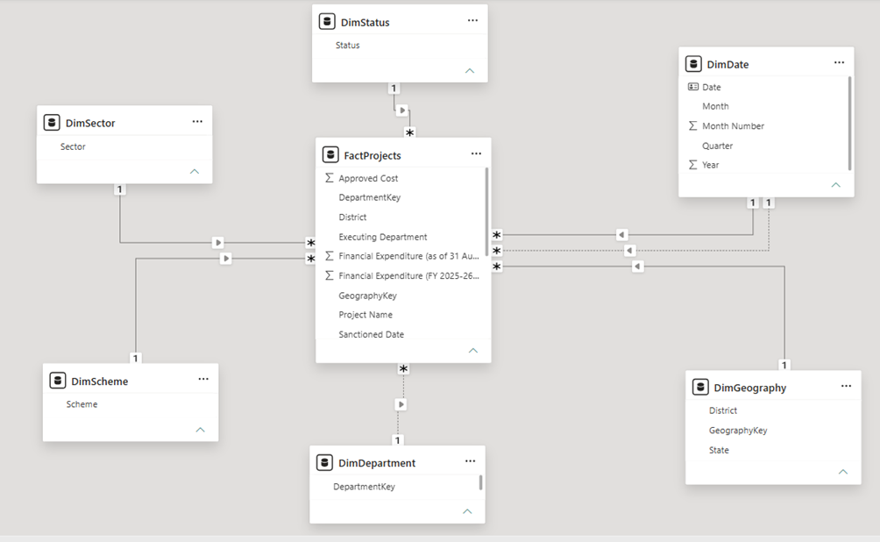
Fig-01 Star - Schema Model View.png

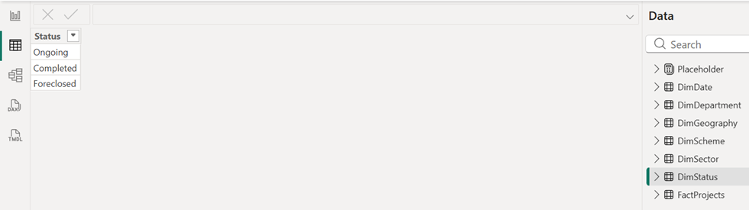
Fig-02 DimStatus Data View.png

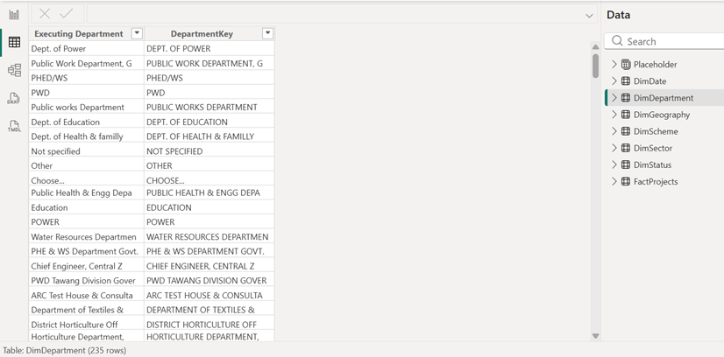
Fig-03 DimDepartment and DepartmentKey Data View.png

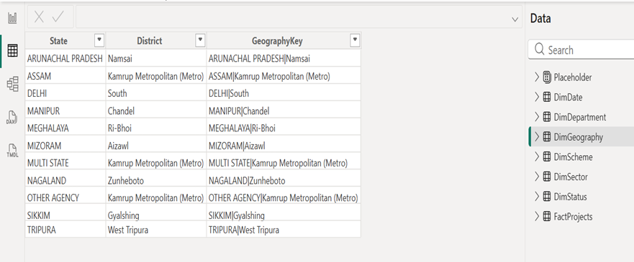
Fig-04 DimGeography Data View.png

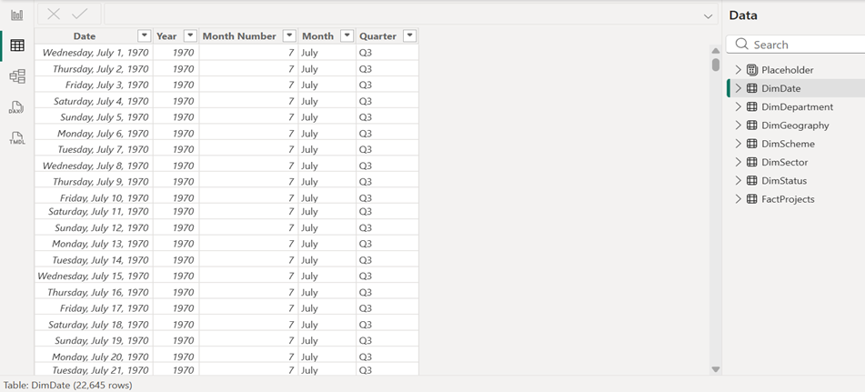
Fig-05 DimDate Data View.png

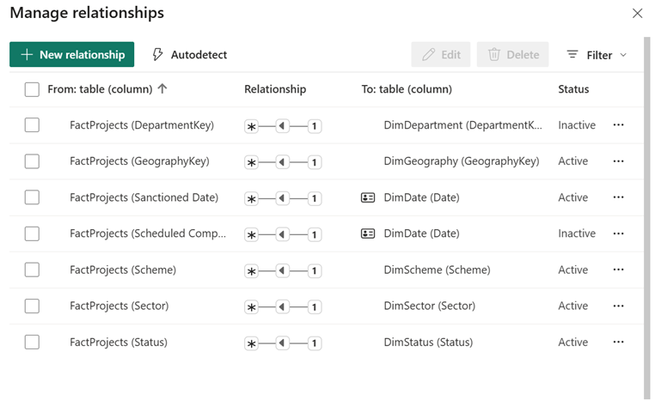
Fig-06 Relationship Matrix.png

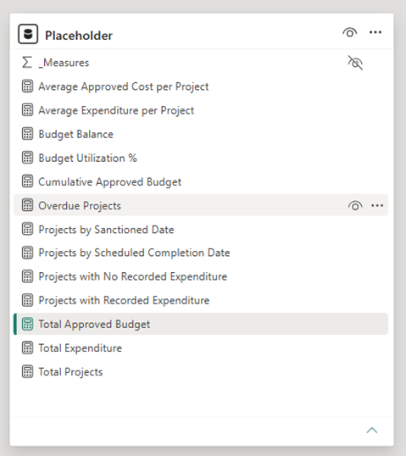
Fig-07 Measures.png

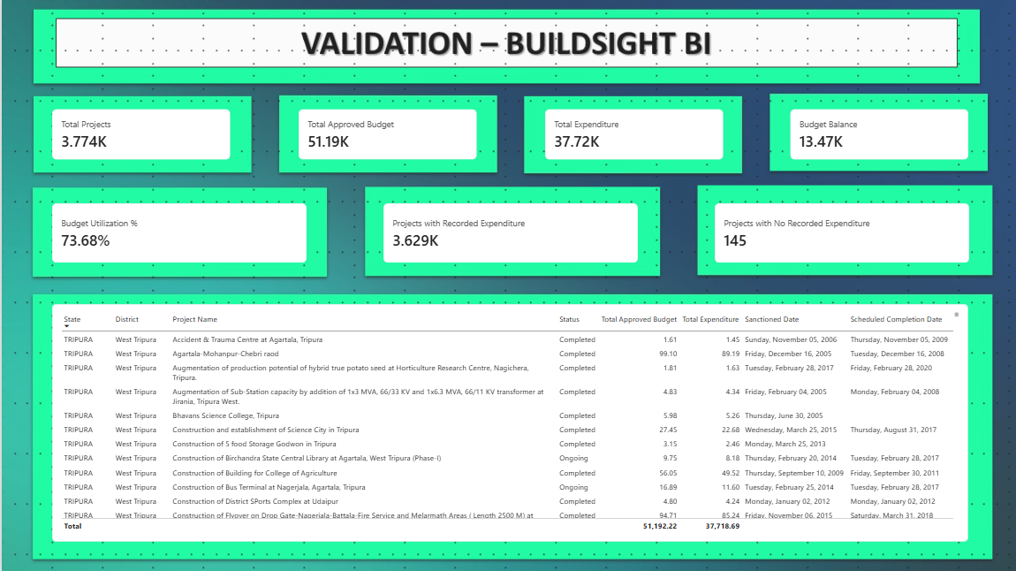
Fig-08 Validation Page.png

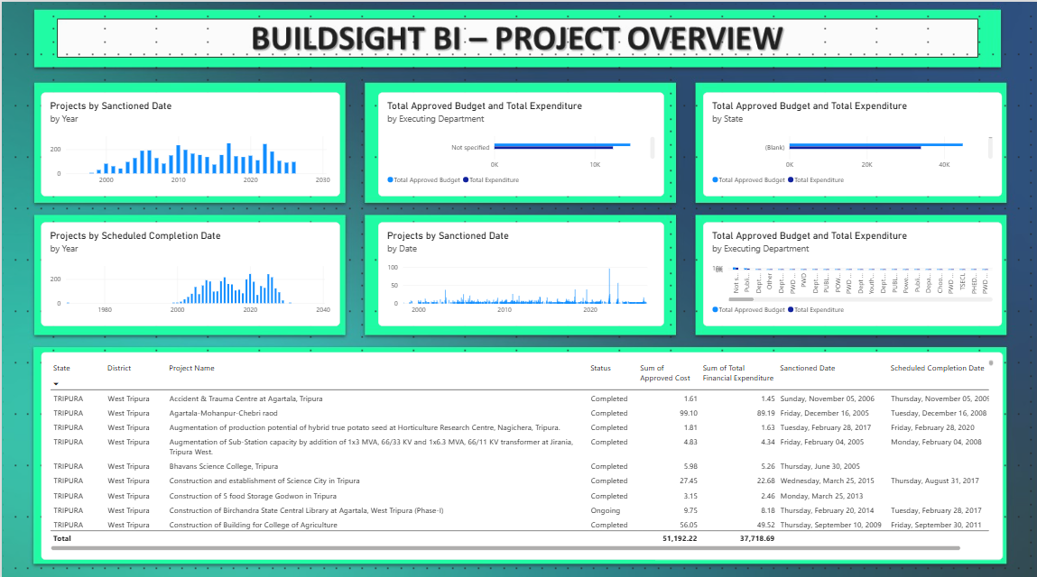
Fig-09 Product Overview Page.png

