WEEK 5 INTERNSHIP REPORT
BUILDSIGHT BI
A Power BI-Based Business Intelligence Framework for Construction Project Performance
Turning Construction Data into Actionable Intelligence
Implementing Predictive Analytics in Virtual Construction

Internship | Virtual Construction Business Intelligence Intern
Platform | YuvaIntern / NSDC
Internship period | 24 August 2026 – 5 October 2026
Assignment | Week 5: Implementing Predictive Analytics in Virtual Construction
Submitted by | Shalvi Atul Surve
Submitter Organization | Vellore Institute of Technology (VIT), Vellore
Submission date | 5 October 2026
Primary tool | Microsoft Power BI Desktop
Dataset | MDoNER NESetu Projects Dashboard (North Eastern Region of India)
Repository | https://github.com/Shalvi-Surve/BuildSight-BI
BuildSight BI is a conceptual project and framework created for this internship. It is not an existing commercial organization or an implemented commercial product.

Table of Contents
1. Executive Summary
2. Introduction and Objectives
2.1 Objectives of Week 5
3. Predictive Analytics Problem Definition and Dataset Limitations
3.1 Week 5 Assignment Context
3.2 Problem Definition
3.3 What the Dataset Can and Cannot Support
4. Predictive Analytics Approach and Methodology
4.1 Intended Technique
4.2 Why a Power BI-Native Approach
4.3 Variable Selection
4.4 Methodology Workflow
4.5 Forecast Analysis Versus Scheduled Workload Analysis
4.6 Evidence Status of the Predictive Component
5. Power BI Implementation
5.1 Connection to the Week 3 Model
5.2 Time-Axis Preparation
5.3 Visual Configuration
5.4 Slicer Configuration
5.5 Forecasting Exploration
5.6 Planning Detail Table
6. Dashboard Design
6.1 Dashboard Mock-up
6.2 Implemented Dashboard
6.3 Conformance of the Dashboard to the Mock-up
6.4 Interactive Slicers
7. Visualization-by-Visualization Documentation
7.1 W5-01 – Historical Project Sanction Trend
7.2 W5-02 – Project Sanction Trend / Predictive Analysis View
7.3 W5-03 – Scheduled Project Completion Workload
7.4 W5-04 – Scheduled Completion Workload by Year
7.5 W5-05 – Project Portfolio Planning Detail
8. Results and Observations
8.1 Historical Project-Record Trend
8.2 Monthly Trend Used for Predictive Analysis
8.3 Scheduled Completion Workload
8.4 Yearly Scheduled Workload
8.5 Project-Level Portfolio Detail
8.6 Slicer-Based Segmentation
9. Business Implications
10. Risk Mitigation
11. Connection to Previous Weeks
12. Limitations and Assumptions
13. Future Enhancements
14. Conclusion
15. GitHub / Technical Repository
References
Appendix A: Dashboard Visual Inventory
Appendix B: Screenshot Evidence Index

List of Figures
Figure 1 Week 5 Predictive Analytics Dashboard Mock-up (planned layout)
Figure 2 Implemented BuildSight BI Predictive Analytics Dashboard
Figure 3 Dashboard Header and Slicers (State, Sector, Project Status)
Figure 4 Historical Project Sanction Trend (Total Projects by Date)
Figure 5 Project Sanction Trend / Predictive Analysis (Total Projects by Month Start)
Figure 6 Scheduled Project Completion Workload (Projects by Scheduled Completion Date by Date)
Figure 7 Scheduled Completion Workload by Year (Projects by Scheduled Completion Date by Year)
Figure 8 Project Portfolio Planning Detail

List of Tables
Table 1 Progression of the BuildSight BI workflow (Weeks 1 to 5)
Table 2 Suitability of the dataset for typical predictive targets
Table 3 Variable selection for the Week 5 analysis
Table 4 Forecast analysis compared with scheduled workload analysis
Table 5 Evidence status of the Week 5 predictive component
Table 6 Model elements used in the Week 5 dashboard
Table 7 Visual inventory and configuration
Table 8 Dashboard layout blueprint (from the mock-up in Figure 1)
Table 9 Interactive slicers
Table 10 Records visible in the Project Portfolio Planning Detail table (Figure 8)
Table 11 Summary of observations by visual
Table 12 Business implications of the Week 5 analysis
Table 13 Risk-mitigation implications (decision support, not guaranteed outcomes)
Table 14 Future enhancement roadmap (proposed; not implemented)
Table 15 Dashboard visual inventory
Table 16 Screenshot evidence index

1. Executive Summary
Week 5 of the BuildSight BI project extended the interactive dashboard of Week 4 toward forward-looking portfolio analysis. Week 2 sourced and prepared the MDoNER NESetu project listing, Week 3 built the star-schema model and DAX measures, and Week 4 turned that model into an interactive dashboard of slicers, KPI cards, charts and a detail table. Week 5 asks what that same model can say about the time dimension of the portfolio: how project records are distributed over time, how scheduled completion workload is spread across years, and whether Power BI’s built-in time-series forecasting can be used to extend the historical trend. The result is a one-page dashboard titled BUILDSIGHT BI – PREDICTIVE ANALYTICS.
What was implemented. The dashboard has three dropdown slicers (State, Sector and Project Status), three trend charts in a second row, one large yearly workload chart and a project-level planning table. The three trend charts show Total Projects by Date, Total Projects by Month Start, and Projects by Scheduled Completion Date by Date. The large chart shows Projects by Scheduled Completion Date by Year. The table lists Project Name, State, District, Sector, Status, Scheduled Completion Date, Sum of Approved Cost and Sum of Total Financial Expenditure, with a total row.
What the evidence does and does not show. The Week 5 evidence document labels its second visual “Project Sanction Trend Forecast”. The supplied screenshot, however, shows only a monthly line of Total Projects by Month Start; it contains no forecast extension, no forecast line and no confidence band. This report therefore documents that visual as a monthly project-trend view prepared for predictive analysis, records that Power BI’s forecasting capability was the intended technique, and does not present any forecast values, confidence intervals or accuracy measures, because none are demonstrated. Likewise, the fourth visual is labelled “Forecast vs Scheduled Workload” in the evidence document, but it is a yearly scheduled-completion workload chart and is documented here under that name.
Main observations. In the captured view (Status slicer set to “Completed”; State and Sector at “All”), project-record activity by sanctioned date appears as a low baseline with isolated spikes, the largest in the early 2020s. Scheduled completion dates are close to zero before about 2000 and concentrate between the early 2000s and the mid-2020s, with several yearly peaks of roughly 170–190 records and a taper towards zero by about 2028. The detail table shows four visible records, and its total row (28,405.03 approved cost; 25,360.94 recorded expenditure) agrees with the Completed-status totals reported in Week 4.
INTERPRETATION BOUNDARY
The dataset is a project-level administrative and financial listing. It contains no physical progress, no actual completion dates, no labour or material data and no detailed expenditure history. Scheduled Completion Date is a planned date, not an actual or predicted one. The Week 5 dashboard is therefore a portfolio planning aid: it supports forward-looking review of scheduled workload, not prediction of construction progress, delays, budget overruns or resource demand.

The report is organised as follows. Sections 3 and 4 define the problem, the data limits, the approach and the variables. Sections 5 to 7 cover the Power BI implementation, the dashboard design and a visual-by-visual account. Section 8 reports the observations, Sections 9 and 10 the business implications and risk-mitigation uses, Section 11 the continuity with previous weeks, and Sections 12 to 15 the limitations, future work, conclusion and repository.

2. Introduction and Objectives
BuildSight BI is a conceptual project created for this internship; it is a framework for a simulated virtual construction organization and not an existing commercial product. The weekly assignments build on one another, from strategic direction and data preparation, through modelling and dashboard design, to predictive analytics. Table 1 places Week 5 in that sequence.
Table 1: Progression of the BuildSight BI workflow (Weeks 1 to 5)
Week | Assignment focus | Contribution to the project | Relationship to Week 5
Week 1 | Strategic planning for virtual construction intelligence | Business intelligence direction and project framing | Defines the decision-support purpose that Week 5 serves
Week 2 | Data sourcing, import and transformation | MDoNER NESetu project table imported and prepared in Power Query | Supplies the date and project fields used on the time axes
Week 3 | Data modelling and DAX | Star-schema model, relationships, DAX measures, date-based measures | Supplies DimDate, FactProjects and the Total Projects and scheduled-completion measures
Week 4 | Interactive dashboard design | Slicers, KPI cards, charts and a detail table on one page | Supplies the slicer and table design that Week 5 reuses
Week 5 | Predictive analytics / forward-looking portfolio analysis | Trend views, scheduled workload views and a planning table (this report) | Extends descriptive analysis towards forward-looking review

This report does not repeat the Week 2 to Week 4 work. It gives only the background needed to show how Week 5 builds on it.

2.1 Objectives of Week 5
- Identify a predictive problem that the available project data can reasonably support.
- Select the variables that describe project activity over time and provide analytical context.
- Prepare a time-based analytical view of project records (daily and monthly).
- Explore Power BI’s built-in forecasting capability on the historical project trend.
- Analyse the distribution of scheduled project completion workload by date and by year.
- Provide project-level detail that supports portfolio review and prioritization.
- Discuss business implications and risk-mitigation uses, with the limitations of the data stated.
- Document the work with evidence, without claiming results the evidence does not show.

3. Predictive Analytics Problem Definition and Dataset Limitations

3.1 Week 5 Assignment Context
The Week 5 theme is “Implementing Predictive Analytics in Virtual Construction”. In a full construction setting, predictive analytics would typically target physical progress, completion, delays, labour demand, material use or budget overruns. The choice of problem is constrained by what the data holds, which is why this section sets out the data limits before the approach.

3.2 Problem Definition
Given a project-level listing with sanctioned dates and scheduled completion dates, two forward-looking questions can be asked without going beyond the data:
- Trend question. How has the number of sanctioned project records changed over time, and can that historical pattern be extended as an indicative trend using Power BI’s time-series forecasting capability?
- Scheduled workload question. In which dates and years are project completions scheduled, so that periods of concentrated planned activity can be identified for monitoring?
The first question is the genuinely predictive one; its output would be an indicative trend of project-record counts, not a forecast of construction. The second is a forward-looking planning question answered directly from planned dates already in the dataset; it involves no predictive model. Keeping these two apart is a central design decision of the Week 5 report (Section 4.5).

3.3 What the Dataset Can and Cannot Support
The BuildSight BI dataset is the MDoNER NESetu project listing for the North Eastern Region of India. It holds project-level administrative and financial fields: Project Name, State, District, Sector, Scheme, Executing Department, Sanctioned Date, Approved Cost, Scheduled Completion Date, Total Financial Expenditure and Status, with other associated fields. Table 2 compares common predictive targets with the data available.
Table 2: Suitability of the dataset for typical predictive targets
Possible target | Supported? | Reason
Count of sanctioned project records over time | Indicative only | Sanctioned Date gives a time series of record counts; suitable for a trend view and exploratory forecasting
Distribution of scheduled completion workload | Yes (descriptive) | Scheduled Completion Date is present; this is planned timing, not a prediction
Physical construction progress | No | No progress measure in the source
Actual project completion or delay | No | No actual completion date; scheduled dates are plans
Labour productivity or labour demand | No | No labour data
Material or resource consumption | No | No resource data
Reliable budget-overrun prediction | No | Only a single recorded expenditure figure per project; no detailed expenditure history

4. Predictive Analytics Approach and Methodology

4.1 Intended Technique
The intended predictive technique is Power BI time-series forecasting, applied to the historical project sanction trend, together with forward-looking trend analysis of scheduled completion dates. No machine-learning algorithm (such as regression, ARIMA, Prophet, Random Forest or LSTM) was implemented or is claimed in Week 5. No custom model was trained and no model-accuracy metric was calculated.

4.2 Why a Power BI-Native Approach
A Power BI-native approach suits the available data for four reasons. First, the data holds one natural time series, the count of project records by date, which is the type of series that Power BI’s forecasting feature for line charts operates on. Second, the approach reuses the Week 3 model and measures, so every figure remains consistent with earlier weeks. Third, it keeps the analysis inside the dashboard, where the slicers and table can be used to interpret it. Fourth, it avoids building complex models on data that lacks the variables such models need.

4.3 Variable Selection
Table 3 lists the variables used and the role of each. State, Sector and Status are contextual and filtering dimensions; the evidence does not show them being used as model predictors, and they are not described as predictive variables.
Table 3: Variable selection for the Week 5 analysis
Variable | Role | Reason
DimDate[Date] | Time variable | Provides the temporal dimension for trend analysis (daily axis)
Month Start (date-derived field) | Time variable (monthly) | Aggregates the series to monthly level for a smoother view prepared for predictive analysis
Total Projects | Primary analytical measure | Represents project-record volume over time
Scheduled Completion Date / Projects by Scheduled Completion Date | Planned workload variable | Represents the scheduled timing of project completion
DimDate[Year] | Time grouping | Summarizes scheduled workload by year
State | Context / filter variable | Enables geographic segmentation
Sector | Context / filter variable | Enables sector-level analysis
Status | Context / filter variable | Enables portfolio segmentation by recorded status

4.4 Methodology Workflow
The workflow below shows the path from the historical dataset to decision support. The highlighted steps are the two analytical branches that Section 4.5 distinguishes.
Historical Project Dataset (MDoNER NESetu, Weeks 2–3)
▼
Data Preparation and Date Modelling (DimDate, relationships)
▼
Project Sanction Time-Series Analysis
▼
Historical Trend Visualization (daily and monthly)
▼
Predictive / Forecasting Capability Exploration
▼
Forward-Looking Portfolio Insight
▼
Scheduled Completion Workload Analysis (by date and by year)
▼
Project-Level Planning Review (detail table)
▼
Management Decision Support

4.5 Forecast Analysis Versus Scheduled Workload Analysis
The two analyses answer different questions and must not be confused. Table 4 contrasts them.
Table 4: Forecast analysis compared with scheduled workload analysis
Aspect | Forecast analysis (W5-02) | Scheduled workload analysis (W5-03, W5-04)
Question | What might the historical sanction trend indicate for later periods? | When are project completions scheduled?
Basis | Historical Sanctioned Date pattern of Total Projects | Scheduled Completion Date already held in the dataset
Nature | Predictive technique (Power BI forecasting), exploratory | Descriptive view of planned dates; not a predictive model
Output in evidence | Monthly trend line only; no forecast extension visible | Daily and yearly workload lines clearly visible
Correct wording | Indicative trend; planning indicator | Scheduled workload; planned completion workload
Must not be called | Guaranteed prediction; construction forecast | Actual completion; predicted completion; delay prediction

4.6 Evidence Status of the Predictive Component
Following the evidence-integrity rule of this report, every technical claim is tied to what the supplied Week 5 evidence demonstrates. Table 5 records that status for the predictive component.
Table 5: Evidence status of the Week 5 predictive component
Item | Demonstrated? | Note
Historical project sanction trend (daily) | Yes | Visible in Figure 4
Monthly aggregation of the trend | Yes | Visible in Figure 5 (Total Projects by Month Start)
Power BI forecasting as the intended technique | Intended | The evidence document labels the visual as a forecast
Forecast line or extension | Not shown | No forecast extension is visible in the supplied screenshot
Confidence interval | Not shown | None visible
Forecast horizon, seasonality or settings | Not shown | Not visible in any supplied evidence
Accuracy metrics (RMSE, MAE, MAPE, R²) | Not calculated | None reported; none claimed
Scheduled completion workload by date and by year | Yes | Visible in Figures 6 and 7
Project-level planning table | Yes | Visible in Figure 8

The Week 5 PBIX file and any separate screenshot of the Analytics pane were not supplied with this report. If such evidence exists, it could be added to document the forecast settings, but this report does not assume it.

5. Power BI Implementation
The Week 5 dashboard is built on the existing Week 3 model rather than on a new dataset. This section describes the model elements and visuals as far as the evidence supports. Visual types are identified from their appearance in the screenshots; formatting properties such as fonts and colours cannot be established from them and are not documented.

5.1 Connection to the Week 3 Model
The central table is FactProjects, connected to the dimension tables DimDate, DimDepartment, DimGeography, DimSector, DimScheme and DimStatus, as set out in the Week 3 and Week 4 reports. The Week 5 visuals draw on DimDate for the time axes, on the geography, sector and status dimensions for the slicers and table, and on FactProjects for the measures and the project-level fields.
Table 6: Model elements used in the Week 5 dashboard
Element | Type | Use in Week 5
FactProjects | Fact table | Project records; source of Total Projects and of the table’s cost and expenditure fields
DimDate | Date dimension | Time axes: Date, Month Start and Year
Sanctioned Date relationship | Model relationship | Links project records to DimDate for the historical sanction trend (W5-01, W5-02)
Scheduled Completion Date relationship | Model relationship | Used by the Projects by Scheduled Completion Date measure (W5-03, W5-04)
Total Projects | DAX measure (Week 3) | Counts project records in the current filter context
Projects by Scheduled Completion Date | DAX measure | Counts project records by scheduled completion date through the scheduled-completion relationship
State, Sector, Status | Dimension fields | Slicers and table columns

According to the evidence document, the Projects by Scheduled Completion Date measure activates the model’s scheduled completion date relationship, so that the same DimDate table can be used for both sanctioned and scheduled dates. The DAX definition is documented in the Week 3 work and is not reproduced here because the Week 5 evidence does not display it.

5.2 Time-Axis Preparation
The trend visuals use two time granularities. The first uses DimDate[Date] on the axis, giving a daily series. The second uses a month-start field, shown on the axis as Month Start, which aggregates the same measure to monthly level. Monthly aggregation reduces day-to-day noise and is the more usual basis for forecasting, which is why the second visual is described as a view prepared for predictive analysis. The evidence shows the visual titles (“by Date” and “by Month Start”); it does not show how the month-start field was constructed, so no construction method is stated.

5.3 Visual Configuration
Each analytical visual combines a time field, which sets the axis, with a measure, which sets the values. Table 7 lists every visual on the page.
Table 7: Visual inventory and configuration
Visual | Power BI visual type | Fields / measure | Purpose
State, Sector, Status slicers | Slicer (dropdown) | State; Sector; Status | Filter the page by state, sector and recorded status
Total Projects by Date (W5-01) | Line chart | DimDate[Date]; Total Projects | Historical project sanction trend
Total Projects by Month Start (W5-02) | Line chart | Month Start; Total Projects | Monthly trend prepared for predictive analysis; forecasting exploration
Projects by Scheduled Completion Date by Date (W5-03) | Line chart | DimDate[Date] (scheduled relationship); Projects by Scheduled Completion Date | Scheduled completion workload over dates
Projects by Scheduled Completion Date by Year (W5-04) | Line chart (smoothed) | DimDate[Year]; Projects by Scheduled Completion Date | Scheduled completion workload by year
Project Portfolio Planning Detail (W5-05) | Table | Project Name, State, District, Sector, Status, Scheduled Completion Date, Sum of Approved Cost, Sum of Total Financial Expenditure | Project-level planning review with total row

5.4 Slicer Configuration
The slicers are dropdowns, as in Week 4, each bound to one dimension field and defaulting to “All”. In the captured screenshot State and Sector show “All” and Status shows “Completed”. Section 6.4 discusses their role.

5.5 Forecasting Exploration
Power BI offers a forecast option for line charts with a time axis, accessed through the Analytics pane. The Week 5 plan was to apply it to the monthly Total Projects line. The supplied screenshot does not show a forecast extension or confidence band on that visual, so the forecast settings (horizon, confidence level, seasonality) are not documented. The report treats forecasting as explored but not demonstrated.

5.6 Planning Detail Table
The detail table has eight fields: Project Name, State, District, Sector, Status, Scheduled Completion Date, Sum of Approved Cost and Sum of Total Financial Expenditure. The two monetary columns are summed, which allows the table to show a total row. In Figure 8 the table is sorted ascending by Project Name, as the sort indicator under that column heading shows.

6. Dashboard Design

6.1 Dashboard Mock-up
The Week 5 evidence includes a text-based mock-up of the planned dashboard (Figure 1). It shows a header, three slicers, three visualization areas in a second row, one large annual workload area and a project-level detail section.
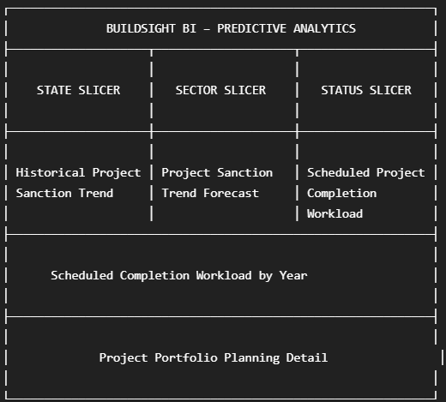
Figure 1: Week 5 Predictive Analytics Dashboard Mock-up (planned layout)
Source: Prepared by the author (Week 5 evidence document).
Table 8: Dashboard layout blueprint (from the mock-up in Figure 1)
Section | Planned content
Header | BUILDSIGHT BI – PREDICTIVE ANALYTICS
Row 1 – slicers | State slicer | Sector slicer | Status slicer
Row 2 – trend visuals | Historical Project Sanction Trend | Project Sanction Trend Forecast | Scheduled Project Completion Workload
Large visual | Scheduled Completion Workload by Year
Bottom | Project Portfolio Planning Detail

6.2 Implemented Dashboard
Figure 2 shows the implemented dashboard. It follows the mock-up section by section: the header, the three slicers, three visuals in the second row, a full-width yearly chart and the detail table at the bottom. The same dark teal background and bright green panel borders are used as in Week 4, which keeps the visual identity consistent.
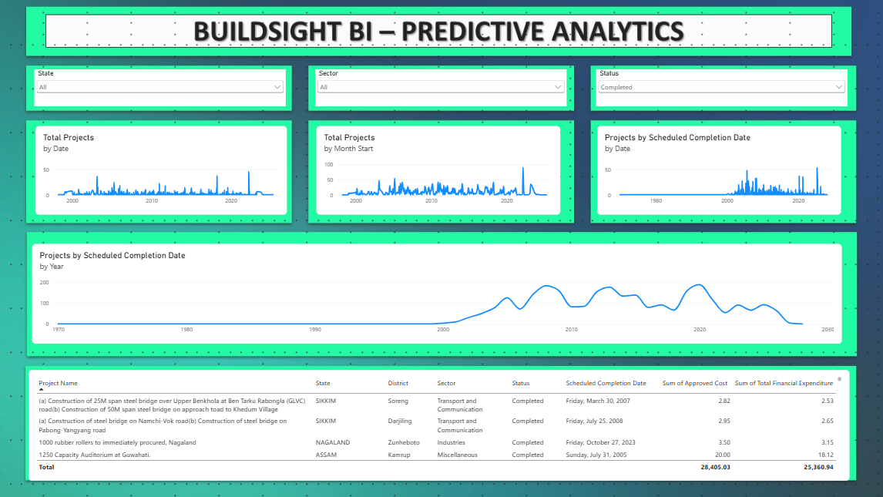
Figure 2: Implemented BuildSight BI Predictive Analytics Dashboard
Source: Prepared by the author. Microsoft Power BI Desktop screenshot of the BuildSight BI dashboard (Week 5 evidence).

6.3 Conformance of the Dashboard to the Mock-up
The layout conforms to the plan. Two differences between the planned labels and the implemented visuals are recorded here so that the report remains accurate.
- Second-row centre visual. The mock-up names it “Project Sanction Trend Forecast”. The implemented visual is titled Total Projects by Month Start and shows no visible forecast extension (Section 4.6). It is documented as a monthly trend / predictive-analysis view.
- Large visual. The evidence document labels it “Forecast vs Scheduled Workload” in places, whereas the mock-up names it Scheduled Completion Workload by Year. The screenshot shows a smoothed line chart of Projects by Scheduled Completion Date by Year, with no forecast series. It is documented as Scheduled Completion Workload by Year.

6.4 Interactive Slicers
Three dropdown slicers sit directly under the header (Figure 3). Because every visual and the table read from the same model, a selection in a slicer changes the context of the whole page.
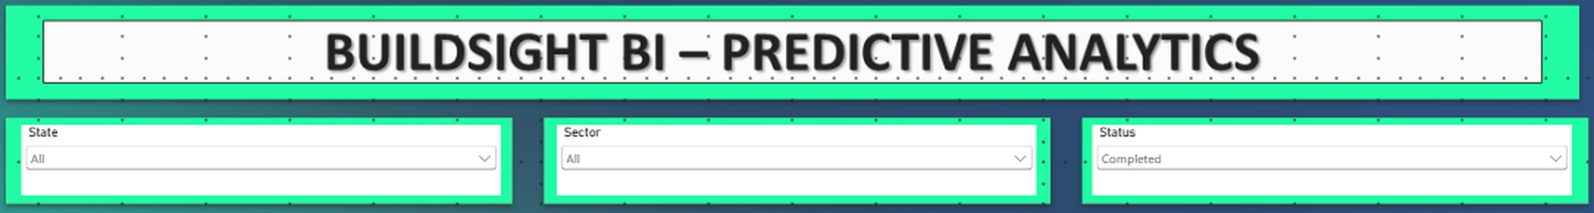
Figure 3: Dashboard Header and Slicers (State, Sector, Project Status)
Source: Prepared by the author. Microsoft Power BI Desktop screenshot of the BuildSight BI dashboard (Week 5 evidence).
Table 9: Interactive slicers
Slicer | Field | State in Figure 3 | Role
State | State | All | Geographic segmentation: from the whole portfolio to one state
Sector | Sector | All | Sector-specific analysis
Project Status | Status | Completed | Status-specific review of the recorded status label

Used together, the slicers allow a move from the overall portfolio, to a state, to a sector within it, to a recorded status. In the supplied evidence only one selection is captured (Status = Completed); the effects of other selections are not shown, and combined selections are not claimed. The Status label is that of the source listing and is not an independent verification of completion.
OBSERVED RESULT
In the captured view, every visual and the table reflect the Completed status. The table rows all read Completed, and the totals (28,405.03 and 25,360.94) match the Completed-status totals reported in Week 4 (28.41K and 25.36K). This is consistent with the slicer acting through the model.

7. Visualization-by-Visualization Documentation
This section documents the five analytical visualizations. Each is described by its purpose, fields, technical interpretation and business relevance, and with the boundary on how it may be read. All screenshots were captured with the Status slicer set to Completed.

7.1 W5-01 – Historical Project Sanction Trend
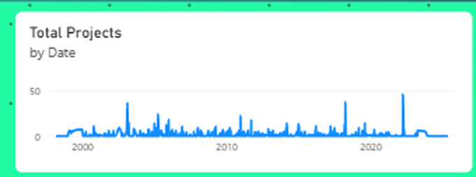
Figure 4: Historical Project Sanction Trend (Total Projects by Date)
Source: Prepared by the author. Microsoft Power BI Desktop screenshot of the BuildSight BI dashboard (Week 5 evidence).
Purpose. To show the historical trend in project records based on their sanctioned dates.
Fields. X-axis: DimDate[Date]. Y-axis: Total Projects.
Description. This line chart presents the historical trend in project records based on their sanctioned dates. The date dimension is plotted along the X-axis, while the Total Projects measure represents the number of project records over time. The visualization establishes the historical time-series pattern used as the basis for the subsequent predictive analysis.
Technical interpretation. The series is daily, so it is made of a low baseline with isolated spikes where many records share a sanctioned date. The y-axis is marked at 0 and 50, and the highest spike approaches the 50 gridline in the early 2020s. Such a spiky daily series is difficult to project directly, which is the reason for the monthly aggregation in W5-02.
Business relevance. It helps identify periods of relatively higher or lower project sanction activity and provides the historical context required for interpreting any forward-looking trend.

7.2 W5-02 – Project Sanction Trend / Predictive Analysis View
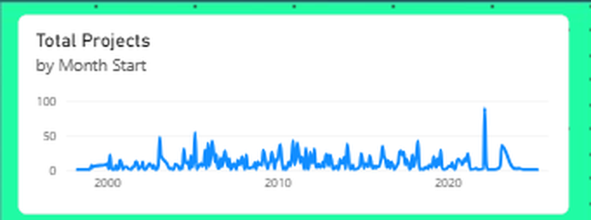
Figure 5: Project Sanction Trend / Predictive Analysis (Total Projects by Month Start)
Source: Prepared by the author. Microsoft Power BI Desktop screenshot of the BuildSight BI dashboard (Week 5 evidence).
Intended purpose. To extend the historical project sanction trend using Power BI’s time-series forecasting capability, so that an indicative future trend could be explored. The planned layout labels this area “Project Sanction Trend Forecast”.
Fields. Time axis: Month Start (monthly representation of the date dimension). Measure: Total Projects.
Description. The visualization analyses the historical Total Projects measure against a monthly time axis. In the supplied screenshot it appears as a monthly line chart whose y-axis is marked at 0, 50 and 100. Its largest value, close to 90, occurs in the early 2020s, and most months in the preceding years lie between about 10 and 50 records.
EVIDENCE STATEMENT
The supplied screenshot does not show a forecast line, a forecast extension or a confidence interval. This report therefore describes the visual as a monthly project-trend view prepared for predictive analysis, and states that Power BI forecasting was explored but that the available evidence does not conclusively demonstrate a generated forecast. No forecast values, confidence intervals or accuracy figures are presented.

Technical interpretation. Aggregating to months removes much of the day-level noise seen in W5-01 and gives a series whose level and spikes are comparable across years. This is the preparation step that a time-series forecast needs. The y-axis range doubles compared with W5-01 because several days are summed into each month. The line falls to zero at the right-hand end, where no sanctioned dates are recorded; this should not be read as a forecast of declining activity.
Business relevance. Once a forecast is generated and validated on suitable data, the same view could provide a planning indicator of future project-record activity. Until then it serves as a monthly historical baseline.

7.3 W5-03 – Scheduled Project Completion Workload
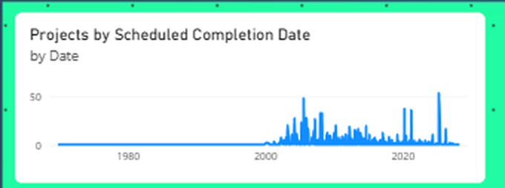
Figure 6: Scheduled Project Completion Workload (Projects by Scheduled Completion Date by Date)
Source: Prepared by the author. Microsoft Power BI Desktop screenshot of the BuildSight BI dashboard (Week 5 evidence).
Purpose. To show the distribution of project records according to their scheduled completion dates.
Fields. Measure: Projects by Scheduled Completion Date. Time dimension: DimDate[Date], through the scheduled completion date relationship of the model.
Description. This line chart shows the distribution of project records according to their scheduled completion dates. It provides a forward-looking view of planned project completion activity and helps identify periods where scheduled project workload may be concentrated.
Technical interpretation. The line is close to zero until about 2000 and then shows repeated clusters of spikes, with the highest spike, a little above 50, in the early 2020s. The measure activates a different date relationship from W5-01, so the two daily charts describe different dates of the same records and should not be compared point by point.
Boundary. Scheduled Completion Date is a planned date. The chart shows planned workload, not actual completion, predicted completion or delay.

7.4 W5-04 – Scheduled Completion Workload by Year
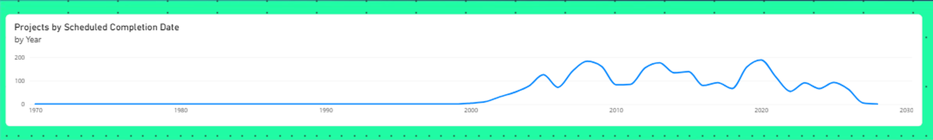
Figure 7: Scheduled Completion Workload by Year (Projects by Scheduled Completion Date by Year)
Source: Prepared by the author. Microsoft Power BI Desktop screenshot of the BuildSight BI dashboard (Week 5 evidence).
Purpose. To summarize the number of projects scheduled for completion in each year.
Fields. X-axis: DimDate[Year]. Y-axis: Projects by Scheduled Completion Date.
Description. This visualization summarizes the number of project records by scheduled completion year. It provides a higher-level view of planned project completion workload across periods and can help identify years with comparatively higher concentrations of scheduled project activity. The evidence document labels this section “Forecast vs Scheduled Workload”; the visual itself is a yearly scheduled-workload chart, and it is documented under that meaning.
Technical interpretation. In the screenshot the visual is a smoothed line chart over an axis running from 1970 to 2030, with the y-axis marked at 0, 100 and 200. Counts are near zero before about 2000, rise to a first peak of roughly 180 around 2008, and peak again at a similar level around 2013 and 2020 (visual estimates). They then fall back to roughly 90 in the mid-2020s and taper towards zero by about 2028. Smoothing joins the yearly values with a curve, so exact yearly values should be read from the data and not from the line.
Business relevance. It lets management see which years carry comparatively more scheduled completions and where monitoring effort might be concentrated.
Boundary. The chart is based on scheduled dates already in the dataset. It is not a predictive forecast, and it does not show actual completion or guaranteed future workload.

7.5 W5-05 – Project Portfolio Planning Detail
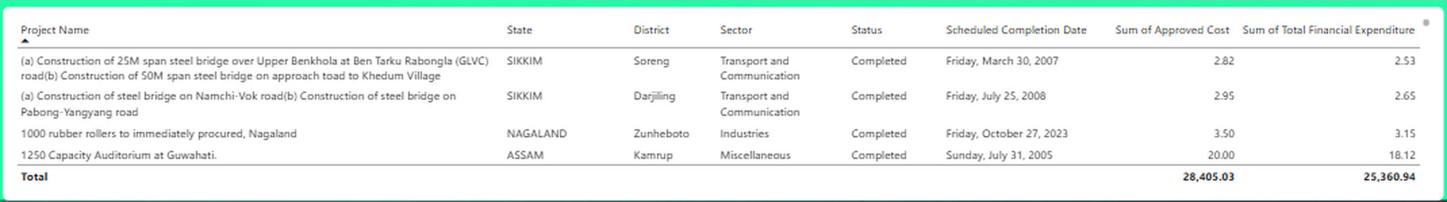
Figure 8: Project Portfolio Planning Detail
Source: Prepared by the author. Microsoft Power BI Desktop screenshot of the BuildSight BI dashboard (Week 5 evidence).
Purpose. To provide project-level detail that supports portfolio planning and the interpretation of the aggregated analysis.
Fields. Project Name, State, District, Sector, Status, Scheduled Completion Date, Sum of Approved Cost and Sum of Total Financial Expenditure.
Description. This table provides project-level detail to support portfolio planning and interpretation of the dashboard analysis. It brings together project identification, geographic, sectoral, status, scheduled completion, approved budget and recorded expenditure information. The State, Sector and Project Status slicers can be used to narrow the displayed project records.
Technical interpretation. The table follows the same filter selection as the charts above it and lists the records that make up the aggregates. Four records are visible in Figure 8, with a total row. A scroll indicator at the top right of the panel suggests that the table can be scrolled, but the evidence does not show further rows.
Boundary. The table does not establish actual project delays or physical construction progress, because actual completion and progress information is not available in the source.

8. Results and Observations
This section reports what the supplied evidence shows. Values are read from the screenshots; where a visual supports only a general pattern, qualitative language is used and no exact figure is stated. All observations apply to the captured filter state (State = All, Sector = All, Status = Completed).

8.1 Historical Project-Record Trend
The daily sanction series (Figure 4) shows a low baseline with isolated spikes from about 2000 onwards. The highest spike approaches 50 project records on a single date in the early 2020s. Activity is not evenly spread: sanction dates appear to cluster on particular days, so that periods of relatively higher and lower sanction activity are visible.

8.2 Monthly Trend Used for Predictive Analysis
The monthly series (Figure 5) is more continuous than the daily one. Most months between about 2000 and 2020 lie roughly between 10 and 50 records, with a visible rise in monthly activity through the 2000s and early 2010s, and one pronounced peak near 90 in the early 2020s. No forecast extension is visible, so no future values are reported.

8.3 Scheduled Completion Workload
The scheduled completion series (Figure 6) is close to zero before about 2000 and is concentrated between the early 2000s and the mid-2020s. Spikes are more frequent than in the sanction series, which shows a visible clustering of scheduled completion dates. The highest spike, slightly above 50, is in the early 2020s.

8.4 Yearly Scheduled Workload
The yearly chart (Figure 7) shows comparatively higher workload in a few years: approximately 2008, 2013 and 2020 are the highest at roughly 170 to 190 records each by visual estimate. Workload then falls and tapers towards zero by about 2028. The decline at the right of the axis reflects the final scheduled dates in the captured selection, not a reduction in future demand.
INTERPRETATION NOTE
Because the captured Status is Completed, most scheduled dates in these charts lie in the past, so the view shows the planned timing of records already labelled Completed. A view of the portfolio that has not yet been completed would need a different Status selection. Such a selection is not part of the supplied evidence and is not described here.

8.5 Project-Level Portfolio Detail
Table 10 lists the four project records visible in Figure 8. The total row shows an approved cost of 28,405.03 and a recorded expenditure of 25,360.94. These totals cover the full filtered selection and not only the four visible rows. The ratio of the totals is 89.28% (author’s calculation), which agrees with the Completed-status Budget Utilization % reported in Week 4. The source worksheet states amounts in Rs. crore (Week 2), but the table carries no unit label, so the figures are quoted as displayed.
Table 10: Records visible in the Project Portfolio Planning Detail table (Figure 8)
Project Name (abridged) | State | District | Sector | Scheduled completion | Status | Approved cost | Expenditure
Steel bridges, Upper Benkhola / Ben Tarku Rabongla (GLVC) road and Khedum Village approach | SIKKIM | Soreng | Transport and Communication | 30 Mar 2007 | Completed | 2.82 | 2.53
Steel bridges, Namchi-Vok road and Pabong-Yangyang road | SIKKIM | Darjiling | Transport and Communication | 25 Jul 2008 | Completed | 2.95 | 2.65
1000 rubber rollers to be immediately procured, Nagaland | NAGALAND | Zunheboto | Industries | 27 Oct 2023 | Completed | 3.50 | 3.15
1250 Capacity Auditorium at Guwahati | ASSAM | Kamrup | Miscellaneous | 31 Jul 2005 | Completed | 20.00 | 18.12
Total (all filtered records) |  |  |  |  |  | 28,405.03 | 25,360.94

8.6 Slicer-Based Segmentation
The slicers allow the dashboard to be narrowed from the overall portfolio to a state, a sector and a recorded status. The evidence demonstrates the Completed status selection, and the visible rows in Figure 8 show records from Sikkim, Nagaland and Assam in the Transport and Communication, Industries and Miscellaneous sectors. The effect of State and Sector selections on the Week 5 visuals is not captured in the Week 5 evidence; the same slicer mechanism was demonstrated in Week 4.
Table 11: Summary of observations by visual
Visual | Observation (qualitative, from screenshot) | Reading boundary
W5-01 Daily sanction trend | Low baseline with isolated spikes; highest near 50 in the early 2020s | Historical record counts; not construction activity
W5-02 Monthly trend | More continuous series; most months about 10–50; one peak near 90 in the early 2020s | No forecast shown; no future values
W5-03 Scheduled workload by date | Near zero before about 2000; clustered spikes to the mid-2020s; highest slightly above 50 | Planned dates, not actual completion
W5-04 Scheduled workload by year | Peaks of roughly 170–190 around 2008, 2013 and 2020; taper towards zero by about 2028 | Not a forecast; smoothed line, estimates only
W5-05 Planning table | Four visible records; totals 28,405.03 / 25,360.94 | No delay or progress information

9. Business Implications
The Week 5 analysis supports portfolio planning in a number of ways. The implications below are decision-support uses of the dashboard, stated cautiously and limited to what the data holds. None of them is an outcome that the analysis guarantees.
Table 12: Business implications of the Week 5 analysis
Use case | Dashboard feature | Example question | Decision support (cautious)
1. Portfolio planning | All five visuals with the slicers | How is project activity distributed over time in the selected segment? | Gives a time-based context for planning discussions
2. Monitoring of activity trends | Daily and monthly sanction trend (W5-01, W5-02) | Have there been periods of higher or lower sanction activity? | If higher activity is seen in a period, management may consider the analytical and monitoring attention it needs
3. Identification of higher scheduled workload | W5-03 and W5-04 | In which dates or years are completions scheduled most densely? | If scheduled projects concentrate in a period, management may prioritize review and monitoring capacity for it
4. Prioritization of management attention | W5-04 with the Status slicer | Which years carry comparatively more scheduled completions? | Helps direct limited attention to years with larger scheduled volumes
5. Review of projects near their scheduled completion | W5-05 table, Scheduled Completion Date column | Which records are scheduled around a period of interest? | Gives a starting list for closer review, not a delay finding
6. Interpretation of portfolio-level activity | State, Sector and Status slicers | How do patterns differ between states, sectors or statuses? | Allows segment-level reading of aggregate trends
7. Forward-looking decision support | Trend views and scheduled workload | What does the history suggest for planning periods? | Provides planning indicators; any forecast would still need validation

These uses depend on the dashboard being interpreted as a portfolio planning aid. They do not show that additional resources will be needed in any period, and they do not forecast actual project outcomes.

10. Risk Mitigation
Risk mitigation in the Week 5 context means using the dashboard to draw attention to periods and segments that merit closer review. Table 12 sets out practical implications. They are decision-support implications and not guaranteed outcomes or confirmed risks.
Table 13: Risk-mitigation implications (decision support, not guaranteed outcomes)
Observation pattern | Possible implication | Suggested action
Higher scheduled workload concentrated in a period | Monitoring effort may be stretched in that period | Prioritize monitoring and review capacity for that period
Projects approaching their scheduled completion dates | Closer review of those records may be useful | Use the planning table to review them; check the status label and recorded expenditure
Increasing historical project-record activity | The volume of records needing analysis may grow | Consider increased analytical and monitoring attention
State- or sector-specific concentrations | Risk of attention being spread evenly where it is not needed | Use the slicers to focus review on the relevant segment
Wide gap between approved cost and recorded expenditure in the table | May warrant a closer look | Review the individual record; the gap is a financial indicator, not a delay finding

INTERPRETATION BOUNDARY
These actions follow from planned dates and recorded figures. Because the dataset has no actual completion dates or progress measures, they cannot confirm that any project is delayed or at risk.

11. Connection to Previous Weeks
Week 5 builds on the analytical foundation established in the earlier weeks, as the sequence below shows.
Week 1 – Strategic planning and business intelligence direction
▼
Week 2 – Data sourcing, import and preparation
▼
Week 3 – Data modelling and DAX
▼
Week 4 – Interactive dashboard design
▼
Week 5 – Predictive / forward-looking portfolio analytics

- From Week 1, the decision-support purpose: portfolio planning and monitoring.
- From Week 2, the cleaned project fields, including Sanctioned Date and Scheduled Completion Date, which supply the time axes.
- From Week 3, the model (FactProjects, DimDate and the dimension tables), the Total Projects measure and the date relationships.
- From Week 4, the dashboard pattern: dropdown slicers, line and column visuals, a detail table with a total row, and the same visual identity.
Week 5 adds the time dimension as the main subject. Where Week 4 compared sanctioned and scheduled years descriptively, Week 5 prepares a monthly trend for forecasting exploration and treats scheduled completion dates as planning information.

12. Limitations and Assumptions
The Week 5 analysis is subject to the limitations of the data and of the evidence supplied:
- The dataset is a project-level administrative and financial dataset.
- Physical construction progress is not available.
- Actual completion dates are not available.
- Labour productivity data are not available.
- Detailed resource and material consumption data are not available.
- Detailed historical expenditure series, suitable for reliable budget-overrun forecasting, are not available.
- Scheduled completion dates represent planned dates, not actual ones.
- Historical project-record trends do not necessarily represent physical construction demand.
- Forecasting, if used, depends on the historical temporal pattern of sanction dates only.
- No predictive accuracy metrics are reported, because none were calculated.
- Results should be read as portfolio planning indicators and not as guaranteed construction outcomes.
- Status values are labels of the source listing and have not been independently verified.
Three further points arise from the evidence. First, the supplied screenshot of the second visual does not show a forecast, so the forecasting component is documented as explored but not demonstrated. Second, all screenshots were captured with the Status slicer set to Completed, so the scheduled workload views describe records labelled Completed and do not by themselves represent outstanding work. Third, the table and charts carry no unit label, although the source amounts are in Rs. crore (Week 2).
These limitations do not invalidate the dashboard. They define its appropriate use as a forward-looking portfolio planning aid based on recorded and scheduled dates.

13. Future Enhancements
The items below are future work. None of them was implemented in Week 5. Several depend on data that the current source does not contain.
Table 14: Future enhancement roadmap (proposed; not implemented)
Phase | Enhancement | Requirement | Status
Phase 1 | Generate and document a Power BI forecast on the monthly series, with horizon and confidence settings shown | Existing model; Analytics pane | Recommended, not demonstrated
Phase 1 | Capture slicer selections for non-completed statuses, State and Sector; add unit labels | Existing model | Recommended, not implemented
Phase 1 | Richer geographic visualizations; drill-through project analysis | Existing geography fields | Recommended, not implemented
Phase 2 | Richer monthly historical expenditure data; actual completion dates | New data from project monitoring sources | Requires additional data
Phase 2 | Physical construction progress; labour and resource information; material consumption; project milestone history | New datasets and model extensions | Requires additional data
Phase 2 | Weather or other external factors, where relevant; project-level delay labels | External and monitoring data | Requires additional data
Phase 3 | Stronger machine-learning models once suitable historical data exist | Phase 2 data | Future modelling work
Phase 3 | Model validation using RMSE, MAE or MAPE where appropriate | Held-out data and a defined model | Future modelling work

14. Conclusion
Week 5 extended BuildSight BI from descriptive dashboard analysis toward forward-looking portfolio analysis. The work built on the Week 3 model and the Week 4 dashboard design and produced a one-page Predictive Analytics dashboard with three slicers, daily and monthly project trend views, a daily scheduled completion workload view, a yearly scheduled completion workload view and a project-level planning table.
The dashboard documents a historical project trend and prepares it for predictive analysis through monthly aggregation. Power BI’s forecasting capability was the intended technique for that step, but the supplied evidence does not show a generated forecast, and the report accordingly presents no forecast values, intervals or accuracy measures. The scheduled completion views show planned workload concentrated between the early 2000s and the mid-2020s, with comparatively higher yearly concentrations in a few years. The planning table links these aggregates to individual project records, and the slicers allow the analysis to be narrowed by state, sector and recorded status.
The analysis has clear limits. The source is a project-level administrative and financial listing without progress, actual completion, labour or resource data, so the dashboard supports portfolio planning and decision support. It does not provide reliable delay prediction, resource forecasting or physical-progress prediction. The next step towards genuine prediction is better data, which Section 13 sets out as future work.

15. GitHub / Technical Repository
The project repository for BuildSight BI is available at:
https://github.com/Shalvi-Surve/BuildSight-BI
The repository holds the technical material of the project. This report does not cite specific commits or files, because none were supplied for Week 5.

References
References follow APA 7th edition as far as practical. Only sources used in this report are listed. The dashboard observations come from the Week 5 screenshot evidence described in Appendix B.
Microsoft. (n.d.-a). Power BI documentation. Microsoft Learn. https://learn.microsoft.com/en-us/power-bi/
Microsoft. (n.d.-b). Use the Analytics pane in Power BI Desktop. Microsoft Learn. https://learn.microsoft.com/en-us/power-bi/transform-model/desktop-analytics-pane
Microsoft. (n.d.-c). Slicers in Power BI. Microsoft Learn. https://learn.microsoft.com/en-us/power-bi/visuals/power-bi-visualization-slicers
Ministry of Development of North Eastern Region. (n.d.). NESetu projects dashboard: Project list [Data set]. Government of India. https://www.nesetu.mdoner.gov.in/projects/project-list
Surve, S. A. (2026a). BuildSight BI Week 2 internship report: Data sourcing, import, and transformation for construction metrics [Unpublished internship report]. Vellore Institute of Technology.
Surve, S. A. (2026b). BuildSight BI Week 3 internship report: Building advanced data models and DAX calculations [Unpublished internship report]. Vellore Institute of Technology.
Surve, S. A. (2026c). BuildSight BI Week 4 internship report: Designing interactive Power BI dashboards for construction analytics [Unpublished internship report]. Vellore Institute of Technology.

Appendix A: Dashboard Visual Inventory
The table lists every visual on the Week 5 dashboard page, as seen in Figure 2. No other visuals or pages are included.
Table 15: Dashboard visual inventory
ID | Visual | Type | Main fields / measures | Purpose
V01 | BUILDSIGHT BI – PREDICTIVE ANALYTICS | Title banner | Static text | Dashboard identity
V02 | State | Dropdown slicer | State | Filter by state
V03 | Sector | Dropdown slicer | Sector | Filter by sector
V04 | Status | Dropdown slicer | Status | Filter by recorded status
V05 | Total Projects by Date (W5-01) | Line chart | DimDate[Date]; Total Projects | Historical sanction trend
V06 | Total Projects by Month Start (W5-02) | Line chart | Month Start; Total Projects | Monthly trend; forecasting exploration
V07 | Projects by Scheduled Completion Date by Date (W5-03) | Line chart | DimDate[Date]; Projects by Scheduled Completion Date | Scheduled workload by date
V08 | Projects by Scheduled Completion Date by Year (W5-04) | Line chart (smoothed) | DimDate[Year]; Projects by Scheduled Completion Date | Scheduled workload by year
V09 | Project Portfolio Planning Detail (W5-05) | Table | Eight project fields; total row | Project-level planning review

Appendix B: Screenshot Evidence Index
The figures were taken from the Week 5 evidence document, whose two images are the text-based dashboard mock-up and one full Power BI Desktop screenshot of the implemented dashboard. Figures 3 to 8 are crops of that screenshot, enlarged for legibility; no content was added or altered. No screenshot of a forecast output or of the Analytics pane was supplied.
Table 16: Screenshot evidence index
Figure | Content | Source | Used in
Figure 1 | Dashboard mock-up (planned layout) | Week 5 evidence image 2 | Section 6.1
Figure 2 | Implemented dashboard (full page) | Week 5 evidence image 1 | Section 6.2
Figure 3 | Header and slicers | Crop of full screenshot | Section 6.4
Figure 4 | Total Projects by Date (W5-01) | Crop of full screenshot | Sections 7.1, 8.1
Figure 5 | Total Projects by Month Start (W5-02) | Crop of full screenshot | Sections 7.2, 8.2
Figure 6 | Projects by Scheduled Completion Date by Date (W5-03) | Crop of full screenshot | Sections 7.3, 8.3
Figure 7 | Projects by Scheduled Completion Date by Year (W5-04) | Crop of full screenshot | Sections 7.4, 8.4
Figure 8 | Project Portfolio Planning Detail (W5-05) | Crop of full screenshot | Sections 7.5, 8.5

