BUILDSIGHT BI
Comprehensive Evaluation and
Performance Metrics Report
Virtual Construction Business Intelligence Internship
Project information | Details
Project | BuildSight BI
Project title | A Power BI-Based Business Intelligence Framework for Construction Project Performance
Internship | Virtual Construction Business Intelligence Intern
Platform | YuvaIntern / NSDC
Intern | Shalvi Atul Surve
Institution | Vellore Institute of Technology (VIT), Vellore
Internship period | 24 August 2026 – 5 October 2026
Final task | Week 6: Comprehensive Evaluation and Performance Metrics Reporting
Primary tool | Microsoft Power BI Desktop

Scope note
BuildSight BI is a conceptual framework for a simulated construction organization. This report evaluates the work produced during the six-week internship and does not represent an operational commercial product.

Table of Contents
1. Executive Summary
2. Project Overview
3. End-to-End Internship Workflow
4. End-to-End BI Architecture
5. Data and Data Quality Evaluation
6. KPI Framework and Performance Metrics
7. Dashboard Effectiveness Evaluation
8. Data Model Robustness Evaluation
9. Predictive Analytics Evaluation
10. Overall Performance Evaluation
11. Critical Insights
12. Key Strengths
13. Limitations and Weaknesses
14. Actionable Recommendations
15. Future Enhancements
16. Evaluation Criteria
17. Conclusion
Appendices

1. Executive Summary
BuildSight BI is a Power BI-based business intelligence framework developed during the Virtual Construction Business Intelligence Internship to demonstrate how construction project information can be prepared, modelled, visualized and extended toward forward-looking portfolio analysis. The project was treated as a conceptual framework for a simulated construction organization rather than an existing commercial product. Its strategic scope covers project performance, cost and budget, schedule and progress, workforce productivity, material and procurement, and project risk; the implemented data work is constrained by the fields available in the selected public project dataset.
The six-week progression established a clear analytical pipeline. Week 1 defined the strategic problem, stakeholder needs, five proposed BI use cases and a KPI framework, while setting boundaries around what the available data could support. Week 2 selected the MDoNER NESetu project listing, imported the 31 August 2026 snapshot into Power BI and documented a repeatable Power Query preparation workflow. The raw workbook contains 15 columns covering project identification, geography, classification, dates, approved cost, expenditure, utilisation certificate information and status. Week 3 converted the prepared table into a documented star-schema design centred on FactProjects and six dimensions, and developed 13 DAX measures for budget, expenditure, project counts and date-based analysis. Week 4 turned that model into an interactive dashboard with State, Sector and Status slicers, four KPI cards, timeline visuals, a department comparison and a project-detail table. Week 5 extended the same model toward forward-looking portfolio review using time-based trend and scheduled-workload views.
The implemented dashboard provides a useful descriptive and interactive layer. In its unfiltered view it reports 3,744 project records, 51,192.22 of approved budget, 37,718.69 of recorded expenditure and a budget-utilization ratio of 73.68%, with financial amounts represented in the source as Rs. crore. Demonstrated slicer interactions for Assam, Education and Completed changed the KPI cards and other page visuals together, providing evidence that filter context flows through the model. The dashboard was assessed as strong in coherence and good in visual hierarchy, interactivity, consistency and descriptive decision usefulness, while unit labelling, department-chart readability and deeper navigation remain improvement areas.
The most important Week 6 finding concerns predictive analytics. Week 5 successfully extended the dashboard into historical project-trend and scheduled-completion workload analysis, but the supplied evidence does not demonstrate a generated forecast, forecast interval or predictive accuracy metric. Consequently, this evaluation does not treat Week 5 as a validated predictive model. Its practical contribution is better described as forward-looking portfolio planning based on recorded and scheduled dates. The dataset contains no physical progress, actual completion dates, labour/resource information or detailed historical expenditure series, which materially limits what can be predicted.
Overall, BuildSight BI demonstrates a coherent end-to-end BI workflow with traceable preparation, a reusable analytical model, interactive reporting and cautious forward-looking analysis. The principal improvements are to complete model validation, resolve the documented geography row-count discrepancy, improve dashboard unit labelling and readability, expand the underlying dataset with actual progress and resource variables, and only then introduce validated forecasting or machine-learning models with held-out evaluation metrics.

2. Project Overview

2.1 Purpose and Scope
Week 1 framed BuildSight BI around five proposed use cases: project performance monitoring, cost and budget intelligence, workforce and productivity analytics, material and procurement analytics, and project risk intelligence. The later implementation narrowed the evidence base to the information actually present in the MDoNER/NESetu project listing.

2.2 Dataset and Source
The implemented workflow uses the All Schemes Projects listing from the MDoNER NESetu Projects Dashboard, with a snapshot dated 31 August 2026. The workbook used in Week 2 is mdoner_projects_raw.xlsx, worksheet overall-schemes-2026-08-31. It contains 15 columns covering serial number and project name, State and District, Sector, Scheme and Executing Department, Sanctioned Date, Approved Cost, Scheduled Completion Date, financial expenditure fields, UC Received and Status. The geographic scope is the North Eastern Region of India rather than a nationwide construction portfolio.

2.3 Technology
Layer | Technology / artifact | Role
Source | MDoNER / NESetu project listing | Public project-level administrative and financial data
Preparation | Microsoft Power BI / Power Query | Import, cleaning, standardization and filtering
Model | Power BI semantic model | Fact and dimension structure, relationships and date roles
Analytics | DAX | Reusable budget, expenditure, utilization, count and date measures
Visualization | Power BI | Interactive KPI and portfolio dashboards
Forward-looking analysis | Power BI time-based views / forecasting exploration | Trend and scheduled workload analysis; forecast not demonstrated
Repository | GitHub | Technical project organization and deliverables

2.4 Scope Boundary
Important interpretation boundary
The implemented dataset does not establish physical construction progress, actual completion, labour productivity, resource demand, material consumption or confirmed delay. Budget utilization is a financial ratio of recorded expenditure to approved cost, not a completion percentage.

3. End-to-End Internship Workflow
Week | Focus | Implemented contribution | Week 6 evaluation
Week 1 | Strategic Planning | Business context, objectives, stakeholders, use cases, KPI framework, architecture and roadmap | Defines what later implementation should answer and establishes success criteria
Week 2 | Data Sourcing & Preparation | MDoNER dataset selection, Power Query import, cleaning, standardization and quality checks | Provides evidence base and data-quality constraints
Week 3 | Data Modelling & DAX | FactProjects, six dimensions, date relationships and 13 documented measures | Provides reusable analytical logic; validation limitations carry forward
Week 4 | Interactive Dashboard | 3 slicers, 4 KPI cards, timeline charts, department comparison and detail table | Provides user-facing descriptive BI layer
Week 5 | Predictive / Forward-looking Analysis | Trend views, scheduled workload views and planning detail table | Adds planning context but does not demonstrate a validated forecast
Week 6 | Comprehensive Evaluation | Integrated assessment and recommendations | Final performance evaluation

3.1 Week 1 — Strategic Planning
Week 1 established six strategic objectives, five stakeholder groups and five proposed analytical use cases. The KPI framework covered financial, schedule, workforce, material/procurement and risk categories. The report explicitly noted that some indicators, particularly Earned Value Management measures such as CPI and SPI, require data that was not available in the eventual public dataset. Proposed success criteria emphasized documented KPI definitions and ownership, repeatable data preparation, reconciliation of report totals to source data, stakeholder-question coverage and transparent limitations.

3.2 Week 2 — Data Sourcing and Preparation
Week 2 transformed the raw workbook through 15 documented Power Query applied steps. The workflow handled title/header structure, data types, blank rows, column standardization, filtering of records with null Project Name or null/empty Serial Number, and text trimming/cleaning. Missing date values were retained rather than deleted. The report recorded a Serial Number profile showing 3,774 distinct values; the later dashboard reported 3,744 project records in its unfiltered view, so reconciliation remains important.

3.3 Week 3 — Data Modelling and DAX
Week 3 documented a star-schema approach with FactProjects at the centre and DimSector, DimScheme, DimDepartment, DimStatus, DimGeography and DimDate as dimensions. DepartmentKey and GeographyKey were used for normalized joins, while the date table supported sanctioned and scheduled-completion date roles through active/inactive relationships. Thirteen DAX measures were documented for approved budget, recorded expenditure, budget utilization, project counts, date-based counts, cumulative approved budget and scheduled-date screening.

3.4 Week 4 — Dashboard Design
Week 4 implemented the BuildSight BI Performance Dashboard using three dropdown slicers, four KPI cards, two year-based timeline charts, a department budget-versus-expenditure chart and a project-detail table. The evidence shows that slicer selections changed KPI cards, timeline charts and the table together.

3.5 Week 5 — Predictive Analytics
Week 5 extended the dashboard toward forward-looking portfolio analysis. The page contains State, Sector and Project Status slicers, trend charts based on sanctioned and scheduled dates, a yearly scheduled-completion workload chart and a project-level planning table. The report explicitly distinguishes forecasting exploration from a demonstrated forecast: no forecast extension, confidence band or predictive accuracy metric is shown in the supplied evidence.

4. End-to-End BI Architecture
The project can be understood as a sequential analytical pipeline in which each weekly assignment contributes a layer. The architecture below represents the implemented workflow rather than a claim of a production system.
1. Data Source
MDoNER/NESetu project listing snapshot as of 31 August 2026.

2. Data Import
Excel workbook imported into Power BI Desktop through Power Query.

3. Data Cleaning & Transformation
Header correction, type assignment, blank-row handling, filtering, text trimming and cleaning.

4. Data Model
FactProjects plus six dimensions, normalized keys and two date roles.

5. DAX / KPI Layer
Reusable budget, expenditure, utilization, project-count and date-based measures.

6. Power BI Dashboard
Interactive slicers, KPI cards, time visuals, department comparison and project detail.

7. Forward-looking Analysis
Monthly trend and scheduled completion workload views prepared for predictive exploration.

8. Business Insight
Portfolio patterns, financial ratios and scheduled workload are interpreted cautiously.

9. Decision Support
Users can segment the portfolio and focus review on states, sectors, statuses and individual records.

The strongest architectural feature is continuity: the same prepared data and model support both the Week 4 dashboard and Week 5 forward-looking views. The principal architectural limitation is the narrow source dataset; the conceptual Week 1 architecture envisioned broader construction intelligence, but the implemented system remains primarily project-level administrative and financial analytics.

5. Data and Data Quality Evaluation
Week 2 provides the strongest evidence for evaluating data preparation because it documents the actual Power Query sequence and quality checks. The raw workbook was preserved unmodified, while preparation was performed through repeatable query steps. Column Quality and Column Distribution were used for inspection, and missing dates were retained rather than silently removed.
Criterion | Evidence | Assessment | Observation
Traceability | 15 documented Power Query Applied Steps | Strong | Transformation sequence is explicit and reproducible.
Header / structure handling | Title row removal, header promotion and type assignment | Strong | Raw worksheet structure explicitly handled.
Blank-row handling | Fully blank rows removed | Strong | Reduces non-data records.
Record filtering | Null Project Name and null/empty Serial Number filtered | Strong | Improves analytical record quality.
Text consistency | Seven text columns trimmed/cleaned | Strong | Reduces matching inconsistencies.
Missing dates | Missing dates retained | Appropriate | Scheduled-date measures must account for blanks.
Row/grain reconciliation | 3,774 distinct Serial Numbers in Week 2 profile; 3,744 dashboard records | Needs attention | Difference should be reconciled before treating counts as definitive project counts.
Geographic dimension | DimGeography row-count discrepancy documented in Week 3 | Needs attention | District-level results require validation.
Source scope | North Eastern Region project listing | Adequate for exercise | Not representative of all Indian construction projects.

Data Quality Conclusion
The preparation workflow is one of the more defensible parts of BuildSight BI because the transformations are documented and repeatable. The main unresolved issue is analytical reconciliation: the project grain and geography dimension require confirmation. This is carried forward as a Week 6 limitation rather than hidden behind dashboard totals.

6. KPI Framework and Performance Metrics

6.1 Implemented KPIs
KPI | Definition / logic | Interpretation | Evidence
Total Projects | COUNTROWS of project records in current filter context | Portfolio record count; subject to grain validation | Week 3/4
Total Approved Budget | Sum of Approved Cost | Sanctioned/approved financial amount | Week 3/4
Total Expenditure | Sum of Total Financial Expenditure | Recorded expenditure, not physical progress | Week 3/4
Budget Utilization % | Total Expenditure ÷ Total Approved Budget | Share of approved cost represented by recorded expenditure | Week 3/4
Projects by Scheduled Completion Date | Project count using scheduled-completion date relationship | Scheduled workload by date | Week 3/5
Cumulative Approved Budget | Running total using selected date context | Cumulative financial view, not a forecast | Week 3
Projects with Recorded Expenditure | Projects filtered to records with recorded expenditure | Shows records with expenditure information | Week 3

6.2 Proposed but Not Reliably Implementable with Selected Data
KPI family | Examples | Why not treated as implemented
Earned Value / schedule | CPI, SPI, Schedule Variance | Requires Earned Value and Planned Value / actual progress data.
Workforce | Productivity measures | No labour/resource dataset.
Material / procurement | Material usage, procurement performance | No detailed material/procurement transactions.
Risk | Confirmed delay / project risk | Actual completion and verified delay labels unavailable.

6.3 Observed Dashboard Performance
Measure | Unfiltered dashboard evidence | Interpretation
Project records | 3,744 | Records visible in unfiltered Week 4 dashboard.
Approved Budget | 51,192.22 | Total approved cost; source amounts are Rs. crore.
Recorded Expenditure | 37,718.69 | Recorded financial expenditure.
Budget Utilization | 73.68% | Recorded expenditure as share of approved budget; not construction completion.
Completed status | 3K displayed; 28.41K approved and 25.36K expenditure | Filter-specific result using compact Power BI notation.

Metric interpretation
The dashboard’s 73.68% utilization figure should never be presented as 73.68% physical completion. It is recorded expenditure divided by approved budget within the current filter context.

7. Dashboard Effectiveness Evaluation

7.1 KPI Coverage
The dashboard directly implements the core financial and portfolio KPIs supported by the selected dataset: Total Projects, Total Approved Budget, Total Expenditure and Budget Utilization %. It also provides time-based project-record views and a project-detail layer. This is good coverage for descriptive portfolio and financial review, but not for physical progress, labour, material or confirmed schedule performance.

7.2 Visual Clarity and Hierarchy
The Week 4 evaluation found the one-page hierarchy coherent: filters above KPIs, KPIs above charts, and charts above the project table. The KPI row is visually prominent. Main clarity issues are compact K notation without unit labels and a department chart whose labels/bars are difficult to read.

7.3 Interactivity
Three dropdown slicers — State, Sector and Status — were demonstrated. Selecting Assam changed the cards to 23 projects, 1.16K approved budget, 529.75 expenditure and 45.64% utilization. Selecting Education produced 464 projects, 4.60K approved budget, 3.20K expenditure and 69.67% utilization. Selecting Completed produced approximately 3K projects, 28.41K approved budget, 25.36K expenditure and 89.28% utilization. Charts and the detail table changed with these selections, demonstrating filter-context propagation.

7.4 Decision Usefulness
The dashboard is useful for descriptive review: users can compare financial values, segment the portfolio geographically or by sector/status, inspect time distributions and investigate individual records. Its usefulness is strongest for portfolio screening rather than operational project control.
Area | Assessment | Evidence / limitation | Improvement
Coherence | Strong | One-page overview-to-detail flow | Retain hierarchy
Visual hierarchy | Good | KPI row prominent; borders compete somewhat with data | Increase whitespace; soften borders
Accessibility | Good | Plain labels and dropdowns; missing units reduce clarity | Add Rs. crore units and clearer formatting
Interactivity | Met | Three slicers and cross-filtering demonstrated | Future drill-through/bookmarks/tooltips
Decision usefulness | Good | Financial, state, sector, status and project-detail views | Improve department comparison readability
Construction relevance | Relevant but bounded | Cost/expenditure/schedule fields; no labour/progress data | Add actual progress/resource datasets
Consistency | Good | Card values agree with detail-table totals | Maintain single model
Expandability | Good | Star-schema model and dimensions provide room to extend | Add pages after validation

8. Data Model Robustness Evaluation
The Week 3 model is conceptually well structured for Power BI: FactProjects provides the central project-level table, while descriptive dimensions separate sector, scheme, department, status, geography and dates. The design includes normalized DepartmentKey and GeographyKey fields and a dedicated DimDate table with active sanctioned-date and inactive scheduled-completion relationships.
Dimension | Assessment | Evidence | Caveat
Logical organization | Strong design | Star-schema approach | Some checks remained pending.
Reusable measures | Strong design | 13 documented DAX measures | PBIX-level formula verification was pending in Week 3 report.
Date handling | Good | DimDate supports two date roles; USERELATIONSHIP for scheduled completion | Requires correct relationship configuration.
Key standardization | Good | DepartmentKey and GeographyKey | Geography discrepancy unresolved.
Safe division | Good | DIVIDE used for utilization/averages | Still a financial ratio.
Scalability | Promising | Dimensions and reusable measures | Source dataset limits breadth.
Validation | Incomplete | Relationships, row counts and status labels flagged for confirmation | Operational use should wait for validation.
Maintainability | Good design | Central measures and separated dimensions | Keep PBIX and documentation synchronized.

Model Strengths
- Star-schema organization separates project records from descriptive attributes.
- Reusable measures allow consistent calculations across slicers and visuals.
- DepartmentKey and GeographyKey address text-matching issues.
- DimDate supports multiple date roles without duplicating date tables.
- Original query is retained separately from the loaded analytical model.

Model Weaknesses
- DimGeography row-count discrepancy remained unresolved.
- Status labels had not been independently verified.
- Project-name uniqueness and record grain were not fully established.
- Missing scheduled dates affect scheduled-date measures.
- The model cannot support physical progress, productivity, actual delay or reliable forecasts from the selected source alone.

9. Predictive Analytics Evaluation

9.1 What Week 5 Actually Implemented
Week 5 extended the existing model into a predictive-analysis-oriented dashboard. It included three slicers, a historical sanctioned-date trend, a monthly project trend prepared for forecasting exploration, a scheduled-completion workload view, a yearly scheduled workload chart and a project-level planning table. The same FactProjects/DimDate foundation and date measures from earlier weeks were reused.

9.2 Evidence Status
Critical finding
The supplied Week 5 evidence does not show a generated forecast. The visual labelled “Project Sanction Trend Forecast” displays a monthly project-trend line but no forecast extension, confidence band or forecast values. No predictive accuracy metrics were calculated. Therefore, this report evaluates Week 5 as forward-looking portfolio analysis and forecasting exploration, not as a validated predictive model.

Evaluation area | Assessment | Evidence
Predictive objective | Partially achieved | Time-based trend and workload views implemented.
Feature/data suitability | Limited | Dates support temporal analysis; physical progress and detailed expenditure history absent.
Forecast implementation | Not demonstrated | No forecast extension/confidence band shown.
Accuracy evaluation | Not available | No accuracy metrics calculated.
Business usefulness | Moderate for planning | Scheduled workload and historical activity can focus review periods.
Risk interpretation | Cautious only | Implications treated as decision support, not confirmed risks.
Future ML potential | Conditional | Requires richer historical and outcome data first.

9.3 Observed Week 5 Patterns
In the captured Completed-status view, sanctioned-date project activity shows a low baseline with isolated spikes, including larger activity in the early 2020s. Scheduled completion dates are concentrated from the early 2000s through the mid-2020s, with several yearly peaks of roughly 170–190 records and a taper toward zero by about 2028. The planning table showed four visible records and a total of 28,405.03 approved cost against 25,360.94 recorded expenditure for the captured Completed selection.

9.4 Predictive Impact
The predictive component’s main impact is preparatory rather than predictive: it demonstrates how the existing BI model can be reorganized around time and scheduled workload to support forward-looking review. It does not establish future construction progress, delay probability, budget-overrun probability or resource demand.

10. Overall Performance Evaluation
Component | Key strengths | Key limitations | Overall assessment
Data preparation | Traceable 15-step Power Query workflow; cleaning documented | Scope and row/grain reconciliation constraints | Strong foundation with validation follow-up
Data model | Star-schema, reusable DAX, date roles and standardized keys | DimGeography discrepancy and validation items | Good analytical design; not fully validated operationally
KPI layer | Financial KPIs clearly defined and reused | Several strategic KPIs require unavailable data | Good within dataset scope
Dashboard | Interactive, coherent, filter-responsive and reconciled to detail totals | Unit labels, chart readability and navigation | Good descriptive BI solution
Predictive analysis | Time-oriented views and scheduled workload planning | No demonstrated forecast or accuracy metrics | Forward-looking planning aid, not validated prediction
Decision support | State/Sector/Status segmentation and project-level table | Cannot answer physical progress/resource questions | Useful for portfolio screening

The overall solution is strongest when evaluated as a layered BI exercise: it moves from strategy to data preparation, modelling, dashboarding and forward-looking analysis without breaking the underlying model. The principal gap is the difference between the strategic breadth proposed in Week 1 and the narrower evidence available from the selected dataset. That gap is a data-scope constraint that should guide future enhancement.

10.1 Validation Dashboard:

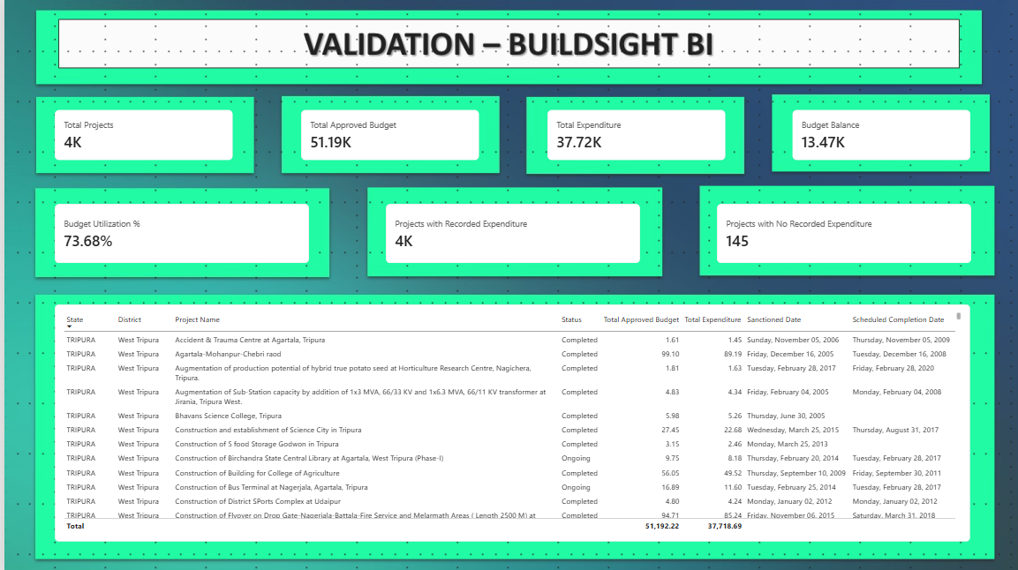

10.2 Implementation Evidence Dashboard:
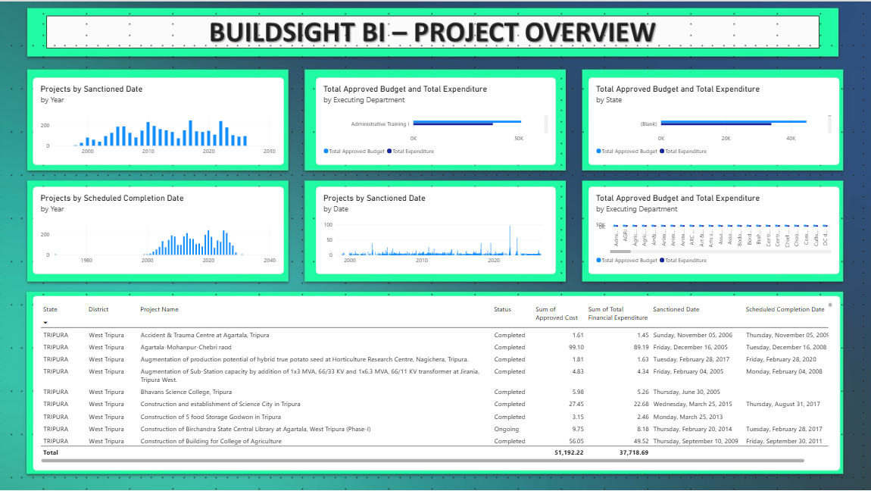

10.3 Performance Dashboard:
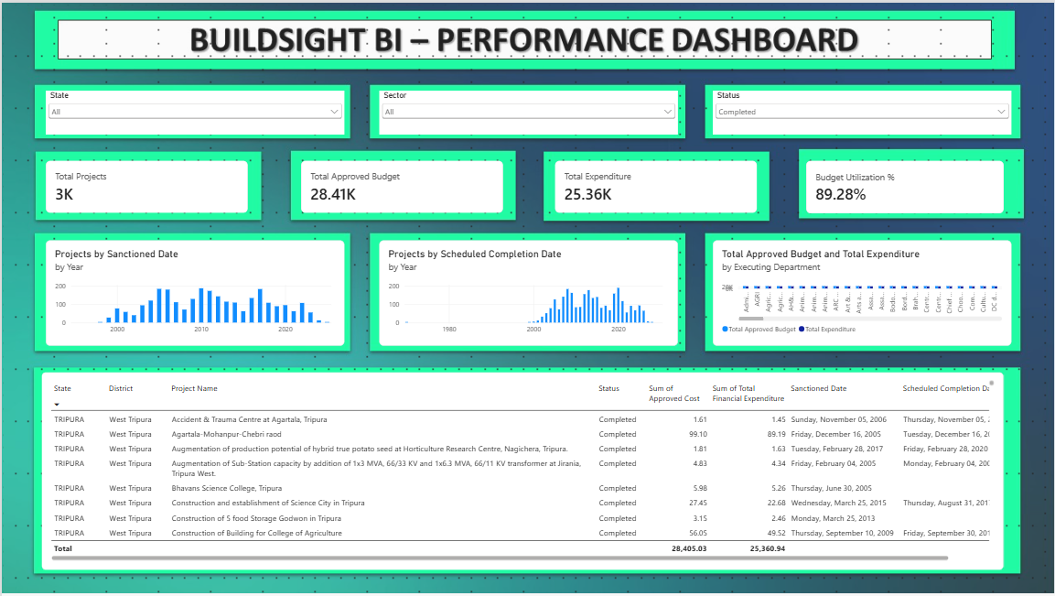

10.4 Predictive Analytics Dashboard:
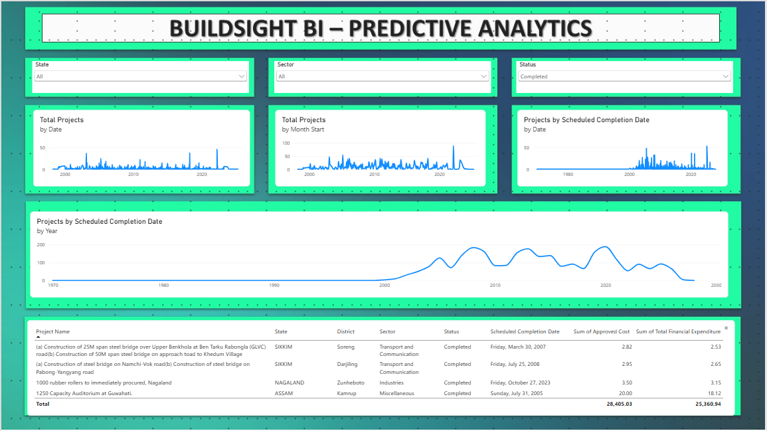

11. Critical Insights

11.1 Financial and Portfolio Insight
The unfiltered dashboard records 3,744 project records, 51,192.22 of approved budget and 37,718.69 of recorded expenditure, corresponding to 73.68% utilization. This indicates substantial recorded expenditure relative to approved cost within the represented portfolio. It should not be interpreted as physical completion.

11.2 Filtered Portfolio Insight
The demonstrated filter interactions show that financial intensity varies across portfolio segments. Assam, Education and Completed selections produced materially different project counts and utilization ratios. This confirms that the dashboard value is not only in portfolio totals but also in segment-specific review.

11.3 Scheduled Workload Insight
Week 5 shows scheduled completion records concentrated in particular periods, with several yearly peaks in the captured view. These patterns can guide monitoring attention, but scheduled dates are planned dates and cannot confirm actual workload, completion or delay.

11.4 Data Governance Insight
The difference between the Week 2 Serial Number profile and the Week 4 dashboard record count, together with the unresolved geography row-count discrepancy, shows why reconciliation should be treated as part of BI delivery rather than an afterthought.

11.5 Predictive Insight
The project demonstrates an important distinction between preparing a dataset for predictive analysis and actually producing a validated prediction. Week 5 establishes time-oriented analytical views but does not provide forecast outputs or accuracy metrics. This is a useful and honest boundary for the current solution.

12. Key Strengths
- Clear six-week progression from strategic planning to implementation and evaluation.
- Repeatable Power Query preparation with documented transformation steps.
- Well-structured star-schema design with reusable DAX measures.
- Interactive Power BI dashboard with demonstrated slicer-driven filter context.
- Consistent financial calculations across KPI cards and detail-table totals.
- Careful separation of implemented functionality from planned/future functionality.
- Explicit interpretation boundaries prevent financial utilization from being misrepresented as physical progress.
- Week 5 connects temporal analysis to portfolio planning without overstating predictive capability.
- Documentation records assumptions, limitations and validation gaps rather than hiding them.

Evidence of Quality
A notable strength of the project documentation is methodological restraint. Week 3 explicitly marked model checks as pending, while Week 5 explicitly stated that no forecast values or accuracy metrics were available. This makes the final evaluation more defensible because it distinguishes observed implementation from intended future capability.

13. Limitations and Weaknesses
Limitation | Effect on evaluation | Severity
North Eastern Region-only source | Limits geographic generalization | High
Administrative/financial dataset | Cannot directly measure physical construction progress | High
No actual completion dates | Cannot confirm actual delay or completion performance | High
No labour/resource data | Workforce/productivity analytics cannot be implemented | High
No material/procurement detail | Material intelligence remains strategic rather than implemented | High
No detailed historical expenditure series | Reliable budget-overrun forecasting unsupported | High
Forecast not demonstrated | Predictive accuracy cannot be assessed | High
No predictive accuracy metrics | No evidence for model performance | High
Status labels not independently verified | Delay/overdue screening remains indicative | Medium
DimGeography discrepancy | District-level outputs require validation | Medium
Repeated project names / grain uncertainty | Record counts should not automatically mean unique projects | Medium
Dashboard unit labels absent | Financial interpretation less clear | Medium

These limitations do not invalidate the internship work. They define the correct scope of the current BuildSight BI implementation and provide a direct roadmap for future data acquisition and validation.

14. Actionable Recommendations
Priority | Recommendation | Reason | Expected benefit
High | Reconcile project grain, Serial Number counts and DimGeography row counts | Unresolved count/relationship checks | Improves trust in portfolio and geographic results
High | Add explicit Rs. crore unit labels to financial KPI cards | Cards currently omit units | Reduces financial misinterpretation
High | Validate Status values and overdue-screening logic | Status analysis depends on source labels | Improves reliability of screening
High | Add actual completion and physical-progress data | Current source cannot establish real schedule performance | Enables true completion and delay analytics
Medium | Improve department chart readability | Week 4 evaluation found it difficult to read | Improves comparative analysis
Medium | Add drill-through and richer tooltip views | Supports project investigation | Improves usability
Medium | Capture non-Completed slicer states for Week 5 | Current screenshots focus on Completed | Broadens portfolio interpretation
Medium | Add richer monthly expenditure history | Needed for stronger financial forecasting | Supports evidence-based prediction
Low | Introduce advanced ML only after richer outcome data exists | Current dataset lacks suitable outcome variables | Prevents weak or misleading models

15. Future Enhancements
Phase | Enhancement | Dependency | Status
Phase 1 | Generate and document a Power BI forecast with horizon/confidence settings | Existing model plus valid temporal series | Recommended; not demonstrated
Phase 1 | Add unit labels and broader slicer evidence | Existing dashboard | Recommended; not implemented
Phase 1 | Richer geographic views and drill-through | Existing geography fields | Recommended; not implemented
Phase 2 | Add monthly historical expenditure and actual completion dates | New monitoring data | Requires additional data
Phase 2 | Add physical progress, labour/resource and material data | New datasets/model extensions | Requires additional data
Phase 2 | Add weather/external factors and project-level delay labels where relevant | External and monitoring data | Requires additional data
Phase 3 | Develop stronger machine-learning models | Suitable historical outcome data | Future modelling work
Phase 3 | Evaluate models using RMSE/MAE/MAPE where appropriate | Held-out data and defined target | Future modelling work

The enhancement roadmap should follow a data-first sequence. Improving model sophistication before improving outcome data would create the appearance of prediction without the evidence needed to validate it.

16. Evaluation Criteria
Criterion | Evaluation approach | Evidence | Assessment
Data quality | Review preparation, missing values, consistency and reconciliation | Week 2 Power Query workflow and quality checks | Strong process; reconciliation remains
Data model robustness | Review structure, keys, relationships, measures and validation status | Week 3 star schema, 13 measures and caveats | Good design; not fully validated
KPI effectiveness | Check KPIs against supported business questions | Four dashboard KPIs plus date/project measures | Good within available data
Dashboard usability | Review hierarchy, labels, interactivity and readability | Week 4 evidence and evaluation | Good; clarity improvements needed
Dashboard effectiveness | Check filtering, consistency and decision support | State/Sector/Status interactions | Good descriptive review
Predictive usefulness | Check outputs and validation evidence | Week 5 trend/workload views; no forecast/accuracy shown | Limited; planning aid
Decision-support value | Assess segmentation and project-level investigation | Slicers, charts and detail/planning tables | Moderate to good
Documentation quality | Assess traceability and limitations | Detailed weekly reports and evidence indexes | Strong
Scalability | Assess model reuse and extension | Star schema and reusable measures | Promising but source-limited
Maintainability | Assess centralized calculations and repeatability | Power Query sequence and measure layer | Good design; synchronize documentation

Evaluation Conclusion
The project meets the Week 6 evaluation intent most convincingly through evidence-based assessment rather than artificial scoring. The strongest evidence concerns data preparation, dashboard interactivity and continuity of the analytical model. The weakest area is validated predictive performance, because the source data and supplied evidence do not support a defensible predictive accuracy claim.

17. Conclusion
BuildSight BI demonstrates an end-to-end approach to construction business intelligence within the boundaries of a simulated internship project. The work progressed from strategic planning and KPI definition through public-data sourcing, Power Query preparation, star-schema modelling, DAX development, interactive dashboard implementation and forward-looking portfolio analysis. Each stage reused the foundation of the preceding stage, which is a meaningful strength of the overall design.
The final evaluation shows that the implemented dashboard is effective for descriptive portfolio monitoring. Its four KPI cards, three slicers, timeline views, department comparison and project-detail table provide a coherent interface for exploring financial and project-record information. Demonstrated filter interactions show that the model responds consistently to State, Sector and Status selections. The dashboard shortcomings are primarily clarity and scope: financial unit labels should be explicit, some visual elements should be more readable, and the underlying dataset needs richer construction-specific fields for deeper decision support.
The data model is structurally promising because it uses a star-schema organization, reusable DAX measures, standardized keys and multiple date roles. However, the Week 3 documentation identifies unresolved validation items, including the DimGeography row-count discrepancy, status-label verification and record-grain uncertainty. These should be resolved before the framework is treated as an operational BI model.
Week 5 adds forward-looking value through temporal trend and scheduled-workload analysis, but it should not be described as a validated predictive model. No forecast values, confidence intervals or accuracy metrics are demonstrated. The correct conclusion is that the project prepares a foundation for predictive analytics and provides a portfolio planning aid. A genuine forecasting or machine-learning layer should follow only after the project obtains richer historical expenditure, actual completion, progress, resource and outcome data.
Overall, the internship demonstrates the ability to connect business requirements, data preparation, analytical modelling, visualization and critical evaluation into one coherent BI workflow. The next stage is not simply to add more charts or complex algorithms; it is to improve data quality, validate the model, strengthen construction-specific measures and then introduce predictive techniques that can be evaluated against real outcomes.

Appendix A — KPI Definitions
KPI | Formula / logic | Caveat
Total Projects | COUNTROWS(FactProjects) in filter context | Counts records until project grain confirmed
Total Approved Budget | SUM(Approved Cost) | Approved/sanctioned amount, not expenditure
Total Expenditure | SUM(Total Financial Expenditure) | Recorded expenditure, not physical progress
Budget Utilization % | Total Expenditure / Total Approved Budget | Financial ratio, not completion
Projects by Scheduled Completion Date | CALCULATE project count using scheduled-date relationship | Depends on blank-date handling
Cumulative Approved Budget | Running total using selected date context | Not a forecast
Projects with Recorded Expenditure | Filtered project records with expenditure | Does not establish physical work completed

Appendix B — Evidence Summary by Week
Week | Primary evidence | What it proves
1 | Strategic Planning Report | Strategic intent, use cases, KPI framework, technology and success criteria
2 | Data Sourcing & Transformation Report | Actual source, Power Query workflow, preparation and quality considerations
3 | Data Modelling & DAX Report | Model structure, relationships, measures, strengths and validation limitations
4 | Interactive Dashboard Report | Implemented dashboard, KPIs, slicer interactions, evaluation and screenshots
5 | Predictive Analytics Report | Trend/workload dashboard, observations, limitations and predictive evidence boundary
6 | This report | Integrated evaluation, insights, recommendations and future roadmap

Appendix C — Evidence Boundaries
- BuildSight BI is a conceptual framework for a simulated construction organization.
- The implemented source covers the North Eastern Region represented in the MDoNER/NESetu listing.
- Financial values in the source are represented in Rs. crore; dashboard cards should ideally display the unit explicitly.
- Budget utilization is recorded expenditure divided by approved cost, not physical completion.
- Scheduled completion dates are planned dates, not actual or predicted completion dates.
- Week 5 does not demonstrate a generated forecast or predictive accuracy metric.
- Future enhancements are proposals, not implemented functionality.

Appendix D — Final Submission Checklist
- Comprehensive synthesis of Weeks 1–5 — addressed.
- Dashboard effectiveness evaluation — addressed.
- Data model robustness evaluation — addressed.
- Predictive analytics impact evaluation — addressed with evidence boundary.
- KPI/performance metrics — consolidated from implemented work.
- Critical insights — included.
- Recommendations — prioritized and actionable.
- Future enhancements — phased and dependency-aware.
- Limitations and assumptions — explicitly documented.
- Professional Word report — prepared for submission.
Prepared for submission as the Week 6 deliverable of the Virtual Construction Business Intelligence Internship. Source basis: the uploaded BuildSight BI Week 1–5 reports and their documented evidence.

