WEEK 3 INTERNSHIP REPORT

BUILDSIGHT BI
A Power BI-Based Business Intelligence Framework for Construction Project Performance
Turning Construction Data into Actionable Intelligence

Building Advanced Data Models and DAX Calculations

Internship | Virtual Construction Business Intelligence Intern
Platform | YuvaIntern
Internship period | 24 August 2026 - 5 October 2026 (6 weeks)
Assignment | Week 3: Building Advanced Data Models and DAX Calculations
Submitted by | Shalvi Atul Surve
Submitter Organization | Vellore Institute of Technology (VIT), Vellore
Submission date | 04.10.2026
Primary Tool | Microsoft Power BI Desktop (Power Query Editor)
Dataset | MDoNER NESetu Projects Dashboard (North Eastern Region of India)

BuildSight BI is a conceptual project created for this internship. It is not an existing commercial organization or an implemented product.

Internship Information

Title | Virtual Construction Business Intelligence Intern
Platform | YuvaIntern
Duration | 6 weeks, 24 August 2026 - 5 October 2026
Focus | Applying business intelligence methods to construction scenarios using Microsoft Power BI
Week 3 assignment | Building Advanced Data Models and DAX Calculations

Weekly assignments

Week | Assignment
1 | Strategic Planning for Virtual Construction Intelligence
2 | Data Sourcing, Import, and Transformation for Construction Metrics (this report)
3 | Building Advanced Data Models and DAX Calculations
4 | Designing Interactive Power BI Dashboards for Construction Analytics
5 | Implementing Predictive Analytics in Virtual Construction
6 | Comprehensive Evaluation and Performance Metrics Reporting

Project Information

Project name | BuildSight BI
Project title | A Power BI-Based Business Intelligence Framework for Construction Project Performance
Tagline | Turning Construction Data into Actionable Intelligence
Nature | Conceptual framework for a simulated construction organization
Focus areas | Project performance; cost and budget; schedule and progress; workforce productivity; material and procurement; project risk
Market context | India (primary), with international references where relevant
Status at Week 3 | Data model and DAX measures created; validation pending.

Table of Contents
1. Executive Summary 1
2. Introduction and Objectives 2
3. Dataset and Source Overview 3
3.1 Source and scope 3
3.2 Fields available for analysis 3
3.3 Limits of the dataset 3
4. Data Model Design 5
4.1 Star-schema approach 5
4.2 Model tables 6
4.3 Query structure and grain 6
4.4 Dimension table design 6
5. Relationship Design 9
5.1 Relationship matrix 9
5.2 The two date relationships 9
5.3 Assumptions 10
6. DAX Measures and KPI Development 11
6.1 Core measures 11
6.2 Advanced measures 12
6.3 Other documented measures 14
6.4 DIVIDE, measures and calculated columns 14
6.5 Recommended improvements (not implemented) 14
7. Validation and Modelling Considerations 16
7.1 Status of checks 16
7.2 Other considerations 16
7.3 Recommended validation page 17
8. Implementation Evidence 18
9. Model Strengths 19
10. Limitations and Assumptions 20
11. Conclusion and Next Steps 21
References 22
Appendix A: DAX Measure Summary 23
Appendix B: Screenshot Evidence Index 24

If entries or page numbers appear blank, right-click the table in Word and choose Update Field.

1. Executive Summary
This report documents the Week 3 work of the BuildSight BI project: designing a star-schema data model in Microsoft Power BI and writing DAX measures for project-level construction information. The model is built on one public dataset, the North Eastern Region projects dashboard of the Ministry of Development of North Eastern Region (MDoNER), accessed through the NESetu portal. It does not cover construction projects across India.
As documented in the project notes, the model places a project-level table, FactProjects, at the centre, with six dimension tables: DimSector, DimScheme, DimDepartment, DimStatus, DimGeography and DimDate. Normalised keys (DepartmentKey, GeographyKey) connect two of the dimensions, and a calendar table connects to two date columns, one relationship active and one inactive. Thirteen DAX measures cover approved budget, recorded expenditure, budget utilisation, project counts, date-based counts, a cumulative approved budget and a scheduled-date screening measure.
PENDING VERIFICATION This is a first draft. The relationships, DAX formulas, row counts and status labels below come from the author's modelling notes and could not be read from the PBIX. The report has no validated results and no dashboard; the PBIX contains one report page with no visuals. Section 7 lists the checks still to be completed, including an unresolved row-count discrepancy in DimGeography.

2. Introduction and Objectives
Week 2 produced a prepared dataset: the MDoNER workbook was imported and cleaned in Power Query. Week 3 turns that single flat table into a model that Power BI can filter and aggregate consistently. A flat table can answer simple questions, but every slicer, grouping and date comparison then depends on repeated text values in the same table. Separating descriptive attributes into dimensions, and defining measures once, makes the analysis easier to maintain and check.
The objectives of the Week 3 work are to:
- structure the project data for analytical use, with one central table of project records;
- separate descriptive attributes (sector, scheme, department, status, geography, dates) into dimension tables;
- connect the tables with explicit relationships and key columns;
- develop reusable DAX measures for budget, expenditure, project counts and date-based analysis;
- enable financial and timeline-oriented analysis within the limits of the source data; and
- document assumptions, data limitations and the checks that remain.

3. Dataset and Source Overview

3.1 Source and scope
The data comes from the MDoNER Projects Dashboard on the NESetu portal (https://www.nesetu.mdoner.gov.in/projects/project-list), a publicly accessible dashboard that lists projects in India's North Eastern Region. The raw workbook used in Week 2 was mdoner_projects_raw.xlsx, worksheet overall-schemes-2026-08-31, with 15 columns and the title "All Schemes Projects, as on 2026-08-31". The coverage is limited to the projects represented in that source.

3.2 Fields available for analysis
Table 1. Source fields by analytical role
Role | Fields (as used in the model) | Use in BuildSight BI
Project identification | Serial Number; Project Name | Record identification. Serial Number is the candidate key; Project Name is not used as a key because Week 2 profiling showed repeated names
Geography | State; District | Filtering and grouping by location
Classification | Sector; Scheme; Executing Department | Grouping by type of work, funding scheme and responsible department
Budget | Approved Cost | Total and average approved budget
Expenditure | Total Financial Expenditure (plus two other expenditure columns, not used in the measures) | Recorded expenditure and utilisation
Timeline | Sanctioned Date; Scheduled Completion Date | Date-based analysis; scheduled-date screening
Status | Status | Status grouping and the overdue screening measure
Source: MDoNER NESetu dashboard; field names as documented in the Week 2 and Week 3 project notes.

3.3 Limits of the dataset
The dataset is a project-level administrative and financial listing. Each of the following is therefore not established by the data, and the model does not claim it:
- actual physical construction progress, or any link between expenditure and physical completion;
- actual completion dates (the scheduled completion date is a planned date only);
- labour productivity, resource allocation or site-level resource use;
- a historical monthly expenditure series suitable for forecasting; and
- whether a project is physically delayed.
These limits shape the design. The model supports descriptive analysis of approved cost, recorded expenditure, distribution across categories and scheduled dates. It is not a progress-prediction or completion-forecasting system.
=Week 2 profiling showed, for the Power Query output at its final step: Serial Number 3,774 distinct and 3,774 unique; Project Name 3,745 distinct and 3,731 unique; State 11 distinct; District 183 distinct; Sector 16 distinct. These Week 2 figures support, but do not replace, Week 3 checks on the loaded FactProjects table.

4. Data Model Design

4.1 Star-schema approach
In a star schema, one central table stores the records to be measured (the fact table), and surrounding dimension tables hold the descriptive categories used to filter and group them. For BuildSight BI the central table is FactProjects, and each project record can be filtered by sector, scheme, department, status, geography and date through its dimension. Filters flow from a dimension to the fact table, so choosing one sector in a slicer restricts the project rows that every measure sees.
The star schema below is the documented design. The Model view layout in the PBIX confirms that the seven tables exist (FactProjects, DimDate, DimDepartment, DimGeography, DimScheme, DimSector, DimStatus).
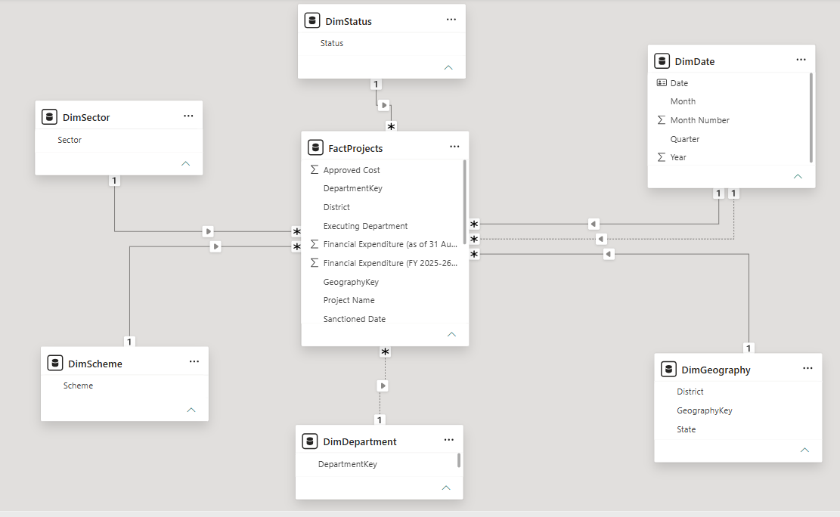
Figure 1. Star-schema Model View

4.2 Model tables
Table 2. Tables in the model
Table | Type | Purpose | Key field(s)
FactProjects | Fact | Central project-level table; referenced query loaded into the model | Serial Number (candidate key, uniqueness to be verified); DepartmentKey; GeographyKey; Sanctioned Date; Scheduled Completion Date
DimSector | Dimension | One row per sector | Sector
DimScheme | Dimension | One row per scheme | Scheme
DimDepartment | Dimension | One row per normalised executing department | DepartmentKey
DimStatus | Dimension | One row per status label | Status
DimGeography | Dimension | Intended: one row per State-District combination | GeographyKey
DimDate | Dimension (date table) | Continuous calendar for time-based analysis | Date
_Measures | Measure table | Holds DAX measures; a hidden field named Placeholder was used in it | None (presence in the PBIX not confirmed)
Source: Week 3 modelling notes. The _Measures table was not seen in the PBIX layout inspection and is flagged for confirmation.

4.3 Query structure and grain
The original query overall-schemes-2026-08-31 was kept in Power Query with Enable Load switched off, so it does not appear as a duplicate table in the model. FactProjects was created as a referenced query from it and is the table loaded for analysis. The dimension tables were also created by referencing the prepared data.
The intended grain of FactProjects is one row per project record. The Week 2 profile shows Serial Number as 3,774 distinct and 3,774 unique, which is consistent with one row per serial number. Because the final row count and the uniqueness of the loaded table have not been checked in Week 3, this report refers to rows as project records and does not state that they are unique projects.

4.4 Dimension table design
Table 3. Dimension design summary
Dimension | Source column(s) | Transformation (as documented) | Relationship key | Analytical value
DimSector | Sector | Referenced from FactProjects; Sector retained; duplicates removed; no blank values found | Sector | Group and filter by type of work
DimScheme | Scheme | Referenced from FactProjects; Scheme retained; duplicates removed; no blank values found | Scheme | Compare projects across funding schemes
DimDepartment | Executing Department | Null replaced with Not specified; DepartmentKey created; duplicates removed on the key (242 to 235 rows) | DepartmentKey | Compare responsible departments
DimStatus | Status | Status retained; duplicates removed; no blank values found | Status | Group by project status
DimGeography | State; District | State and District retained; distinct combinations kept; GeographyKey created | GeographyKey | Analyse by state and district
DimDate | Sanctioned Date; Scheduled Completion Date (for range only) | Calendar generated in Power Query between the minimum and maximum non-null dates of both columns | Date | Calendar analysis by year, quarter and month
Source: Week 3 modelling notes. Row counts other than DimDepartment's are to be verified (see Section 7).
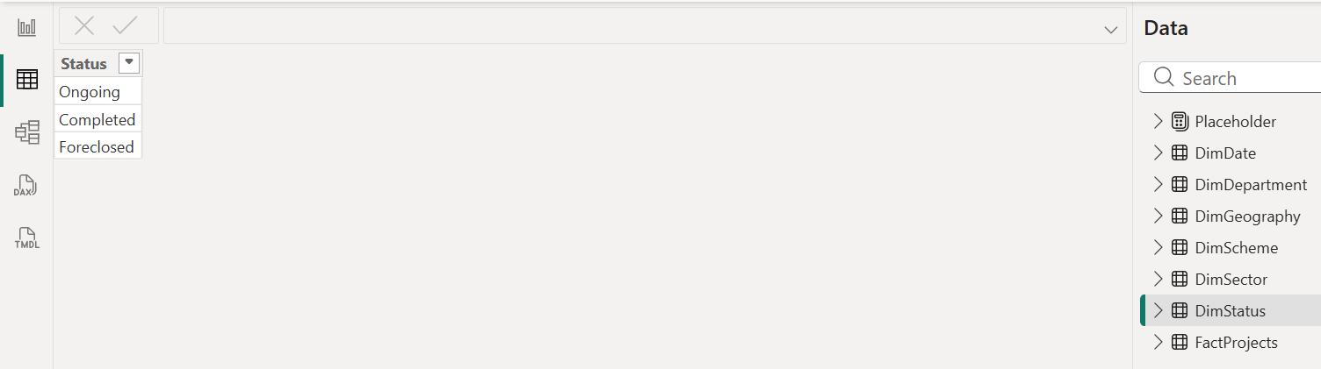
Figure 2. DimStatus Data View

DimDepartment and DepartmentKey
The source column is Executing Department. A null value was replaced with Not specified in both FactProjects and DimDepartment, so every fact row has a department value. A key column was then created in both tables:
DepartmentKey (Power Query M)
Text.Upper(Text.Trim(Text.Clean([Executing Department])))

Text.Clean removes non-printable characters, Text.Trim removes leading and trailing spaces, and Text.Upper removes differences in capitalisation. Without this, two department names that differ only by case, a trailing space or a hidden character would be separate rows in the dimension and would not match consistently in the relationship. The dimension had 242 rows before de-duplication and 235 after de-duplicating on DepartmentKey. The fact table was not reduced. The key is used for the relationship, and the original Executing Department text is kept for display.
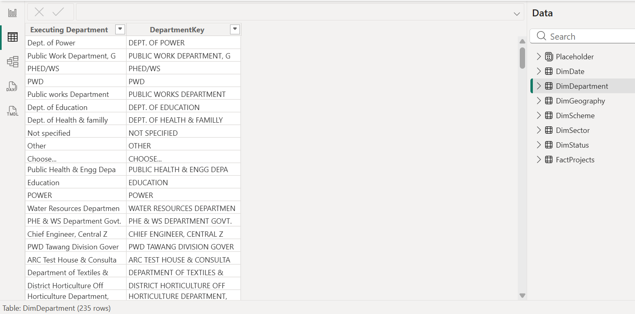
Figure 3. DimDepartment and DepartmentKey Data View

DimGeography and GeographyKey
DimGeography is intended to hold one row per distinct State-District combination. A single combined key lets the pair be used as one relationship column, since a Power BI relationship connects one column to one column. The key was created in FactProjects and DimGeography:
GeographyKey (Power Query M)
Text.Trim([State]) & "|" & Text.Trim([District])

Two consequences follow if the check shows a problem. If the dimension has non-unique keys, Power BI cannot treat the relationship as one-to-many. If fact rows carry keys that are absent from the dimension, those rows will fall into a blank group in any visual that uses DimGeography fields. A further caution: in Power Query, joining text with a null value gives null, so a null District would produce a null key; the notes report no null States or Districts.
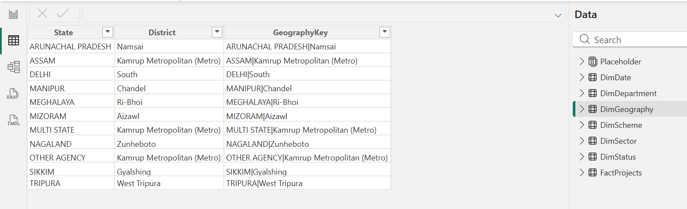
Figure 4. DimGeography Data View

DimDate
DimDate is a continuous calendar generated in Power Query from the minimum and maximum non-null values found across both Sanctioned Date and Scheduled Completion Date. Its columns are Date, Year, Month Number, Month and Quarter. DimDate[Date] was marked as the date table. A continuous calendar is needed because time-based DAX functions and cumulative measures require every date in the range to exist, including dates on which no project was sanctioned.
Both source date columns were originally text in dd-mm-yyyy format. They were converted with Change Type, Using Locale, Date, English (United Kingdom), so that day-first dates such as 02-06-2015 are read as 2 June 2015 and not 6 February 2015. After conversion the profile reported Sanctioned Date at about 99% valid with 0% errors and 0% empty, and Scheduled Completion Date at about 99% valid with 0% errors and less than 1% empty. These are profile percentages, not exact row counts. Records with an empty scheduled completion date were retained, not deleted.
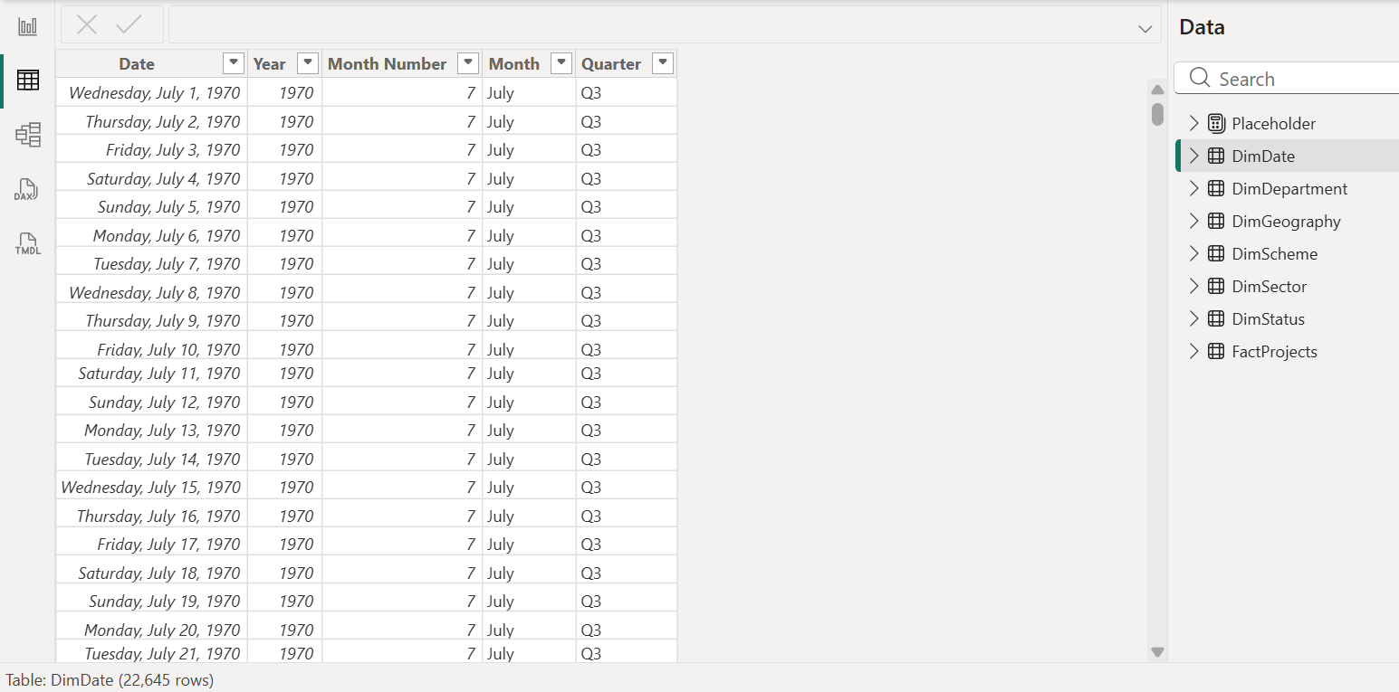
Figure 5. DimDate Data View

5. Relationship Design

5.1 Relationship matrix
Table 4. Relationship design (documented, pending verification)
From (one side) | To (many side) | Cardinality | Filter direction | Status | Reason
DimSector[Sector] | FactProjects[Sector] | One-to-many | Single (dimension to fact) | Active | Filter projects by sector
DimScheme[Scheme] | FactProjects[Scheme] | One-to-many | Single | Active | Filter by scheme
DimDepartment[DepartmentKey] | FactProjects[DepartmentKey] | One-to-many | Single | Active | Filter by executing department using the normalised key
DimStatus[Status] | FactProjects[Status] | One-to-many | Single | Active | Filter by status
DimGeography[GeographyKey] | FactProjects[GeographyKey] | One-to-many (to be verified) | Single | Active | Filter by State-District pair
DimDate[Date] | FactProjects[Sanctioned Date] | One-to-many | Single | Active | Default calendar for project dates
DimDate[Date] | FactProjects[Scheduled Completion Date] | One-to-many | Single | Inactive | Second date role, used on demand
Source: Week 3 modelling notes. The PBIX layout stores table positions only, so these relationships were not read from the file.
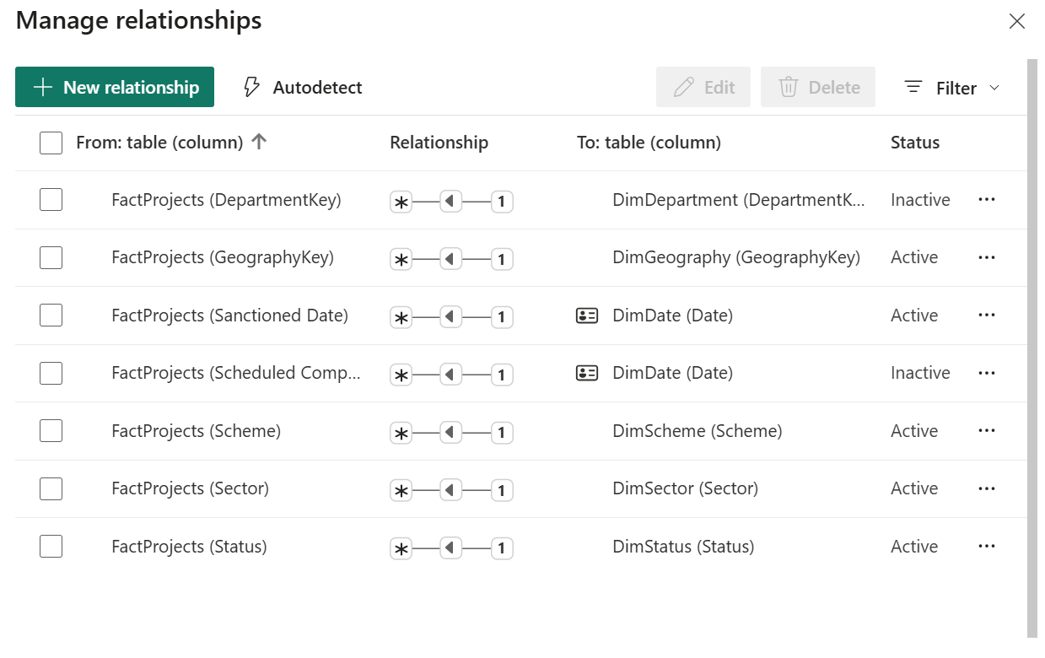
Figure 6. Relationship Matrix

5.2 The two date relationships
FactProjects has two date columns that both describe a project, but Power BI allows only one active relationship between the same pair of tables. The relationship to Sanctioned Date is kept active, so by default any visual that places DimDate fields on an axis counts or sums projects by the date they were sanctioned. The relationship to Scheduled Completion Date is inactive. It still exists in the model, and a measure can switch to it temporarily by calling USERELATIONSHIP inside CALCULATE. During that calculation the inactive relationship is used and the active one is ignored.
This avoids creating a second copy of the date table. A single calendar table is used for both date roles, and measure names state which date is being used.

5.3 Assumptions
Table 5. Modelling assumptions
Topic | Assumption or treatment
Grain | One row in FactProjects represents one project record. Uniqueness of Serial Number in the loaded table is to be verified.
Approved Cost | The approved cost of the project as given in the source, in Rs crore.
Financial expenditure | Recorded financial expenditure as given in the source (Total Financial Expenditure), in Rs crore. It is a financial figure and is not physical progress.
Missing department | Null Executing Department replaced with Not specified in both FactProjects and DimDepartment.
Department text | Normalised only for the relationship key (case, whitespace, non-printable characters). Original text kept for display.
Geography | State and District combined into GeographyKey; State and District remain available for display.
Missing scheduled dates | Retained. Such records are not counted by date-based measures that depend on the scheduled completion date.
Status | Treated as the source label as recorded. The label for a completed project must be checked before measures rely on it.
Scale | A small project-level analytical model for a single public dataset. It is not a construction data warehouse and has no resource, labour or progress tables.
Source: Prepared by the author.

6. DAX Measures and KPI Development
The measures below are stored in the _Measures table and are documented as created during the Week 3 work. No measure has yet been checked against a Power BI visual in this report, and no values are quoted. Monetary measures are in Rs crore.

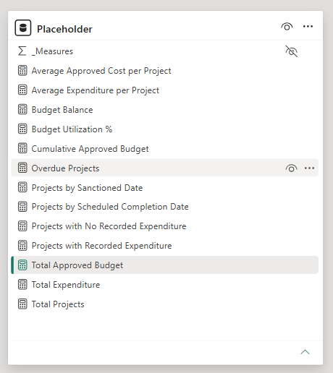
Figure 7. Measures

6.1 Core measures
Total Approved Budget
Total Approved Budget =
SUM(FactProjects[Approved Cost])

Total Expenditure
Total Expenditure =
SUM(FactProjects[Total Financial Expenditure])

Budget Balance
Budget Balance =
[Total Approved Budget] - [Total Expenditure]

Budget Utilization %
Budget Utilization % =
DIVIDE([Total Expenditure], [Total Approved Budget], 0)

Total Projects
Total Projects =
COUNTROWS(FactProjects)

Table 6. Core measures: interpretation and caveats
Measure | Purpose and interpretation | Caveat
Total Approved Budget | Sum of Approved Cost over the project records visible in the current filter context (Rs crore). | Reflects approved cost as recorded, not money spent.
Total Expenditure | Sum of Total Financial Expenditure over the visible records (Rs crore). | Recorded financial expenditure only; it is not physical progress.
Budget Balance | Approved budget minus recorded expenditure for the visible records. | A financial difference, not an accounting balance available to spend. It is negative where recorded expenditure exceeds approved cost.
Budget Utilization % | Recorded expenditure as a share of approved cost, formatted as a percentage with two decimals. | At any grouping it is total expenditure divided by total budget, so large projects weigh more than small ones; it is not an average of project ratios. A value near 100% does not mean a project is physically complete.
Total Projects | Counts rows of FactProjects in the current filter context. | Counts project records, not verified unique projects, until the grain is confirmed.
Source: Prepared by the author.
All five measures respond to filter context. Placed in a card with no filters, each reflects every row of FactProjects. Placed in a table by Sector, each row of the table filters FactProjects through the DimSector relationship, so the same formula returns a different value per sector without being rewritten. The same happens with slicers on any dimension.

6.2 Advanced measures

Projects by Scheduled Completion Date
Projects by Scheduled Completion Date
Projects by Scheduled Completion Date =
CALCULATE(
[Total Projects],
USERELATIONSHIP(
DimDate[Date],
FactProjects[Scheduled Completion Date]
)
)

CALCULATE evaluates [Total Projects] in a modified filter context. USERELATIONSHIP makes the inactive relationship between DimDate[Date] and FactProjects[Scheduled Completion Date] the one in use for this calculation, replacing the active sanctioned-date relationship. Placed on a visual with DimDate[Year] on the axis, the measure counts projects by the year in which they are scheduled to complete, whereas [Total Projects] on the same axis counts them by sanctioned year. Records with an empty scheduled completion date have no date to match, so they appear under a blank date, if at all, and not under any real date. The measure counts scheduled dates only; it says nothing about when work actually finished.

Cumulative Approved Budget
Cumulative Approved Budget
Cumulative Approved Budget =
CALCULATE(
[Total Approved Budget],
FILTER(
ALLSELECTED(DimDate[Date]),
DimDate[Date] <= MAX(DimDate[Date])
)
)

This is a running total. MAX(DimDate[Date]) returns the latest date in the current visual cell, for example the last day of a month on a monthly axis. ALLSELECTED(DimDate[Date]) returns all dates that survive the report's outer selections (slicers, page filters) while ignoring the filter that the axis itself applies to that cell. FILTER keeps those dates up to the cell's date, and CALCULATE then sums the approved cost of all records related to those dates. Because the active relationship is the sanctioned date, the result is the cumulative approved cost of projects sanctioned up to that point. It is a historical accumulation and not a forecast.
Two points affect interpretation. DimDate runs to the latest scheduled completion date, so on a long axis the cumulative line is flat after the last sanction date. Records with a blank sanctioned date do not fall on any date and would be missing from the running total.

Projects with Recorded Expenditure
Projects with Recorded Expenditure
Projects with Recorded Expenditure =
CALCULATE(
[Total Projects],
FILTER(
FactProjects,
FactProjects[Total Financial Expenditure] > 0
)
)

FILTER walks through the rows of FactProjects that are visible in the current context and keeps those with positive recorded expenditure; CALCULATE then counts them. Used by sector, scheme, department or state, it shows how many records in each group have any recorded spending. A positive value shows that expenditure has been recorded and does not show that construction has progressed.

Projects with No Recorded Expenditure
Projects with No Recorded Expenditure
Projects with No Recorded Expenditure =
CALCULATE(
[Total Projects],
FILTER(
FactProjects,
ISBLANK(FactProjects[Total Financial Expenditure])
|| FactProjects[Total Financial Expenditure] = 0
)
)

This is the counterpart measure: it counts records whose expenditure is blank or zero. In DAX a blank value compared with zero evaluates as equal, so the ISBLANK clause is probably redundant, though it makes the intent explicit and does no harm. The measure identifies records without recorded expenditure; the data do not explain why expenditure is absent (not started, not yet reported, or other reasons). Where no record is blank or zero in the selected context, the result is blank, not zero.

Overdue Projects
Overdue Projects
Overdue Projects =
CALCULATE(
[Total Projects],
FILTER(
FactProjects,
NOT ISBLANK(FactProjects[Scheduled Completion Date])
&& FactProjects[Scheduled Completion Date] < TODAY()
&& FactProjects[Status] <> "Completed"
)
)

The measure counts records that have a scheduled completion date earlier than today's date and whose status is not the text "Completed". It is a screening indicator based on a planned date and a status label. It does not prove that a project is delayed: the dataset contains no actual completion date and no measure of physical progress, so a scheduled date in the past is only a reason to look more closely.

6.3 Other documented measures
Average Approved Cost per Project
Average Approved Cost per Project =
DIVIDE([Total Approved Budget], [Total Projects], 0)

Average Expenditure per Project
Average Expenditure per Project =
DIVIDE([Total Expenditure], [Total Projects], 0)

Projects by Sanctioned Date
Projects by Sanctioned Date =
CALCULATE(
[Total Projects],
USERELATIONSHIP(
DimDate[Date],
FactProjects[Sanctioned Date]
)
)

The two average measures give the mean per project record (the wording "per project" is the measure name; it is accurate only if each row is one project). Projects by Sanctioned Date names the sanctioned-date relationship explicitly. Because that relationship is already active, the measure should return the same result as [Total Projects] on a date axis, so it is redundant. Its only value is that its name states which date is being counted.

6.4 DIVIDE, measures and calculated columns
DIVIDE(numerator, denominator, alternate) performs division and returns the alternate result when the denominator is zero. Documentation describes the alternate result as a constant, with BLANK as the default if none is given (Microsoft, n.d.-b). In BuildSight BI this matters because a slicer selection can leave no records, making [Total Approved Budget] or [Total Projects] zero; with DIVIDE, the three ratio measures return 0 instead of an error. Returning 0 where there are no records in context is a design choice: a blank result may be preferable to show that no data exist.
A measure is calculated at query time for whatever the filter context is, which suits totals, ratios and counts. A calculated column is calculated once per row when the data is refreshed and stored in the table. All the figures in this section are measures, because they must change with slicers. The keys DepartmentKey and GeographyKey are the opposite case: they are row-level values, so they were created in Power Query as columns.

6.5 Recommended improvements (not implemented)
RECOMMENDATION The following changes are recommendations only. The formulas in Sections 6.1 to 6.3 are as documented and have not been altered.
- Overdue Projects: confirm the exact label for finished projects in DimStatus and update the comparison (or test against a list of labels). Consider a fixed snapshot date, because the dataset is as on 31 August 2026 and TODAY() makes results drift. An example is shown below, using a placeholder for the verified label.
Overdue Projects (recommended, not implemented)
Overdue Projects =
VAR SnapshotDate = DATE(2026, 8, 31)
RETURN
CALCULATE(
[Total Projects],
FILTER(
FactProjects,
NOT ISBLANK(FactProjects[Scheduled Completion Date])
&& FactProjects[Scheduled Completion Date] < SnapshotDate
&& FactProjects[Status] <> "<verified completed label>"
)
)

- Projects by Sanctioned Date: keep for naming clarity or remove as redundant.
- Projects with No Recorded Expenditure: the ISBLANK clause may be removed; both forms give the same result.
- Measure naming: rename the averages to "per project record" unless row uniqueness is confirmed.
[SCREENSHOT PLACEHOLDER — W3-07: DAX formula evidence]
Caption: DAX implementation of budget utilisation, scheduled-date counting and cumulative approved budget.
Intended to show: the formula bar for Budget Utilization % (with percentage formatting), Projects by Scheduled Completion Date and Cumulative Approved Budget, matching the formulas above; also the `_Measures` table in the Fields pane, confirming it exists in the model.

7. Validation and Modelling Considerations

7.1 Status of checks
The table separates what is documented as done in the modelling notes from what is still to be confirmed. None of the pending items has been tested in this report, and no results are claimed.
Table 7. Validation status
Item | Status | Notes
Date conversion (dd-mm-yyyy, English (United Kingdom)) | Documented as done | Profile after conversion: Sanctioned Date about 99% valid, 0% errors, 0% empty; Scheduled Completion Date about 99% valid, 0% errors, under 1% empty. Percentages, not counts.
Blank scheduled completion dates retained | Documented as done | Records kept; date-based counts on that column exclude them.
Null Executing Department replaced with Not specified | Documented as done | Applied in FactProjects and DimDepartment.
DepartmentKey de-duplication (242 to 235 rows) | Documented as done | Fact table not reduced. Confirm in DimDepartment (W3-03).
Number of tables in the model | Verified in PBIX layout | Seven tables present in Model view layout; _Measures not seen.
Report page contents | Verified in PBIX | One page, zero visuals. No validation page or dashboard exists yet.
FactProjects row count and Serial Number uniqueness | Pending | Week 2 profile supports uniqueness, but the loaded table must be checked.
DimGeography row count and GeographyKey uniqueness | Pending (discrepancy) | Notes say 11 rows; Week 2 profile shows 183 distinct districts. See Section 4.4.
Status label for completed projects | Pending | Exact DimStatus values not yet seen; "Completed" unconfirmed.
Relationships: cardinality, direction, active status | Pending | Confirm in Manage relationships (W3-02).
_Measures table and DAX formulas | Pending | Confirm in Data pane and formula bar.
Date table marked on DimDate[Date] | Documented | Confirm in Table tools.
Source: Prepared by the author from the Week 3 notes and PBIX inspection.

7.2 Other considerations
- Project names repeat. Week 2 profiling showed 3,745 distinct but 3,731 unique project names, so names are not used as keys and similar names should not be merged or deleted without checking other fields.
- Expenditure column labels (Week 2). The Week 2 renaming steps relabelled the raw column "Financial Expenditure as on 31-03-2025" as an expenditure figure "as of 31 Aug 2026". In the visible rows of the raw workbook, Total Financial Expenditure equals that column plus the current-year column, which suggests the relabelling may not match the source meaning. The Week 3 measures use only Approved Cost and Total Financial Expenditure, so they are not affected, but the labels should be reviewed before those two columns are used.
- Source date labels. The dashboard header and the Excel header carry different reference years for the expenditure columns in the Week 2 screenshots; the source's own definition should be checked before the columns are described in a report.
- Dates and TODAY(). Scheduled-date screening depends on the date used for comparison (see Section 6.5).

7.3 Validation page
PowerBI dashboard with cards for Total Projects, Total Approved Budget, Total Expenditure, Budget Utilization %, Projects with Recorded Expenditure and Projects with No Recorded Expenditure, and a table showing State, District, Project Name, Status, Approved Cost, Total Financial Expenditure, Sanctioned Date and Scheduled Completion Date. Then complete the checks below and record the results.
Table 8. Recommended checks
Check | How to perform it | Result
Total Projects matches the fact table | Compare the card with the FactProjects row count in Power Query or Data view | Passed
Serial Number is unique | Column profile in Power Query: distinct count equals row count | Passed
Dimension keys are unique | Check each dimension's key: distinct count equals row count  (DepartmentKey 235 expected; DimGeography count) | Passed
Geography is complete | Distinct State-District combinations in FactProjects equal DimGeography rows | Passed
Relationships have intended cardinality | Manage relationships: one-to-many, single direction, as in Table 4 | Passed
Budget Balance arithmetic | Card values: Total Approved Budget minus Total Expenditure equals Budget Balance | Passed
Budget Utilization % denominator | Total Expenditure divided by Total Approved Budget equals the card value | Passed
Scheduled-date measure uses the inactive relationship | Table by DimDate[Year]: Projects by Scheduled Completion Date differs from Total Projects | Passed
Cumulative budget behaviour | Monthly axis: values never fall; flat after the last sanction date | Passed
Status counts reconcile | Projects per DimStatus value add up to Total Projects | Passed
Overdue measure label | Compare the status labels in DimStatus with the text used in the formula | Passed
Blank scheduled dates | Count of blank Scheduled Completion Date, and confirm they are not counted by the scheduled-date measure | Passed
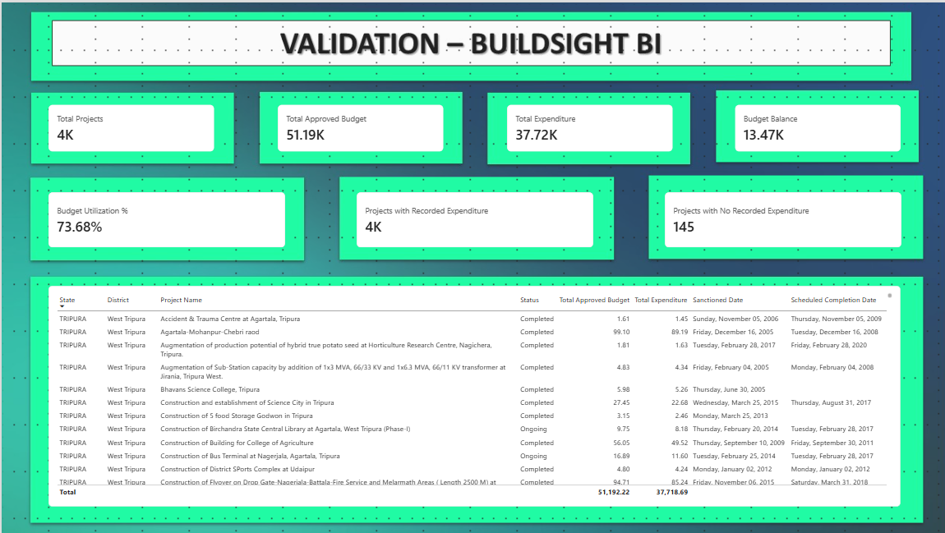
Source: Prepared by the author. Results are intentionally blank until the checks are run.
Figure 8. Validation Page

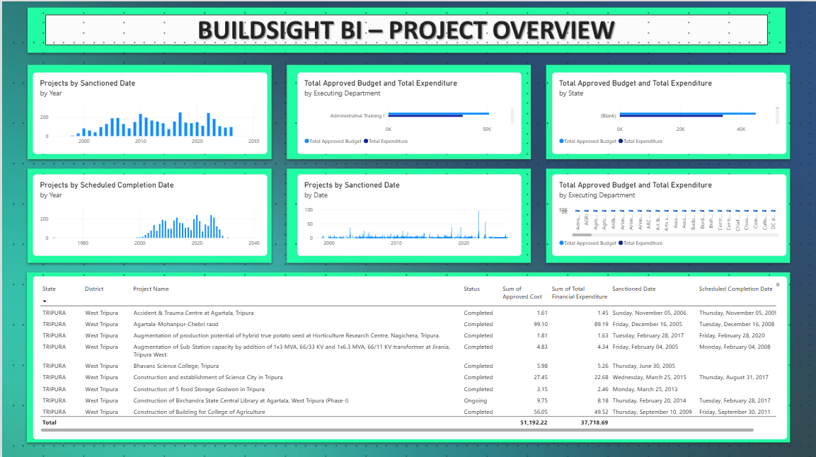
8. Implementation Evidence
Figure 9. Product Overview Page

9. Model Strengths
The following are strengths of the design as documented. They are not measured performance claims, and the first three depend on the checks in Section 7.
- Star-schema organisation: one central table of project records with descriptive categories in separate dimensions, matching Microsoft's guidance on star schemas for Power BI (Microsoft, n.d.-a).
- Reusable measures: budget, expenditure and count logic is written once in the measure table and responds to any slicer.
- Consistent department key: DepartmentKey reduces matching failures caused by case, spaces and hidden characters.
- Composite geography key: GeographyKey lets a State-District pair join through a single column (subject to the pending row-count check).
- Dedicated date table: one calendar serves two date roles, sanctioned (active) and scheduled completion (inactive, used by USERELATIONSHIP).
- Clear separation of querying and loading: the original query is retained but not loaded, avoiding a duplicate table.
- Financial KPIs with safe division: utilisation and averages use DIVIDE, which handles zero denominators.

10. Limitations and Assumptions
- Scope: the data covers only the North Eastern Region projects represented in the MDoNER/NESetu source.
- No physical progress or actual completion date: the model cannot show whether a project is physically behind schedule.
- No resource, labour or monthly expenditure data: workforce analysis and expenditure forecasting are not possible with this dataset.
- Missing scheduled dates: a small share of records has no scheduled completion date and is excluded from scheduled-date measures.
- Status labels: unconfirmed; the Overdue Projects measure depends on them.
- Overdue Projects: indicative screening only; it is not proof of delay.
- Financial utilisation is not completion: expenditure divided by approved cost is a financial ratio.
- Repeated project names and unverified grain: project counts are counts of records until uniqueness is confirmed.
- Unresolved geography row count: the State-District dimension must be checked before district-level results are relied on.
- Further validation needed: the model has not been fully validated and should not be used operationally.

11. Conclusion and Next Steps
Week 3 produced a documented star-schema design for the MDoNER project data: a project-level fact table, six dimensions, normalised department and geography keys, a calendar table with active and inactive date roles, and thirteen DAX measures covering budget, expenditure, counts, a cumulative approved budget and a scheduled-date screening measure. The model supports descriptive questions such as how approved budget and recorded expenditure are distributed across sectors, schemes, departments, states and years. It does not support claims about physical progress, productivity, actual delay or forecasts.
The PBIX at present holds no visuals, and relationships, formulas, row counts and status labels remain to be confirmed from within Power Query and Power BI Desktop. The next steps are:
- resolve the DimGeography row-count discrepancy and record all row counts;
- confirm relationships in Model view and Manage relationships;
- check the status labels and correct the Overdue Projects comparison if needed;
- confirm the _Measures table and compare each formula with the PBIX;
- build and document the validation page, then record results in Table 8;
- insert the screenshots W3-01 to W3-12 that apply; and
- build dashboard visuals (Week 4) only after the checks pass.

References
Ministry of Development of North Eastern Region. (n.d.). NESetu: Projects dashboard [Public project list]. Government of India. https://www.nesetu.mdoner.gov.in/projects/project-list
Microsoft. (n.d.-a). Understand star schema and the importance for Power BI. Microsoft Learn. https://learn.microsoft.com/power-bi/guidance/star-schema
Microsoft. (n.d.-b). DIVIDE function (DAX). Microsoft Learn. https://learn.microsoft.com/en-us/dax/divide-function-dax
Microsoft. (n.d.-c). USERELATIONSHIP function (DAX). Microsoft Learn. https://learn.microsoft.com/en-us/dax/userelationship-function-dax
Microsoft (n.d.-b) and (n.d.-c) are cited for the behaviour of DIVIDE and USERELATIONSHIP as described in Sections 5.2 and 6.4.

Appendix A: DAX Measure Summary
Table 9. Measures and DAX concepts used
Measure | Main DAX concepts | Caveat
Total Approved Budget | SUM | Approved cost, Rs crore
Total Expenditure | SUM | Recorded expenditure, not progress
Budget Balance | Measure arithmetic | Not an accounting balance
Budget Utilization % | DIVIDE, measure reference | Weighted ratio; not completion
Total Projects | COUNTROWS | Counts records until grain verified
Projects by Scheduled Completion Date | CALCULATE, USERELATIONSHIP | Blank scheduled dates excluded
Cumulative Approved Budget | CALCULATE, FILTER, ALLSELECTED, MAX | Running total, not a forecast
Projects with Recorded Expenditure | CALCULATE, FILTER | Not physical progress
Projects with No Recorded Expenditure | CALCULATE, FILTER, ISBLANK | Cause of absence unknown
Average Approved Cost per Project | DIVIDE | Per project record
Average Expenditure per Project | DIVIDE | Per project record
Projects by Sanctioned Date | CALCULATE, USERELATIONSHIP | Redundant: relationship already active
Overdue Projects | CALCULATE, FILTER, ISBLANK, TODAY | Status label unconfirmed; screening only
Source: Prepared by the author.

Appendix B: Screenshot Evidence Index
Table 10. Screenshot placeholders
ID | Content | Where it appears | Captured
W3-01 | Full Model view | 4.1 | No
W3-02 | Manage Relationships | 5.1 | No
W3-03 | DimDepartment key and row count | 4.4 | No
W3-04 | DimGeography with row count | 4.4 | No
W3-05 | DimStatus values | 4.4 | No
W3-06 | DimDate and date table setting | 4.4 | No
W3-07 | DAX formulas and _Measures table | 6.5 | No
W3-08 | Validation page | 7.3 | No
W3-09 | Date analysis, sanctioned | 8 | No
W3-10 | Date analysis, scheduled completion | 8 | No
W3-11 | Department / geography analysis | 8 | No
W3-12 | Final report page | 8 | No
Source: Prepared by the author.

