SriShakthi S R

Department of EEE

*St. Joseph’s College of Engineering*  
Chennai, India

srishakthi677@gmail.com

Shabana Asmeen M J

Department of EEE

*St. Joseph’s College of Engineering*  
Chennai, India

shabanaasmeen2003@gmail.com

Shamrutha J A

Department of EEE

*St. Joseph’s College of Engineering*  
Chennai, India

Shamrutha.2905@gmail.com

Dr. Jayarama Pradeep

Professor, Department of EEE

*St. Joseph’s College of Engineering*  
Chennai, India

hodeeeaffairs@stjosephs.ac.in

Advanced IoT-Integrated Health Kiosk System for Autonomous Medication Dispensing, Accurate Diagnosis, and Real-Time Data Analytics Utilizing RFID and Cloud Technologies

*Abstract* - In areas that do not enjoy easy access to a medical facility, the timely availability of diagnosis and medication is an issue of great importance. This project introduces a prototype for a patient kiosk that will be able to diagnose an individual's health in public places, such as pharmacies, shopping malls, transportation hubs, and along highways. The system tends to offer temporary relief by providing preliminary health assessment, therefore increasing the prospect of a person resisting medical withdrawal before consulting a doctor. Once the health check-up is completed, the machine provides prescription medication to the user's registered mobile phone number. In conditions of critical symptoms, it advises immediate medical consultation. Secure storage of patient health history in the cloud is also performed by the system for future treatments. This approach tries to improve access to healthcare, especially in rural and underserved communities, by solving the gap that exists from diagnosis to professional medical care.

Keywords—Arduino MEGA, AT-mega 2560 Microcontroller, Temperature sensor, Heartbeat, Wi-Fi, Internet of Things, Radio Frequency Identification, Python, Global System for Mobile Communication, Emergency, Medical assistance.

# INTRODUCTION

Emergency medicine assistance is a national health care program for people with life-threatening illnesses if you get sick during a trip or in some other situation our medical device will help you with your current condition based on a health report and prescribe medicines this noble service is available to customers 247365 days in this busy world there is no need to book an appointment for the Doctors consultation or wait in a long queue.

The Humans medical information is stored and updated securely in our cloud database if you contact doctor in case of an important condition you don’t need to import old records because our system is already in our database and makes our work easier current problems with pill medications include taking the wrong medication you are taking the wrong dose of the medicine taking the medicine at the wrong time forget to take the medicine altogether medicines are often taken in ways that were not intended by the doctor or anyone other than the person for whom they are prescribed often patients forget to take the medicine prescribed by the doctor or stop using it according to the scheme recommended by the doctor current equipment used to design and deliver tablet vaccines to patients lacks many key features to address these issues we usually don’t realize the damage we do to our bodies if we don’t take the pills on time delay or stop taking them altogether or make the wrong mistake a persistent lack of interaction with existing tables was also observed little sample teaching is given to the patient using the drug some current devices have buttons that the caregiver can use to configure phone settings but currently the caregiver does not have a digital signal this project aims to create an independent framework a managed device that allows a nurse to set up a digital interface to manage the delivery of tablet medications to patients the goal of this project is to eliminate the use of the wrong type of medicine and provide a solution to patients with an Arduino controlled user interface that automatically diagnoses vital conditions and determines the health status of the patient and prescribes the medicine the purpose of this project is to separate the poor which it effectively comforts.

# Literature Survey

V.A. Dang, et al. [1] investigate the integration of IoT with emerging technologies to enhance healthcare systems. The study focuses on leveraging intelligent solutions to improve patient care through advanced data management techniques, emphasizing innovations that facilitate real-time health monitoring and personalized care.

M. Mansour, et al. [2] provide a comprehensive overview of IoT protocols, architectures, and technologies, discussing their evolution and future directions. The paper details current research trends, the integration of various IoT technologies, and their implications for future developments, offering a snapshot of the state-of-the-art in IoT research.

Z. Haitaamar, et al. [3] propose a new satellite communication concept specifically designed for IoT applications in near-equatorial regions. The concept utilizes low inclination orbits to enhance communication capabilities for IoT devices, addressing the challenges of satellite connectivity in these regions.

D. Shehada, et al. [4] discuss a fog-based system designed to manage trust and reputation within IoT networks. The system tackles the challenges of decentralized trust management by leveraging fog computing to provide scalable and secure solutions for IoT trust and reputation systems.

B. Tekinerdogan, Ö. Köksal, T. Çelik [5] examine the architectural design considerations for IoT systems within smart cities. The paper focuses on integrating various IoT technologies and infrastructure to enhance urban management, addressing the challenges of infrastructure and system integration for effective urban management.

M. Ryalat, H. ElMoaqet, M. AlFaouri [6] describe the design of smart factories using IoT and cyber-physical systems, highlighting advancements towards Industry 4.0. The paper emphasizes the role of IoT and cyber-physical systems in transforming industrial processes and achieving greater efficiency and automation.

H.H. Alshammari [7] analyzes an IoT healthcare monitoring system that utilizes the MQTT protocol for real-time data communication and monitoring. The study explores how MQTT can enhance data exchange and monitoring capabilities in IoT-based healthcare systems.

B.G. Mohammed, D.S. Hasan [8] provide insights into IoT-based smart healthcare monitoring systems, including design and implementation considerations. The paper discusses various aspects of IoT integration in healthcare, focusing on system design, functionality, and practical applications.

S. Tiwari, K. Nahak, A. Mishra [9] highlight the impact of IoT on healthcare monitoring, discussing innovations and practical applications. The study covers advancements in IoT technology and its implications for improving healthcare monitoring and management.

S. Krishnamoorthy, A. Dua, S. Gupta [10] survey the role of emerging technologies in Healthcare 4.0, addressing challenges and future directions for IoT in healthcare. The paper explores how new technologies are shaping the future of healthcare and their potential to enhance patient outcomes.

M. Juma, F. Alattar, B. Touqan [11] investigate the use of blockchain technology for securing big data in industrial IoT applications. The study focuses on how blockchain can be applied to smart manufacturing to enhance data security and integrity.

R. Krishankumar, F. Ecer [12] discuss a method for selecting IoT service providers for sustainable transportation using fuzzy logic and decision-making techniques. The paper presents a decision-making framework to evaluate and select IoT service providers based on sustainability criteria.

H. Jiang, et al. [13] originally focused on creating ubiquitous learning environments through IoT in transportation but the paper was later retracted. The initial study aimed to explore IoT applications in enhancing learning environments within the transportation sector.

H. Zeng, et al. [14] examine the integration of IoT and blockchain for smart waste management in hospitals. The study highlights the design and benefits of combining IoT and blockchain technologies to improve waste management practices in settings.

V. Bhatt, S. Chakraborty [15] explore how IoT-based healthcare systems can enhance service engagement and patient outcomes. The paper discusses the potential of IoT systems to improve healthcare services and patient interactions through advanced technology.

M.B. Alazzam, F. Alassery, A. Almulihi [16] examine federated deep learning methods to enhance privacy and security in IoT systems. The study addresses the challenges of privacy and security in IoT environments and presents federated learning as a solution.

S.S. Albouq, et al. [17] survey interoperability challenges in IoT environments and present solutions to improve system integration. The paper discusses various interoperability issues and proposes strategies to enhance the integration of IoT systems.

J. Shahid, et al. [18] discuss data protection and privacy concerns in IoT-based healthcare systems. The study focuses on strategies for safeguarding sensitive information and addressing privacy issues in IoT healthcare applications.

T. Taft, et al. [19] analyze ongoing issues with medication administration technology, providing insights from healthcare professionals. The paper reviews current challenges in medication administration and discusses potential solutions to improve technology and practices.

E.A. Banu, V. Rajamani [20] explore the design and implementation of an online vitals monitoring system using IoT and big data analytics for real-time health tracking. The study highlights the development and application of an IoT-based system for continuous health monitoring and data analysis.

# EXISTING SYSTEM

The existing solutions to the current healthcare systems are filled with lots of limitations in many ways due to operational and accessibility-related issues. First, there are dependencies on manual operations and software-based systems, to which equal contributions are brought to the slow response time and inefficiency of the system. Delays and errors in systems that rely on manual data entry and processing, for instance, may interfere with how timely a medical consultation and interventions would be. This delay could be quite problematic in urgent healthcare situations where speed could be determinant to ensure appropriate treatment.

Moreover, most healthcare solutions need patients to pay additional costs for direct consultations with health experts, thereby making such services unaffordable for people belonging to low-income strata and further worsening health disparities due to lack of access to timely professional advice and support. In this regard, the expenses of such services might contribute negatively towards rendering individuals helpless in approaching professional assistance; rather, they are likely to use poor internet resources for self-medication purposes.

Other grave issues involve self-medication whereby the patients are often taking refuge in resources from the internet without proper advice. This may lead to counterfeit 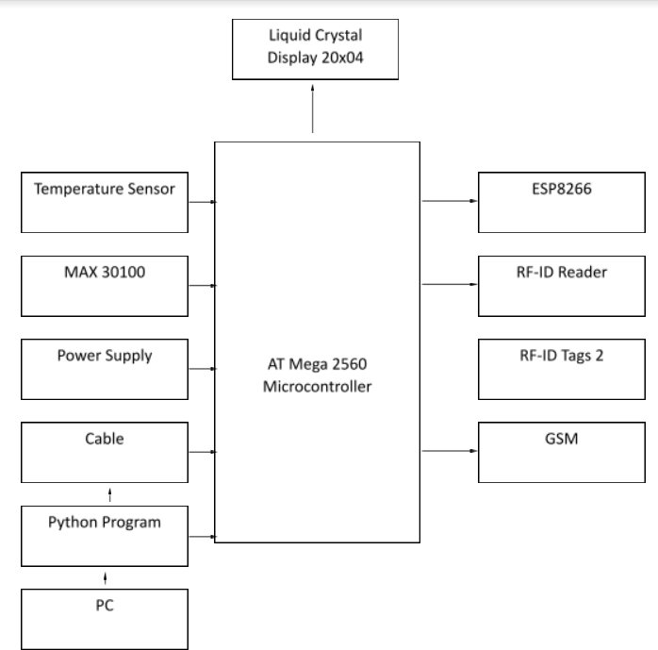and inappropriate medicines that have severe health consequences, including life conditions. Delays or inaccuracies in immediate medical interventions result in 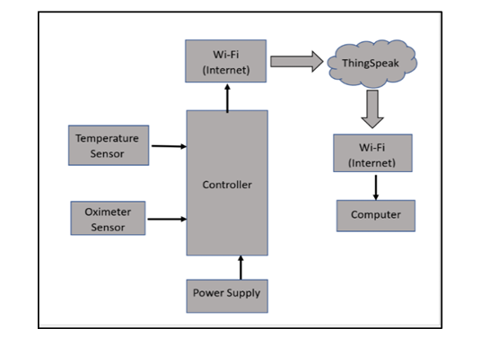aggravation of health problems and delay treatment.

IoT technologies face various issues in healthcare systems relating to interoperability and system integration challenges. Most of the existing systems are not easily integrated; hence, their overall effectiveness and efficiency may be compromised when being tied to a general system of operation [17]. These challenges create a need for more streamlined approaches with minimal need for human intervention and one that offers real-time communication and support for the patients.

In all, each of these systems presents its limitation for reasons one would want an improved system that is more efficient, accessible, integrated at less cost to meet those needs, and take better care of the patient.

# Proposed System

This prototype is destined to bridge specific critical gaps in healthcare access and diagnosis among people from rural or underserved areas. The general lack of immediate, convenient medical support is a major challenge for these regions, which can often be compelling enough for one to delay seeking professional help until they are able to reach a healthcare provider. The prototype is only temporary relief and support but works as a useful tool for users to confront the doctor after an appraisal of the status of their health.  
  
The main advantage of the system will be its public availability in the likes of pharmacies, shopping malls, bus and train stations, and along highways. It is with such positioning of the prototype that health checks become easily accessible to most people without necessarily going to a medical facility. This way, accessibility to health monitoring services, especially for those that would otherwise have little access to healthcare resources, is greatly improved.  
  
The most important feature of the prototype is attaching an RFID reader to it wherein retrieval of all information regarding the patients could be done efficiently. The RFID capability ensures that accurate recordings of the patients' information will be obtained and linked with their health assessments for personal health monitoring. The collected data would fall directly into the IoT cloud system, which would allow secure storage and management of patient records. This cloud-based storage enables recommendation support not only for current medication but also extends to future forecasting and analysis based on real-time health data.  
  
It uses analytics on the cloud to provide personalized medicine recommendations depending on the individual health condition. With this data-driven approach, most of the risks of self-medication are minimal since one gets to make informed suggestions rather than relying on unreliable online sources. The system is hence affordable and practical since one will not suffer from the pitfalls of self-care and will not have to consult directly with healthcare providers for every minor complaint in life.

# Methodology

Algorithm:

1. User Identification: 1.1. RFID tag scanning. 1.2. Connect to the cloud and fetch user information using the details on the RFID. 1.3. Authentication of the user with the data available on the cloud; if authenticated, proceed forward or prompt again for authentication.
2. Initial Request: 2.1. Ask for Questionnaire: Send the message to the user via the GSM module to fill out the health questionnaire.
3. User Interaction: 3.1. Questionnaire Display: Present the questionnaire in front of the user through the system interface display. 3.2. Response Collection: The system will gather the responses of the user related to symptoms and health conditions.
4. Health Measurement: 4.1. Physical Parameter Measurement: Measure body temperature using a temperature sensor. Heart rate and blood oxygen are measured by pulse oximetry using the MAX30100 sensor. 4.2. Data Acquisition: The measurement data with respect to temperature, heart rate, and blood oxygen level are recorded.
5. Data Analysis: 5.1. Input to System: Input of user's answers and sensor data into the system. 5.2. Evaluate Condition: Analyze the data using Python GUI software along with the Twilio API. Assume factors such as age, weight, and symptoms-cold, difficulty in breathing. 5.3. Generate Prescription: According to the evaluation, the prescription or recommendations should be generated.
6. 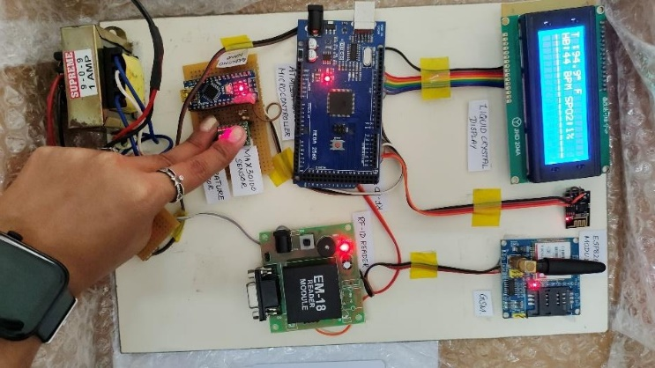Notification: 6.1. Prescription Sent: Send the prescription along with a notification to the user's cell phone as an SMS by availing the Twilio API services. 6.2. User Notification: Notify the user about using the prescription at any medical store.
7. Data Storage: 7.1. Data Storage: Store the data of the user's health on the cloud with ThingSpeak.

Graph and plot users' temperature, heart rate, and blood oxygen level on ThingSpeak. 7.2. Securing Storage: Store data securely and make it accessible.

1. User Control: 8.1. View Information: Enable the user to view her health-related information at any time in ThingSpeak using a cell phone number.
2. End of Process: 9.1. End Interaction: Terminate the session and await any further interaction or whatever updates when necessary.

# FLOW CHART

Initialize GSM Module

Transmit messages

GSM

Python User Interface

Get user info

Transmit SMS

RF-ID reader

Prescribed medicines

Microcontroller

Get patient details

Compare answers and values

Display on LCD

Get sensor values

# RESULTS

The proposed system will avail real-time health data on an LCD display, use a GSM module to send prescriptions directly to the users' mobile phones via SMS, and provide secure storage of patient data on the cloud for future reference. This will not require patients to wait for an appointment with a doctor but will have them easily monitor their health state and receive timely medical consultations.

Fig 7.1 Hardware Unit of the System

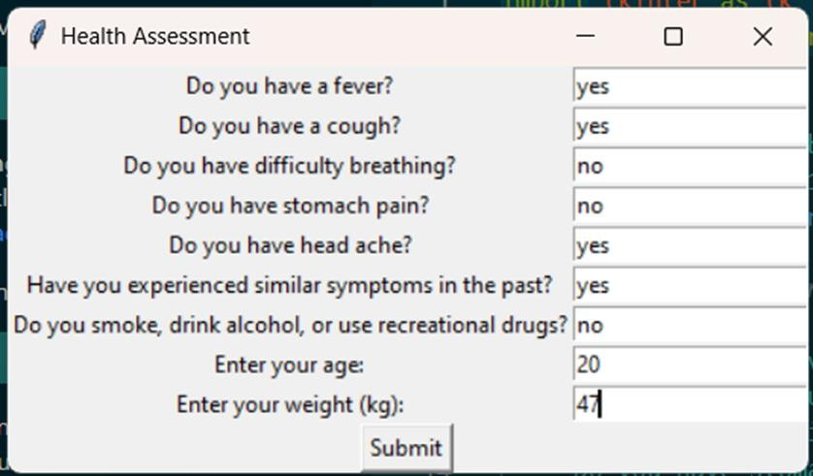

Fig 7.2 Questions asked in the Tkinter Software

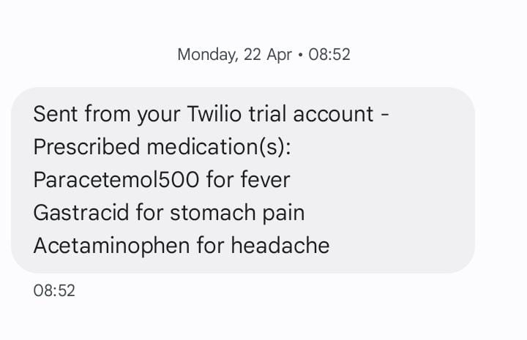

Fig 7.3 Message sent for Stomach Pain Prescription

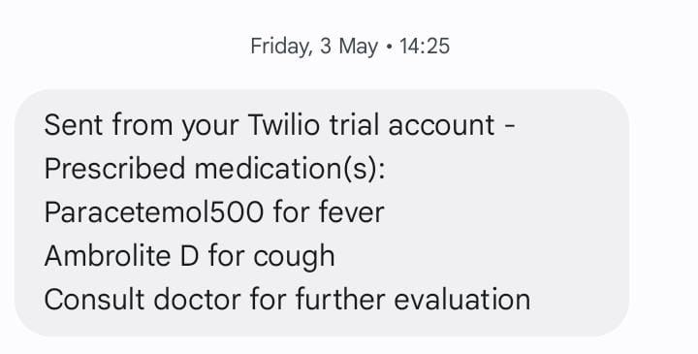

Fig 7.4 Message sent for Fever and Cough Prescription



Fig 7.5 Message sent for Fever and Cough Prescription

SMS alerts are routed through the system by using a Twilio account. The analysis of the user's symptoms and physical data, upon sending out prescriptions or health updates via the Twilio API, goes directly to the user's mobile device. This will make the communication timely, hence more reliable, for the purpose of the proposed health monitoring system.

# CONCLUSION

In this paper, the challenges mentioned have been addressed by designing and demonstrating the system to address all those challenges, with an Arduino-driven user interface for correct medication. The system is autonomous in diagnosis of the vital signs and evaluates the health status of the patient; it prescribed medication while maintaining a record for future reference. The project aims at offering an affordable and accessible healthcare solution, particularly to underserved areas, which has been achieved in this paper. The system ensures the right kind of medication is provided, as it also enables healthcare professionals to give improved care since they have more accurate and timely information.

# References

[1] V.A. Dang, et al., "Intelligent healthcare: integration of emerging technologies and internet of things for humanity," Sensors, vol. 23, no. 9, pp. 4200, 2023.

[2] M. Mansour, et al., "Internet of things: a comprehensive overview on protocols, architectures, technologies, simulation tools, and future directions," Energies, vol. 16, no. 8, pp. 3465, 2023.

[3] B. Tekinerdogan, Ö. Köksal, T. Çelik, "System architecture design of IoT-based smart cities," Appl. Sci., vol. 13, no. 7, pp. 4173, 2023.

[4] H.H. Alshammari, "The internet of things healthcare monitoring system based on MQTT protocol," Alex. Eng. J., vol. 69, pp. 275-287, 2023.

[5] B.G. Mohammed, D.S. Hasan, "Smart healthcare monitoring system using IoT," iJIM, vol. 17, no. 01, pp. 141, 2023.

[6] S. Tiwari, K. Nahak, A. Mishra, "Revolutionizing healthcare: the power of IoT in health monitoring," J. Data Acquis. Process., vol. 38, no. 2, pp. 2416, 2023.

[7] S. Krishnamoorthy, A. Dua, S. Gupta, "Role of emerging technologies in future IoT-driven Healthcare 4.0 technologies: a survey, current challenges and future directions," J. Ambient Intell. Humaniz. Comput., vol. 14, no. 1, pp. 361-407, 2023.

[8] A. Chakraborty, et al., "Smart healthcare systems: technologies, challenges, and solutions," Comput. Electr. Eng., vol. 101, pp. 108009, 2022.

[9] Y. Zhang, et al., "Blockchain-based secure and efficient IoT healthcare system: a survey," IEEE Access, vol. 11, pp. 25450-25463, 2023.

[10] S. Ahmed, et al., "AI-based solutions for smart healthcare systems: a comprehensive review," Future Gener. Comput. Syst., vol. 140, pp. 471-493, 2023.

[11] J. Yao, et al., "IoT-based real-time healthcare monitoring system with wearable devices," Sensors, vol. 23, no. 5, pp. 2370, 2023.

[12] C.S. Yeo, et al., "Edge computing for IoT-based healthcare systems: a survey," IEEE Internet Things J., vol. 10, no. 7, pp. 6094-6105, 2023.

[13] M.G.M. Hasan, et al., "A survey on IoT-based health monitoring systems: challenges and future directions," IEEE Access, vol. 11, pp. 19827-19846, 2023.

[14] J. Kim, et al., "Advanced IoT technologies for smart healthcare applications," J. Biomed. Inform., vol. 130, pp. 104233, 2023.

[15] L. Liu, et al., "Smart healthcare system design using IoT: opportunities and challenges," Comput. Sci. Rev., vol. 48, pp. 100462, 2023.

[16] A. Bhattacharya, et al., "Review of IoT-based smart healthcare solutions and their future perspectives," Health Inf. Sci. Syst., vol. 11, no. 1, pp. 12, 2023.

[17] E. Farag, et al., "IoT-enabled smart healthcare systems: a survey on applications, architecture, and challenges," Comput. Sci. Rev., vol. 51, pp. 100495, 2023.