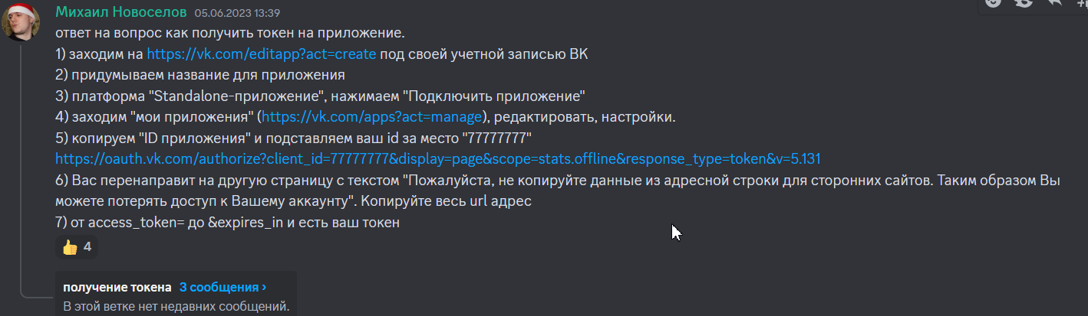
vk1.a.sWqx81s8-CqovWTyOYkiC2KOSXPjIw3vJVXzdxlvaSpQX_anHIZL8hH7ndb71ow7a3aHBHumWgnG4io9DrwOdDZvyC5BzFg5w0VKOrDpuTVTj8-auiiZtAApLoLi9BEVoEUHg9f5yPLtOPEt-DjyE-RO2Rgvi7e_cuptJKasQv4hXnEGiLYdaYwZk-CzSJ4so0S6Bu-dveA_sTjJmN7Big

vk1.a.JyoOuCpejFeLvybOL5DSL6NWa8ltmsXDgRuapT_UmL6WKdD0df1S5bGkrxjXnyw5-Strngy_RfYsY2pJjDCQX5d9nuveu4vMLLa2WODLiR5QxaN2AEVH-_Fe7MDbdOf4leEcktmNkYi0DEmF5G1X_7b3XewK-TwiTj2drHVKFHvzqMX2Q-_O3VVZwIgHNZ87ET4EXXmsnZ-v5OrkuM5SLw

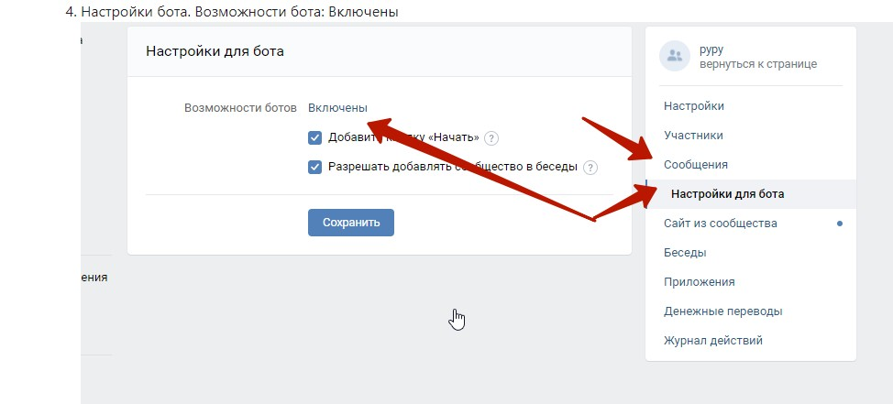

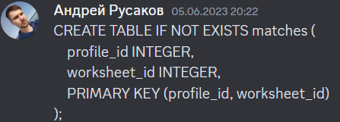

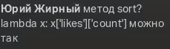

likes.getList
