**Web Development Project Report**

**Phase 1**

**Spring 2024**

**Name:** Sham Amer Alkhais

**QUID:** 202003696

**Name:** Samia Hasan

**QUID:** 202105152

**GitHub link:** https://github.com/ShamA-source/WD-lec.git

**Dr.** Mucahid Kutlu

**1) All the HTML, CSS, JavaScript, and other files that you used to create your e-commerce platform. Compress all documents and upload a single zip file. Note that these documents should also be pushed to Github.**

**2) A video file in which you will show your e-commerce platform. That is, record your screen and do a demo of your e-commerce platform. The recording should not be more than 2 minutes.**

-video recording is attached with the zip-file

**3)Application design documentation should include the Entities, Repositories, and Web API class diagrams. If you have not used Web API, explain how you did it without Web API providing class diagrams, etc.**

I did not use API for the product images, I used an items. JSON file that contained the information for each item such as (id- image- title-price-and category), and I linked the images using the path of the saved images in a media folder.

Note: I took the images from a real makeup website called KIKO.

**4)Document the app testing using screenshots illustrating the results of testing. For each use case, provide screenshots of your web page and explain each of them.**

**Case1:**

* **Show that when a user cannot log in if the password and username does not match**

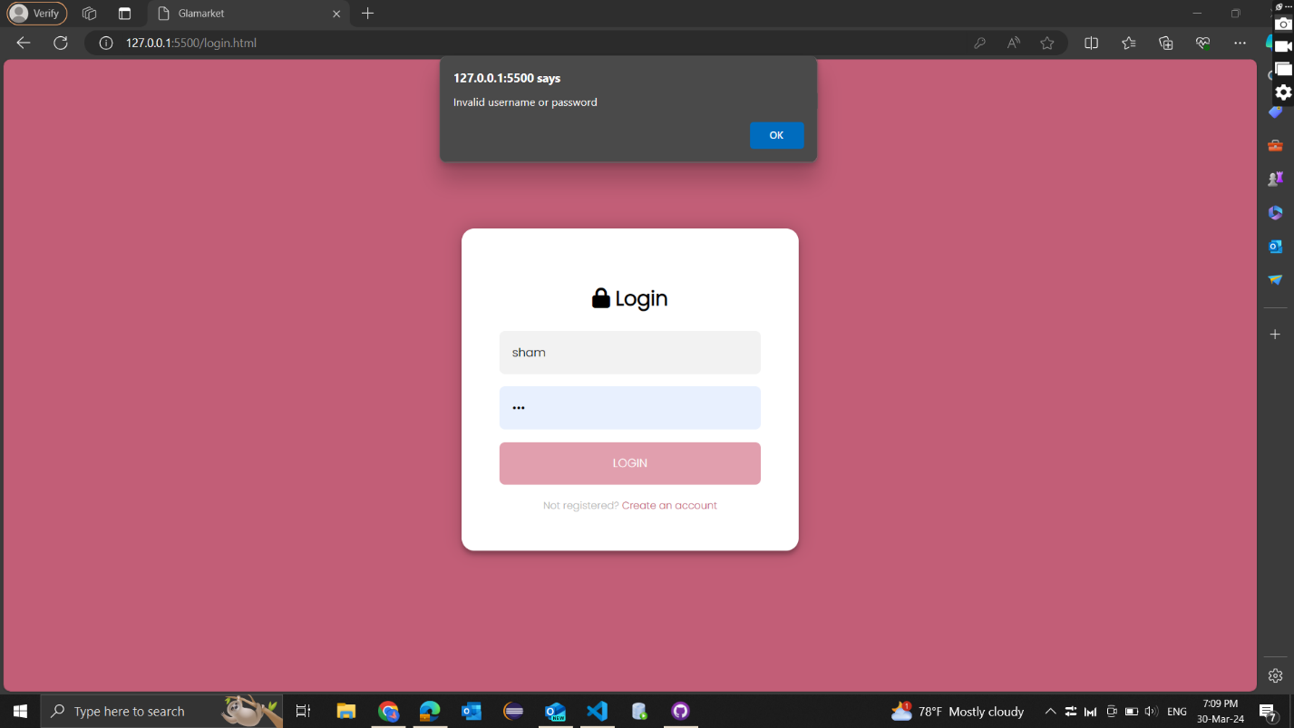

* **Show that a user as a customer successfully logs in**

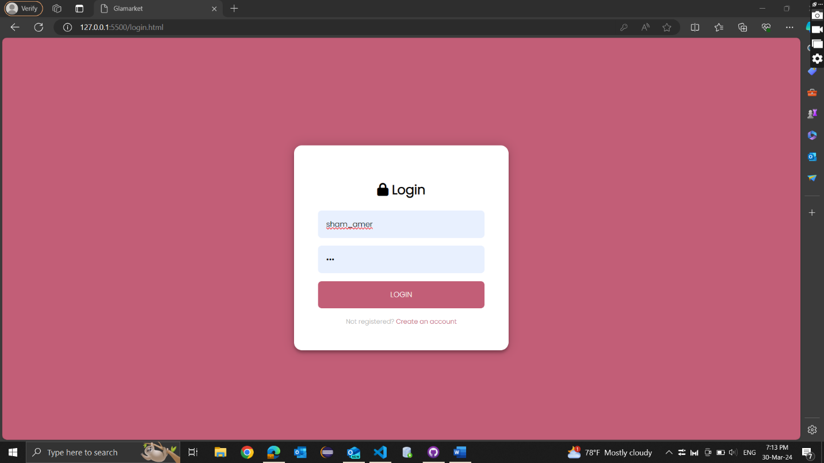

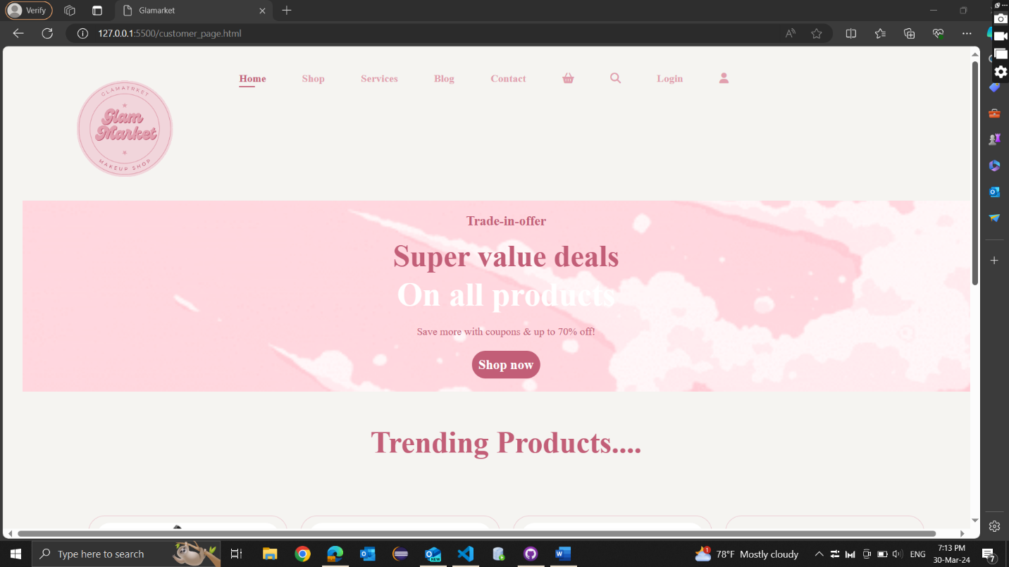

* **Show that a user as a seller successfully logs in**

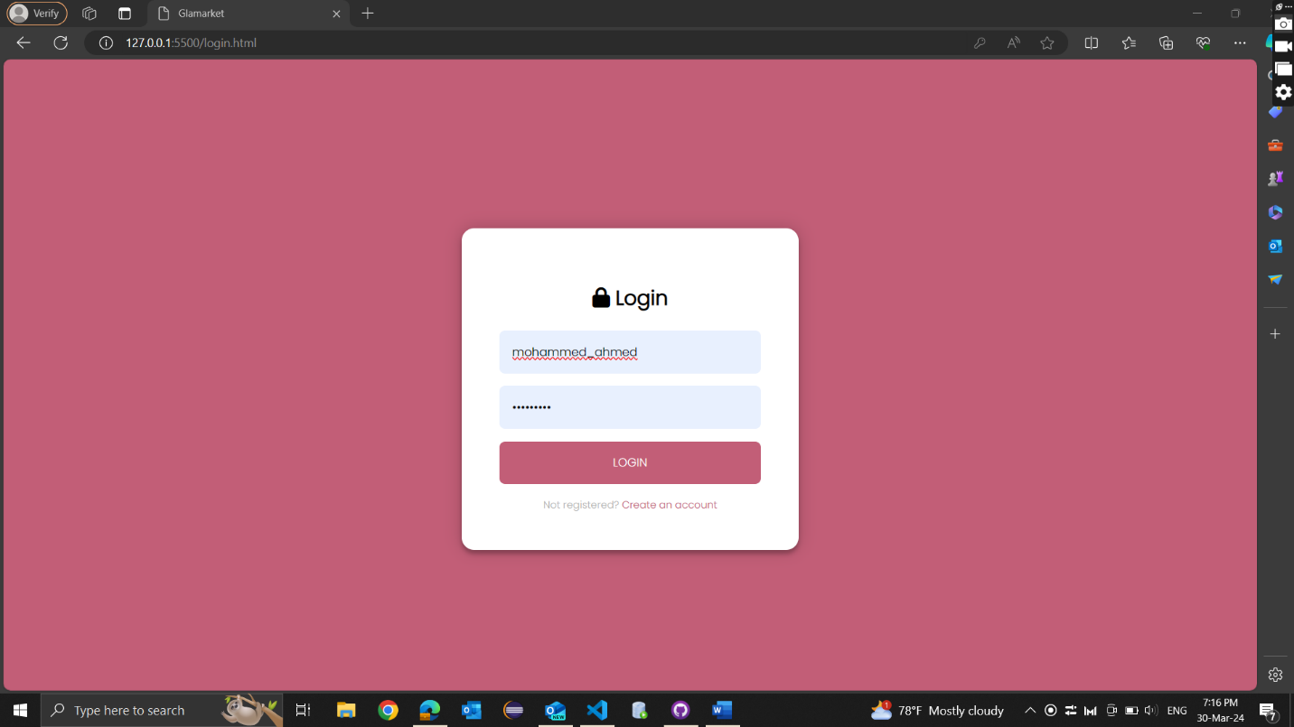

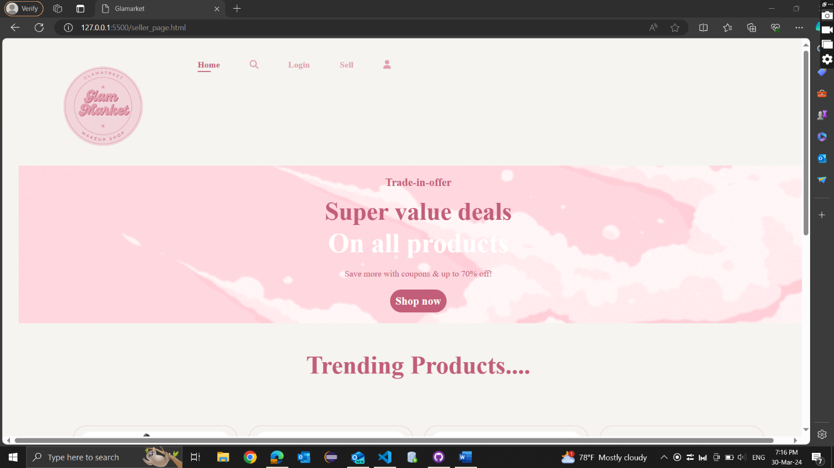

**Case2:**

* **Do a search in which there is no available item**

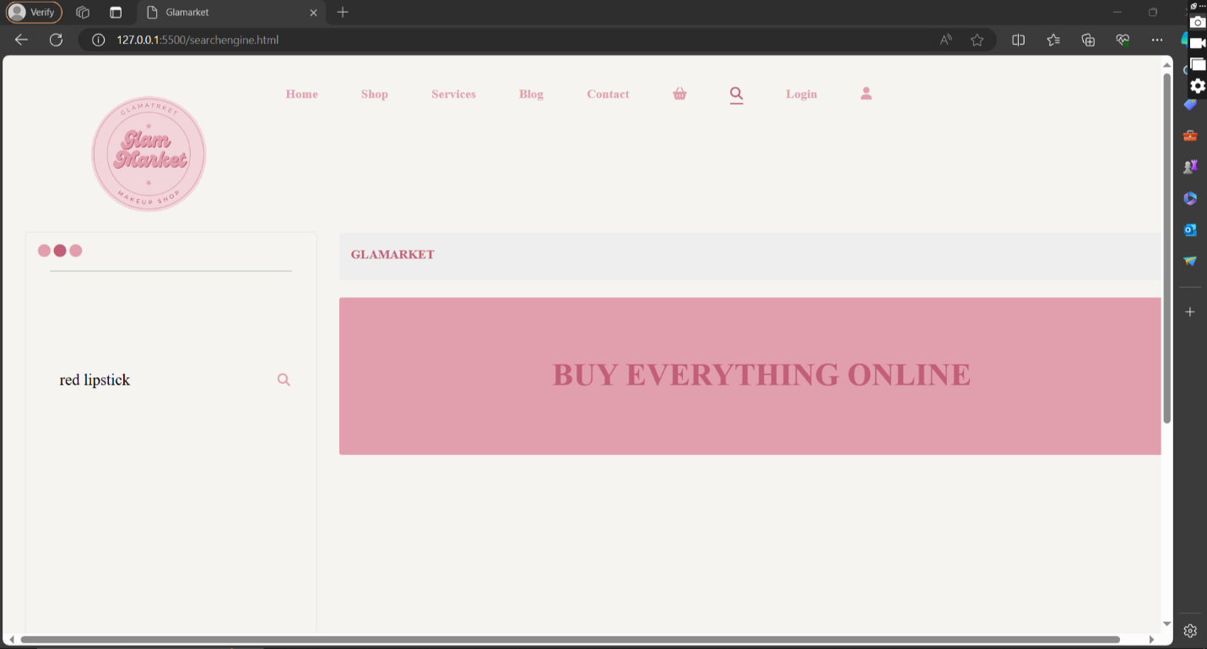

* **Do a search in which there are some available items**

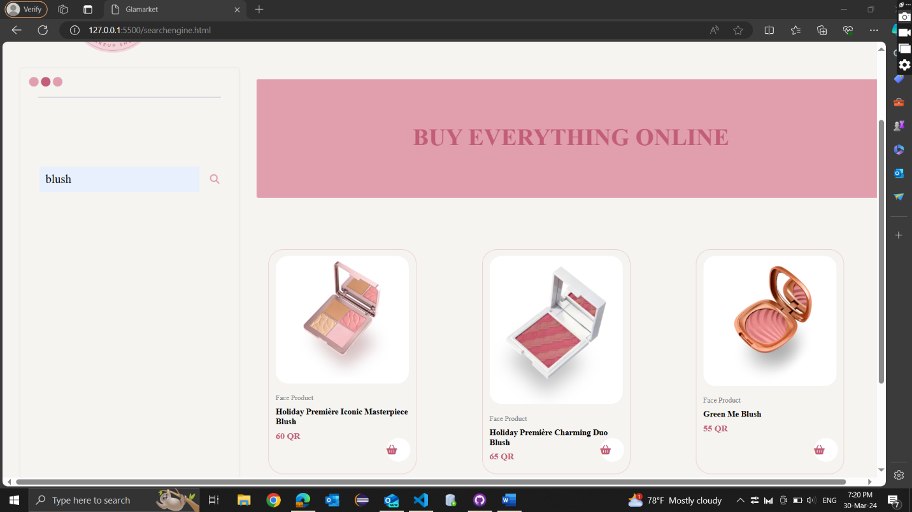

* **Do another search in which there are some available items**

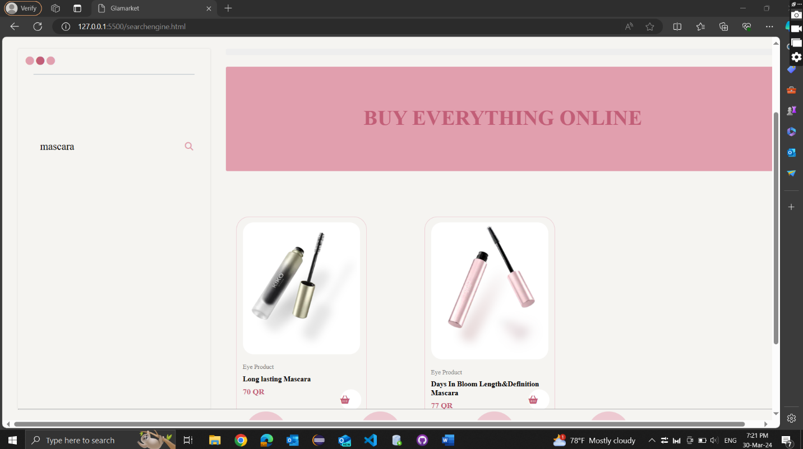

**Case3 & 4:**

* **Try to purchase an item when you are not logged in (it should fail)**

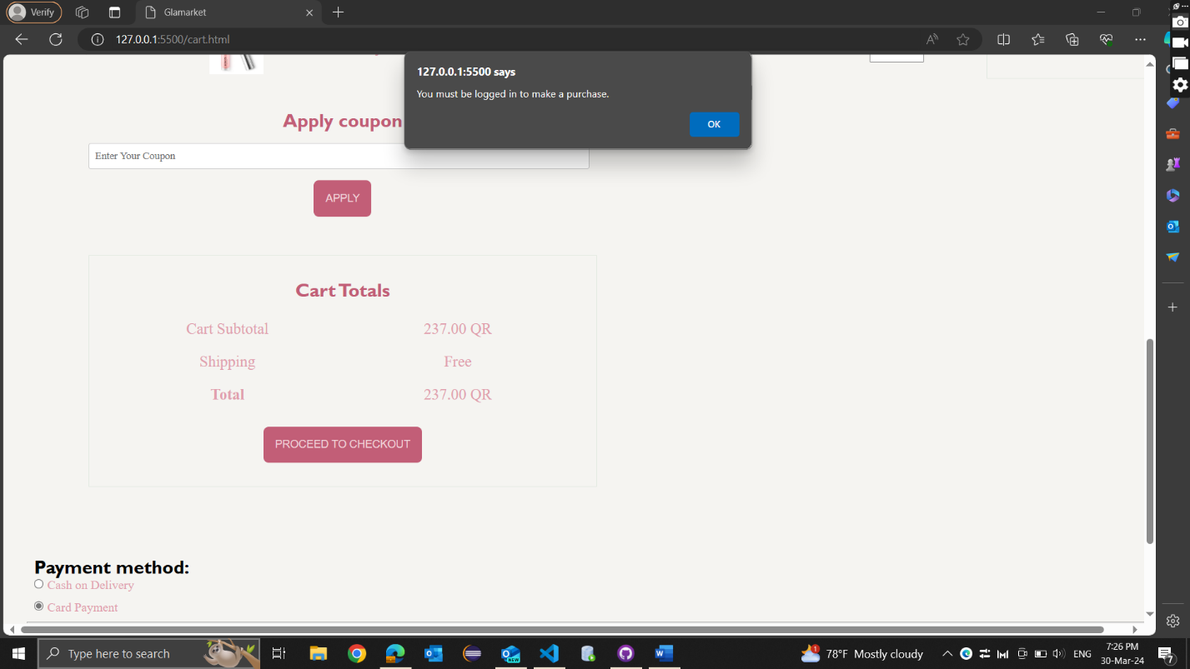

* **Try to purchase an expensive item that the user does not have enough money (it should fail)**

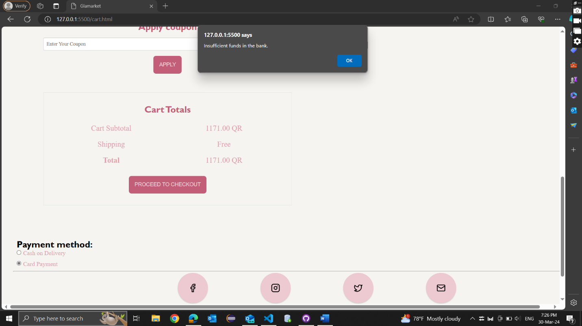

* **Purchase an item successfully**

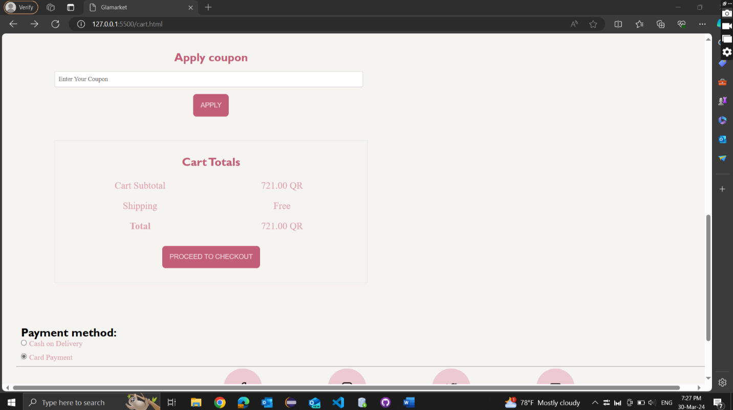

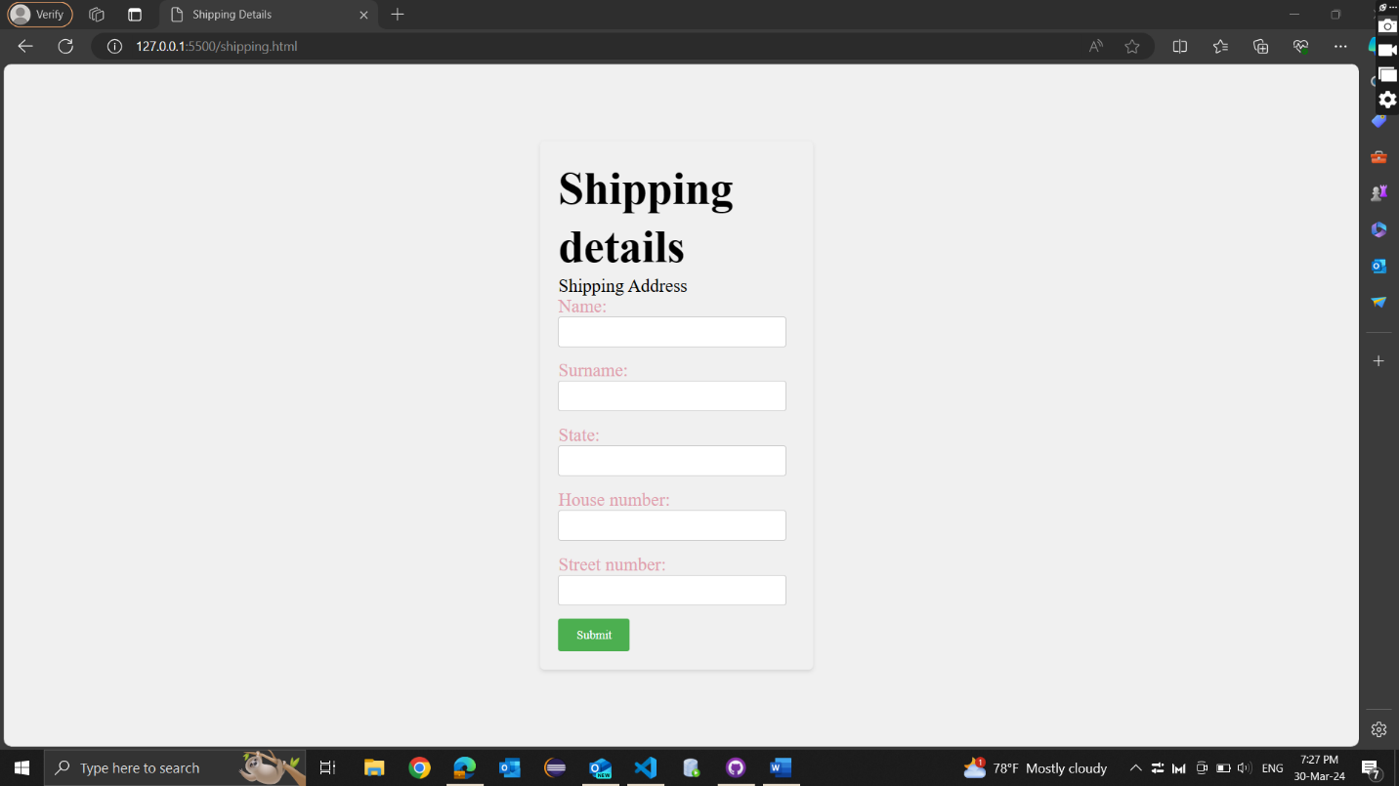

* **Go to the purchase history and show that item has been bought**

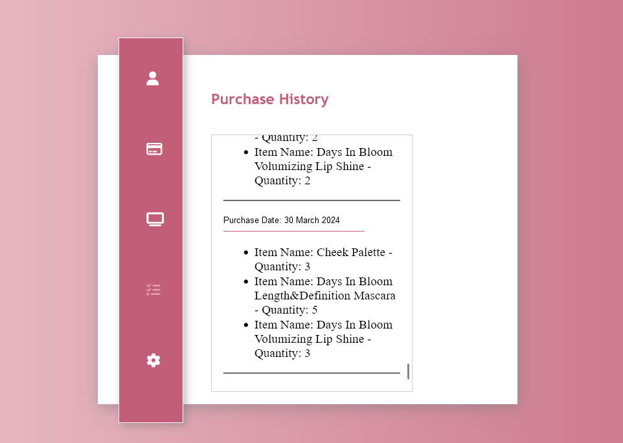

**5)The self-evaluation report. This document must contain details about the contribution of every team member. There is one important thing you have to be careful. Each member will prepare a separate file and explain the contribution of each member from their perspective. Its name should be “Contribution_<NAME>.pdf” where <NAME> is the name of the student who wrote it. Since each student will make a separate submission, this file should be different for each student. You should not copy-paste from others. Note that claiming that “we did everything together” is not a valid response to this requirement.**