AnonymizeDicom — Software Description
AnonymizeDicom is a small command-line program that removes identifying information from DICOM files. You point it at a folder of DICOM images and it writes anonymized copies into another folder, keeping only a short list of non-identifying fields and deleting everything else. It is written in C# on .NET 10 and uses the open-source fo-dicom library to read and write the files.

How it works
The program does its work in a single pass, in this order:
- Scan - the input folder is walked recursively. Anything that is not a real DICOM file (zip archives, text files and so on) is skipped, and the subfolder layout is kept in the output.
- Anonymize - each file is opened with fo-dicom and trimmed down to the whitelisted tags. Every other tag is deleted; this is where patient names, IDs, institution names and similar identifying fields disappear.
- Shift the dates - a random number of days is picked per image and subtracted from both PatientBirthDate (0010,0030) and StudyDate (0008,0020). The same offset is used for both, so the gap between the two dates stays the same even though the dates themselves are no longer real.
- Validate - every output file is opened again and checked against its original: only whitelisted tags are present, the kept values are unchanged, the two dates moved by the same amount, and the pixel data is byte-for-byte identical.
- Report - the program prints either "Validation : SUCCESS" or "Validation : FAILED". Per-file timings and any failures go into anonymizeDicom.log, next to the program.

The anonymization pipeline

What is kept and what is removed
Only the fields listed in tables A.1-A.5 of the specification survive. That means PatientSex, StudyInstanceUID, Modality, Manufacturer, ManufacturerModelName, SoftwareVersions, ImagerPixelSpacing, Rows, Columns, PixelSpacing, BitsAllocated, PixelRepresentation, the smallest and largest pixel values, PixelData, SOPClassUID and SOPInstanceUID - plus the two date fields above, which are shifted. SpecificCharacterSet (0008,0005) is kept as well so that non-ASCII text round-trips correctly.
The full list:
Field | Tag | Handling
PatientBirthDate | 0010,0030 | Shifted (random offset)
PatientSex | 0010,0040 | Kept
StudyDate | 0008,0020 | Shifted (same offset)
StudyInstanceUID | 0020,000d | Kept
Modality | 0008,0060 | Kept
Manufacturer | 0008,0070 | Kept
ManufacturerModelName | 0008,1090 | Kept
SoftwareVersions | 0018,1020 | Kept
ImagerPixelSpacing | 0018,1164 | Kept
Rows | 0028,0010 | Kept
Columns | 0028,0011 | Kept
PixelSpacing | 0028,0030 | Kept
BitsAllocated | 0028,0100 | Kept
PixelRepresentation | 0028,0103 | Kept
SmallestImagePixelValue | 0028,0106 | Kept
LargestImagePixelValue | 0028,0107 | Kept
PixelData | 7FE0,0010 | Kept
SOPClassUID | 0008,0016 | Kept
SOPInstanceUID | 0008,0018 | Kept
Everything else - including PatientName and PatientID - is removed entirely.

How it is put together
The code is organised in a few small pieces, shown below. A thin command-line parser reads the two arguments. The AnonymizationService then walks the files and processes a few of them at a time. Each tag is handled by one of a small set of strategies - keep, shift the dates, or remove - chosen from a lookup table. After processing, a separate ValidationService re-opens every file and runs five checks before the result is reported.
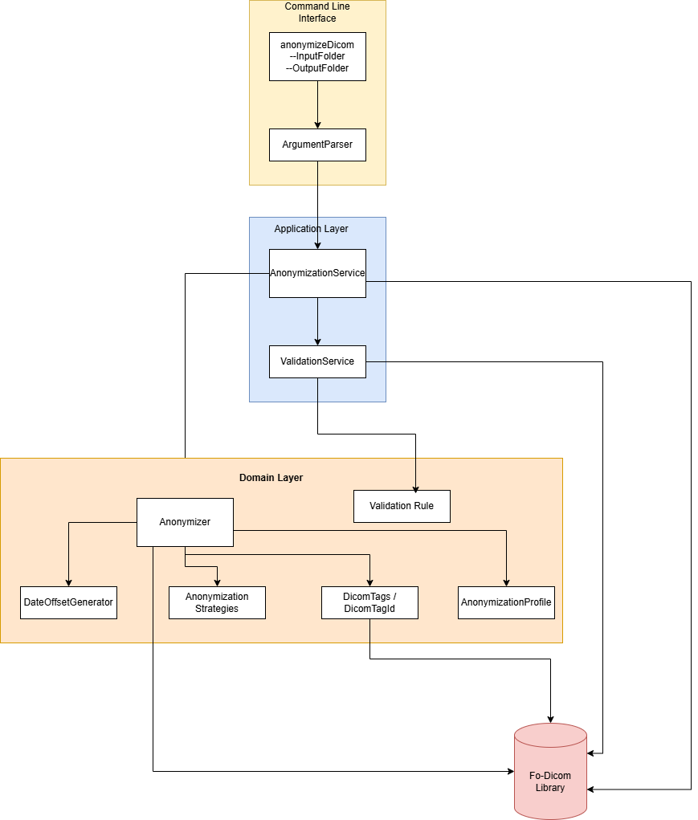
The main components and how they relate to the fo-dicom library
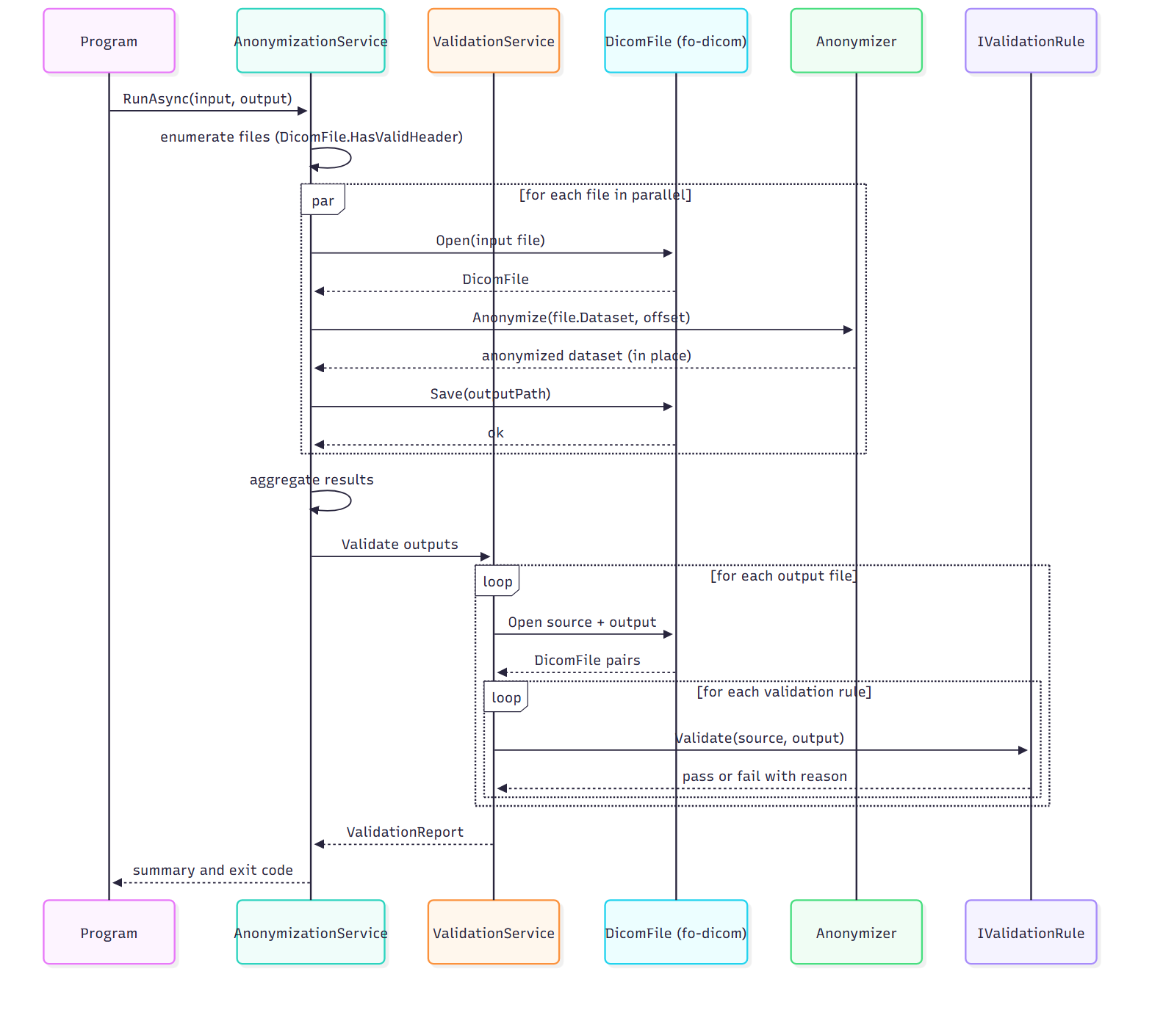
How the pieces interact when a file is processed
The project is a standard .NET solution with a src project (the tool) and a tests project with xUnit tests covering the anonymizer, the strategies, the parser and the validation rules.

Installing and running
To run the tool you need the .NET 10 Runtime on the machine. Copy the whole folder - the exe together with its DLLs and config files - to a permanent location, then run install.bat once. It adds that folder to the PATH. Open a new Command Prompt and run:
anonymizeDicom --InputFolder C:\DICOM\original --OutputFolder C:\DICOM\anonymized
You can check it is installed with anonymizeDicom --help. A typical successful run prints the totals and then Validation : SUCCESS. The exit code is 0 on success and 1 if anything failed. To remove it, delete the folder and its PATH entry.
Example of a successful run:
Anonymizing DICOM files from 'C:\DICOM\original' to 'C:\DICOM\anonymized'...
Total files : 10
Anonymized : 10
Failed : 0
Skipped : 1 (non-DICOM)
Validation : SUCCESS
To prepare the package you hand to a customer, publish the Release build (dotnet publish -c Release) and send them the whole publish folder - src/AnonymizeDicom/bin/Release/net10.0/publish. It already contains anonymizeDicom.exe, the DLLs and config file it needs, and install.bat, so there is nothing else to copy.

Building from source (developers)
Developers need the .NET 10 SDK. Build and test with:
dotnet build AnonymizeDicom.slnx
dotnet test

