Assignment Day2

1. Display the details from Customer table who is from country NY

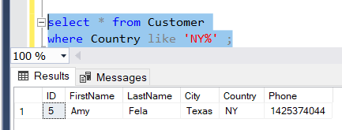

1. Display the fullname of the customer.

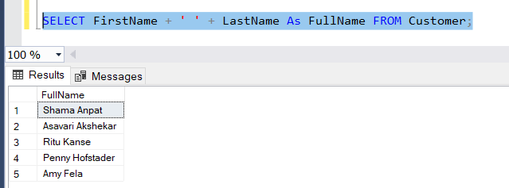

1. Display the customer details who has Fax number.
2. Display the customer details whoes name holds second letter as M.

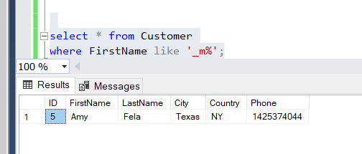

1. Select order Details where unit price is greater than 10 and less than 20.

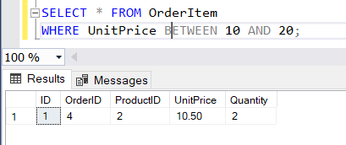

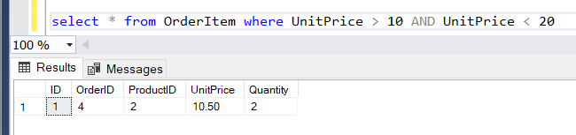

1. Display order details which contains shipping date and arrange the order by date.

Before:

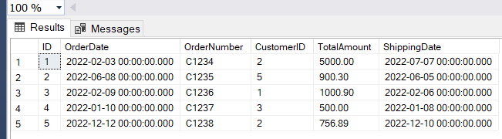

After:

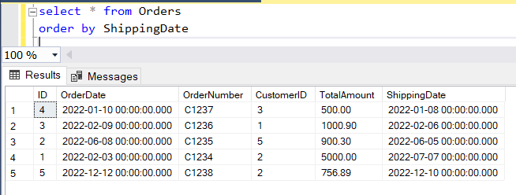

Print the orders shipped by ship name 'La corne d'abondance' between 2 dates(Choose dates of your choice)

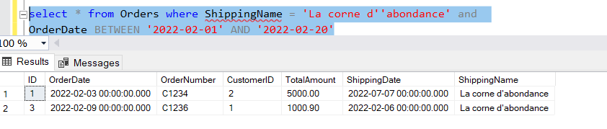

1. Print the products supplied by 'Exotic Liquids'.

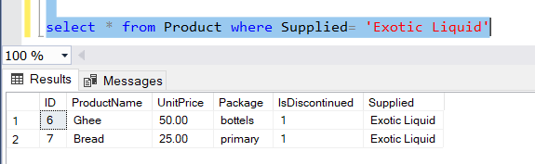

1. Print the average quantity ordered for every product

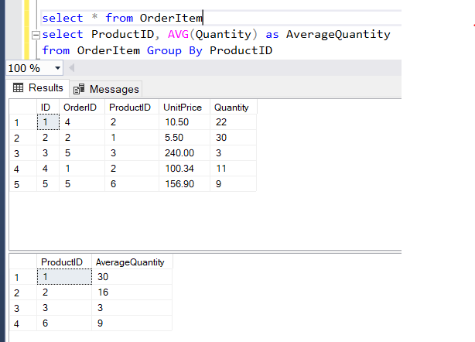

1. Print all the Shipping company name and the ship names if they are operational
2. Print all Employees with Manager Name.

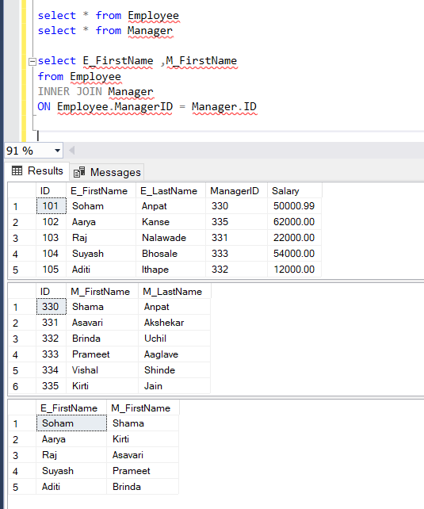

1. Print the bill for a given order id .bill should contain Productname, Categoryname,price after discount

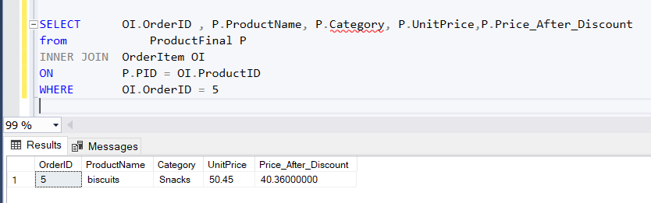

1. Print the Total price of orders which have the products supplied by 'Solid' if the price is > 50 and also print it by Shipping company's Name.

