1.write a query to display the orders placed by customer with phone number 8796045392

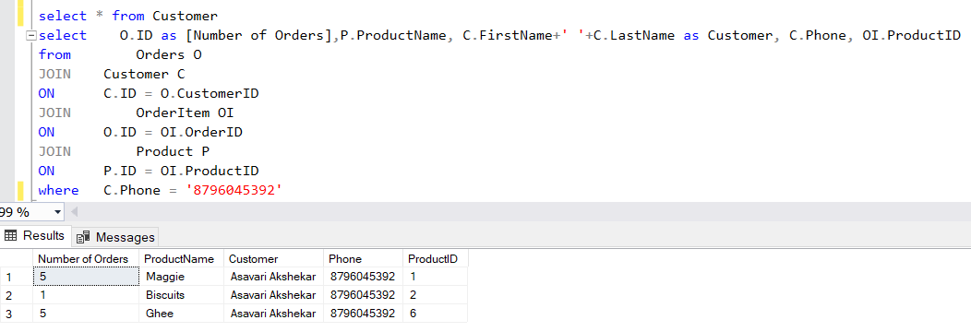

2. fetching all the products which are available under Category ‘Dairy.

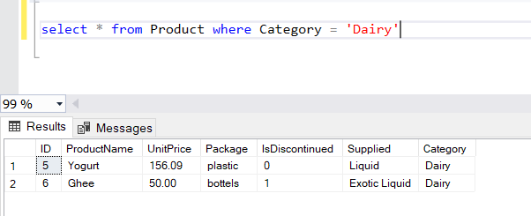

3.Display the orders placed by customers not in NY.

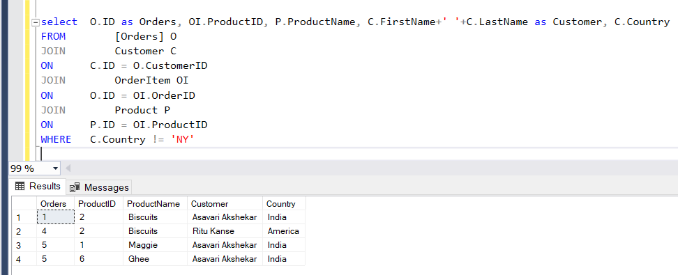

4. selects all the order which are placed for the product Biscuits.

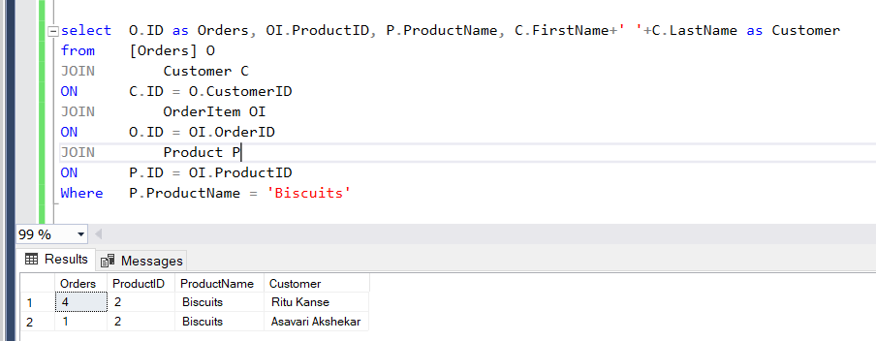.

5.Write a query to display the name , department name and rating of any given employee.

