Automatic Generation control of Autonomous Hybrid power system using Single and Multi objective Salp swarm Algorithm
V.S.R.Pavan Kumar.Neeli1, Dr.U.Salma²

1 Research Scholar, 2Associate Professor
Dept of EEE, GITAM (Deemed to be University), Visakhapatnam,A.P, INDIA pavanscholar123@gmail.com
Abstract. The main objective of the paper is to deign a load frequency controller for Autonomous Hybrid power system using Single and Multi objective soft computing technique. A novel controller such as Two degree of freedom PID (2DOFPID) controller is established as a secondary controller for minimization of frequency of oscillations. Recently proposed Salp swarm algorithm (SSA) technique is used to obtain the parameters of the controller. In order to obtain the effectiveness of proposed technique, the performances are compared with other techniques such as Grasshopper optimization algorithm (GOA), Ant Lion optimizer (ALO) and Particle swarm optimization (PSO). The simulation studies are carried out under five different sets of load disturbances which reveal the efficacy and superiority of Salp swarm algorithm based controller compared with other controllers.
Keywords: Salp swarm algorithm (SSA), Grasshopper optimization algorithm (GOA), Ant Lion optimizer (ALO), Particle swarm optimization (PSO), and Two degree of freedom PID (2DOFPID) controller.
1 Introduction
In a growing world the utilisation of electricity is increasing rapidly. Electricity generation using conventional sources such as coal combustion in thermal power stations, Hydro power stations are not aable to meet the demannd of the consumer’s utilisation. The raw materials used for genearation are also decreasing gradually. In this scenario most of the generation units are accomplished the promising challenge of inegration of generating unit with Non conventional based generating units. Wind energy and Solar energy soures which non harmful to the environment are picked as a renewable sources for the production of eletricity. Though these two energy sources cannot able meet the entire demand but can be used for reducing the total electricity production from cnventional generating units. The main aim of the Automatic generation control (AGC) is to establish a balance between generation and demand maintaining the frequency of the whole system within acceptable range [4].
An autonomous Hybrid power system presented by Lee and wang [6] is a combination of Thermal generating unit which is integrated with Distributed generation (DG) resources. These DG resources consists of both conventional and Non conventional energy based units such as Wind turbine generator, Solar PV system, Fuel cell with aqua electrolyser, Diesel engine generator and enegy storage unit such as Battery storage system[2]. Two different design objectives, the frequency deviations and Area control error (ACE) are considered for controller design which forms as a multi objective are combined and resulting to form as a single objective function.
The main contribution of the work are summarised below:
- To develop the model of Autonomous hybrid power system.
- To obtain the parameters of proposed controller using different optimization techniques.
- Comparitive analysis is to be carried out under different loading conditions.
2 Modelling of the Power system
For simulation of the large scale systems, simplified models such as transfer function models are to be developed. Hence all generating units are developed as first order tranfer funtion models. Therefore the total power obtained is the combination of power from thermal unit and power from the DG resources [3]. The output power of Distributed Generation system is given
(1)
For small signal stability analysis, the generating units like Wind generator, Solar PV, Fuel cell with electrolyzer and Diesel generator can be modelled by the single order transfer functions with system gains and time constants. The simplified and linearized model of various generation systems is represented as

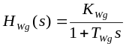 (2) 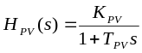 (3) 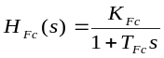 (4) 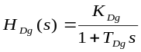 (5)
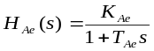 (6) 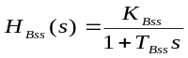 (7)

The general block diagram of Autonomous hybrid power system [1] is shown below
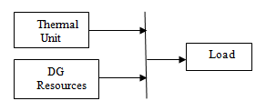
Fig1: Block Diagram of Power system
2.1 Two degree of freedom PID (2DOFPID) controller
2DOFPID is a controller whose serial compensator is a PID element and feedback compensator is a PD element.Degree of freedom of a control system is the number of closed-loop transfer functions which can be adjusted independently. 2DOFPID controller is a two input and single output system [5].
R(s), Y(s) and U(s) represent reference signal, feedback from the measured system output, and output signal respectively. Proportional, integral and derivative gains are represented respectively by Kp, Ki and Kd. PSW and DSW are the set point weights of proportional and derivative respectively. It evaluates a weighted difference signal depending on the propotional and derivative set point weighting for each of the three actions, that is, proportional, integral and derivative. Its generated output signal is determined by the difference in the reference and measured system output. General layout of 2DOFPID controller is shown as
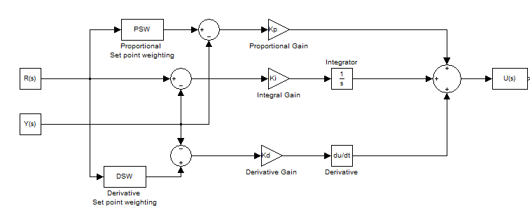
Fig2: Structure of 2DOFPID controller

The applied variations in components like generated powers (P_{W}; P_{sol}) are shown as

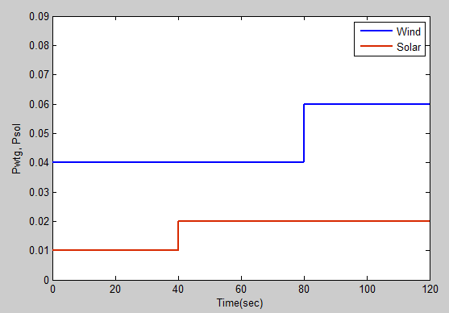
Fig.3. Realization of the renewable power generatn
3 Problem Formulation
Design of a controller depends upon well-defined objectives meeting the system requirements.
3.1 Single objective function
Each and every objective functions are having their own merits and demerits. Therefore in the present study is carried out with Integral of Square error {ISE} is chosen as a desired objective function for the tuning and obtaining gains of 2DOFPID controller.
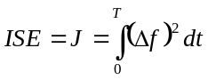 (8)
3.2 Multi objective function
The Multi-Objective (MO) function considered as combination of Integral of sum of squares with Incremental of Change in frequency deviations (∆f) and Area Control error (ACE). The final Objective function is given below.

Min J = Min (J1 + J2) (8)

Where J1 is given by
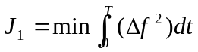 (9)
And J2 is given by
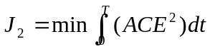 (10)

Where ‘J’ is minimized subjected to

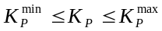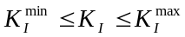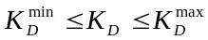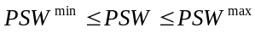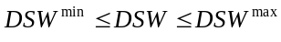
4 Soft Computing Technique
SalpSwarm Algorithm (SSA) is a recent Swarm intelligence algorithm [7] developed in 2017 by Mirjalili. SSA is a population based method which explains the mimicking behaviour of Salp Swarms and their social interaction. The group of Salps called salp chains mathematically divide in to two groups: head salp is a leader and other arefollowers. Till now, the behaviour of salp swarm is not well conveyed, hence the researcher scholars consider the behavior of it to intensify their movement in seeking for food.
Steps followed in SSA:
- Parameter initialization: The algorithm starts by initializing the parameters such as size in population N, no.of iterations t, and maximum iterations max_{iter}.
- Initial Population: We generate initial population x_{i}, i= {1…..n} randomly in the range of [u,l] where u,l are upper and lower boundaries respectively.
- Individuals Evaluations: Each individual (solution) in the population are evaluated by calculating its objective function value and the overall the best solution is assigned for F.
- Exploration and exploitation: In order to balance between the Explorations and exploitations of the algorithm, we update the value of parameter c₁ given in the equation
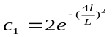 (11)
Where l is the present iteration and L is the maximum no.of. Iterations.
- Position updation of solutions: The position of the leader solution and the other follower solutions are updated as given by
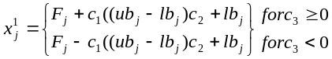 (12)
Where x_{j}¹ is the leader position in j^{th} dimension and ub_{j} & lb_{j} are the max and min boundaries for j^{th} dimension and F_{j} is the food source position.
And 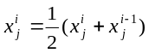 (13)
Where ; x_{j}^{i} depicts the position of i^{th} follower Salp in the j^{th} dimension
- Boundaries violations: If any solution violates the range of the search space during the update process, it returned back in the range of the problem.
- Termination criteria: The number of iterations t is increased gradually untill it reaches to maximum iterations max_{iter} then the algorithm terminates search process and produces the overall best solution found so far.
5 Results and Analysis
This section deals with the presentation of system dynamic responses i.e deviations in frequency (∆f) with various load uncertainities (∆P_{L}) presented in Table.1 Simulations are carried out with Matlab 7.10.0 (2010a) software and Intel i3 processor, 4GB ram based system. In order to examine the robutness of the proposed 2DOFPID controller, its response are being compared with PI and PID controllers. The efficacy and superiority of proposed SSA technique is demonstrated by comparing its dynamic respones with GOA, ALO [8-9] and PSO techniques.

Scenario | Simulation time | Ranges | Conditions
1. | 120 sec | 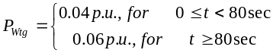  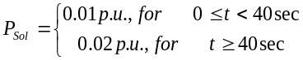 | Base Loading
2. | 120 sec | 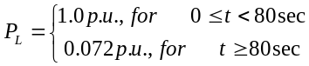 | Increment of load by 20% at  t=80sec from Base load
3. | 120 sec | 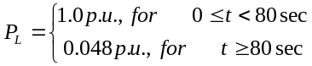 | Decrement of load by 20% at  t=80sec from Base load
4. | 120 sec | 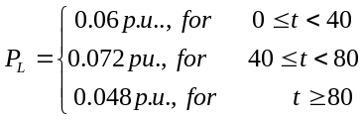 | Variation of Load by ±20% from Base load
5. | 120 sec | Incorporates randomly variable  model of Load demand | Random loading
Table.1 Details of studied scenarios

Scenario-1: Base loading condition
In this scenario the dynamic performance of Hybrid power system is investigated subjected to the variations in wind, soalr and load. As presented in table1 P_{wtg} is maintained at 0.04p.u upto 80sec and increased to 0.06p.u after 80sec. Similarly P_{Sol is} maintained at 0.01p.u upto 40sec and increased to 0.02p.u after 80sec and the load demand is 0.06p.u during the period 0≤t≤120sec. The mismatch between the generation and load demand is alleviated by the action of controllers. Fig 4(a) and Fig 6(a) revelas the comparative performance of frequency deviations of hybrid power system w.r.t different controllers and different soft computing techniques.
Scenario-2: Increment of load by 20% at t=80sec from Base load
In this scenario sensitivity analysis of different controllers are performed to determine their robustness. As presented in table1 the variations in P_{wtg} and P_{Sol} are maintained similar in all scenarios while the load demand increased by 20% from base load at t=80sec. Comparative responses of (∆f) obtained under the action of three controllers based on the SSA are shown in Fig 4(b) and Fig 6(b).
Scenario-3: Decrement of load by 20% at t=80sec from Base load
This scenario is similar to previous one but the only difference is the load demand is being decreased by 20% from base laod. Fig 4(c) and Fig 6(c) presents the frequency deviations of the proposed system and the responses reveals the robustness of SSA optimized 2DOFPID controller compared with PI and PID.
Scenario-4: Variation of load by ±20% from Base load
Another sensitivity analysis is performed to determine efficacy of the proposed controller under the variations of wind energy, solar energy and load demand.In this scenario the load demand is maintained at 0.06p.u upto 40sec and increased by 20% from nominal load and maintained upto 80sec and later the load demand is decreased to 20% from nominal load. Fig 4(d) and Fig 6(d) presents the frequency deviations carried out during this sensitivity analysis.
Scenario-5: Random Variation of load
The supermacy analysis of the proposed controller is carried out under the random loading condition in this scenario.The dynamic performances are illustrated in Fig 4(e) and Fig 6(e) with deviations in frequency due to different optimized controllers. All the test results in all scenarios confers that the responses of proposed SSA optimized 2DOFPID controller exhibits superior performanace over other techniques implemented.

Responses for Single Objective

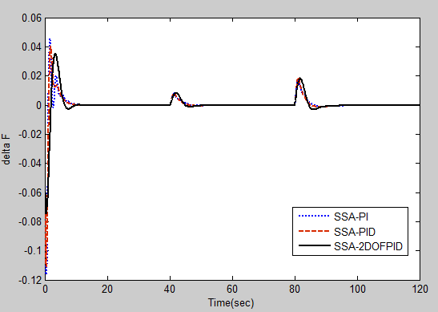
(a)
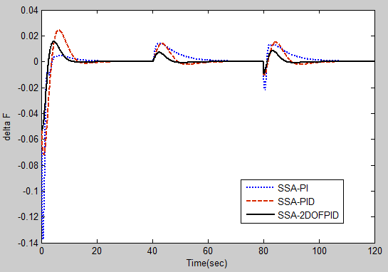
(b)

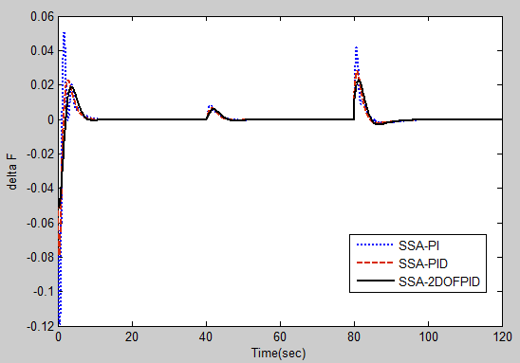
(c)

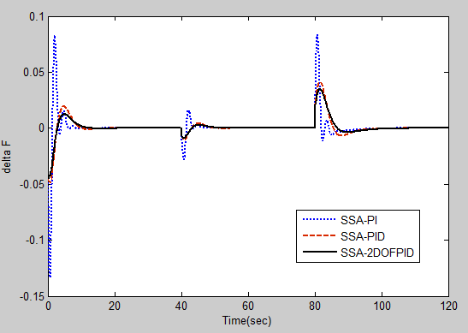
(d)
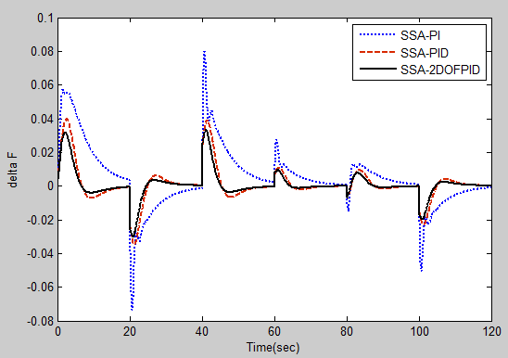
(e)
Fig 4(a-e): Frequency deviations under scenario 1,2,3,4 and 5

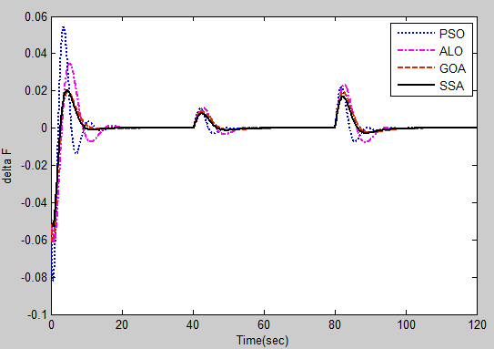
(a)

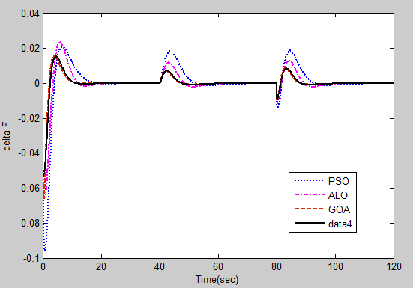
(b)
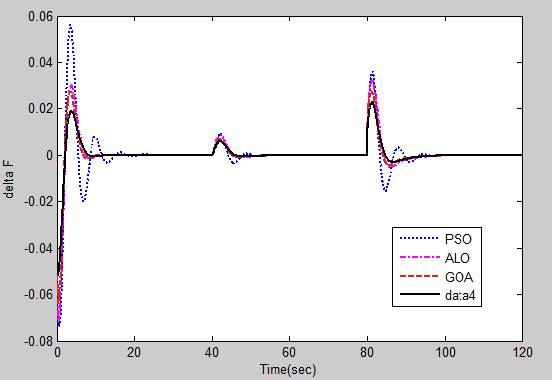
(c)

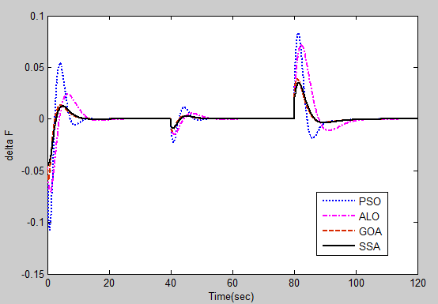
(d)

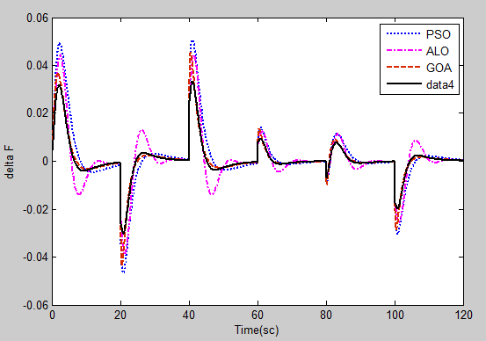
(e)
Fig 5(a-e): Comparative responses of SSA, GOA, ALO & PSO in Scenario 1,2,3,4 & 5
Responses for Multi Objective

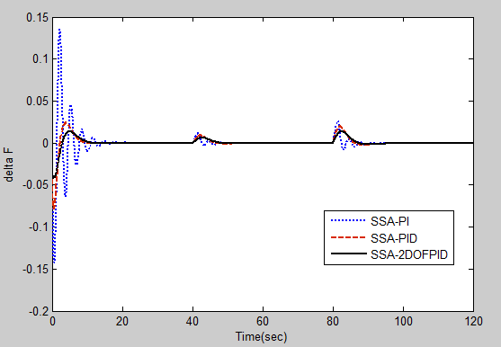
(a)

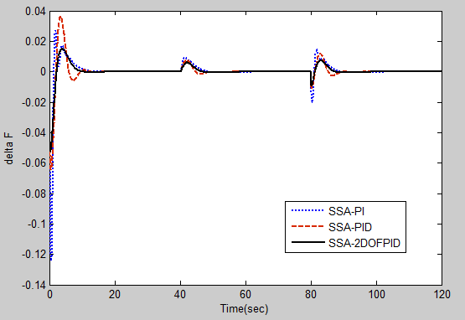
(b)

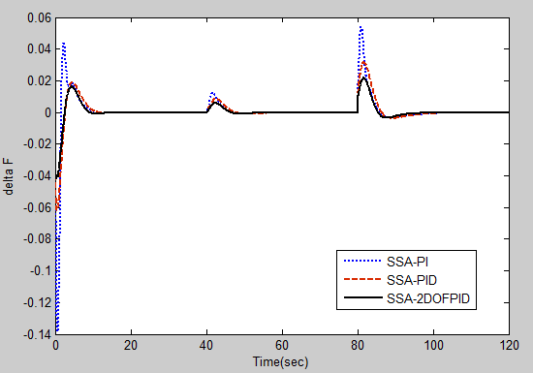
(c)
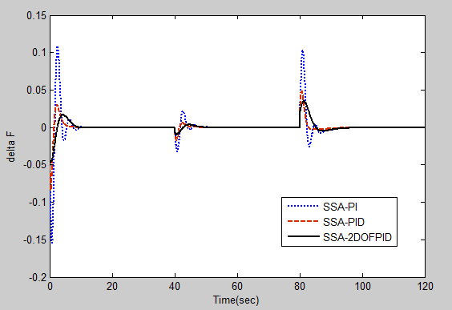
(d)

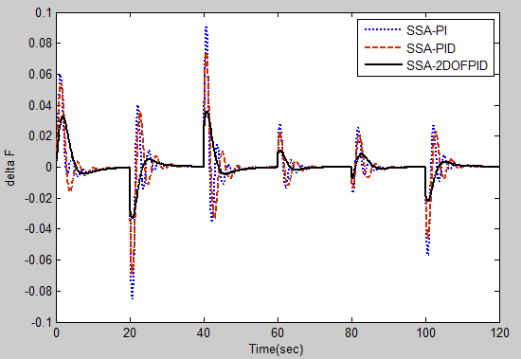
(e) Fig 6(a-e): Frequency deviations under scenario 1,2,3,4 and 5

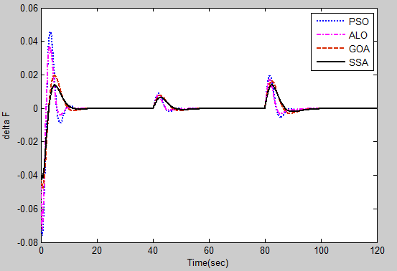
(a)
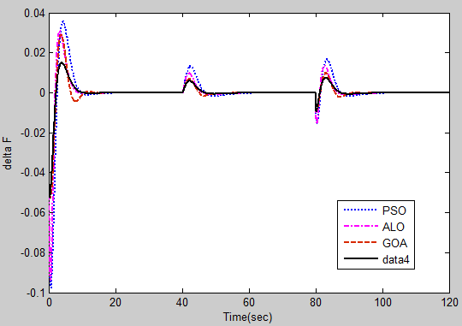
(b)

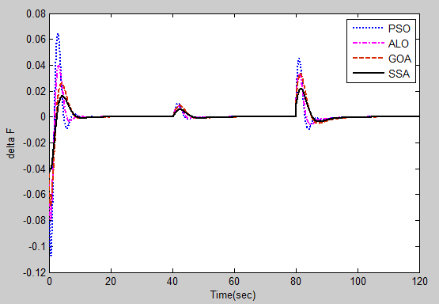
(c)

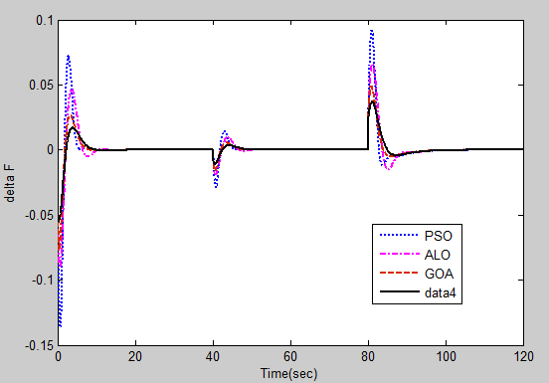
(d)
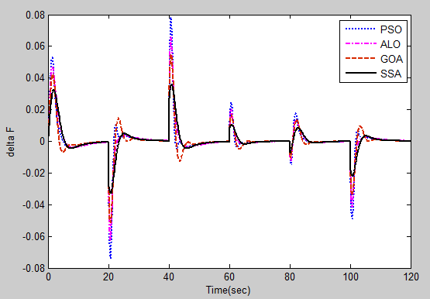
(e) Fig 7(a-e): Comparative responses of SSA, GOA, ALO & PSO in Scenario 1,2,3,4 & 5

The robustness of SSA technique is being alleviated by comparing their responses with other techniques are presented in respective Fig.5 and Fig.7
6 Conclusion
This research article focussed to propose an effective 2DOFPID controller for load frequency control of Autonmous Hybrid power system under various load un-certainities. To obtain the optimal gain values of proposed controller, a novel Meta heuristic alogorithm named as Salp swarm algorithm through Single and Multi objective techique is implemented and the responses reveals that the proposed controller is more effective than PI and PID controller in reducing the fequency deviations. The time domain responses also confer the supermacy and efficacy of SSA technique in comparision with other techniques.
Finally it can be concluded that the SSA optimized 2DOFPID controller is better option for Autonomous Hybrid power system to enable automatic generation control in both Single and Multi objective conditions.

Soft Computing technique | Fitness value  (ISE value with Multi objective function)
Soft Computing technique | Case1 | Case 2 | Case 3 | Case 4 | Case 5
PSO | 0.01437 | 0.02150 | 0.01497 | 0.03586 | 0.02178
ALO | 0.01180 | 0.01016 | 0.00960 | 0.03136 | 0.01674
GOA | 0.00750 | 0.00503 | 0.00695 | 0.00788 | 0.01104
SSA | 0.00597 | 0.00447 | 0.00457 | 0.00664 | 0.00826
Table.2 Comparision of Fitness value for Single objective

Soft Computing technique | Fitness value  (ISE value with Multi objective function)
Soft Computing technique | Case1 | Case 2 | Case 3 | Case 4 | Case 5
PSO | 0.010630 | 0.01605 | 0.01931 | 0.03569 | 0.01794
ALO | 0.008033 | 0.01068 | 0.01054 | 0.02168 | 0.01504
GOA | 0.005446 | 0.005462 | 0.009813 | 0.01090 | 0.01213
SSA | 0.003831 | 0.003481 | 0.004203 | 0.006926 | 0.00788
Table.3 Comparision of Fitness value for Multi objective

From the Table 2 and 3, it is evident that the objectives of minization of frequency deviations and area control error are achieved by uing more significantly with SSA technique compared with other techniques.
References

1. Pandey, Shashi Kant, Soumya R. Mohanty, Nand Kishor,"Frequency regulation in hybrid power systems using particle swarm optimization and linear matrix inequalities based robust controller design." International Journal of Electrical Power & Energy Systems 63 (2014): 887-900.
2. Das, Dulal C., N. Sinha, and A. K. Roy. "Automatic generation control of an organic rankine cycle solar–thermal/wind–diesel hybrid energy system." Energy Technology 2, no. 8 (2014): 721-731.
3. Lal, Deepak Kumar, and Ajit Kumar Barisal. "Load frequency control of AC microgrid interconnected thermal power system." In IOP Conference Series: Materials Science and Engineering, vol. 225, no. 1, p. 012090. IOP Publishing, (2017).
4. Shankar, G., and V. Mukherjee. "Load frequency control of an autonomous hybrid power system by quasi-oppositional harmony search algorithm." International Journal of Electrical Power & Energy Systems 78 (2016): 715-734.
5. Gaur, Pushpa, Nirmala Soren, and Debashish Bhowmik. "Impact Assessment of Vehicle-to-grid Technology in LFC of Multi-area Solar-thermal Power System." International Journal of Renewable Energy Research (IJRER) 8, no. 3 (2018): 1580-1590.
6. Lee, Dong-Jing, and Li Wang. "Small-signal stability analysis of an autonomous hybrid renewable energy power generation/energy storage system part I: Time-domain simulations." IEEE Transactions on Energy Conversion 23, no. 1 (2008): 311-320.
7. Mirjalili, Seyedali, Amir H. Gandomi, Seyedeh Zahra Mirjalili, Shahrzad Saremi, Hossam Faris, and Seyed Mohammad Mirjalili. "Salp Swarm Algorithm: A bio-inspired optimizer for engineering design problems." Advances in Engineering Software 114 (2017): 163-191.
8. Mirjalili, Seyedali. "The ant lion optimizer." Advances in Engineering Software 83 (2015): 80-98.
9. Saremi, Shahrzad, Seyedali Mirjalili, and Andrew Lewis. "Grasshopper optimisation algorithm: theory and application." Advances in Engineering Software 105 (2017): 30-47.

