Performance Assessment of four types of Cyclone Separator using Computational Fluid Dynamics
Vivekanandan M¹, Premalatha, M^{1,} and Anantharaman, N^{1,2}
¹Department of Energy and Environment
²Department of Chemical Engineering,
National Institute of Technology Trichy, Thuvakudi, Tiruchirappalli 620 015, India
1.0 Introduction
The essential purpose of the cyclones used in the industrial process is the removal of solid dusts within the flue gas, thus the cyclone separator indulges in removal of solid based wastes from the flues and hence reduces air pollution [1]. Cyclone separators uses the gravitational and centrifugal forces to separate the solid dust particles from the flue gas, which is very must cost and energy efficient withered to low investment and operating cost. These qualities of the cyclone separator make in industry friendly [2].
The important thing in choosing the right cyclone for the required purpose, involves deriving the perfect numerical model to study the flow and geometric characteristics of the cyclone. Upon considering various numerical models, computational fluid dynamics is proven to be the most stable tool to study the characteristics of the cyclone [3]. Several numerical studies were undergone to study various characteristics of the cyclone. The geometrical characteristic study was done by Lee et al [4], where he found that the pressure drop, within the cyclone can be adjusted by modifying the cyclone body diameter.
Chuah et al [5], states that cyclone with small cone diameter poses good pressure drop and collection efficiency in comparison with cyclones with larger cone diameter. A high efficient stairmand cyclone including Reynolds stress model and large eddy simulation model was modeled by Slack et al [6], which is a temperature constrained study. Karagoz et al [7] modeled a cyclone with with a conical part and the various characteristics studies were studied over the developed mode.
Wang et al [8] derived various methods of classifying various cyclones my means of centrifugal forces, geometric profiles, cyclones with/without fans, cyclones with axial/reverse flow vortex. Johansson and Evertsson et al [9] had made some studies on second stage classifiers, the effects of the inlet velocity, particle shape of the flue gas without considering the particle size of the flue gas solid particle. Some studies were conducted on the flow stability of the flue gas solid particle. Yoshida et al [10] had made a new approach to enhance the flow stability by means of fluid flow control and submicron particle classification. Based on their study to improvise the separation efficiency the apex angle is to be 70˚, and hence increasing the flow stability.
Boyson et al. [11], was the first to apply the computational fluid dynamics in a cyclone model to study the flow simulation and to study the collection efficiency and the separation efficiency of the cyclone model. Faqi Zhou et. Al. [12] study gives us an experiment and analytical Results on tangential inlet type cyclone with spiral Guide Vane. The analytical results are good in agreement with the experimental results. The flow will improve after the spiral guide vane is placed to some extent. This study shows the position of spiral guide vanes for effective functioning of cyclone.
Sakura Ganegama Bogodage et. Al. [13] research is about the Multiphase Fluid Modelling of gas – solid flow to analyze the flow distribution and functioning of a cyclone separator. Analytical results of process parameters are compared with the experimental results. Tracking the path of particles due to the difference in flow inside the cyclone gives us detail of deposition of dust below the cyclone. Though the CFD results are good in agreement with experimental results, which helps us to assess the dust collection rate and efficiency by modifying the corners within the acceptable limit of pressure drop.

2.0 Computational fluid dynamics models for cyclone separators
The flow inside a cyclone separator is very complex. It consists of many practical difficulties for numerical simulations. The primary difficulty arises from the fact that the turbulence observed in cyclones is highly anisotropic. This renders most of the first order turbulence closures, like the popular k-e model, unusable for reliable prediction of the flow characteristics. Several attempts were made to overcome this limitation. Boysan et al. (1982, 1983) were one of the first to report CFD studies of cyclone flows. These early studies realized that the standard k-e turbulence model is not able to accurately simulate this kind of flow and that at least a second-order closure.

2.1 Momentum and Energy Conservation Equation:
FloEFD solves the Navier-Stokes equations, which are formulations of mass, momentum and energy conservation laws for fluid flows. The equations are supplemented by fluid state equations defining the nature of the fluid, and by empirical dependencies of fluid density, viscosity and thermal conductivity on temperature. Inelastic non-Newtonian fluids are considered by introducing a dependency of their dynamic viscosity on flow shear rate and temperature, and compressible liquids are considered by introducing a dependency of their density on pressure. A particular problem is finally specified by the definition of its geometry, boundary and initial conditions. FloEFD is capable of predicting both laminar and turbulent flows. Laminar flows occur at low values of the Reynolds number, which is defined as the product of representative scales of velocity and length divided by the kinematic viscosity. When the Reynolds number exceeds a certain critical value, the flow becomes turbulent, i.e. flow parameters start to fluctuate randomly. Most of the fluid flows encountered in engineering practice are turbulent, so Flow Simulation was mainly developed to simulate and study turbulent flows. To predict turbulent flows, the Favre-averaged Navier-Stokes equations are used, where time-averaged effects of the flow turbulence on the flow parameters are considered, whereas the other, i.e. large-scale, time-dependent phenomena are taken into account directly. Through this procedure, extra terms known as the Reynolds stresses appear in the equations for which additional information must be provided. To close this system of equations, FloEFD employs transport equations for the turbulent kinetic energy and its dissipation rate, the so-called k-ε model. FloEFD employs one system of equations to describe both laminar and turbulent flows. Moreover, transition from a laminar to turbulent state and/or vice versa is possible. Flows in models with moving walls (without changing the model geometry) are computed by specifying the corresponding boundary conditions. Flows in models with rotating parts are computed in coordinate systems attached to the models rotating parts, i.e. rotating with them, so the models' stationary parts must be axisymmetric with respect to the rotation axis. The conservation laws for mass, angular momentum and energy in the Cartesian coordinate system rotating with angular velocity Ω about an axis passing through the coordinate system's origin can be written in the conservation form as follows:

$\frac{∂ρ}{∂t}+\frac{∂}{∂x_{i}} \left(ρu_{i}\right) =0$ (2.1)
$\frac{∂ρu_{i}}{∂t}+\frac{∂}{∂x_{j}} \left(ρu_{i}u_{j}\right)+\frac{∂ρ}{∂x_{i}}=\frac{∂}{∂x_{j}} \left(τ_{ij}+τ_{ij}^{R}\right)+S_{i }i=1,2,3$ (2.2)
$\frac{∂ρH}{∂t}+\frac{∂ρu_{i}H}{∂x_{i}}=\frac{∂}{∂x_{i}}=\left(u_{j}\left(τ_{ij} +τ_{ij}^{R}\right)+q_{i}\right)-τ_{ij}^{R}{\frac{∂u_{i}}{∂x_{j}}+ρε+S_{i}u_{i}+Q_{H}}_{ },$ (2.3)
$H=h+\frac{u^{2}}{2}+\frac{5}{3}k-\frac{Ω^{2}r^{2}}{2}-\sum_{m}{h_{m}^{0}y_{m}}$ (2.4)

where u is the fluid velocity, ρ is the fluid density, is a mass-distributed external force Si per unit mass due to a porous media resistance (S_{i} ^{porous}), a buoyancy (S_{i} ^{gravity} = - ρgi, where gi is the gravitational acceleration component along the i-th coordinate direction), and the coordinate system’s rotation (S_{i} ^{Rotation}), i.e., Si = S_{i} ^{porous} + S_{i} ^{Gravity} + S_{i} ^{Rotation} , h is the thermal enthalpy, Q_{H} is a heat source or sink per unit volume, τ_{ik} is the viscous shear stress tensor, q i is the diffusive heat flux, Ω is an angular velocity of the rotating coordinate system, r is the distance from a point to rotation axis in rotation reference frame, k is kinetic energy of turbulence, h_{m}⁰ is an individual thermal enthalpy of the m-th mixture component, y_{m} is a concentration of the m-th mixture component. The subscripts are used to denote summation over the three coordinate directions. For calculations with the High Mach number flow option enabled, the following energy equation is used:
$\frac{∂ρE}{∂t}+\frac{∂ρu_{i}\left[E+\frac{p}{ρ}\right]}{∂x_{i}}=\frac{∂}{{∂x}_{i}} \left(u_{j}\left(τ_{ij}+τ_{ij}^{R}\right)+q_{i}\right)-τ_{ij}^{R}\frac{{∂u}_{i}}{{∂x}_{j}}+ρε+S_{i}u_{i}+Q_{H},$ (2.5)
$E=e+\frac{u^{2}}{2}$ (2.6)
where e is the internal energy.
For Newtonian fluids the viscous shear stress tensor is defined as:
$τ_{ij}=μ\left(\frac{{∂u}_{i}}{{∂x}_{j}}+\frac{{∂u}_{j}}{{∂x}_{i}}-\frac{2}{3}δ_{ij}\frac{{∂u}_{k}}{{∂x}_{k}}\right)$ (2.7)
Following Boussinesq assumption, the Reynolds-stress tensor has the following form:
$τ_{ij}^{R}=μ_{t}\left(\frac{{∂u}_{i}}{{∂x}_{j}}+\frac{{∂u}_{j}}{{∂x}_{i}}-\frac{2}{3}δ_{ij}\frac{{∂u}_{k}}{{∂x}_{k}}\right)-\frac{2}{3}ρkδ_{ij}$ (2.8)
$μ_{t}=f_{μ}\frac{C_{μ}ρk^{2}}{ε}$ (2.9)
Here $f_{μ}$ is a turbulent viscosity factor. It is defined by the expression
$f_{μ}= {\left[1-exp⁡(-0.0165R_{y})\right]}^{2}.\left(1+\frac{20,5}{R_{T}}\right),$ (2.10)
where $R_{T}=\frac{ρk^{2}}{με},R_{y}=\frac{ρ√ky}{μ}$
and y is the distance from the wall. This function allows us to take into account laminar-turbulent transition. Two additional transport equations are used to describe the turbulent kinetic energy and
dissipation,
$\frac{∂ρk}{∂t}+\frac{∂}{∂x_{i}} \left(ρu_{i}k\right)=\frac{∂}{∂x_{i}}\left(\left(μ+\frac{μ_{t}}{σ_{k}}\right)\frac{∂k}{∂x_{i}}\right)+S_{k,}$ (2.11)
$\frac{∂ρε}{∂t}+\frac{∂}{∂x_{i}} \left(ρu_{i}ε\right)=\frac{∂}{∂x_{i}}\left(\left(μ+\frac{μ_{t}}{σ_{ε}}\right)\frac{∂ε}{∂x_{i}}\right)+S_{ε,}$ (2.12)
where the source terms $S_{k,}$ and $S_{ε,}$ are defined as
$S_{k}=τ_{ij}^{R}\frac{∂u_{i}}{∂x_{j}}-ρε+μ_{t}P_{B}$ (2.13)
$S_{k}=C_{ε1}\frac{ε}{k}\left(f_{1}τ_{ij}^{R}\frac{{∂u}_{i}}{{∂x}_{j}}+μ_{t}C_{B}P_{B}\right)-C_{ε2}f_{2}\frac{{ρε}^{2}}{k}$ (2.14)
Here $P_{B}$ represents the turbulent generation due to buoyancy forces and can be written as
$P_{B}=-\frac{g_{i}}{σ_{B}}\frac{1}{ρ}\frac{∂ρ}{∂x_{i}}$ (2.15)
Where $g_{i}$ is the component of gravitational acceleration in direction $x_{i}$, the constant $σ_{B}$ = 0.9, and constant $C_{B}$ is defined as: $C_{B}$ = 1 when, $P_{B}$ > 0, and 0 otherwise;
$f_{1}=1+{\left(\frac{0.05}{f_{μ}}\right)}^{3}, f_{2}=1-exp⁡(-R_{T}^{2})$ (2.16)
The constants $C_{μ}$, $C_{ε1}$,$C_{ε2}$,${ σ}_{k}, { σ}_{ε}$ are defined empirically. In Simulation the following typical values are used:
$C_{μ}$=0.09, $C_{ε1}=1.44$, $C_{ε2}=1.92$, ${ σ}_{k}=1, { σ}_{ε}=1.3$
Where Lewis number Le=1 the diffusive heat flux is defined as
$q_{i}=\left(\frac{μ}{Pr}+\frac{μ_{t}}{σ_{c}}\right) \frac{∂h}{{∂x}_{i}}, i=1,2,3.$ (2.17)
Here the constant $σ_{c}$ = 0.9, Pr is the Prandtl number, and h is the thermal enthalpy. These equations describe both laminar and turbulent flows. Moreover, transitions from one case to another and back are possible. The parameters k and $μ_{t}$ are zero for purely laminar flows.

2.6 Boundary conditions:
Initial conditions of the working fluid (air) Velocity is taken as 25, 30 and 35 m/s and mass flowrate of solid particles is bot 1.2 kg/for conjugate erosion analysis of four different cyclone separator is solved by using floEFD software in a Xeon 32 logical core processor and 64 GB ram computer.

3.0 Results and Discussions
Performance assessment of four types cyclones is done using computational fluid dynamics, results and discussions are given below
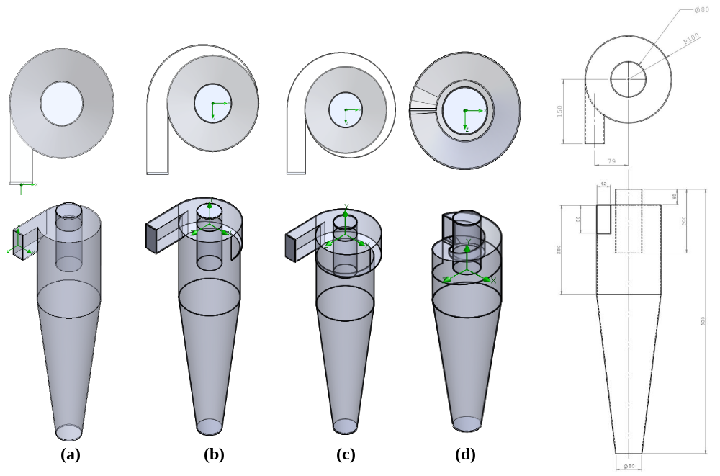
Fig 1: Geometric details of four types of cyclones
Fig 1 shows the geometric details of the four types of cyclones, (a) is a conventional cyclone, (b) is 180° Wrap around scroll cyclone, (c) is 360° Wrap around scroll cyclone, (d) is a Helicoidal inlet cyclone.
All the four cyclone are assessed for its performance using computational fluid dynamics, where the performance parameters studied on this paper are pressure, velocity, axial velocity, tangential velocity, turbulence intensity, vorticity and mass erosion rate.
All the four cyclone are simulated for three velocities 25,30,35 m/s, results discussed here are for 30 m/s which is prominent or operating velocity
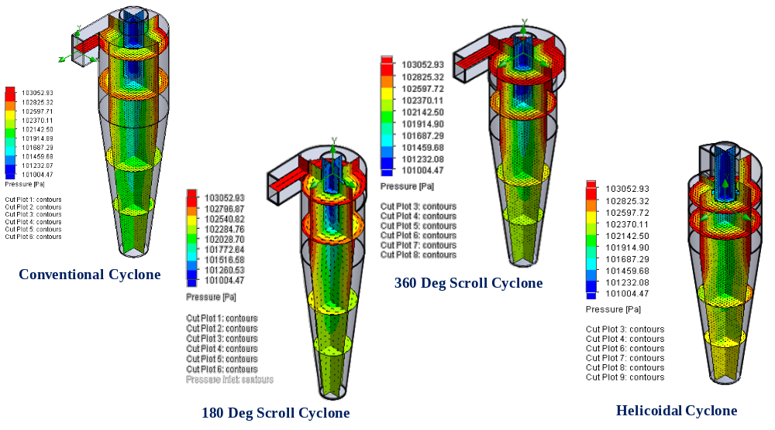
Fig 2: 3D pressure contour plots four types of cyclones
Fig 2 shows the 3D Pressure contour plots of four types of cyclones. In comparison of pressure between four cyclones, 360 Degreeree scroll cyclone generates low pressure near the vortex finder and helicoidal cyclone generates high pressure around the body wall and entry of bottom cone.
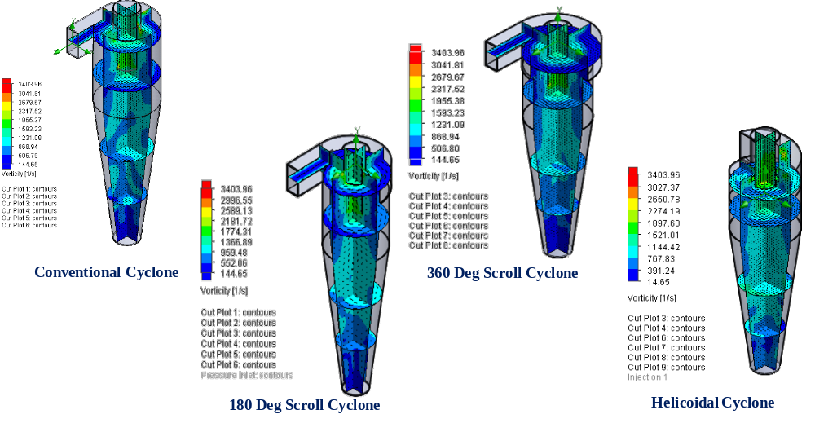
Fig 3: 3D vorticity contour plots four types of cyclones
Fig 3 shows the 3D Vorticity contour plots of four types of cyclones. A good vorticity is found in the helicoidal cyclone in comparison with the other three cyclones.

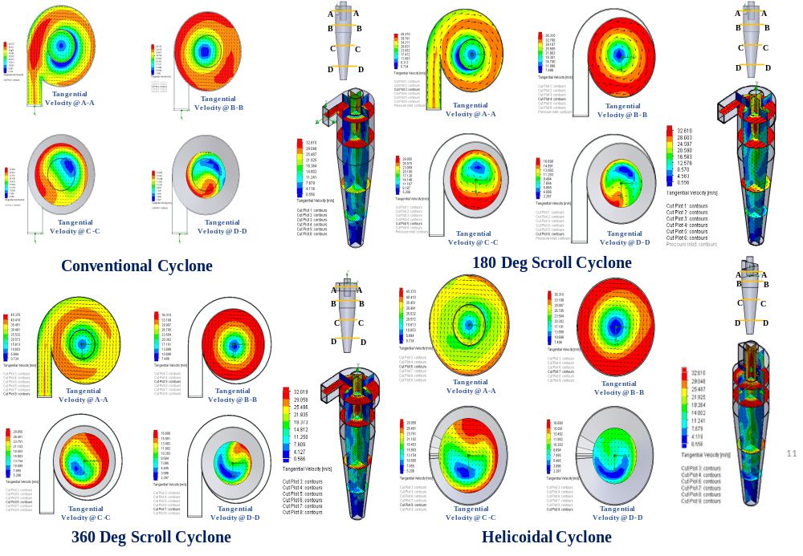
Fig 4: Various sectional tangential velocity contour plots of four types of cyclones
Fig 4 Shows the various sectional tangential velocity contour plots of four types of cyclones. In conventional cyclone, tangential velocity @ A-A is high, this will lead to an erosion in mother plate. But in other three cyclones, tangential velocity @ A-A less in comparison with the conventional cyclone as the entry to the cyclone is wrap around. Less tangential velocity at the entry will prevent the erosion in mother plate. In helicoidal cyclone, the velocity distribution is even at the entry of the cyclone because of its helicoidal type inlet.
Tangential velocity @ B-B shows that all the cyclones predicts the same velocity pattern, here the tangential velocity is very high which leads to the separation of particles in that portion. Tangential velocity @ C-C is high at 180 Degree near the surface of the top body portion in conventional cyclone, and it is high at 270 Degree portion near the surface of the top body portion in both 180 Degree scroll cyclone and 360 Degree scroll cyclone. Though the tangential velocity in all the cyclone is high @ B-B which also leads to good separation of particles.
Tangential velocity @ D-D is low for all the cyclones. If the tangential velocity is low in bottom portion of any cyclone which will not require a vortex breaker at the bottom of the cone. For helicoidal cyclone tangential velocity @ D-D is very low when compared to all other cyclones.
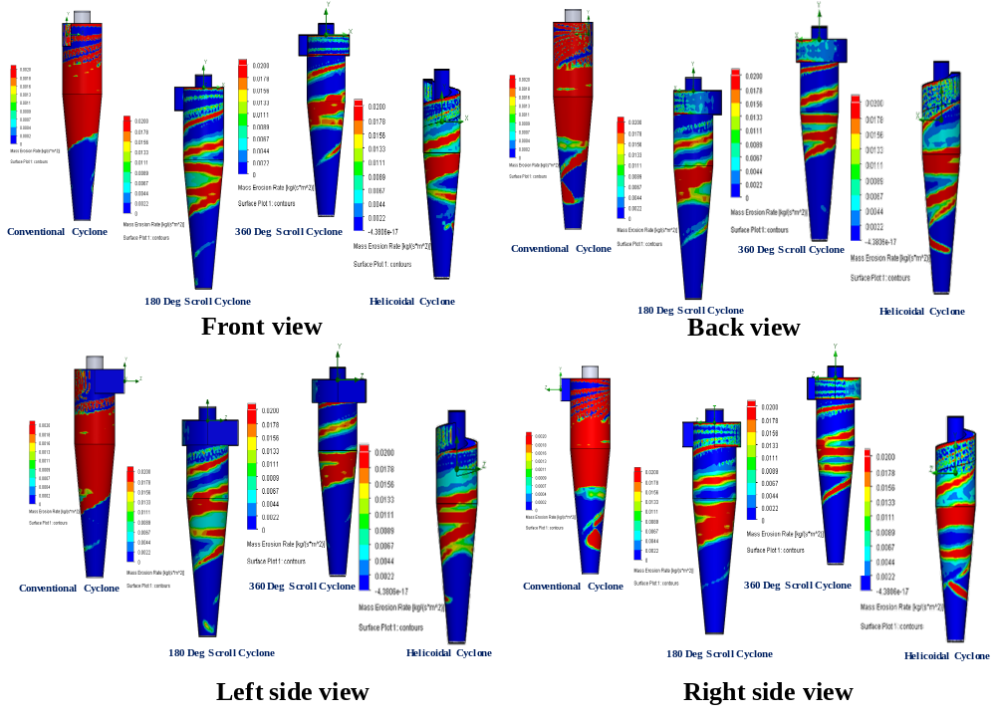
Fig 5: Mass erosion rate contour plots of four types of cyclones
Fig 5 Shows the mass erosion rate contour plots of four types of cyclones. 360 Degree scroll cyclone gives less mass erosion rate on the surface of the cyclone viewing from all the direction when compared to all other cyclones. Based on the erosion rate 360-degree wrap around cyclone performed better followed by helicoidal cyclone.
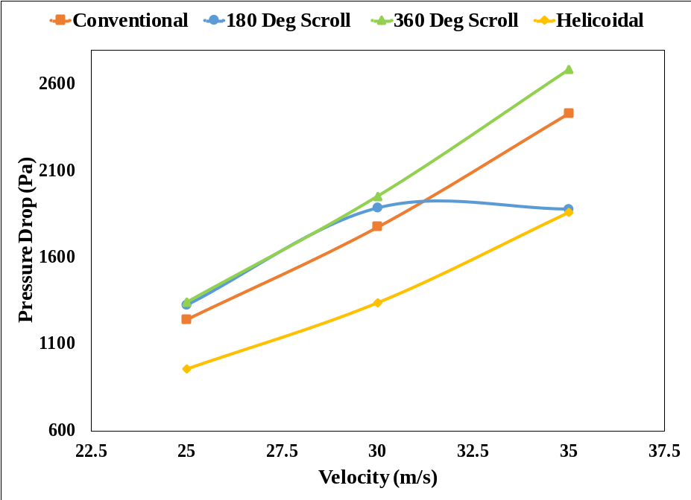
Fig 6: Velocity Vs Pressure drop for four type of cyclones
Fig 6 shows the velocity and pressure drop for four types of cyclones, in which helicoidal is having less pressure drop for all velocities, followed by conventional cyclone, 180 Deg scroll and 360 Deg Scroll
4.0 Conclusions
The following conclusions are attained, based on the CFD studies on performance of four types of cyclone separator
- Helicoidal cyclone is having less pressure drop for all velocities, followed by conventional cyclone, 180 Deg scroll and 360 Deg Scroll
- 360 Degree scroll cyclone gives less mass erosion rate on the surface of the cyclone viewing from all the direction when compared to all other cyclones. Based on the erosion rate 360-degree wrap around cyclone performed better followed by helicoidal cyclone.
- In conventional cyclone, tangential velocity @ A-A is high, this will lead to an erosion in mother plate, but in other three cyclones, tangential velocity @ A-A less in comparison with the conventional cyclone as the entry to the cyclone is wrap around. Less tangential velocity at the entry will prevent the erosion in mother plate.
- Based on the above points helicoidal cyclone might be selected for lesser pressure drop and lower erosion rates
References:
- W.P. Martignoni, S. Bernardo, C.L. Quintani, Evaluation of cyclone geometry and its
inﬂuence on performance parameters by computational ﬂuid dynamics (CFD), Braz. J. Chem. Eng. 24 (1) (2007) 83–94.
- J. Cernecky, K. Plandorova, The effect of the introduction of an exit tube on the separation efﬁciency in a cyclone, Braz. J. Chem. Eng. 30 (3) (2013) 627–641.
- Mehdi Azadi, Mohsen Azadi, Ali Mohebbi, A CFD study of the effect of cyclone size
on its performance parameters, J. Hazard. Mater. 182 (1) (2010) 835–841.
- Jin W. Lee, Hoe J. Yang, Dong Y. Lee, Effect of the cylinder shape of a long coned cyclone on the stable ﬂow-ﬁeld establishment, Powder Technol. 165 (1) (2006) 30–38.
- T.G. Chuah, Jolius Gimbun, Thomas S.Y. Choong, A CFD study of the effect of cone dimensions on sampling aero cyclones performance and hydrodynamics, Powder Technol. 162 (2) (2006) 126–132.
- M.D. Slack, R.O. Prasad, A. Bakker, F. Boysan, Advances in cyclone modelling using
unstructured grids, Chem. Eng. Res. Des. 78 (8) (2000) 1098–1104.
- Karagoz, A. Avci, A. Surmen, O Sendogan, Design and performance evaluation of a new
cyclone separator. J. Aerosol Sci. 59(2013) 57-64.
- P. Fu, F. Wang, L. Ma, X. Yang, H. Wang, Fine particle sorting and classification in the cyclonic centrifugal field, Sep. and Purif. Technol. 158(2016)357-366.
- R. Johansson, M. Evertsson, CFD simulation of a centrifugal air classifier used in the aggregate industry, Minerals Eng. 63(2014)149–156
- H. Yoshida, K. Ono, K. Fukui, The effect of a new method of fluid flow control on submicron particle classification in gas-cyclones, Powder Technol. 149 (2005) 139-147.
- F. Boysan, W.H. Ayer, J. Swithenbank, Fundanmental mathematical-modelling approach to cyclone design, Trans. Inst. Chem. Eng. 60 (1982) 222-230.
- Faqi Zhou, Guogang Sun, Xiaopeng Han, Yong Zhang, ‘Experimental and CFD study on effects of spiral guide vanes on cyclone performance’, Powder Technology 286 (2015) 488–506.
- Sakura Ganegama Bogodage,,AndrewY.T.Leung, CFD simulation of cyclone separators to reduce air pollution, Powder Technology 286 (2015) 488–506. Advanced Powder Technology 142 (2018) 323-371.

