Parametric studies on combined conduction and convection heat transfer in perforated fins

Darawath Srinu¹, G. Ganesh Kumar^{2*}, K. Sridhar³
^{12,3}Kakatiya Institute of Technology and Science, Warangal
ABSTRACT
The present paper discuss about an numerical, analytical and experimental studies pertaining to heat transfer through perforated fins. Various types of geometries are considered to study and compare heat transfer parameters. Among the latest works one of the prominent study was done by Kern and Kraus [1], who gave the concept of usage of fins in various electronic applications to enhance the dissipation of heat. Further Kraus and Bar-Cohen [2] extended their work by optimize the geometry of the fin. The usage of a fin though increases the heat transfer rate leads to increase in weight and cost of a device. Prominent results of an experimental probe into the problem of combined conduction- convection from a vertical, thin plate fins with different shaped perforations were presented here. An experimental set up was designed and fabricated to study the effect various parameters like temperature, heat generation, thermal conductivity, overall heat transfer coefficient in the perforated fin.
Keywords: Mixed-Convection, Conduction, Pin-fins, Perforated-fins, knurled fin.

Literature review
Fin geometry and its effect on heat transfer rate is the most important parameters in the literature. Kern, and Kraus [1] are the prominent authors who gave the concept of usage of fins in various electronic applications to enhance the dissipation of heat. Then Kraus and Bar-Cohen [2] has optimized the geometry of the fin. Though the usage of a fin increases the heat transfer rate it leads to increase in weight and cost of a device. Hence, it is the design engineer who has to strive for compact devices in improving the overall efficiency of a device.
Shaeri et al. [3] have presented that the fins are the good examples of the passive method where there is no need to have an external agency to increase heat transfer rate and hence are regularly used in industries for better design applications. Bayram and Alparslan [4] have introduced anisotropic composite as well as perforated fins for enhancement of heat transfer rate.
Subsequently, different processes in improving the heat transfer viz., Active and Passive methods is explained by Bergles [5] to decrease and optimize the weight and size of a fin.
Further, the results of modeling and simulation in CFD by experiment on the fluid flow and heat transfer characteristics of a fin arrays with lateral circular perforation are presented by Dhanawade Hanamant [6]. They found that the increase in the fluid flow movement around the fin resulted in increase in the heat dissipation rate by adding perforation to the fins. Further, they concluded that new designed perforated fins have an improvement in average Nusselt number, over its external dimensionally equivalent solid fin arrays.
Al-Essa Elshafei [7] have strived to increase the heat transfer area and heat transfer coefficient. He has introduced shape adjustments by making cavities, holes, slots, grooves or channels through the fin body.
Wadhah, Hussain [8] explained the concept of enhancement of natural convection heat transfer from rectangular fins by circular perforations.
The minimization of an entropy generation and application of an EGM technique for determining the thermodynamic losses caused by heat transfer and pressure drop in cylindrical pin-fin heat sinks was discussed by Khan et al. [9]. They have obtained a general expression for the entropy generation rate by considering the whole heat sink as a control volume and applied the conservation equations for mass and energy with the entropy balance. They showed that all relevant design parameters for pin-fin heat sinks, including geometric parameters, material properties and flow conditions can be simultaneously optimized.
It can be seen from the literature that there are no experimental studies on pin fins with various configurations. Hence an attempt is made to study the comparisons of performance of different pin fin configurations.

INTRODUCTION
Exhaustive applications uses Fins to increase the heat transfer from surfaces. Typically, the fin material has a high thermal conductivity. Fins are used to enhance convective heat transfer in a wide range of engineering applications, and offer practical means for achieving a large total heat transfer surface area without the use of an excessive amount of primary surface area. Fins are commonly applied for heat management in electrical appliances viz., computer power supplies or substation transformers and other applications include cooling of Internal Combustion engine such as Fins in a car radiator. Fins are widely used in the trailing edges of gas-turbine blades, in electronic cooling and in the aerospace industry.
The relative fin height (H/d) affects the heat transfer of pin-fins, and other affecting factors include the velocity of fluid flow, the thermal properties of the fluid, the cross-sectional shape of the pin-fins like perforation, the relative inter-fin pitch, the arrangement of the pin-fins like in-line, staggered arrangement and others. It is proposed to study the parameters affecting the heat transfer through perforated pin fin with different configurations have been investigated.
Here an attempt is made on experimental investigation on the effect of heat transfer parameters by introduction of perforations with different configurations such as solid pin fin, hollow pin fin, solid pin fin with four equal perforations, solid pin fin with one large perforation, knurled fins, hollow fin.

Experimental set-up

To study the heat transfer parameters, an experimental set-up has been fabricated for the purpose. This set-up primarily consists of a Rectangular Duct, a Heating Unit, a blower, a Data Unit and an Anemometer. Fig. 1 shows a line diagram of the set-up. This experimental set up was fabricated based on an experimental studies made by Amol B et al. (2013).
A Rectangular Duct is made of galvanized iron with a thickness of 0.5 mm. It is made up of 130×150 mm internal cross-section and the length of the channel was taken as 890 mm.
A 2.4 HP capacity Blower is used to allow the air to flow with a required velocity. It will be operated from 0 to 2800 rpm, 130W, 180/230V, 50 Hz, Single Phase. It is operated from a convergent channel made of Galvanized Iron. It has a convergent and divergent section at both ends having the inclination of 30°.
An Anemometer is used to measure the mean inlet velocity of the air flow entering and leaving the test section.
The specification of anemometer used is: Range: 4 to 30 m/s or 1.4 to 108 KMPH, Vane Probe, Model No. AM 4201, LT – Lutron, Made in Thaiwan.

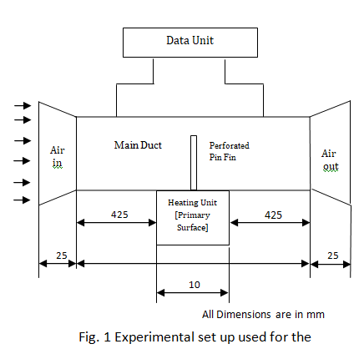

The range of the Reynolds number used for the experimentation is 4,000 – 10,000, which is based on the hydraulic diameter of the channel over the test section (D_{h} = 139.286 mm) and the average velocity (U). The heating unit for the test section mainly consisted of an electrical heater. The heater output has a power of 180 W at 220V and a current of 10 A. The whole assembly was mounted on a Flat Table made up of wood. The temperature measurement of the base plate is done by RTD Sensors which can sense the temperature from 0°C to 600°C. The RTD ‘s are screwed into the heater and temperature is obtained from on the data unit as shown in Fig.1.

solution methodology

The net rate of heat transfer is obtained from the energy balance which is given as follows:

qheat generated due to electric power q_{net,conduction}+q_{net, convection}+q _{net radiation} [1]

Rearranging the above equation we get,
q_{net,convection}=qheat-generated-due-to-electric-power-q_{net,cond.}-q_{net-rad.} [2]
The heat generated in terms of voltage and current is given by:
qheat generated due to electric power = VI [3]

Where I is the current in amperes and V is a voltage in Volts supplied to the heating unit.
q heat generated due to electric power, represents is electrical heat generated in the primary surface
q _{net, conduction} is the net rate of heat transfer due to conduction,
q _{net, convection} net rate of heat transfer due to convection,
q _{net radiation} net rate of heat transfer due to radiation.

As per the literature review the net rate of heat transfer due to radiation is 0.5 % of the total heat supplied in the form of power and hence can be neglected. The heat losses due to side, bottom and top walls of the test section were assumed to be neglected since the side walls are insulated. Thus the heat transfer due to convection is equal to net rate of electrical heat generated in the primary surface.
[4]
A_{s} = Surface area of the fin, T_{s} = Surface temperature of the fin, T_{out} and T_{in} represents the duct inlet and outlet temperatures of the ambient air.
Rearranging the above equation, we get the average heat transfer coefficient as follows:
 [5]
From the above the Nusselt number is found by using the following equation:
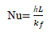 [6]
The correlation used for Nusselt Number without fin is given by following equation:

[7]

Results and Discussion

The effect of heat transfer parameters are discussed here in detail.
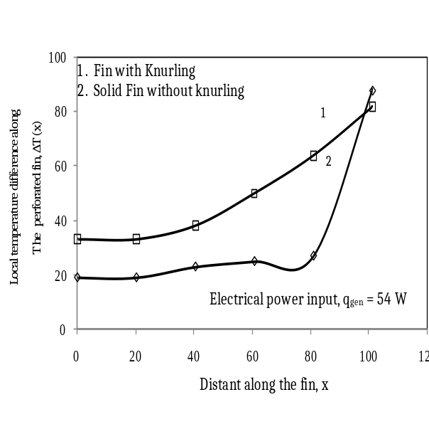
Hollow cylindrical pin fin with perforations.
Solid cylindrical pin fin with perforations.

1

2

Vertical distance along the fin, x
Local temperature difference
along the perforated fin, ∆T (x)
Electrical power input, q_{gen} = 54 W
Fig. 2 Variation of local temperature difference along the pin fin in forced convection mode of heat transfer

Figure 2 the comparative studies on variation of temperature difference along the fine for two different fin configurations viz., fin with knurling and fin without knurling is presented. This study was performed in forced convection mode of heat transfer. A fixed electrical input power of 54W is maintained throughout the study. A uniform velocity of air at 20 m/s is maintained. Curve 1 shows the variation in knurled fin and curve 2 shows the variation of temperature difference in solid fin. It can be seen from that the heat transfer rate is more in knurled fin than that of a solid fin. Further it can be seen that the temperature difference increases as we move from primary surface to the fin tip.
An attempt is done to study temperature difference variation temperature along the pin fin for two modes of heat transfer viz., the free convection and forced convection. Figure 3 shows the local temperature difference [∆T(x)] profiles along the vertical hollow cylindrical perforated pin fin and vertical solid cylindrical perforated pin fin with same cross sectional area and of same length. The experiment was performed in free convection mode. The fixed electrical power input of 54 W is used at the primary surface of the pin fin. It can be seen that at a given location along the perforated fins the local temperature difference is more for hollow-cylindrical perforated pin fin than that of the solid perforated pin fin. This is so because more surface area of hollow-cylindrical perforated pin fin was exposed to air which increases the convective heat transfer rate both from inside as well as outside surface of the pin fin. Also, as we move from primary surface to the tip of the fin, the temperature difference decreases and reaches to the minimum for both the cases. Here, we can see that the drop in fin temperature is found to be decreasing by 3.21 % and 4.86 % at the tip and primary surface respectively. Also the drop in temperature for hollow and solid perforated pin fins as we move from primary surface to tip of the fin are given by 8.33 % and 5.11 % respectively.
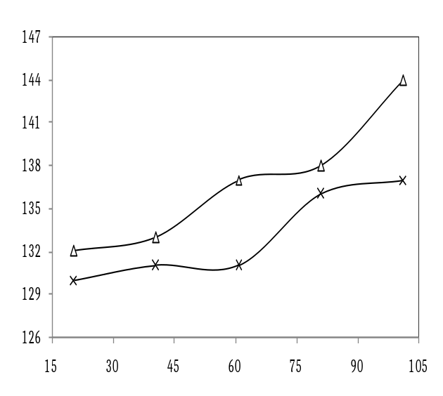
Fig. 3 Variation of local temperature the pin fin in free convection mode of heat transfer
Free Convection heat Transfer

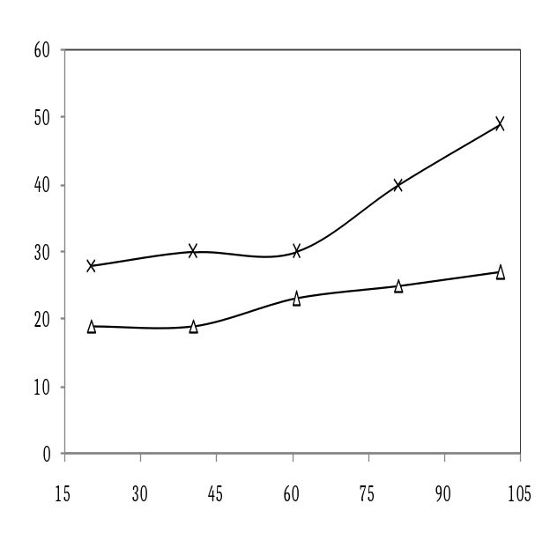
1
2
Local temperature along the perforated fin, ∆T (x)
2

Forced Convection heat Transfer
- Hollow cylindrical pin fin with perforations.
- Solid cylindrical pin fin with perforations.

Vertical distance along the fin, x
Fig. 4 Variation of local temperature difference along the pin fin in forced convection mode of heat transfer

A similar study was also performed by using the same set up under forced convection mode of heat transfer. As shown in Fig. 4.The air was pumped at the velocity of 20 m/s at inlet of the duct and as it reached the outlet it is reaching approximately 5 m/s. This study is also performed for a constant input power of 54 W. As in Fig. 2 here also the temperature difference drops down as we move from the primary surface to the tip of the pin fin. But the drop in temperature at the tip is decreasing by 44.89 % and that of at primary surface is 34.14 %. This show that there is a large increase in the heat transfer from the surface by using forced convection instead of free convection mode of heat transfer. Also here too the temperature difference is decreasing as we move from primary surface to the tip of the pin fin. The tip and surface temperature is decreasing by temperature is decreasing by 29.63 % and 42.85 % respectively.

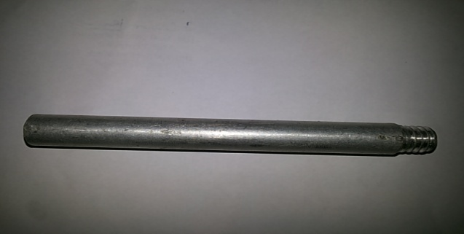
Fig. 5 Solid Pin fin used for the purpose

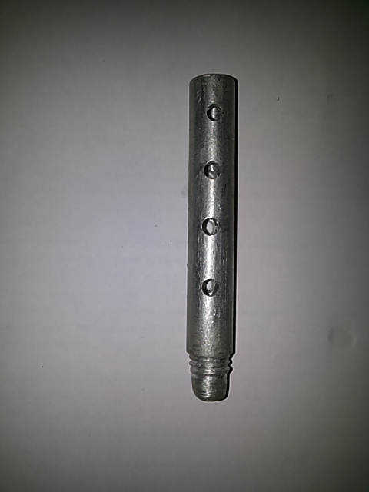
Local temperature
along the perforated fin, ∆T (x)
1. Solid Pin fin with
2. Solid Pin fin with single perforation

1
2
Vertical distance along the fin, x
Electrical power input, q_{gen} = 54 W

Fig. 9 Temperature difference profiles along the solid pin fin and Single perforated solid pin fin.
Fig. 6 Perforated Pin Fin used for the purpose

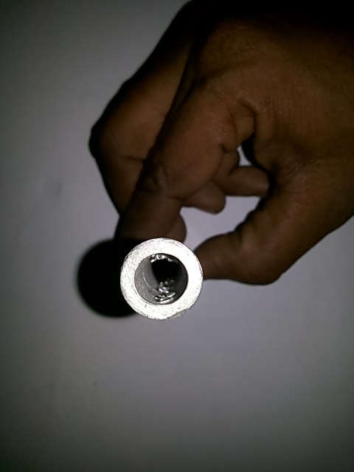
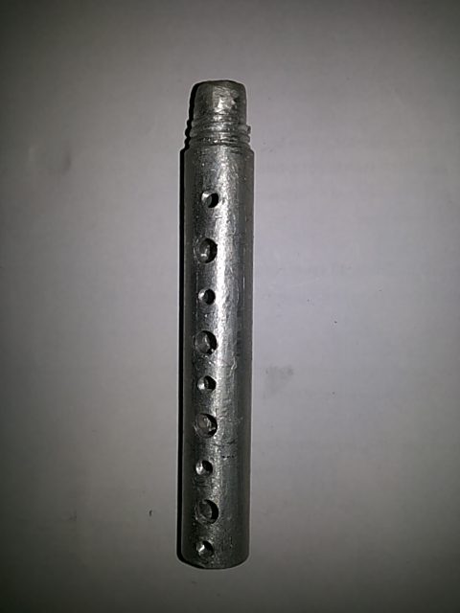
Fig. 7 Fin with four perforations used for the purpose

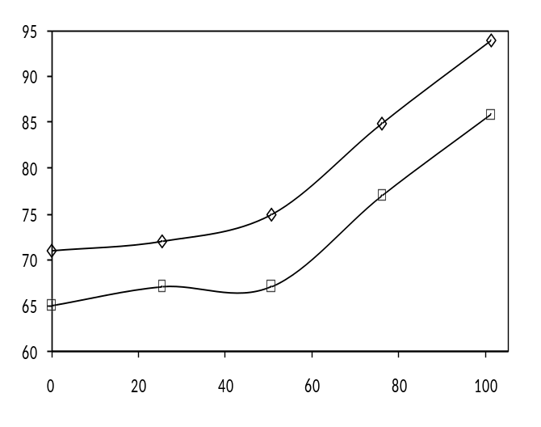
Local temperature
along the perforated fin, ∆T (x)
1. Pin fin with air passing into perforations
2. Pin fin with air not passing into perforations

2

Vertical distance along the fin, x
Electrical power input, q_{gen} = 54 W

1

Fig. 8 Temperature difference profiles along the pin fin with change in orientation

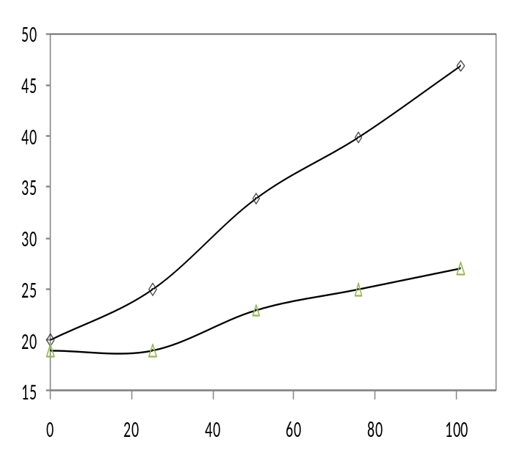

The variation of temperature difference along the pin fin with change in orientation of pin fin is shown in Fig. 8. This is study is performed for a forced convection heat transfer mode with the air being pumped through the duct by using blower at constant air flow rate of 15 m/s at inlet of the duct. The figure shows that the temperature difference is decreases from the primary surface to the tip. The temperature difference at a given location for a fin is more for the case where the air is restricted to flow through the perforations than that when we allow the air pumped into the perforations. The temperature difference is dropping by 8.51 % at primary surface, 10.67 % at center and 8.45 % at the tip. Also, it can be seen that the temperature difference drop is high at centre than that of at tip and primary surface as the air is flowing into the perforation there by increasing the interactive surface area at the center and thus increasing convective heat transfer rate.

Figure 9 shows the temperature difference profiles for two cases viz., Solid pin fin with no perforations and Solid pin fin with a single large perforation. The volume of the perforation is same as that of the sum of the small perforations made in perforated fin. From the figure it can be seen that the temperature difference is very less as for single perforated pin fin than that of non-perforated pin fin. The temperature difference is dropping as large as 40. 81 % for perforated fin as we move from primary surface to the tip of the fin. Thus it would be more suitable to use perforated pin than that of the solid fin to enhance the heat transfer rate.

Conclusions

An experimental study was made to comparison of solid with two different configurations knurled and fin without knurling, pin fin with four perforations and single large perforation was discussed. A brief comparison has been done to select an appropriate pin fin. Different temperature difference profiles are discussed for validation.

Nomenclature

A_{s} Surface are of the fin pin
D_{h} Hydraulic Diameter, m
h heat transfer coefficient, W/m² K
mean heat transfer coefficient(W/m² K)
I Current, A
k_{f} thermal conductivity of air, (W/m K)
k thermal conductivity of pin fin, (W/m K)
Pr Prandtl number of air
Nu Nusselt Number
q heat transfer rate, (W)
Re Reynolds number
T_{in} Inlet temperature of the air from duct, K or °C
T_{out} Outlet temperature of the air from duct, K or °C
T_{s} average temperature of pin fin, K or °C
T_{s} (x) temperature at any location on pin fin, K or °C
T_{w} wall temperature of the pin fin, K or °C
T free stream temperature of air, K or °C
u velocity air along the pin fin, (m/s)
u free stream velocity of air, (m/s)
V Voltage, V
x Horizontal distance of the pin fin, m
GREEK SYMBOLS
υ_{f} Kinematic viscosity of air, (m2/s)
ρ Density of air, Kg/m³
SUBSCRIPTS
conduction conduction heat transfer through pin fin
convection convective heat transfer through pin fin
radiation radiation heat transfer through pin fin

REFERENCES

[1] D. Q. Kern, and A. D. Kraus, “Extended surface heat transfer”, New York: McGraw-Hill, 1972.

[2] A. D. Kraus, and A. Bar-Cohen,” Thermal analysis and control of electronic equipment”, Hemisphere Publication Corporation Washington, 1983.

[3] M. R. Shaeri, and M. Yaghoubi, “Thermal enhancement from heat sinks by using perforated fins”, Energy Conversion and Management vol. 50, pp. 1264-1270, 2009.

[4] S. Bayram, and D. Alparslan, “Performance analysis of a heat exchanger having perforated square fins”, Applied Thermal Engineering, vol. 6, pp. 621-632, 2008.

[5] A. E. Bergles, “The implications and challenges of enhanced heat transfer for the chemical process industries”, Chemical Engineering Research and Design, vol . 79(4), pp.437-444, 2001.

[6] S. Dhanawade Hanamant, K. N. Vijaykumar and Dhanawade Kavita, “Natural convection heat transfer flow visualization of perforated fin arrays by CFD simulation”, International Journal of Research in Engineering and Technology PI SSN: 2321-7308 vol 02 (12) Dec-2013.

[7] A. H. Al-Essa, and Al-Hussien.,” The effect of orientation of square perforations on the heat transfer enhancement from a fin subjected to natural convection”, Heat and Mass Transfer, F.M.S. vol, 40, pp.509-515, 2004.

[8] Wadhah, H.,Razzaq, A. D., (2011) Enhancement of natural convection heat transfer from rectangular fins by circular perforations, International Journal of Automotive and Mechanical Engineering, 4, 428-436.

[9] W. A .Khan, J. R. Culham, and M. M. Yovanovich,” Optimization of Pin-Fin Heat Sinks Using Entropy Generation Minimization”, Inter society conference on thermal phenomena, April 2014 PP: 259-267

[10] H. Al. Abdullah, and Q. A. Mohammed “Enhancement of natural convection heat transfer from a fin by triangular perforations of bases parallel and toward its base”, The Arabian Journal for Science and Engineering, vol. 34(2B), 531-544, 2009.

[11] B. Amol Dhumne, S. Hemant Farkade,“Heat Transfer Analysis of Cylindrical Perforated Fins in Staggered Arrangement”, International Journal of Innovative Technology and Exploring Engineering Volume-2, Issue-5, April 2013.

