Production and characterization of activated carbon from pterospernum acerifolium

Shubham Deshmukh^{1*}, Poonam Gera¹, Anjireddy Bhavanam¹
Dr B.R. Ambedkar National Institute of Technology Jalandhar Punjab
s.m.deshmukh24@gmail.com, chadhap@nitj.ac.in, bhavanama@nitj.ac.in
ABSTRACT
The structural morphology of activated carbon making it a good adsorbent for variety of applications in removing pollutants from industrial effluents which causes water and air pollution. Pterosperum acerifolium (commonly known as kanak champa) was selected for this study, because of it high fixed carbon content and low ash content which provides high heating value up to 16.44 MJ/kg. In this study pterospernum acerifolium sample was first pyrolized to get biochar in muffle furnace. Biochar was impregnated with KOH with impregnation ratio 1 at room temperature for 24 hours and then carbonized for producing activated carbon. To study the effect of change in temperature and carbonization time on structural morphology of activated carbon, carbonization was carried out at different temperature (500 to 700 ºC) and time (30 to 90 min). Activated carbon produced was further characterized by Brunauer Emmett Teller (BET) surface area analysis , Fourier transform infrared spectroscopy (FTIR). Activated carbon produced 700 ºC for KOH/ biochar ratio 1:1 and residence time 60 min with area about 430.173 m²/g. the yield of activated carbon decreased with increase in temperature and time. Surface area increases with temperature.
Keywords: Activated carbon, carbonization,

INTRODUCTION

Activated carbon is modified amorphous form of carbon which is thermally decomposed to make it highly porous and increase surface area. Main characteristics of activated carbon are highly porous surface, large surface area, adsorption capacity, high degree of surface chemistry, thermal stability, low acid/base reactivity [1] enables it for such a widespread applications. These properties of activated enables activated carbon for widespread applications in water purification , gas purification [2], sewage treatment , gas storage [3], energy storage , supercapacitor [4] etc.
Two processes are mainly used for the production of activated carbon; physical activation and chemical activation. In physical activation carbon is produced by mild oxidation of carbonized precursor using steam, N2, CO2 etc. [5] Whereas chemical activation is carried out in presence of chemical dehydrating agents mixed with biomass before activation [5]. Chemical activation is more advantageous as low process temperature, gives high yield, surface with highly developed porous structure [6] and higher surface area in shorter activation time [7]. Various chemical activation agents used ZnCl₂ [6], KOH [7], H₃PO ₄ [1] , K ₂ CO₃ [8] , NH₄ NO₃ [9], NaOH [10].
Chemical activation can be done using two process i.e one step and two step processes. In one step activation impregnated biomass is directly carbonized to produce activated carbon. Where as in two step activation the precursor is first carbonized then activated KOH [11] .In previous paper, authors compared both one and two step for production of activated carbon from rice straw. Two step process produced high performance carbon with better yield and 1917 m²/g. [12] But the process consumes high energy and labour cost, therefore their overall cost increases [9].
Commercially Activated Carbon is produced mainly using coal, Pet coke. These are expensive raw material, thereby increasing its production cost. Moreover these resources are non-renewable, are bound to be exhausted. Due to these reasons focus of research has been shifted to finding cheap, renewable sources which can see to the above problems. These precursor used should be accessible, inexpensive, abundant, and non-hazardous materials.
Some of the precursor studied are Sunflower seed extracted meal [1] grape seed [13], rice straw [7], arundo donax [6], pistachio wood [9], chestnut oak shells [14] , apple tree branches [8], olive waste cake [15].
In a previous study activated carbon produced from acacia mangium exhibited surface area up to 1448 m²/g. at an impregnation ratio 5%, residence time 2 h and temperature 800 ºC, which was more than commercial carbon exhibited area of 1024 m²/g. at same conditions [5].
Pterospernum acerifolium (Kanak Champ) can be used as new carbon source for preparation of activated carbon. pterospernum acerifolium is large tree, widely found in India mainly in sub Himalayan tract and Outer Himalayan valleys and hills up to 4000 ft. [16]. PA shells can be used be effectively used to prepare a good adsorbent by sulphuric acid treatment [17].
Study suggest that impregnation ratio, carbonization time and temperature have a significant effect on morphology and surface area of activated carbon [6]
No study has been reported on preparation of activated carbon from pterospernum acerifolium, activated using KOH. Purpose of this study was to study optimal condition for preparation of activated carbon using pterospernum acerifolium. Effect of temperature and residence time on yield and BET surface area of activated carbon were investigated. Obtained Activated carbon was characterized by BET surface area, N₂ adsorption-desorption isotherm.

Materials and Methods

Material
Activated Carbon was prepared from Pterospermum Acerifolium (PA) as precursor using KOH for activation. PA was collected for National Institute of Technology, Jalandhar campus. KOH used was reagent grade supplied by sd Fine chemicals Limited.

Sample Preparation
Sample Collected was crushed in Crushing Rolls, then grounded using grinder and was sieved using sieve BSS 30 to get particle size between 500 µm to 300 µm. Segregated precursor was washed thoroughly with distilled water to remove contaminants and dried in oven at 105º C overnight.

Activated Carbon Preparation
10 g of PA were taken in covered crucibles and were heated in muffle furnace, to carbonize it at different temperatures (500 – 700 º C) for different residence time (30- 90 min).Biochar obtained was then activated with KOH in weight ratio 1:1 (biochar/ activation agent) using similar procedure as done for precursor. Resulted activated carbon was washed with 0.1 M HCl until pH 6.5 – 7 and dried at 110 ºC and stored in air tight sample bags.
Table 1 Different carbonization time and temperatures
Sr no | Carbonization temperature. ºC |  | Carbonization Time, min
1 | 500 |  | 30
2 |  |  | 60
3 |  |  | 90
4 | 600 |  | 30
5 |  |  | 60
6 |  |  | 90
7 | 700 |  | 30
8 |  |  | 60
9 |  |  | 90

Characterization of Activated carbon
The surface chemistry of activated carbon was analysed with FTIR technique. The Surface area and porosity of activated carbon were estimated based on the adsorption-desorption isotherms of N2 at 77 K using Quantachrome NOVA 1000 system.

Results and Discussion

Analysis of biomass PA
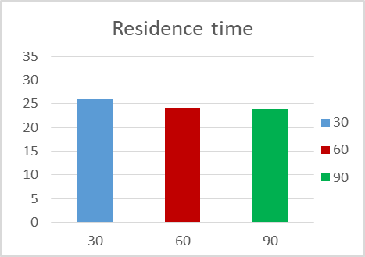
Proximate analysis of PA samples were done by D442-07, D1102, and E872 for moisture, ash and volatile matter respectively. Proximate analysis and Ultimate analysis [18] are shown in 1,Error: Reference source not found. It was found that fixed carbon content was 13.72% and a low ash content of 7 %.
Figure 2 Graph of yield v/s temperature

Table 2 Proximate analysis results for PA
Components | % Mass | Standards
Moisture Content | 10.96 | D442-07
Volatile Matter | 68.16 | D1102
Ash Content | 7 | E872
Fixed Carbon | 13.72
Table 3 Ultimate analysis results for PA
Components | % Mass
Carbon | 41.54
Hydrogen | 5.23
Nitrogen | 0.84
oxygen | 52.39
HHV | 16.44 MJ/Kg

HHV highest heating value

  - Yield
Yield of activated carbon were shown in Error: Reference source not found. It is observed that yield reduced from 31.1 to 22.4% for temperature increase from 500 to 700ºC. Yield of activated carbon decreased as carbonization temperature is Increased. Highest yield of 31.1 % was obtained at temperature of 500 ºC. marginal decrease in yield was observed for increase in residence time, from 26% to 24% for time increased from 30 to 90 min.

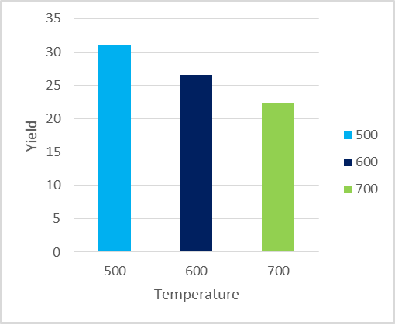
Figure 1 Graph of yield v/s temperature
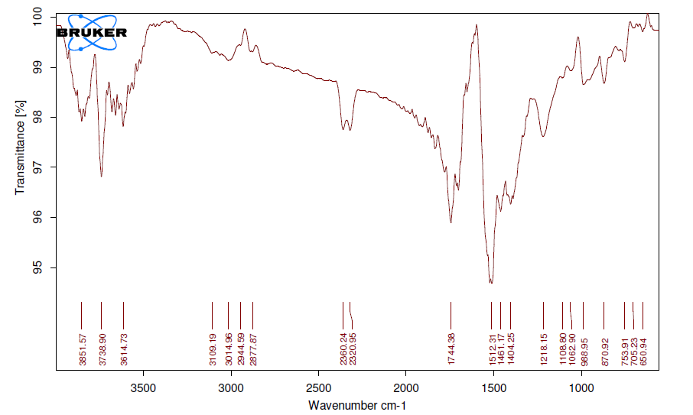
Figure 3 FTIR spectra for AC prepared at 700 ºC, KOH/char ratio 1:1 and residence time 60
Figure 4 N₂ adsorption–desorption isotherms of the ACs obtained at temperature 700 for 60 min a KOH to char ratio of 1:1

  - FTIR analysis
FTIR analysis was performed on sample at different Temperatures. FTIR spectra for AC prepared at 700 ºC is shown in figure 3 IR spectra was similar for samples at different temperatures was similar. O-H stretching vibration in aromatic and aliphatic structure was attributed by presence of peaks between 3851 – 3614.73 cm^{-1.} Vibrations around 3014 cm⁻¹ ⁽methyl and methylene groups C-H), 2360.24 cm⁻¹ (aldehyde group CHO), 1744.28 ^{cm-1 (}carbonyl group C=O) were observed. Out of plane vibration of carboxylic groups occurred around 753 cm⁻¹.

  - Surface area and porosity
Figure 4 N₂ adsorption–desorption isotherms of the ACs obtained at temperature 700 for 60 min a KOH to char ratio of 1:1

Surface area was measured for samples prepared at different temperature keeping residence time and KOH to char ratio constant. The maximum area was obtained for Temperature of 700 ºC with area about 430.173 m²/g. It was observed area increased from 161.168 m²/g at 600 ºC to 430.173 m²/g at 700 ºC, showed that there was increase in surface area with increase in temperature.

  - N₂ adsorption desorption Isotherm
An Adsorption Isotherm was obtained by measuring the amount of gas adsorbed across a wide range of relative pressures at a constant temperature (typically liquid N2, 77K). Figure 4 N₂ adsorption–desorption isotherms of the ACs shows For activated carbon prepared at 700 ºC for 60 min with impregnation ratio 1:1 mixture of type I and type IV Isotherm was obtained. Presence of H4 hysteresis loop indicated micro-mesopores were present. Less mesopore can be attributed from narrow H4 hysteresis loop. Pore volume of activated carbon was found to be 0.225 cc/g.
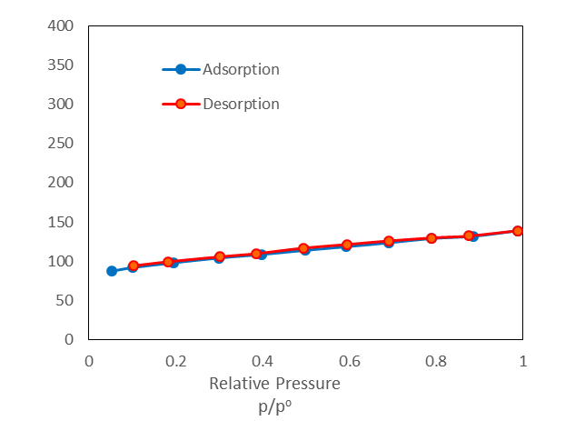

- Conclusions
A micro-meso porous activated carbon was prepared from Pterospermum Acerifolium. Yield of activated carbon decreased with increase in temperature from 500 to 700 and residence time from 30 to 90. Activated. Whereas Surface area increased with increase in temperature. Maximum area was obtained at 700 ºC time 60 as high as 430.173 m²/g. N₂ adsorption-desorption isotherm obtained at 700 ºC for KOH/ char ratio 1:1 and residence time 60 min were mixture of type I and type IV with narrow H4 Hysteresis which indicated presence of less mesopores.

References

[1] H. Demiral and S. Sevgi, “Optimization of activated carbon production from sun fl ower seed extracted meal : Taguchi design of experiment approach and analysis of variance,” vol. 189, pp. 602–611, 2018.
[2] E. Jang, S. W. Choi, S. M. Hong, S. Shin, and K. B. Lee, “Development of a cost-effective CO2adsorbent from petroleum coke via KOH activation,” Appl. Surf. Sci., vol. 429, pp. 62–71, 2018.
[3] W. Zhao, V. Fierro, N. Fernández-Huerta, M. T. Izquierdo, and A. Celzard, “Impact of synthesis conditions of KOH activated carbons on their hydrogen storage capacities,” Int. J. Hydrogen Energy, vol. 37, no. 19, pp. 14278–14284, 2012.
[4] S. Li, K. Han, P. Si, J. Li, and C. Lu, “High-performance activated carbons prepared by KOH activation of gulfweed for supercapacitors,” Int. J. Electrochem. Sci., vol. 13, no. 2, pp. 1728–1743, 2018.
[5] M. Danish, T. Ahmad, R. Hashim, M. Nishat, J. Mohamad-saleh, and O. Sulaiman, “Comparison of surface properties of wood biomass activated carbons and their application against rhodamine B and methylene blue dye,” vol. 11, no. February, pp. 1–13, 2018.
[6] O. Üner and Y. Bayrak, “Microporous and Mesoporous Materials The e ff ect of carbonization temperature , carbonization time and impregnation ratio on the properties of activated carbon produced from Arundo donax,” Microporous Mesoporous Mater., vol. 268, no. January, pp. 225–234, 2018.
[7] H. Nam, W. Choi, D. A. Genuino, and S. C. Capareda, “Journal of Environmental Chemical Engineering Development of rice straw activated carbon and its utilizations,” J. Environ. Chem. Eng., vol. 6, no. 4, pp. 5221–5229, 2018.
[8] Apple tree branches derived activated carbons for the removal of β-blocker.pdf.” .
[9] S. Sajjadi, A. Mohammadzadeh, H. Nguyen, I. Anastopoulos, A. Ivanets, and A. Hosseini-bandegharaei, “E ffi cient mercury removal from wastewater by pistachio wood wastes- derived activated carbon prepared by chemical activation using a novel activating agent,” vol. 223, no. May, pp. 1001–1009, 2018.
[10] M. A. Islam, I. A. W. Tan, A. Benhouria, M. Asif, and B. H. Hameed, “Mesoporous and adsorptive properties of palm date seed activated carbon prepared via sequential hydrothermal carbonization and sodium hydroxide activation,” Chem. Eng. J., vol. 270, pp. 187–195, 2015.
[11] Y. Fu, Y. Shen, Z. Zhang, X. Ge, and M. Chen, “Activated bio-chars derived from rice husk via one- and two-step KOH-catalyzed pyrolysis for phenol adsorption,” Sci. Total Environ., vol. 646, pp. 1567–1577, 2019.
[12] A. H. Basta, V. Fierro, H. El-Saied, and A. Celzard, “2-Steps KOH activation of rice straw: An efficient method for preparing high-performance activated carbons,” Bioresour. Technol., vol. 100, no. 17, pp. 3941–3947, 2009.
[13] M. Al Bahri, L. Calvo, M. A. Gilarranz, and J. J. Rodriguez, “Activated carbon from grape seeds upon chemical activation with phosphoric acid : Application to the adsorption of diuron from water,” Chem. Eng. J., vol. 203, pp. 348–356, 2012.
[14] L. Niazi, A. Lashanizadegan, and H. Shari, “Chestnut oak shells activated carbon : Preparation , characterization and application for Cr ( VI ) removal from dilute aqueous solutions,” vol. 185, pp. 554–561, 2018.
[15] N. T. Abdel-Ghani, G. A. El-Chaghaby, M. H. Elgammal, and E. S. A. Rawash, “Optimizing the preparation conditions of activated carbons from olive cake using KOH activation,” Xinxing Tan Cailiao/New Carbon Mater., vol. 31, no. 5, pp. 492–500, 2016.
[16] S. A. I. Rizvi, “STUDIES OF THE FLOWERS OF PTEROSPERMUM Pterospermum acerifolium Willd ., l a large tree belonging to the Sterculiaceae , is widely distributed in India particularly in sub-Himalayan tract and outer Himalayan valleys and hills up to 4000 ft . Survey of the,” vol. 11, no. 1933, pp. 856–858, 1972.
[17] S. Rangabhashiyam and P. Balasubramanian, “Adsorption behaviors of hazardous methylene blue and hexavalent chromium on novel materials derived from Pterospermum acerifolium shells,” J. Mol. Liq., vol. 254, pp. 433–445, 2018.
[18] S. P. Bhagat, P. Gera, and A. Bhavanam, “Catalytic co-pyrolysis of Pterospermum acerifolium and plastic waste,” J. Mater. Cycles Waste Manag., vol. 0, no. 0, p. 0, 2017.
[19] A. ÖzyuǧUran and S. Yaman, “Prediction of Calorific Value of Biomass from Proximate Analysis,” Energy Procedia, vol. 107, no. September 2016, pp. 130–136, 2017.

