Evaluation of Real Time Embedded Systems In HILS & Delay Issues

LAV Sanhith Rao¹ Dr. P Sreehari Rao² Dr. I M Chhabra³ L. Sobhan kumar⁴
.
^{1,3,4} Scientist, RCI, DRDO, Hyderabad, India; ¹ sanhith139@rediffmail.com
² Associate Professor, NIT Warangal, Warangal, India

Abstract : The present generation war game requires precision engagement with agility. Embedded systems of Aerospace vehicle like Seekers/Sensors are used to provide the necessary Guidance in the terminal phase. Seeker based guidance can shape the latax demand within the capability of the Aerospace vehicle for a precision impact in the terminal phase. In addition, the autonomous guidance of Passive Imaging Infrared (IIR) seeker is less susceptible to external counter measures. Thorough performance evaluation of IIR Seekers and Guidance schemes is very essential for the effectiveness of the mission. For terminal engagement, Aerospace vehicle dynamics and accuracy are the prime factors which can be met by appropriate homing guidance design. Latest advances in seeker/sensor technology for locating target need to be integrated with the guidance system for steering and stabilizing the guided vehicle. Hardware-in-loop Simulation (HILS) of IIR Seekers integrated with the Real Time Six Degrees of Freedom plant & target model helps in evaluation of Aerospace vehicle embedded system design. Establishing the HILS test-bed with seeker & target along with Dynamic Motion Simulators and other sub systems is a major challenge. Various tests and the detailed procedures adopted to evaluate the Embedded systems of Aerospace vehicle in HILS is explained in this paper. The delay issues associated with the HILS runs also discussed at the end.

Keywords:
Seeker, HILS, Embedded systems, Real-time, Delay.

- INTRODUCTION
Seekers locate and track the target to provide in-flight guidance for the flight vehicle and increase the probability of kill based on received energy from the target. Present generation seekers, based on the terminal engagement requirement can be RF / IIR / MMW / Laser or even electro-optical and IR. The data collection from these seeker based sensors (multimode, multispectrum etc) with the interfaces is an important element for guidance system engineering in achieving precision strike with agility under all weather conditions. The seekers for the guidance are mostly stabilized. However, conformal arrays strapped on the body are also being attempted.

Presently, a variable range flight vehicle using homing guidance system based on Charged Coupled Device (CCD) / Imaging Infrared (IIR) stabilized seeker with Lock on before Launch (LOBL) configuration has been integrated for guiding the vehicle from liftoff to terminal engagement. The seeker with its stiff stabilization loop (Bandwidth > 15 Hz) and accurate (≈ 1 milli radian) tracking loop (with agility > 2 Hz bandwidth) needs to be tested with the 5-axis motion simulator to represent real flight combat scenario. Innovative ideas were implemented for evolving various semi-natural (near natural) configurations to validate the embedded guidance and control software with number of flight hardware including the sophisticated seeker systems. The 6-DOF real-time vehicle model was validated during control flight with simulated guidance for flight vehicles. This was extended to a full-scale HILS along with target dynamics for guided flights. A full scale dynamic tests [1] have been evolved for seeker characterization to fine-tune the performance of seeker before HILS.

A Seeker model before dynamic tests is helpful in specifying the requirements of dynamic tables. A target motion system dynamics has to be much higher than that of guidance loop and preferably more than Seeker track loop. Further, Aerospace vehicle autopilot bandwidth requirement demands much higher dynamics of Flight motion simulator (FMS). The Isolation ratio of seeker can be tested with a higher dynamic FMS. A typical HILS testbed has been established within the present limitation for validating the guidance and control system. At present, HILS configuration has been upgraded depending on the available state-of-the-art vehicle and target motion simulation systems.

Attempts are being made to introduce IR target growth, atmospheric attenuation and background Scene generation in HILS. This will avoid the uncertainties arising due to simplifications in mathematical models for validating the Image processing algorithms under dynamic conditions. Facilities are geared up to connect entire hardware, actual/simulated ground computers with sophisticated and flexible input-output interfaces to bring connectivity in real time simulation environment.

In this paper the homing guidance requirements and techniques along with seeker are brought at the beginning. Simulation techniques, modelling features are followed by dynamic tests with results. Finally, HILS with an IIR seeker of anti tank aerospace vehicle has been highlighted with the results. Relevant conclusions and references are given at the end.

- HOMING GUIDANCE REQUIREMENTS AND TECHNIQUES

For guided vehicle terminal engagement, vehicle dynamics and accuracy are the prime factors which can be met by appropriate homing guidance design. Latest advances in sensor/seeker technology for locating target and vehicle need to be integrated with the guidance system for steering and stabilizing the guided vehicle. The functional block diagram of any Flight vehicle can be shown as given in Fig.1

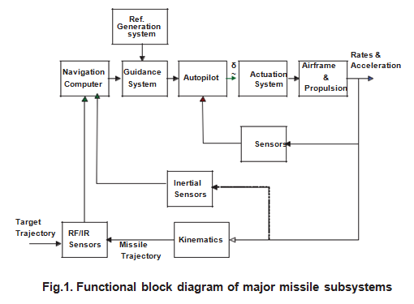
Fig. 1 Functional block diagram of aerospace vehicle

In this context, a typical Anti Tank weapon using homing guidance system based on IIR stabilized seeker is considered. This uses Lock On Before Launch (LOBL) for guiding the weapon. The seeker system as well as entire guidance and control system need to be evaluated independently before integration. A typical dynamic test plan for characterizing the seeker was evolved which helped in evaluating the performance of the seeker for meeting the need of guidance system design. Additionally, total dynamic target scene generation for IIR need to be evolved for validating the image processing algorithm required for homing guidance systems. Presently the image processing for finding the target signatures by IIR seeker is carried out by Captive Flight Trials using helicopter.

The flight vehicle homing guidance requirements with stabilized seekers change with miniaturization as well as state of the art algorithm design. The Precision Guided Munition (PGM) also have similar requirements with stabilized seeker where the Lock On has to be carried out after ejection with appropriate automatic target recognition techniques. In this case integration with mother vehicle avionics including transfer of navigation data after appropriate sensor data fusion using GPS/INS techniques is also needed. Further mother vehicle strapdown GPS/INS guidance scheme may be enhanced with the aid of IIR stabilized seeker with reasonable range (<10Km). The ABMs also need IIR based stabilized seekers with range around 30Km for endo and exo atmospheric engagement against high velocity air targets (with relative velocity 3-6Km/s).

Classical guidance schemes based on homing using pursuit path, constant bearing path and proportional navigation [2] has been used traditionally. Augmented proportional navigation law with addition of acceleration command to account for target manoeuvring has also been pursued. Today’s modern guidance schemes for meeting the homing guidance requirements may be summarized as below:

- Variants of PN (e.g. APN ) with estimation techniques and other image processing techniques
- Enhanced guidance law (e.g. Zero Sliding Guidance law etc.) with more number of state estimations and prediction of target recursively
- Use of optimal control based on linear quadratic techniques
- Use of neutral nets in a hybrid fashion.
- Parallel structures with distributed storage and processing for faster numerical computations.
- Learning ability for adjusting weight and biases for nonlinear dynamics.
- Adaptability in the changing environment.

A typical seeker based terminal guidance scheme can be described by the Fig. 2.

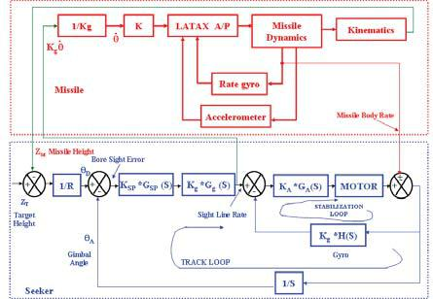

Fig. 2 Typical Seeker Based Terminal Guidance Scheme

The stiff stabilization loop for precise tracking by the seeker is one of the technology needs for various kinds of stabilized seeker systems. In today’s world, attempts are made to build state-of-the-art strap down seeker using embedded/ conformal arrays. However, IIR/Electro-optical stabilized seeker based terminal guidance has been realized and flight proven for Anti Tank Aerospace vehicle. The world scenario for stabilized seekers is progressing well but information about the use of state-of-the-art strap down seekers is limited. This technology has to be explored separately for future terminal guidance.
In today’s scenario aim of terminal guidance for neutralizing number of surface targets can be achieved by using terminally guided sub munitions. However, the homing guidance requirements may be summarized as:

- Lesser gathering basket based on mid-course, energy management inertial instrumentation and processing aided with GPS.
- Appropriate lock on to target (before or after launch depending on need)
- Reliable tracking data
Relative aerospace vehicle-target range
LOS angle
LOS angle rate
Bore sight error angle
- Appropriate guidance law leading to minimum miss distance in the presence of
Target manoeuvres
External and internal disturbances
- Effective flight control system
Steering capability for the guidance law
Required Latex generation
Stabilization of bare airframe
Reduction of sensitivity to disturbance inputs
Use of three loop autopilot with synthetic stability loop.

Dynamic tests as well as state of the art HILS techniques are to be pursued for freezing terminal guidance system design.

- SEEKER MODELLING & DYNAMIC TESTS

The use of modelling and simulation in the development of military weapon system began to expand several years ago as the cost of flight testing began to rise. Since then, the role of modelling and simulation has expanded to include Hardware In Loop Simulation (HILS), which helps for system design and development. It also plays an important role in development of seeker based terminal guidance for guided aerospace vehicles. The seeker based terminal guidance system can be visualized as shown in Fig. 3.

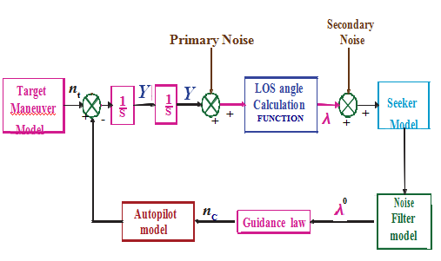
Fig.3 Seeker based Terminal Guidance System

The mathematical modelling and its match with H/W characterization with appropriate test bed leading to total HILS can be summarized as below:
A. Mathematical Model
- Seeker dynamic system model
- Seeker system front end model
- Seeker model integration with aerospace vehicle model
- Aerospace vehicle +seeker integrated model in mission scenario.

B. Test-bed Preparation
- Simulink / MatrixX Software and generated / developed S/W in Non Real Time (NRT)/ Real time (RT) environment for seeker model.
- Use distributed processing environment with Guidance laws, Navigation & Control modules for RT Rapid Prototype environment using PCs & state of the art RT simulation computers
C. Seeker H/W Characterization
- Dynamic characterization of H/W seeker
- IIR system characterization including dome

D. Test-bed Preparation
- Use the RT test-bed with high speed data link for control & visualization.
- Independent test-bed for seeker system characterization.

This needs to be followed by Hardware in Loop Simulation (HILS) which has been described in next section.

During development of CCD based seeker of ATM, it was felt necessary to evolve a full scale dynamic test bed for characterizing the seeker. The homing guidance loop with its inner tracking and stabilization has been described in Fig.2. The independent characterization of the stabilization loop as well as track loop is necessary for meeting the performance requirements of PN guidance law as observed during the course of seeker based guidance system design. The test bed was geared up with a high fidelity (±30º/s body rate@40 Hz).

Single Axis Rate Table (SART). Further Target Motion System (TMS) with dynamic response much higher than the track loop (>1.5 Hz @ 10º/s SLR) was also introduced.

IIR Seeker mounted on SART (Single Axis Rate Table) Test bed for Conducting HILS and Dynamic tests

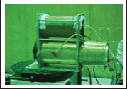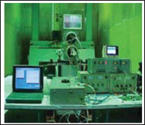

Fig.4 Setup for Seeker HILS & Dynamic Tests
The following tests have been performed for characterizing the seeker dynamically.

- Isolation Ratio
- Decoupling Ratio
- Bore sight shifting test (Step body rate)
- Track loop bandwidth
- Bore sight step response
- Step target motion (Bore sight Impulse response)
- Sight Line rate calibration

The ratio of Aerospace vehicle body rate to gimbal angle rate and sight line rate are defined as Isolation and decoupling ratios respectively. Isolation ratio defines the degree of Isolation between Aerospace vehicle body and Seeker gimbal i.e irrespective of aerospace vehicle body disturbances seeker gimbal will continue to stare at the target. Decoupling ratio dictates the tracking of target irrespective of disturbances in body rate. A picture of test setup is given in Fig. 4. However detailed setup of both the tests is shown in Fig. 5.

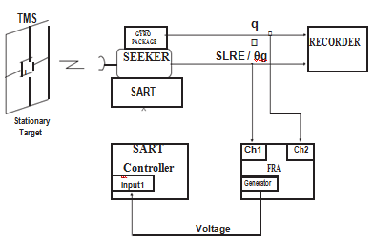
Fig. 5. Isolation and Decoupling test

The bore sight shifting against a sudden body jerk was tested in the dynamic test bench as shown in Fig.6.
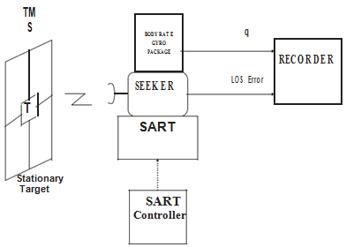

Fig.6. Bore Sight Shifting test

It was observed that LOS error was less than 0.36º (<1/3 FOV) even for 100º/s step body rate experienced. Bore sight step response test (test bed similar to bore sight shifting test) has been designed to test shift in bore sight at the start of track loop. This requirement is very typical for Lock On After Launch (LOAL) situation especially for PGMs. A typical bore sight step requirement of 1º gives an overshoot of 0.3º only (< FOV). To determine the impulse response of bore sight against a step target motion the test bed used is given in Fig 8.

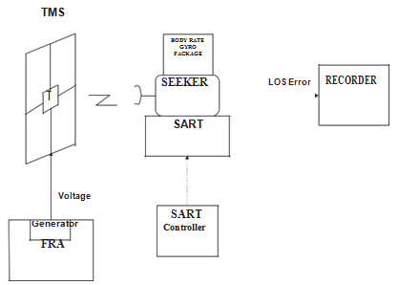
Fig.7. Step Target Motion test

In case of IIR seeker of an ATM, even for a step input of 0.5º to the target (1/3 FOV) the seeker does not loose the track and bore sight error settles within 800ms with a peak SLR of 5-6º/s. The track loop bandwidth was tested with physical sinusoidal target motion (± 2º/s over a sweep of 0.5-3.0 Hz) and the seeker was able to track upto 2.5 Hz (>Guidance bandwidth of 0.5-0.6 Hz) with 90º phase shift. The test setup is similar to Fig 4 and details are given in Fig. 8.

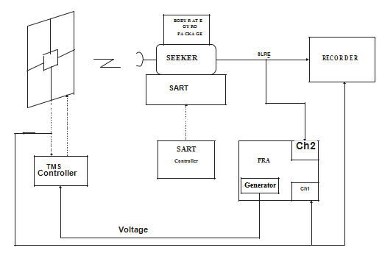
Fig.8. Track Loop Bandwidth

Sight Line Rate (<10º/s) need to be calibrated against target accelerations of 10º/s². The calibrations were done in both Azimuth and Elevation planes over entire dynamic range of seeker gimbal angle. A typical trapezoidal SLR target motion was designed for performing this test as given Fig.9 and test setup is shown in Fig.10.

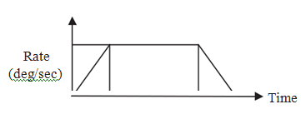
Fig.9. Trapezodial Waveform Input to TMS

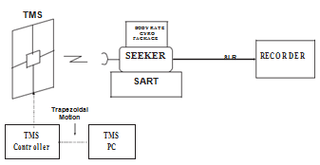
Fig. 10. SLR Calibration

This new testbed setup for performing dynamic tests and calibration was established and performance of the CCD & IIR seekers were thoroughly validated which brought out deviations in design precisely. A typical Isolation ratio, Decoupling ratio and Track loop bandwidth test plots for IIR seeker with various rates at different frequencies is given in Fig 11.

- HARDWARE IN LOOP SIMULATION AND RESULTS

The dynamic tests have also helped to make the seeker ready for integrated HILS[3-10]. During HILS tests, a Six DOF rigid body model was integrated with the Hardware seeker and On board computer. At the beginning a simplified seeker model was introduced which was later replaced by the real hardware. A typical seeker dynamic model has been already described in Fig 2. This needs to be augmented with Front end CCD/IIR processing details. IR Target Growth Simulator will be introduced in HILS for simulating the growth of target along with atmospheric attenuation during the course of the flight. This will be enhanced subsequently by Target scene generation system. However, Helicopter based captive flight trials were performed for validating the Image processing algorithms independently.

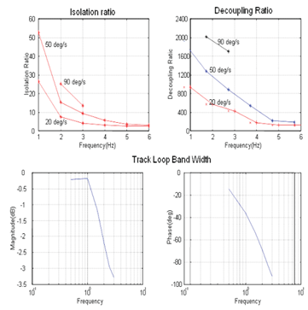
Fig.11. Typical Dynamic Test Results

A test plan was worked out for performing HILS with CCD/IIR seeker. The main objectives of seeker in loop HILS are

- Validation of Control & Guidance system.
- To study seeker dynamic performance with Aerospace vehicle and trajectory dynamics.
- To check functionality & performance of various Flight Hardwares
- To check the Flight H/W & S/W in the integrated manner.

Due to the limitation of existing Aerospace vehicle Motion Simulator (MMS) it was decided to use SART and TMS during initial phases for validating basic design related issues as well as clearance of subsystems for initial flight trials. In addition a point target (bulb) was used on the TMS for closing the track loop during HILS. As mentioned earlier this will be augmented by appropriate target growth & scene generation systems in future.

Open loop guidance, guidance FLIP run, semi closed loop HILS, and single plane HILS were performed in stepwise manner. Further open loop guidance was continued leading to closed loop HILS using 5-Axis motion simulator (after upgradation) and TMS. No target motion was imparted till semi closed loop HILS since appropriate TMS was not available. After the introduction of TMS full scale single plane HILS was performed using high fidelity SART . Initially the aim was to test the performance of the stabilization and track loop in guided flight trajectory which was followed by testing of control & Guidance algorithm resident in the CGC during Guidance FLIP (Flight Input Profile) run. Certain semi natural closed loop HILS were performed with static & moving targets. It was found that Single plane HILS in Azimuth & Elevation planes with synthetic SLR to TMS and corresponding plane body rates to SART creates a meaningful realistic dynamic combat scenario. This was validated with number of flight trial results. The semi natural single plane HILS, where complete 6 DOF equations are enabled is described in Fig.12.

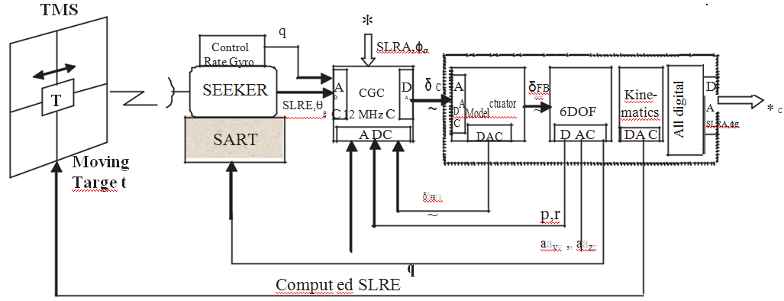
Fig.12 Single Plane HILS

The SLRs & Gimbal angles from seeker and Aerospace vehicle body rate from rate gyro in one plane are fed physically to CGC and the same in the orthogonal plane are fed from the data generated apriori from All digital 6 DOF simulation runs. A typical Single plane HILS results as compared to flight results is given in Fig.13.

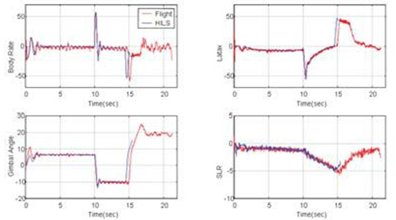
Fig. 13 Typical Seeker HILS Results

The body rates, accelerations, SLRs and Gimbal angles in the same plane are validated with actual flight results. Final closed loop HILS with 5-Axis motion simulator was also performed within limitation of the facility. This setup is shown in Fig.14. However a full scale 5- Axis closed loop HILS facility has been evolved for future missions.

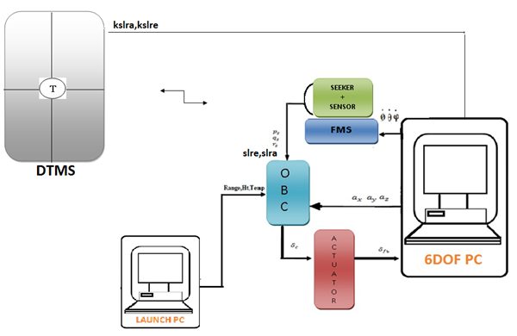

Fig.14 Complete Seeker HILS Setup

- DELAY ISSUES

The delay associated with different subsystems and motion simulators in HILS test bed is very critical in conducting the HILS runs. As we said earlier the delay offered by TMS will cause the tracking delay of seeker. This tracking delay will enter into the track loop of the seeker and gives a delayed Line of sight (LOS) errors and in turn gives delayed Sight line rate (SLR) values. This delayed SLR enters into the guidance loop of Aerospace vehicle and gives delayed latex. This delayed latex will excite control algorithm and results into diverging oscillations.

This delay has to be compensated to conduct the HILS runs efficiently in order to validate the Embedded systems of Aerospace vehicle in Real time closed loop environment much prior to the actual field tests.

- CONCLUSIONS
Homing guidance requirements and techniques along with seeker modelling and various dynamic tests have been brought out in this paper. Integrated seeker dynamic tests have been evolved for IIR and CCD seeker characterization. It has helped in guidance system design and validation before flight trials. Typical modelling features and various HILS configurations have been highlighted starting from semi natural configuration within limitation of available motion simulators.
The single plane HILS has been validated with flight trial results. However, state-of-the-art HILS facility with high fidelity motion simulators and IR target growth and dynamic scene generation facilities are being introduced for simulating the future aerospace vehicle-target engagement scenario. The delay issue existing in HILS runs is discussed and to be compensated in future to carry out HILS runs effectively.

- REFERENCES

- Dr. S.K. Chaudhuri, G.Venkatachalam, M.Prabhakar, etal “Validation of Guidance and Control systems for Tactical Aerospace Vehicles” AIAA Modeling and Simulation Technologies Conference, 6-9 August, 2001 Montreal, Canada.
- Zarchan “Tactical and Strategic Missile Guidance”.
- S.K.Chaudhuri, G. Venkatachalam and M. Prabhakar, “Hardware-in-Loop Simulation for Missile Guidance & Control Systems”, Defence science journal , vol 47, No.3, July 1997
- Kresimir Cosic, Ivica Kopriva, Todor Kostic, Miroslav Slamic, Marijo VolareviC, “Design and implementation of a Hardware-in-the loop simulator for a semi-automatic guided missile system,” Simulation Practice and Theory Volume 7, Issue 2, 15 April 1999, Pages 107-123
- Ryan C. Underwood, Bruce M. Mc Millin ,M. L. Crow “An open framework for highly concurrent hardware-in-the-loop simulation,” 2008 32nd Annual IEEE International Computer Software and Applications Conference, CD-ROMISBN: 978-0-7695-3262-2, DOI: 10.1109/COMPSAC.2008.165
- Mahmoud Matar, Houshang Karimi, Amir Etemadi and Reza Iravani, “A High Performance Real-Time Simulator for Controllers Hardware-in-the-Loop Testing,” 4June 2012. Energies 2012, 5, 1713-1733; doi:10.3390/en5061713
- Mariano I. Lizarraga, Vladimir Dobrokhodovy, Gabriel H. Elkaimz, Renwick Curryx, Isaac Kaminer, “Simulink Based Hardware-in-the-Loop Simulator for Rapid Prototyping of UAV Control Algorithms,” Unmanned...Unlimited Conference 6- 9 April 2009, Seattle, Washington.
- Erkan Duman, “FPGA Based Hardware-in-the-Loop (HIL) Simulation of Induction Machine Model” 21-24 Sept. 2014,16th International Power Electronics and Motion Control Conference and Exposition Electronic ISBN: 978-1-4799-2060-0, DOI: 10.1109/ EPEPEMC.2014.6980564, Antalya, Turkey
- Haowen Zhang; Wulong Zhang; Yunjie Wu; Jianmin Wang, "Background modeling in infrared guidance hardware-in-loop simulation system," Guidance, Navigation and Control Conference (CGNCC), 2014 IEEE Chinese , vol., no., pp.553,557, 8-10 Aug. 2014
- NingShen; Zhaojiang Su; Xinmin Wang; Yan Li, "Robust controller design and hardware-in-loop simulation for a helicopter," Industrial Electronics and Applications, 2009. ICIEA 2009. 4th IEEE Conference on , vol., no., pp.3187,3191, 25-27 May 2009

