Experimental Study to Determine LDR in Deep Drawing of C11000 Copper blanks

A C Sekhara Reddy Researc Scholer, O U Dept. of Mechanical Engineering Sreyas Institute of Engineering and Technology Hyderabad, Telangana acsreddy64@gmail.com
S Rajesham
Dept. of Mechanical Engineering
Rajiv Gandhi University for Knowledge Technologies Basar, Telangana, India rajesham_s@yahoo.com
P Ravinder Reddy
Dept of Mechanical Engineering
C B I T, Gandipet,
Hyderabad, India
reddy.prr@gmail.com

Abstract— The number of stages in design of multistage deep drawing process depends upon the limiting drawing ratio (LDR). The LDR is an essential design component for process engineers to minimize forming steps in multistage deep drawing process. The deep drawing experimental tests were conducted using the test-rig developed at research facility in the lab. The 80 mm die and punch set was used for producing copper C11000 cups of 1 mm thickness. The size range of blanks used was from 100 mm to 180 mm with 10 mm increment. The maximum punch load and the quality of the cups produced were recorded. The LDR was found using the concept of characteristic punch limit load. The LDR found through experiments was 1.8875.
Keywords— Deep drawing, Blank offset, FE simulation, PAM-STAMP
- INTRODUCTION
The sheet metal forming process is used for the production of cup shaped quality products at low manufacturing costs. It is essential to produce 2D or 3D components for automobile bodies, railroad cars, airplanes, farm and construction equipment, office furniture, electronic instruments, computer appliances, using a minimum number of forming operations. The major reasons for advancement in research and development in sheet metal forming process is to have pollution-free environment and safety.
In the past two decades, the automotive industry is facing enormous challenges in reducing the weight of vehicles, using lightweight materials. The sheet metal stampings are having large applications in automobile and beverage industry. Limiting Drawing Ratio (LDR) is an important formability measures in manufacture of cup shaped components such as fuel tanks. The Fig.1 shows the sketch of the deep drawing process.
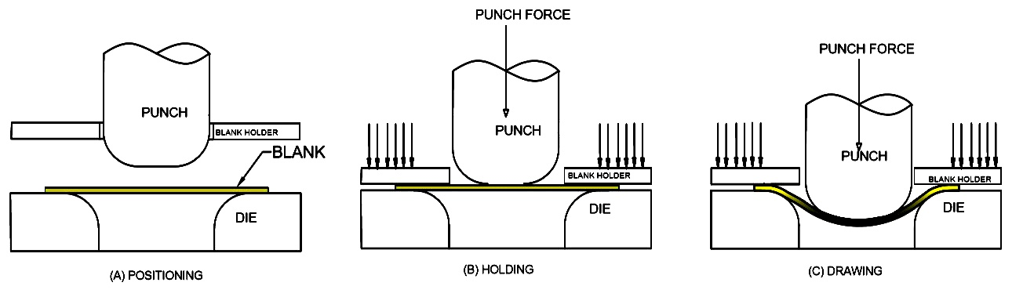
Fig.1. Different stages in deep drawing process

Pourboghrat et al. [1] conducted a research study on the deep drawing of AA5754 aluminum sheets. Forming experiments were conducted using cylindrical punch and various parameters such as displacement, punch force, hydro-forming pressure, temperature and the maximum draw depth prior to wrinkling/tearing were recorded for comparing with simulation readings. It was concluded that Sheet Hydro-Forming (SHF) and Thermo Hydro-Forming (THF) can achieve more than 100% deep drawing with the AA5754 aluminum sheet. Ibrahim et al. [2] conducted a study of the influence of the blank holder force in deep drawing on the AA5754-O material. An experimental setup was constructed to apply variable forces through computer-control of the blank holder and sheet plate. Cup depths, tearing and variation in wall thickness of experimental and numerical results were compared. It was observed that no. of ears and wrinkles for blank holder pressures between 1.3 MPa and 8 MPa in square cup deep drawing process, whereas the tears observed for pressures exceeding 18 MPa. It was further observed that the best forming took place at 5 MPa and the numerical and experimental model developed was in harmony with each other at the rate of 85%. Hot drawing process of aluminum alloy sheet was conducted by W. Ma et al [3] in order to gain deep insight into the deep drawing process. The simulations at elevated temperatures were carried out with experimental validation. The influence of parameters, namely punch velocity, Blank- Holding Force (BHF) and friction coefficient were investigated. In the deep drawing process, the BHF is an important process parameter affecting the energy consumption successful for production of the parts [4].
The formability of AZ31 studied experimentally and numerically by Reddy et al [5] using FEM software ABAQUS. In both cases LDR increased significantly as the temperature increases. Experimental study had been conducted by Reddy et al [6] on single stage deep drawing process for assessment of radial strain, circumferential strain and thickness variation in aluminum alloyAA6061. Cylindrical cup deep drawing experimental tests were performed with blank of 350 mm diameter of 0.9 mm thickness sheet. It has been found that deeper cups were produced by selecting the optimum design parameters and the results are in good agreement with simulation results found form literature. The experimental investigation of rapid determination of LDR had been performed on an automotive aluminum alloy sheet AA6111 by Reddy et al [7] based on characteristic limit load. The LDR found was 2.37 and it is indeed in good agreement with the results found elsewhere in the literature. The optimization techniques using Taguchi techniques were very well experimented [8-16] for parameter optimization in design of experiments and this concept can be well applied for deep drawing process for yielding quality cups.
The amount of drawing performed on a sheet metal blank has to be quantified by means of drawing ratio. There is a limit to the amount of deep drawing that can be performed on a sheet metal blank in a single operation due to various parameters influencing in the process.
The drawing ratio is roughly calculated as
DR = Db/Dp (1)
The determination of LDR for a given material is an important method to bring down the tooling costs and minimize rejections. The Limiting Drawing Ratio (LDR) is defined as the ratio of the maximum diameter of the blank that can be successfully drawn without failures for the given punch diameter and can be expressed as
L D R= (Db)_{max}/D_{p} (2)
where (Db)_{max} is the maximum size of the blank to be successfully drawn and D_{p} is the diameter of the punch. Various parameters influencing in LDR are punch nose radius, die shoulder radius, punch speed, blank holding force, friction, type of lubrication, clearance between punch and die and material properties, thickness of the blank. The process involves different types of stresses as shown in Fig.2.
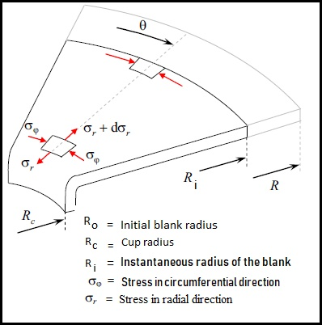
Fig. 2. Stress state in flange portion during deep drawing
- THEORETICAL ANALYSIS

The simplifying assumptions used in this model are [154, 155]:
1. The energy loss due to friction while bending and unbending is negligible and deformation efficiency factor h is employed at the final step
2. As the stress-strain exponent has negligible effect upon LDR, the material is considered perfectly plastic with strain hardening exponent n = 0.
3. No change in thickness of the sheet.
4. Material exhibits planar isotropy
The process of deformation in deep drawing process and its mechanism is shown in the Figure 3.109.
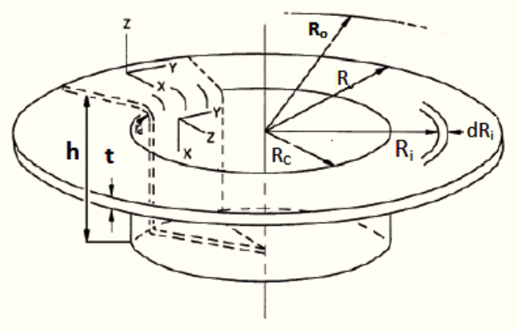
Fig. 2. Drawn cup with flange

Considering the geometry of the process as shown in Figure 2 and assuming plane strain condition, i.e., strain (e_{z}) in thickness direction is zero. Then, according to the principle of volume constancy
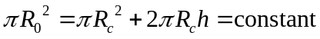 (1)
The incremental reduction in the flange area is equal to p R2o
= p R2c
+ 2 p Rc h = constant (3.13)

Hence the incremental reduction in the flange area is equal to the incremental increase in the wall. Hence

in the wall portion. It can be written as shown in equation 3.14 below.
2 p Ri dR = 􀀀 2 p Rc dh (3.14)
Where
Ri = Instantaneous radius of the blank
dh = Instantaneous increment in the height of the cup
143
Rc = Radius of the cup
The Equation 3.14 can be rewritten as
dR
Ri
= 􀀀
Rc dh
R2i
(3.15)
i.e., strain over the flange portion can be written as
dex = 􀀀dey =
Rc dh
R2i
(3.16)
The incremental work done for an incremental change in cup height ’dh’ with cup radius
Rc is
dW = stress x strain x volume change (3.17)
=(sx􀀀sy) (
Rc dh
R2i
) (2p t Ri dRi) (3.18)
=
2 p t Ri dRi (sx􀀀sy) Rc dh
R2i
(3.19)
=
2 p t Ri dRi (sf ) Rc dh
R2i
(3.20)
=
2 p t dRi (sf ) Rc dh
Ri
(3.21)
where sf is the flow stress of the material
For an ideally plastic material, the total work for an increment of punch travel is given by
dW
dh
=
Z R
Rc
2 p Rc t sf
Ri
dRi (3.22)
=2 p Rc t sf ln
R
Rc
(3.23)
=Fd (3.24)
where Fd is the punch load
The drawing force is maximum when R = R0
Therefore, this maximum force is as follows
144
Fd(max) = 2 p Rc t sf ln
Ro
Rc
(3.25)
where R0 and Rc are the blank and cup radii respectively.
Fig. 3.109: Drawn cup with flange
Fig. 3.110: Relation between ln (Ro=Rc) and Ro=Rc
145
As we seen from the above Figure 3.110 that ln(Ro=Rc) linearly increases with
Ro=Rc ratio.
Fd(max) = k 2 p Rc t sf
Ro
Rc
(3.26)
The equation can be simplified to to
Fdmax =2 p Rc t sf ln(
R0
Rc
) (3.27)
=k 2 p Rc t sf
R0
Rc
(3.28)
=( k 2 p t sf ) R0 (3.29)
= K D0 (3.30)
Where k and K are the proportionality constants
Hence, It has been proved that the maximum punch load is linearly proportional to the
maximum diameter of the blank below its critical size.
Fdmax = K D0 (3.31)
Hence, it is has been proved that the maximum drawing force is linearly proportional to
the blank diameter up to the limit of failure. After the failure limit, there will be tearing
instead of drawing and tearing force remains constant and it doesn’t depends upon the
oversize of the blank.
1
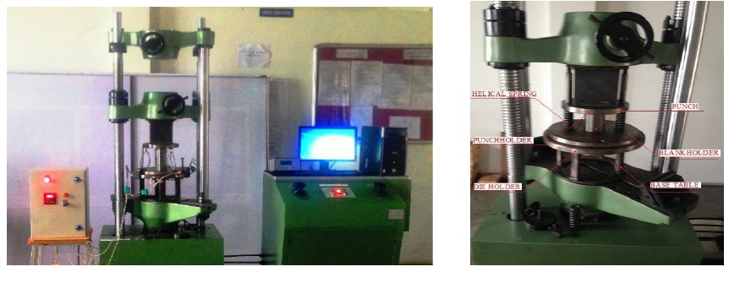
Fig. 3. Deep drawing setup used for experimental works

- EXPERIMENTAL WORKS
The deep drawing tests were conducted at room temperature using the deep draw test-rig developed in the Department using universal testing machine as shown in Fig. 3. The material and tool properties are shown in Table 1.

Component | Parameter | Value
Punch | Diameter | 80 mm
Punch | Nose radius | 5.5 mm
Die | Inner diameter | 81.5 mm
Die | Shoulder radius | 5.5 mm
Blankholder | Inner diameter | 85 mm
Blankholder | Outer diameter | 250 mm
Blankholder | Thickness | 30 mm
Blank | Diameter(s) | 120-140 mm
Blank | Thickness | 0.9 mm

The draw tests were conducted on different sizes of circular blanks such as 100 mm, 110 mm, 120mm, 130 mm, 140 mm, 150 mm, 160 mm, 170 mm and 180 mm of 1 mm thick. The drawn cups with the load vs. displacement curves are shown in Fig. 3 to Fig. 11.
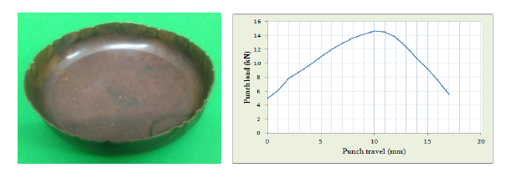
Fig. 3. Punch load vs. depth curve and the cup drawn for 100 mm copper blank drawn at room temperature
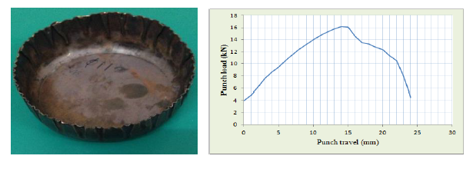
Fig. 4. Punch load vs. depth curve and the cup drawn for 110 mm copper blank drawn at room temperature
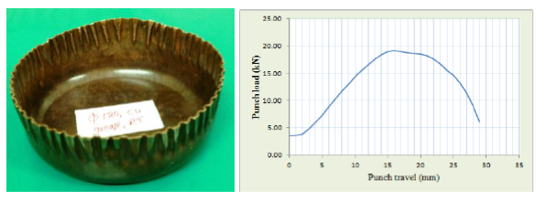
Fig. 5. Punch load vs. depth curve and the cup drawn for 120 mm copper blank drawn at room temperature
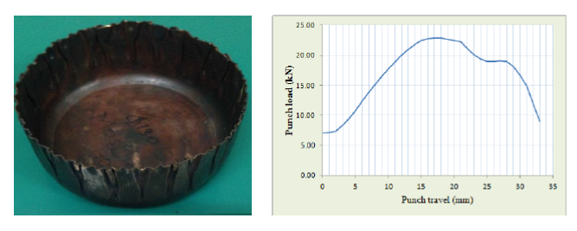
Fig. 6. Punch load vs. depth curve and the cup drawn for 130 mm copper blank drawn at room temperature
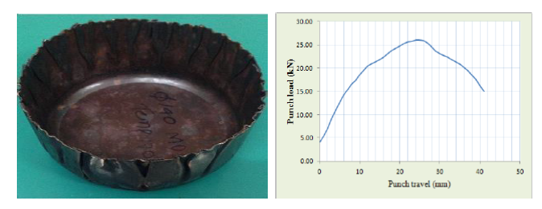
Fig. 7. Punch load vs. depth curve and the cup drawn for 140 mm copper blank drawn at room temperature
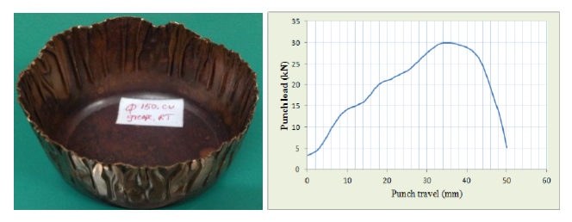
Fig. 8 Punch load vs. depth curve and the cup drawn for 150 mm copper blank drawn at room temperature
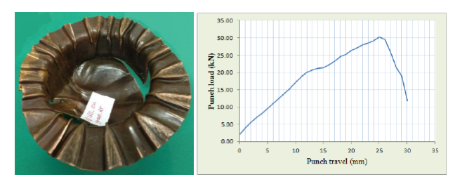
Fig.9. Punch load vs. depth curve and the cup drawn for 160 mm copper blank drawn at room temperature
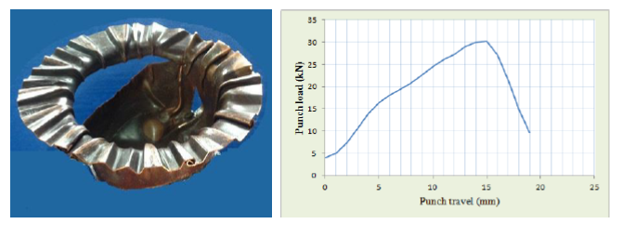
Fig. 10. Punch load vs. depth curve and the cup drawn for 170 mm copper blank drawn at room temperature

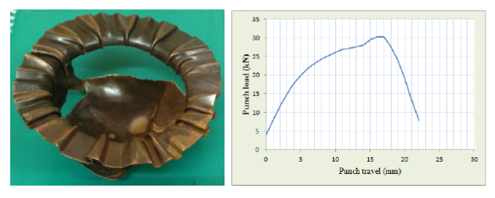Fig.11. Punch load vs. depth curve and the cup drawn for 180 mm copper blank drawn at room temperature

results an discussions
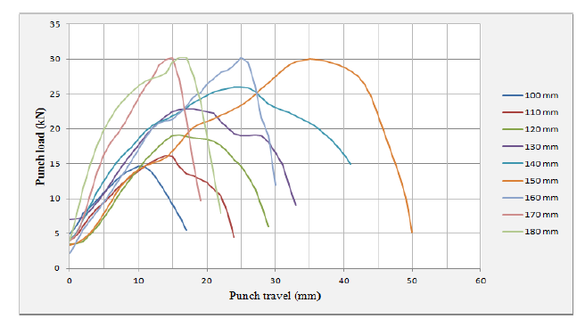
Fig.12. Punch load vs. punch displacement for copper blanks drawn at room temperature
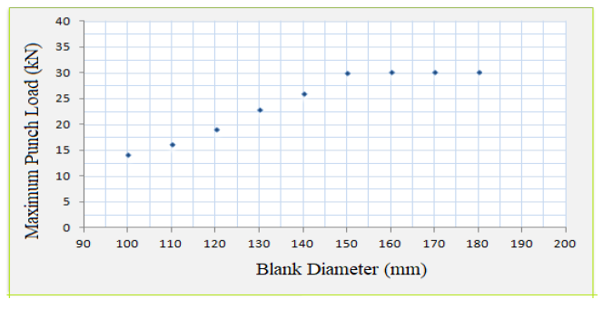
Fig.12. Maximum punch load vs. punch displacement for copper blanks drawn at room temperature
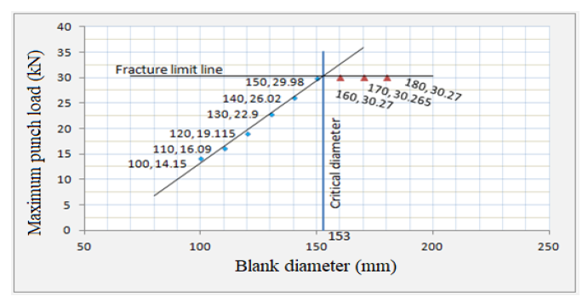

Fig.12. Determining the critical diameter by traditional method

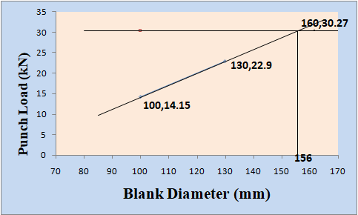

Fig.13. Rapid method of determination critical diameter of the blank

Conclusion
The following conclusions are drawn from the current study.
1. The maximum punch load drawn is linearly proportional to blank diameter up to critical diameters and remains constant thereafter.
2. The critical diameter was found from the current study for copper C11000 151 mm.
3. The Limiting Drawing Ratio (LDR) obtained was 1.8875

References
- Ngoc-Trung Nguyen, Oh Suk Seo, Chung An Lee, Myoung-Gyu Lee, Ji-hoon Kim, and Heon Young Kim. Mechanical behaviour of az31b mg alloy sheets under monotonic and cyclic loadings at room and moderately elevated temperatures. Materials, 7(2), 1271–1295 (2014)
- Young Moo Heo, Sung Ho Wang, Heon Young Kim and Dae Gyo Seo. The effect of the drawbead dimensions on the weld line movements in the deep drawing of tailor –welded blanks, Journal of material processing Technology, 113, 686-691 (2001)
- Mark Vrolijk, Takayuki Ogawa, Arthur Camanho, Manfredi Biasutti, and David Lorenz. A study with ESI PAM-STAMP on the influence of tool deformation on final part quality during a forming process. Proceedings of the 21st International ESAFORM Conference on Material Forming, 1600291-1600296 (2018)
- Lin, Bor-Tsuen, and Cheng-Yu Yang. "Applying the Taguchi method to determine the influences of a microridge punch design on the deep drawing." The International Journal of Advanced Manufacturing Technology 88, no. 5-8 (2017): 2109-2119.
- Shukla, Anoop Kumar, T. Raghu, S. Rajesham, and I. Balasundar. Analysis of significant parameters influencing formability of titanium alloy by using over all evaluation criteria and new matrix model based on Taguchi method. Transactions of the Indian Institute of Metals 67(5), 721-730 (2014)
- Shukla, Anoop Kumar, T. Raghu, S. Rajesham, and I. Balasunder. Optimization of formability parameters of alpha–beta-processed titanium alloy at elevated temperature. Proceedings of the Institution of Mechanical Engineers, Part L: Journal of Materials: Design and Applications 228(3), 231-240 (2014)
- Reddy, A. C. S., S. Rajesham, and P. R. Reddy. Experimental and simulation study on the warm deep drawing of AZ31 alloy. Advances in Production Engineering & Management 10(3),153-161 (2015)
- Kumar, Anoop, T. Raghu, and S. Rajesham. Influences of Temperature of Thermo Mechanical Working on Hardness of Titanium Alloy. In Advanced Materials Research, 585, 381-386 (2012)
- Reddy, AC Sekhara, and S. Rajesham. Determination of LDR in deep drawing using reduced number of blanks. Materials Today: Proceedings 5(13), 27136-27141 (2018)
- Kandasamy, J., M. Manzoor Hussain, and S. Rajesham. "Computational Analysis And Experimental Investigations On The Influence Of The Fsw Tool Pin Profiles Towards Superior Imc In Aluminum Alloys." i-Manager's Journal on Mechanical Engineering 2(2),7-12 (2012) Farhang Pourboghrat, Senthilkumar Venkatesan, and John E Carsley. Ldr and hydroforming limit for deep drawing of aa5754 aluminum sheet. Journal of Manufacturing Processes, 15(4) (2013) 600–615.
- Reddy A C Sekhara, S Rajesham and P Ravinder Reddy, Experimental study on strain variation and thickness distribution in deep drawing of axisymmetric components, International Journal of Engineering 2(12) (2013) 2214-2218.
- Reddy A C Sekhara, S Rajesham, P RavinderReddy, Evaluation of limiting drawing ratio (LDR) in deep drawing by rapid determination method. Internal Journal of Current Engineering and Technology 4(2), (2014) 757-762.
- Rao R S, Prakasham R S, Prasad K K, Rajesham S, S P N , Sarma P N and Rao, LV, Xylitol production by Candida sp, Parameter optimization using Taguchi approach. Process Biochemistry, 39 (8) (2004) 951-956.
- Rao R. Sreenivas, Xylitol production by Candida sp, parameter optimization using Taguchi approach, Process Biochemistry 39.8 (2004) 951-956.
- Prakasham R S, Rao C S, Rao, R S, Rajesham S, & Sarma P N, Optimization of alkaline protease production by Bacillus sp. using Taguchi methodology, Applied biochemistry and biotechnology 120.2 (2005) 133-144.
- Reddy, A C S, Rajesham S, Reddy P R, Kumar T P, and Goverdhan J, An experimental study on effect of process parameters in deep drawing using Taguchi technique, International Journal of Engineering, Science and Technology 7.1 (2015) 21-32.
- [154] F Fereshteh-Saniee and MH Montazeran. A comparative estimation of the forming load in the deep drawing process. Journal of Materials Processing Technology, Vol. 140, No. 1:pp. 555–561, 2003.
- [155] Edward M Mielnik. Metalworking science and engineering. McGraw-Hill, Inc.(USA), 1991,, pp.976, 1991.

