Ultrasonic waveguide based liquid Level Measurement using Flexural mode F(1,1)
Nishanth Raja^{a*}, Krishnan Balasubramaniamª and Suresh Periyannan^{b}
ª Centre for Nondestructive Evaluation, Department of Mechanical Engineering,Indian Institute of Technology Madras, Chennai 600 036,Tamilnadu, India
^{b} Department of Mechanical Engineering, National Institute of Technology Warangal 506004, Telangana, India
*Corresponding author Email: nisanth.be@gmail.com

------------------------------------------------------------------------------------------------------------------
This paper reports an ultrasonic flexural wave mode-based waveguide sensor for liquid level measurements. The F(1,1) wave modes were simultaneously transmitted/received in a thin stainless steel wire using a standard shear wave transducer oriented at 45˚ to the axis of the waveguide. Experiments were conducted in non-viscous fluid (water) and viscous fluid (castor oil). It was observed that the flexural F(1,1) wave mode was showed a change in both time of flight (due to change in velocity and dispersion effects) and amplitude (due to leakage) at different levels of the fluid media. Using Flexural wave mode a more reliable measurement of the fluid level inside critical enclosures of process and petrochemical industries can be made.

Keywords: Ultrasonic, Waveguide sensor, Guided wave, Temperature measurement.

- Introduction

The measurement of liquid level in industries (oil, petrochemical, etc.) is essential during process monitoring and custody transfer. Typically, in industries, two types of liquid level measurement techniques were reported [1] namely, (a) invasive (contact type) and (b) non-invasive (non-contact type). In an invasive type of liquid level measurement concept, the sensor shall be in contact with the liquid or embedded in it, for example, floats, dip probes etc. The non-invasive techniques (acoustic sensors, ultrasonic and optical sensing methods) are widely used in specific applications which involve more safety requirements in the hazardous/ inaccessible region of interest [2]. Different ultrasonic waveguide sensors (contact type) have been reported [3-10] in a wide range of applications, and also these sensors are capable of providing accurate measurements of the properties of the surrounding medium that include temperature, fluid level, rheological properties, cure monitoring etc.In this work, we are interested in the development of a contact type waveguide sensor for the level measurement of viscous and non-viscous fluids based on the changes in the behaviour of F(1,1) wave modes, using a single shear transducer. The transducer is rigidly fixed on the surface of the thin circular waveguide to transmit/receive F(1,1) wave modes in a pulse-echo modality. These wave modes are explored for measurement of level of fluids, and the sensitivity of these wave modes are also studied.
Lynnworth et al. [11] have extensively reported on the fluid level, temperature and flow of fluid measurement concepts using ultrasonic waveguide techniques. Later, different waveguide configurations were developed by different authors for fluid level sensing. Initially, a rectangular ribbon like waveguide was used for level measurement [12]. Kim et al. [13] developed a diamond-shaped waveguide for sensing the liquid’s density, viscosity and surface level using torsional modes. Spratt et al. [14] developed a torsional acoustic waveguide sensor for measurement of temperature and liquid level.Flexural wave modes inside a waveguide are expected to be more sensitive to fluid loading, as compared to the longitudinal and torsional wave modes, due to the out-of-plane displacement components, which leads to high rate of wave energy leakage from the waveguide surface into the fluid medium. Recently, the transverse pulse train technique [15] was demonstrated for measuring the liquid surface level using flexural wave on a pipe waveguide. Knowles [16] studied the excitation and propagation of flexural waves to detect the surface level of an aerated fluid using high-frequency pulse train technique. JC Pandey et al [17] measured high-temperature properties of mould powder slags using F(1,1) wave mode. In this study, the objective is to develop an ultrasonic waveguide sensor using a single shear transducer setup for fluid level sensing using fundamental wave modes F(1,1).

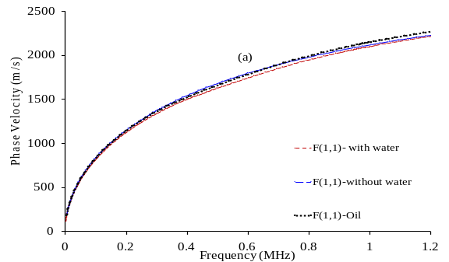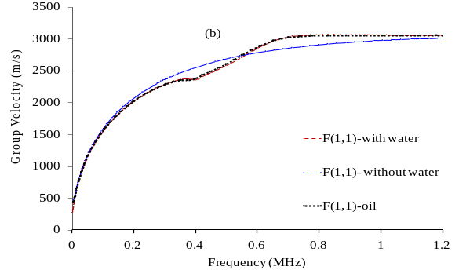

Fig.1. Dispersion curves for stainless steel waveguide; (a) Phase Velocity (Vp) and (b) Group Velocity (Vg),

Table.1. Waveguide properties and dimensions

Material | SS-308L
Mass density (ρ) - kg/m³ | 7950
Young’s modulus (E) GPa | 183
Poisson's ratio (µ) | 0.3
Waveguide Diameter (D) mm | 1
Frequency (f)-kHz | 500
No of cycles | 3

- Experimental Setup

A thin stainless steel (SS) waveguide was selected in this work. The waveguide dimensions and material properties are given in Table 1, and the obtained dispersion curves [18-19] are shown in Fig. 1. An operational frequency of 500 kHz was preferred in this work in order to limit the level of dispersion. A conventional shear transducer was placed on the surface of the waveguide and the transducer was oriented at an angle of 45° to the axis of the cylindrical waveguide as shown in Fig. 2 for simultaneous transmission/reception of F(1,1) wave modes. The earlier reported experimental setup [20-24] was used here to receive the ultrasonic signals. By adjustment of the normal force between the transducer surface and the waveguide, it was feasible to control the relative amplitudes of the wave mode. It was determined that at an optimal force, the F(1,1) wave mode was found to be maximum and this condition was used for all experiments reported here
The schematic of the experimental setup is shown in Fig. 2. The waveguide was positioned vertically in the container for level measurement experiments. The reference level scale was marked on the test beaker. One end of the waveguide was connected to the shear transducer and the other end of the waveguide was immersed inside the liquid for level measurement. The surface of the waveguide was rigidly fixed to the shear transducer (Panametrics V151-500kHz) for simultaneously transmitting/receiving the flexural wave mode in the thin waveguide using an ultrasonic pulser/receiver (TechnoFour UTUSB2.0) with 100 MHz sampling rate. The level sensing experiments were carried out in two different fluids (a) Water, (b) Castor oil which are non-viscous and viscous medium respectively.

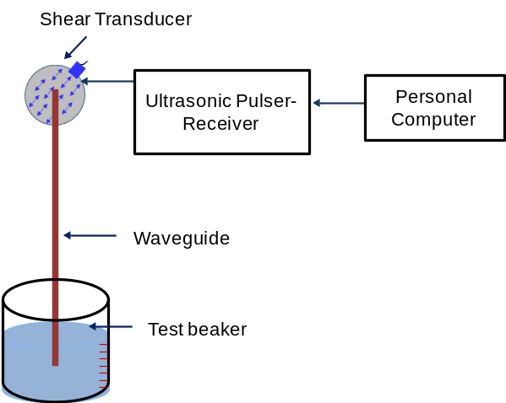
Fig.2. Schematic of the experimental setup for liquid level measurement using a single waveguide.

- Result and Discussion
The liquid level sensing was based on the measurement of ultrasonic wave behaviour in the straight waveguide configuration. The initial A-scan signal was when the waveguide was not subjected to fluid loading (air medium) as shown in Fig. 3 (0-cm)) and subsequently, the fluid (water) was filled gently in the cylindrical container with an increment of 10 mm. The A-scan signals were acquired at each 10 mm interval while filling 90 mm depth of water in the beaker; the (acquired) corresponding A-scan signals are shown in Fig. 3. The water level was measured based on the strength (amplitude) as well as change in time of flight (δTOF) from the reflected signals. Here, the amplitude and δTOF variations for F(1,1) were measured at every 10 mm increment of fluid loading and the A-scans are shown in Fig. 3. It was observed that the Sensitivity was higher in flexural wave mode F (1,1) when the sensor was exposed to different water levels as shown in Fig. 3. Due to the dispersive nature, it was very critical to extract δTOF and peak amplitude information from the flexural wave mode using peak tracking concept [22-24]. Hence, the Hilbert transform was identified an appropriate tool and utilised for peak tracking the dispersive signal (F(1,1)) to measure the time of flight shifts and peak amplitude during level measurements as shown in Fig. 4.The individual modes were extracted in the time domain signal Significant time of flight difference was observed at each 10 mm interval on the F(1,1) wave mode in both viscous (castor oil) and non-viscous fluid (water). Fig. 5 (a) shows the δTOF effect on the F(1,1) wave modes, when the sensor was immersed in different levels on water and castor oil. Also, signal strength (Amin/Amax) of reflected signals of all the flexural mode were tracked and shown in Fig. 5 (b).
Fig.3. A-scan signals observed at different depths of fluid.
Fig.4. Hilbert transform of the F(1,1) modes in A-scan signals observed at different depths of fluid.
Nevertheless, at the same operating frequency while using the flexural wave mode the dispersion effect, as well as the change in velocities were observed. The change in frequency was found to be a predominant effect from the F(1,1) reflected signal at each level of waveguide immersion. Therefore, a liquid level sensor can be designed to obtain the exact level measurement based on the amplitude drop, frequency shift and time shifts using flexural wave mode.
Form the obtained results it was observed that the flexural wave mode F(1,1) was much more Sensitivity to the surrounding fluid as compared to the other two wave modes. In addition to the fluid level information, this waveguide sensor system has a great potential to measure any parameter related to acoustic properties of the surrounding fluid. However, due to the high sensitivity and dispersive nature the flexural wave mode are more suitable for precise liquid level measurement.

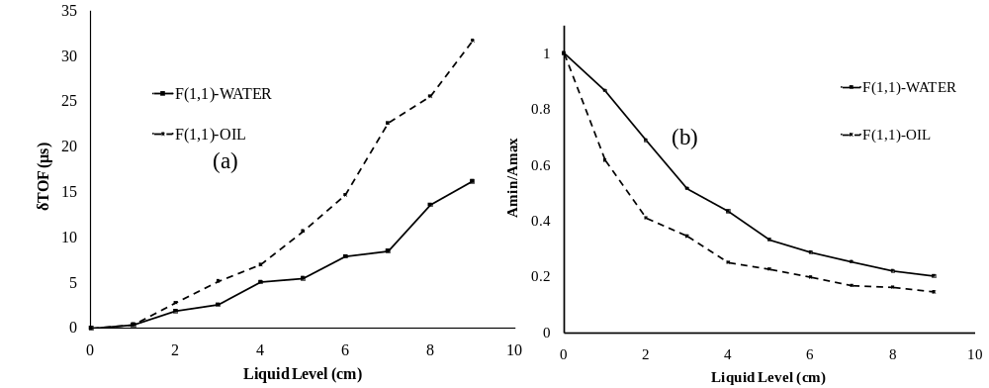
Fig. 5. (a) Change in time of flight (δTOF) vs liquid level and (b) Change in amplitude vs liquid level of the F(1,1) modes observed at different depths of fluid (oil and water).

- Conclusion
In this work, we reported an innovative concept for measuring the level of fluids using an ultrasonic waveguide technique. Here the F(1,1) wave mode is transmitted/received in thin stainless steel (SS) waveguide using a single shear transducer. Also, in this study, the dispersive effects were observed in F(1,1) wave mode at different levels. The liquid level can be measured based on the significant changes in amplitude drop, frequency shift and time shifts when the waveguide was embedded in the fluid at different levels. This wave mode was much more sensitive and suitable for more precise liquid level measurement and not suitable for long range inspection due to its high dispersive nature but this depends on the waveguide material, operating frequency and the fluid medium to be measured.
In addition to the fluid level information, the proposed technique also has a great potential to measure acoustic properties of fluid, such as temperature, liquid viscidity and liquid density. This waveguide sensor system could be valuable for reliable measurement of the fluid level inside critical enclosures of hazardous environment and in many process and petrochemical industries etc.

References

- The Engineer’s Guide to Level Measurement, Emerson process management, (2013).
- H. K. Singh, S. K. Chakraborty, H. Talukdar, N. M. Singh and T. Bezboruah, IEEE Sensors Journal.11,391, (2011)
- S.H. Sheen, H.T. Chien and A.C. Raptis, Rev. Prog. Quant. Non-destr. Eval. 14A, (1995),
- V.V. Shah and K. Balasubramaniam, Ultrasonics. 34, 8, (1996).
- R. Nishanth, K. Balasubramaniam and S. Periyannan, IEEE Sensors Journal.18, (2018).
- C.K. Jen and J.G. Legoux, US Patent 5 828 274, (1998).
- T.F. Chen, K.T. Nguyen, S S.L. Wen and C.K. Jen, Meas. Sci. Technol.10,3, (1999).
- V.V. Shah and K. Balasubramaniam, Ultrasonics.38, 9, (2000).
- T.K.Vogt, M.J.S.Lowe and P.Cawley, IEEE Trans Ultrason Ferroelectr Freq Control.51,6. (2004).
- K. Balasubramaniam, V.V. Shah, G. Boudreaux, R.D. Costley, C. Menezes and J.P. Singh, Rev. Prog. Quant. Non-destr. Eval. 18B ,(1999).
- L. C. Lynnworth, "Ultrasonic Measurements for Process Control: Theory,Techniques, Applications," Academic Press, New York, (1989).
- S. C. Rogers and G. N. Miller, IEEE Trans. Nucl. Sci. 29, 1, (1982).
- J. O. Kim, H. H. Bau, Y. Liu, L. C. Lynnworth, S. A. Lynnworth, K. A. Hall and J. A. Korba. IEEE Trans. Ultrason., Ferroelectr., Freq. Control. 40,5,(1993).
- W.K. Spratt and J.F. Vetelino, Frequency Control Symposium, Joint with the 22nd European Frequency and Time forum. IEEE International, pp. 850-854. (2009).
- Bo Liu, Dorothy Yunjing Wang, and Anbo Wang, IEEE Sensors Journal. 16, 8, (2015).
- T. J. Knowles,U.S. Patent 9,285,261. (2016).
- J. C. Pandey, M.Raj, S. N. Lenka, P. Suresh, and K. Balasubramaniam, journal of Ironmaking & Steelmaking, 38,1, (2011).
- B.N. Pavlakovic, M.J.S. Lowe, P. Cawley and D.N. Alleyne. Rev Progress Quantitative Non-Destruct Eval,(1997),
- P. Suresh and K. Balasubramaniam, Experimental Mechanics, 56, 1257. (2016).
- P. Suresh, P. Rajagopal and K. Balasubramaniam, Journal of Applied Physics, 119,144502, (2016).
- P. Suresh, and P. Rajagopal and K. Balasubramaniam, Ultrasonics, 74, 211-220 (2017).
- P. Suresh, P. Rajagopal and K. Balasubramaniam, AIP Advances, 7, 035201 (2017).
- S.Periyannan, and K. Balasubramaniam, Review of Scientific Instruments., 86,11,(2015).
- R. Nishanth, K. Lingadurai, S. Periyannan, and K. Balasubramaniam, Insight-Non-Destructive Testing and Condition Monitoring, 59, 7,(2017).

