ANALYSIS OF NACA AIRFOIL USING ANSYS FLUENT

Kondaguli R¹,Dr.H.KAmarnath.², Dr.O.D.Hebbal³
¹Mechanical Dept, BLDEAS DR.P.G.H COLLEGE OF ENGG & TECH VIJAYAPUR,586103,KARNATAKA,India
²Mechanical Dept, Don Bosco College Of Engineering,Margoa,403602 Goa,India
¹Mechanical Dept, PDA College of engineering Kalburgi,585102,KARNATAKA,India

*Corresponding author Email: ravindrakondaguli@gmail.com

------------------------------------------------------------------------------------------------------------------
In this work, flow analysis of aerofoil (NACA 2412 ) was investigated. Drag force, lift force as well as the overall pressure distribution over the aerofoils were also analysed. By changing the angle of attack, variation in different properties has been observed. The outcome of this investigation was shown and computed by using ANSYS workbench 16. The pressure distributions as well as coefficient of lift to coefficient of drag ratio of aerofoils were visualized and calculate the result .From this result, we compared the better one . The whole analysis is solely based on the principle of finite element method and computational fluid dynamics (CFD). Finally, by comparing different properties i.e drag and lift coefficients, pressure distribution over the aerofoils, it was found that NACA 2412 aerofoil is more efficient for practical applications than NACA 6409 aerofoil. In this paper found the drag and lift forces of aircraft wing using CFD. In experimental setup, the design model has to place in testing; this process is quite difficult & cost more than CFD techniques cost for the same. Thus the entire analysis gone through computational fluid dynamics method .The analysis of the two dimensional flow over a NACA 2412 airfoil at various angles of attack and operating pressure . The CFD simulation results show good agreement with theoretical values it leads to recommend an optimized wing
Keywords: ANSYS, CFD, NACA, AERODYNAMICS

- Introduction
Aerodynamics is a branch of science that deals with the analysis of flow over a body. The rapid evolution of CFD has been driven for faster and accurate method for solving problems related to aerodynamics. The flow of air over the aerofoils is the most important thing that has to be considered during designing an aircraft, missile, sport vehicles or any other aerodynamic objects. Analysing the flow of a compressible fluid is always complex and consists of different terms and characteristics. By using ANSYS, flow analysis becomes more effective as it investigates everything more thoroughly than experimental method. Computational fluid dynamics provides a qualitative and sometimes even quantitative prediction of fluid flow by means of mathematical modelling, numerical method and software tools. CFD analysis enables an engineer to compute the flow numerically in a ‘virtual flow laboratory’. The analysis consists of several steps such as: problem statement, mathematical modelling, mesh generation, space discretization, time discretization, iterative solver, simulation run, post processing, and verification. ANSYS is vast computational software that enables researchers to analyse the problems related to different engineering sectors. It is used to solve problems related to heat transfer, fluid flow, turbulence, industrial machineries, explicit dynamics, and structural analysis with the assistance of numerical analysis. Aerofoils and aerodynamic shaped objects are extensively used in all types of air vehicles for example space shuttle, aircrafts, helicopters and even in various types of missiles. The NACA airfoils are airfoil shapes for aircraft wings developed by the National Advisory Committee for Aeronautics (NACA). The shape of the NACA airfoils is described using a series of digits following the word "NACA". NACA 4-digit series. For example, the NACA 2412 airfoil has a maximum camber of 2% located 40% (0.4 chords) from the leading edge with a maximum thickness of 12% of the chord objective.

Litreture review
Mr. Aravind [1] research on NACA 4412 airofoil and analyzed its profile for consideration of a aeroplane wing. The Airofoil Was created by catia and analysis was carried out in ansys. he was consider angle of attack 0 ,6,12 and 16 degrees.Karna .s. patel [2] studied the CFD analysis of the flow over the NACA 0012 airofoil and he concluded that at 0 degree of angle of attack there no lift force generated. The amount of increment in drag force quite lower compare to lift force. Kevadiya [3] concentrated on the NACA 4412 aerofoil profile and remembered its significance for examination of wind turbine edge. Geometry of the aerofoil is made using GAMBIT 2.4.6. Additionally CFD examination is done using FLUENT 6.3.26 at distinctive methodologies from 0˚ to 12˚. Gencetal[4] conducted experiments on NACA 2415 aerofoil by varying angle of attack from -120 to 200 at low Reynolds number flight regime (0.5x10^5 to 3x10^5). Using pitot static tube, scan valve and pressure transducer, the pressure distribution over aerofoil was measured. Lift, drag and pitching moment were obtained by 3-component load cell system. Hot wire anemometer and oil flow visualization was used to photograph surface flow patterns. Arvind [5] looked into on NACA 4412 aerofoil and investigated its profile for thought of a plane wing .The NACA 4412 aerofoil was made utilizing CATIA V5 And examination was completed utilizing business code ANSYS 13.0 FLUENT at a rate of 340.29 m/sec for angle of attacks of 0˚, 6˚, 12˚ and 16˚. k-ε turbulence model was accepted for Airflow. Changes of static weight and element weight are plotted in type of filled shape

Methodology
Following is the method employed to carry through the CFD simulation:
      - Prepare geometric model.
      - Meshing
      - Boundaries
      - Software (Fluent) set up, initialization and solving
Geometric model: Model is prepared in ANSYS design modeler.
.
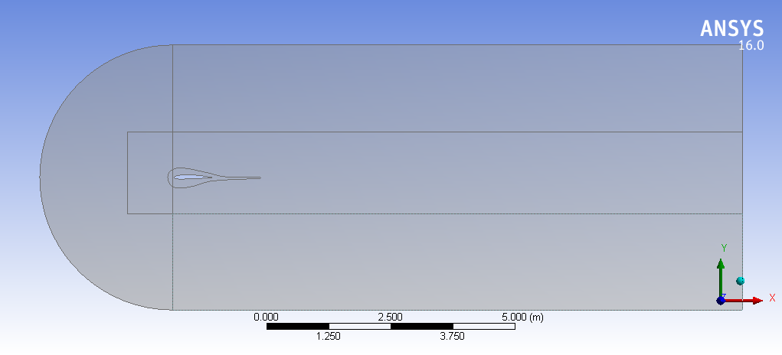  Fig 1: 2D model of 2412 Airfoil. | 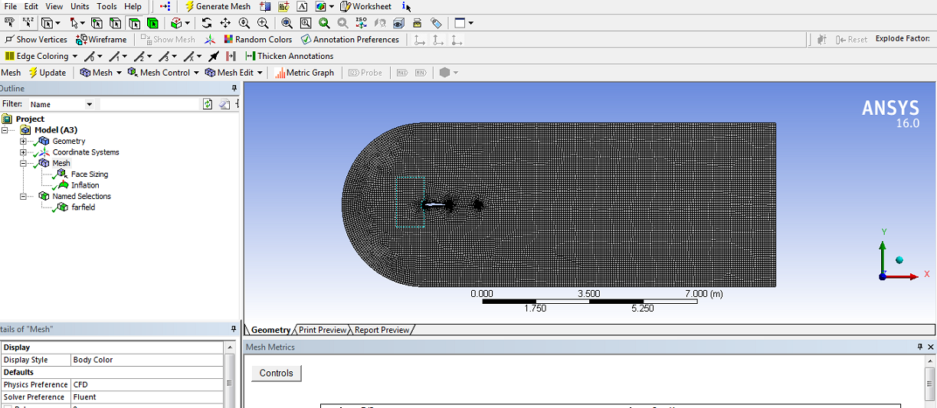  Fig 2:Meshed Image of Airfoil
Meshing: Meshing is done in ANSYS Mesh with the following details
Statistics
Nodes | 16531
Elements | 16252
Mesh Metric | Element Quality
Min | 0.14073721298961
Max | 0.99983841755391
Average | 0.946094336951309
ANALYSIS USING ANSYS FLUENT:Analysis is done using Ansys Fluent. Spalart Allmars(1Equation model is used).Analysis is done for different MACH numbers and different angle of attack .Coefficient of drag and lift are calculate using Ansys Fluent. SIMPE scheme is used for pressure velocity coupling. Density momentum is calculated by second order upwind method.
Results:
Mach no 0.6 and AOA 0°  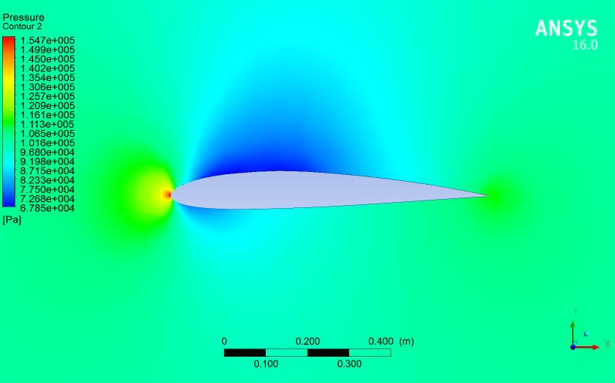 | Mach no 0.6 and AOA 0°  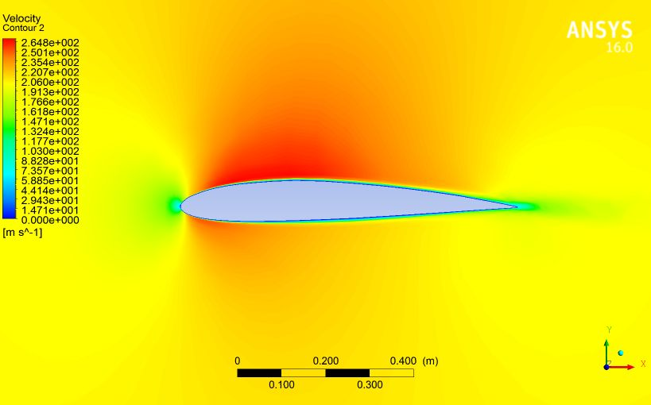 | Mach no 0.6 and AOA 5°  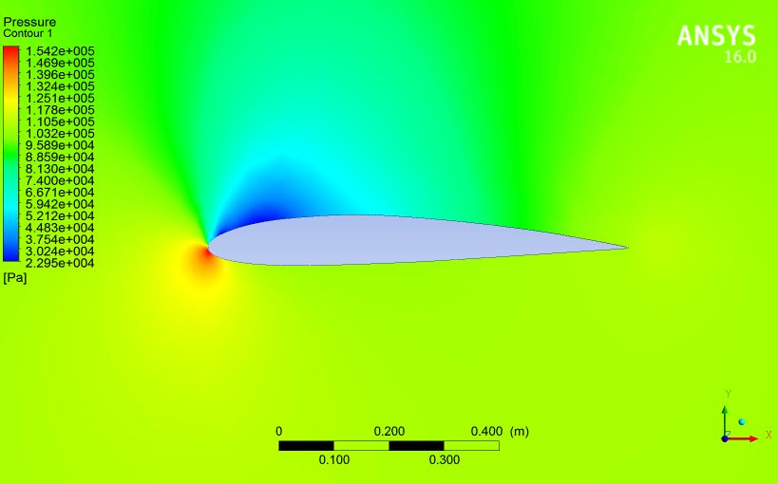
Mach no 0.6 and AOA 5°  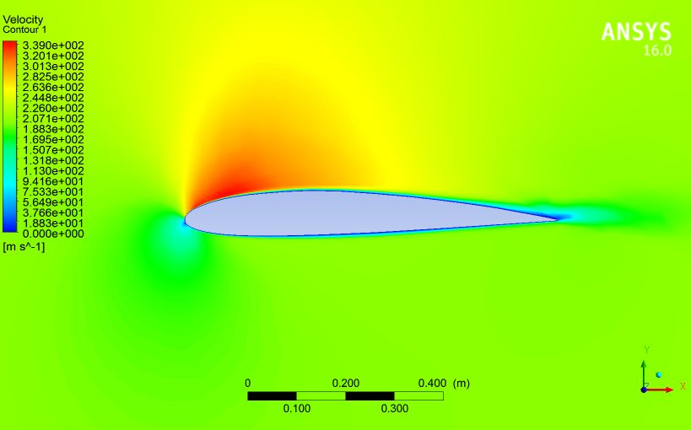 | Mach no 0.6 and AOA 10°  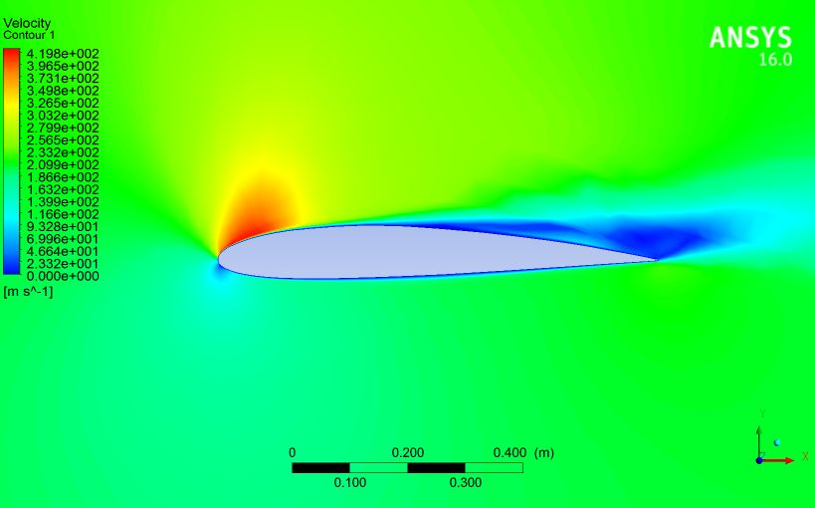 | Mach no 0.6and AOA 10°  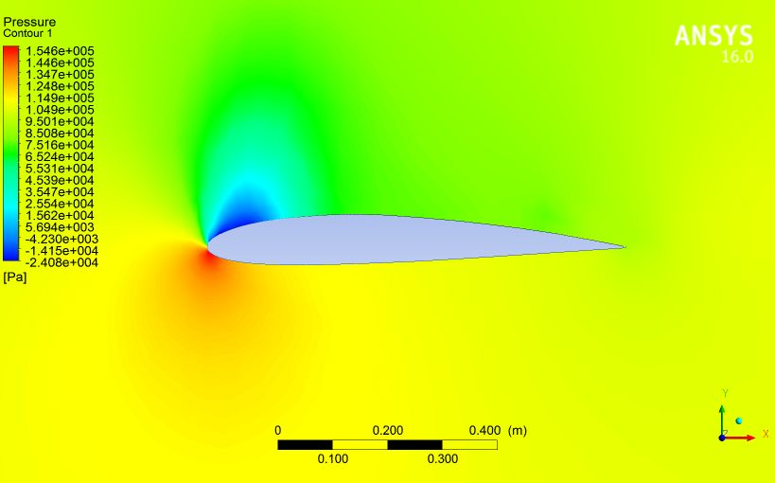
Mach no 0.6 and AOA 15°  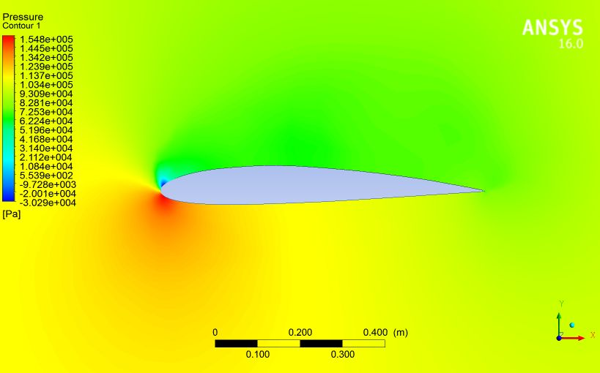 | Mach no0.6 and AOA15°  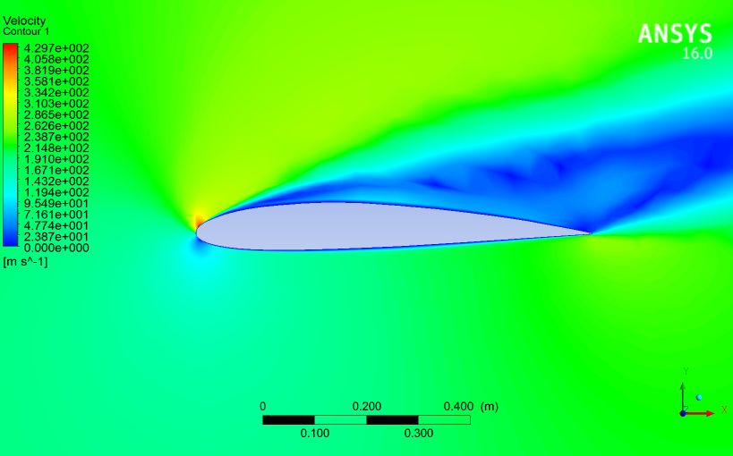 | Mach no 0.8 and AOA 0°  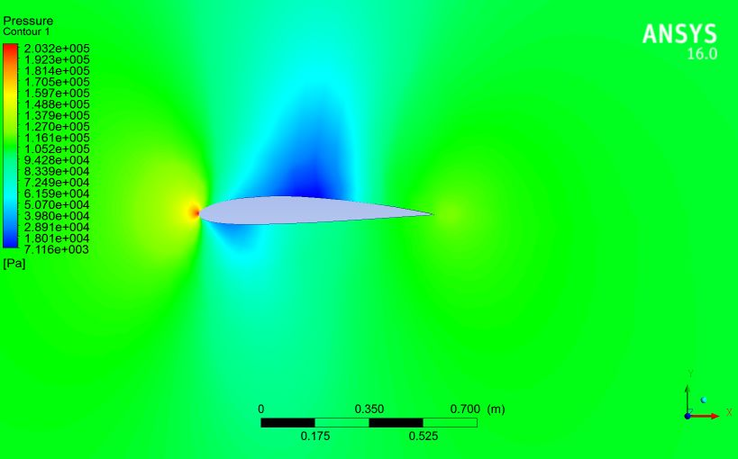
Mach no 0.8 and AOA 10°  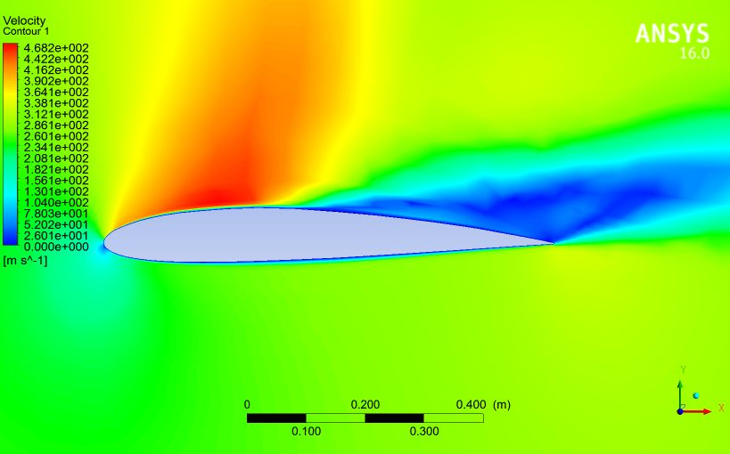 | Mach no 0.8 and AOA 15⁰  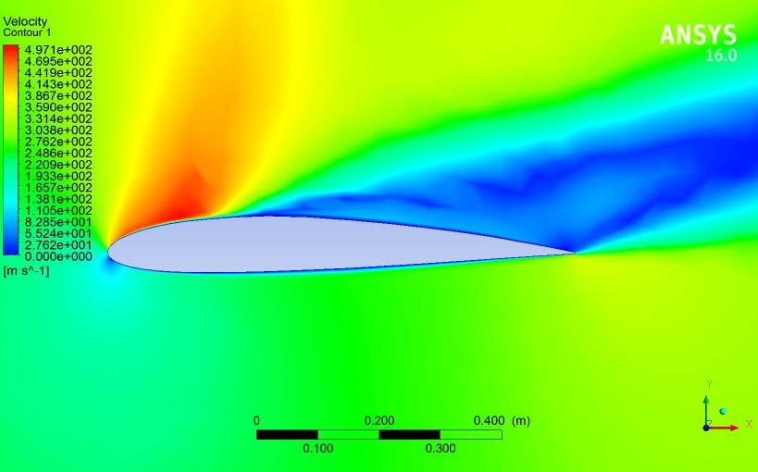 | Mach no 1 and AOA 0°  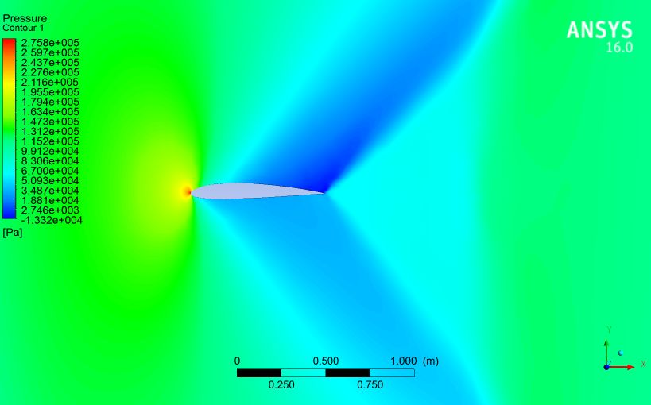

GRAPH OF Cd Vs ANGLE OF ATTACK
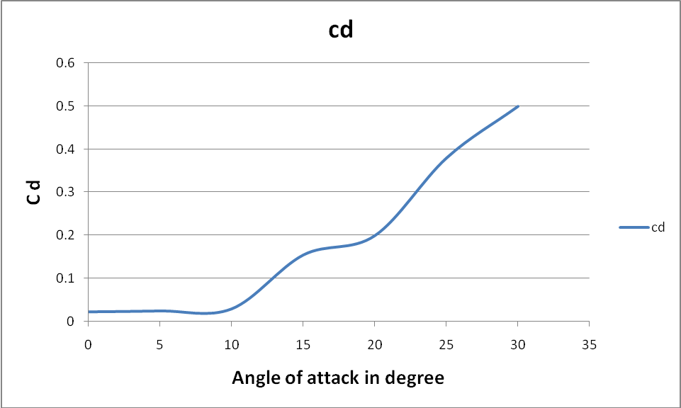

GRAPH OF Cl Vs ANGLE OF ATTACK
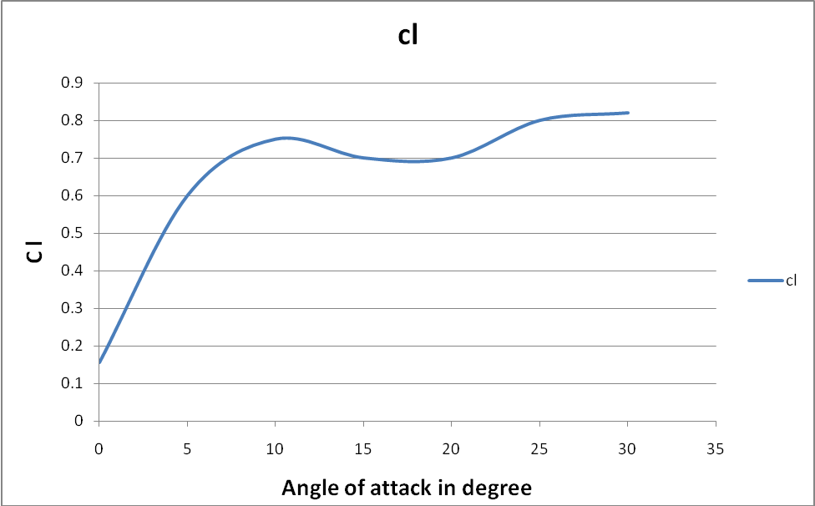

Conclusion:
From the analysis it can be observed that drag coefficient and lift coefficient are increasing with increase in angle of attack. At angle of attack of 18⁰ drag coefficient has drastically increased.
ANSYS Fluent can be used as tool to analyze fluid flow over the airfoil.

REFERENCES

[1] J.E. Copper, “Towards Faster and Safer Flight Flutter Testing”, Proc. Symp. Reduction of Military Vehicle Acquisition Time and Cost through Advanced Modelling and Virtual Simulation, Paris, 2002.
[2] W.Shyy, H. Aono, C. Kang, H. Liu, “An Introduction to Flapping Wing Aerodynamics”, Cambridge University Press, pp. 42, 2013
[3] R.M. James, “The theory and design of two-airfoil lifting systems”, Computer Methods in Applied Mechanics and Engineering, vol. 10, pp. 13-43, 1997.
[4] M.T. Nguyen, M.T. Pham, M.C.Vu and D.A. Nguyen, “Design wireless control system for aircraft model”, Proceeding of International Conference on Engineering Mechanics and Automation, pp. 283-286, Hanoi, 2014.
[5] Ülgen Gülçat, “Fundamentals of Modern Unsteady Aerodynamics”, Springer-Verlag Berlin Heidelberg, pp. 4,2010.
[6] Karna S. Patel, Saumil B. Patel, Utsav B. Patel, Prof. Ankit P. Ahuja “CFD Analysis of an Aerofoil” International Journal of Engineering Research Volume No.3, Issue No.3, pp : 154-158, ISSN:2319-6890)(online),2347-5013(print) 01 March 2014.

