EFFECT OF CNT DEFECTS ON ELASTIC PROPERTIES OF BORON HYBRID COMPOSITE USING FINITE ELEMENT METHOD

Surapaneni Snigdha*, Indupalli Arun Babu, P. Phani Prasanthi, B. Raghu Kumar and M.S.R. Niranjan Kumar

Department of Mechanical Engineering
Prasad. V. Potluri Siddhartha Institute of Technology, Kanuru, Vijayawada

*snigdhasurapaneni11@gmail.com

Abstract. Defects at the nano scale may influence the elastic properties at Macro level. Stone wale, vacancy defects is important defects in carbon nanotubes. The present work addresses the influence of above defects on elastic properties of Boron fiber reinforced composites using multiscale modeling approach. The total work is planned in three phases. In the first phase of the work, the Carbon Nanotube with stone wale and vacancy defects are modeled and elastic properties are evaluated. In the second phase, using Micromechanics approach, the elastic response with SW and vacancy are estimated with the support of Finite Element Method. In the third phase, using homogenized approach, the influence of SW and vacancy defects in Boron fiber reinforced composite were evaluated. The finite element models are validated with analytical results. The effect of SW and vacancy defects on longitudinal modulus, transverse modulus major and minor Poisson’s ratio were predicted.

Key words: Carbon nanotube∙ Micromechanics∙ Elastic Properties∙ Volume Fraction∙

1 INTRODUCTION

In the mid-1980s, nano based composites are gained importance due to the discovery of nano fullerenes, carbon nano tubes because of their high specific strength high stiffness to weight ratio [1-3]. Many authors showed path to aware the benefits of contributed in the field of nano composites by exploring the mechanical, thermal and electrical properties [3-5]. To understand the failure behavior of nano composites few authors studied their fracture response [6-7]. While these nano CNT’s are used as reinforcing agent in conventional composites, it is required to understand the nano level defects influence on bulk material properties. The effect of CNT waviness and vacancy defects in nano composite properties is estimated using finite element method. [8]

Using a multiscale finite element (FE) modeling approach, pinhole defects in CNT reinforced composite properties are estimated by reinforcing armchair (5, 5) and zigzag (9, 0) in a matrix material.[9]

The defects such as vacancies, Stone-Wales in the CNT are generated during the production stage and these defects influence on elastic response was estimated [10]. The combination of finite element method and Micromechanics are used to determine the advantage of using nano reinforcement in regular fiber reinforced composites is evaluated by P.Prasanthi et al. [11]. The aim of the present research work is to address the properties of defected CNT reinforcement on Boron fiber reinforced composites are estimated using Micromechanics and finite element method.

2 FINITE ELEMENT MODELING
The beam element 2 node 188 is selected to create the Armchair (3,3) CNT with vacancy and SW defect. The Young’s modulus of the CNTs are estimated with defect free and vacancy defected and stone wales defected carbon nanotubes. As shown in Fig. 1-2, Unit forces are applied at one end of the tube and the other end is fixed in all aspects. Using the relation between the force and strain, the Young’s modulus is predicted. Identifying lateral and longitudinal strains, the Poisson’s ratio is calculated in the first phase of the work. Using the continuum approach with Micromechanics approach, the properties of defected CNT reinforced polymer composite properties are evaluated with the properties obtained in the first phase. To reach the final stage of the analysis, the boron fibers are assumed to be distributed in defected CNT mixed matrix.
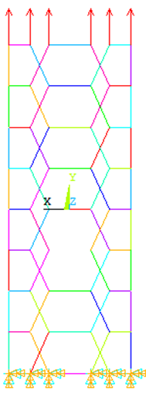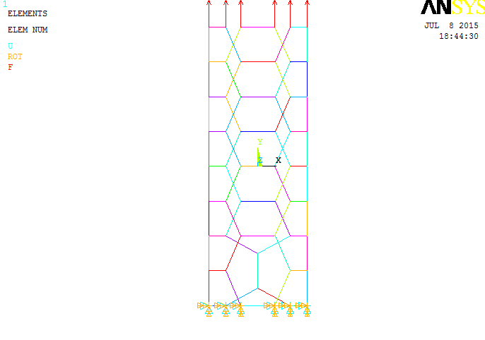
Vacancy Defect
Stone wale Defect
Fig.1. CNT with vacancy defect in FE model Fig.2. CNT with SW defect in FE Model
Using the Micromechanics approach and selecting one unit cell which contains Boron fiber in the homogenized CNT mixed matrix. Solid 95 of ANSYS element is chosen to generate mesh on the geometrical models as presented in Fig.3.
2.1 Material Properties
The Young’s modulus of Boron Fiber is E=400Gpa, Poisson’s ratio is ν =0.2. The CNT Young’s modulus is 1TPa. Polymer Matrix Young’s modulus: 5.171 GPa, Poisson’s ratio is 0.35.
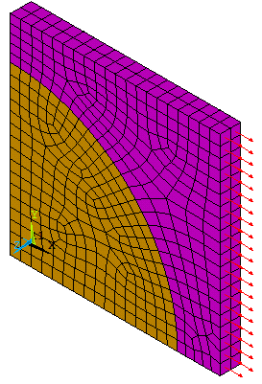
Boron Fiber
Homogenized CNT Matrix
X
Z
Y
Fig.3. Geometrical model at 50% volume fraction

2.2 Geometry, Loading and Boundary Conditions
For Armchair (3,3), Diameter, D₀= 0.235nm, Thickness, t=0.25, Length, L₀=1.88. For Hybrid composite, the Boron fiber is maintained at 50% volume fraction and the Unit cell dimensions are maintained at 100X100X10 units. The radius of the fiber is calculated based on the volume fraction. Periodic boundary conditions are applied on FE model at macro level. 1 MPa of Uniform Pressure is applied on Fe model in the area corresponding to the positive Z-plane to predict the fiber directional modulus and major Poisson’s ratio. To estimate the transverse modulus and minor Poisson’s ratio of hybrid composite same pressure is applied on X-plane area as shown in Fig.3

RESULTS AND DISCUSSIONS

The objective of the present work is to estimate the effect of nano level defects on macro level properties of Boron fiber composites. The Boron fiber is maintained at 50% and the remaining matrix contains the cnt at different volume fractions of 1% to 5%. The CNT has defects such as vacancy, stone wales. To identify the effect of defects, the properties are compared with defect free composite properties.
Fig.4. shows the variation of longitudinal modulus of Boron fiber reinforced composite with arm chair (3,3) cnt mixed composite. In this property, the property is same for all the defected composites. i.e Boron/epoxy composite, Boron/SW defect CNT composite, Boron/vacancy defect CNT and Boron with defect free CNT composite. The Boron fiber offers more strength in longitudinal direction which offers the same resistance whether it is mixed with any type of defected CNTs.
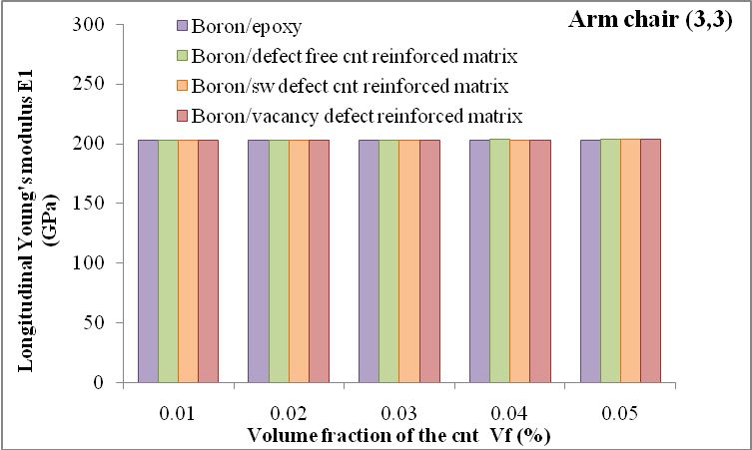
Fig.4. Variation of Longitudianl Modulus with respect to volume fraction of CNT
Fig.5. shows the variation of transverse modulus with respect to CNT volume fraction with SW and vacancy defects. Compared to Fig.4, a clear variation is observed in transverse modulus of boron composite. The influence of SW defect is more on transverse modulus than vacancy defect. The magnitude of transverse modulus is less compared to longitudinal modulus which is shown in Fig.4
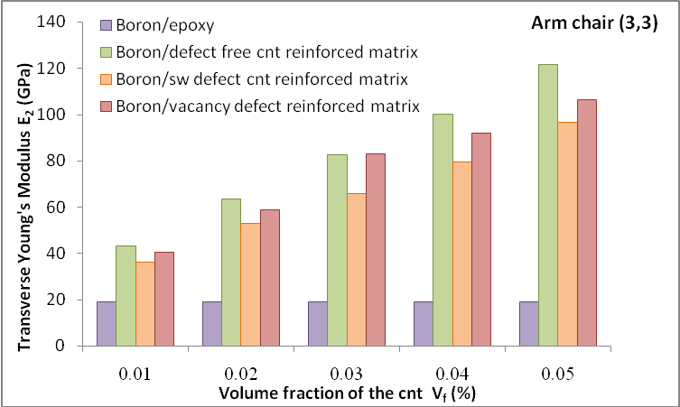
Fig.5. Variation of Transverse Modulus with respect to volume fraction of CNT
Fig.6.shows the variation of major Poisson’s ratio of boron hybrid composite. Compared to boron hybrid composite, the conventional Boron composite major Poisson’s ratio is high. There is no considerable change in major Poisson’s rato due to CNT reinfrocement with and without defect. With the Nano reinforcement, the longitudinal deformation magnitude is decreasing as a result, the decrement in major poisson’s ratio is observed to be decreasing with nano reinforcement. The variation of minor Poisson’s ratio is presented in Fig.7. The magnitude of minor Poisson’s ratio is less for ordinary Boron fiber composite compared to hybrid composite. With the nano reinforcement , the lateral deformation is decreasing and no clear difference are noticed due to CNT defects.
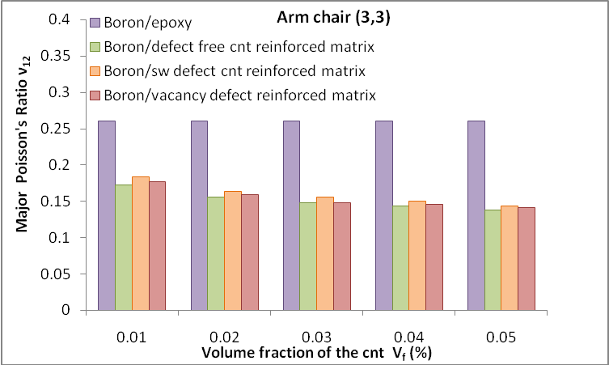
Fig.6. Variation of Major Poisson’s ratio with respect to volume fraction of CNT
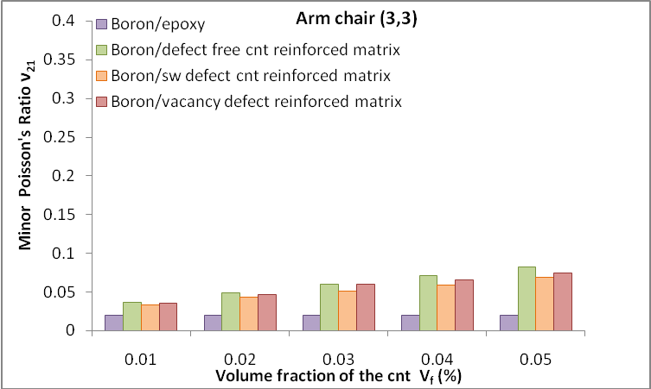
Fig.7. Variation of Major Poisson’s ratio with respect to volume fraction of CNT

CONCLUSIONS
The elastic properties of hybrid boron composites are estimated using Micromechanics and Finite element method. The longitudinal modulus, transverse modulus, major and minor Poisson’s ratio are estimated for three phase boron composites. The influence of the SW and vacancy defects at nano stage on boron fiber composites is estimated. The longitudinal modulus and major Poisson’s ratio are unaffected by the SW, Vacancy defect of the CNT. The transverse modulus is greatly affected by SW and vacancy defects. Compared to vacancy defect, SW defect showed a more decrement in transverse modulus.
Reference
1. Kroto HW, Heath JR, O’Brien SC, Curl RF, Smalley RE, (1985), C60: Buckminsterfullerene. Nature, 318:162-3.
2. Thostenson ET, Chou T-W, (2002), Aligned multi-walled carbon nanotube-reinforced composites: processing and mechanical characterization. J Phys D Appl Phys, pp: 77–80.
3. Iijima S, (1991), Helical microtubules of graphitic carbon. Nature; pp:354:356
4. Li and Chou C. Li and T.-W. Chou,(2003) “Multiscale modeling of carbon nanotube reinforced polymer composites”, Journal of Nanoscience. Nanotechnology, pp:423–430.
5. Liu and Chen Y. J. Liu and X. L. Chen, (2003) “Evaluations of the effective material properties of carbon nanotube-based composites using a nanoscale representative volume element”, Mechanical Materials. pp: 69–81.
6. Dong-Li Shi, Xi-Qiao Feng, Hanqing Jiang, Yonggang Y. Huang and keh-chih Hwang, (2005) “Multiscale analysis of fracture of carbon nanotubes embedded in composites”, International Journal of Fracture, Vol: 134, pp: 369–386.
7. Joaquin Blanco, Enrique J. García, Roberto Guzmán de Villoria and Brian L. Wardle, (2009)” Limiting Mechanisms of Mode I Interlaminar Toughening of Composites Reinforced with Aligned Carbon Nanotubes”, Journal of Composite Materials, Volume: 43, pp: 825-841.
8. Marino Brcic, Marko Canadija JosipBrnic, (2015)” Influence of Waviness and Vacancy Defects on Carbon Nanotubes Properties”, Procedia Engineering, Volume: 100, pp: 213-219.
9. Gupta A.K. Harsha S.P., (2016) “Analysis of mechanical properties of carbon nanotube reinforced polymer composites using multi-scale finite element modeling approach”, Composites Part B: Engineering, Volume: 95, pp: 172-178.
10. Amit Kumar, Kamal Sharma, Pradeep K Singh, Vijay K Dwivedi, (2017) “Mechanical characterization of vacancy defective single-walled carbon nanotube/epoxy composites”, Materials Today Proceedings, Volume: 4, pp 4013-4021
11. P. Prasanthi, G. Sambasiva Rao , B. Umamaheswar Gowd, (2014), Effectiveness of Buckminster Fullerene Reinforcement on Mechanical Properties of FRP Composites, pp:1243-1252

