Optimisation of machining parameters for multi-performance characteristics in milling of composite solid propellants using Response Surface Methodology
Kishore Kumar Katikaniª , Anne Venu Gopal^{b}, V.V. Rao^{c}
ª Scientist-E,NSTL, DRDO, Visakhapatnam-530027, Andhra Pradesh, India, Email:b4ukishore@rediffmail.com
^{b}Professor, NIT Warangal-506004, Andhra Pradesh, India, Email: venu@nitw.ac.in
^{c}Scientist-H, ASL, DRDO, Hyderabad-500058, Telangana, India, Email:vemanavrao2005@gmail.com
----------------------------------------------------------------------------------------------------------------------------
Abstract

The Solid Rocket Motors (SRM) produced with case bonded Composite Solid Propellant (CSP) grains are formulated with Metallic Aluminium (Al) powder as the fuel , Ammonium Per chlorate (NH₄ClO₄) as the oxidizer and HTPB (Hydroxyl Terminated Polybutadiene) as a polymer binder .Thrust characteristics of the SRM are largely determined by the initial ignition surface of CSP, called grain configuration, is to be accurately produced by machining techniques. But the composite solid propellants (CSP) of SRM are sensitive to fire hazard by mechanical stimuli such as friction, heat, impact load and static charge which are inevitably present in conventional machining operations. In order to machine this ‘hazardous to machine’ CSP material safely, a custom build cutting tool called ‘Turbine cutter’ was developed with suitable tool signature for minimum cutting force and with safety features. The main objective of this study is to identify the optimum process input parameters for low cutting power and high MRR, further to enhance the safety in machining of ‘hazard to machine’ materials. To achieve this objective, the effect of machining parameters on cutting power (CP) and material removal rate (MRR) was investigated. Full factorial experiments were carried out on propellant grain using the Turbine cutter on CNC VTM. In order to investigate the influence of process parameters in machining CSP material two factor interaction (2FI) models are developed and subsequently ANNOVA is performed to evaluate the significant process parameters. Response surface methodology (RSM) is used to develop the mathematical models and also for multi-response optimisation, based on desirability functions using commercial software, Design-Expert. The optimum values of machining parameters attained with a desirability value of 0.88 are cutting speed is 125 rpm (196 m/min), feed rate is 24 deg/min (0.418 m/min) and depth of cut is 4 mm for minimum (CP) and Max MRR and their values are 15.75 x 10⁻² KW and 1092.11x10⁻⁶ m³/min respectively.

Keywords: Composite Solid Propellant (CSP), Desirability function, Multi response optimisation, Response surface methodology (RSM).

- Introduction
HTPB/AP/AL based CSP material of SRM are produced by chemical casting under vacuum condition and machining of these material comes under 1.3 hazard division classifications. Sutton and Biblarz ¹ reported that ballistic requirement of SRM will not meet by simple casting. It requires machining on the propellant grain to generate the desired profile as initial ignition surface, called grain configuration. In addition to this, uneven and porous surface of propellant grain, non-uniform deposition of propellant, extra propellant cast for machining allowance during casting of SRM segments require machining as secondary operation to bring the size of grain to exact dimensions for assembly of segments into motor as reported by Raja ram² and Alain³.

Safe machining practices have been highly emphasized to deal with heterogeneous CSP materials, especially highly filled CSP, pose complex technological problems due to their sensitivity to fire hazard by mechanical stimuli. The viable method to exercise the safe machining operations on CSP grain, to control and maintain the cutting force at a prescribed safe level is standardizing the cutting tool geometry as well as adjusting the machining parameters for minimum cutting energy simultaneously. To cater these functional and safety requirement of machining of hazard to machine CSP material, a custom build cutter called ‘Turbine cutter’ is developed with suitable tool signature and by incorporating various safety features to mitigate the risk of hazard.

Data on process parameters on machining of CSP material is seldom found in the literature due to their strategic application and safety stringent & expensive infrastructure requirement to generate such data. Hence attempts are made in the present study to generate such valuable experimental data based on full factorial (27) experiments, using developed Turbine cutter on special purpose CNC Vertical Trun Mill (VTM). The main goal of this study is to optimize the input machining parameters for desired performance characteristics i.e., low Cutting Power (CP) and maximum Material Removal Rate (MRR). Hence in the present study, Response Surface Methodology(RSM) is used to develop desirability function for multi-response optimisation of machining parameters for the two performance characteristics CP and MRR in milling of hazard to machine CSP materials. Mathematical models also developed for each response within the operating capacity of CNC VTM.

- Experimental method and procedure
A special purpose CNC VTM machine, which can be operated and controlled remotely was used for experimentation whose illustration are shown in Fig.1. Turbine cutter is connected to vacuum line of safety equipment called Chip and Dust Collection System (CDCS) through a hollow arbour and rotary joint as shown in Fig.1.(a) for safe and instant chip disposal. Wu⁴ et.al, reported that the indirect measurement of cutting forces through cutting power is quite reasonable, economical and it has an important application value with high compatibility in machining studies. Altintas⁵ predicted cutting force and tool breakage in Milling from feed drive current measurement while machining the metals. Kim⁶ et.al, investigated a simple and economical method to measure the cutting force indirectly i.e., by measuring the power drawn by the servo motor drive of spindle in NC milling process and claimed to be the most economical solution compare to other alternatives The indirect measurement of cutting forces through cutting power is quite reasonable, economical and it has an important application value with high compatibility. In line with above references, for the present study cutting power is measured from the AC drive of spindle motor of SP CNC VTM machine using Power quality analyzer (PQA) - fluke make. The schematic of general layout of experimental set-up is shown in the Fig.1. Monitoring and control of machining was done from this remote control room through remote operator panel as shown in Fig.1(b). CCTV cameras for visibility and safety interlocks of the machine are also employed in the experiments.

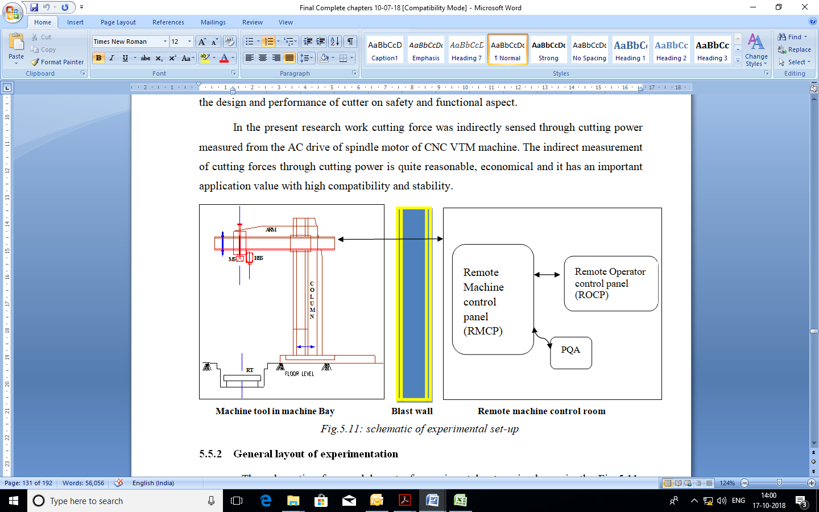
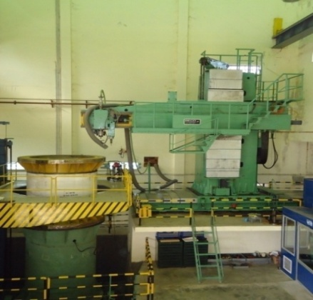
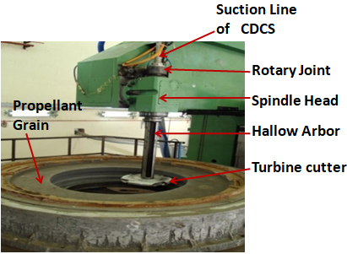

a) Cutter/arbour/CDCS setup b) Machine bay with control panels
Fig.1: Schematic of machining experimental set-up for’ hazard to machine’ materials

Experiments were conducted using a specially designed Turbine cutter as shown in Fig.2 on HTPB/AP/Al based live CSP material of SRM. Custom build type conical HSS inserts in four numbers were integrated to the turbine shaped cutter as shown in Fig.2. Due to explosive nature of the material, experiments were remotely monitored and controlled. Safe machining parameters were investigated by monitoring cutting temperature less than 50ºC using an infrared thermometer. Range of machining parameters and environmental conditions at which the experiments were conducted are summarised in Table 1.
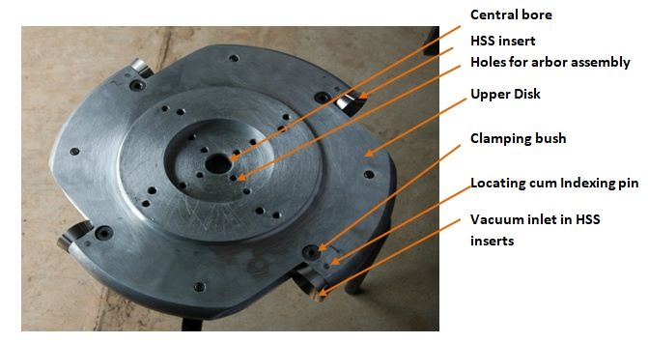
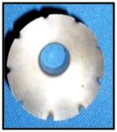
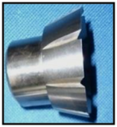
Table1: Machining parameters & environmental factors
Machining Parameters
Cutting speed range | 117- 196 m/min
Rotary table feed | 0.42- 0.84 m/min
Depth of cut | 2- 4mm
Machining environment factors
Machine bay Ambience Temperature | 28 -32° C
Relative Humidity | 75-85%
Coolant | Dry machining
Vacuum at the cutting edge | 240 mm Hg below Atm
Spindle

job
Rotary Table

F
Rotary Table
Fig.2. Developed Turbine Cutter for CSP machining
Parameters | Units | Levels
Parameters | Units | 1 | 2 | 3
Cutting  Velocity (A) | rpm  (m/min) | 75  (117) | 100  (157) | 125  (196)
Table  Feed rate(B) | deg/min  (m/min) | 24  (0.418) | 36  (0. 628) | 48  (0. 378)
Depth of cut (C) | mm | 2 | 3 | 4
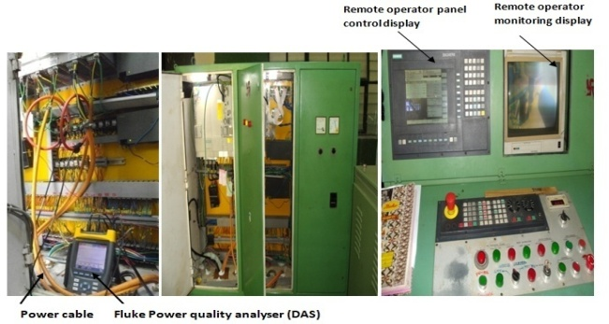
Table 2: Experimental factors and their levels

Fig.3. Measurement of cutting power using PQA

Spindle power is measured from servo drives of the machine spindle using advanced power analyzer having real-time electrical data acquisition system. These servo drives are located in the remote control room of the machine, isolating the machining ambience from source of electrical energies so as to eliminate the source of hazard. An additional machine inbuilt default display on operator panel as shown in Fig.3 was used as redundant provision for verification of measured cutting power values. MRR is measured from the volume of the chips collected in CDCS and Cutting power in KW from PQA. The scheme of taping power from the machine power drives and measurement of cutting power using PQA is illustrated in Fig.3. MRR is measured from the quantity of chips collected in CDCS.

- Experimental Results and analysis
Nayak⁷ et al. used RSM for Investigation of Cutting Force in Elastomer Machining under Ambient and Cryogenic Conditions, a similar approach is adopted in this study using commercial statistical software Design expert 7.1.0 . With the limited and expensive resources the possible approach would be to limit the number of levels to three (the minimum to study the nonlinear effects) and conducted full factorial experiments. However the broad range was chosen in feed, speed range as limited by safety aspects and capabilities of resources as shown in Table 2.

3 .1 Experimental Results

The Experiments conducted with developed turbine cutter on live propellant and the results are as shown in Table 3.
S. No. | CV | TFR | DOC | CP | MRR | S. No. | CV | TFR | DOC | CP | MRR
1 | 75 | 24 | 2 | 16. 75 | 325. 96 | 15 | 100 | 36 | 4 | 18. 25 | 985. 96
2 | 75 | 24 | 3 | 17. 8 | 452. 12 | 16 | 100 | 48 | 2 | 17. 2 | 525. 63
3 | 75 | 24 | 4 | 18. 75 | 651. 92 | 17 | 100 | 48 | 3 | 18. 1 | 788. 45
4 | 75 | 36 | 2 | 17. 12 | 367. 38 | 18 | 100 | 48 | 4 | 18. 5 | 1051. 27
5 | 75 | 36 | 3 | 18. 23 | 551. 07 | 19 | 125 | 24 | 2 | 13. 75 | 546. 05
6 | 75 | 36 | 4 | 19. 5 | 734. 76 | 20 | 125 | 24 | 3 | 14. 12 | 819. 08
7 | 75 | 48 | 2 | 19. 5 | 391. 71 | 21 | 125 | 24 | 4 | 15. 75 | 1092. 11
8 | 75 | 48 | 3 | 20. 75 | 587. 57 | 22 | 125 | 36 | 2 | 16 | 615. 44
9 | 75 | 48 | 4 | 21. 62 | 783. 43 | 23 | 125 | 36 | 3 | 16. 7 | 923. 16
10 | 100 | 24 | 2 | 16. 5 | 477. 4 | 24 | 125 | 36 | 4 | 17. 26 | 1230. 88
11 | 100 | 24 | 3 | 17. 25 | 656. 1 | 25 | 125 | 48 | 2 | 16. 5 | 656. 2
12 | 100 | 24 | 4 | 18. 1 | 904. 12 | 26 | 125 | 48 | 3 | 17 | 984. 31
13 | 100 | 36 | 2 | 16. 81 | 492. 98 | 27 | 125 | 48 | 4 | 17. 5 | 1312. 41
14 | 100 | 36 | 3 | 17. 5 | 739. 47 | Cutting Power : (x 10⁻² KW)  MRR : (m³/min x10⁻⁶)
Table 3: Experimental Result

3.2 Analysis
3.2.1 Analysis for Cutting power
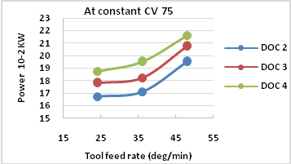
The main effects of each parameter on Cutting Power (CP) are plotted on graphs shown in Fig. 4 (a) to 4 (c). These figures clearly indicate how Cutting velocity, Table Feed Rate, Depth of cut affects Cutting Power.
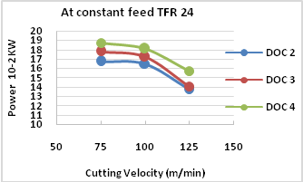
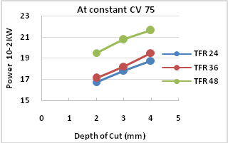
(a)Main effects of CV on CP (b) Main effects of TFR on CP (c) Main effect of DoC on CP
Fig.4. Measurement of process parametrs on cutting power
3.2.2 Analysis for MRR
The main effects of each parameter on MRR are plotted on graphs shown in Fig. 5 (a) to 5 (c). These figures clearly indicate how Cutting velocity, Table Feed Rate, Depth of cut affects MR\
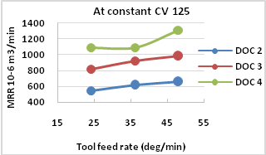
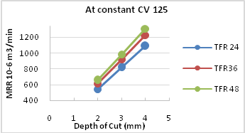
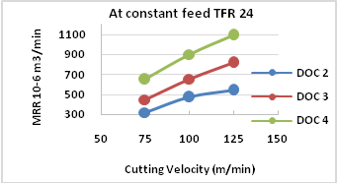
(a) Main effects of CV on MRR (b) Main effects of TFR on MRR (c) Main effect of DoC on MRR
Fig.5. Measurement of process parametrs on MRR
3.2.3 Analysis of Variance for Cutting Power and MRR & its regression models
Since response cannot be assigned criteria unless it has a model. ANOVA statistics and diagnostics graphs were used to check the design evaluation and to find most influencing process parameter on Cutting Power. These tools are used to make sure the models provide a good estimate of the true response surface. From the results it can be concluded that CV (47.96) shows most influencing process parameter on CP and is followed by TFR and DoC. ANOVA analysis for MRR is shown that DoC is strongly influencing the MRR followed by CV and TFR. To obtain applicable and practical predictive quantitative relationships, it is necessary to model the machining responses and the process variables. These models would be of great use during the optimization stage of milling of CSP materials
Regression model for cutting power & MRR:
Cutting Power =018+0. 014*CV-0. 0098*TFR-0. 0083*DoC+0. 0069CV*TFR
MRR = 0. 000728-0.00019CV+0.00001TFR-0. 00024DoC+0. 0000128CV X TDR + 0. 000062CV X DoC -0. 000011TFR X DoC

3.3 Multi response Optimization
The experimental results were used to model the various responses using multiple regression method and non-linear fit among the responses and the corresponding significant parameters. In the present work, a commercially available statistical software Design Expert 7.1.0 package was used for the computation of regression constants, parameters and mathematical modelling. In the present study, full factorial design, the most commonly used RSM design, is chosen for modelling and optimization to achieve the maximum MRR and minimum power. In RSM, a suitable approximation has been made to establish the relationship between the dependent and independent variables.

3.3.1 Method followed for multi-response optimization
The present approach uses desirability functions, after identification of performance characteristics, where independent desirability function for individual response will be made and combining them will form a two–sided desirability function. Solution to the two-sided desirability function will be the optimum combinations of parameters for multi-response optimisation. The present problem in the study is solved using the later one using Design-Expert software package and the response yield in illustrated as follows

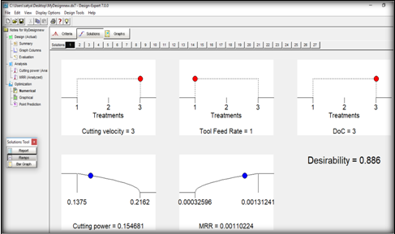
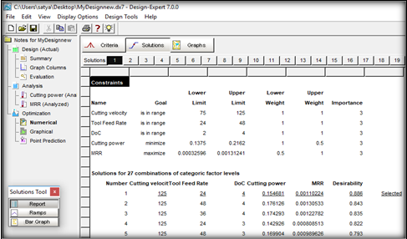
3.3.2 Selection of Optimum levels and its validation
Fig.6. Constraints for the process parameters and performance characteristics and optimum levels
Here numerical optimization of process parameters for milling of CSP material with Turbine cutter using Design Expert (response surface methodology) is presented. The process parameters considered are speed, feed, and depth of cut are optimized with considerations of multiple process characteristics including minimum cutting power and Maximum MRR. From the Fig .6 it can be concluded that for getting optimum condition one can perform experiments at cutting velocity at level 3, Table feed rate at level 1 and Depth of cut at Level 3 with Desirability 0.88. From the Fig.6. Illustrate the graphical view of each optimal solution as Ramps. Optimal factor settings are shown with red points. Optimal response prediction values are displayed in blue.
Validation:
The optimal parameter combination for achieving minimum cutting power and max MRR is obtained using the design expert software is validated with the optimum conditions correlated with 21 run of the full factorial experiment shown in Table 3.
Conclusions
- Cutting power increases with increase in DoC and TFR, this is because at larger feeds or depths of cut, larger volume of the deformed metal and consequently the resistance of the material to chip formation is greater. Cutting power decreases with increase in CV this is because as CV increases, following chips are thinner and shear angle increases and increase in rake angle leads to decrease in tool-chip contact area.
- MRR increases with increase in CV, TWR and DoC this is because at lower speeds, due to high coefficient of friction between tool and rubbery binder of work material cutting forces are significantly high. In comparison with feed the depth of cut influence largely on MRR.
- The finest combination of machining parameters values for maximizing the multiple performance characteristics are 125 m/min, 24 deg/min and 4 mm for CV, TFR and DoC respectively. The result of optimum condition was correlated with the experiment results of full factorial experiments. The experimental results confirm the predicted results from mathematical modelling. Adopted approach for optimizing the cutting parameters was validated. The cutting power and MRR are 15.75 x 10⁻² KW and 1092.11x10⁻⁶ m³/min respectively at the optimum machining parameters. The experimental results confirm the predicted results from mathematical modelling.
- The results of ANOVA have proved that the 2FI models can complete prediction of Power and MRR with 95% confidence interval. Safe and effective cutting parameters for machining of CSP material using the developed cutter were established which has great value in production.

Acknowledgements
The authors express their sincere thanks to GM, DRDO, Jagdalpur and Director, NSTL for the support of facility extended and equipments.

References

- Sutton GP, Biblarz O., 1989 “Rocket propulsion elements”, 7th Edition, Willey-Interscience .
- Raja ram Nagappa, 2014. “Evolution of solid propellant rockets in India”, Published by DRDO, Min of Defence, India .
- Alain Devenas, 1992. “Solid rocket propulsion technology”, PERGMON press.
- Wu H., G. Turyagyenda and J. G. Yang, 2006,Modeling and Real-time Compensation of cutting Force–Induced Errors in NC Turning Center, Trans Tech Publications, Switzerland, Vol 315-316:274-278.
- Altintas, Y., 1992, Prediction of cutting force and tool breakage in Milling from feed drive current measurement, ASME journal of Engineering for Industries, Vol.114:386-392.
- Kim T.Y, Woo J., Shin D., and J. Kim, 1999. “Indirect cutting force measurement in multi-axis simultaneous NC milling processes,” Int’l J.of Machine Tools and Manufacture, 39-11, pp. 1717-1731
- Nayak, Rajesh, Sawan and Shetty, 2014 “Investigation of Cutting Force in Elastomer Machining under Ambient and Cryogenic Conditions Using Response Surface Methodology”, III world conference on applied science, engineering and technology.

