Experimental Study of Closed Loop Thermosyphon System using Different Working Fluids

Mahasidha R. Birajdar^{a*}, C. M. Sewatkar^{b}
ªDepartment of Mechanical Engineering, College of Engineering, Pune-411005, Maharashtra, India
^{b}Department of Mechanical Engineering, College of Engineering, Pune-411005, Maharashtra, India

*Corresponding author Email: mrbirajdar88@gmail.com
------------------------------------------------------------------------------------------------------------------

Thermosyphon is a heat transferring device which transfers heat over long distance and where the liquid is returned to the evaporator by gravitational force. The two-phase closed loop thermosyphon (TPCT) transfers heat with phase change phenomenon. A large amount of heat is transferred from evaporator section to condenser section with relatively small temperature difference. Thermal performance of two-phase closed loop thermosyphon is influenced by the governing parameters like filling ratio, heat input, adiabatic length, working fluid, etc. This paper investigates effect of these parameters on thermal performance of two-phase closed loop thermosyphon system for different working fluids. In this work the filling ratio (FR) is varied in the range of 30% to 80% in the step of 10% at various heat inputs of 0.5 kW to 2 kW with step of 0.5 kW for each evaporator and adiabatic length (vapour line length) is taken as 200 mm. The working fluid used as water, methanol, ethanol and acetone. The performance plots of the performance parameters like thermal resistance, evaporative heat transfer coefficient and condensation heat transfer coefficient for these different working fluids, heat inputs and filling ratios are plotted, and results are analysed. From the result, it is found that acetone has comparatively lowest thermal resistance. Water has highest evaporative heat transfer coefficient and lowest condensation heat transfer coefficient.

Keywords: Two phase closed loop thermosyphon; Thermal performance; Working fluids

- Introduction
The two phase closed loop thermosyphon (TPCT) transfers large amount of heat from evaporator section to condenser section with relatively small temperature difference. The heat applied at evaporative section is converted liquid into vapor and that vapor then condenses after passing through the condenser section. During this process heat transferred from evaporator to condenser through latent heat of evaporation, therefore this method is very efficient than conventional heat exchange method. In this process of heat transfer, there is no requirement of power or pump for transferring heat from one location to other. Therefore, this method of heat exchange is known as passive heat exchange method ^{[1-3]}. Analysis of two-phase closed loop thermosyphon is carried out by different researchers at different working fluids and other parameters. Pal et al. ^{[4]} analysed the performance of a two-phase compact thermosyphon applied for cooling a processor in a personal computer. The thermosyphon is experimented using the working fluids like deionized water and PF5060 (dielectric liquid) at different input power such as 20 to 90 W. The working fluid significantly affected the performance and found that water is better working fluid. Ersoz and Yıldız ^{[5]} analyzed the effect of working fluids such as methanol, petroleum ether and distilled water on thermo economic analysis of thermosyphon. For all input conditions, the highest energy and exergy performance are obtained for methanol, the lowest energy and exergy performance are obtained for petroleum ether. Also, this study show that distilled water is more effective than that of methanol and petroleum ether in terms of cost. Jouhara and Robinson ^{[6]} carried out an experimental investigation of the performance of thermosyphon charged with water as well as the dielectric heat transfer liquids FC-84, FC-77 and FC-3283. The thermal performance of the water charged thermosyphon better than other three working fluids. Karthikeyan et al. ^{[7]} carried out experiments on the TPCT with working fluid as distilled water and an aqueous solution of n-butanol. The thermal performance of aqueous solution of n-butanol charged TPCT was better than the distilled water. Tong et al. ^{[8]} experimentally analysed the performance of R744 two-phase closed loop thermosyphon (TPCT) and found that R744 thermosyphon can work with a small temperature difference of 5 ⁰C. The working fluid R744 shows better heat transfer performance than R22^{[9]}.
From the literature review it is noticed that at low operating temperatures water gives less satisfactory heat transfer performance compared with low saturation temperature fluids. Therefore, in this study, different working fluids are used such as ethanol, methanol, acetone and water. The comparative studies of these four fluids are carried out at different heat inputs, filling ratios and at certain adiabatic length (vapour line length) in the following sections.

- Experimental Setup and Procedure
The experimental test rig consists of two heaters, a thermosyphon loop with two evaporators and plate type condenser, a cooling (fan) section, a liquid reservoir for charging, a vacuum pump, data acquisition (logger) system and measuring instruments like ultrasonic flow meter, anemometer and thermocouples. Figure 1 shows schematic diagram of experimental setup. The abbreviations mentioned in the figure 1 are such as, PRV: Pressure relief valve, VL: Vapor line length, LL: Liquid line length, E-1: Evaporator 1 and E-2: Evaporator 2, PC: Personal computer.
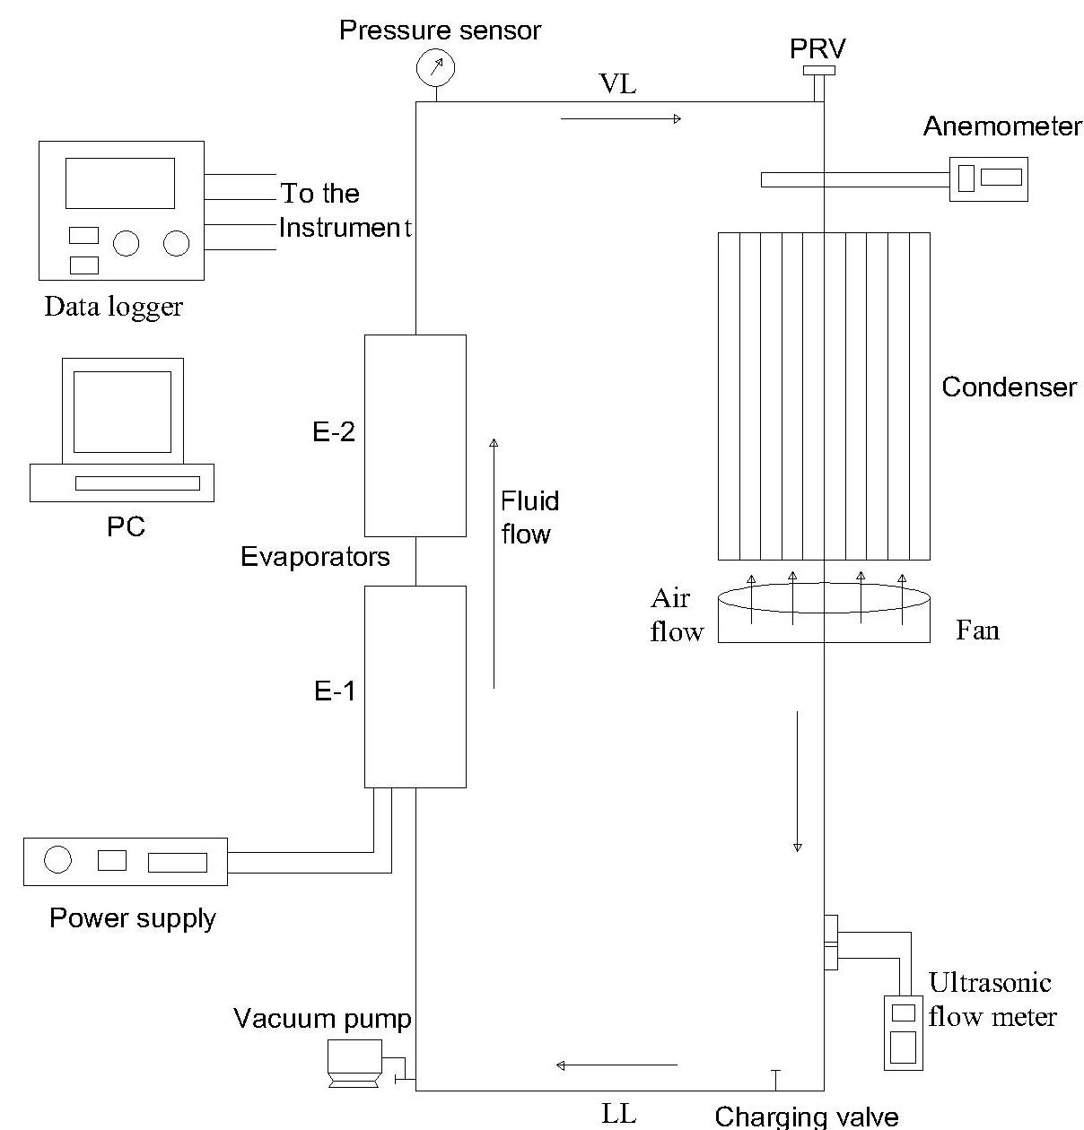
- Schematic diagram of experimental setup
The lower part of the thermosyphon is equipped with a vacuum seal valve for connection to a mechanical vacuum pump and a charging valve to the working fluid charging line. A mechanical pump is used for evacuation of closed loop and partial elimination of the non-condensable gases from the thermosyphon. The thermosyphon is a long carbon steel pipe having an inside diameter of 32 mm and outside diameter of 42 mm. Insulation is wrapped around the evaporator section to prevent the heat loss. Heat flux is given to evaporator through heater using power supply. Amount of input heat flux is controlled with help of controller on control panel. The condenser section of the pipe consists of enclosure surrounding a plate type heat exchanger. Heat is removed from the condenser section by forced air convection through fan. There is a pressure transmitter to measure the loop pressure and 20 thermocouples to measure temperatures. All thermocouples are connected to a data-logger which is connected to a computer for displaying data. All the experimental data is recorded and stored in computer system till the steady state condition is achieved.
Before charging the thermosyphon, gases and air present in loop are removed by a vacuum pump to ensure the perfect operation of the thermosyphon. Vacuuming is down to 0.09 bar (abs). After vacuuming no leakages in the system are ensured. After evacuation the loop is charged with working fluid as per the required filling ratio. After charging all the valves are closed tightly. The evaporator section is heated using the power supply. The power input to the two-phase closed thermosyphon is gradually raised to the desired power level. Fans are started. The surface temperatures at ten different locations along the evaporator section of TPCT are measured. The system pressure is measured by a pressure transmitter located at the upper part of the thermosyphon. The input and output temperatures of the air flowing over the condenser plates are measured. The flow rate of working fluid is measured by an ultrasonic flow meter. The air velocity is measured after it passes over the condenser plates. Temperatures of incoming and outgoing fluid are measured in the evaporator as well as condenser section at regular time intervals until the thermosyphon reaches the steady state condition ^{[10]}.

- Results and Discussions
Analysis of two-phase closed loop thermosyphon is carried out to understand thermal behaviour of the thermosyphon system and to determine performance parameters such as thermal resistance, evaporative heat transfer coefficient and condensation heat transfer coefficient at different working fluids. In these experiments the filling ratio (FR) is varied in the range of 30% to 80% in the step of 10% at various heat inputs of 0.5 kW to 2 kW with step of 0.5 kW for each evaporator and different adiabatic length (vapour line length) of 200 mm. The working fluids used for the experimentations are distilled water, acetone, methanol and ethanol. The comparative study of these different working fluids is reported in this section. The plots given in this section are representative plots for understanding basic behaviour of the system and similar trends are also obtained for the other configurations.

3. 1. Thermal resistance
Thermal resistance is function of temperature difference between evaporator and condenser section and heat input. Thermal resistance against heat input is plotted for all working fluids at filling ratio (FR) = 0.3 (30%) and at the adiabatic length of 200 mm as shown in the fig. 2.
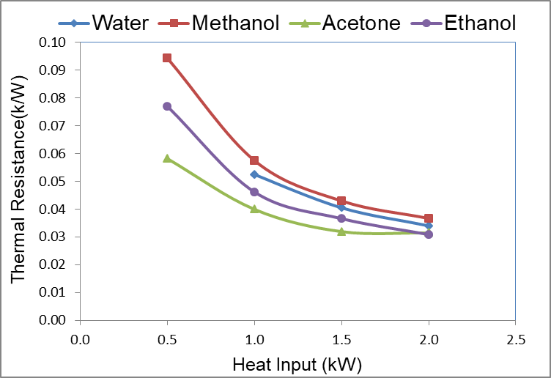
- Thermal resistance (k/W) vs. heat input (kW) at FR = 0.3
It is noticed that for all the working fluids thermal resistance decreases with increase in heat input. At smaller heat input thermal resistance is higher because of large number liquid molecules in the evaporative section became obstacles to transfer of heat. From this result, it is noticed that thermal resistance is higher for the methanol working fluid at all the heat inputs and it is lower for acetone for the all heat input except at 2 kW. Thus, acetone is better fluid comparatively as its thermal resistance is lower below 2 kW heat load.

3. 2. Evaporative heat transfer coefficient
The evaporator heat transfer coefficient is one of the important performance parameters of the TPCT. Evaporative heat transfer coefficient vs. heat input at FR = 0.3 and at the adiabatic length of 200 mm is shown in the fig. 3. Water shows several orders of magnitude greater evaporative heat transfer coefficient than other working fluids and its trend is different than remaining other three fluids. For distilled water, with increase in heat input the evaporative heat transfer coefficient decreases. On the other hand, with increase in heat input the evaporative heat transfer coefficient of acetone, methanol and ethanol increases. The heat carrying capacity of water is more than other fluids therefore water having highest evaporative heat transfer coefficient than other and also its heat carrying capacity decreases slightly with increase in heat input.
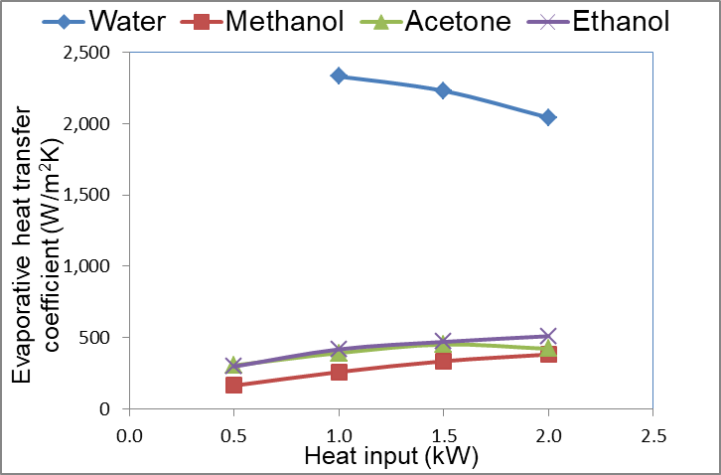
- Evaporative heat transfer coefficient (W/m²K) vs. heat input (kW) at FR = 0.3

3. 3. Condensation heat transfer coefficient
Condensation heat transfer coefficient vs. heat input at FR = 0.3 is shown in the fig. 4.
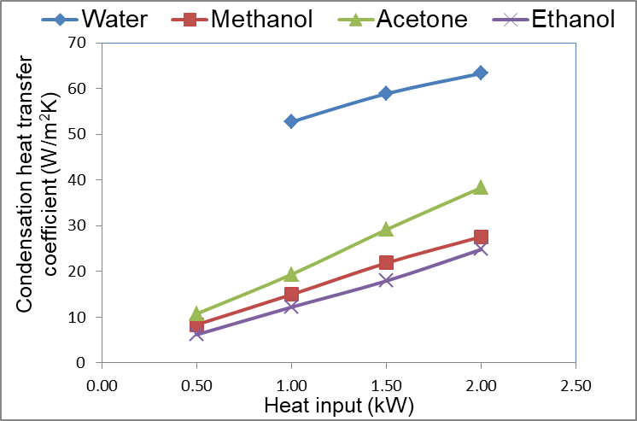
- Condensation heat transfer coefficient (W/m²K) vs. heat input (kW) at FR = 0.3
Water shows much higher condensation heat transfer coefficient than other working fluids. With increase in heat input the condensation heat transfer coefficient increases for all the working fluids. The higher condensation heat transfer coefficient of the water should allow maximum heat transfer rate from the condenser than other fluids. Also it is noticed that condensation heat transfer coefficient is lower than evaporative heat transfer coefficient because of filmwise condensation start in the adiabatic section which leads to decrease in heat transfer rate which further reduces condensation heat transfer coefficient.

- Conclusions
The effect of the different working fluids on the thermal performance of two-phase closed loop thermosyphon has been investigated experimentally. The conclusions are drawn as follows:
Thermal resistance decreases with increase in heat input for the all the working fluids used in this experimentation. Its value is minimum for acetone and maximum for methanol. Evaporative heat transfer coefficient decreases with increase in heat input for distilled water as a working fluid, but for methanol and ethanol evaporative heat transfer coefficient increases with increase in the heat input. The distilled water shows much higher evaporative heat transfer coefficient than other working fluids because it has higher heat carrying capacity. Condensation heat transfer coefficient increases with heat input for all the working fluids. Its value for distilled water is much higher than other working fluids whereas ethanol shows comparatively lower condensation heat transfer coefficient. Also the condensation heat transfer coefficients are lower than evaporative heat transfer coefficients; this is because of filmwise condensation start in the adiabatic section which leads to decrease in heat transfer rate.

- References
- D. A. Reay, P. Kew, ‘Heat Pipes’, 5th ed. Oxford, UK: Butterworth-Heinemann, (2006).
- A. Franco, S. Filippeschi, Closed Loop Two-Phase Thermosyphon of Small Dimensions: a Review of the Experimental Results, Microgravity Sci. Technol. (2012).
- A. D. Patel,R. B. Yarasu, Factors Affecting the Thermal Performance of Two Phase Closed Thermosyphon: A Review, International Journal of Emerging Technology and Advanced Engineering, 2(9), (2012).
- A. Pal , Y. K. Joshi, M. H. Beitelmal, C.D. Patel, T. M. Wenger, Design and Performance Evaluation of a Compact Thermosyphon, IEEE Transactions on Components, Packaging, and Manufacturing Technology, 25 (4), (2002) 601 - 607.
- M. Ali Ersoz, A. Yıldız, Thermoeconomic analysis of thermosyphon heat pipes, Renewable and Sustainable Energy Reviews 58 (2016) 666–673.
- H. Jouhara, A. J. Robinson, Experimental investigation of small diameter two-phase closed thermosyphons charged with water, FC-84, FC-77 and FC-3283, Applied Thermal Engineering 30, (2010).
- M. Karthikeyan, S. Vaidyanathan, B. Sivaraman, Heat Transfer Analysis of Two Phase Closed Thermosyphon using Aqueous Solution of n-Butanol, International Journal of Engineering and Technology, 3(6), (2013).
- Z. Tong, T. Ding, z. li, X. H. Liu, An experimental investigation of an R744 two-phase thermosyphon loop used to cool data center, Applied Thermal Engg. 90, (2015), 362-365.
- M. G. Mousa, Thermal Performance of Thermosyphon Charged by Nanofluid for Cooling Electronic Component, International Journal of Scientific & Engineering Research, Volume 2, Issue 6, (2011).
- Y. Naresh, C. Balaji, Experimental investigations of heat transfer from an internally finned two phase closed thermosyphon, Appl. Therm. Eng. 112 (2017) 1658 - 1666.

