Industry 4.0 technology: Design and Manufacturing of Modular Fixture
Pooja Raval1, Dr. Nirav P. Maniar¹, Sudhir Thaker2

1 V. V. P. Engineering College, Virda-Vajdi, Opposite Motel The Village, Kalawad Road, Rajkot – 360005, Gujarat, India
{pooja.ghodasara.me, nirav.maniar.me}@vvpedulink.ac.in

2 M/s Supra Technology, 51 A Bhaktinagar Industrial Estate, Behind Shaktivan Manufacturers, Rajkot – 360002, Gujarat, India
sudhir, pradeep}@supratechnology.in
Abstract. The growing interest in mass customization has felt the need for the implementation of modular fixture in the field of manufacturing. Modular fixtures fulfill the demand of locating, holding and supporting parts for customized products that exhibits dimensional variances. Major of the literature is focused on theoretical and conceptual aspects of fixture design. In this paper a real industrial component is considered for modular fixture designing. The component is die height platen widely used in plastic injection molding machine. The major operations to be performed are boring and facing which require two set up of fixtures. The innovative use of modular fixture eliminates the need of dedicated fixture and thus results in huge cost saving. Fixture not only designed, but manufactured also; it sets the classical example of design for manufacturing.
Keywords: Modular fixture, Die height platen, Plastic injection molding machine
1 Introduction
Injection molding machine is one of the most widely used method of conversion of plastic into various end products applicable to wide range of plastic materials from plastic commodity to specially prepared engineering plastics. It consists of pump, barrel with hopper, heater, nozzle, stationary platen, die height platen, tie bar and ejector. Because of the high pressure used to inject the molten metal into the die, many tons of forces are required to hold the two die halves together. This holding force is accomplished with the tie bar-platen-toggle type machine. The construction arrangement not only achieves the required holding (clamping) force, but it also opens and closes the die rapidly.
The machine tool industry has undergone sufficient changes as the requirement of user engineering systems changed; first it started with the manufacture of basic general purpose machine tools. These machines though offered higher flexibility were not suitable for mass production. Mass production machines are conceived with growing need of fast production. These machines were highly specialized but inflexible. Thus great need is felt for tools that could bridge the gap between highly flexible general purpose machine tools and highly specialized, but inflexible mass production machines. Numerical control machine tools with proper modular fixture set up have to take up this role very well and it blends the advantage of mass production with flexibility.
2 Related Work
Research work on fixture started from 1940. Various manual and handbooks are available giving set of guidelines for fixture design.
A. Illidge & G. Bright [1] focused on the issues facing the implementation of mass customization; automated flexible fixture system has been designed and manufactured that provided automated setups and setup changeovers, accommodated a large variety of part families and geometries. Wei Fan et al. [2] designed an automated reconfigurable and flexible assembly fixture for aerospace pipelines prior to welding. Enrico Naidoo and Jared Padayache [3] presented a method for the scheduling of an on-demand fixture manufacturing cell in-tandem with a part processing cell. The concept was developed as a solution for the efficient production planning of reconfigurable modular fixtures in mass customization production systems.
Kuigang Yu et al. [4] proposed a flexible fixture system design method for similar automotive body parts, which contains structure and locating control algorithm design of a flexible fixture. Suman Gothwal and Tilak Raj [5] proposed conceptual designing of a pneumatically operated flexible fixture can be used in any manufacturing industry which is dealing in milling and drilling operations. Balasuriya et al. [6] gave a new concept of granular jamming to be used in fixturing to reduce the negative effects of point loading. Matezik. M et al. [7] presented the development of novel multipurpose solution for modular fixture design with high efficiency, higher accessibility and flexibility.
P. Sivasankaran [8] designed and analyzed the modern screw less machine vice using CATIA and ANSYS APDL package. Gelareh Namdar et al. [9] presented novel meso-scalar modular fixturing system with embedded sensing elements at the conceptual level. Cai Jin et al. [10] integrated modelling method supplying a new way for modular fixture system to be used in heterogeneous environment using Object oriented (OO) method.
The following section presents the real-time research work of designing and manufacturing modular fixture for machining real industrial component i.e. die height platen of plastic injection molding machine. The important details of the part and fixture are included in each section along with 3D view of finished component & 3D assembled view of both set up of fixture. The fixture is not only designed but manufactured also, it sets the classical example of design for manufacturing and excellence in manufacturing infrastructure.

3 Design and Development of Modular Fixture
3.1 Statement of Problem
“Design and development of modular fixture for machining platen of plastic injection molding machine. The operations to be performed are leg facing, boring, tapping, side milling and back facing. Two set up of fixtures are required to complete all operations.”
3.2 Component Details
The component is die height platen of plastic injection molding machine, made up of S. G. Iron, weighing 540 kg. Figure 1 shows 3D views of component.
The list of operations to be performed for set up I fixture are as under:
- Mounting Leg
- Making tooling hole for set up II fixture
- Top and bottom facing
The list of operations to be performed for set up II fixture are as under.
- Boring (Stain rod bore, toggle bore and hug arm bore)
- Facing on all sides
- Side milling at hug arm bore

3.3 Design of Fixture
Fixtures consist of three primary components: locators, clamps, and a baseplate. The locators accurately and precisely position the workpiece so that repeatability can be achieved; the clamps push the workpiece against the locators to minimize vibration; and the baseplate is the platform to which the locators and clamps are attached.
The location and clamping in set up I fixture are achieved by two job locators, resting jacks and clamp studs. Two Job locators are used for locating and orientation, which consist of spring-loaded piston. Resting Jacks- Four jacks are used to rest the component. Four clamp studs are used to clamp the component. The clamp assembly consist of resting jack, clamp stud and clamp support.
Dowel pins and M20 bolts are used to locate and clamp the component in set up II fixture. Each M-20 bolt can apply clamping force of 7120 N with torque ranging from 500 to 700 N m. All locators and clamps can be provided with T – slots and adjustable height mechanisms to accommodate variation in part dimensions, eliminating the need of flexible fixtures and thus resulting in cost effective solution.
Figures 2 and 3 show 3D view of set up I fixture without component and with component respectively. Figure 4 shows 3D view of set up II fixture. Figure 5 show photograph of manufactured fixture.

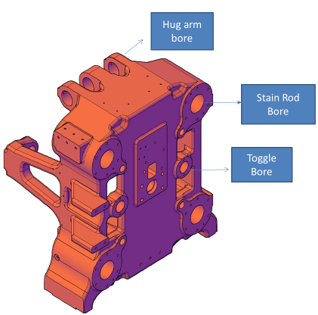  Fig. 1. 3D view of component. | 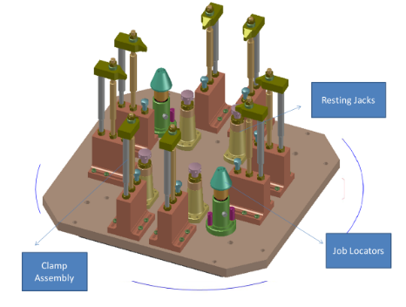  Fig 2. 3D view of set up - I fixture with component.
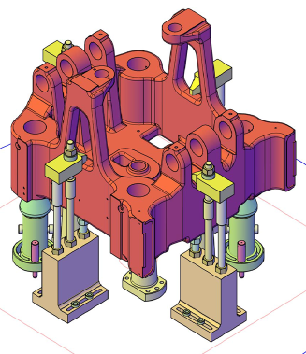  Fig 3. 3D view of set up - I fixture with component | 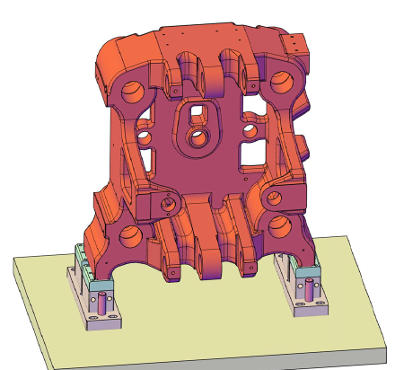  Fig 4. 3D view of set up - II fixture with component
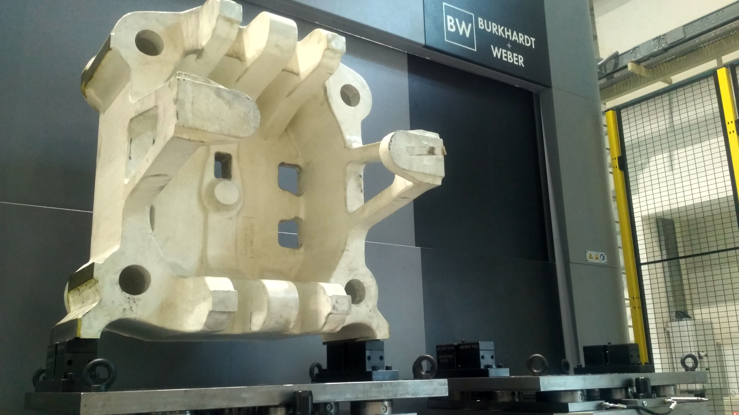
Fig 5. Photograph of manufactured fixture
4 Conclusions
Current fixture technology does not possess the flexibility required for mass customization. Automated flexible fixture system(AFFS) came out with the proof of concept only not as final product. Commercialization of the flexible fixture yet not implemented. The flexible fixture design method for similar automotive body parts are proposed but not manufactured. Majority of the research is reported in different aspects of fixture design in isolation, such as fixture planning, layout optimization, fixture design verification and automated assembly of fixtures. But a comprehensive computer aided fixture design system integrating all these aspects is not reported. The present research work deploys fixture design task into an overall manufacturing process to obtain best fixture design solution for real industrial component.
An integrated approach of design and manufacturing of a modular fixture has been adopted in this work. This approach is of crucial importance in real manufacturing environment. It is already recognized that computerized fixture design can result in high efficiency, stable accuracy, short set-up time and low cost. But the real performance of a computerized fixture design system is rooted in a powerful ability of the system to ‘‘replace’’ or exceed that which is done conventionally by a fixture designer. Another important research is on the integration of various techniques directly used in computer aided fixture design. As we know, an optimal fixture solution is a hybrid result of many different considerations, such as tolerance configuration, stiffness configuration, machining process, etc. In the present research work, focus is given on the establishment of a systematic way of integrating various techniques. It is apparent that almost all the literature is focused on principles and theoretic aspects of fixture design. This puts a question of the practical value of fixture research. There is a clear demand for designing & manufacturing fixture for real industrial component and more research in computerized fixture design in such fields. The present research work satisfies this demand by deploying the fixture design task into an overall manufacturing process to obtain best fixture design solution for real industrial component. Fixture is not only designed but mass balanced and manufactured also, hence the present research work sets the classical example of design for manufacturing.
References
- A. Illidge1 & G. Bright1.: An Automated flexible fixture system for mass customization. South African J of Industrial Engineering 29 (1) (2018) 21-34
- Wei Fan, Lianyu Zheng & Yahui Wang.: An automated reconfigurable flexible fixture for aerospace pipeline assembly before welding. The Int J of Advanced Manufacturing Technology, https://doi.org/10.1007/s00170-018-2120-9 (2018)
- Enrico Naidoo, Jared Padayachee.: Scheduling Technique for Customized Parts with Modular Fixtures in On-Demand Fixture Manufacturing Cells. IEEE 14th International Conference on Control and Automation (2018)
- Kuigang Yu, ShiyaWang, YananWang, Zhihong Yang.:A flexible fixture design method research for similar automotive body parts of different automobiles”. Advances in Mechanical Engineering 10(2) (2018) 1–8
- Suman Gothwal and Tilak Raj.: Conceptual design and development of pneumatically controlled flexible fixture and pallets. Int. J. Services and Operations Management 29 (2018)
- B.M.S.C.B. Balasuriya, H.W.P. Bhanuka, H.R.L. Sampath, A. L. Kulasekera and N. D. Jayaweera.: An Improved Fixturing Solution for Holding Complex Shaped Components. Moratuwa Engineering Research Conference (2018)
- Mateic. M, Tadic. B, Lazarevic. M, Misic. M and Vukelic. D.: Modelling and simulation of a novel modular fixture for flexible manufacturing system. Int J of Simul Model 17 (2018 )
- P. Sivasankaran.:Design and Analysis of Modular Fixture for Machine Vice.: International Journal of Industrial & Production Engineering & Technology 8 (2018) 1-6
- Gelareh Namdar, Chen Liu, James Mills.: A reconfigurable modular fixture design for meso-milling. Int J of mechatronics and Automation 3 (2014)
- Cai Jin, Duan Guolin, Yao Tao, Chen Xuebin.: Research on integrated modelling method for modular fixture based on OO technology. J Of Production Engineering (2018)
- Claudio Costa, F. J. G. Silva, Ronny M. Gouveia, R. P. Martinho.: Development of Hydraulic Clamping Tools for the Machining of Complex Shape Mechanical Components. Procedia Manufacturing 17 (2018) 563–570

