Effect of waste materials as alternative of natural resources for sustainable bituminous paving mixes
Jagadeesh Gopalam¹, Jyoti Prakash Giri^{2*}, Mahabir Panda³
¹ P.G. Student, Department of Civil Engineering ,GMR Institute of Technology, Civil Department, Rajam, India;
² Assistant Professor, Department of Civil Engineering ,GMR Institute of Technology, Civil Department, Rajam, India;
³ Professor, Department of Civil Engineering,National Institute of Technology, Civil Department, Rourkela, India;
* e-mail: jagadeesh1329@gmail.com

Introduction
Sustainable development offers various scopes of civil constructions for gaining importance to the noticeable and appropriate reasons. In different transportation construction industries, engineers from industry, and researchers are all craving this for bituminous paving as well as concrete mixes for highway projects which transfer to a sustainable future. In the flexible pavement, a reflective number of innovative materials and technologies are being developed to ascertain their suitability for the design, construction and maintenance of these pavements. Warm mix asphalt (WMA), recycled asphalt pavement (RAP), fly ash, bottom ash and shingles are some of the materials that transportation researchers believe to have hold the future to sustainability in the bituminous highway construction industry in conventional way (Mills-Beale and You, 2010). Utilization of these sustainable materials or techniques have resulted tremendous benefits for the conservation of natural resources, optimizing the landfill use and saving the project cost corresponding to the waste dumping charge (Giri et al., 2018). Another potential material that few researches have attempted for its re-use in bituminous paving mixes, is recycled concrete aggregate (RCA). (RCA) which is basically a demolition waste originated from the concrete structures due to either attaining their expected life or due to other reasons. The large scale generation of RCA is a common feature mostly in urban areas and large project sites. On the contrary, RCA has been found to have offered promising results when utilized as base aggregate material for sub base layer in bituminous pavement and in Portland Cement Concrete (PCC) pavement worldwide (Motter et al., 2015). However, studies on the use of RCA in bituminous paving mixes are limited. This fact has motivated the authors to investigate and explore the practicality implication of RCA as replacement of coarse aggregates in bituminous paving mixes and take up a comparative study with respect to the conventional bituminous mix. In this experimental research, the RC aggregates have replaced fully the coarse aggregate portion in the bituminous mix with two different types of fillers namely fly ash and stone dust addition to two types of bitumen such as VG 30 and VG 40. The impact of aggregate, filler and bitumen type on bituminous mix performances has been evaluated in terms of conventional Marshall properties, moisture sensitivity and resilient modulus values.

Materials and Methods
In the present experimental investigation, to study the effects of aggregate, bitumen and filler types on the performances of dense bituminous macadam (DBM) mixes, eight combinations with two different types of aggregates, i.e., natural aggregate (NA) and recycled concrete aggregate (RCA), two types of bitumen, i.e., VG 30, and VG 40 and two types of fillers, i.e. stone dust (SD) and fly ash (FA) are tried. The properties of all the materials used in this study have been determined in the laboratory. The test results satisfy all the parameters according to Ministry of Road Transport and Highways (MoRTH, 2013). From the test results, it is observed that RCA has a bit lower specific gravity as well as higher water absorption value compared to conventional aggregate. For evaluation purposes, different performance tests on each type of mix such as Marshall properties, indirect tensile strength, moisture susceptibility [in terms of tensile strength ratio (TSR) and retained stability (RS)] and resilient modulus test, have been taken up. For these performance tests, all the eight bituminous mixes were prepared with 5% bitumen content as per Marshall procedure. The mixes prepared with NA, two types of filler (SD and FA) and two types of bitumen (VG 30 and VG 40) have been given nomenclature as NSD 30, NFA30, NSD 40 and NFA 40. Similarly, the mixes made with RCA as coarse aggregate have been named as RSD 30, RFA30, RSD 40 and RFA 40.

Results and Concluding Remarks
The test results of DBM mixes prepared with different combinations are presented below through Figure 1 through Figure 4. The Marshall parameters such as Marshall stability, flow value and air voids for the eight mixes compacted with 5% bitumen are presented in the Table 1.
Table 1. Marshall parameters of different DBM mixes
Mix type | Marshall Stability (kN) | Flow value (mm) | Air voids (%)
NSD 30 | 13.66 | 3.35 | 4.18
NFA 30 | 12.89 | 3.45 | 4.29
RSD 30 | 15.89 | 3.1 | 4.10
RFA 30 | 16.10 | 3.15 | 4.18
NSD 40 | 15.28 | 3.3 | 3.63
NFA 40 | 14.29 | 3.35 | 4.21
RSD 40 | 17.61 | 2.68 | 3.94
RFA 40 | 17 | 2.82 | 4.15

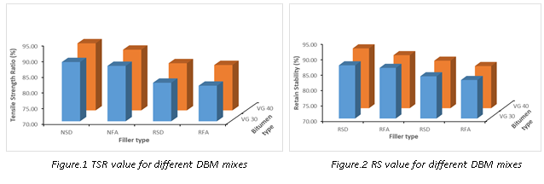
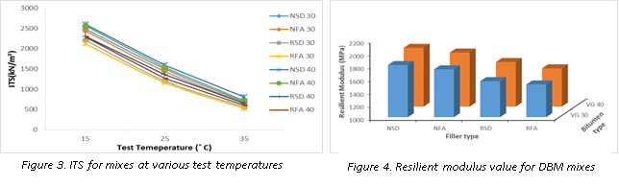

From the above mentioned results, it is concluded that, the mixes prepraed with NA, stone dust as filler and VG 40 bitumen offered highest resistance to moisture susceptibility and maximum resilent modulus value as compared to the other mixes. However from Marshall stability point of view, the samples made with RCA, stone dust and VG 40 as binder, resulted maximum values compared to other mixes. However in general, satifactory values are observed when RCA and stone dust have been used in the bituminous mixes.

References
Mills-Beale, J., & You, Z. (2010). The mechanical properties of asphalt mixtures with recycled concrete aggregates. Construction and Building Materials, 24(3), 230-235.
Giri, J. P., Panda, M., & Sahoo, U. C. (2018). Performance of Bituminous Mixes Containing Emulsion-Treated Recycled Concrete Aggregates. Journal of Materials in Civil Engineering, 30(4), 04018052.
Motter, J. S., Miranda, L. F. R., & Bernucci, L. L. B. (2015). Performance of hot mix asphalt concrete produced with coarse recycled concrete aggregate. Journal of Materials in Civil Engineering, 27(11), 04015030.

