Decay of Blended Geopolymer Concrete in Acidic Environment
A.K.Mallinadh¹, T.Chandra Sekhar Rao^{2*}, N.V.Ramana Rao³
¹Ph.D Scholar, Department of Civil Engineering, Jawaharlal Nehru Technological University, Hyderabad
² Bapatla Engineering College, Bapatla
³National Institute of Technology, Warangal
* e-mail: mallinadhkashyap@gmail.com

Introduction
Geopolymer concrete(GPC) is a most versatile futuristic concrete as it enables the researchers to utilize the industrial waste by product materials whose disposition is a major problem as an alternative to the cement concrete. Ordinary Portland Cement (OPC) is a primary binding material which is used in conventional construction practices. It was estimated that the manufacture of one ton of cement produces nearly one ton of carbon dioxide which emits into the atmosphere which causes the environmental pollution and leads to global warming. On par with the durability considerations of the ordinary Portland cement concrete, it was evident that in corrosive environments the OPC concrete starts to deteriorate. Henceforth, “Geopolymer Concrete” which was coined by Davidovits in 2005 [1] gained the interest of the researchers as an alternative material to the conventional cement concrete. Davidovits concluded that by the alkaline activation of the source materials like fly ash, ground granulated blast furnace slag, silica fume and metakaoline etc., with the polymeric reaction by sodium based or potassium based solutions. The inorganic alumino-silicate polymer made from the materials which are rich in silicon (Si) and aluminium (Al) materials by the polymerization process in a chemical reaction under alkaline condition gives the Geopolymer binding material.

Materials and Methods
Fly ash (Class F) was procured from Vijayawada Thermal Power Station (VTPS) and Ground Granulated Blast Furnace Slag was obtained from Vizag Steel Plant. Locally available River sand was used as fine aggregate. Coarse aggregate of sizes 20 mm,12 mm amd 6 mm were used in the present study so as to fill the voids. Distilled Water was used to prepare 12 Molarity concentration of Sodium Hydroxide Solution which was prepared prior to one day of casting. Sodium Silicate which is available in liquid form was used in the present study. The sodium Silicate to Sodium Hydroxide ratio adopted was 2.5.The Cube specimens after demolding were kept in different concentrations of Sulphuric acid, Hydrochloric acid and Sodium Chloride solutions for acidic exposure on high strength grade geopolymer concrete after 28 days,56 days and 90 days. The compressive strength of Geopolymer concrete has been evaluated on hydraulic compression testing machine of 2000kN capactiy. For the compressive strength test, cubes of size 150mm x 150mm x 150mm for H₂SO₄,HCl exposure and 100mmx100mmx100 mm for NaCl exposure are tested in compression.

Results and Concluding Remarks
Table: 1 Mix Design of M70 grade of Geopolymer Concrete
S.No | Constituents | Quantity( kg/m³)
1. | Binder content(GGBS+Fly ash) | 410.70
2. | Fine aggregate | 770.00
3. | Coarse aggregate | 1155.00
4. | Sodium Silicate solution | 117.30
5. | Sodium Hydroxide solution | 47.00
6. | Admixture (2%) | 8.21
7. | Extra water (10%) | 41.07

Table 2: Effect of various alkaline environments on compressive strength of M70 grade GPC
Mix Designation | Mix Specification | Weight of the Cube (Kgs) |  | Compressive Strength (MPa)
Mix Designation | Mix Specification |  |  | 28 days | 56 days | 90 days
Mix Designation | Mix Specification | Initial | Final | 28 days | 56 days | 90 days
M1 | M70 CM | 9.10 | 8.95 | 77.77 | 83.11 | 90.22
M2 | M70-1%H₂SO₄ | 8.60 | 8.56 | 74.22 | 84.44 | 87.55
M3 | M70-3% H₂SO₄ | 8.57 | 8.53 | 72.88 | 83.11 | 86.66
M4 | M70-5% H₂SO₄ | 8.54 | 8.50 | 71.11 | 80.44 | 84.88
M5 | M70-1% HCL | 8.58 | 8.54 | 74.88 | 85.77 | 89.33
M6 | M70-3% HCL | 8.52 | 8.45 | 73.33 | 84.00 | 88.00
M7 | M70-5% HCL | 8.56 | 8.51 | 71.55 | 81.77 | 86.22
M8 | M70-1% NaCl (100x100x100mm) | 2.52 | 2.48 | 76.00 | 86.66 | 88.44
M9 | M70-3% NaCl (100x100x100mm) | 2.53 | 2.50 | 75.11 | 85.77 | 88.00
M10 | M70-5% NaCl (100x100x100mm) | 2.48 | 2.42 | 73.33 | 84.88 | 87.11
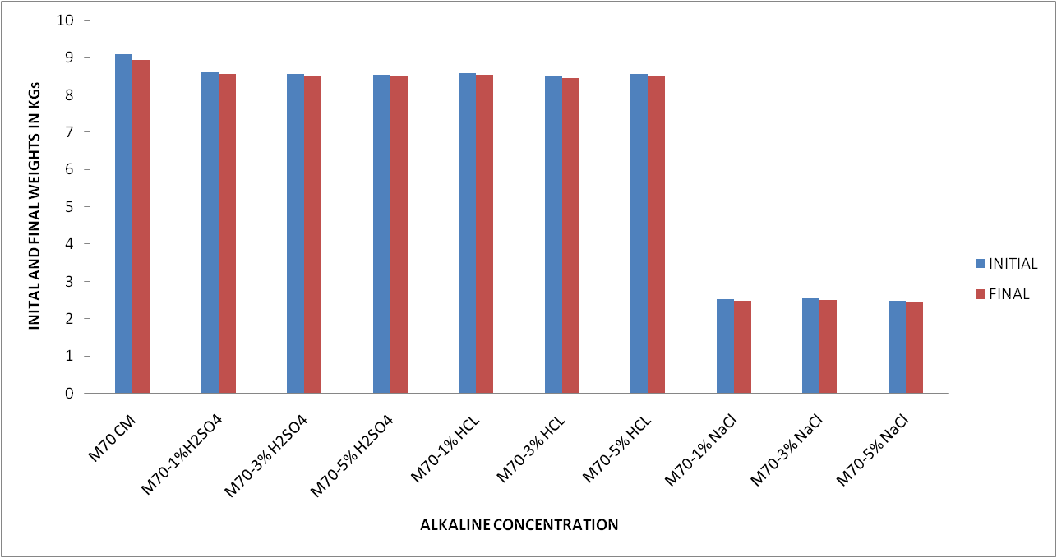
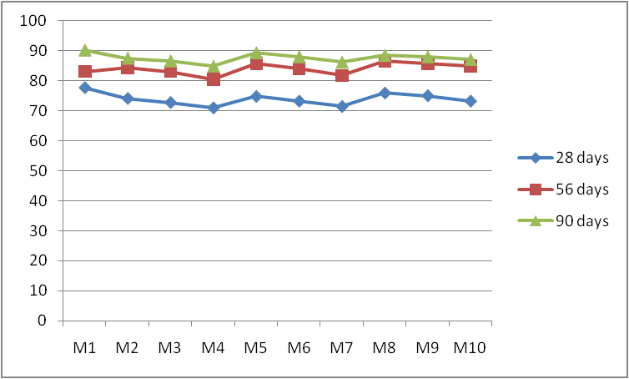
Fig.1 Effect of Various Alkaline Concentration on the Fig2 Effect of various alkaline concentrations on the
Weights of M70 grade GPC Compressive Strength of M70 grade GPC
Conclusions
The experimental results stated that the GGBS and fly ash based geopolymer concrete showed an excellent resistance to sulphate and chloride attack on par with the controlled concrete. There are no compelling changes in the weight of the specimens and the compressive strength of the concrete upto 90 days of immersion in the acidic environment. The sulphuric acid exposure to the geopolymer concrete specimens damaged the surface of the specimens and the compressive strength was found to be decreased and the percentage decrease was found to be 4.6%,6.28%,8.5% for 28 days, 1.5% increase, 0%,3.21% for 56 days and 3%,3.94% and 5.91% for 90 days of immersion in the sulphuric acid of various concentrations when compared with the control mix.The Hydrochloric acid exposure to the geopolymer concrete specimens damaged the surface of the specimens and the compressive strength was found to be decreased and the percentage decrease was found to be 3.71%,5.70%,8% for 28 days, 3.1% increase, 1.05% increase,1.61% for 56 days and 1%,2.5% and 4.5% for 90 days of immersion in the Hydrochloric acid of various concentrations when compared with the control mix. The Sodium Chloride acid exposure to the geopolymer concrete specimens damaged the surface of the specimens and the compressive strength was found to be decreased and the percentage decrease was found to be 2.27%,3.45%,5.7% for 28 days, 4.1% increase, 3.2% increase,2.1% increase for 56 days and 2%,2.5% and 3.5% for 90 days of immersion in the Sodium Chloride acid of various concentrations when compared with the control mix.

References
1.Davidovits.J, “Geopolymer, Green Chemistry and Sustainable Development Solutions”, France:Institute of Geopolymer, 2005,PP-9-15.
2.Rangan BV, Hardjto D. Development and properties of low calcium fly ash based geopolymer concrete. Research report GC-1. Faculty of Engineering, Curtin University of Technology, Australia. 2005: 35-50. 5.
3. Rangan BV, Wallah SE. Low-calcium fly ash based Geopolymer concrete Long term properties. Research report GC-2. Faculty of Engineering, Curtin University of Technology, Australia. 2006: 28-32.
4. Rajamane NP, Nataraja MC, Dattatreya JK, Lakshamanan N, Sabitha D. Sulphate resistance and eco-friendliness of geopolymer concrete. The Indian Concrete Journal. 2012: 13-22.
5. Bakharev T. Durability of geopolymer materials in sodium and magnesium sulphate solutions. Cement and Concrete Research. 2005(b): 1233-1246.

