Analytical Behaviour of Steel Hybrid Girder with Opening in Web
Sandhya Kumbhar¹, Samadhan.G.Morkhade², G.N.Narule³
¹P.G.Student, Department of Civil Engineering, VPKBIET, Baramati, Pune.
²Assistant Professor, Department of Civil Engineering, VPKBIET, Baramati, Pune.
³Assistant Professor, Department of Civil Engineering, VPKBIET, Baramati, Pune.

Introduction:
A hybrid Steel girders are made up of plates with different steel grades in flanges and webs. Steel hybrid girder is economical over long length of member and enhances the load carrying capacity. In hybrid girder, generally flanges have high strength as compared to web. Beam is designed for bending and deflection and flange resist bending, hence high strength flanges are used. As web carries the shear force, there is no requirement of high strength web. Steel structures are advantageous due to their durability, design, low cost and precise manufacturing. Opening in beam is adaptable for its high strength to weight ratio and increase in depth of section without any further weight. So, that lighter section can be manufactured. Castellated hybrid beam carries 40% more load than that of homogenous beam with web opening (Morkhade et al. 2019). Furthermore, the steel girder having different steel grades for flanges and web are more economical than homogenous girder if strength of flanges should be less than two times the strength of web for serviceability reasons is recommended (Veljkovic et al. 2004). Castellated hybrid girder is favourable owing to dual benefits of hybrid section and opening provided in web.
The analysis has implemented on three dimensional nonlinear finite element models. Finite element modelling of steel girder with or without opening has been studied using ANSYS 12.0. The flanges are made of high strength steel of grade 460 MPa and web of lesser grade 345 MPa. Results are presented in terms of Load–deflection behaviour and von mises stress concentration. A comparative study has been performed on homogenous and hybrid girder with or without opening in web. From the analytical results, it has been observed that the hybrid girder has higher load carrying capacity when compared with homogenous specimens.

Parametric study
The analysis has been conducted by using ANSYS version 12.0. Figure 1 shows the deflection of homogenous and hybrid girder. The comparisons of variation of load verses deflection are as shown in Figure 2 and 3 respectively. The data has been used in the modelling and analysis of steel girder is:

1) Section type: Homogenous and hybrid 2) Young’s Modulus : 2x10 ⁵ N/mm²
3) Poissons ratio : 0.3 4)steel grade : Homogenous section = Q460
Hybrid section = Q345

Sr.No. | Section type | Total length | Thickness of flange  (mm) | Thickness of web (mm) | Total height(mm)
1 | Homogenous | 3400 | 11.90 | 7.87 | 381.20
2 | Homogenous | 3400 | 11.85 | 7.82 | 382.20
3 | Homogenous | 3400 | 12.56 | 7.94 | 622.10
4 | Hybrid | 3400 | 12.60 | 7.83 | 383.70
5 | Hybrid | 3400 | 12.68 | 7.79 | 384.20
6 | Hybrid | 3400 | 12.63 | 7.93 | 623.40

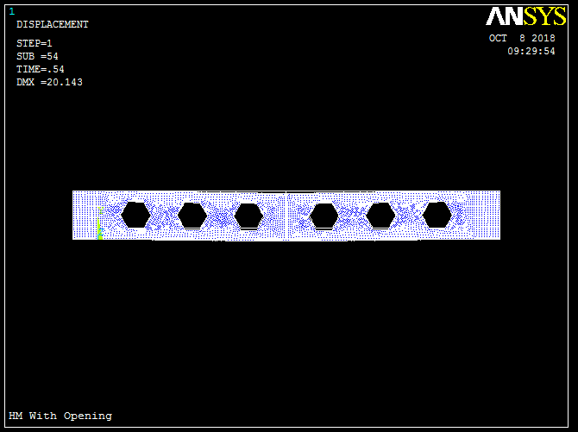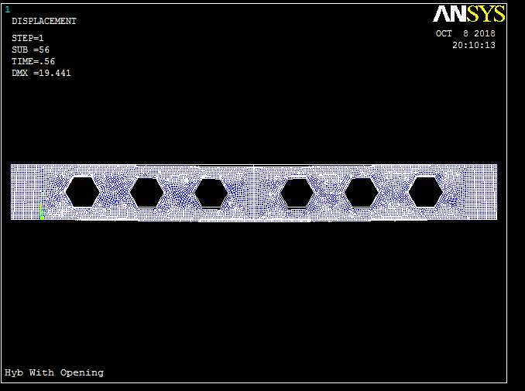
Fig.1 deflection of homogenous girder and hybrid girder with opening

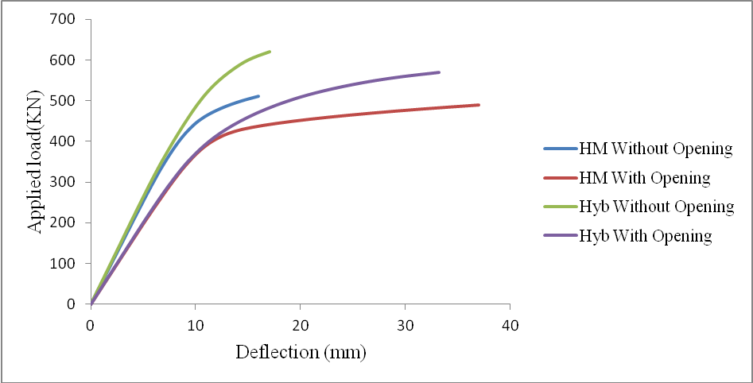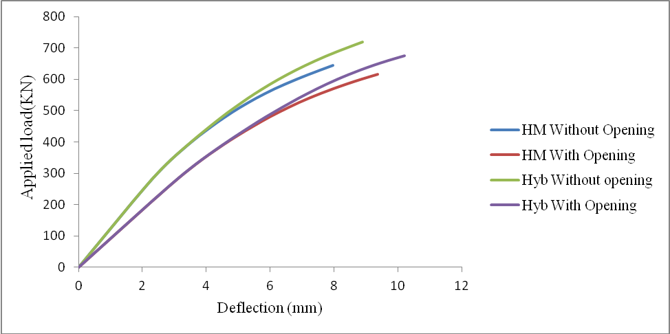
Fig.2 Load deflection curve for homogenous and hybrid girder with or without opening

Concluding Remarks
The behaviour of I section girder involves comparative study between homogenous girder and hybrid girder with plain web and opening provided in web. Based on analytical results, the following conclusion are given:
- It is observed that the hybrid girder has higher load carrying capacity when compared with homogenous specimens in both conditions.
- The failure modes are found to be similar in both homogeneous and hybrid girder.

References
1. Samadhan G. Morkhade, Manisha Kshirsagar, Radhika Dange, Apurva Patil Ghosh(2019). “Analytical study of effect of web opening on flexural behavior of hybrid beams.”, Asian Journal of Civil Engineering , Volume 20, Issue 4, pp 537–547
2. Chun-Sheng Wang , Lan Duan, Y. Frank Chen , Shi-ChaoWang (2016) “ Flexural behavior and ductility of hybrid high performance steel I-girders”, Journal of constructional steel research, Vol 125, Pp: 1–14.
3. M. Veljkovic B. Johansson (2004) “Design of hybrid steel girders”, Journal of constructional steel research, Vol. 60, Pp: 535–547
4. Mehdi Shokouhian, YongjiuShi “Flexural strength of hybrid steel I-beams based on slenderness”, Engineering Structures; Volume 93, 15 June 2015, Pp: 114-128

Corresponding author E-Mail: samadhanmorkhade@gmail.com

