Image-based analysis of concrete deterioration
A V. Guru Prathap Reddy ¹, B B. Murali Krishna ^{1,2}, C L. Pranay Kumar ¹, D T. Tadepalli¹, E P. Rathish Kumar¹,
F K. Gopi Krishna¹, G M. Shashi¹, H MVN Sivakumar¹
¹ Department of Civil Engineering, NIT Warangal, India.
² Research Scholar
* e-mail: vguruprathap@gmail.com

Introduction

Concrete structures undergo deterioration naturally when affected by external environment. Concrete loses its strength and durability with the passage of time. In order to repair and rehabilitate these structures, the causes and extent of deterioration must be identified and quantified for solutions to be provided. The most common methods for condition assessment of structures are visual inspection and contact based non-destructive tests (NDTs) which can be conducted only for structures that are accessible. In cases when structure is inaccessible, image based condition analysis is feasible. This study identifies and quantifies concrete deterioration using digital image processing techniques. Digital image processing enables correlation of greyscale intensities with various deterioration measures such as mass loss, dimension loss and strength loss.

Materials and Methods
In the present experimental study, M30 grade concrete cubes (60 nos.) are cast using ordinary portland cement (OPC-53), fine aggregate, coarse aggregate, and water. After 28 days of curing, these 150x150x150mm concrete specimens are exposed to chemicals. For durability studies, 3 cubes each are immersed in plastic tubs containing HCl, H₂SO₄, NaCl and MgSO₄ at 5% concentration for periods of 3, 8, 15 and 30 days. After exposure to chemical attack, the photographs of all six faces of each cube are captured and greyscale intensity analysis is performed. The samples are weighed, measured and the compressive strength of concrete is obtained using rebound hammer test and destructive test to failure. This enables correlation between various image characteristics and deterioration measures like acid mass loss factor, acid attacking factor, acid strength loss factor, and acid durability loss factor.
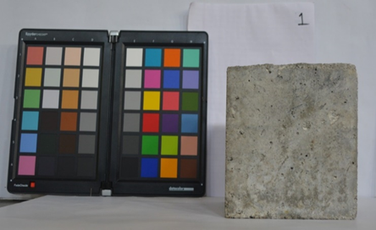
Figure 1. Experimental set up

Results and Concluding Remarks

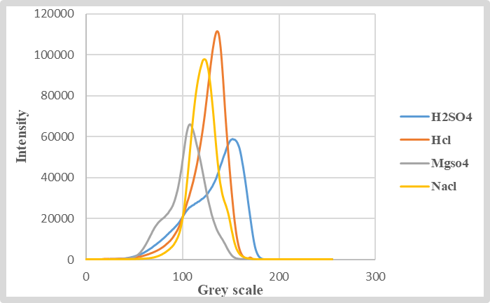
Figure 2: Grey scale Intensity for 30day duration

Table 1. Age of immersion vs Acid Durability Loss Factor (ADLF).
No of days exposure | HCl | H₂SO₄ | NaCl | MgSO₄
0 | 0 | 0 | 0 | 0
3 | 0.04 | 0.05 | 0.00 | 0.00
8 | 0.34 | 0.78 | 0.04 | 0.05
15 | 2.78 | 4.47 | 0.44 | 0.33
30 | 14.05 | 23.93 | 1.79 | 1.08

Results indicate that the both peak intensity of grey scale as well as mean grey scale value are found to be good predictors of the extent of deterioration in concrete exposed to HCl and MgSO₄. Whereas, in the case of H₂SO₄ and NaCl, it is observed that both intensities of grey scale as well as mean grey scale are moderate predictors of extent of deterioration in concrete. The peak grey scale intensities enable identification of the individual chemicals. Relationships between the various deterioration parameters and grey scale spectrum obtained from digital images of concrete at various stages of deterioration, when exposed to four chemicals typically found in the environment, have been developed.

Acknowledgments: This study has been funded by the MHRD-IMPRINT project No. 7338.
References
- Muthu, M., & Santhanam, M. (2018). Effect of reduced graphene oxide, alumina and silica nanoparticles on the deterioration characteristics of Portland cement paste exposed to acidic environment. Cement and Concrete Composites, 91, 118-137.https://doi.org/10.1016/j.cemconcomp.2018.05.005
- Chand, M. S. R., Giri, P. S. N. R., Kumar, P. R., Kumar, G. R., & Raveena, C. (2016). Effect of self-curing chemicals in self-compacting mortars. Construction and Building Materials, 107, 356-364.https://doi.org/10.1016/j.conbuildmat.2016.01.018
- Zhou, Y., Tian, H., Sui, L., Xing, F., & Han, N. (2015). Strength deterioration of concrete in sulfate environment: an experimental study and theoretical modelling. Advances in Materials Science and Engineering, 2015.http://dx.doi.org/10.1155/2015/951209
- Annerel, E., & Taerwe, L. (2011). Methods to quantify the colour development of concrete exposed to fire. Construction and building materials, 25(10), 3989 3997. https://doi.org/10.1016/j.conbuildmat.2011.04.033

