
NATIONAL SYMPOSIUM ON

TRENDS IN ELECTRONICS & TELECOM (TREAT17)

Organized by

Department of ELECTRONICS AND

COMMUNICATION ENGINEERING, NIT Warangal

17TH - 18TH FEBRUARY2017
REGISTRATION FORM

Name: ………………………………………………...……………………

Designation: ……………………..…………………...………………….

Organization: …………………………………………...………………

Address for Correspondence:

………………...……...….……...................................................................

………………………………………………………...….…..........................

.......................................................................................…………………..

Tel/mobile no.…………………….. E-mail: ………………………..

Category: Oral/Poster presentation

Title of Paper:…………………………………………………………….

……..…………………………………………………………………………..

DD Particulars:

Amount …………………………….No..................................................

Date ………………………………….Bank ……………………..……….

Accommodation Required: Yes / No

Date:

Place:

Signature of the Applicant
CHIEF PATRON


Prof. G.R.C. Reddy, I/C Director, NIT Warangal

ADVISORY COMMITTEE

National

Prof. R.V. RAJA KUMAR, IIT, Bhubaneswar
Prof. AJAY CHAKRABARTY, IIT Kharagpur

Prof. SHANKAR P., IIT DELHI

Prof. RAMA SUBBA REDDY, IIT, Madras

Prof. D. JALIHAL, IIT Madras

Dr. D. R. JAHAGIRDAR , RCI Hyderabad

Prof. M.V. Karthikeyan, IIT ROORKEE
Prof. Ratnajit Bhattacharjee IIT Guwahati
Prof. Dr. Elizabeth Elias NIT Calicut
Prof. Muralidhar Kulakarni NITK, Suratkal

Prof. B. Venkataramani NIT Trichy

Dr. Lava Bhargava NIT Jaipur

Departmental Organizing Committee

Prof. Krishna Prasad K S R

Sri Raghunath M. V

Dr. C.B. Rama Rao

Sri K.Ravi Kishore

Sri S.K.L.V.Sai Prakash

Sri P.Harikrishna Prasad
Dr. B. Lakshmi

Dr. N.Bheema Rao

Dr.L.Anjaneyulu

Sri K.V.Sridhar

Dr.T.V.K.Hanumantha Rao

Dr. P.Sreehari Rao

Sri A.Prakasa Rao

Sri P.Muralidhar

Smt.P.Prithvi

Smt.V.Rama

Dr.J.Ravi Kumar

Dr.D.Vakula
Sri K. Sarangam

Dr.S.Anuradha

Dr.V.V.Mani

ORGANISING SECRETARY

Dr. T. Kishore Kumar

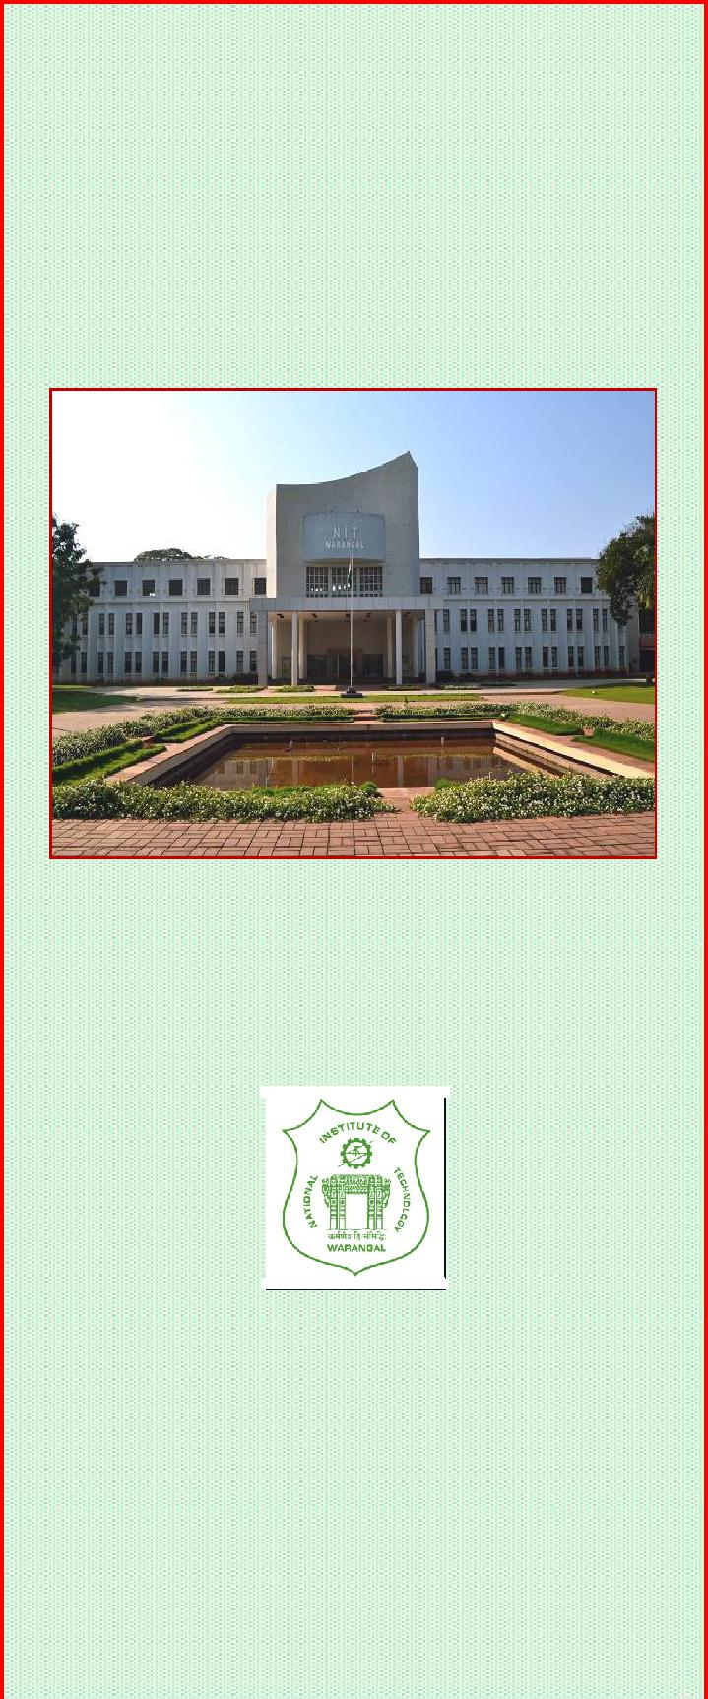
NATIONAL SYMPOSIUM ON

TRENDS IN ELECTRONICS & COMMUNICATION (TREAT17)

17th – 18th FEBRUARY, 2017

ORGANISING SECRETARY

Dr. T. Kishore Kumar
Head of the Department

Convenor
PROF. N.V.S.N. SARMA

Organized by

DEPARTMENT OF ELECTRONICS & COMMUNICATION ENGINEERING
NATIONAL INSTITUTE OF TECHNOLOGY

Warangal-506 004

Telangana State, India.

Web Site:www.treat2017.org

OBJECTIVE

The objective of this symposium is to bring awareness and exposure to research scholars in various topics of current research interest so that they can actively pursue or incorporate the novel methods in other areas in their area of work. Also this symposium gives a forum for the researchers to have long discussions on future trends. The symposium is open to professionals, academics, and individuals from government agencies and other institutions registered for Ph.D. to exchange information and ideas on the advancement of Communications and Electronics technology.
The conference will feature a comprehensive technical program offering numerous technical sessions with papers showcasing the latest technologies, applications
and services. In addition, the conference program includes keynote talks from industrial leaders and renowned academicians,
TOPICS OF INTEREST
Topics on recent advances Electronics Engineering will include but are not limited to

Wireless Communication

Wireless Sensor Networks

Microwave and Antennas

Optical Communication

Signal processing

Internet of Things

Embedded systems

Advances in Digital Design Analog / RF Design VLSI system Design with SDR Architectures

CALL FOR PAPERS

Authors are invited to submit the Full Papers, not exceeding 6-pages in MS word format (soft copy) and neatly typed on A-4 size paper. Each manuscript will undergo a peer review process.

Web Site: www.treat2017.org

The contributed papers must be original and should not have published/ accepted in journals/proceedings. Upon the notification of acceptance, the author will have to submit final copy of the manuscript of the paper, copyright transfer agreement and registration fee and registration form on or before the last date.

TREAT-2017 is planning to bring out Proceedings in the form of a DVD.

IMPORTANT DATES
Submission of Full Paper | 20th Jan, 2017
Acceptance of Paper | 25th Jan, 2017
Receipt of full length | 10th Feb, 2017
paper
Last Date of Registration | 6th Feb, 2017
BEST PAPER AWARD
A "Best Paper Award" will be conferred to the author(s) of a full paper presented at the conference
REGISTRATION FEE

Delegates from Academic , R &D | Rs. 2000/-
Institutions
Delegates from Industry | Rs. 6000/-
Students | Rs. 1000/-
Mode of Payment:

Account Name Director, (TEQIP-II), NITW
Account Number 62182612968
Bank State Bank of Hyderabad
Branch REC Warangal (NIT Campus)
Branch Code 20149
IFSC SBHY0020149
The registration fee can be paid through Demand Draft

- drawn in favor of “Director, (TEQIP), NIT WARANGAL” or Online/NEFT. The filled in registration form along with the DD/Payment receipt should be sent by post or email to:

Organising Secreatary,Treat-2017, Department of ECE,

National Institute of Technology, Warangal-506 004, Telangana State, India.

Ph: 0870-2462412,09849639262(M)

E-mail: treat2017.nitw@gmail.com;
ACCOMMODATION


Limited accommodation may be provided on payment basis in the institute Visitors Block depending on availability and on first come first served basis. Participants who require accommodation in hotels will be arranged on PAYMENT basis. Warangal city covers a wide range of hotels and other accommodation facilities to suit every budget. Participants are advised to contact the hotels directly and book their accommodation. However, in case of difficulty, we will assist on your prior request.

ABOUT THE DEPARTMENT & INSTITUTE

National Institute of Technology (formerly Regional Engineering College), Warangal is the first among 17 RECs setup as joint venture of the Government of India and the state government. Over the years the college has established itself as a premier Institution imparting technical education of a very high standard leading to the B.Tech degrees in various branches of engineering and M.Tech. and Ph.D programs in various specializations.

The Department of Electronics and Communication Engineering offers an Undergraduate program in Electronics and communication Engineering and three Postgraduate programs in EI, VLSI, and ACS Specializations. The Department has experienced faculty and well-established laboratories to meet the requirement of UG, PG and Phd students. The Department has liaison with reputed industries and R&D organizations like DRDO, ISRO ECIL, Analog Devices Bangalore and C-DAC. Department conducts various sponsored programs throughout the year. At present, more than 30 Research Scholars are working for their Ph.D program.

