Modeling Of Material Removal Rate And Hole Circularity On Soda Lime Glass For Ultrasonic Drilling

Abhilash Kumar1 ,Sanjay Mishra2 and Sanjeev kumar Singh yadav3
1,2 Madan Mohan Malaviya University of Technology, Gorakhpur Uttar Pradesh, India 273010
3Harcourt Butler Technical University, Kanpur Uttar pradesh
abhilashkumar905@gmail.com

Abstract. Soda-lime glass possesses high hardness and brittleness. Analysis of machining of soda lime glass becomes essential as it is now being extensively used material for different engineering and medical purposes. The intrinsic characteristics of soda lime glass make it difficult to machine materials. In this study, experimental modelling for material removal rate (MRR) and hole circularity has been performed using the Response Surface Methodology (RSM) for ultrasonic drilling (USD) of 2 mm diameter hole in 3mm thick soda- lime glass. The effect of input process parameters like ultrasonic power, frequency and abrasive grit number has been analyzed on MRR and hole circularity. It was experiential that the effect of ultrasonic power on both MRR and hole circularity for different grit size is not very important. Abrasive with high grit number rises the MRR but declines the MRR after initial rise upto grit number of 40. At a specific ultrasonic power, the increase of frequency continuously increases the hole circularity but in case of MRR it begins to decrease after 23 KHz. The result of ultrasonic power on both MRR and hole circularity is non linear gradual decline up to 80 W further increase later.
Keywords: Response surface method, Soda lime glass, Silicon Carbide, circularity, , ultrasonic drilling

1. Introduction

The rapid development in the field of medical, electrical and optical devices lead to the development of micro devices where glasses are widely used as an engineering material due to its chemical and electrical resistivity, temperature stability, optical transparency and biocompatibility. But the amorphous structure of these materials which provide high hardness and brittleness make it difficult to machine material. The soda lime glass which is prepared by melting silica with soda, dolomite, lime and alumina at the temperature of approx. 1700º C is used in production of MEMS, microfluidic devices, optomechatronic systems, data storage disks, touch screens, photomasks etc. The wide application of soda lime glass required creation of small diameter holes in the glass substrates. Therefore the feasibility of machining of soda lime glass with good geometrical accuracy and productivity is of utmost importance to manufacturing engineers.
Ultrasonic Machining (USM) a non-traditional machining method which uses the mechanical means in the form of ultrasonic vibration to remove the material from both conductive and non-conductive materials. Ultrasonic drilling (USD) removes the material by brittle fracture produced by the repeated hammering action of the abrasive grain. The materials are continuously removed from the machining zone by the abrasive slurry.
Cong et al. performed an analysis in order to assess the result of several processing parameters on quality features in rotary ultrasonic machining (RUM) of CFRP/Ti stacks. The effect of ultrasonic power and tool rotation on MRR at constant feed rate was investigated. It was found to be higher in comparison with conventional drilling. [3] Zhang et al. performed an analysis to examine the effect of the process parameters of RUM in optical K9 glass. Coolant used in the experiment was compressed air. Resultant surface roughness (SR) was found to increase with increasing feed rate and ultrasonic power, and decrease with increase in spindle speed. [4] Zhang et al. used the compressed air as coolant and K9 as glass to study the effect of various process inputs in contrast to power consumption by RUM components and the total RUM system. On varying ultrasonic power (0-50%), a nonlinear increase of ultrasonic power consumption was observed. Also, with increasing spindle speed (2000-5000rpm), nearly a linear decrease of power consumption was noted. Electrical voltage, current and feed rate were the key elements influencing power consumption of ultrasonic power supply. [5] Churi et al. studied Cutting Force during RUM of Ti alloy. They described that the effect of spindle speed on Cutting Force is also dependent on work piece [6]. Zhang et al. reported the effect of spindle speed and feed rate RUM while machining K9 glass. They observed that low feed rate & high spindle rotation may cause low value of chipping size. Also, the effect of low feed rate on the chipping size was stronger as compared to high spindle speed. [7]
Lv et al. observed that subsurface damages of lower order can be attained at a spindle speed at 12000rpm and feed rate of 200 mm/min in RUM of BK7 glass. [8].Cong et al. performed experiment on RUM of CFRP composites. They assessed cutting force under the effect of two separate coolants. They used cutting fluid and cold air as coolants. The difference in cutting force for both coolants were unaffected with ultrasonic power (from 0% to 80%). It was also observed the cutting force decreased with increase in spindle speed (1000-5000rpm). [9].Cong et al. investigated twist drilling and RUM of CFRP composites. They reported spindle speed as insignificant for material removal rate (MRR) during the machining of CFRP composites with RUM. Linear increase in MRR was noted with increasing feed rate. Enhancement and increase in MRR was also observed at higher feed rates. Spindle speed and ultrasonic power had insignificant outcome on MRR. [10]. Ya et al. experimentally analyzed the influence of machining variables on MRR while performing RUM of glass and found that MRR was higher with RUM than that produced with stationary USM process.[11]. Zou et al. investigated cutting temperature under the deviation of ultrasonic power. They applied novel fiber optic sensors during RUM of titanium, spindle speed and feed rate remaining constant. Ultrasonic power was found to have substantial result on cutting temperature. [12] .The above literature survey indicate that even though experimental work has been carried out to analyze the performance of USD for different set of input parameters but specific study to investigate the impact of ultrasonic power, frequency and grit size on the MRR has not been reported. Therefore in this study experimental model has been developed using RSM approach to study the above aspects. Furthermore, the combined effect of various input parameters on MRR has been elaborated using RSM surface plots.

2. Experimental Details
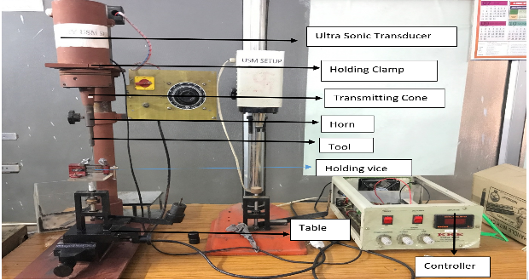
Fig1.USD set up
The experiments were performed on 3 mm thick soda lime glass using mild steel tool of diameter 2 mm using the USM set up as shown in Fig. 1. For determining the viable range of input parameters at which a quality hole drilling could be done, pilot experiments were performed. Black silicon carbide of three different sizes was used to prepare slurry with water. The details of the input process parameter have been shown in Table 1.
Table 1. Input Process Variables
Parameters | Symbol | Level 1 | Level 2 | Level 3
Ultrasonic Power (W) | A | 70 | 80 | 90
Frequency (KHz) | B | 21.5 | 22.5 | 25.5
Grit Size | C | 30 | 46 | 60
The workpiece of dimension 25mm x 25 mm were used to drill hole as shown in Fig. 2(a). To determine the MRR the weight of the workpiece before and after performing the drilling operation were measured using the electronic weighing balance (ACZET make) of maximum weighing capacity of 220 g and minimum readability of 0.0001g. The hole dimension were measured using digital microscope (Dino- Lite make).The image of the drilled hole is shown in Fig 2(b).

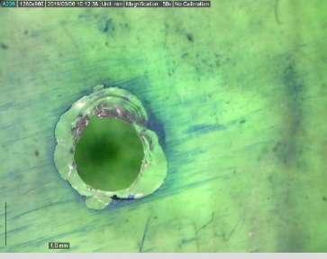

Fig.2(a). Actual drilled hole Fig.2(b). Microscopic image of drilled hole

3. Methodology
Response Surface Methodology (RSM) is used to develop the experimental model of MRR using Box-Behnken approach. It is a second order regression model to establish the relation between the input and output using Design of Experiment (DOE) approach. Box- Behnken approach requires only three levels to run an experiment. It does not contain any points at the vertices of the experiment region. This approach is particularly advantageous when the points on the corners of the cube represent level combinations that are prohibitively expensive or impossible to test because of physical process constraints. Using the Box-behnken approach 15 experiments were performed for three input parameters at three levels. The weight of the work piece before and after the machining were measured using scientific weighing balance and MRR were calculated using Eq. (1)

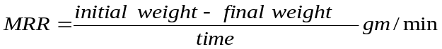 (1)

Hole circularity at entry (C_{entry}) were calculated as the ratio of minimum to maximum diameter of hole at entry side. using digital microscope. Since most of the geometrical variation occurs at the entry side therefore circularity at the entrance will provide a good information about the effect of process parameters on geometrical accuracy. The geometrically circular hole will give the value of hole circularity as one.

 (2)

4. Results and Discussion

The experimental test result obtained from experimental planning using Box-Beckhenn approach of RSM for MRR and Hole circularity is shown in Table 2.

Table 2. Experimental plan showing the input values and observe responses

S.No | Ultrasonic Power | Frequency | Abrasive Grit No | Initial Weight | Final Weight | MRR | Hole Circularity
1 | 70 | 21.5 | 46 | 3.8831 | 3.8497 | 0.00209 | 0.9338
2 | 90 | 21.5 | 46 | 3.593 | 3.5579 | 0.00289 | 0.9365
3 | 70 | 25.5 | 46 | 3.7571 | 3.721 | 0.00188 | 0.9450
4 | 90 | 25.5 | 46 | 3.7043 | 3.6717 | 0.00161 | 0.9670
5 | 70 | 22.5 | 30 | 3.5367 | 3.4935 | 0.00248 | 0.9385
6 | 90 | 22.5 | 30 | 3.2972 | 3.2579 | 0.00213 | 0.9533
7 | 70 | 22.5 | 60 | 3.3904 | 3.3529 | 0.00708 | 0.9123
8 | 90 | 22.5 | 60 | 3.3071 | 3.2806 | 0.00624 | 0.9548
9 | 80 | 21.5 | 30 | 3.2894 | 3.2505 | 0.00138 | 0.9100
10 | 80 | 25.5 | 30 | 3.831 | 3.7891 | 0.00144 | 0.9470
11 | 80 | 21.5 | 60 | 3.7647 | 3.7373 | 0.00269 | 0.9036
12 | 80 | 25.5 | 60 | 3.5193 | 3.4794 | 0.00300 | 0.9136
13 | 80 | 22.5 | 46 | 3.7313 | 3.7004 | 0.00203 | 0.9425
14 | 80 | 22.5 | 46 | 3.5053 | 3.4691 | 0.00232 | 0.9340
15 | 80 | 22.5 | 46 | 3.3928 | 3.3519 | 0.00393 | 0.9540

The mathematical model as shown in Eq. (3)-(4) has been obtained using RSM approach to correlate the various input parameters i.e. ultrasonic power, ultrasonic frequency and grit size with MRR and hole circularity through MINITAB software.

MRR=0.223- 0.00119 A+ 0.0233 B- 0.000020 C+ 0.000009 A*A- 0.000476 B*B+ 0.000004 C*C- 0.000007 A*B- 0.000001 A*C 0.000009 B*C (3)

HOLE CIRCULATORY=-1.26 - 0.02251 A + 0.2428 B + 0.00761 C. + 0.000117 A*A- 0.00503 B*B - 0.000071 C*C + 0.000119 A*B + 0.000044 A*C - 0.000229 B*C (4)

where A,B,C are the ultrasonic power, frequency and grit size respectively. The statistical probability of regression model was displayed through F-value and p-value as shown Table .The analysis of variance (ANOVA) of the response surface of quadratic model is also shown in Table. 3 and Table 4 for MRR and hole circularity respectively. The adequacy of the developed model can be verified using Table 5 and Table 6 .

Table 3. ANOVA result for MRR
Source | F-Value | P-Value
Model | 2.57 | 0.155
Linear | 3.3 | 0.116
Square | 3.3 | 0.116
2-Way Interaction | 0.12 | 0.947
Lack-of-Fit | 1.57 | 0.413

Table 4. ANOVA result for Hole circularity
source | F-Value | P-Value
Model | 6.06 | 0.031
Linear | 9.93 | 0.015
Square | 9.13 | 0.018
2-Way Interaction | 1.65 | 0.291
Lack-of-Fit | 0.72 | 0.027

Table 5. Model Summary for MRR
S | R-sq | R-sq(adj) | PRESS | R-sq(pred)
0.0011821 | 82.23% | 50.25% | 0.0000843 | 0.00%

Table 6. Model summary for Hole circularity
S | R-sq | R-sq(adj) | PRESS | R-sq(pred)
0.0091498 | 91.60% | 76.47% | 0.0037044 | 25.63%

The combined effect of various input parameters on MRR and hole circularity has been depicted though response surface plots. Fig 3(a) depicts that with the increase of grit no. the MRR increases very rapidly for all values of ultrasonic power. The comparative effect of ultrasonic power on MRR is not significant and it shows a non linear variation with reduction in MRR at initial value but with the increase of power it again shown slight increment in MRR. Similarly the effect of ultrasonic power on hole circularity is not very dominant. As the grit no increases the effect of power on circularity shows slight decreasing and then increasing trend [Fig. 3(b)].As the grain size decreases(grit no increases) the circularity initially rises but very small grain size decreases the circularity. The magnitude of variation in circularity due to increase of grit number decreases at high ultrasonic power.

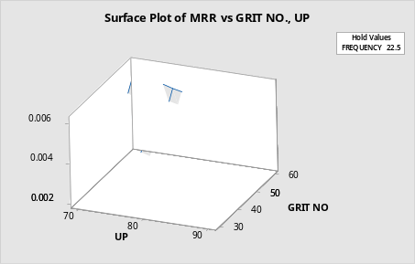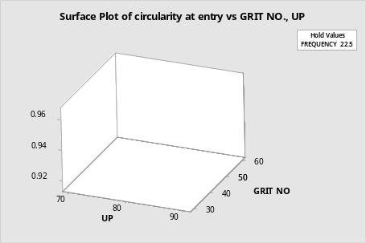
3(a) 3(b)

Fig.3. Effect of ultrasonic Power and abrasive grit number on (a) MRR (b) Circularity

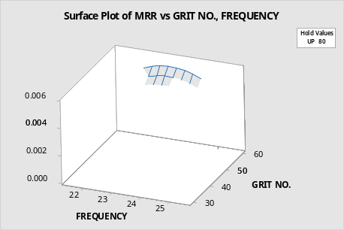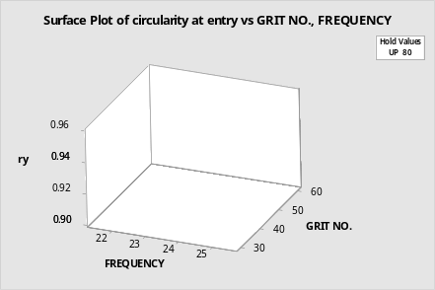
4(a) 4(b)

Fig.4. Effect of frequency and abrasive grit number on (a)MRR (b) Circularity

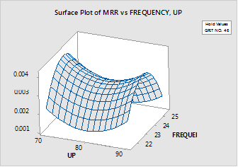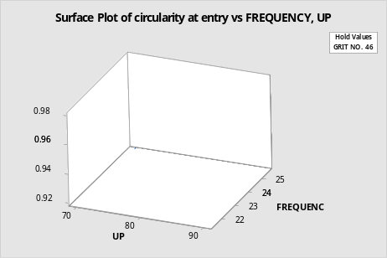
5(a) 5(b)

Fig.5.Effect of ultrasonic power and frequency on (a)MRR (b)Circularity

It can be observed from Fig. 4(a) and 4(b) that the comparative affect of frequency on both MRR and circularity is more compare to grit no. With the decrease of grain size the circularity decreases but the MRR increases at a particular frequency. Both the figure depicts that upto 23 KHz both the MRR and circularity increases after which it begins to decrease. Similarly upto grit no 40 the MRR decreases whereas circularity increases. The combined effect of ultrasonic power and frequency on MRR and hole circularity has been elaborated in Fig. 5(a) and (b) respectively. The MRR increases till 23 kHz after which it shows a decline trend. For all range of frequency the MRR shows a decline trend upto 80 and later on it gradually increases. The frequency has more dominant impact on the circularity with increasing trend. The rate of variation of frequency on circularity increases with increase of ultrasonic power.

5. Conclusions

Experimental investigation of Ultrasonic Drilling was performed using Box-Beckhenn approach of RSM for the creating hole of diameter 2 mm in soda lime glass sheet of thickness 3 mm. Second order regression model was developed for MRR and hole circularity considering the input process parameters of ultrasonic power, ultrasonic frequency, grit number using the mid steel tool. The following conclusions can be drawn for MRR and hole circularity using the response surface plots for different combination of input process parameters.

- The effect of ultrasonic power on both MRR and hole circularity for different grit size is not very significant. Abrasive with high grit number increases the MRR but decreases the MRR after initial rise upto grit number of 40.
- The combined analysis of grit number and frequency shows that both MRR and circularity are highly affected by frequency and up to 23 kHz both the parameters increases after which it declines. Both these parameters show contrasting effect after grit size number 40.
- At a particular ultrasonic power, the increase of frequency continuously increases the hole circularity but in case of MRR it begins to decrease after 23 KHz. The effect of ultrasonic power on both MRR and hole circularity is non linear gradual decrease up to 80 W further increase afterwards.

References
[1] Kataria, R.; Kumar, J.; Pabla, B.S. Experimental investigation and optimization of machining characteristics in ultrasonic machining of WC-Co composite using GRA method. Materials and Manufacturing Processes 2015, 0, 1-9.

[2] Zhang C, Feng P, Zhang J, Wu Z, Yu D. Theoretical and Experimental Research on the Features of Cutting Force in Rotary Ultrasonic Face Milling of K9 Glass. Appl Mech Mater Vols Trans Tech Publ. 2012; 158: 1674-167

[3] Cong, W.L.; Pei, Z.J.; Treadwell, C. Preliminary study on rotary ultrasonic machining of CFRP/Ti stacks. Ultrasonic 2014, 54(6), 1594-1602.

[4] Zhang, C.; Cong, W.; Feng, P.; Pei, Z. Rotary ultrasonic machining of optical K9 glass using compressed air as coolant: A feasibility study. Proceedings of the Institution of Mechanical Engineers, Part B: Journal of Engineering Manufacture 2014, 228(4), 504-514.

[5] Churi, N.J.; Pei, Z.J.; Treadwell, C. Rotary ultrasonic machining of titanium alloy: effects of machining variables. Machining science and technology 2006, 10(3), 301-321

[6] Zhang, C.L.; Feng, P.F.; Wu, Z.J.; Yu, D.W. An experimental study on processing performance of rotary ultrasonic drilling of K9 glass. Advanced Materials Research 2011, 230, 221-225

[7] Lv, D.; Huang, Y.; Tang, Y.; Wang, H. Relationship between subsurface damage and surface roughness of glass BK7 in rotary ultrasonic machining and conventional grinding processes. International Journal of Advanced Manufacturing Technology 2013, 67(1-4), 613-622.

[8] Cong, W.L.; Feng, Q.; Pei, Z.J.; Deines, T.W.; Treadwell, C. Rotary ultrasonic machining of carbon fiber-reinforced plastic composites: using cutting fluid vs. cold air as coolant. Journal of Composite Materials 2011, 46(14), 1745-1753.

[9] Cong, W.L.; Pei, Z.J.; Feng, Q.; Deines, T.W.; Treadwell, C. Rotary ultrasonic machining of CFRP: a comparison with twist drilling. Journal of Reinforced Plastics and Composites 2012, 31(5), 313-321.

[10]. Ya, G.; Qin, H.W.; Xu, Y.W.; Zhang, Y.S. An experimental investigation on rotary ultrasonic machining. Key engineering materials 2001, 202, 277-280.

[11]. Zou, X.; Cong, W.; Wu, N.; Pei, Z.J.; Wang, X. Novel fiber optic sensors and their application on cutting temperature measurement in rotary ultrasonic machining of titanium. Proceedings of the AME/ISCIE International Symposium on Flexible Automation, Missouri: USA 2012

[12] Hu P, Zhang JM, Pei ZJ, Treadwell C. Modeling of material removal rate in ultrasonic machining: designed experiments. Journal of Materials Processing Technology 2002;129:339–44.

[13] K.A. Abou-El-Hossein, K. Kadirgamaa, M. Hamdib Journal of Materials Processing Technology 182 (2007) 241–247, K.Y. Benyounis, Prediction of cutting force in end-milling operation of modified AISI P20 tool steel, Journal of Materials Processing Technology 182 (2007) 241–247

[14] Nam-Ky Nguyena, John J. Borkowskib, New 3-level response surface designs constructed from incomplete block designs, Journal of Statistical Planning and Inference 138 (2008) 294–305.

