A Finite Element study of unsteady free convection heat and mass transfer in a Rivlin-Ericksen viscoelastic flow past a semi-infinite vertical plate
Veena Sharma^{1*}, Rajneesh Kumar² and Urvashi Gupta³
¹Department of Mathematics & Statistics, Himachal Pradesh University, Summer Hill, Shimla-171 005, INDIA
*Email: veena_math_hpu@yahoo.com
²Department of Mathematics, Kurukshetra University, Kurukshetra, INDIA
³Dr.S.S.Bhatnagar University Institute of Chemical Engineering, Panjab University, Chandigarh-160 014, INDIA
Email:dr_urvashi_gupta@yahoo.com
Abstract
This paper deals with the unsteady two-dimensional natural convective heat/mass transfer of incompressible rheological fluid past a semi-infinite vertical plate. The rheology of the fluid is described by the Rivlin-Ericksen model. A stable Galerkin Finite Element Method is employed to solve the coupled non- dimensional non-linear partial differential equations numerically. The influence of various parameters on the velocity profiles , the temperature field and the concentration diffusion species are investigated numerically and presented graphically.
- Introduction
Pohlhausen has originally studiedThe unsteady free convection heat flow past a semi-infinite plate analytically the heat transfer between solid body and fluid flow with small friction forces and small heat flux was originally studied by Pohlhausen. Later on, Somers (1956) has studied theoretical considerations of combined thermal and mass transfer from vertical flat plate and Mathers et al. (1956) have studied simultaneous heat and mass transfer in free convection. Hellums and Churdhill (1962) was the first to solve unsteady natural convection flow past a semi-infinite vertical plate, using an explicit finite difference method. Gebhart and Pera (1971) have obtained The first systematic steady state solution for natural convection on a vertical plate with variable surface temperature and variable mass diffusion has been obtained by Gebhart and Pera using similarity variables. Callahan and Marner (1976) have solved numerically the problem of transient free convection with mass transfer on an isothermal vertical plate. Later on, Soundalgekar et al. (1981) studied transient free convective flow past a semi-infinite vertical plate with mass transfer by using Crank-Nicolson finite difference method. In all the above studies the fluid has been assumed to be Newtonian.
The study of simultaneous heat and mass transfer from the different geometries of non-Newtonian fluids is gaining great importance due to many applications in science and technology in the manufacture of carbon super-fibers, mayonnaise elastic-viscous flow, Xanthan gum hydrogel flows , polygalacturonase-based food stuff. The Rivlin-Ericksen viscoelastic fluid has relevance and importance in geophysical fluid dynamics, chemical technology and industries. Sivaraj Kumar (68) have made investigations on chemically reacting dusty viscoelastic fluid flow in an irregular channelwith convective boundaries. Rana 80 Thermal instability of compressible Rivlin-Ericksen rotating fluid permeated with suspended dusty particles in porous medium has been studied by Rana Recently, Malleswari investigated the influence of viscoelastic Rivlin-Ericksen fluid on free convective flow past a vertical plate filled in porous medium in presence of transverse magnetic and magnetic field double diffusion effects.Owing to the diverse applications mentioned above, an unsteady free convection of heat and mass transfer in a viscoelastic flow past a semi-infinite vertical plate is analysed numerically. A Galerkin weighted residue finite element method is utilized to solve two-dimensional dimensionless equations of continuity, linear momentum, energy and diffusion governing the flow field.
- Mathematical model
The unsteady two-dimensional free convection of heat and mass transfer in a Rivlin-Ericksen viscoelastic flow past a semi-infinite vertical plate of width $d$ is considered. The $x$- axis is taken along the plate in the vertically upward direction and the $y$-axis is chosen perpendicular to the plate at the leading edge. The origin of $x$-axis is taken to be at the leading edge of the plate. The physical system is pervaded by the acceleration due to gravity $g\left(0,0,-g\right)$.
Initially , it is assumed that the plate and the fluid are at the same ambient temperature $T_{∞}^{'}$ and the species concentration $C_{∞}$. When $t^{'}>0$, the temperature of the plate and the species concentration maintained are $T_{w}^{'}$ and $C_{w}^{'}$, respectively. The viscous dissipation is assumed to be negligible in the energy equation. The concentration of the diffusing species in the binary mixture is assumed to be very small in comparison with other present chemical species to neglect Soret and Dufour effects. Then under the these assumptions, the governing boundary layer equations with Boussinesq approximation are
$\frac{∂u}{∂x}+\frac{∂v}{∂x}=0$, (1)
$\frac{∂u}{∂t^{'}}+u\frac{∂u}{∂x}+v\frac{∂u}{∂y}=gβ\left(T^{'}-T_{∞}^{'}\right)+gβ^{'}\left(C^{'}-C_{∞}^{'}\right)+\left(ν+ν^{'}\frac{∂}{∂t}\right)\frac{∂^{2}}{∂y^{2}}u$ , (.2)
$\frac{∂T^{'}}{∂t^{'}}+u\frac{∂T^{'}}{∂x}+v\frac{∂T^{'}}{∂y}=κ\frac{∂^{2}T^{'}}{∂y^{2}}$ , (3)
$\frac{∂C^{'}}{∂t^{'}}+u\frac{∂C^{'}}{∂x}+v\frac{∂C^{'}}{∂y}=κ_{1}\frac{∂^{2}C^{'}}{∂y^{2}}$ . (4)
The initial boundary conditions are:
$t^{'}≤0:u=0, v=0, T^{'}=T_{∞}^{'}, C^{'}=C_{∞}^{'}$,
$t^{'}>0:u=0, v=0, T^{'}=T_{w}^{'}, C^{'}=C_{w}^{'} at y=0$ ,
$u=0, T^{'}=T_{w}^{'}, C^{'}=C_{∞}^{'} at x=0$ ,
$u→0, T^{'}→T_{∞}^{'}, C^{'}→C_{∞}^{'} as y→∞$. (5)
Using the following non-dimensional quantities:
$X=\frac{x}{d}, Y=\frac{yG_{r}^{1/4}}{d}, U=\frac{uLG_{r}^{{-1}/2}}{ν}, V=\frac{vLG_{r}^{{-1}/4}}{ν}, θ=\frac{T^{'}-T_{∞}^{'}}{T_{w}^{'}-T_{∞}^{'}}, C=\frac{C^{'}-C_{∞}^{'}}{C_{w}^{'}-C_{∞}^{'}}$,
$t^{'}=\frac{tL^{2}}{ν}G_{r}^{{-1}/2},N=\frac{β^{'}\left(C_{w}^{'}-C_{∞}^{'}\right)}{β\left(T_{w}^{'}-T_{∞}^{'}\right)} , G_{r}=\frac{L^{3}gβ\left(T_{w}^{'}-T_{∞}^{'}\right)}{ν^{2}}$,
$Γ=\frac{{ν^{'}}_{\sqrt{G_{r}}}}{L^{2}}, p_{1}=\frac{ν}{κ}, S_{C}=\frac{ν}{κ_{1}},$ (6)
equations (1)-(4) are reduced to the following non-dimensional form:
$\frac{∂U}{∂X}+\frac{∂U}{∂Y }=0$, (7)
$\frac{∂U}{∂t}+U\frac{∂U}{∂X}+V\frac{∂U}{∂Y}=\frac{∂U}{∂Y}+T+NC+\frac{∂^{2}U}{∂Y^{2}}+Γ\frac{∂^{3}U}{∂Y^{2}∂t}$, (8)
$\frac{∂T}{∂t}+U\frac{∂T}{∂X}+V\frac{∂T}{∂Y}=\frac{1}{p_{1}}\frac{∂^{2}T}{∂Y^{2}}$ , (9)
$\frac{∂C}{∂t}+U\frac{∂C}{∂X}+V\frac{∂C}{∂Y}=\frac{1}{S_{c}}\frac{∂^{2}C}{∂Y^{2}}$. (10)
where $G_{r}$ is the thermal Grashof number, $p_{1}$ is the fluid Prandtl number and $S_{c}$ is the Schmidt number, $N$ is the buoyancy ratio parameter.
The corresponding initial and boundary conditions are
$t≤0: U=0, V=0, T=0 , C=0$,
$t>0: U=0, V=0, T=1, C=1 at Y=0$ ,
$U=0, T=0, C=0 at X=0$,
$U→0, T→0, C→0 as Y→∞$. (11)
The physical quantities of interest are the local skin friction, the local Nusselt number and the local Sherwood number, which are expressed as
$τ_{x }=G_{r}^{3/4}{\left(\frac{∂U}{∂Y}\right)}_{Y=0}, {Nu}_{x}=\frac{-X{G_{r}^{1/4}\left(\frac{∂T}{∂Y}\right)}_{Y=0}}{T_{Y=0}}, {Sh}_{x}=-\frac{XG_{r}^{1/4}{\left(\frac{∂C}{∂Y}\right)}_{Y=0}}{C_{Y=0}}$. (12)
- Numerical results and discussion
The dimensionless unsteady coupled and non-linear partial differential conservations equations (7)-(10) for the boundary layer regime satisfying the boundary condition (11), are solved numerically by an efficient, accurate and unconditionally stable Finite Element Method of the Galerkin weighted residue type. The numerical results so obtained are plotted for velocity, temperature, concentration fields, the local Nusselt number, the local skin friction and the local Sherwood number in figures 1-10, wherein the following default parameters values are used: thermal Grashof number $G_{r}=1.0$, species Grashof number $G_{m}=1.0$, Schmidt number $S_{c}=0.6$, Prandtl number $p_{1}=0.71$.
The variation of velocity $U$, temperature function $T$, concentration $C$, local skin friction $τ_{x}$ the local Nusselt number ${Nu}_{x}$ and the Sherwood number ${Sh}_{x}$versus $Y$ with collective effects of viscoelasticity $Γ$ have been presented in figures 1-4 at $X=1$,
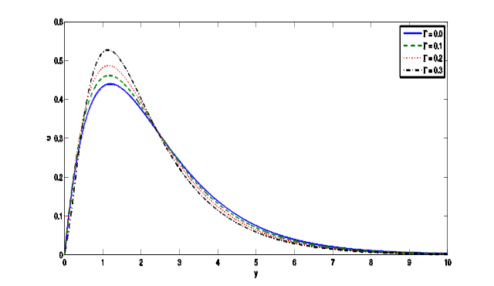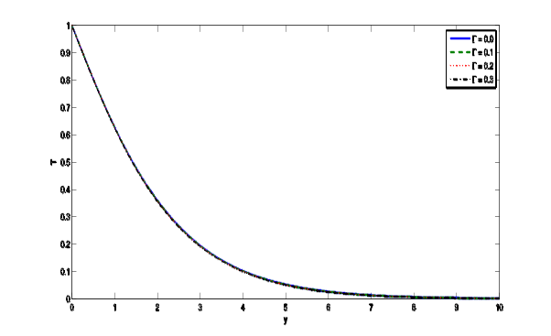
Figure 1: Steady state velocity profile for different Figure 2: Steady state temperature profiles for different
values of $Γ=0.0, 0.1, 1.2, 0.3$ values of $Γ=0.0, 0.1, 0.2,0.3$.
An increase in viscoelastic parameter, $Γ$ from 0 to 0.1, 0.2, and 0.3, as depicted from figure 1, clearly enhances the velocity profiles $U$ which ascends sharply and peaks in close vicinity to the plate surface $\left(Y=0\right)$. With increasing distance from the plate wall however, the velocity $U$ is adversely affected by increasing viscoelasticity i.e., the flow is decelerated. Therefore, close to the plate surface the flow velocity is maximized for the case of a Newtonian fluid (vanishing viscoelastic effect i.e., $Γ=0$), but this trend is reversed as we progress further into the boundary layer regime.

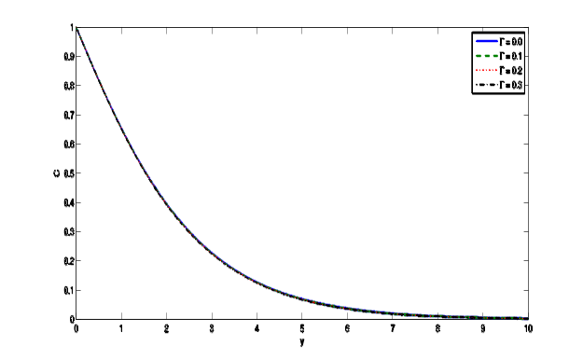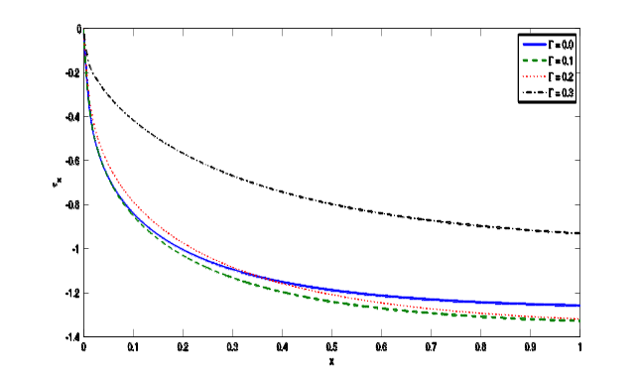
Figure 3: Steady state concentration profiles for different Figure 4: Variation of the local Skin friction for
different values of $Γ=0.0, 0.1, 0.2,0.3$. values of $Γ=0.0, 0.1, 0.2,0.3$.

It is clear from figure 2 and 3 that the temperature profiles and concentration field decrease throughout the boundary layer approaching the free stream. The profiles are merged all together with increase in the viscoelastic parameter$Γ$, showing thereby the negligible effect of viscoelasticity on the temperature profiles and the concentration field. Thus the flow is cooled away from the vertical plate.
Figure 4 depicts that shear stress is enhanced with increasing viscoelasticity (i.e, stronger elastic effect) and accelerates the flow, which is in good consistency with our earlier computations in figure 1. The ascent in shear stress is very rapid from the leading edge $\left(X=0\right)$, but more gradual as there is a progression along the plate surface away from the plate.
It is observed from figures 5 and 6 that there is a very little enhancing effect of viscoelasticity on the local Nusselt number ${Nu}_{x}$ and the local Sherwood number ${Sh}_{x}$ showing thereby that the surface heat transfer and surface concentration of the diffusing species remain uninfluenced by the variations in the viscoelastic parameter.
Figures 5-7 depict the distributions of velocity profiles $U$, temperature field $T$ and concentration field , $C$ versus coordinate $Y$ for various Schmidt numbers $S_{C}$.
Increase in the Schmidt number, $S_{C}$ from 0.1 through 0.5, 1.0, 3.0 and 5.0 as depicted in figure 5, clearly decelerates the velocity $U$ which descends sharply and peaks in close to vicinity to the plate surface $\left(Y=0\right)$. All profiles descend smoothly to zero in the free stream. With higher $S_{C}$ values the gradient of velocity profiles is lesser prior to the peak velocity, but greater after the peak.
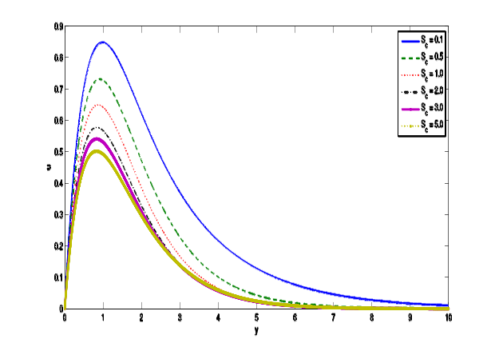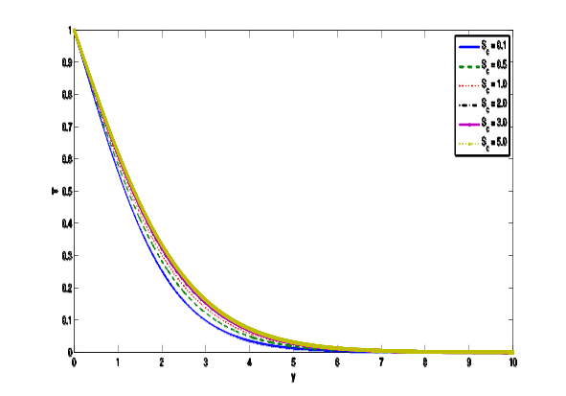
Figure 5: Steady state velocity profile for different Figure 6: Steady state temperature profiles for different
values of $S_{C}=0.1, 0.5, 1.0, 2.0,3.0,5.$ values of $S_{C}=0.1, 0.5, 1.0, 2.0,3.0,5.0$.

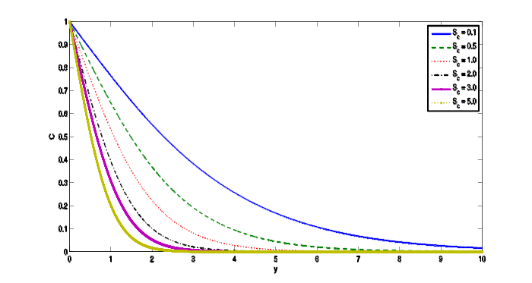
Figure 7: Steady state concentration profiles for different values of $S_{C}=0.1, 0.5, 1.0, 2.0,3.0,5.0$.

In figure 6, for the case of non-Newtonian fluids $\left(Γ≠0\right)$ and for Schmidt number $S_{C}=0.1$ and 5.0, the temperature field increases throughout the bounder layer and from the figure 7, there is a decrease in concentration species throughout the boundary layer regime $\left(0<y<14\right)$ for different values of $S_{C}=0.1, 0.5, 1.0, 2.0,3.0,5.0$, respectively. All profiles decrease from the maximum at the wall to zero in the free stream. For $S_{C}<1$, species diffuse much slower than momentum so that maximum concentrations are associated with this case $S_{C}=0.1$. For $S_{C}>1$, momentum diffuse slower than species causing progressively lower concentration values.

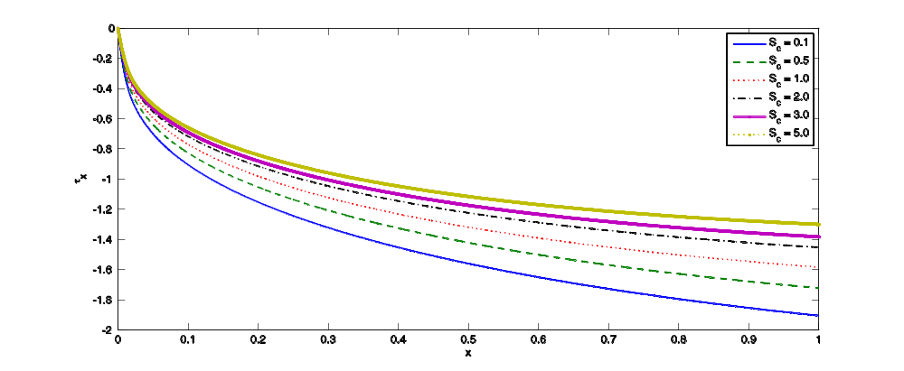

Figure 8: Variation of the local Skin friction at $X=1.0$ for different values of $S_{C}=0.1, 0.5, 1.0, 2.0,3.0,5.0$.

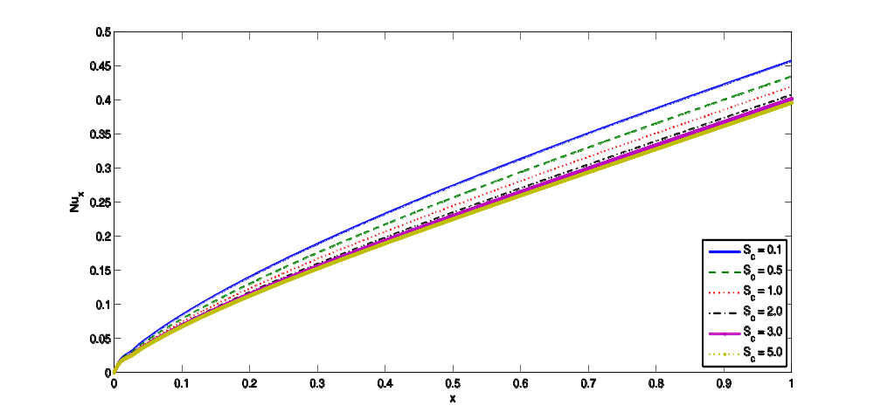
Figure 9: Variation of the Nusselt number at $X=1.0$ for different values of $S_{C}=0.1, 0.5, 1.0, 2.0,3.0,5.0$.
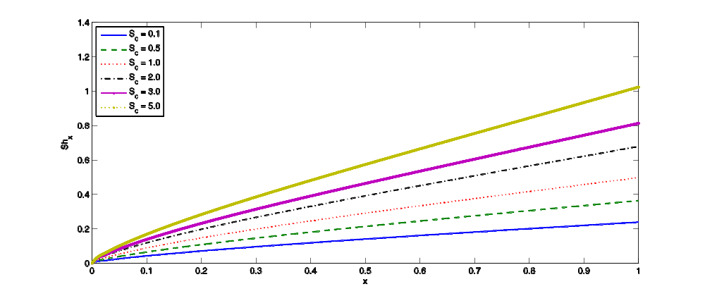
number (surface concentration gradient), ${Sh}_{x}$ versus axial coordinate $\left(X\right)$, respectively. Shear stress is clearly enhanced with increasing $S_{C}$ from 0.1 through 0.5, 1.0, 2.0, 3.3 and 5.0 i.e., the flow is accelerated which is consistent with our earlier computations in figure 1. The ascent in shear stress is very rapid from the leading edge $\left(X=0\right)$, but more gradual as there is a progress along the surface away from the plate. The decrease in the local Nusselt number ${ Nu}_{x}$ values is observed in figure 9 with the increase in the Schmidt number, $S_{C}$.Similarly from figure 10, the local Sherwood number ${Sh}_{x}$, values are observed elevated considerably with an increase in Schmidt number along the plane surface gradients.
4. Conclusions
The principal conclusions drawn are as follows:
- The velocity profiles are accelerated with the increase in viscoelastic parameter.
Temperature and concentration of the species reduce with the increase in viscoelasticity parameter in the boundary layer. Increasing viscoelasticity again reduce the concentration showing thereby the species diffuse more rapidly. Figure 10: Variation of the Sherwood number at $X=1.0$ for different values of $S_{C}=0.1, 0.5, 1.0, 2.0,3.0,5.0$.
- Figures 8-10 show the influence of the Schmidt number, $S_{C}$ on local skin friction (surface shear stress), $τ_{x}$, Nusselt number (surface heat transfer gradient),${ Nu}_{x}$ and the Sherwood
- The shear stress (local skin friction), surface heat transfer gradient (local Nusselt number) and the surface concentration gradient, (local Sherwood number) are enhanced with the increase in viscoelasticity.
- The velocity profiles decelerate with higher values of Schmidt number and descend smoothly to zero in the free stream.
- The temperature field increases throughout boundary layer with increase in Schmidt number and decreases from the maximum at the wall to zero in the free stream. However, the concentration decreases throughout the boundary layer with the increase in Schmidt number.
- Shear stress and surface concentration gradient are enhanced with the increase in Schmidt number.
- Surface heat transfer gradient decreases with the increase in Schmidt number implying thereby cooling the system effectively.
References
- K.Pohlhausen, “Zur haherungsweisen integration der differential gleichung der laminaren Grenzschicht” Journal of Applied Mathematics and Mechanics, 1 (4),(1921) 252-290.
- W.G., Mather, A.J. Madden and E.L. Piret (1957). “Simultaneous heat and mass transfer in free convection”. Industrial Engineering Chemical 49, 961-968.
- J.D. Hellums and S.W. Churchill (1962) “Transient and steady state, free and natural convection numerical solutions: Part 1 . The isothermal vertical plate” AIChEJ.8, 690-692.
- B. Gebhart, L. Pera (1971). “The nature of vertical natural convection flows resulting from the combined buoyancy effects of thermal and mass diffusion”. International Journal of Heat and Mass Transfer, 14, 2025–2050.
- G.D. Callahan and W.J. Marner, “Transient free convection with mass transfer on an isothermal vertical flat plate”. International Journal of Heat and Mass Transfer, 19, 165-174(1976)
- V.M. Soundagekar and P. Ganesan “Finite difference analysis of transient free convection on an isothermal flat plate” .International Journal of Heat and Mass Transfer,3 ,219-224 (1981).

- R. Sivaraj, and B.R. Rushi Kumar, “Chemically reacting dusty visco elastic fluid flow in an irregular channel wiht convective boundary”. Journal of Ain Shams Engineering, 4(1), 93-101(2013).
- G.C. Rana, “Thermal instability of compressible Rivlin- Ericksen rotating fluid permeated with suspended dust particles in porous medium”. International Journal of Applied Mathematics and Mechanics, 8(4), 97-110(2012).
- D. Malleswari , “The influence of visco elastic Rivlin- Ericksen fluid on free convective flow past a vertical plate filled in porous medium in presence of transverse magnetic field and double diffusion effects”. IOSR Journal of Applied Physics, 10 (3) Ver.II,45-62 (2018).

