Numerical Solution of Twelfth Order Boundary Value Problems by Galerkin Method with Sextic
B-splines
Sreenivasulu Ballem *
Department of Mathematics, Central University of Karnataka, Kalaburagi-585 367, India.

*Corresponding author Email:sreenivasm.maths@gmail.com
________________________________________________________________________
Abstract: A finite element method involving Galerkin method with sextic B-splines as basis functions has been developed to solve the twelfth order boundary value problems. The approximation solution has been modified into a form which takes care of given boundary conditions. To test the efficiency of the proposed method, we have solved twelfth order linear and nonlinear BVP’s.

Keywords: Galerkin method; Sextic B-spline; Basis function; Twelfth order boundary value problem; Absolute error.

1. Introduction
In this paper, we consider a general, tenth order linear boundary value problem given by
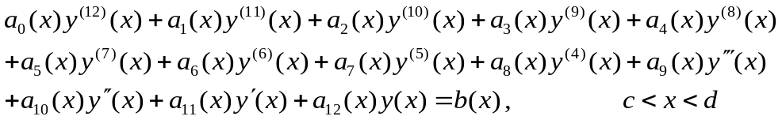 (1)
subject to boundary conditions
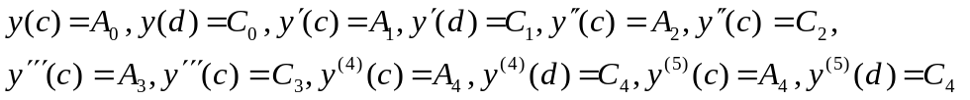 (2)
where A_{i}’s, C_{i}’s are finite real constants and a_{i}(x)’s and b(x) are all continuous functions defined on the interval [c, d].

In generally, these kind of BVP’s arise in the areas of hydrodynamics and hydromagnetic stability and other parts of applied mathematical physics and engineering sciences. The book by Chandrasekhar[1] explained in detailed, how it is modeled by twelfth order BVP’s. Agarwal[2] book contains the theorems on the existence and uniqueness for the solutions of these kinds of problems.

In general, obtaining analytical solutions of these problems are very difficult and solving in very few cases. From the few years, many researchers have been developed numerical schemes to get the approximate solutions of these kind of problems. To mention few, using finite difference Twizell et. al. [3], Twizell and Boutayeb [4] , Dijidejeli and twizell [5] developed numerical schemes to solve eight, tenth, twelfth order eigen value problems arising in thermal instability. Using spline twelve and thirteen degree polynomials Twizell and Siddiqi [6, 7] developed a numerical scheme for (1)-(2). Some of the numerical methods developed to solve this kind of problems are differential transform method [8], Adomain decomposition method [9], Homotopy-perurbation method [10], Variational iteration method[11-13].

In the present paper, we aims is develop a numerical algorithm to solve the BVP (1)-(2) by Gelerkin method with quartic B-splines. This method has been employed to solve a large variety of linear and nonlinear problems. The nonlinear problems has been to convert the nonlinear problem into a sequence of linear problems by quasilinearization technique[14]. The justification for using the Galerkin method is given in [15-17].

2. Description of the method
The sextic B-splines are defined in [18-20]. We defined the approximate solution of the equation (1) and (2) is y(x) as
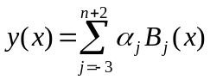 (3)
where 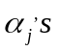 are the nodal parameters to be determined. If the approximation solution satisfies the given boundary conditions, then it gives more precise results. Accordingly to this, the basis functions are remodified into a new set of basis functions. The remodified of the basis functions is given below.
Applying the given boundary conditions of (2) to the approximate solution (3), we get
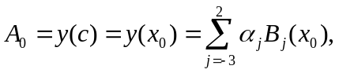 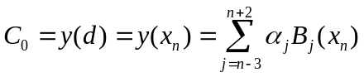 (4) 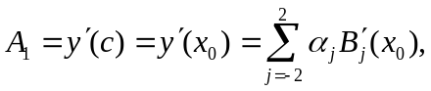 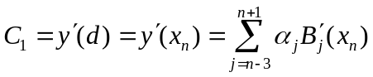 (5)
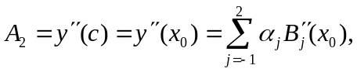 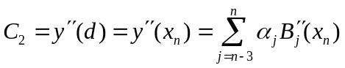 (6)
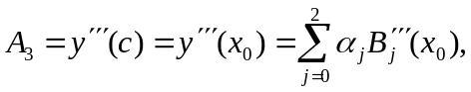 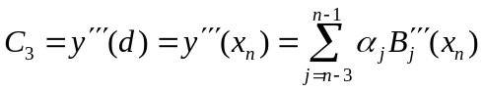 (7)
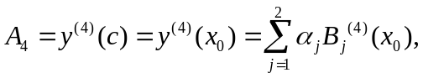 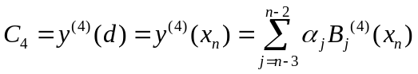 (8) 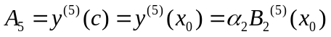, 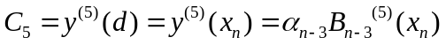 (9)

Removing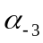to 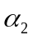and 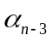to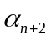from the above equations (3)-(9), we obtain the approximate solution y(x) as
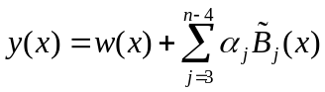 (10)
where 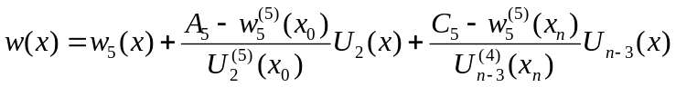
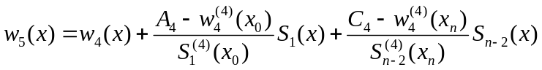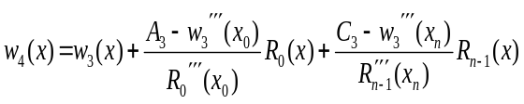, 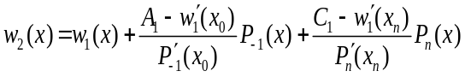
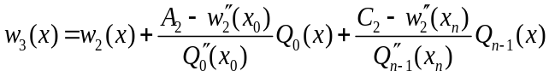, 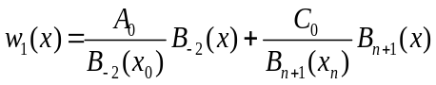

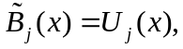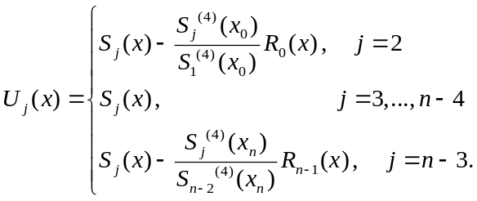

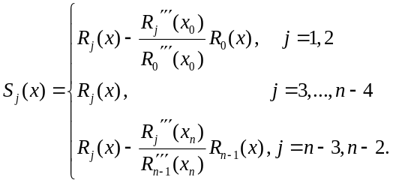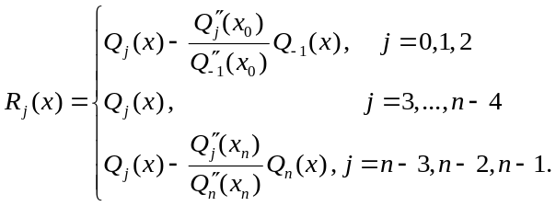

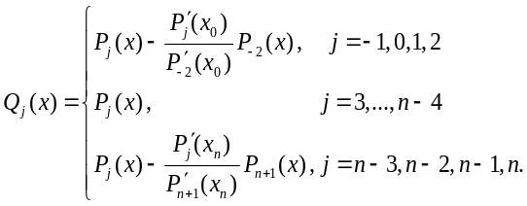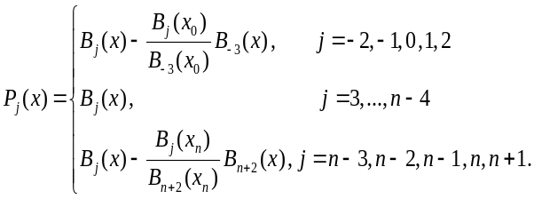
Now,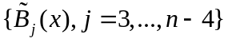 is the newfangled set of basis functions for the approximation y(x). Applying the Galerkin method to (1) with a newfangled set of basis functions, we get
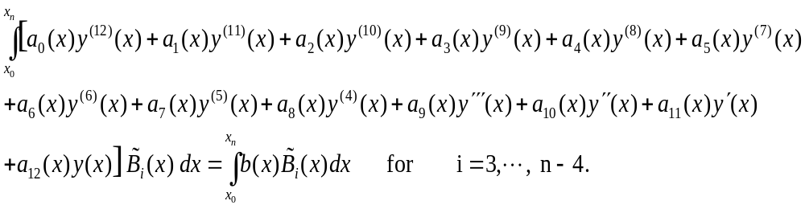 (11)
The first seven terms on the left hand side of (11) are simply using integrating by parts and after put on the boundary conditions prescribed in (2), we get a system of equations
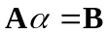 (12)
where 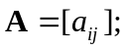

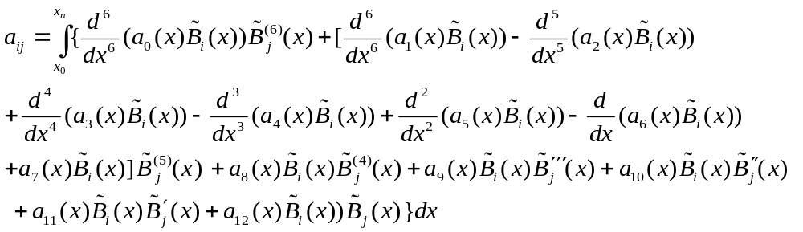 (13)
for i= 3,4,…, n-4; j= 3,4,…,n-4.

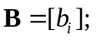
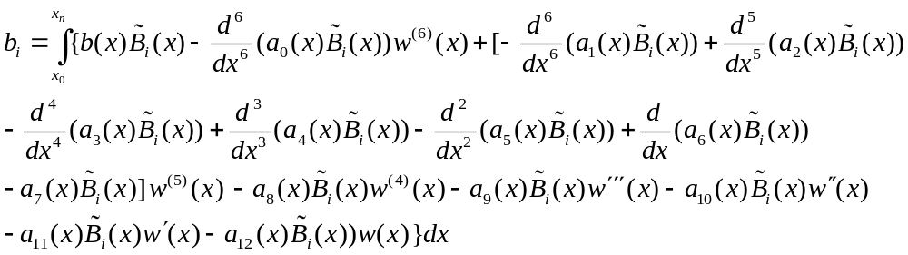 (14)
for i= 3,4,…, n-4.
and 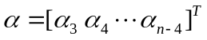

3. Procedure to find a solution for nodal parameters
A typical integral element in the matrix  is in the form 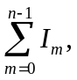 where 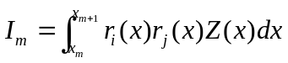 and 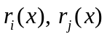are the sextic B-spline basis functions or their derivatives. It may be noted that 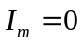 if 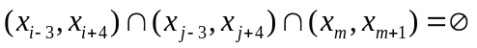. We applied 7-point Gauss-Legendre quadrature formula for to solve typical intergral 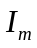 in the above form. Thus, we get thirteen diagonal band stiffness matrix. Using band matrix solution package solve system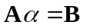 for unknown nodal parameters.

4. Numerical Results
To demonstrate the proposed method for solving the twelfth order boundary value problems of the types (1) and (2), we considered one linear and one nonlinear boundary value problems. Numerical results for each problem are presented in tabular forms and compared with the exact solutions available in the literature. We define max norm for computing error to the each example by 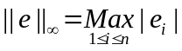, where 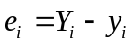, is exact solution at grid point 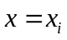 and  is approximate solution solution at grid point .

Example 1: we consider the following boundary value problem
(15)
subject to 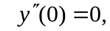 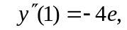
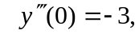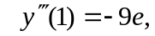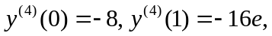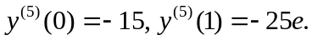
The exact solution of the above differential equation is y =x(1-x)e^{x}.
The domain [0, 1] is parted into 10 equal subdomains, to test the efficiency of the proposed method on this problem. The gotten numerical results to this problem (15) are presented in Table 1. The proposed method given error by max norm is 1.800060x10⁻⁵

Example 2: Next we consider the nonlinear boundary value problem
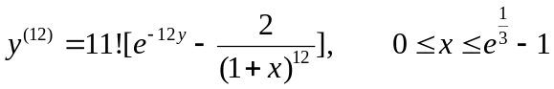 (16)
subject to 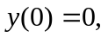 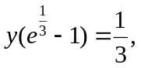 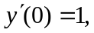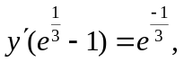
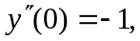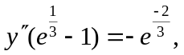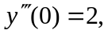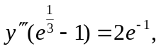
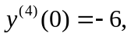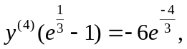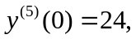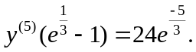
The exact solution of the above differential equation is y(x)=ln(1+x).
The nonlinear boundary value problem (16) is converted into a sequence of linear boundary value problems generated by quasilinearization technique [23] as
(17)
subject to 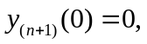 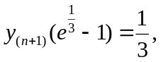 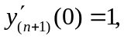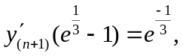
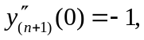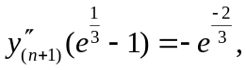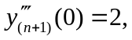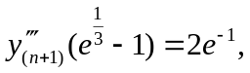
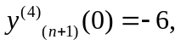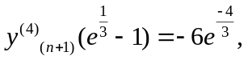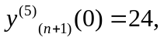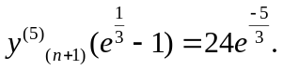
Here 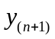 is the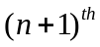 approximation for 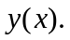 The domain 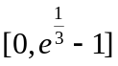 is parted into 10 equal subdomains and the proposed method is applied to the sequence of a linear problems (17). The gotten numerical results to this problem (16) are presented in Table 2. The proposed method given error by max norm is 6.958842x10⁻⁶.

5. Conclusions
In this paper, proposed method has been tested on one linear and one nonlinear twelfth order boundary value problems. To get more approximate solution, sextic B-splines basis set has been modified into a new set of basis functions. The error in the numerical results which was obtained by the proposed method is to small. The asset of the established method is easy to solve applications, simple, accuracy and efficiency.

Table 1: Numerical results for Example1 Table 2: Numerical results for Example 2
x | Absolute Error by  proposed method
0.1  0.2  0.3  0.4  0.5  0.6  0.7  0.8  0.9 | 3.278255E-07  6.407499E-07  5.364418E-07  7.092953E-06  1.800060E-05  1.427531E-05  7.092953E-06  2.652407E-06  8.940697E-06
x | Absolute Error by proposed method
3.956125E-02 7.912249E-02  1.186837E-01 1.582450E-01  1.978062E-01 2.373675E-01  2.769287E-01 3.164900E-01  3.560512E-01 | 6.072223E-07  1.192093E-07  2.980232E-07  4.217029E-06  3.293157E-06  8.493662E-07  1.576543E-05  6.958842E-06  2.473593E-06

References :

- Chandra sekhar S, Hydrodynamics and Hydromagnetic Stability, New York:Dover, (1981).

- Agarwal R.P, Boundary value problems for Higher Order Differential Equations, World Scientific, Singapore, (1986).

- Boutayeb A and Twizell E. H, Finite difference methods for twelfth order boundary value problems, Journal of Computational and Applied Mathematics, 35, 133-138, (1991).

- Twizell E. H and Boutayeb A, Numerical methods for eighth, tenth and twelfth order eigenvalue problems arising in thermal instability, 2, 407-436, (1994).

- Dijidejeli K and Twizell E, Numerical methods for special nonlinear boundary value problems of order 2m, Journal of Computational and Applied Mathematics, 47, 35–45, (1993).

- Shahid S. Siddiqi and Twizell E. H, Spline solution of linear twelfth-order boundary value problems, Journal of Computational and Applied Mathematics, 78, 371-390, (1997).

- Shahid S. Siddiqi and Ghazala Akram, Solutions of twelfth order boundary value problems using the thirteen degree spline, Applied Mathematics and Computation, 182, 1443–1453, (2006).

- Siraj-Ul Islam, Sirajul Haq and Javid Ali, Numerical solution of special 12th-order boundary value problems using differential transform method, Communications in Nonlinear Science and Numerical Simulation, 14, 1132-1138, (2009).

- Wazwaz A.M, The Modified Adomian Decomposition Method for solving linear and nonlinear boundary value problems of tenth-order and twelfth-order, International Journal of Nonlinear Sciences and Numerical Simulation, 1, 17-24, (2000).

- Ravikanth A.V.S and Aruna K, He's homotopy-perurbation method for solving higher order boundary value problems, Chaos, Solitons and Fractals, 41, 1905-1905, (2009).

- Ravikanth A.V.S and Aruna K, Variational iteration method for twelfth-order boundary value problems, Computers and Mathematics with Applications, 58, 2360-2364, (2009).

- Shahid S.Siddiqi, Ghazala Akram and Imran Zulfiqar, Solutions of twelfth order boundary value problems using Variational Iteration Technique, European Journal of Scientific Research, 33, 96-114, (2009).

- Mukesh Grover and Arun kumar Tomer, Comarision of Variational iteration method Decomposition method with Optimal homotopy asymptotic of higher order boundary value problems, International journal of Scientific and Engineering Research, 2, 1--5, (2011).

- Kalaba R.E and Bellman R.E, Quasilinearzation and nonlinear boundary value problems, American Elsevier, New York, (1965).

- Bers L, John F and Schecheter M, Partial differential equations, John Wiley Inter Science, New York, (1964).

- Lions J. L and Magenes E, Non-homogeneous boundary value problem and applications. Springer-Verlag, Berlin, (1972).

- Mitchel A.R and Wait R, The finite element method in partial differential equations, John Wiley and Sons, London, (1977).

- Prenter P.M, Splines and variational methods, John-Wiley and Sons, New York, (1989).

- Carl de-Boor, A pratical guide to splines, Springer-Verlag, (2001).

- Schoenberg I.J, On spline functions, MRC Report 625, University of Wisconsin, (1966).

