Titanium Dioxide Supported Platinum Catalyst Synthesis: Ultrasound Approach

Shital B. Potdar¹, Prashant Suryawanshi², S.H.Sonawane², B.V.S.Praveen^{1*}
¹Department of Chemical Engineering, B.V. Raju Institute of technology, Telangana State, India
²Department of Chemical Engineering, National institute of Technology Warangal, Telangana State, India.
* Corresponding author: praveen.bvs@bvrit.ac.in

ABSTRACT
Noble metals such as platinum, gold are quite expensive, in spite of this; they have proven their existence in catalysis. This fact has motivated for the synthesis of supported metal catalyst, where the noble metal is uniformly dispersed onto the support. The present work is focused on the synthesis of titanium dioxide (TiO₂) supported platinum (Pt) catalyst. The synthesis was carried out by ultrasound technique. Microjets formed during ultrasound cavitation avoid the interaction between crystals achieving smaller size crystals with high surface to volume ratio.
The synthesized catalyst is characterized using various characterization techniques such as X-ray diffraction (XRD), transmission electron microscopy (TEM), field-emission scanning electron microscopy (FE-SEM), energy dispersive spectra (EDS) and particle size analysis (PSA). The results obtained corroborated the size and composition of the synthesized catalysts. The size of the Pt/TiO₂ catalyst is in the nano meter range and uniform dispersion of platinum catalyst over the titanium dioxide support.

Keywords: Ultrasound, acoustic cavitation, TEM, PSA, supported catalyst etc.

INTRODUCTION
Catalyst is a substance that increases the rate of reaction by lowering the activation energy and converts the raw material into final products. This fact has gained lot of attention in motivating catalysis industry. The nanosized catalyst performs better as compared to bulk catalyst because it has large number of particles at surface. In this regard ultrasound is a good approach to synthesize nano catalyst.

With some precious metals, it is an essential fact to use their surface effectively. This fact has motivated the synthesis of supported metal catalyst, Where precious novel metals such as gold (Au), silver (Ag), platinum (Pt) and so on are dispersed on various types of supports such as organic polymer, metal, carbon and Dendrimer. As mentioned by Bagheri and his co-workers in their review article reported that each type of support has its own advantages and disadvantages [1] like organic polymers are easy to adapt and are inert towards catalyst but have decreased heat transfer capacity and poor mechanical properties, metals as a support posses an advantage that they are easy to separate and exhibits anticorrosive properties but also posses disadvantage that optimization of the reaction conditions is more complex because there are more variables. Carbon as a support have an advantage that it has high surface area due to porous structure, but it could not be used for hydrogenation reaction because it may become gasified to yield methane and CO_{2,} Dendrimers have strong bond with catalyst metal and forms recyclable catalyst system but It suffers from diminished activity due to the reduction in accessibility. Different metal supports can be listed as Al₂O₃, TiO₂, ZrO₂, ZnO and so on.

Platinum and gold particles, when dispersed on a specific group of reducible metal oxide supports become active for the low temperature oxidation of carbon monoxide, even at room temperature [2]. The support (titanium dioxide) disperses the metal as well as increases the thermal stability which increases the life of the catalyst [3]. The metal support Titanium dioxide (TiO₂) is having high surface area to support the novel metal platinum catalyst in its pores. The use of TiO₂ as support have dual advantage that support TiO₂ acts as secondary catalyst in oxidation-reduction reaction as takes place at lower operating condition of temperature and pressure in the presence of TiO₂ [4]. And also supports novel metal catalyst.
Considering all these factors our present focus on synthesis of titanium dioxide supported platinum catalyst.

Material
Titanium Tetra isopropoxide (TTIP) were obtained from Spectrochem Pvt. Ltd. Mumbai, India. Sodium hydroxide, methanol and acetone were procured from Molychem Ltd., Mumbai, India. Potassium hexachloroplatinate (K₂PtCl₆) was purchased from Sainergy fuel cell Pvt. Ltd. Chennai India

Experimental
Probe ultrasound was used to synthesize support material titanium dioxide as well as platinum supported on titanium dioxide. The transducer transforms the ultrasonic waves (frequency = 22 kHz) into mechanical vibration. Uniform cylinder type probe (tip diameter = 20 mm) was used to vibrate the particles of the reaction mixture which results in intense collapse of bubbles formed during ultrasound on-off cycle which results in particle size at nanoscale. To avoid local hotspots the reaction mixture was surrounded with cold water. Care is taken such that the height of probe in the reactor is at appropriate height in the liquid mixture.
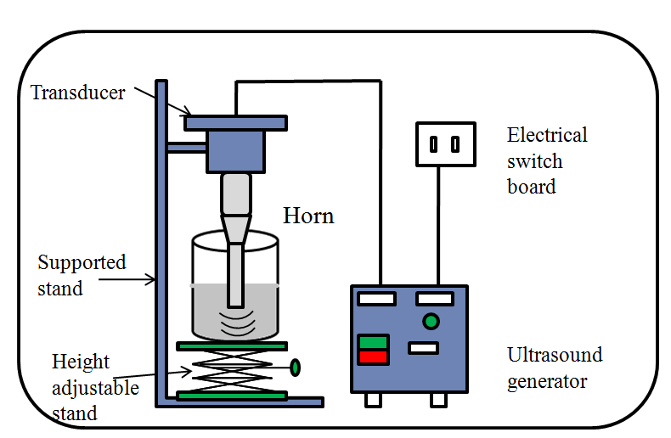
Figure 1: Ultrasound probe sonicator set-up for synthesis of TiO₂ and Pt/TiO₂

Synthesis of metal support TiO₂
Titanium dioxide nanoparticles were synthesized using ultrasound approach. To initiate the reaction 10 mL of titanium isopropoxide (TTIP) was mixed with 2 mL acetone and 2 mL methanol in a 250 mL beaker (ultrasound reactor). Here solvents used acetone and methanol acts as pressure transmitting media. This mixture was kept in an ultrasound reactor. The ultrasound generator was initially set for 30 min which was further extended to another 30 min. After initial mixing of TTIP, methanol and acetone in the reactor using ultrasonic waves the dropwise addition 50 mL of sodium hydroxide was initiated. The passing of ultrasonic waves was continued after the completion of addition to ensure that there is 100 % conversion of TTIP. The product in the form of white precipitate was formed filtered, dried and calcined at 800 ºC for 5 h [5, 6]. The flowchart (Figure 2) below shows the experimental path.
The particle size and morphology of the synthesized TiO₂ nanoparticles was studied using transmission electron microscopy [TEM]. The TEM analysis confirmed the nanoscale synthesis of TiO₂. To obtain the Rutile phase of TiO₂ the white precipitate synthesized with Ultrasound was calcined at 800ºC for 4 - 5 h [5].
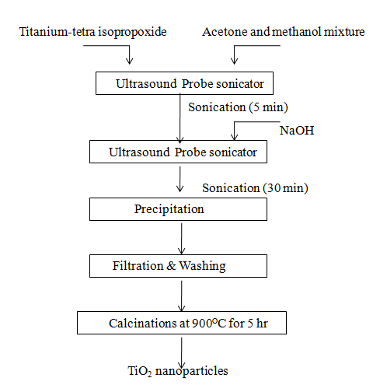
Figure 2: Flowchart for synthesis of TiO₂ nanoparticles

Supported metal catalyst synthesis Pt/TiO₂
In the synthesis of platinum (Pt) supported on titanium dioxide (TiO₂) nanoparticles, the precursor solution of TiO₂ was made as above mentioned. For the synthesis of dopant solution, 70 mL of polyvinylpropylene (PVP) stock solution (beaker A) was prepared by dissolving 0.07 gm of PVP in 70 mL of deionised (DI) water [8]. From the prepared PVP solution 40 mL solution was taken in another beaker (beaker B) and 0.5 g of Potassium hexachloroplatinate (K₂Ptcl₆) and 0.75 g of titanium dioxide (TiO₂) was dissolved, this mixture was kept for magnetic stirring for 7-8 h for a proper dispersion. The remaining 30 mL of polyvinylpropylene (PVP) solution was taken in beaker (beaker C) to which 0.037 g of sodium borohydride (NaBH₄) was added. The solution in beaker B and beaker C was mixed and sonicated using ultrasound probe reactor (Dakshin ultrasonic probe sonicator, 22 kHz operating frequency, 130 W power supply) for 2 h to ensure the completion of the reaction. The colour of the solution turns into black as shown in figure 3.

Polyvinylpropylene (PVP) is used as surfactant to reduce the surface tension between two phases i.e. platinum precursor solution and Titanium dioxide solution.When they are well mixed under constant stirring for 6-8 hour it allowed to sonicate with sodium borohydride solution in PVP solution [7]. The added sodium borohydride solution and ultrasonic waves passing through the medium acts as reducing agent. It reduces platinum precursor K₂PtCl₆ as Pt⁺ and KCl⁻ and these ions reacts with TiO₂ which is also ionized in the presence of ultrasonic waves to form Pt/TiO₂ (supported metal catalyst synthesis) [8].

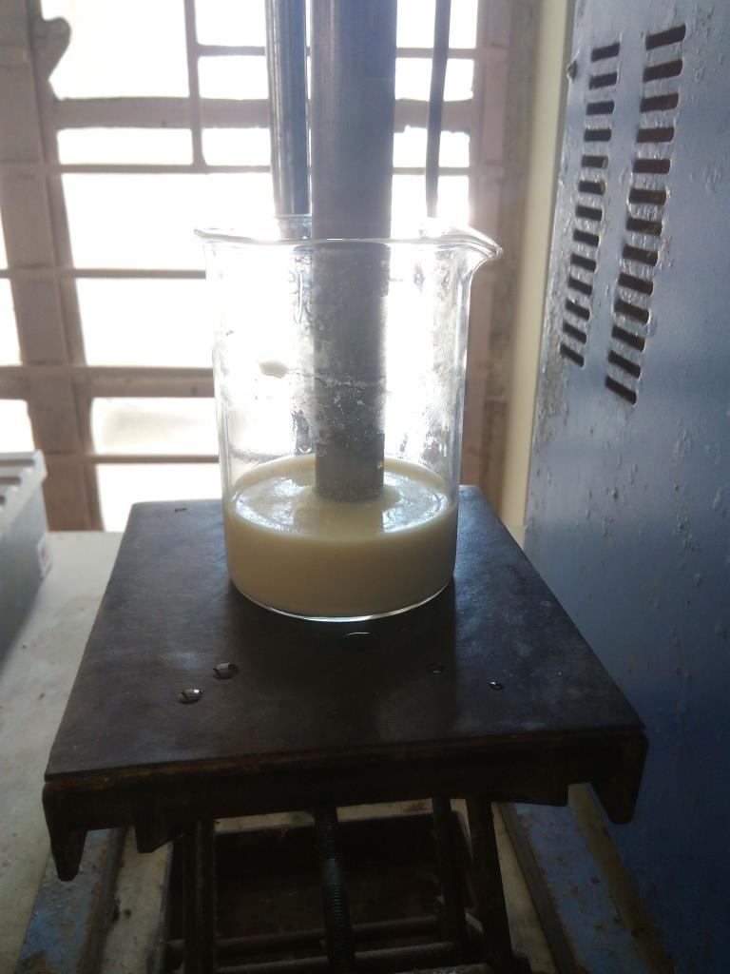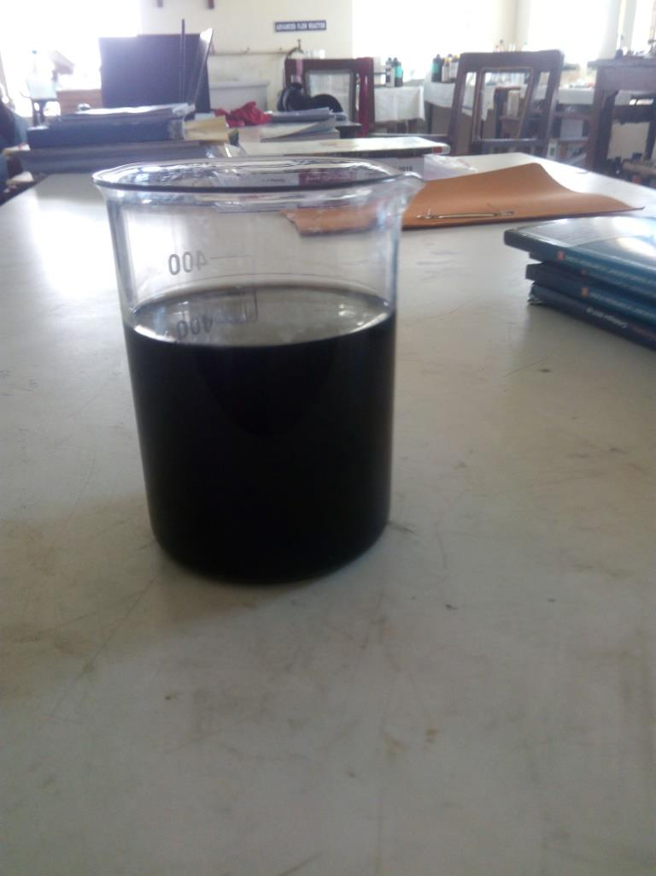
- (b)
Figure 3: Mixture of Pt/ TiO₂ a) before reaction b) after reaction with added water for washing purpose

The product was washed with DI water and seperated using centrifuge operated at 9000 rpm and temperature of 10 ℃ for 12 min. This procedure of centrifugation for the separation of product of 12 min interval was repeated four times, which ensured complete washing and separation of the product. The schematic drawing for the synthesis of Pt/TiO₂ catalyst is shown in figure 4.

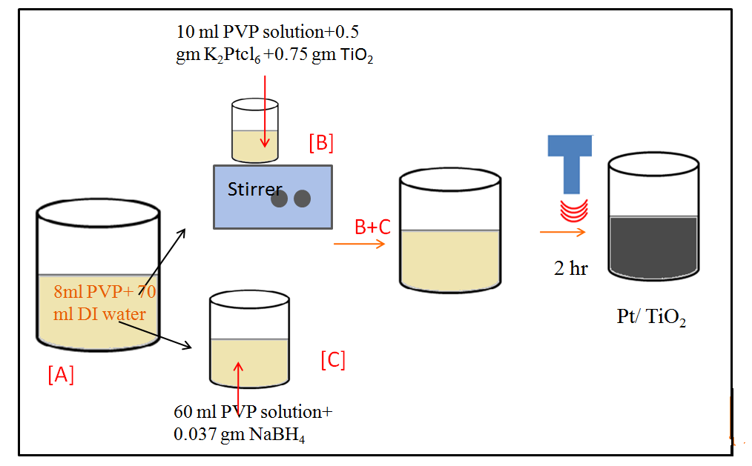

Figure 4: Schematic of synthesis of TiO₂ supported Pt catalyst (Pt/TiO₂) synthesis

4. RESULTS
4.1 Field-emission scanning electron microscope (FE-SEM) analysis of TiO₂
FESEM analysis is used primarily to analyze surface morphology. The sample was spread over the substrate and was analyzed. For titanium dioxide powder sample, we prepared a suspension of it in a volatile solvent like methanol, and spread it over a carbon tape as a substrate. After the solvent evaporates it creates something like a "thin film" of the sample providing the "required surface" as mentioned earlier and also ensuring uniform thickness. The titanium dioxide particles are spherical in shape and uniform in nature

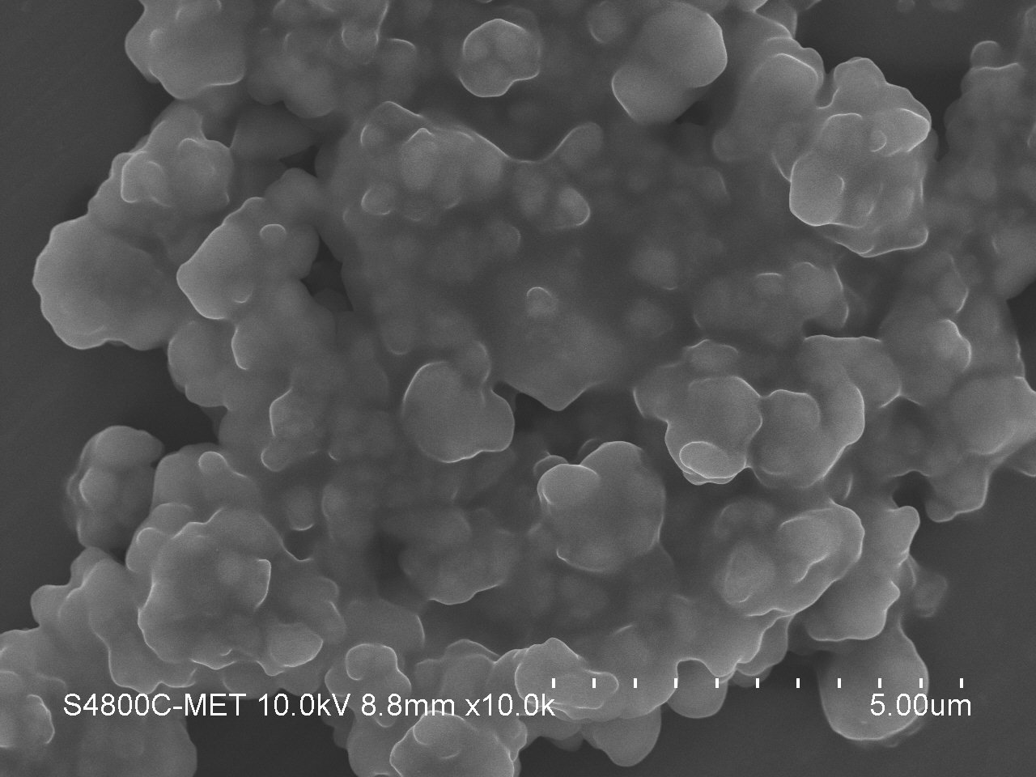
(a)
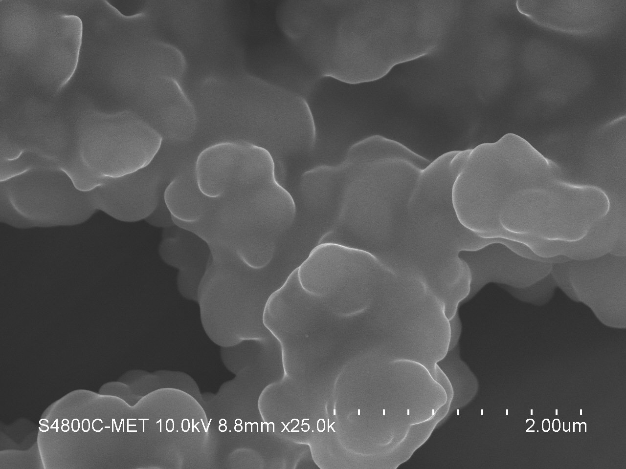
(b)

Figure 5: FE-SEM images of synthesized TiO₂ using ultrasound (a) 5 µm (b) 2 µm

4.2 Particle size analysis (PSA) (Pt/TiO₂)
The particle size and zeta potential of nano-dispersions analysis was done using Malvern Zetasizer (Nano S90 version 7.02). Dilute solution of Pt/TiO₂ was characterized using dynamic light scattering method.
The average hydrodynamic diameter and poly-dispersity index (PDI, Malvern definition) found out by quasi-elastic light scattering. The zeta potential determinations were performed using electrophoretic laser Doppler velocimetry. Before putting the samples to analysis it was diluted to 1/300 in De-ionized water (DIW) for size analysis and in 1 mM NaCl solution.
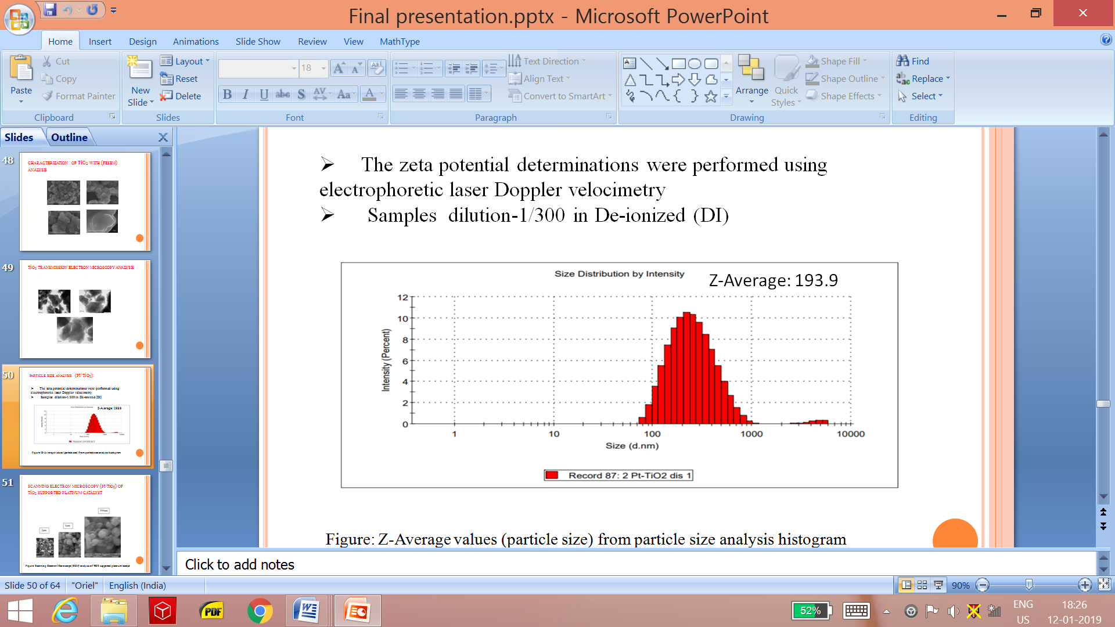
Figure 6: PSA analysis of Pt supported on TiO₂

4.3 Energy dispersive X-ray analysis (EDX) (Pt/TiO₂)
Figure 6 shows the energy dispersive X-ray analysis (EDX) for the titanium dioxide supported platinum catalyst obtained using ultrasound. The strong peak of titanium (41.28 weight %) and oxygen (55.51 weight %) in the spectra indicates that the concentration of support (TiO₂) is higher as compared with platinum nanoparticles (3.21 weight %), as platinum is costly catalyst its lower percentage and good dispersion on support was obtained which can be seen from EDX spectra. The initial peak is nothing but the indication of Mcarbon used for dispersion of product sample on analysis kit plate.
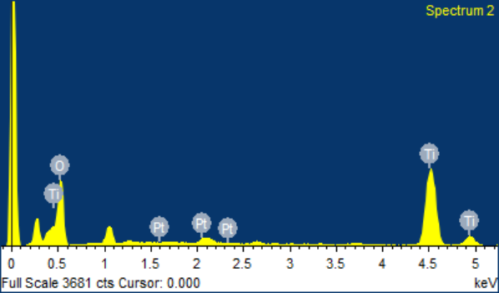
Figure 7: EDX analysis of Pt supported on TiO₂ using ultrasonic cavitation
4.3 Transmission Electron Microscope (TEM) analysis (Pt/TiO₂)
The morphological characterization of the nanoparticles was performed using the TEM (FEI-TechnaiTE-20 and JEOL JEM-2100F field emission transmission 12 electron microscope) TEM samples were made on a carbon coated 14 TEM grid by putting a 7 µL drop of an as-prepared solution of nickel and palladium on nickel 15 NCs analysis and the obtained results have been shown in Figure 6. From images it is clear that platinum catalyst have uniform distribution over the titanium dioxide support material. The product titanium dioxide supported platinum catalyst has uniform particle size. The average particle size of the particle is 50 nm which confirms nanoscale production of supported metal catalyst for its effective use in the reaction. The smallest particle size of Pt/TiO₂ is 2.29 nm

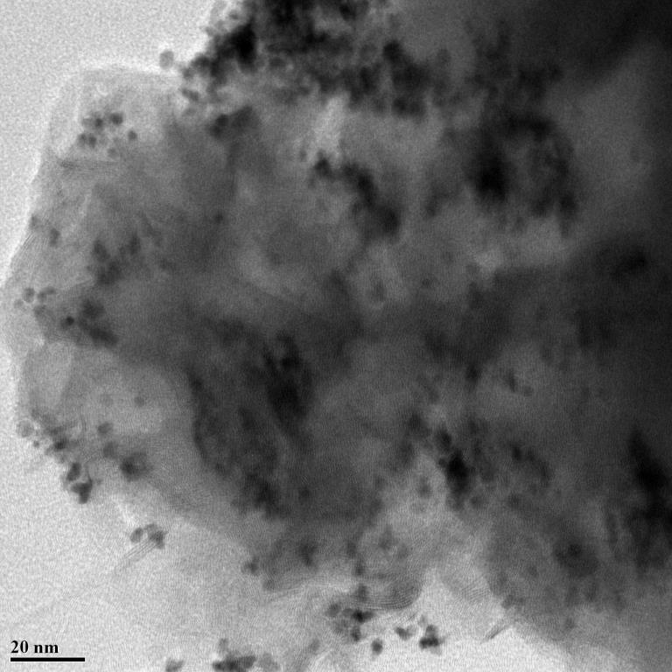
(a)
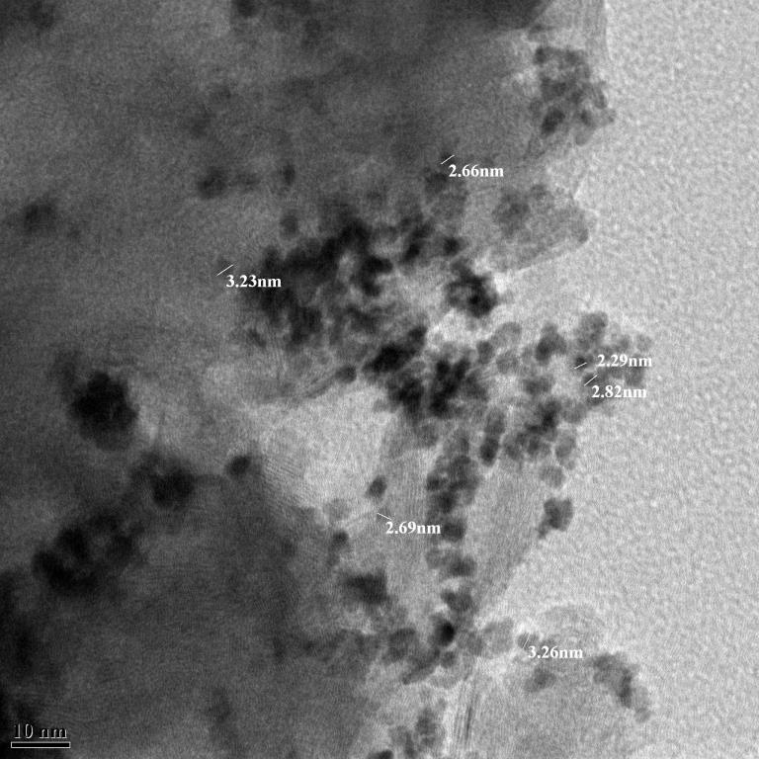
(b)
Figure 6: TEM images of synthesized TiO₂ using ultrasound a) 20 nm and b) 10 nm

5. conclusionS
The micro jets formed due to acoustic cavitation gives the growth and intense collapse of the bubbles and promises the nanoscale synthesis of Pt/TiO₂.
The Pt/TiO₂ system is also termed as bi-functional catalyst which is used as heterogeneous catalyst in various reactions, where TiO₂ acts as catalyst in discoloration and platinum performs as a catalyst in fuel cell application. Nano characterization of the Pt/TiO₂ shows crystallinity of support TiO₂. TEM analysis of Pt/TiO₂ shows a uniform dispersion of platinum catalyst over TiO₂ support.

Acknowledgements
Dr. Shirish Sonawane acknowledges to Science and Engineering Research Board (SERB) DST Govt. of India for financial support through grant No: SERB/EMR/2016/007585

5. REFERENCES
- Bagheri, S., Muhd Julkapli, N. and Bee Abd Hamid, S., 2014. “Titanium dioxide as a catalyst support in heterogeneous catalysis”. The Scientific World Journal, pp.1-21.
- Tauster, S.J., Fung, S.C. and Garten, R.L., 1978. “Strong metal-support interactions. Group 8 noble metals supported on titanium dioxide”. Journal of the American Chemical Society, 100(1), pp.170-175.
- Islam, A. and Ravindra, P., 2017. “Biodiesel production with green technologies” Cham: Springer, 89, pp. 1-105.
- Bamwenda, G.R., Tsubota, S., Nakamura, T. and Haruta, M., 1997. “The influence of the preparation methods on the catalytic activity of platinum and gold supported on TiO₂ for CO oxidation”. Catalysis Letters, 44(1-2), pp.83-87.
- Bethi, B., Sonawane, S.H., Rohit, G.S., Holkar, C.R., Pinjari, D.V., Bhanvase, B.A. and Pandit, A.B., 2016. “Investigation of TiO₂ photocatalyst performance for decolorization in the presence of hydrodynamic cavitation as hybrid AOP”. Ultrasonics sonochemistry, 28, pp.150-160.
- Reyes-Coronado, D., Rodríguez-Gattorno, G., Espinosa-Pesqueira, M.E., Cab, C., de Coss, R.D. and Oskam, G., 2008. “Phase-pure TiO2 nanoparticles: anatase, brookite and rutile”. Nanotechnology, 19(14), pp.1-10.
- Gardner, S.D., Hoflund, G.B., Schryer, D.R. and Upchurch, B.T., 1991. “Characterization study of silica-supported platinized tin oxide catalysts used for low-temperature carbon monoxide oxidation: Effect of pretreatment temperature”. The Journal of Physical Chemistry, 95(2), pp.835-838.
- Suryawanshi, P.L., Gumfekar, S.P., Rajesh Kumar. P., Kale, B.B., Sonawane, S.H., 2016. “Synthesis of Ultra Small Platinum Nanoparticles in a Continuous Flow Microreactor”, Colloid and Interface Science Communications, 13, pp 6–9.
- Huang, S. Y., Ganesan, P., Park, S., Popov, B.N., 2009, “Development of a Titanium Dioxide-Supported Platinum Catalyst with Ultrahigh Stability for Polymer Electrolyte Membrane Fuel Cell Applications”, J. Am. Chem. Soc., 131, pp 13898–13899.

