DESIGN OF ELECTRICITY GENERATING DEVICE USING AUTOMATIVE ENGINE EXHAUST

Authors: Aravindan K, Senthil kumar S, Balaji.K, Akash K, Magesh G

RMK College of Engineering and Technology, Puduvoyal

ABSTRACT

Here we are modifying an automobile for producing power using turbines. Nowadays in automobilefield many innovating concepts are being developed. We are using the power from vehicle exhaust to generate the electricity which can be stored in battery for the later consumption. In this project, we are demonstrating a concept of generating power in a moving vehicle by the usage of turbines.
Here we are placing a turbine in the path of exhaust inthe silencer. An engine is also placed in the chassis of the vehicle. The turbine is connected to a dynamo, which is usedto generate power. Depending upon the airflow the turbine will start rotating, and then the dynamo will also start torotate. A dynamo is a device which is used to convert the kinetic energy into electrical energy.
The generated power isstored to the battery. It can be stored in the battery after rectification. The rectified voltage can be inverted and can beused in various forms of utilities. The battery power can be consumed for the users comfort.

KEYWORDS: turbine, dynamo, battery, electrical generator

INTRODUCTION

In recent years the scientific and public awareness on environmental and energy issues have, brought in major interests tothe research of advanced technologies particularly in highly efficient internal combustion engines. Viewing from the
socio-economic perspective, as the level of energy consumption is directly proportional to the economic development and total number of population in a country, the growing rate of population in the world today indicates that the energy
demand is likely to increase. Two-thirds of the energy from combustion in a vehicle is lost as waste heat, of which 40% is in the form of hot exhaust gas. The latest developments and technologies on waste heat recovery of exhaust gas from internal combustionengines (ICE). These include thermoelectric generators (TEG), Organic Rankine cycle (ORC), six-stroke cycle ICengine and new developments on turbocharger technology. Being one of the promising new devices for an automotive waste heat recovery, thermoelectric generators (TEG) will become one of the most important and outstanding devices in the future. A thermoelectric power generator is a solid state device that provides direct energy conversion from thermal energy (heat) due to a temperature gradient into electrical energy based on “Seebeck effect”. The thermoelectric power cycle, charge carriers (electrons) serving as the working fluid, follows the fundamental laws of thermodynamics and intimately resembles the power cycle of a conventional heat engine.
One potential solution is the usage of the exhaust waste heat of combustion engines. This is possible by the waste heat recovery using thermoelectric generator. A thermoelectric generator converts the temperature gradient into useful voltage that can be used for providing power for auxiliary systems such as air conditioner and minor car electronics. Even it can reduce the size of the alternator that consumes shaft power. If approximately 6% of exhaust heat could be converted into electrical power, it will save approximately same quantity of driving energy. It will be possible to reduce fuel consumption around 10 %; hence AETEG systems can be profitable in the automobile industry.

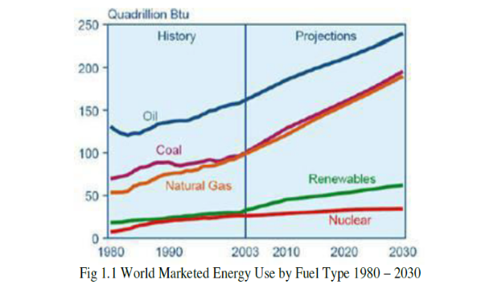
The number of vehicles (passenger and commercial vehicles) produced from 2005 to 2010 shows an overall increasing trend from year to year despite major global economic downturn in the 2008–2010 periods Note that China’s energy consumption in transportation sector is the lowest (13.5%) Although the country produced the highest number of vehicles in 2009 to 2010 as compared to the other countries A number of irreversible processes in the engine limit its capability to achieve a highly balanced efficiency.
The rapid expansion of gases inside the cylinder produces high temperature differences, turbulent fluid motions andlarge heat transfers from the fluid to the piston crown and cylinder walls. These rapid successions of events happening in the cylinder create expanding exhaust gases with pressures that exceed the atmospheric level, and they must be released while the gases are still expanding to prepare the cylinder for the following processes. By doing so, the heated gases produced from the combustion process can be easily channeled through the exhaust valve and manifold. The large amount of energy from the stream of exhausted gases could potentially be used for waste heat energy recovery to increase the work output of the engine. Consequently, higher efficiency, lower fuel consumption by improving fuel economy, producing fewer emissions from the exhaust, and reducing noise pollutions have been imposed as standardsin some countries. The waste heat produced from thermal combustion process generated by gasoline engine could get as high as 30–40% which is lost to the environment through an exhaust pipe. In internal combustion engines a huge amount of energy is lost in the form of heat through the exhaust gas.
We have investigated that the percentage of fuel energy converted to useful work only 10.4% and also found the thermal energy lost through exhaust gas about 27.7%. The second law (i.e., energy) analysis that fuel energy is converted to the brake power about 9.7% and the exhaust about 8.4% 3. In another research the value of exhaust gases mentioned to be 18.6% of total combustion energy. It is also found that by installing heat exchanger to recover exhaust energy of the engine could be saved up to 34% of fuel saving. For example, the heat of the car's exhaust can be used to warm the engine coolant to keep the engine running warm, even when the motor has been turned off for a significant length of time. A vehicle's exhaust can actually be used to generate electricity. Although these technologies can be used in any car, truck or SUV with an internal combustion engine, they're particularly important to hybrid vehicles, which need to produce maximum fuel efficiency and minimal emissions. The potential cost savings, improved energy efficiency and broad application of such technology is enormous, experts say.
II. DESIGN OF EQUIPMENT AND DRAWING
2.1 COMPONENTS AND ITS FUNCTIONS
The generations of electricity using the flow or velocity of vehicle exhaust gas of the following components to fulfill the requirements of complete operation of the machine are
1. Turbine
2. Dynamo
3. Battery
4. Engine
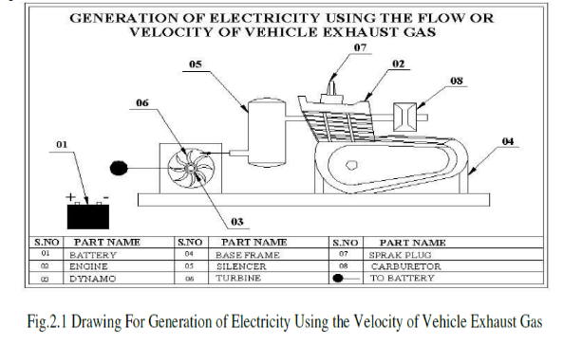
TURBINE
A steam turbine is a mechanical device that extracts thermal energy from pressurized steam, and converts it into rotary motion. It has almost completely replaced the reciprocating piston steam engine primarily because of its greater thermal efficiency and higher power-to-weight ratio. Because the turbine generates rotary motion, it is particularly suited to be used to drive an electrical generator – about 90% of all electricity generation in the United States is by use of steam turbines. The steam turbine is a form of heat engine that derives much of its improvement in thermodynamic efficiency through the use of multiple stages in the expansion of the steam, which results in a closer approach to the ideal reversible process.
A turbine is a rotary mechanical device that extracts energy from a fluid flow and converts it into useful work. The work produced by a turbine can be used for generating electrical power when combined with a generator or producing thrust, as in the case of jet engines. A turbine is a turbo machine with at least one moving part called a rotor assembly, which is a shaft or drum with blades attached. Moving fluid acts on the blades so that they move and impart rotational energy to the rotor. Early turbine examples are windmills and waterwheels.
Gas, steam, and water turbines have a casing around the blades that contains and controls the working fluid. Credit for invention of the steam turbine is given both to British engineer Sir Charles Parsons for invention of the reaction turbine, and to Swedish engineer Gustaf de Laval for invention of the impulse turbine. Modern steam turbines frequently employ both reaction and impulse in the same unit, typically varying the degree of reaction and impulse from the blade root to its periphery.
The word "turbine" was coined by the French mining engineer Claude Burdin from the Latin turbo, or vortex, in a memo, "Des turbines hydrauliques ou machines rotatoires à grande vitesse", which he submitted to the Académie royale des sciences in Paris. Benoit Fourneyron, a former student of Claude Burdin, built the first practical water turbine.
DYNAMO
Dynamo is an electrical generator. This dynamo produces direct current with the use of a commutator. Dynamos are the first generator capable of the power industries. A dynamo machine consists of a stationary structure called the stator which provides a constant magnetic field, and a set of rotating windings called the armature which turn within that field. On small machines the constant magnetic field may be provided by one or more permanent magnets; larger machines have the constant magnetic field provided by one or more electromagnets, which are usually called field coils.
The commutator was needed to produce direct current. However, in the early days of electric experimentation, alternating current generally had no known use. The few uses for electricity, such as electroplating, used direct current provided by messy liquid batteries. Dynamos were invented as a replacement for batteries. The commutator is a set of contacts mounted on the machine's shaft, which reverses the connection of the windings to the external circuit when the potential reverses, so instead of alternating current, a pulsing direct current is produced.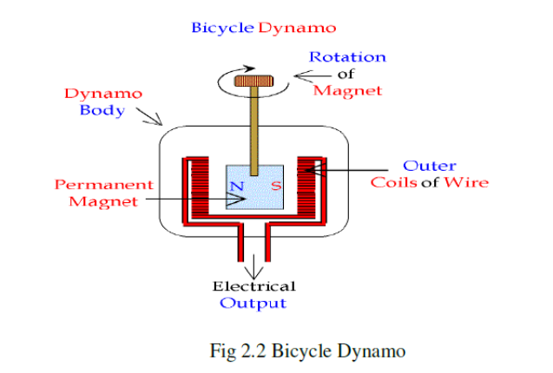
A dynamo is an electrical generator that produces direct current with the use of a commutator. Dynamos were the first electrical generators capable of delivering power for industry, and the foundation upon which many other later electric-power conversion devices were based, including the electric motor, the alternating-current alternator, and the rotary converter. Today, the simpler alternator dominates large scale power generation, for efficiency, reliability and cost reasons. A dynamo has the disadvantages of a mechanical commutator. Also, converting alternating to direct current using power rectification devices is effective and usually economical.

BATTERY
In our project we are using secondary type battery. It is a rechargeable type. A battery is one or more electrochemical cells, which store chemical energy and make it available as electric current. There are two types of batteries, primary (disposable) and secondary (rechargeable), both of which convert chemical energy to electrical energy.
An electric battery is a device consisting of one or more electrochemical cells with external connections provided to power electrical devices such as flashlights, smartphones, and electric cars. When a battery is supplying electric power, its positive terminal is the cathode and its negative terminal is the anode. The terminal marked negative is the source of electrons that when connected to an external circuit will flow and deliver energy to an external device. When a battery is connected to an external circuit, electrolytes are able to move as ions within, allowing the chemical reactions to be completed at the separate terminals and so deliver energy to the external circuit. It is the movement of those ions within the battery which allows current to flow out of the battery to perform work.^{[3]}Historically the term "battery" specifically referred to a device composed of multiple cells, however the usage has evolved to additionally includedevices composed of a single cell.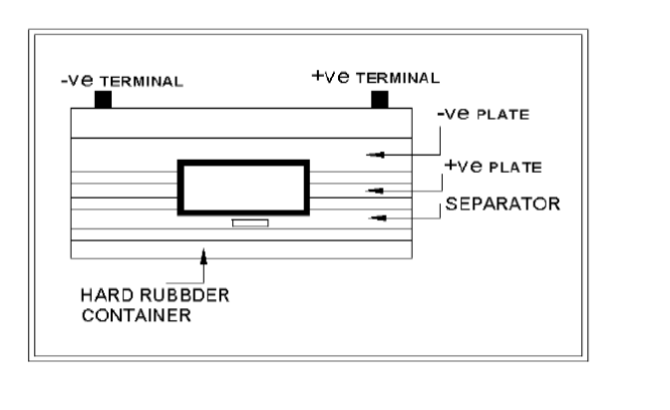
Primary batteries are used once and discarded; the electrode materials are irreversibly changed during discharge. Common examples are the alkaline battery used for flashlights and a multitude of portable electronic devices. Secondary (rechargeable) batteries can be discharged and recharged multiple times using mains power from a wall socket; the original composition of the electrodes can be restored by reverse current. Examples include the lead-acid batteries used in vehicles and lithium-ion batteries used for portable electronics such as laptops and smart phones.
Batteries come in many shapes and sizes, from miniature cells used to power hearing aids and wristwatches to small, thin cells used in smart phones, to large lead acid batteries used in cars and trucks, and at the largest extreme, huge battery banks the size of rooms that provide standby or emergency power for telephone exchanges and computer data centres.
ENGINE
An engine or motor is a machine designed to convert energy into useful mechanical motion. Heat engines, including internal combustion engines and external combustion engines (such as steam engines) burn a fuel to create
heat, which then create motion. The term internal combustion engine usually refers to an engine in which combustion is intermittent, such as the more familiar four-stroke and two-stroke piston engines.
A petrol engine (known as a gasoline engine in American English) is an internal combustion engine with spark-ignition, designed to run on petrol (gasoline) and similar volatile fuels.
In most petrol engines, the fuel and air are usually pre-mixed before compression. The pre-mixing was formerly done in a carburettor, but now it is done by electronically controlled fuel injection, except in small engines where the cost/complication of electronics does not justify the added engine efficiency. The process differs from a diesel engine in the method of mixing the fuel and air, and in using spark plugs to initiate the combustion process. In a diesel engine, only air is compressed, and the fuel is injected into very hot air at the end of the compression stroke, and self-ignites.

III. EXPERIMENTAL SETUP
Here we are placing a turbine in the path of exhaust in the silencer. An engine is also placed in the chassis of the vehicle. The turbine is connected to a dynamo, which is used to generate power. Depending upon the airflow the turbine will start rotating, and then the dynamo will also start to rotate. A dynamo is a device which is used to convert the kinetic energy into electrical energy. The generated power is stored to the battery. It can be stored in the battery after rectification. The rectified voltage can be inverted and can be used in various forms of utilities. The battery power can be consumed for the user’s comfort.

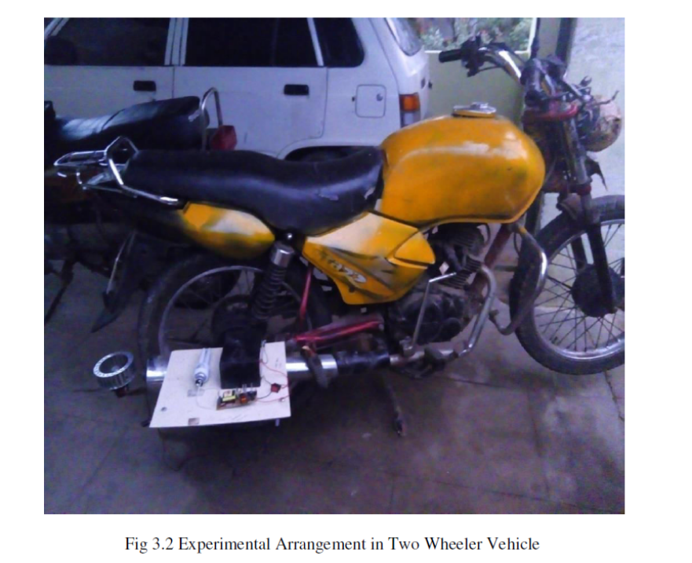
IV. CALCULATIONS
Maximum Power of the Bike = 8.3bhp
Fuel Efficiency of Bike = 65.8km/h
TURBINES
Number of Blades = 40
Diameter = 15cm
INVERTER
It Converts DC to AC (12Volts to 230 Volts)
BATTERY
12Volt Rechargeable Battery
FORMULA TO BE USED
Area of Swept, A= (22/7) x (radius of turbine) 2
Velocity of the Turbine= ((22/7)x D x N)/60
Where
D=diameter of turbine
N=number of revolution per minute

POWER AVAILABLE AT THE TURBINE,
P= (1/2) x Density x (Velocity) 3xCpxArea
MODEL CALCULATION
Swept area by the turbine, A = (22/7) x radius2
=3.14 x (0.05) ²
=0.00785 m²
Velocity of the turbine, V= ((22/7) x D x N)/60
= (3.14x0.10x45)/60
=0.2357 m/s
Power available at the turbine
=1/2x density x area x (velocity) 3 x Cp
=1/2 x1.23 x 0.00785 x (0.2357)3x0.4
=2.57x10-5 watts
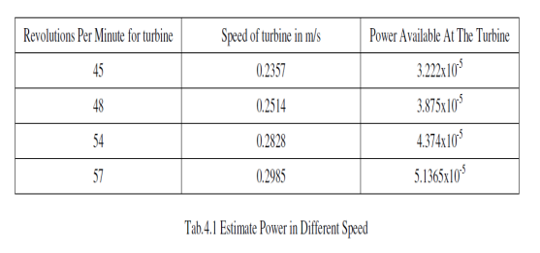
ADVANTAGES
1. Efficiency method of charging the battery
2. Power is stored in a battery; we have to use other application like lighting, etc…

DISADVANTAGES
1. Additional cost is required
2. Additional space is required to install this arrangement in vehicles

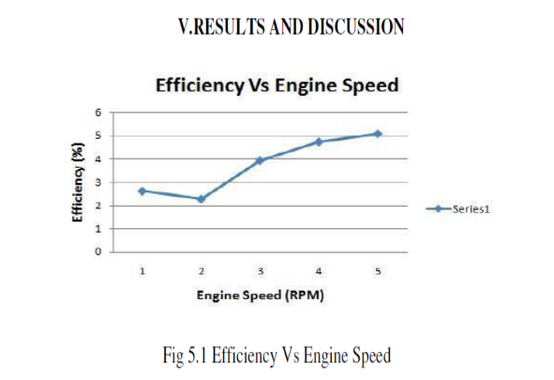
The graph explains the relation between the overall efficiency of the system and engine speed. At 3970 RPM the efficiency obtained was 5.078%.
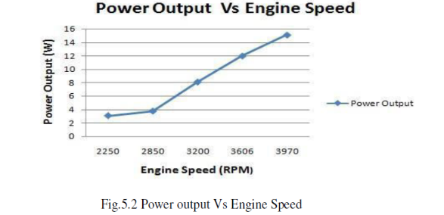
The graph shows that the power output of engine speed. At the speed of 3970 RPM, the power developed by TEG is 15.225 W.

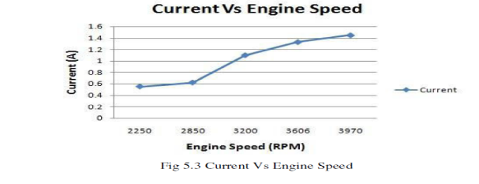
The graph explains that the current increases with the engine speed. It first increases gradually up to 2850RPM then rapidly beyond that speed. At the speed of 3970 RPM the current is 1.45 A.

Scope for Future Work:
• Making the turbine enclosure more compact.
• Finding ways to enhance output.
• Designing a system for four- wheelers.
• Experimenting with Piezoelectric materials as an added source for Power generation.

CONCLUSION
From the study, it has been identified that there are large potentials of energy savings through the use of waste heat recovery technologies. Waste heat recovery entails capturing and reusing the waste heat from internal combustion engine and using it for heating or generating mechanical or electrical work. It would also help to recognize the improvement in performance and emissions of the engine if these technologies were adopted by the automotive manufacturers.
The study also identified the potentials of the technologies when incorporated with other devices to maximize potential energy efficiency of the vehicles. The project carried out by us made an impressing task in the field of mechanical department. It is used to produce the current in vehicle exhaust unit. This project has also reduced the cost involved in the concern. Project has been designed to perform the entire requirement task which has also been provided.

FINISHING AND PAINTING
JOB PREPARATION:
Before Welding, remove any bend in the L angle with the sludge hammer on the anvil block. Then it is cut to the required dimensional shape with arc welding

FINISHING OPERATION BEFORE PAINTING:
After Welding, any slag on the welded area is removed with the chipping hammer and cleaned with the metal wire brush. Then all the surfaces are rubbed with the emery sheet.
Metal primer is applied on the surfaces with the brush. After drying the metal primer, the second coating is applied with the paint.

REFERENCES
1. Dipak Patil, Dr. R. R. Arakerimath”, A Review of Thermoelectric Generator for Waste Heat Recovery from Engine Exhaust” Vol.1Issue.8,December 2013.

2. Prathamesh Ramade, Prathamesh Patil, Manoj Shelar, Sameer Chaudhary, Prof. Shivaji Yadav,Prof. Santosh Trimbake” automobileExhaust Thermo-Electric Generator Design &Performance Analysis” International Journal of Emerging Technology and Advanced EngineeringWebsite: www.ijetae.com (ISSN 2250-2459, ISO 9001:2008 Certified Journal, Volume 4, Issue 5, May 2014).

3. R. Saidur , M.Rezaei , W.K.Muzammil , M.H.Hassan , S.Paria , M.Hasanuzzaman” Technologies to recover exhaust heat from internal
combustion engines”ElsevierLtd.

4. Jia S, Peng H, Liu S, Zhang X. Review of transportation and energy consump- tion related research. Journal of Transportation SystemsEngineering and Information Technology 2009

5. Saidur R. A review on electrical motors energy use and energy savings. Renewable and Sustainable Energy Reviews 2010
6. Saidur R, Atabani AE, Mekhilef S. A review on electrical and thermal energy for industries. Renewable and Sustainable Energy Reviews2011.
7. Jahirul MI, Saidur R, Hasanuzzaman M, Masjuki HH, Kalam MA. A comparison of the air pollution of gasoline and CNG driven car forMalaysia. International Journal of Mechanical and Materials Engineering 2007

8. Saidur R, Jahirul MI, Hasanuzzaman M, Masjuki HH. Analysis of exhaust emissions of natural gas engine by using response surfacemethodology. Journal of Applied Science 2008
9. UNESCAP. Country Reports: Population and Poverty in Malaysia. United Nation Economic and Social Commission for Asia and thePacific; 2002.
10. Kaya D, Yagmur EA, Yigit KS, Kilic FC, Eren AS, Celik C. Energy efficiency in pumps. Energy Conversion and Management 2008;49(6):1662–73. [9] Saidur R, Sattar M, Masjuki H, Ahmed S, Hashim U. An estimation of the energy and exergy efficiencies for the energy resourcesconsumption in the transportation sector in Malaysia. Energy Policy 2007
BIBLIOGRAPHY
- The US Patent for an ‘Exhaust muffler for engines’ was awarded to Milton O. Reeves and Marshall T. Reeves of Columbus, Indiana of the Reeves Pulley Company on 11 May 1897.
- “Automotive Engineering Fundamentals” by Richard Stone, Jeffery K.Ball
- www.google.com
- Automobile Engineering----- g.b.s. narang

