Experimental Studies on Steel Beam- to- Column Connections under Elevated Temperature
Cinitha.A1ª ,V.Nandhini 2^{b}
ªSr.Scientist, CSIR-Structural Engineering Research Centre, Chennai-600113, Tamil Nadu, India
^{b}ME student, Department of Civil Engineering, Nandha Engineering College, Erode-638052-,Tamil Nadu, India
*Corresponding author Email: cinitha@serc.res.in

------------------------------------------------------------------------------------------------------------------

Abstract: The connection behaviour of Square Hollow Section as column welded with I-section as beam (SHCWIB) are commonly used in the construction of modern steel buildings. The behaviour of such connections under elevated temperature or fire load is limited. In this paper the experimental studies on the behaviour of SHCWIB connection, subjected to an elevated temperature (of 600 ^{O}C) are presented. The beam-to- column connection is exposed to the elevated temperature and then subsequently cooled to the room temperature. The beam is then put through an increasing monotonic load while the column is subjected to a constant axial compression. The inelastic connection behaviour in terms of moment rotation is studied. It is observed that the connection failed at lower loads due to combination of p-Δ effect along with high temperature.

Keywords: Square hollow section, Moment connection, Elevated temperature, Monotonic loading

- Introduction
The welded beam –to-column connections are widely adopted in steel framed structures due to easiness in construction and economy. The fire resistant design of steel framed structures demands enough strength to resist thermal and service loads, during such events to prevent sudden failures. The members are designed to possess adequate strength at specified elevated temperature for a period of time. The effect of thermal forces in beams and columns are determined by the type of the beam- to-column connections, such as rigid, semi-rigid, and flexible [1-4]. The connection member’s response to fire has been examined by Lawson [5] under varied moment. Three typical connections were studied: an extended end plate, double-sided web cleat and a flush end plate and demonstrated that significant moments could be sustained during fire event. Al-Jabri et al [6,7] conducted a series of elevated temperature connection tests to study the response under fire by varying parameter such as member size, thickness composite slab characteristics and end plate type. However, there is limited information on the connection behaviour of SHS column and I-section as beam. Hence at CSIR-SERC, efforts has been put forward to understand the connection behaviour of Square Hollow Section as column welded with I-section as beam (SHCWIB).

Problem definition
The connection consists of square hollow section (SHS) column of 220x220x6mm of height 1500mm and ISMB200 beam of length 2500mm. The connection is established by welding I- beam to SHS column member with mig weld of size 6mm. An equal angle of IS 80x6 is used as seat and cleat connection, which is welded between I- beam and SHS column with 6mm fillet weld as given in Fig.1.

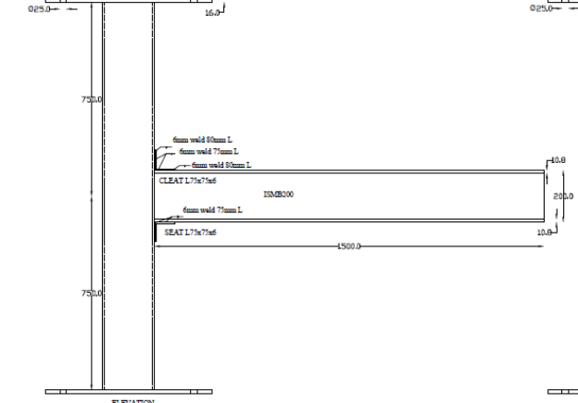

Fig.1 Schematic sketch of the connection

3.0 Experimental set-up for inducing elevated temperature effect
In order to induce elevated temperature effect on the connection from ambient to 600ºC, specially fabricated radiation heaters were used. The flexible heaters were wrapped over the three regions exposed to elevated temperature effect [8]. Insulators capable to with stand more than 1200^{O}C were used to prevent dissipation of heat to the atmosphere and to the other regions of the structure. The heat conducted to the other part of the structure is measured with adequate numbers of thermocouples. The experimental set-up is as shown in Fig 2. Fig.3 shows the measured temperature distribution across the joint zone.

.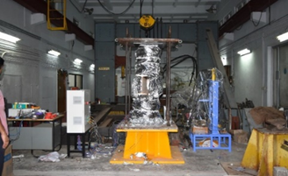
Fig.2 Experimental set-up to induce elevated temperature on SHCWIB

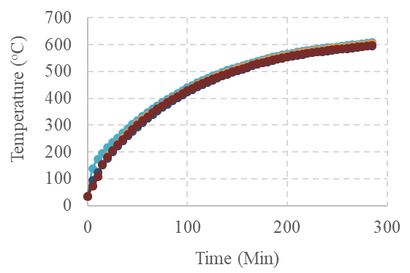
Fig.3 Measured temperature distribution across connection

Experimental set-up for mechanical loading
To examine the response of temperature on affected SHCWIB moment connection, full-size welded moment connection is subjected to incremental monotonic load till failure. The column member is axially restrained and loaded with a constant load. To understand the P-Δ effect, an axial load of 0.6Py is applied to the column. The I-beam being subjected to incremental load with 25ton actuator (in monotonic manner) till failure takes place. Linear Variable Differential Transducers (LVDT) and strain gauges were used to monitor the deformation and strain value of the specimen at identified regions during the test. The test set-up is shown in Fig.4. The typical stress vs strain behaviour of coupons at ambient temperature is shown in Fig.5. Fig.6 shows load vs strain behaviour of beam-to-column connection while subjected to mechanical loading.

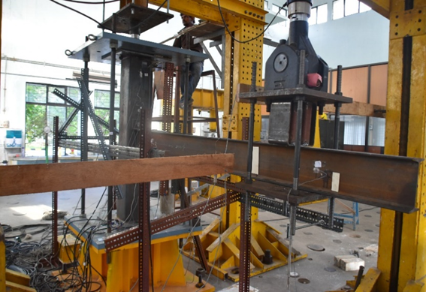

Fig.4 Experimental set-up for mechanical loading to shcwib connection

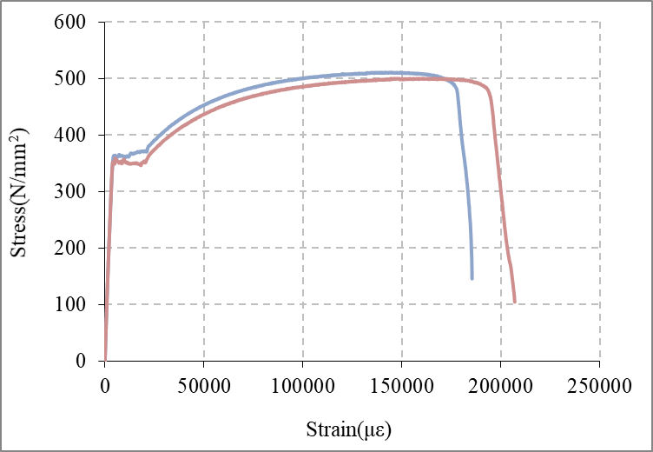

Fig.5 Typical Stress vs Strain behaviour of coupons at ambient temperature

Results and discussions

The temperature distribution across the connection region shows uniform distribution in beam and column members. Mild colour change is observed on the exposed surface with no significant visual deformation in any of the structural member after exposing to elevated temperature The deterioration in the strength and stiffness at elevated temperature are important characteristics of steel beam-to-column moment connection [Eurocode 3]. The load vs deflection behaviour of beam-to-column connection subjected to elevated temperature and cooled at room temperature is shown in Fig.7. The beam has undergone a deflection of 80mm at failure. The damage in connection region was less and no cracks were found in welded regions. The beam member has undergone plastic deformation which was evident from the formation of Lüder’s lines found in the top flange.

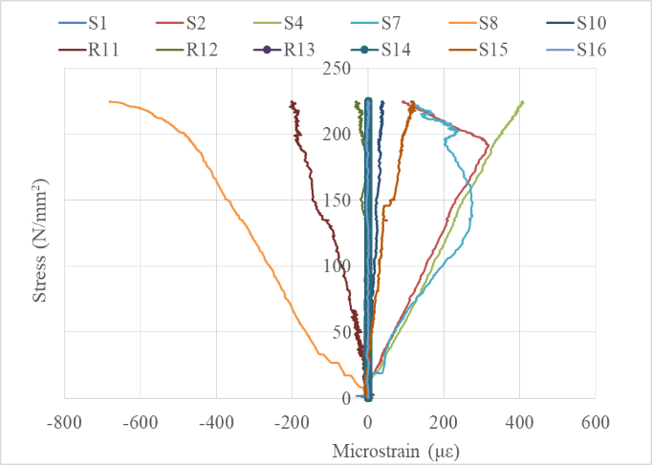

Fig.6 Stress vs Strain behaviour of beam-to-column connections

The inelastic connection behaviour in terms of moment-rotation is required for the prediction of failure in steel structures. The moment-resisting frames have large number of dissipative zones, located near the beam-to-column connections and it is complex to compute the ultimate load analytically. The experimentally observed moment vs rotation behaviour is shown in Fig. 8.

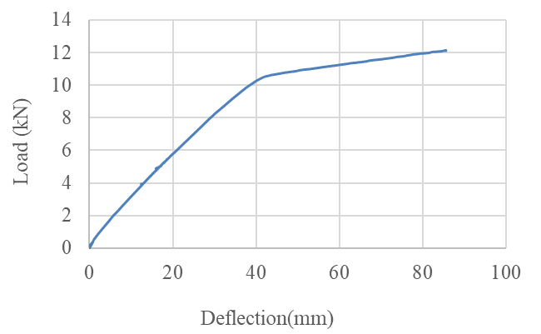

Fig 7. Load vs Deflection behaviour

- Conclusion

The behaviour of SHCWIB type moment connection subjected to elevated temperature are experimentally studied. It is found that the connection region had no crack formation or any other significant damages. The results demonstrate that the moment capacity of the connection decreases by exposure to elevated temperatures. This insight is further emphasised with the load vs strain behaviour of beam-to column connections under mechanical load (the strain at ultimate load ranges from 100 to 650 microstrain). The connection subjected to the elevated temperature (600^{O}C) has undergone comparatively lesser strain value than the ambient condition. It is also noticed that axial restraint i.e (P-Δ effect) force has significant effect on moment capacity of steel beam-to-column connection viz. the connection failed at lower loads.

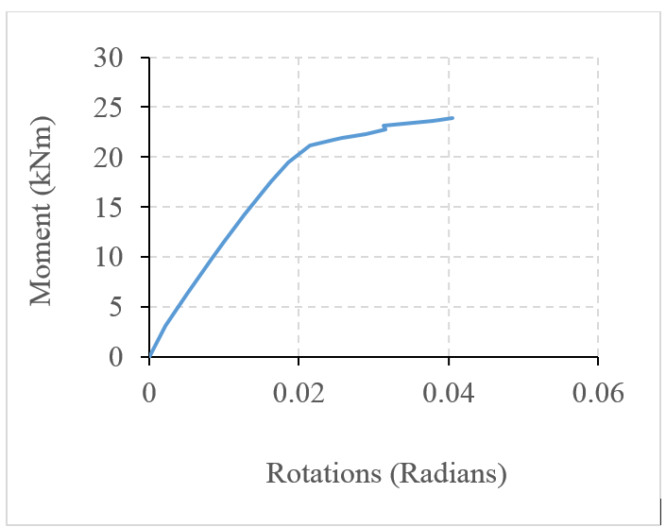
Fig.6 Moment vs Rotation curve

Acknowledgement

This work has been supported by CSIR-SERC as part of an in-house R&D work. The technical assistance rendered by the technical staffs, Mr.M.Kumarappan and Mrs.S.Vimala and Ms.M.Nandhini project assistant of Steel Structures Laboratory are greatly acknowledged

References

1. UK Sun Kim, Jong Suk Lee and Young Bong Kwon ,Behaviour of Connections Between SHS Columns & W-section Beams, International speciality Conference, Missouri University of Science and Technology. Paper 1(1994).
2. Khalifa S. Al-Jabri, J. Buick Davison and Ian W.Burgees, Performance of beam-to-column joints in fire – A review, Fire safety Journal 43 (2008) 50-62.
3. Kuo-CheanYang, Sheng-Jin Chen and Ming-Chin Ho, Behaviour of beam-to-column moment connection under fire load, Journal of construction Steel Research 65 (2009) 1520-1527.
4. Al-Jabri KS, Modelling and simulation of beam-to-column joints at elevated temperature: A review” Journal of the Franklin Institute 348 (2011) 1695-1716.
5. Lawson RM, Behaviour of steel beam-to-column connections in fire, Journal of structural Engineering 68 (1990) 262-71.
6. Al-Jabri KS, Lennon T, Plank RJ, Behaviour of steel and composite beam-column connections, Journal of constructional steel research 18 (1987) 17-54.
7. Al-Jabri KS, Davison JB, Burgess IW. Performance of beam-to-column joints in fire_A review. Fire Safety J 2008;43:50_62.
8. A.Cinitha, P.K.. Umesha, G.S. Palani and V. Sampath , Compression behaviour of steel tubular member under simulated corrosion and elevated temperature, International journal of steel structures 18(2018) 139-152
9. Eurocode 3 (1995) Design of steel structures-Part1.2: General rules-structural fire design, European Community for Standardisation, Brussels.

