On the role of amylum additive based cutting fluids in machining – An Experimental Investigation

Padmini R ^{a,*}, Vamsi Krishna P, Jeevan Kumar P ^{c}
^{a, c} Department of Industrial Engineering, GITAM Institute of Technology, Visakhapatnam – 530045, Andhra Pradesh, India
^{b}Department of Mechanical Engineering, National Institute of Technology, Warangal - 506004,Telangan State, India

*Corresponding author Email: padhmini.r@gmail.com
------------------------------------------------------------------------------------------------------------------
This work deals with the application of amylum additive based cutting fluids while turning AISI 304 steel using carbide inserts. Amylum additive is dispersed in vegetable oil at varying percentages. Absorbance of the additive in pure bio-oil is examined using spectrophotometer and thermal conductivity of these formulations is also obtained. Machining performance is assessed by comparing dry, synthetic cutting fluid, pure oil for fixed cutting conditions. After basic machining, percentage of amylum additive is changes and machining is done to examine the best concentration (0.3%-0.9%) of additive in pure oil through minimal quantity lubrication technique. Machining performance is obtained by measuring cutting tool temperatures, surface roughness and tool flank wear. It is inferred that, when compared to dry machining, synthetic fluid and pure oil assisted machining, amylum assisted cutting fluids have resulted in improved machining performance. Hence, it can be comprehended that amylum additive has the potential to be used as additive in bio-degradable oils in view of eco-friendly and user compatible machining operations.

Keywords: Amylum additive, MQL, cutting fluids, user compatible machining

- Introduction

Synthetic cutting fluids applied during machining lead to various technical and environmental issues. It was observed that, wide use of synthetic cutting fluids lead to derma related problems to machinists^{[1,2]}. They hinder the ecological balance, being toxic and non-biodegradable ^{[3,4]}. High amounts of cutting fluids in million metric tons are utilized by manufacturing industries ^{[5]}. Researchers experimented with solid lubricant assisted machining and pinpointed the friction reducing ability of MoS₂. They noted that this behaviour is affirmative for machining and it is due to the physical and chemical properties of MoS₂ surface layers ^{[6]}. Suresh and Rao^{[7]} worked with solid lubricants like graphite, molybdenum disulphide (MoS₂). They inferred that, milling using MoS₂ minimized friction, main cutting force, and specific energy required by 28%. It was inferred through experimentation that application of solid lubricants in hard turning operation was beneficial compared to dry machining ^{[8,9]}. Moving ahead to vegetable oil based cutting fluids, Susan woods ^{[10]} worked with lubricative nature of biodegradable fluids and found that they can be used in machining due to film formation capacity of these fluids on the job. Enhancement in tool life, minimization of cutting tool wear and forces by using vegetable oils was reported ^{[11,12]}. Machining results were found to be encouraging as reported by other researchers by applying different vegetable oils like canola and castor oils ^{[13,14]}. Nanofluids as additives comprise of good thermal and physical properties due to higher surface area to volume ratio. Investigators developed various relations to find the thermal properties of nanofluids ^{[15, 16]}. It was noted that due to enhancement in thermal properties nanofluids can reduce the cutting temperatures during machining operations ^{[17, 18].} Next to mention, MQL involves very low quantity of cutting fluid (10ml/min). Shen ^{[19]} estimated the effect of Al₂O₃, nano diamond and zinc oxide (nano) in grinding operation through MQL and found affirmative results. Researchers observed enhancement in surface integrity of workpiece during turning with high cutting tool pressure by implementing MQL ^{[20,21]}. Abiodun ^{[22]} conducted experiments to examine the performance of amylum starch dispersed cutting fluids in turning and found improvement in machining performance. Flood mode of supply was implemented in this work. Research works on the applicability of natural additives like amylum or maize starch to biodegradable oils through MQL mode have not been explored and the present work attempts to address this aspect.

2 Materials and Methods

The methodology implemented to examine the impact of additive based cutting fluids is discussed in the following sections:

  - Formulation of additive based cutting fluids

The cutting fluids are formulated through ultra sonication process using a bath type sonicator. Pre-weighed quantity of amylum is dispersed in coconut oil (CCO) and sonicated thoroughly for a period of 60 minutes for thorough mixing of additive in base oil. These fluids are prepared at different weight percentages varying in the range from 0.3% to 0.9% of amylum (Amy) additive.

  - Absorbance and Thermal conductivity

Before being applied as cutting fluids it is important to understand the level of dispersion of additive in the base fluid. Spectral analysis is one method to assess the absorbance of formulated cutting fluids. Absorbance is analyzed by using a UV-Visible spectrometer. The cutting fluids being applied at machining zone must possess good thermal properties. Thermal conductivity is an important property of cutting fluids due to which heat generated during machining is dissipated

  - Machining

After evaluation of thermal conductivity of the formulated cutting fluids, experiments are conducted to assess the influence of these fluids while turning AISI 304 grade steel at fixed machining conditions, using coated carbide insert. Cutting temperatures are measured online using k-type shielded embedded thermocouple. Tool flank wear is obtained by using optical microscope. Surf test SJ-301 equipments is used to measure surface roughness. All the experiments and tests conducted thrice and average values are taken to obtain precise results.

3 Results and Discussion

This work aims at investigating the role of additive based bio-degradable cutting fluids in machining using amylum as additive 0.3%, 0.6%, 0.9%. Absorbance and thermal conductivity are tested to check the viability of these cutting fluids to be applied in machining. Machining performance is assessed by measuring cutting temperatures, tool wear, and surface roughness at constant cutting conditions. In this section graphical results are presented and comparative analysis is done and discussed.

3.1 Absorbance
Extent of dispersion of additive particles in coconut oil is presented in figure 1. It is observed that absorbance has significantly increased from 0.3%AMY in CCO to 0.6%AMY in CCO approximately by 12%. The increase in absorbance at 0.9%AMY from 0.6% is very less that is 2%. This can be attributed to the agglomeration of additive in base fluid as percentage additive is increased. Hence increase in %additive does not proportionally increase the absorbance.
3.2 Thermal conductivity
Results of thermal conductivity of additive based cutting fluids are shown in table 1. With increase in % additive thermal conductivity is also found to increase. Thus, this aspect makes the cutting fluid formulated from amylum additive in coconut oil to be viable in machining applications. Increase in thermal conductivity makes the cutting fluid reduce the cutting temperatures.
Table 1. Thermal conductivity (kW/m-K) of additive based cutting fluids

Thermal conductivity | Percentage of amylum additive
Thermal conductivity | 0 | 0.3 | 0.6 | 0.9
CCO | 0.1815 | 0.1826 | 0.1830 | 0.1848

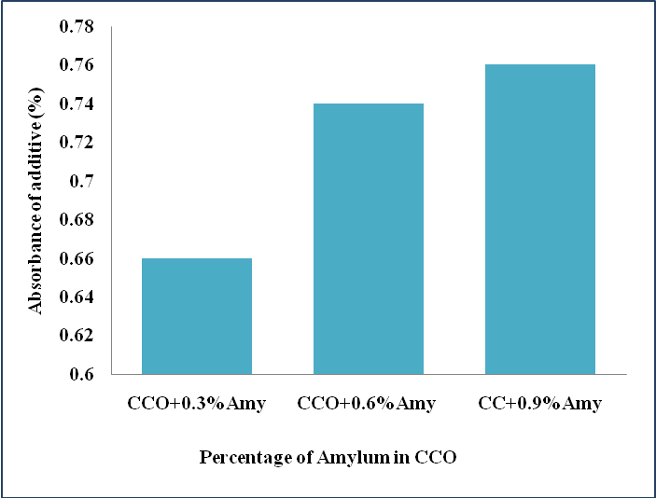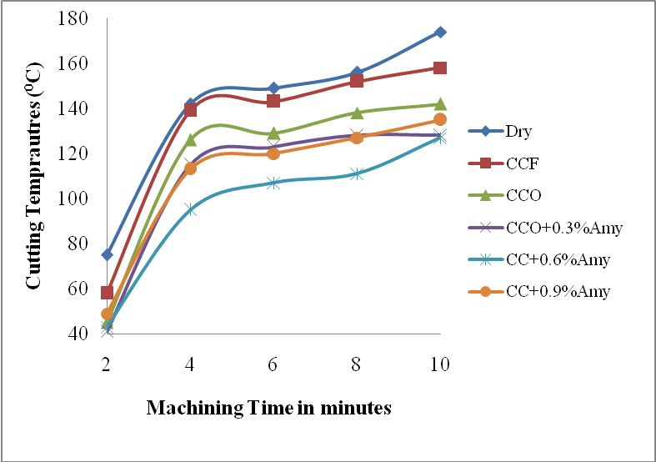
Fig. 1 Absorbance of additive at varying percentages in base fluid fluid (CCO)

Fig. 2 Variation in cutting temperatures with machining time under various lubricant conditions environments

3.3 Cutting temperatures

Variation of cutting temperatures with machining time is reflected in figure 2. It is noticed that, cutting temperatures increase with increase in machining time. Maximum temperatures are recorded during dry machining. Cutting temperatures are found to be minimum by applying CCO+0.6%Amy compared to CCO+ 0.3%Amy and pure CCO. Increase in % of amylum additive does not show a proportionate reduction in cutting temperatures. This is due to the extent of absorbance of additive in base fluid, though there is increase in thermal conductivity with enhancement in % additive. Due to agglomeration, at higher percentages of additive in CCO ability to reduce friction at the contact surfaces and thereby cutting temperatures reduction is affected. It can be inferred that inclusion of additive in base fluid has reduced the temperatures to an extent of 28% and 19% when compared to dry and pure oil assisted machining respectively.

3.4 Surface Roughness
It is noticed that, amylum additive based cutting fluids have reduced surface roughness of workpiece. The results are presented in figure 3. It is seen that under dry machining environment maximum the workpiece is subjected to maximum surface roughness, while at 0.6%Amy in CCO it is found to be less compared to other lubricant environments. Reduction in surface roughness can be attributed to the combined effects of reduction in cutting temperatures and tool wear as well. Film formation ability of the additive based cutting fluids leads to reduction in surface roughness The extent of reduction in surface roughness by using 0.3% amy in CCO is observed to be 37% and 12% when compared to dry and pure oil assisted machining environments.

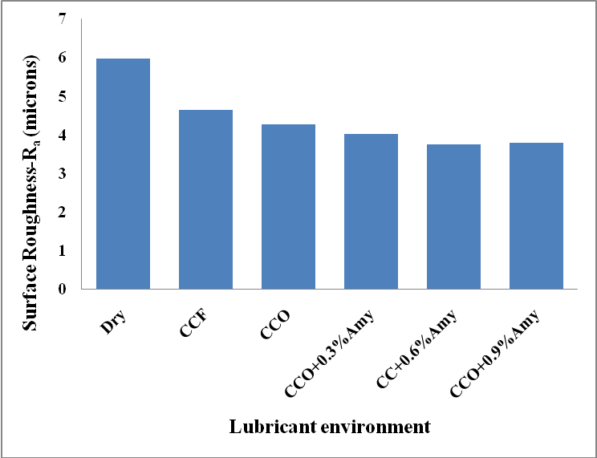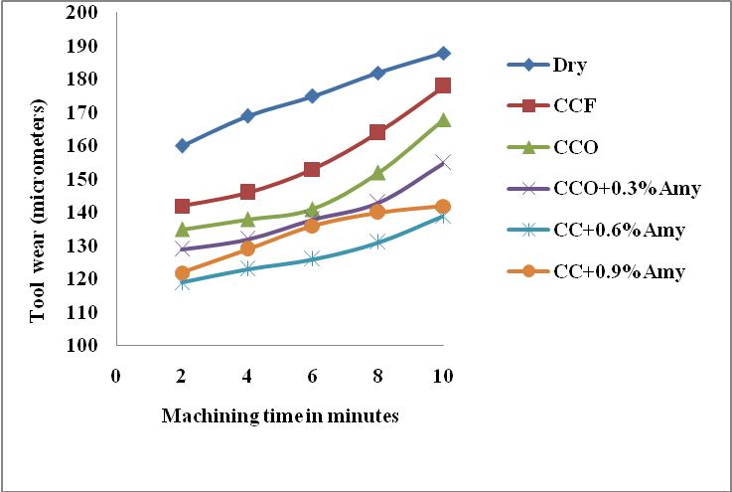
Fig. 4 Variation in tool wear with machining time under various lubricant environments
Fig. 3 Variation in surface roughness - R_{a} with machining time under various lubricant environments

3.5 Tool wear
Results of tool wear obtained under different lubricant environments are presented in figure 4. It is evident that for all the conditions tool wear has increased with machining time. Under dry cutting condition tool wear is maximum, under pure oil assisted machining (CCO) tool wear is found to be less compared to dry machining and by applying CCO+0.6% Amy tool wear is found to be least. This is due to reduced cutting temperatures and ability of the additive to form a thin film of lubricant between the surfaces in contact. Percentage reduction in tool wear is 29% and 13% in comparison with dry and CCO assisted machining.

4 Conclusions
- Experimental investigations to examine the performance of amylum or Maize Starch based additive in coconut oil are carried out. Absorbance is found to increase with increase in percentage of additive in base fluid upto 0.3% and not beyond. Thermal conductivity increased with increase in % additive. Consistent increase in the basic properties with varying amount of additive does not mean that the same behavior should be exhibited by additive based cutting fluids during machining.
- It is observed that 0.6% Amy in CCO resulted in reduced cutting temperatures, tool wear and surface roughness.Extent of reduction in machining performance parameters is approximately 31% and 12% compared to dry machining while working with CCO+0.6%Amy
- Hence, application of natural additives like amylum to vegetable oils is an amicable alternative to explore eco-friendly and sustainable alternatives to conventional cutting fluids.

References

- Passman, F.J., and Roossmoore, H.W, Re assessing the health risks associated with employee exposure of metal working fluid microbes. Lubrication Engineering, 58(7), 30-38,(2002).
- Bennett, E.O. Water based cutting fluids and human health. Tribol Int,16(3),133-136, (1983)..
- Korde, V. M., Phelps, T. J, Bienkowski, P.R, and White. D.C., Biodegradation of chlorinated
aliphatics and aromatic compounds in total-recycle expanded-bed reactors.Appl.Biochem
Biotechnol, 45(46), 731–740, (1993).
- Zeman, A., Sprengel, A., Niedermeier, D., and Spath, M., Biodegradable lubricants-studies on
thermo oxidation of metal–working fluids by differential scanning calorimetry (DSC).
Thermochim Acta, 268, 9–15, (1995).
- Kline & Company, Inc., Competitive intelligence for the global lubricants industry, 2004–
2014. Kline & Company , (2006).
- Singh Dilbag, PV Rao, Performance improvement of hard turning with solid lubricants, International Journal of Advanced Manufacturing Technology, 32, 170-177, (2007).
- Suresh Kumar Reddy, N., and Rao, P.V., Performance improvement of end milling using graphite s a solid lubricant. Materials and Manufacturing Processes, 20, 673-686, (2005).
- P Vamsi Krishna and D Nageswara Rao, The influence of solid lubricant particle size on machining parameters in Turning, International Journal of Machine Tools and Manufacture, 48 (1), 107-111, (2008).
- P Vamsi Krishna and D Nageswara Rao, The influence of solid lubricant particle size on machining parameters in Turning, International Journal of Machine Tools and Manufacture, 48 (1), 107-111, (2008).
- Susan W.,Vegetable oil-based metalworking fluids can provide better performance and environmental results than mineral oil-based fluids. Cutting tool magazine 57(2),1-3, (2005).
- Belluco W, De Chiffre L, Surface integrity and part accuracy in reaming and tapping stainless steel with new vegetable based cutting oils, Tribology International, 35, 865–870, (2002).
- Skerlos S, Hayes K, Vegetable Based Cutting Fluid- A New Dimension in Research, http://www.engn.umich.edu/alumni/engineer/03FW/research/holography/index.html
- Alves SM, Oliveiria J F G. Vegetable based cutting fluids- an environmental alternative to grinding process. In.: Proceedings of the 15th CIRP international conference on life cycle engineering. Elsevier: 664-8, (2005).
- Ion, I.S., Camelia, C., and George, C., On the future of biodegradable vegetable lubricants used for industrial tribo systems. The Annals of University“Dunarea De Jos” of Galati Fascicle, 8, 94-98, (2002).
- Kaufui V. Wong and Omar De Leon, “Applications of Nanofluids: Current and Future”, Advances in Mechanical Engineering (2010) (Available online).
- Sarit K. Das, Stephen U. Choi, Wenhua Yu and T. Pradeep “Nanofluids: Science and Technology”, Wiley-Interscience, USA, (2008).
- Nandy Putra, Wilfried Roetzel, Sarit K. Das, “Natural convection of nano-fluids”, Heat and Mass Transfer 39 775– 784,(2003).
- Xuan Yimin Li, Qiang. Heat transfer enhancement of nanofluids. International journal Heat Fluid Flow 2000: 21:58-64.
- Shen B, Shih A, Tung S.C., “Application of nanofluids in mql grinding”, Tribology and lubrication Technology, 51, pp. 730-737, (2008).
- Attanasio A, Gelfi M, Giardini C, Remino C. Minimum quantity lubrication in turning. Wear 2006: 260-338-8.
- Diniz A E, Ferreira J R. Filho F T. Influence of refrigeration / lubrication condition on SAE 52100 hardened steel turning at several cutting speeds Int. J Mach tools Manuf 2003, 43: 317-26.
- M.O. Abiodun, D.A. Adetan, K.A. Oladejo, "A Study of the Performance of Maize Starch Based Cutting Fluids in the Turning of AISI 304 Stainless Steel", International Journal of Engineering Research in Africa, Vol. 6, pp. 13-24, 2011.

