Evaluating FEM based simulation with experimental results to establish superior machinability of Inconel-625 using MQL with h-BN nano cutting fluid over other lubricating methods

Pariniti Singhª*, Chinmaya Padhy ^{b}

^{a,b}Dept of Mechanical Engineering, School of Technology, GITAM University, Hyderabad, India

* pariniti_singh@rediffmail.com

------------------------------------------------------------------------------------------------------------------
This paper discusses the FEM based simulation for evaluating machinability of Inconel 625 using MQL with h-BN nano cutting fluid over other lubricating methods. As we understand, that addition of h-BN nanoparticles improves anti-friction and anti-wear properties of the cutting fluid, complements its use in machining of hard to cut material like Inconel-625, and has got wide applications in aerospace, marine and nuclear sector. To establish superior machinability of Inconel-625 using MQL with h-BN nano cutting fluid, a comparative study for machining of Inconel 625 under different conditions namely dry, flooded, MQL with conventional cutting fluid and MQL with h-BN nano cutting fluid was conducted. Various parameters (machining interface temperature, stress, strain and deformation generated on workpiece) were investigated using Ansys software. Further these simulation results were compared with experimental results, which showed difference in the range of 15%-18% for values pertaining to various parameters, i.e., the simulation results were in good agreement with experimental results. Also, this paper analysed behaviour of cutting tool wear under above mentioned lubricating conditions leading to the conclusion that MQL with h-BN nano cutting fluid improves the machinability by substantial reduction in notch wear at the flank face of tool over dry and MQL with conventional cutting fluid.

Keywords: FEM- Finite Element Method, h-BN nano cutting fluid, MQL-Minimum Quantity Lubrication,
Tool Wear

- Introduction

Inconel 625, a Nickle based alloy exhibits remarkable properties such as high strength, creep resistant, corrosion and thermal fatigue resistant, oxidation resistant, outstanding weldability and braze ability. These properties are key factors for its widespread acceptance in aerospace, nuclear and marine industries. With all the above noteworthy properties, it is a hard to cut material and has tendency to adhere to the tool [1-2], which increases the tool wear, leading to high machining temperature, cutting forces and lowers the machinability. To address these problems, widely considered solution is flooded/wet lubrication; however, these solutions are associated with problems like - high disposal cost, environmental and health issues [3-4]. Hence, alternatives are required for coming up with a sustainable option, which reduces the usage of harmful cutting fluid, improves machinability and is a greener option. Application of MQL with nano cutting fluid which includes use of an effective lubricant at high pressure in minimal quantity is one such effective alternative. To infuse objectivity, an attempt has been made to investigate and validate the influence of MQL with h-BN nano cutting fluid during machining of Inconel 625.

Hexagonal boron nitride nano particles are environmentally safe additive which are lubricious at wide range of temperature, display improved thermal conductivity and anti-friction property [5] of base cutting fluid and thus being an appropriate choice for MQL in machining.

Further finite element method (FEM) is used to investigate the superiority of MQL with h-BN nano cutting fluid in machinability of Inconel-625 over other lubricating method. It is a numerical method which splits a problem into small parts. It’s a useful method, which is economic, consumes less time and forecast the machining parameters like cutting force, cutting temperature, stress, strain induced and deformation caused during the machining process.So, this paper focuses on investigating the effect and efficiency of MQL with h-BN nano cutting fluid over other (dry, Wet/Flooded conventional MQL with conventional cutting fluid and MQL with h-BN nano cutting fluid) lubricating methods during turning of hard material Inconel – 625 by FEM simulation. Simulation aids in evaluating the capability of MQL with h-BN nano cutting fluid.

- Establishment of simulation model based on ANSYS

FEM simulation was done using ANSYS software. As a part of simulation, the cutting tool was considered to be a rigid body and the effect of vibration was neglected. The geometry of this model had 13229 elements and 58467 nodes. Table.1 shows the input cutting parameters and machining conditions during study.
Table 1. Input cutting parameters and machining conditions

Cutting Parameters | Cutting Speed | 60 m/min
Cutting Parameters | Feed | 0.3mm/rev
Cutting Parameters | Depth of Cut | 0.25 mm
Workpiece (Inconel 625) | Diameter mm | 30 mm
Workpiece (Inconel 625) | Thickness mm | 250 mm
Cutting Tool | PVD Coated Carbide Inserts (CCMT09T308-HMP)

- Results and Discussion

  - Effect of lubricating conditions on temperature of machining zone

It was observed from the simulation results, refer Table.2, that due to the absence of cutting fluid in dry machining amount of heat generated at tool -workpiece interface was very high. The magnitude of machining temperature greatly depends on the lubrication condition. It was inferred from refer Fig.1, the simulation that MQL assisted with h-BN nano cutting fluid lubrication dry reduces the machining temperature up to 25% as compared to dry machining and close to 10 % vis a vis MQL with conventional lubrication.
Table 2. Cutting temperature for different modes of lubrication based on FEM estimations

Temperature ( ͦ C) | Dry | Wet | MQL | MQL with h-BN
Maximum | 170.15 | 87.06 | 133.11 | 122.1

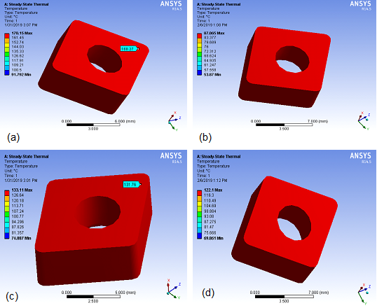

Figure 1. Machining Temperature Predictions by Ansys Simulation for (a) Dry, (b) Wet/Flooded, (c) MQL conventional cutting fluid, (d) MQL h-BN nano cutting fluid.

  - Analysis of Stress, Strain and Deformation generated

Refer Table 3. for analysis of stress, strain and deformation under considered lubricating conditions. Analysis showed that dry machining has maximum stress generation followed by MQL conventional, MQL nano cutting fluid and curtailed by Wet/ flooded lubrication. The high value of stress in dry machining is caused as the tool becomes blunt and results in increase the cutting forces as well as the machining temperature.
The strain was higher in dry machining at the cutting zone followed by MQL conventional and on the lower end for MQL nano cutting fluid and flooded lubrication. The higher values for strain resulted into higher value of deformation generated in Dry and MQL with conventional cutting fluid. The strain and deformation distribution in MQL with h-BN nano cutting fluid showed approximately similar profile for wet lubrication.

Table 3. Comparative analysis of different lubrication technique based on FEM estimations

 | Dry | Wet | MQL (conve-  ntional) | MQL with h-BN cutting
Stress (MPa) | .27368 | 0.19145 | 0.26788 | 0.22627
Strain | 0.00048 | 0.00033 | 0.00047 | 0.00039
Deform-  ation (mm) | 0.06103 | 0.04138 | 0.05965 | 0.04971

- Effect of Machinability on tool wear

Good machinability which is defined as ease of machining is quantified in terms of magnitude of cutting forces, tool life, surface finish or surface roughness, magnitude of cutting temperature and chip formation. All these parameters are largely governed by the failure of the tool or tool wear. Tool wear occurs due to the heat generated by high cutting force, temperature causing plastic deformation and material erosion, thus affecting the machinability. This phenomenon of tool wear cannot be stopped, but can be curtailed with the application of various lubrication methods. This paper analysed the tool wear for various lubrication conditions - dry, wet, MQL with conventional cutting fluid and MQL with h-BN nano cutting fluid for turning of Inconel 625 and recognised that MQL with h-BN nano cutting fluid results into the best machinability with minimal application of lubricant.

  - Wear behaviour of Inconel 625 under different modes of lubrication

There are various types of wear which arise during machining and are caused due to lubricating condition, type of cutting tool and workpiece material [6]. For the current analysis, the tool wear images are taken with help of Rapid – I microscope. The tool wear at the flank caused due to breakage of the cutting edge and abrasion is known as flank wear. Figure 2. (a-b-c-d) show tool wear at flank face for dry, flooded/conventional lubrication, MQL with conventional cutting fluid, MQL with BN nano cutting fluid. In dry cutting, due to intense rubbing and affinity of Inconel to the cutting tool and absence of any cutting fluid to cool, machining zone deteriorates the tool surface and contact area increases forming a notch as shown in fig 2. (a) along with chipping of cutting edge and thus increasing the machining temperature. Whereas, in conventional cutting, wear was comparatively suppressed, refer fig 2. (b) due to excessive flow of lubricant which provided good cooling at machining interface. MQL with conventional cutting fluid showed a similar trend of wear like in dry cutting, forming notch at contact area as seen in fig 2. (c). MQL with BN nano cutting fluid causes adhesion and plastic deformation at cutting edge refer fig 2. (d)). It was observed that MQL with BN nano cutting fluid in comparison with dry and MQL conventional eliminates the formation of notches and chipping at cutting edge.

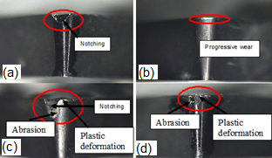

Figure 2. Tool Wear Analysis of Flank for (a) Dry, (b) wet/flooded, (c) MQL with conventional cutting Fluid, (d) MQL h-BN nano cutting Fluid

The crater wear for machining under considered lubricating conditions can be seen in Fig 3. and it was observed that the wet/flooded lubrication has curbed the wear at the rake face. For dry cutting, refer fig 3. (a) that shows chip adhesion, fracture and grooving as main wear due to the flow of chips at high temperature thus exacerbating the rake face. Similar wearing of rake surface was observed in MQL with conventional cutting fluid, refer fig 3. (c) and MQL with BN nano cutting fluid but the impact of grooving is much less in MQL with BN nano cutting fluid refer fig 3. (d).

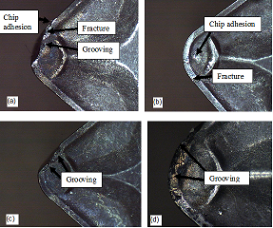

  - Fig 3. Tool Wear Analysis of Rake Face for (a) Dry, (b) wet/flooded, (c) MQL with conventional cutting Fluid, (d) MQL h-BN nano cutting Fluid

- Validation of the influence of h-BN assisted MQL machining by FEM analysis

FEM simulation with similar cutting forces was executed and it was observed that experimental cutting temperature for different modes of lubrication displayed good pact with cutting temperature by FEM analysis, refer Fig 4. It was seen that experimental cutting temperature reaches its maximum value for dry machining followed by MQL conventional and much lower for MQL with h-BN nano cutting fluid which is similar to the pattern showed by FEM analysis.

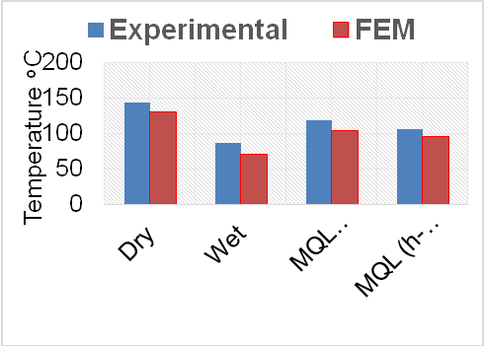

Fig 4. Comparison of mean
temperature for experimental and simulation results

- Conclusion

The influence of h-BN nano-fluids in enhancing the MQL lubrication capabilities during machining of Inconel-625 have been investigated and experimental results pertaining to machining of Inconel - 625 under dry, wet, MQL (conventional fluid) and MQL (h-BN nano cutting fluid) were compared with FEM simulated results and the values were found in agreement. With the FEM tool wear analysis inferences were drawn regarding pre-eminence of MQL with h-BN nano cutting fluid. MQL with h-BN nano cutting fluid clearly reduced the machining temperature along with induced stress and deformation in comparison with Dry machining and MQL with conventional cutting fluid which reduces tool wear and improves tool life. Also, the amount of lubricant used with h-BN nano cutting based MQL machining was much less as compared to wet machining and it has emerged as a sustainable and greener lubricating option , thus taking the machining performance to an appropriate bench mark.

References

- M. Davami, M. Zadshakoyan, Investigation of tool temperature and surface quality in hot machining of hard-to-cut materials, World Acad. Sci. Eng.Technol. 46,672–676 (2008).
- Dudzinski, D., Devillez, A., Moufki, A., Larrouquère, D., Zerrouki, V., et al., “A Review of Developments Towards Dry and High Speed Machining of Inconel 718 Alloy,” International Journal of Machine Tools and Manufacture, Vol. 44, No. 4, 439-456 (2004)
- Saha, R., Donofrio, R.S., The Microbiology of Metalworking Fluids. Applied Microbiology and Biotechnology, 94/5: 1119–1130(2012)
- Arora, P.K., Sasikala, C., Ramana, C.V., Degradation of Chlorinated Nitro-aromatic Compounds. Applied Microbiology and Biotechnology, 93/6: 2265– 2277 (2012)
- Lipp A, Schwetz K A, Hunold K. Hexagonal Boron Nitride: Fabrication, Properties and Applications. J Eur Ceram Soc, 5(1): 3-9 (1989)
- Poulachon, G., Bandyopadhyay, B.P., Jawahir, I.S., Pheulpin, S., Seguin, E., Wear behavior of CBN tools while turning various hardened steels, Wear 256, 302-10( 2004)

Table 1. Input cutting parameters and machining conditions

Cutting Parameters | Cutting Speed m/min | 60 m/min
Cutting Parameters | Feed (mm/rev) | 0.3mm/rev
Cutting Parameters | Depth of Cut mm | 0.25 mm
Workpiece Geometry (Inconel 625) | Diameter mm | 30 mm
Workpiece Geometry (Inconel 625) | Thickness mm | 250 mm
Cutting Tool | PVD Coated Carbide Inserts (CCMT09T308-HMP) Model: PC9030
Lubrication Environments | Dry, Wet, MQL-conventional cutting fluid, MQL h-BN nano cutting fluid

Table 2. Cutting temperature for different modes of lubrication based on FEM estimations

Temperature ( ͦ C) | Dry | Wet | MQL | MQL with h-BN
Maximum | 170.15 | 87.06 | 133.11 | 122.1

Table 3. Comparative analysis of different lubrication technique based on FEM estimations

 | Dry | Wet | MQL  (conve-  ntional) | MQL with h-BN cutting
Stress (MPa) | .27368 | 0.19145 | 0.26788 | 0.22627
Strain | 0.00048 | 0.00033 | 0.00047 | 0.00039
Deform-ation (mm) | 0.06103 | 0.04138 | 0.05965 | 0.04971

