Design and Fabrication of Human Powered Vehicle
Pratik Kaleª, PankajArdak^{b,*}
ªUG Student, Mechanical Engineering,P.R.Pote (Patil )College of Engineering and Manangement, Amravati 444606, Maharashtra, Amravati
ªAssistant Professor Mechanical Engineering,P.R.Pote (Patil )College of Engineering and Manangement, Amravati 444606, Maharashtra, Amravati

*Corresponding author Email: pratikkale416@gmail.com
------------------------------------------------------------------------------------------------------------------
In this paper design, fabrication and analysis of a Human Powered Vehicle is discussed. The current scenario of HPV’s can be changed with the use of highly engineered techniques. This research work has been carried out to provide new vehicle to society which is energy efficient, eco-friendly and economical thereby contributing to nature and surrounding. The proper planning, design attributes play very crucial role in it. The major attributes are frame design, steering system, transmission and braking. Fabrication of HPV may not require high precision and does not involve critical methods, subsequently reducing the cost of production of vehicle. Testing is the most important parameter of HPVs.

Keywords: Human Powered Vehicles (HPVs), Rollover Protection, Steering, Transmission

- Introduction

Human Powered Vehicles are supposed to be the most appropriate option over the vehicles using non-renewable energy sources. If built properly with the use of proper engineering and considering human ergonomics these vehicles becomes more efficient than conventional HPVs. The Human powered vehicles were designed and developed for the daily life travelling and for short distances. The long-distance efficiency of HPV is not high not even decent (1). In urban areas these vehicles are not used mostly because of their slow speed and discomfort (2). Speed is one of the biggest reason or parameters which has contributed towards the growth of fuel consuming vehicles. The fuel consumed by the vehicles causes very large amount of pollution and that amount of pollution can be reduced with the help of human powered vehicles (3).

- Methodology

Design, fabrication and analysis of a HPV consist following attributes.

  - Design Selection

For the human power vehicle only two competitive designs are used a recumbent with 2 wheel and a recumbent with 3 wheel and in order to make a selection between two, a comparisons was conducted. It has been decided to use 3 wheels and the reason was stability, so for three wheel recumbent two of the most variant alternative were ‘Tadpole’ and ‘Delta’.
Tadpole vs Delta –
Table. 1. Comparison between Tadpole and Delta.

Parameter | Tadpole  (finalized) | Delta
Speed | Better Speed can be achieved | Moderate Speed
Aerodynamic | Better Aerodynamic tear drop can be easily achieved | Less Aerodynamic Design
Brakes | Good braking stability | Moderate braking stability
Steering | Low turning radius can be achieved with better safety | Better turning radius but not too safe
Stability | Excellent stability when cornering | Moderate stability
Drive system | Simple drive system | Complex drive system
Ergonomics | Ergonomics is noble for tadpole design

2.2 Frame

While considering primary materials for frame design materials physical properties and its weight were the main constraints. Aluminium 6061 T6 and AISI 4130 were the first priorities of team while selecting material because of their better properties compared to materials like Mild steel. Though Aluminium 6061 T6 is light in weight and has less percentage of elongation it faces huge problems about weldability. Aluminium has the least weldability among the all materials shortlisted. MIG welding can be easily done on this material providing better strength.
Table. 2.Material Properties.

Properties | AISI 4130
Elastic modulus | 410 MPa
Density | 7.80 g/cm³
Strength to weight ratio | 86
Tensile strength | 630 MPa
Yield strength | 435MPa
Thermal expansion | 11.8
Cost | Moderate

2.2.1 Frame Design

Main motive behind designing a frame or chassis is to provide better comfort and safety to the rider and must provide proper mounting to other components of vehicle. As per ASME HPVC Asia Pacific 2018 Rulebook ,RPS should be the most important part of vehicle, so our teams focus was also on designing the proper RPS for better safety to rider. Survey should be done for checking comfort. As specified in the ASME HPVC Rulebook 2018 a load of 2670 was applied at an angle of 12⁰ from the vertical. The FEA in Ansys was done by considering the assumption that the member away from the RPS was made fixed and the member near to the RPS were made flexible.For side loading ,load of 1330N is applied horizontally to the side of roll bar at the height of shoulder of stroke

Fig. 1,2,3. Result of Ansys for Top Loading Condition
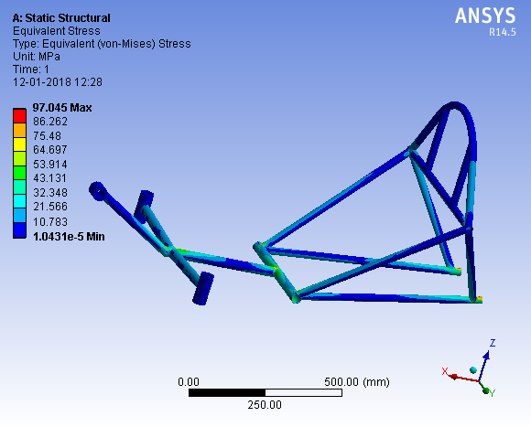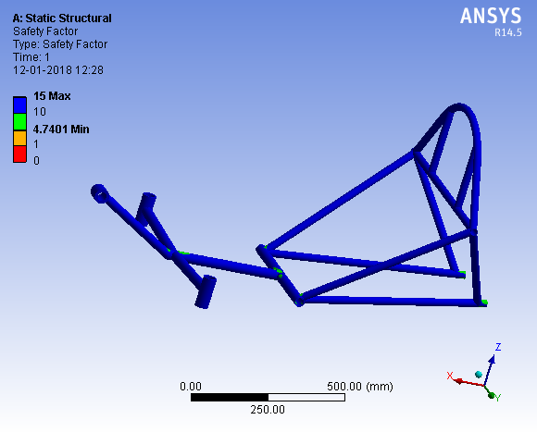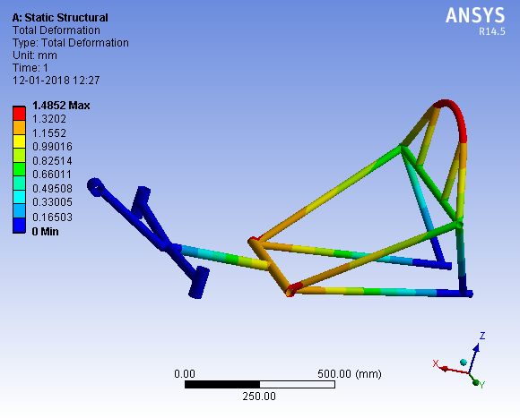

Fig. 4,5,6. Result of Ansys for Side Loading Condition
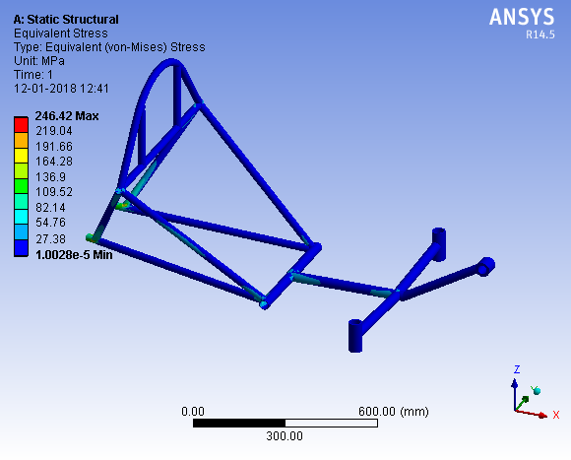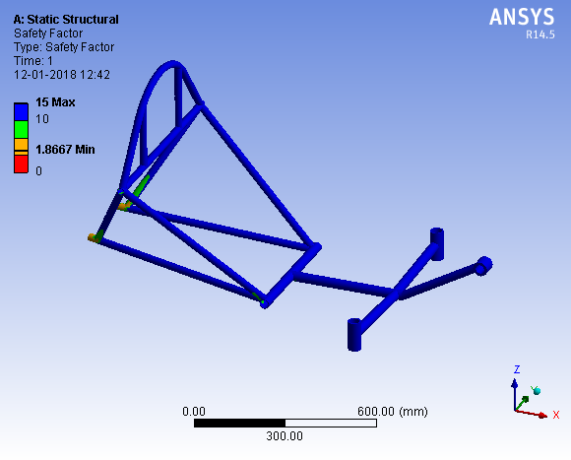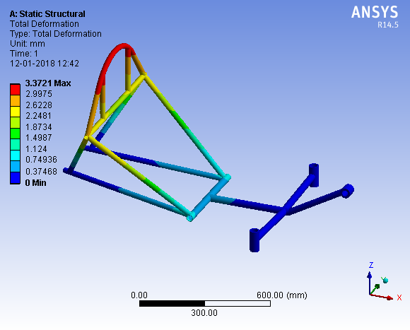

2.3 Steering System
As an alternative, there are choices to use simple four bar mechanism with connecting rod and steering arm or Go-cart type. The reason why rack and pinion wasn’t selected because after research we concluded that rack and pinion would be an over designed and weight too much from this it was decided to use linkage which inculpates connecting rod to steering arm. This type of steering is easy to design and set handling. As HPV has Tadpole Trike type of configuration i.e. it has two wheels in front. So front steered tadpole was selected. For designing steering system Ackerman’s Principle has been chosen.
For the analysis of proper steering system we calculated following parameter,

Table. 3. Steering System Parameters and values after calculations.

Sr. No | Parameter | Calculated Values
1 | Inner Angle | 24⁰
2 | Outer Angle | 15.25⁰
3 | Ackerman Angle | 17.19⁰
4 | Ackerman Percentage | 70%
5 | Turning Radius | 4.2m
6 | Steering Ratio | 1:1
7 | Connecting rod length | 700mm

Results should be verified by using Perfect steer condition
cot(Inner Angle) - cot(Outer Angle)=
;LHS=RHS
Hence the steering will work properly

2.4 Braking System

The alternative option of vehicle was disc brake and rim brake. The best option for our HPVC is mechanical disc brake. At the initial assessment it is being decided to provide a disc brake at front as well as at rear. But in actual the brake has been provided at the rear. Secondly there would be two option either to use hydraulic disc brake or cable actuated disc brake. Between two cable actuated disc brake was selected.
Table. 4.BrakingSystem Calculations.

Sr.No | Parameter | Calculated Values
1 | Braking Force | 105N
2 | Force on Calliper | 11875.22 N-mm
3 | Clamping Force | 4750.088 N-mm
4 | Deceleration | m/sec²
5 | Stopping Distance | 2.04 m
6 | Stopping Time | 0.99 sec

2.5 Drive Train (Transmission)

As per the requirement, the drive mechanism being powered by a human operator the drive train will have configuration advance to as compared to bicycle. Length of the chain is the major issue in recumbent cycles. Idler should be used at every bent into the frame. Use of idler increase losses in transmission, so there is need of arrangement which will decrease number of idler and collectively increase the efficiency of the system. Rear wheel drive system has been used. Instead of using single chain we have used two chains (one from pedal to compound assembly and other from compound assembly to rear wheel). Compound assembly is simply shaft carrying two different freewheel. Due to this assembly we’re able to achieve more speed.
Six speed gear box containing teeth from 14 to 28 is used on the rear wheel to provide variable gear ratio due to this speed of 25 to 45 kmph can be achieved.
By considering rate of pedalling minimum.

Table. 5. Gear train Calculation

No of Teeth  (Rear Sprocket) | Gear Ratio | N(RPM) | Speed
14 | 3:14 | 209.51 | 26.1kmph
16 | 2:75 | 183.32 | 22.82kmph
18 | 2:44 | 162.95 | 20.28kmph
21 | 2:09 | 139.67 | 17.38kmph
24 | 1:83 | 122.21 | 15.21kmph
28 | 1:57 | 104.75 | 13.03kmph

3. Conclusion

In engineering, there is a constant need for improvements as there is a never ending list of flaws. These flaws, with the correct processes, can and should be predicted and dealt with before catastrophic failure. Mitigating the cause of failure of the suspension, found to be instability of vehicle coupled with unexpected steering problems, could have been accomplished with more testing. The RPS testing should be done with to verify the analytical values. Dynamic modelling software would have been useful, but only as a preliminary step before physical testing. Performance testing needs to be more through. Theoretically steering will work with the calculated values. There are assumptions involved in the calculations and in reality, there are errors during manufacturing. It is recommended that instead of doing steering analysis, to perform steering testing. Similarly, for braking more test should be performed instead of calculations only.

References

- J Abhilash, M. R. S. R Sri, “Design, Analysis and Fabrication of a Human Powered Vehicle”, INTERNATIONAL JOURNAL OF ENGINEERING SCIENCES & RESEARCH ISSN: 2277-9655 , Dec-2014
- M. A. Abdullah, M. H. A. Rahman, M. Z. Azis1 , S. A. Shamsudin, F. R. Ramli, and M. N. Sudin “Ergonomic study on human-powered vehicles” at MATEC Conference Jan-2017
- U. S. Gupta, S. Chandak, D. Dixit, “Design of Efficycle - Human Powered Hybrid Tricycle”, International Journal of Engineering Trends and Technology (IJETT) – Volume 19 Number 3 – Jan 2015
- “Human Powered Vehicle: Mjölnir” by Portland State University Mechanical Engineering Department 1930 S.W. 4th Ave Portland, OR 97201 (503)725-4290
- R.S.Khurmi and J.K.Guptha, A Textbook of Machine Design, Eurasia Publishing House (Pvt.) Ltd. 2010
- “Human Powered Vehicle Challenge 2018 Rulebook” by ASME

