Upgrading biogas with a solution of aqueous amine, barium chloride and piperazine - an economic experimental study

Avneesh Kumar Gehlaut, Ankur Gaur,*, Shabih-Ul-Hasan
Department of Chemical Engineering, Motilal Nehru National Institute of Technology, Allahabad, U.P. India 211004
* Corresponding author e-mail address: ankur@mnnit.ac.in

Abstract
The focus of the present work is to study the effect of piperazine (PZ) solvent for the removal for CO₂ from biogas using carbon capture and utilization (CCU) technology. For rapid conversion of absorbed gaseous CO₂ into aqueous CO₂ a solution of monoethanolamine (MEA), diethanolamine (DEA) and piperazine (PZ) was undertaken. Barium Chloride (BaCl₂) was added as a precipitating agent to react with the aqueous CO2 and thereby ultimately forming BaCO₃. The characteristics of the BaCO₃ precipitates using X-ray diffracometry (XRD), scanning electron microscopy and energy-dispersive X-ray spectroscopy (SEM-EDS) and Fourier-transform infrared spectroscopy FT-IR analyses were analysed. The precipitates exhibited the witherite morphology as confirmed by XRD results. FT-IR confirmed the formation of metal salt i.e. BaCO₃ and EDS confirmed that no impurities were present in it. It is found that the solvent piperazine enhanced CO₂ absorption with BaCO₃ purity remains unaffected. Further we also compared the properties of BaCO₃ produced in this work with the BaCO₃ directly used in other industries (such as earthenware, pottery, ceramics) and found that the properties matched well with marketed product. The method is economical due to simultaneous reactive absorption and precipitation in a single stage. Highly pure biogas (97%) was obtained along with the simultaneous production of industrial grade BaCO₃.
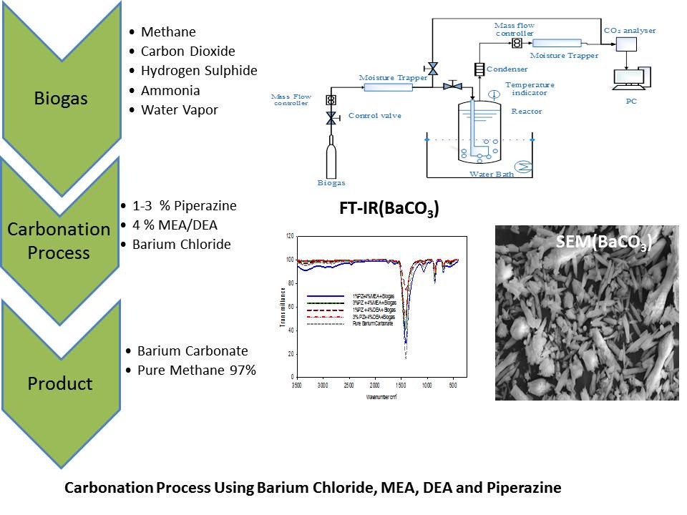

Outline of the whole process.
.

