Intelligent Glove For Visually Impaired People using Haptic Feedback System

M.Neela Harish¹, K.Thamizharasan², R.Saravanan³
¹Assitant Professor, Dept.Of Biomedical, Rajalakshmi Engineering College
²UG Student, Dept.Of Biomedical, Rajalakshmi Engineering College
³UG Student, Dept.Of Biomedical, Rajalakshmi Engineering College
* M.NeelaHarish: neelamadhu_psbb@yahoo.co.in

ABSTRACT
The primary objective is to bridge the gap between the visually impaired people and society. There are approximately 37 million people across the globe who are blind, over 15 million are from India. People with visual disabilities are often dependent on external assistance. Blind people use Braille language for reading, writing and for communication purpose. Blind people face problems such as reading SMS and replying for it in case of emergency. Braille language is used as the basis of the project. Therefore interfacing Braille pad with the GSM module so that the blind people can have the access to the SMS system is advantageous. Thus we were motivated to develop an experimental system for communication to assist people who are completely blind using Braille pad system. In which GSM module convert text inputs into Braille patterns through vibrations using DC cylindrical motors with PIC microcontroller as the master. Therefore the words corresponding vibration will be intimated through the gloves to the visually impaired people. It will result to overcome the disabilities of visually impaired to understand other’s expressions.
.
Keywords: Braille pad,visually impaired,GSM,glove,vibration motors.

INTRODUCTION
.
With the convention on the rights of persons with disabilities implemented in 2008, since then over 150 countries have signed the ratification. The declaration has introduced the recognition of persons with disabilities on an equal basis with others worldwide. Additionally, society is beginning to recognize the need to present equality for all citizens within its communities. Therefore public spaces continue to present tools and aids for all disabilities. Blind people use Braille language for reading, writing and for communication purpose.
Blind people face problems such as reading SMS and replying for it in case of emergency. Therefore interfacing Braille pad with the GSM module so that the blind people can have the access to the SMS system is advantageous. Thus we were motivated to develop a Braille pad system for visually impaired people using GSM module. A person who reads Braille can roam independently among the community as Braille increasingly is showing up everywhere. With the convention on the rights of persons with disabilities implemented in 2008, since then over 150 countries have signed the ratification. The declaration has introduced the recognition of persons with disabilities on an equal basis with others worldwide.
Additionally, society is beginning to recognize the need to present equality for all citizens within its communities. Therefore public spaces continue to present tools and aids for all disabilities. Braille is used in everyday communication and as a literate blind or visually impaired individual, independence is given. To read without Braille, a person who is blind is entirely dependent on computers with voice synthesizers or audio recording, neither of which is useful in every circumstance. The Braille characters make up the letters of the alphabet, punctuation marks, numbers, and everything else you can write in print. The letter "a" is written with only dot 1.

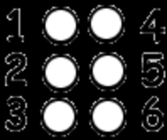

Figure 1: The Braille Cell

Releated work

The Braille pad is considered as a boon for visually impaired people Research to pauperize the communication gap between normal people of society and the visually impaired. The earlier works in this field are as follows. In [8] the glove fixed with flex sensor and accelerometers have been deployed to translate Indian sign language to voice outputs. A low cost Braille hand glove designed in [7] using slot sensors and vibration motors read and write emails messages and read e-books. The vibration in six different positions of the glove which matches to the Braille code allows them to read characters. Bhagyashri Shirude, et al. [2] proposed a system-stereotype called as Sharojan-Bridge, which take any form of disabled people input and convert it to audio or video form for long distances. It consists of various sensors and Braille pad.
Xiaosong Wu et al. reported in [12] portable pneumatically-actuated refreshable Braille cell based on micro machined, kinematically -stabilized endoskeleton, which has a maximum operating frequency of 200 Hz useful for vibratory tactile applications. Braille alphabets converted into test through SMS using a smart glove [11] using capacitive touch sensors. D. Sreenivasan and Dr.S.Poonguzhali have described a portable electronic reading aid in [10] captured the printed text as the image and recognizes the character using the OCR system sends the ASCII representation of the character to the ARDUINO UNO board which correspondingly actuates the Braille display. When the visually impaired person touches the Braille display, they could understand the printed text. Braille pad dots in [1] have been constructed suing solenoids controlled by microcontroller and send messages through GSM.
In [3] electro active polymer (EAP) is used over a tactile technology over any part of visually impaired body and acts a human interface. Review of automatic Braille production at a low cost of translation in Laboratory of Electronics, Massachusetts Institute of Technology in [5]. Prince Rajan and B.Thilagavathi [9] introduced design which enables a visually impaired person to read messages from cell phones. Here the message received in a mobile phone is converted into Braille format using Arduino Due. In [4] optical-to-tactile image conversion systems being developed for the blind. The first is a reading aid in which an area on the printed page is translated into a tactile image. The tactile image is produced by a 24-by-6 array of pins driven by piezoelectric bimorphs. The piezoelectric bimorphs cause the pins to impact the skin in a nonlinear manner. As developed in [6] the tactile image is presented by a dense array of pins which can be made to vibrate individually through perforations in a plate on which the user's finger is rested. In the arrangement proposed, the image of ordinary printed matter is focused on an array of photocells which are coupled one-to-one to piezoelectric reeds which drive the image-producing pins.

Materials and Methodlogy

Experimental Setup

The Intelligent glove designed for visually impaired using haptic feedback system (Figure 3) has the following components as shown in Figure 2:

HARDWARE REQUIREMENTS:

- PIC 16F877A MICROCONTROLLER
- BRAILLE PAD
- GSM
- RELAY
- VIBRATION MOTOR
- FLEX SENSOR
- LCD

SOFTWARE REQUIREMENTS:

- MPLAB IDE
- PROTEUS

.
Using these components the Braille pattern of the words from the mobile phone will be transmitted through the vibration motors to the glove worn by visually impaired people.
The visually impaired people are able to interpret the messages as a result. A flex sensor is used. When it is bent, the user can reply to the sender. The main purposes of microcontroller are:

- A timer module to allow the microcontroller to perform tasks for certain time periods.
- A serial I/O port to allow data to flow between the controller and other devices such as a PIC or another microcontroller.
- An ADC to allow the microcontroller to accept analogue input data for processing.

A GSM module is used to establish communication between a mobile device o and a GSM system. SIM900 is the widely used GSM modem around the globe after EOL of SIM300 which was more popular.

A relay is an electrically operated switch. Relays are used where it is necessary to control a circuit by a low-power signal where several circuits must be controlled by one signal.

Operation:

- Relays operate using the same basic principle.
- Relays have two circuits: control circuit and a load circuit.
- The control circuit has a small control coil while the load circuit has a switch the coil controls the operation of the switch.

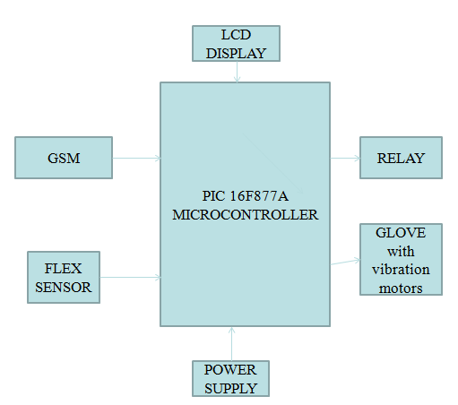

Figure 2: Block Diagram of the Braille Glove

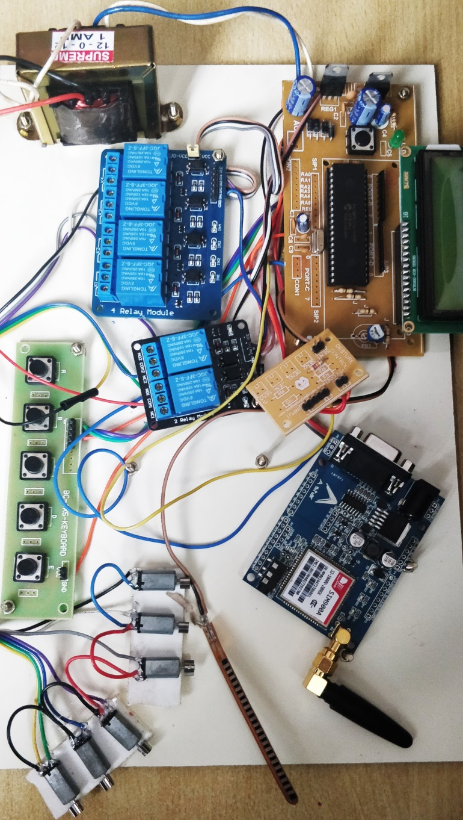
Figure 3: Experimental Setup

The visually impaired people are able to interpret the messages as a result. A flex sensor is used. When it is bent, the user can reply to the sender.

Glove
Braille is a tactile writing system used by people who are visually impaired. Gloves are attached to the users’ hand and vibration motors are fixed on it. They vibrate according to the Braille pattern when messages are sent. Gloves are used as a support for vibration motors to vibrate. They are worn by the users so that they can sense the messages.
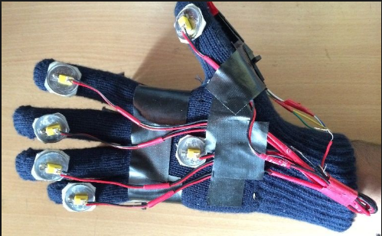
Figure 4: Braille Glove with vibration motors
3.5 Vibration motor
Nowadays, electric motors are commonly used in people’s daily life. Imagine that, in an apartment, a man is watching a movie played by his laptop. At that moment, a motor in his computer runs a CPU fan to draw cooler air into the case from the outside, and some motors runs the cd driver so the information on the disc could be read. In the closet, there is a vacuum cleaner, which has a motor on it to run the impeller. Over in the kitchen, there are motors in the refrigerator run the compressor which runs the refrigerant to cool, and run the fan to blow of the heat. Almost every mechanical movement that people could see in the house is made by an AC or DC electric motor. It is not an exaggeration to say that electric motors are everywhere! Haptic technology is one application of electric motors. What is the haptic technology? This technology is a tactile technology that uses the human’s sense of touching by applying force, vibration, or motions to users. This physical stimulation can be used to alert users to pay attention to the incoming signals, such as the vibrating mode of cell phones. What’s more, haptic technology can also be used to inform users of getting feedback from their previous movements, and this is widely used in gaming systems. 36 In order to take advantages of haptic technology, defined set of hardware needs to be implemented to create a force feedback system in the internal circuits of the application. Moreover, the output signal need to be able to transferred and successfully read by computer. Through this way, the adjustment of the force can be controlled and modified by computers, which provides the personalized function to different applications. Electric motors can be configured into DC motor and AC motor based on different type of power supplies. In this application note, the procedures of hardware implements to achieve will be discussed.
Vibration motor is a compact size coreless DC motor used to informs the users of receiving the signal by vibrating, no sound. Vibration motors are widely used in a variety of applications including cell phones, handsets, pagers, and so on. The main features of vibration motor is the magnet coreless DC motor are permanent, which means it will always have its magnetic properties (unlike an electromagnet, which only behaves like a magnet when an electric current runs through it); another main feature is the size of the motor itself is small, and thus light weight. Moreover, the noise and the power consumption that the motor produce while using are low. Based on those features, the performance of the motor is highly reliable. The vibration motors are configured in two basic varieties: coin (or flat) and cylinder (or bar). There are some components in both of their internal constructions.

3.6 Troubleshooting

When the power supply is given to the module, with the pin 3 (VL) connected to ground, all the pixels of a character gets activated in the following manner: All the characters of a single line display, as in CDM 16108.The first eight characters of a single line display, operated in the two-line display mode, as in CDM 16116. The first line of characters of a two-line display as in CDM 16216 and 40216. The first and third line of characters of a four-line display operated in the two-line display mode, as in CDM 20416. If the above mentioned does not occur, the module should be initialized by software. Make sure that the control signals ‘E’, R/W and RS are according to the interface timing requirements.

conclusionS
A Braille pad system using GSM technology has been designed to assist visually impaired people in communication. They will be able to interpret messages by sensing vibrations through the gloves attached in the hands. The vibrational motors are attached in the dorsal side of the glove which vibrates according to the braille pattern when messages are sent.
As an outcome, visually impaired people are able to interpret messages. In future, this project can be developed by finding a solution for identifying the individuals’ details so that the user can know the name of the person from whom the messages are received.

Acknowledgements
The authors wish to thank all the Principals, teachers and students of our college and various visually impaired students. Also express my gratitude for providing technical support in the area of Braille pad usage.

REFERENCES

- Amar Banmare, Anshika S. Chawhan ,”Hardware Based Braille pad on mobile phone”, (IJRASET),Volume 6, Issue III ,2018.
- Bhagyashri Shirude, Aishwarya Mohite, Kalyani Aghav, Pranjali Gade,”Providing Effective Approach for Communication among Blind, Deaf and Dumb People”, International Journal of Advanced Research in Computer Engineering & Technology (IJARCET) Volume 5 Issue 3, March 2016.
- Igmokoo, Kwangmok Jung, Jachoonkoo,” WERABLE FINGER TIP TACTILE DISPLAY”, SICE-ICASE, International Joint Conference, 2006.
- James C. Bliss, Michael, H. Katcher, Charles H. Rogers, Raymond P.Shepard, “Optical-to-Tactile Image Conversion for the Blind,” IEEE Transactions on man-machine systems, March 1970.
- Kenneth R. Ingham “Braille, the Language, Its Machine Translation and Display,” IEEE Transactions on man-machine systems, vol. mms-10, No. 4, December 1969.
- J. G. LmvILL, J.C Bliss, “A Direct Translation Reading Aid for the Blind,” Proceedings of the IEEE, January 1966.
- Mukul Bandodkar, Virat Chourasia,”Low Cost Real-Time Communication Braille Hand-Glove for Visually Impaired Using Slot Sensors and Vibration Motors”, World Academy of Science, Engineering and Technology ,International Journal of Information and Communication Engineering,Vol:8, No:6, 2014.
- M.Neela , Dr.S.Poonguzhali,”Design and development of Hand Gesture Recognition system for speech impaired people”,IEEE International Conference on Industrial Instrumentation, May,2015, COEP,Pune,India.
- Prince Rajan, B.Thilagavathi,”A system to convert electronic message to Braille for visually impaired”, International Journal of Emerging Technology in Computer Science & Electronics (IJETCSE), Volume 8 Issue 1 ,2014.
- D. Sreenivasan , Dr.S.Poonguzhali,”An electronic aid for visually impaired in reading printed text ” , International journal of scientific and engineering Volume 4, Issue 5,ISSN 2229-5518,May ,2013.
- Tanay Choudhary, Saurabh Kulkarni, Pradyumna Reddy,” Braille-based Mobile communication and translation glove for deaf-blind people”, International Conference on Pervasive Computing (IPCPC)-2015.
- Xiaosong Wu, Haihong Zhu, Seong-Hyok Kim, “Portable Pneumatically-Actuated Refreshable Braille cell”, International solid-state sensors, actuators and Microsystems Conference, 2007, TRANSDUCERS 2007 .

.

