Effect of roadside friction elements on traffic characteristics of urban arterials - a systematic review and a pilot study
Shishodiya Ghanshyam Singh^{1*}, S. Vasantha Kumar²
¹ Ph.D Scholar, School of Civil Engineering, VIT University, Vellore – 632014, Tamilnadu, India.
² Associate Professor, School of Civil Engineering, VIT University, Vellore – 632014, Tamilnadu, India.
* e-mail: shishodiyaghanshyam@gmail.com

Introduction
In developing countries like India, the growth of population has led to the increase in the vehicular population which is showing adverse effects on the existing urban arterials. Various steps are being carried out by the Government to improve the conditions of the existing facilities and increase the vehicle carrying capacity with the improvement in the level of service. One of the important factors for not reaching the objective of free flow of traffic on the urban arterials is the presence of side friction. Side friction is the interference caused to the moving vehicles on the carriage way due to various factors like on-street parking, roadside encroachment, presence of garbage bins, stopping of buses, pedestrian movement on carriageway, entries and exists from approach roads, etc. These factors on the carriage way affect the normal traffic flow and thereby causing speed reduction and travel time increase. These side friction parameters leads to capacity and level of service (LOS) reduction which finally results in poor performance of facilities. The situation is even worsen in a heterogeneous type of traffic condition prevailing in countries like India. This paper reviews what has been studied in the area of impact of roadside friction elements on traffic characteristics of urban arterials in India and abroad. A pilot study was also carried out to understand the reduction in road width due to side friction elements along the two important highways in the city of Vellore, India.

Materials and Methods
As the present study is primarily a systematic review of studies in the area of road side friction elements and its impact on traffic characteristics, the literature review was carried out in two aspects: one is the study of side friction elements/factors considered and another is the methodology used to study its impact on traffic characteristics. The various friction types considered in existing studies were listed out and the friction elements that are very peculiar in Indian roadways but were not considered also were identified. The studies on impact of side friction on traffic characteristics were analyzed with respect to the traffic parameters considered, i.e., whether only speed reduction was focussed and/or capacity/LOS reduction also was addressed. The mathematical techniques used to quantify the impact were also investigated.
For the pilot study, two important highways that passes through Vellore, namely, NH-234 (Mangalore Villupuram national highway) and SH-59 (Katpadi-Tiruvalam state highway) were considered. Even though they are national and state highways, they serve as major arterial roads for the city of Vellore, as they carry heavy local traffic during peak hours in addition to bypassable traffic. A stretch of about 3 kms with road widths ranging from 4.8 to 6.8 m (one side) was taken into account for side friction measurement. Using measuring tape, the road widths were measured at the locations where the side frictions were present and the type of friction was also noted down along with the GPS coordinates. The obtained measurements were then used to analyze the reduction in road width due to side friction elements.

Results and Concluding Remarks
Based on the detailed study of literature, 12 side friction elements were found to adversely affect the facilities and they were pedestrian on the carriageway, vehicles stopping and parking manoeuvre, bus stops, wrong movements of the vehicles, entry and exit manoeuvre, different types of stalls, electric pole on the road, waste and dustbins, police barricades, lack of lateral clearance and lane discipline, roadside cutting activities and slow moving vehicles like bicycle, rickshaw van, etc. Among them the pedestrian movement, bus stops, on street parking of the vehicles, wrong movements of the vehicles, entry and exit manoeuvre and slow moving vehicles were considered in larger extent (Ashish 2017; Pallavi and Mehar 2018; Salini and Ashalatha 2018). Besides it, there are few more peculiar activities of side friction happening in India like a strip of sand particles found on carriageway edges, pot holes, rain water stagnating on the roads, hoardings which not only encroach the carriageway and footpath but also obstruct the sight of the vehicle drivers, drainage water spilling out on the carriage way due to overflowing, vendors sitting on the edge strips of carriage way should also be taken into consideration. However not much studies were found addressing the above peculiar side friction factors found in India. More research needs to be carried out to address how all these side friction elements affect the smooth flow of traffic. It is important to investigate how these side friction elements affect the speeds of various types of vehicles in different types of urban roads such as arterial roads, collector streets and local roads.
The methods used to study the impact of side friction factors can be broadly divided into two groups. One is relating friction parameters with the speed observed at stretches where side friction elements are present. Regression models were developed to quantify the relationship and with the developed models it would be easy to predict the speed for varying levels of side friction. The second group falls in development of speed-density and speed-flow curves for with and without side friction cases. Traffic flow models like Greenshields, Greenberg, etc. were fitted and using which capacity and LOS reduction due to side friction were calculated. Few studies have used microsimulation using VISSIM to study the impact of side friction on traffic flow. Some researchers have used indices like road side friction index to quantify the effect of side friction on heterogeneous traffic flow. Though there are many studies reported but still the research on study of side friction factors and its impact on traffic flow is in nascent stage especially under Indian traffic conditions and hence this necessitates need for further exhaustive research. The results of pilot study revealed that from 5% to almost 50% of the roadway was reduced due to various side friction elements such as sand particles, electric poles, on-street parking, dwell time of buses, road side shops, banners, barricades and potholes. A photograph showing the presence of sand particles and banner can be seen in Fig.1. These side friction elements not only reduce the effective road width but also raise questions on motorists and pedestrians safety.

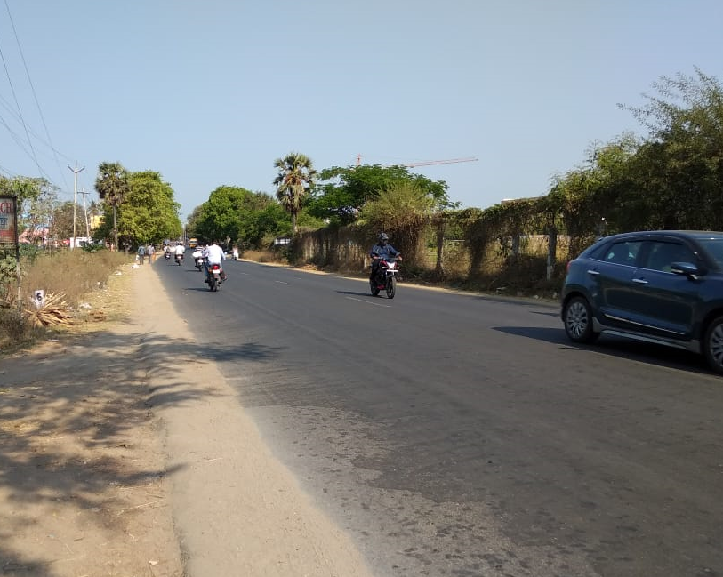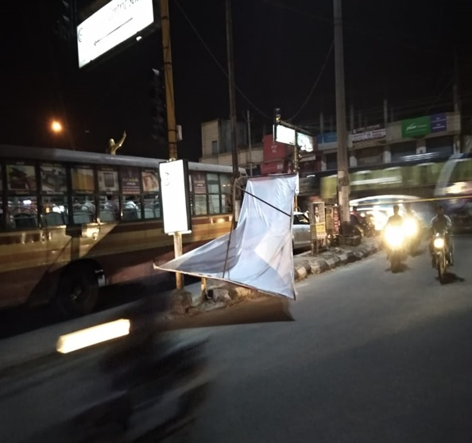

Figure 1. Presence of sand particles (left) and unsafe banners in the study stretch

References
Ashish D (2017) Influence of crossing pedestrians at undesignated locations on capacity of 4-lane urban midblock sections. Journal of Traffic and Logistics Engineering 5(1): 10-14. https://doi.org/10.18178/jtle.5.1.10-14.
Pallavi G, Mehar A (2018) Analysis of side friction on urban arterials. Transport and Telecommunication 19(1): 21–30.
https://doi.org/10.2478/ttj-2018-0003.
Salini S, Ashalatha R (2018) Analysis of traffic characteristics of urban roads under the influence of roadside frictions. Case Studies on Transport Policy, https://doi.org/10.1016/j.cstp.2018.06.008.

