Comparative Study for Effectiveness of X-Bracing and Steel Plate Shear Wall
Samadhan G.Morkhade^{1*}, L. M. Gupta²
¹Assistant Professor, Department of Civil Engineering, VPKBIET, Baramati, SPPU, Pune.
²Professor, Department of Applied Mechanics, Visvesvaraya National Institute of Technology, Nagpur, India
* e-mail: corresponding.author: samadhanmorkhade@gmail.com

Introduction
Steel structures have been known to perform well under earthquake loads provided certain guidelines are to be followed in design. Steel being a ductile material, is ideally suited for earthquake resistant structures. Multi-storeyed buildings can be constructed in steel as framed structures. A ductile frame can undergo inelastic deformations. The steel frames may either be unbraced, braced or with steel plate shear wall. Unbraced steel buildings are ductile but tend to deform greatly causing serious damage during small to medium size earthquakes. Frames with bracing or steel plate shear wall can resist large amount of lateral forces and have reduced lateral deflection (Roberts 1995, Gosh et al.2009). However, a uniform distribution of bracing & proper location of steel plate shear wall throughout the structure is desirable (Londhe et al.2010). Steel braced frame is one of the structural systems used to resist earthquake loads in multi-storeyed buildings. Many existing reinforced concrete buildings need retrofit to overcome deficiencies to resist seismic loads (Vishwanath et al. 2010). The use of steel bracing systems for strengthening or retrofitting seismically inadequate reinforced concrete frames is a viable solution for enhancing earthquake resistance. Steel bracing is economical, easy to erect, occupies less space and has flexibility to design for meeting the required strength and stiffness.

In this paper, a parametric study has been conducted to verify the effectiveness of various bracing systems used structure. The types of bracing considered in the study are X-bracing, K-bracing, X-intersected bracing and diagonal bracing. After analyzing, a building for different types of bracing system it was found that X-bracing comes out to be very effective as lateral load resisting system. Later a comparative study has also been conducted between the X-bracing and steel plate shear wall.

Parametric Study
The following data has been used in the modelling and analysis of building using STAAD Pro. The analysis has been performed, as per IS 1893 Part-I (2016). Figure 1 shows the 3-d model of the analysed buildings. The comparison of variation of bending moments and storey drift are as shown in Figure 2 and 3 respectively.

1) | Type of structure: M.R.S.F (G+9) storey | 2) | Lateral load resisting system: SPSW’s & X-bracing
3) | Height of each storey: 3.0 m | 4) | Depth of foundation: 1.5 m
5) | Thickness of slab: 150 mm | 6) | External wall thickness: 230 mm
7) | Internal wall thickness: 150 mm | 8) | Shear wall Thickness: 8 mm
9) | Unit weight of masonry: 19 kN/m³ | 10) | Floor Finish: 2 kN/m²
11) | Live load: 4 kN/m² | 12) | Type of soil : Medium
13) | Response reduction factor: 5 | 14) | Importance factor: 1.5
15) | Seismic zone: IV (z=0.24) | 16) | Beam section: B1=ISMB 500
17) | Angle used for bracing:100x100x10mm | 18)
19) | Column section: C1= ISMB 600, C2= ISMB 450, C3= ISMB 400

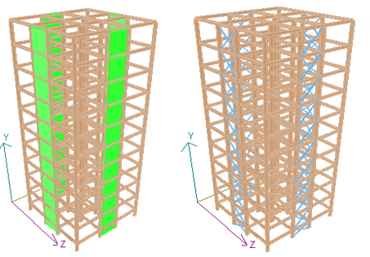
Figure 1. 3-D view of a G+9 Storey Building with (a) SPSW’s & (b) X-bracing

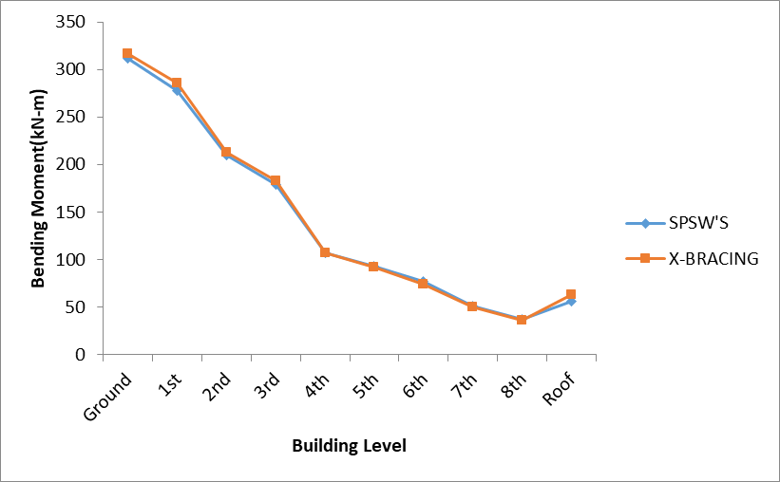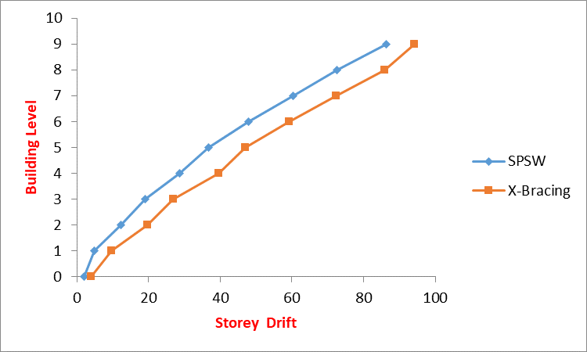
Figure 2. Variation of bending moments (kN-m) in beams Figure 3. Variation of storey drift (mm)

Concluding Remarks
In accordance to the present study, the analysis and the behaviour of the frame with SPSW’s & concentric braced frames systems as recorded in the literature emphasizes the following salient points:
- The presence of steel shear walls significant increase in the column loads particularly in some of the lower columns.
- There is no significant difference in variation of bending moment, shear force & axial force in beams & columns respectively in steel frame with SPSW’s & X-bracing.
- Frame with SPSW’s is very effective in limiting the storey drift compared to the frame with X-bracing

References
- Roberts T.M. (1995) Seismic resistance of steel plate shear walls. Engineering Structures, No 5, 17. pp 344-51.
- Ghosh Siddhartha, Farooq Adam, Das Anirudha (2009). Design of steel plate shear walls considering inelastic drift demand. Journal of Constructional Steel Research 65. pp 1431_1437.
- Londhe R.S. and Chavan. A. P. (2010). Behavior of building frames with steel plate shear wall. Asian Journal of Civil Engineering (building and housing) vol. 11, no. 1 pages 95-102.
- Viswanath K.G, Prakash K.B., Anant Desai (2010) Seismic analysis of steel braced reinforced concrete frames. International J. Civil and Structural Engineering, V.1, No. 1, pp. 114-122.
- IS 1893 (Part 1):2016, Indian Standard, “CRITERIA FOR EARTHQUAKE RESISTANT DESIGN OF STRUCTURES”, PART 1 GENERAL PROVISIONS AND BUILDINGS.(Fifth Revision).

