Comparison Between Remote Sensing Based Drought Indices for Telangana Region
Soumyasree Dixit^{1*}, Mahesh Ramesh Tapas², Syed Tayyaba², K. V. Jayakumar³
¹PhD Scholar NITW,² MTech Students NITW,³ Dean IRAA NITW
* e-mail: dixitsoumya1993@gmail.com

Introduction
The grievousness of Drought is becoming a paramount issue among the extreme events in the region of Telangana due to poor and dawdle monsoon, very high temperature, and inadequate water resources. The satellite-based drought indices may be applicable on a regional scale to help decision-makers in taking timely and appropriate actions. The Various Remotely Sensed Drought indices available are Enhanced Vegetation Index (EVI), Evaporation Stress Index (ESI), NDVI, Temperature Condition Index (TCI), Vegetation Condition Index (VCI), Vegetation Drought Response Index (Veg DRI), Vegetation Health Index (VHI), Water requirement Satisfaction Index (WRSI), Normalized Difference Water Index (NDWI), Soil adjusted water index (SAVI), Soil Water (SW). The drought in May month for the Warangal Region (both Rural and Urban) is computed using Normalized Difference Vegetation Index (NDVI), Normalized Difference Water Index (NDWI), Vegetation Condition Index (VCI), and Soil Water (SW), from the year 2014 to 2019 for the month of May. The objective of this study is to classify images unsupervised and compare drought indices by calculating the percentage of area under each Drought Category.

Materials and Methods
The Landsat eight images of Warangal are downloaded from USGS NASA for path 82 and row 235. The image is processed in Qgis 3.8.0 to find NDVI, NDWI, VCI, SW. The output raster image is classified unsupervised in ERDAS imagine 2015.
The total area of Warangal District (both urban and rural) is classified into five different drought categories. The percentage area coming under each drought category with various drought indices are computed and compared.
Normalized Difference Vegetation Index (NDVI) calculates vegetation by measuring the difference between Wavelengths which vegetation strongly reflects and vegetation absorbs.
NDVI = (NIR-RED) / (NIR+RED)
Normalized Difference Water Index (NDWI) indicates water content in plants and soil and is determined by calculating analogy with Normalized Difference Vegetation Index (NDVI).
NDWI = (NIR-SWIR) / (NIR+SWIR)
Vegetation Condition Index (VCI) anchor on the influence of drought on vegetation and can provide information on the arrival, duration, and severity of drought by considering vegetation changes and comparing them with previous values.
VCI= (NDVI- NDVI_{MIN}) / (NDVI_{MAX} - NDVI_{MIN})
The Reflectance of the soil decreases with increase in Soil Water (SW) for all Wavelengths.
SW= NIR Band/ Blue Band

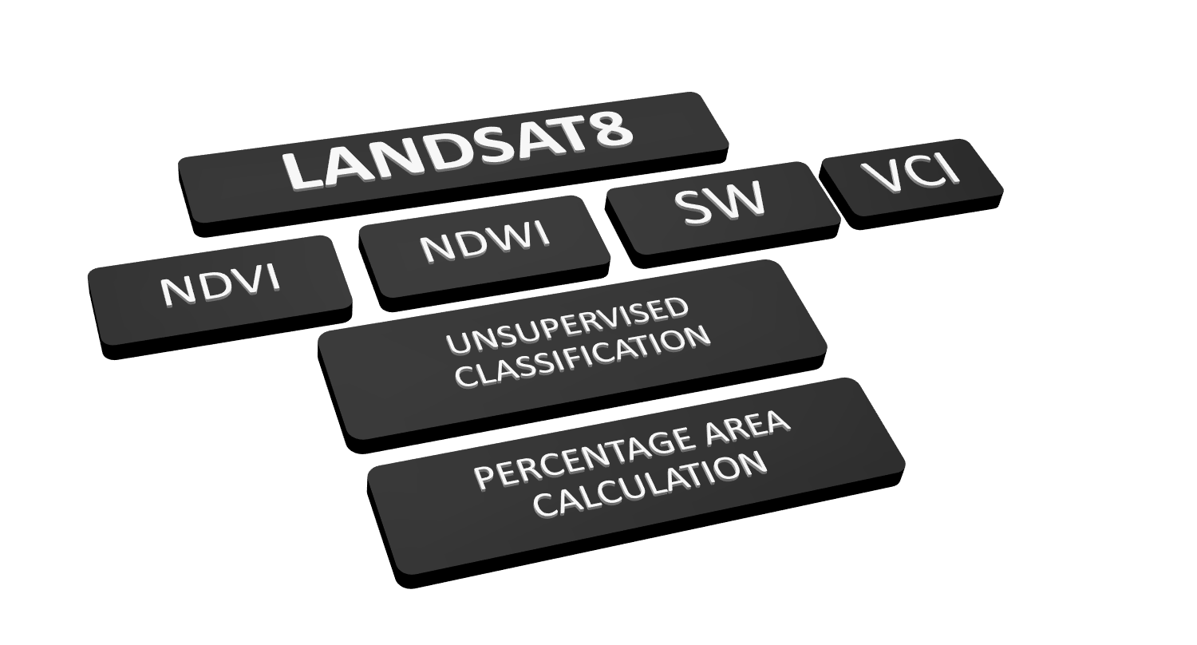
Figure 1. Flowchart of Methodology.

Results and Concluding Remarks
The maximum, minimum values of NDVI, NDWI, SW, and VCI is discussed in Table 1. The Percentage of the area under each drought category for the years 2014 to 2019 is discussed in Table 2. The Minimum value of NDVI was observed in the year 2016. The Maximum value of NDVI was observed in the year 2014. The Minimum value of NDWI was observed in the year 2015. The Maximum value of NDWI was observed in the year 2019. The Minimum value of SW was observed in the year 2019. The Maximum value of SW was observed in the year 2015. The Maximum percentage of Extreme Drought was found in the year 2017.

Table 1. Maximum and Minimum values of Drought Indices
 |  | 2014 | 2015 | 2016 | 2017 | 2018 | 2019
NDVI | Maximum | 0.465925 | 0.460922 | 0.410087 | 0.460858 | 0.413698 | 0.431791
NDVI | Minimum | -0.0684027 | -0.0564994 | -0.127692 | -0.0946926 | -0.0197515 | -0.0708879
NDWI | Maximum | 0.318672 | 0.316489 | 0.247844 | 0.293753 | 0.279692 | 0.320453
NDWI | Minimum | -0.211752 | -0.565197 | -0.164865 | -0.185156 | -0.4474 | -0.176433
SW | Maximum | 2.27812 | 2.32896 | 2.25028 | 2.39653 | 2.14751 | 2.27001
SW | Minimum | 0.77635 | 0.817597 | 0.875172 | 0.801198 | 0.838527 | 0.75181

Table 2. Percentage Area and Drought Category
YEAR | DROUGHT INDEX | EXTREME DRY | DRY | NORMAL | WET | EXTREME WET
2014 | NDVI | 43.81093 | 15.49146 | 20.84126 | 13.04571 | 6.810316
2014 | NDWI | 43.81093 | 19.54231 | 18.79485 | 11.47588 | 6.366482
2014 | VCI | 43.81093 | 15.49179 | 20.84126 | 13.04577 | 6.810316
2014 | SW | 43.81093 | 12.68223 | 17.67645 | 18.49968 | 7.3307
2015 | NDVI | 43.81 | 18.32 | 18.62 | 12.90 | 6.35
2015 | NDWI | 43.81 | 18.79 | 19.32 | 12.77 | 5.30
2015 | VCI | 43.81 | 18.32 | 18.62 | 12.90 | 6.35
2015 | SW | 43.81 | 14.18 | 17.69 | 15.77 | 8.54
2016 | NDVI | 43.81 | 19.28 | 15.33 | 14.02 | 7.56
2016 | NDWI | 43.81 | 15.34 | 20.26 | 12.25 | 8.32
2016 | VCI | 43.81 | 14.02 | 19.28 | 15.33 | 7.56
2016 | SW | 43.81 | 20.32 | 15.33 | 12.30 | 8.23
2017 | NDVI | 43.81093 | 14.43144 | 21.55199 | 15.49018 | 4.715137
2017 | NDWI | 43.81093 | 17.66989 | 20.54002 | 14.03157 | 3.94003
2017 | VCI | 43.81093 | 14.4307 | 21.55281 | 15.49039 | 4.715137
2017 | SW | 43.81093 | 13.9115 | 18.80404 | 13.51555 | 9.958086
2018 | NDVI | 43.81093 | 17.4982 | 19.25025 | 12.77672 | 6.663694
2018 | NDWI | 43.81093 | 18.29748 | 19.5041 | 12.1665 | 6.210021
2018 | VCI | 43.81093 | 17.49804 | 19.25058 | 12.77676 | 6.663694
2018 | SW | 43.81093 | 14.34689 | 17.40538 | 15.29835 | 9.138506
2019 | NDVI | 43.81 | 16.39 | 20.21 | 15.22 | 4.36
2019 | NDWI | 43.81 | 18.51 | 20.20 | 14.30 | 3.54
2019 | VCI | 43.81 | 16.31 | 20.21 | 15.22 | 4.36
2019 | SW | 43.81 | 14.18 | 18.78 | 14.91 | 8.31

References
Eriyagama, N., V. Smakhtin and N. Gamage, 2009: Mapping Drought Patterns and Impacts: a Global
Perspective. IWMI Research Report No. 133. Colombo, International Water Management Institute,
http://www.iwmi.cgiar.org/Publications/IWMI_Research_Reports/PDF/PUB133/RR133.pdf.

