Comparison Between Remote Sensing Based Drought Indices for Telangana Region
K V Jayakumar¹ , Soumyasree Dixit², Syed Tayyaba³, Mahesh Tapas^{3*}
¹ Dean IRAA NITW, ² PhD Scholor NITW, ³ MTech Students NITW
* e-mail: mtapas@student.nitw.ac.in

Introduction
The grievousness of Drought is becoming paramount issue among the extreme events in the region of Telangana due to poor and dawdle monsoon, very high temperature and inadequate water resources. Water connects every aspect of life and it is a basic need and the right to get sufficient water. Drought is a serious natural hazard with far-reaching impacts including soil damages, economic losses, and threatening the livelihood and health of local residents. The satellite-based drought indices may be applicable on regional scale to help decision makers in taking timely and appropriate actions.

Materials and Methods
The drought in May month for the Warangal Region (both Rural and Urban) was computed using Normalized Difference Vegetation Index (NDVI), Normalized Difference Water Index (NDWI), Vegetation Condition Index (VCI), and Soil Moisture (SM), from the year 2013 to 2019.
The Landsat eight images of Warangal downloaded from USGS NASA for path 82 and row 235. The image was processed in Qgis 3.8.0 to find NDVI, NDWI, VCI, SM. The output raster image was classified unsuperwised in ERDAS imagine 2015.
The total area of Warangal District (both urban and rural) were classified into five different drought categories. The percentage area coming under each drought category with various drought indices were computed and compared.
Normalized Difference Vegetation Index (NDVI) calculates vegetation by measuring the difference between near-infrared (which vegetation strongly reflects) and red light (which vegetation absorbs).
NDVI = (NIR-RED) / (NIR+RED)
Normalized Difference Water Index (NDWI) indicates moisture content in plants and soil and is determined by analogy with NDVI.
NDWI = (NIR-SWIR) / (NIR+SWIR)
Vegetation Condition Index focuses on the impact of drought on vegetation and can provide information on the onset, duration and severity of drought by noting vegetation changes and comparing them with historical values.
VCI= (NDVI- NDVI_{MIN}) / (NDVI_{MAX} - NDVI_{MIN})
As soil water increases, reflectance of soil decreases at all wavelengths.
SW= NIR Band/ Blue Band

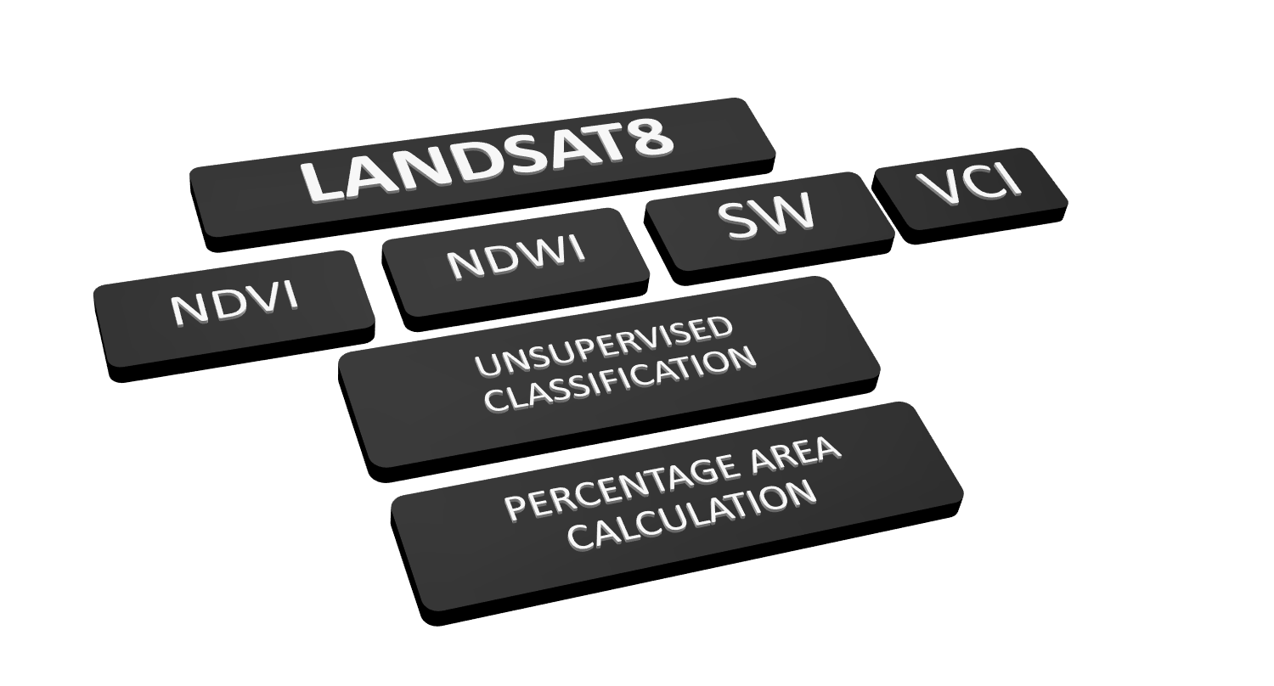
Figure 1. Flowchart of Methodology.

Results and Concluding Remarks
The maximum, minimum values of NDVI, NDWI, SW, and VCI is discussed in Table 1. The Percentage of area under each drought category for years 2014 to 2019 is discussed in Table 2. The Minimum value of NDVI was observed in year 2016. The Maximum value of NDVI was observed in year 2014. The Minimum value of NDWI was observed in year 2015. The Maximum value of NDWI was observed in year 2019. The Minimum value of SW was observed in year 2019. The Maximum value of SW was observed in year_. The Maximum percentage of Extreme Drought was found in the year 2017.

Table 1. Maximum and Minimum values of Drought Indices
DROUGHT INDEX |  | 2014 | 2015 | 2016 | 2017 | 2018 | 2019
NDVI | Maximum | 0.465925 | 0.460922 | 0.410087 | 0.460858 | 0.413698 | 0.431791
NDVI | Minimum | -0.0684027 | -0.0564994 | -0.127692 | -0.0946926 | -0.0197515 | -0.0708879
NDWI | Maximum | 0.318672 | 0.316489 | 0.247844 | 0.293753 | 0.279692 | 0.320453
NDWI | Minimum | -0.211752 | -0.565197 | -0.164865 | -0.185156 | -0.4474 | -0.176433
SW | Maximum | 2.27812 | 2.32896 | 2.25028 | 2.39653 | 2.14751 | 2.27001
SW | Minimum | 0.77635 | 0.817597 | 0.875172 | 0.801198 | 0.838527 | 0.75181

Table 2. Percentage Area and Drought Category
YEAR | DROUGHT INDEX | EXTREME DRY | DRY | NORMAL | WET | EXTREME WET
2014 | NDVI | 43.81093 | 15.49146 | 20.84126 | 13.04571 | 6.810316
2014 | NDWI | 43.81093 | 19.54231 | 18.79485 | 11.47588 | 6.366482
2014 | VCI | 43.81093 | 15.49179 | 20.84126 | 13.04577 | 6.810316
2014 | SW | 43.81093 | 12.68223 | 17.67645 | 18.49968 | 7.3307
2015 | NDVI | 43.81 | 18.32 | 18.62 | 12.90 | 6.35
2015 | NDWI | 43.81 | 18.79 | 19.32 | 12.77 | 5.30
2015 | VCI | 43.81 | 18.32 | 18.62 | 12.90 | 6.35
2015 | SW | 43.81 | 14.18 | 17.69 | 15.77 | 8.54
2016 | NDVI | 43.81 | 19.28 | 15.33 | 14.02 | 7.56
2016 | NDWI | 43.81 | 15.34 | 20.26 | 12.25 | 8.32
2016 | VCI | 43.81 | 14.02 | 19.28 | 15.33 | 7.56
2016 | SW | 43.81 | 20.32 | 15.33 | 12.30 | 8.23
2017 | NDVI | 43.81093 | 14.43144 | 21.55199 | 15.49018 | 4.715137
2017 | NDWI | 43.81093 | 17.66989 | 20.54002 | 14.03157 | 3.94003
2017 | VCI | 43.81093 | 14.4307 | 21.55281 | 15.49039 | 4.715137
2017 | SW | 43.81093 | 13.9115 | 18.80404 | 13.51555 | 9.958086
2018 | NDVI | 43.81093 | 17.4982 | 19.25025 | 12.77672 | 6.663694
2018 | NDWI | 43.81093 | 18.29748 | 19.5041 | 12.1665 | 6.210021
2018 | VCI | 43.81093 | 17.49804 | 19.25058 | 12.77676 | 6.663694
2018 | SW | 43.81093 | 14.34689 | 17.40538 | 15.29835 | 9.138506
2019 | NDVI | 43.81 | 16.39 | 20.21 | 15.22 | 4.36
2019 | NDWI | 43.81 | 18.51 | 20.20 | 14.30 | 3.54
2019 | VCI | 43.81 | 16.31 | 20.21 | 15.22 | 4.36
2019 | SW | 43.81 | 14.18 | 18.78 | 14.91 | 8.31

