**Productivity and efficiency improvement of assembly line of cotton ginning machine**

**[1] Dr. Ashok G. Matani,** Associate Professor -Mechanical Engineering Department, Government College of Engineering, Amravati- [M.S.] India E-mail: ashokgm333@rediffmail.com, dragmatani@gmail.com

[2] [**Mohd. Sohail Ansari**](http://www.gcoea.ac.in)**,** 2nd Year M.Tech. Production, Government College of Engineering, Amravati – 444604 [M.S.], Email: [ansari10sohail@gmail.com](mailto:ansari10sohail@gmail.com)

**Abstract**

Problem-solving and ongoing procedure enhancements are key elements to obtaining quality improvement in business operations. Many process and machine improvement strategies have been suggested and implemented in organizations, where define, measure, analysis, improve and control is mostly applied. Here we aimed at improving the machine productivity of assembly line in a cotton ginning assembly line in an Industry. The tool which is used to improve the productivity of assembly line are time study and method study. Based on this, the study provides data of time required for each assembly processes, sequence of each operations and flow of the product in assembly line. The present study has been done at an industry, a leading manufacturer of cotton ginning machine. The aim of the study is to identify the various problems on the assembly line which causes unnecessary delay in the operations. The problem is found in the assembly line and is solved by work study techniques and it is found that cycle time of bottle neck operation was reduced by 40.08 % per trolley.

**Keywords:** Bottlenecks in the assembly line, side frame, crossbars and rails, imbalances at workstations, seed guard jumbo fitting.

**Objectives:**

* To identify the operations causing bottlenecks in the assembly line.
* By using the method study technique, identify the problem work stations in the assembly line.
* Develop a method to solve the problem which is causing unnecessary delay in the assembly line.
* Conduct time study in the assembly line after implementation of the new method for trial period of 10 days.
* Suggest new method to the concern personnel in the organisation.

**Current assembly method:**

In the original assembly method, the product is assembled and passes through six workstations. All workstations has one or two workers for the assembly operation. The side frame, crossbars and rails are fitted at station 1 then it is passed to station 2 where fitting of side channels takes place. The product is passed to station 3 where back knife, knife holder, fix knife and seed guard jumbo are fitted and passed to the station 4 where ratchet, side plate and beater assembly fits. The unfinished product is passed to the station 5 where weight lever and gear box are fitted and then move the product to the station 6 where gear box plate cover is fixed. This finished product is now ready for the inspection.

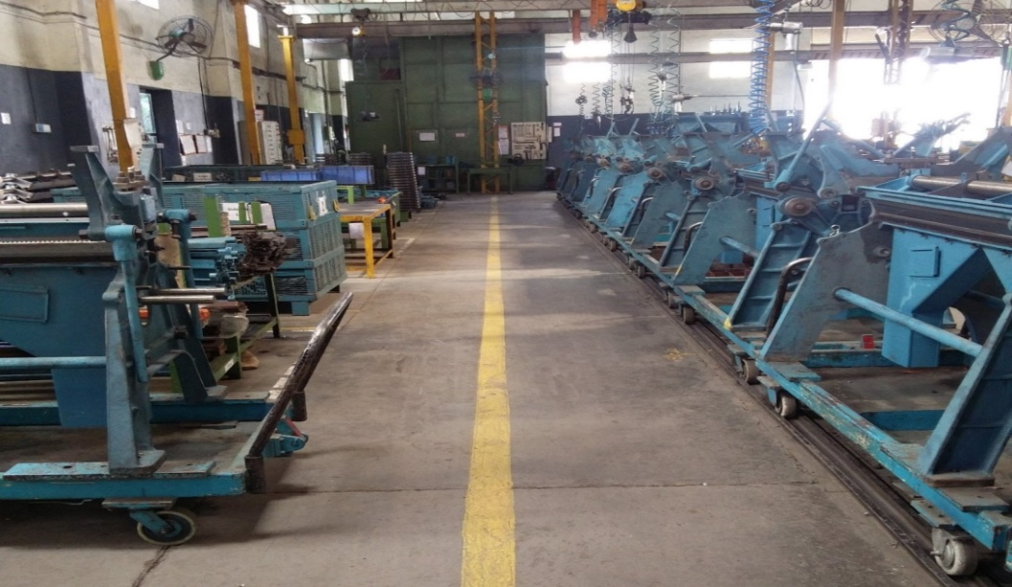

**Figure 1: Assembly line of cotton ginning machine**

**Observations and analysis:**

Table 1: Imbalances at workstations before implementation of the new method

|  |  |  |  |  |  |  |
| --- | --- | --- | --- | --- | --- | --- |
| **SN** | **Operation sequence** | **Average time (seconds)** | **Work station** | **Workstation time (seconds)** | **Cycle time** | **Imbalance** |
|  | Side Frame | 88.66 | 1 | 474.63 | 403.54 | -71.09 |
|  | Cross bar fitting | 21.8 |
|  | Rail fitting | 86.83 |
|  | Seed channel loose fitting | 278 |
|  | Seed channel 1 tightening | 99.63 | 2 | 373.83 | 29.71 |
|  | Seed channel 2 tightening | 274.2 |
|  | Back knife fitting | 88.53 | 3 | 288.3 | 115.24 |
|  | Knife holder fitting | 110.4 |
|  | Fix knife fitting | 9.67 |
|  | Seed Guard Jumbo fitting | 79.83 |
|  | Ratchet fitting | 18.5 | 4 | 417.47 | -13.93 |
|  | Side plate fitting | 82.33 |
|  | Beater assembly fitting | 316.63 |
|  | Weight lever fitting | 168.1 | 5 | 500.9 | -97.36 |
|  | Gear box fitting | 333.13 |
|  | Gear box plate cover fitting | 366.13 | 6 | 366.13 | 37.41 |

Table 2: Imbalances at workstations after implementation of the new method

|  |  |  |  |  |  |  |
| --- | --- | --- | --- | --- | --- | --- |
| **SN** | **Operation sequence** | **Average time (seconds)** | **Work station** | **Workstation time (seconds)** | **Cycle time** | **Imbalance** |
|  | Side Frame | 88.66 | 1 | 474.63 | 403.54 | -71.09 |
|  | Cross bar fitting | 21.8 |
|  | Rail fitting | 86.83 |
|  | Seed channel loose fitting | 278 |
|  | Seed channel 1 tightening | 99.63 | 2 | 373.83 | 29.71 |
|  | Seed channel 2 tightening | 274.2 |
|  | Back knife fitting | 88.53 | 3 | 288.3 | 115.24 |
|  | Knife holder fitting | 110.4 |
|  | Fix knife fitting | 9.67 |
|  | Seed Guard Jumbo fitting | 79.83 |
|  | Ratchet fitting | 18.5 | 4 | 417.47 | -13.93 |
|  | Side plate fitting | 82.33 |
|  | Beater assembly fitting | 316.63 |
|  | Weight lever fitting | 168.1 | 5 | 500.9 | -97.36 |
|  | Gear box fitting | 333.13 |
|  | Gear box plate cover fitting | 366.13 | 6 | 366.13 | 37.41 |

After changing the operation sequence in the process sheet and by changing the wrench, we can see that the imbalances at all the workstations reduced.

**Figure 2: Comparison of workstation times of all workstations before and after implementation of new method for productivity improvement**

**Calculations:**

Cycle time of each operations in the work stations and work station time are given above in the table. Thus by using the above table we can calculate line efficiency of the assembly line.

* Number of work stations = 6
* Capacity of assembly line = 40 units per shift per day
* Total shift time = 480 minutes
* Unproductive time or worker allowances = 60 minutes
* Actual production time = Total shift time - Unproductive time or worker allowances

= 480-60

= 420 minutes.

* For full capacity, time required by one workstation for one trolley

= $\frac{Actual production time}{Capacity of plant}$

= $\frac{420}{40}$

= $10$.5 minutes

* Therefore, line efficiency before implementation of new method

= $\frac{Actual production time}{number of workstations × largest workstation time}$

= $\frac{420}{6 ×13.92}$ = 50.28 %

* Line efficiency after implementation of new method

= $\frac{420}{6 × 8.34}$ = 83.93%

Thus by implementing new method, line efficiency increases from 50.28% to 83.93%.





**Figure 3: comparison of the workstation 1 and workstation 2 before and after implementation of new method**

It can be seen and compared from the above two graphs that the workstation time of workstation 1 is increased and workstation time of w/s 2 is decreased by changing the operation in the process sheet and thus reducing w/s time of the workstation 2.

**Conclusions**

* The result can be concluded that the time required to complete the sub assembly of seed channel in the work station 2 is reduced to 8.34 minutes from 13.92 minutes.
* Percentage decrease in time by above study is

= $\frac{13.92-8.34}{13.92} ×100$

= 40.08 %

* Thus the productivity of the assembly line of the cotton ginning machine is improved and the line efficiency are increased by the application of work study and change in operation in the process sheet.
* Thus by implementing new method, line efficiency increases from 50.28% to 83.93%.
* Thus the bottle neck between station 1 and station are eliminated.

**References:**

1. Ashish Kalra, Sachin Marwah, Productivity improvement in assembly line of automobile industry by reducing cycle time of operations, International Journal of Engineering Research & Technology, 5(5), 2016:28-31.
2. Swapnil T. Firake, Dr. K. H. Inamdar, Productivity improvement of automotive assembly line through line balancing, International Journal of Technical Research and Applications, 2(3), 2014:124-128.
3. Cengiz Durana, Aysel Cetindereb, Yunus Emre Aksuc, Productivity improvement by work and time study technique for earth energy-glass manufacturing company, 4th World Conference on Business, Economics and Management, WCBEM, Science Direct, Procedia Economics and Finance 26 (15), 2015:109 – 113.
4. Mayourshikha Pancholi (Bhatnagar), Productivity improvement in chassis assembly line of automotive industry by using work study methods, International Journal of Engineering Sciences & Research Technology, 7(6), 2018: 454-459.
5. Shamuvel V Pandit, Sunil J Kadam, Avinash Kharat, Chetan U Nayakawade, Productivity improvement by application of line balancing, International Journal of Innovative Research in Science, Engineering and Technology, 3(4), 2014 :11495-11502.
6. Nikhil Verma, Pulkit Trivedi, Vivek Agnihotri, Productivity improvement in assembly line of an automobile industry, IOSR Journal of Mechanical and Civil Engineering (IOSR-JMCE), 12(4), 2015: 01-06.
7. Vivek Kumar, Productivity improvement of an assembly line, International Journal for Research in Applied Science & Engineering Technology (IJRASET), 5(10), 2017: 2246-2249.
8. K Dharma Reddy, M Bhupal, G Chiranjeevi Naidu, Productivity improvement by using line balancing and automation strategies in order to improve overall equipment effectiveness, International Journal of Engineering Science Invention (IJESI), 7(1), 2018: 21-27.
9. Roongrat Pisuchpen and Wongsakorn Chansangar, Modifying production line for productivity improvement: A Case Study of Vision Lens Factory, Songklanakarin J. Sci. Technology, 36(3), 2014: 345-357.
10. Naveen Kumar & Dalgobind Mahto, Productivity improvement through process analysis for optimizing assembly line in packaging industries, Global Journal of Researches in Engineering Industrial Engineering, 13(3), 2013: 11-26.
11. Dharit Pambhar, Shubham Awasthi, A Case study on productivity improvement of assembly line using VSM methodology, International Conference on Ideas, Impact and Innovation in Mechanical Engineering (ICIIIME 2017), 5(6), 2017: 58-63.
12. Ratnesh Gedam & Yogesh Agrawal, Productivity improvement through mosttechnique in assembly line at mediumsize manufacturing (MSM), Imperial Journal of Interdisciplinary Research (IJIR), 3(7), 2017: 419-421.
13. Fawaz A. Abdulmaleka, Jayant Rajgopal, Analysing the benefits of lean manufacturing and value streammapping via simulation: A process sector case study, Int. J. Production Economics 107 (2007), 223–236.
14. Dinesh Seth and Vaibhav Gupta, Application of value stream mapping for lean operations and cycle time reduction: an Indian case study, Production Planning & Control: The Management of Operations, 16(1), 2012: 44-59.
15. P. Kuhlang , T. Edtmayr, W. Sihn, Methodical approach to increase productivity and reduce lead time in assembly and production-logistic processes, CIRP Journal of Manufacturing Science and Technology, 4(11), 2011: 24-32.