**SEM of Group 1a:** Teeth extracted from young males for orthodontic purpose, powdered and demineralized

**Figure 1. SEM Group 1a**

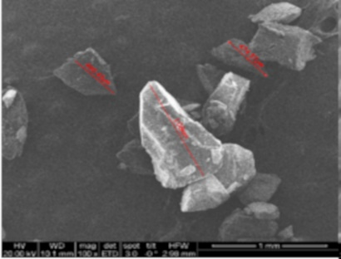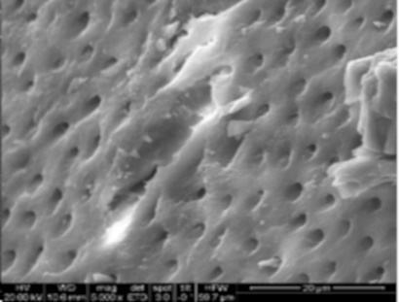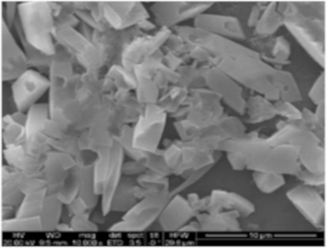

A B C

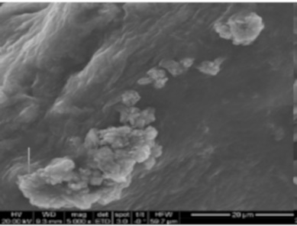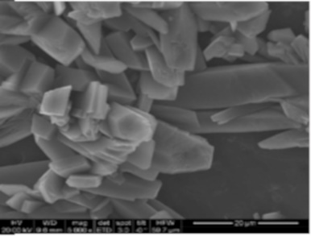

D E

1. Particle size, B. Dentinal tubules and collagen ,C. Crystals covering the dentinal tubules, D. Cluster of crystals between the dentinal tubules, E. Hydroxyapatite crystals at higher magnification

**SEM of Group 1b:** Teeth extracted from young females for orthodontic purpose, powdered and demineralized

**Figure 1.1. SEM of Group 1b**

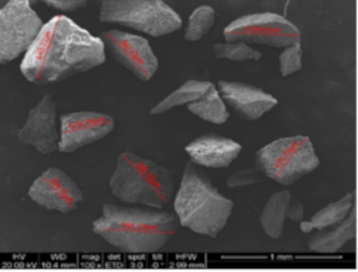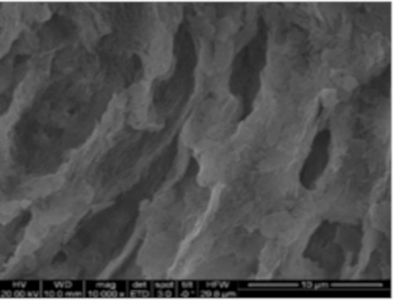

A B

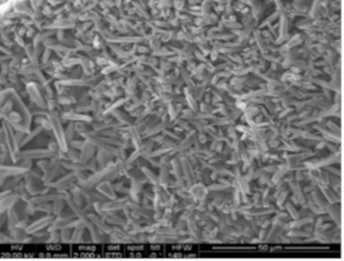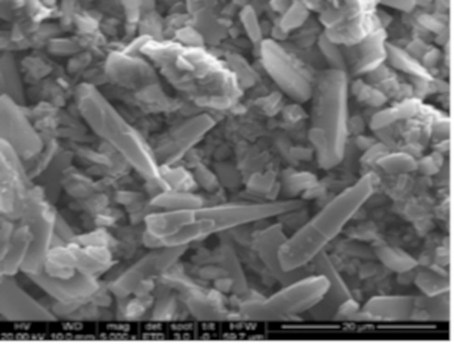

C D

1. Particle size, B. Dentinal tubules, C .Crystals covering the dentinal tubules, D. Cluster of hydroxyapatite crystals between the dentinal tubules at higher magnification

**SEM of Group 2a:** Teeth extracted from old adult males due to periodontal issues, powdered and demineralized

**Figure 1.2 SEM of Group 2a**

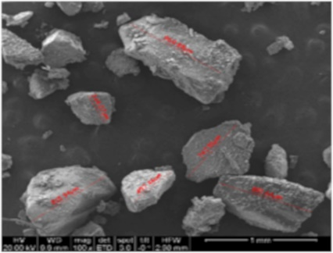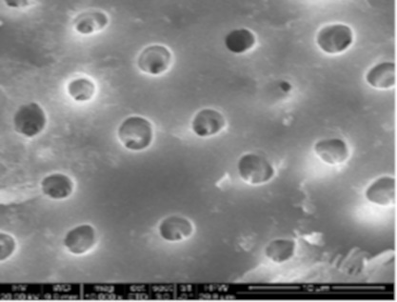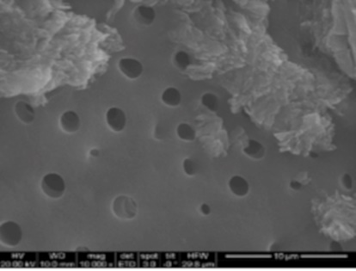

A B C

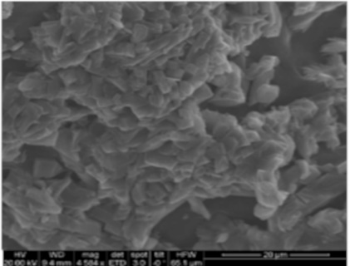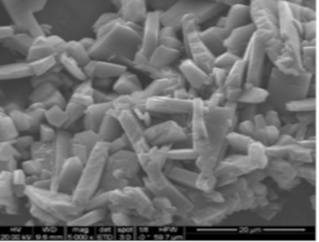

1. Particle size, B. Rounded dentinal tubules, C. Dentinal tubules with scattered cluster of crystals and smooth surface, D. Higher magnification showing crystal distribution. Hydroxyapatite crystals under high magnification

D E

**SEM of Group 2b:** Teeth extracted from old adult females due to periodontal issues, powdered and demineralized

**Figure 1.3. SEM of Group 2b**

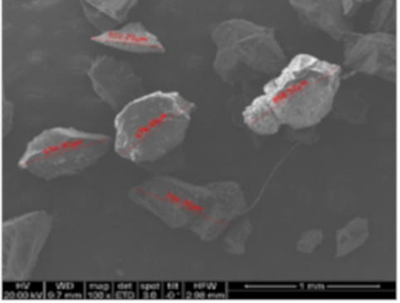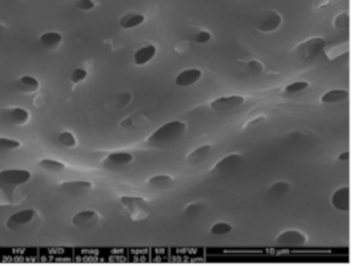

A B

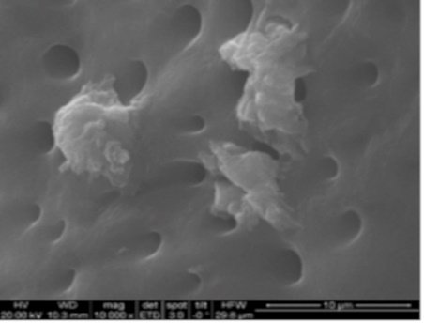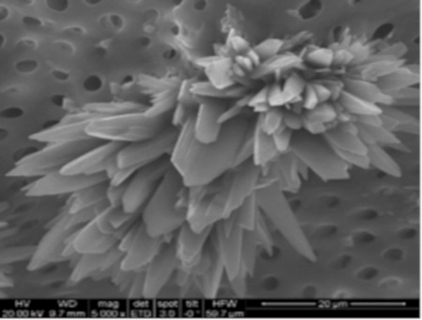

C D

1. Particle size, B. Smooth dentinal tubules, C. Cluster of crystals between the dentinal tubules, D. Higher magnification sows needle like hydroxyapatite crystals

**SEM of Group 3:** Teeth extracted from each of the subgroups but, were not demineralized

**Figure 1.4.SEM of Group 3(young male)**

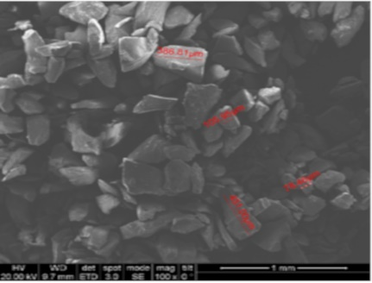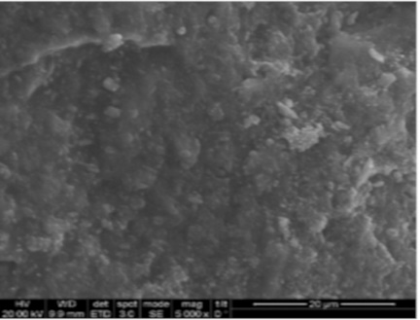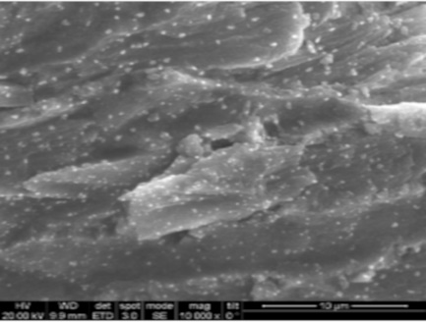

A B C

1. Particle size, B &C. Dentinal tubules with crystals shown as white sports

**Figure 1.5.SEM of Group 3(young female)**

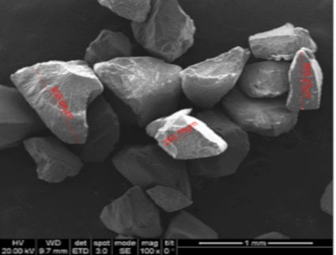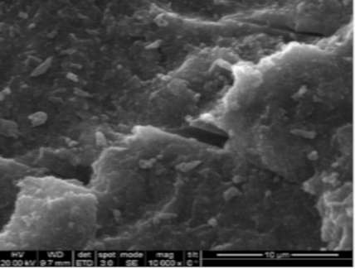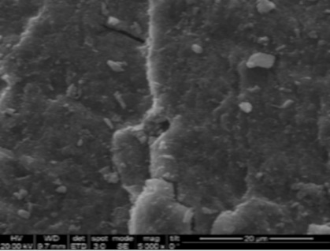

A B C

1. Particle size, B &C. Dentinal tubules with irregularly shaped tiny particles

**Figure 1.6. SEM of Group 3(old male)**

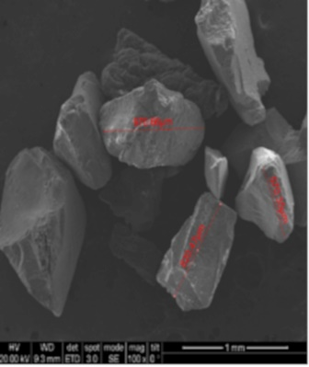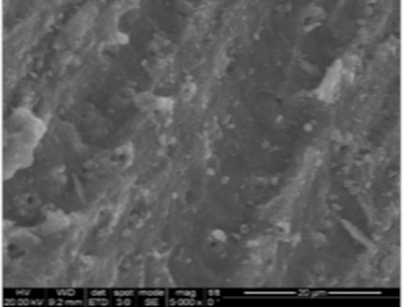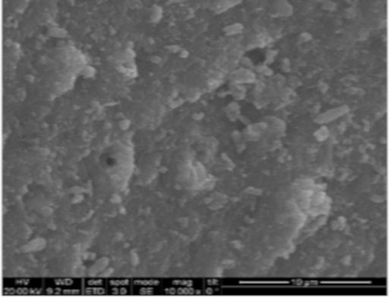

A B C

A. Particle size, B &C. Dentinal tubules with irregularly shaped tiny particles not as tightly packed

**Figure 1.7. SEM of Group 3(old female)**

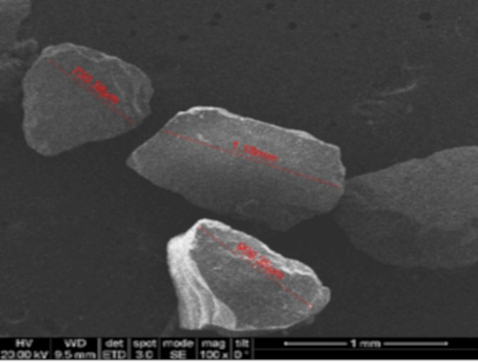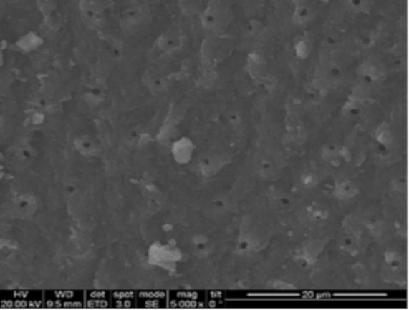

A B

A. Particle size, B. Dentinal tubules with irregularly shaped tiny particles not as tightly packed