**Design and Development of Needle Filling Machine for Needle Roller Bearings**

*Anant A. Bade1, Chetan D. Kuthe2*

1, 2 Department of Mechanical Engineering,

Maharashtra Institute of Technology,

1NRB Industrial bearings Limited.

Aurangabad, India.

Email: anantbade810@gmail.com

**Abstract:**

Needle filling machine is essential for all types of needle roller bearing. Development in this machine is helpful to increase the production rate. It can be used for all types of needle roller bearing. this machine is used to fill needle in polyamide cage as well as metal cage.it can be able to fill the all types of needle in the cage. Needle roller bearing is mostly used for high load application If any needle is missing in cage then bearing fails during its operation. To avoid this a needle filling machine is required. T type needle is also inserted in cages with the help of this modified machine.

**Keywords**: Needle roller bearing, polyamide cages.

**Introduction**

Needle roller bearings are bearings with cylindrical rollers that are small in diameter. In spite of their low cross section, needle roller bearings have a high load carrying capacity and are therefore extremely suitable for bearing arrangements where radial space is limited. NRB Industrial bearings ltd. supplies needle roller bearings in different designs and in a wide range of sizes, which are appropriate for different applications [2].

The bearing size to be used can be selected on the basis of its load ratings in relation to the applied loads and the requirements regarding bearing life and reliability. A simple way to calculate bearing life is the classic ISO formula for basic rating life. However, NIBL recommends using the NIBL rating life, which makes predicting bearing life more reliable.

Compared with other types of rolling bearings, needle roller bearings have a small cross-sectional height and significant load-bearing capacity and rigidity relative to their volume. Also, because the inertial force action on them is limited, they are ideal choice for oscillating motion. Needle roller bearings contribute to compact and lightweight machine designs. They serve also as a ready replacement for sliding bearings. their volume. Also, because the inertial force action on them is limited, they are ideal choice for oscillating motion. Needle roller bearings contribute to compact and lightweight machine designs. They serve also as a ready replacement for sliding bearings.

**Literature survey**

A long fatigue life is one of the most important criteria in the optimum design of needle roller bearings (NRBs). In the present work the dynamic capacity of the bearing is optimized. This non-linear optimization formulation has been solved using the artificial bee colony algorithm (ABCA), differential search algorithm (DSA), grid search method (GSM) and hybrid method (HM, a novel approach of combination of the ABCA/DSA and GSM). A total of four design variables procedure for the optimum design of NRBs has been proposed. The bearing design has been optimized

using the artificial bee colony algorithm, differential search algorithm, grid search method, and a novel hybrid method. The dynamic capacity is taken as objective functions subject to non-linear constraints. Optimum designs from all four methods are compared and it is concluded that the hybrid method gives the best optimum value. To ensure the global optimum in the design, the

convergence study is carried out. The fatigue life of optimized bearings has been found to be as high as 2.5 times the catalogue life values whereas in terms of increase in the dynamic capacity it is as high as 33.4%. This shows the relevance of optimization of engineering design of needle roller bearings. corresponding to bearing geometry are considered, which include the roller diameter, roller length, pitch diameter and number of rollers[1].

As bearing raceways of non-rotating rolling element bearings exposed to vibration or sliding oscillation false Brinelling occurs. Bearing surface due to false Brinelling tends to damage within a short period, due to cavities created on the bearing raceway. Recommendation towards enhancement of bearing life is also suggested.

At the contact area between the rolling element and raceways lubricant is squeezed out that leads to wear due to direct contact of two metal surfaces. False brinelling detected after starting of machine, and at extreme high loads, due to loud sound generated in the machine component. Vibration causes wear of the surfaces in contact and the fine abrasive particles produced rapidly that results in a characteristic grooves with the oxide acting as an abrasive The corrugated surfaces produced by false brinelling may produce excessive noise and cause premature spalling by rolling-contact fatigue.

**Experimental setup**

Needle required as per part no. of bearings put in the hopper of the machine. first check the setting of the cage which is inserted at the setting plate this setting will be change as per cage diameter. then press electric control panel switch which is below the tray of machine. induction motor is start and rotary hopper rotate all needles in it.

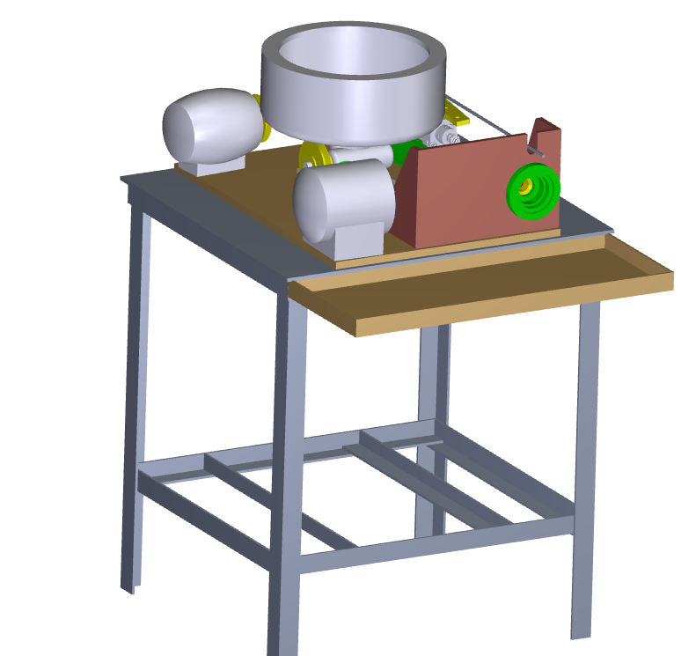

Fig.1 Experimental setup

Then feeder plate is already inserted in the hopper it helps to give direction to needle out and at the same time press foot valve to actuate pneumatic cylinder which is arranged with connecting shaft it connects to the setting plate.

After that cage is manually remove from mandrill and check the all needles are fill or not.

**List of components in needle filling Machine**

1.Cylinder base, Shaft, Table Frame, Base Plate, Housing, Feeder Plate, Connecting Shaft-1, Setting Plate, Pulley 1,Pulley 2, pulley 3, Cylinder Coupling, Pulley 4

**Std. Mechanical parts**

1.Deep groove ball Bearing, I Circlip. V-belt

**Std. Pneumatic Parts**

Pneumatic cylinder, PU tube, Foot valve 5/2 way,connector, Silencer limit switch,etc.

**Std. Electric parts**

3Phase induction motor, motor reducer, electrical control panel,etc.

**Modification**

Insert the feeder plate in hopper and placed at 20degree angle. we can change feeder plate angle position as per the cage requirement. Then the needle are coming out fast to setting plate due to this angle air blows to it for fitting in cage slots immediately.

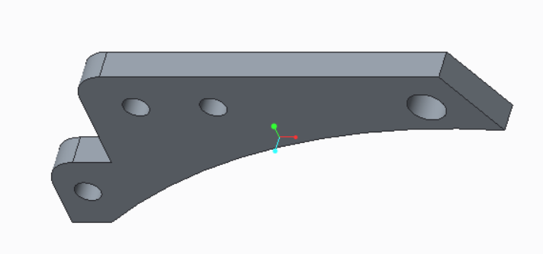

Fig2.Feeder Plate

**Discussion**

Needle filling machine is help to reduce man power and improve the accuracy of needle fill in cages. there are two types of needle filling machine. these types are based on the axis of cage.1.horizontal axis 2.vertical axis. We develop the horizontal needle filling machine to avoid needle missing cage.

Cycle time for polyamide split cage is reduced. previous 200 p/min after modification 300p/min.in future it can be made used for without split cage materials.

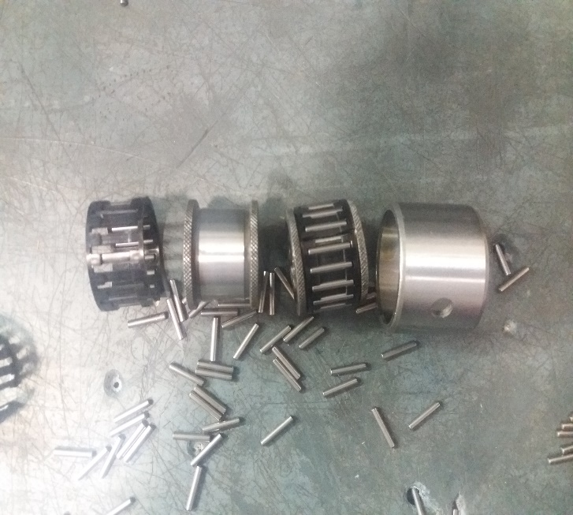

Fig.3-Needle roller bearing assembly

**Conclusion**

We reduce the bearing failure chance if no any needle is missing in cage.it will directly affect on bearing life. It help to increase the production rate increase upto 40%. It can be used for 10 mm dia. To 50 mm dia of polyamide cage.

This machine can be used for different types needle filling in metal or polymid cages. Easy loading an unloading of cage id also helpful to reduce the time in future modifications.

**References**

[1] P.A.Chandak a. d. thakare, s.p. untawale, G.R.Nakhale,Design & analysis of needle roller bearing at gudgeon pin of ginning machine - 2016.

[2]. Prof. S. G. Kulkarni, Prof. S. A. Sonawane, Department of Mechanical Engineering, Faculty of Mechanical Engineering, SKN Sinhgad college of Engg. optimization of Needle Roller Bearing System by using Finite Element Analysis -2013.

[3] Yoshinobu Akamatsu, Noriyuki Tsushima, Toshihide Goto, Kenji Hibi, and Kunio ltoh NTN corp Improvement of Roller Bearing Fatigue Life by Surface Roughness Modification -2016.

[4] Dalton de paula cavalcanti and katia lucchesi, cavalca Unicamp, roller bearing design optimization Applying hertz contact theory international mobility technology Conference & exhibit Sao paulo, brazil October 4 -2016.

[5] Osamu kodama and kaoru hasegawa Komatsu ltd. Development of long-life needle roller and Cage assembly with special specification and Shaft with unique heat treatment

K S Raju, Mahesh Puthiya Veettil and Sudipto Ray-General Motors Technical Centre Pvt. Ltd, India Needle Roller Bearing Lubricant Flow CFD Simulations.

[7].Tuckmante, Felipe Wenzel da Silva Camshaft vibration characteristic assessment when applying needle roller bearings as solution for efficiency increase -2012

[8]. NSK, Needle Roller Bearings, CAT.NO. 1419c, 2007. E-11

[9] SKF, Needle Roller Bearings, Catalogue 4703/IE, (Sweden), 2001.

[10]T.Sakaguchi, Two-dimensional dynamic analysis of cage stress for needle roller bearings that support connecting rods in reciprocating engines, NTN Technical

Review No.79, 2011.

[11]. Analysis of a Needle Bearing Kong Ping Oh Mechanical Research Department,General Motors Research Laboratories, Warren, Mich. 48090.

[12] SKF bearings catalogues.

[13] Siemens 2016 catalogue.

[14] ABB motors catalogues.

[15] FESTO catalogues.

[16] spac catalogues.2014

[17] ENDURA HI-TECH Catalogue.