Numerical analysis of liquid mixing in a T-micromixer with Taylor dispersion obstructions

**T Manoj Dundia, Chandrasekhar Sa, Shasidar Rampallia, V. R. K. Rajua,*, V. P. Chandramohana**

*a* *Mechanical Engineering Department, National Institute of Technology Warangal, Telangana State - 506004, India.*

*Corresponding author Email: vrkraju9575@gmail.com

Received: Date? Accepted: Date?

Micromixers play an important role in µTAS (micro-Total Analysis Systems) or lab-on-chips to carry out chemical, biomedical and biomedical analyses. Recently, they are also widely being used in the field of chemical processing for organic synthesis, reaction kinetic studies and chemical production. Passive micromixers are always preferred over active micromixers for micromixing applications as they are cheap, easy to fabricate and easy to integrate into complex systems. The inherent laminar nature of microfluidic flows and the absence of turbulence make mixing very difficult in passive mixers, particularly for liquids due to their very low diffusion coefficients. It is known that mixing can be enhanced due to velocity gradients in the flow known as Taylor dispersion effect. In the present study, this concept has been implemented in a passive T-micromixer by employing Taylor Dispersion Obstructions (TDOs) in the mixing channel. The mixing performance of T-mixer with TDOs (thin rectangular slabs) oriented in the flow direction has been evaluated in the *Re* range of 0 to 350. It is observed that in the low *Re*, the velocity gradients created in the flow by the presence of TDOs in the mixing channel are quickly damped due to the dominant viscous effects. This resulted only in a small improvement in the mixing quality in the *Re* range 0 to 100. The vortex nature of the flow in the *Re* range of 100 to 220 did not favor the creation of velocity gradients in the flow and therefore there is negligible effect due to the presence of TDOs in the mixing channel. However, a significant improvement in the mixing quality is obtained at high *Re* (250 to 350) with the presence of TDOs in the mixer. The increasing inertial effects in the flow with the increase in *Re* have sustained the velocity gradients generated in the flow due to the presence of TDOs in the mixer and thereby a considerable enhancement in mixing performance is obtained.

***Keywords*:** CFD; micromixer; mixing quality; obstructions; Taylor dispersion; T-mixer.

1. **Introduction**

Micromixing is an essential function for many important applications in the field of bio-medical and bio-chemical engineering. The most important advantages of micromixers as compared to their counter parts (macro batch reactors) are low cost of manufacturing, rapid analysis, consumption of very small amount of expensive reagents and improved portability. In bio-medical engineering micromixers are used in the applications of protein folding studies1, DNA micro-arrays2, cell separation and detection3. In the chemical processing field they are utilized for organic synthesis4, extraction5 and chemical production6. Micromixers are classified as active and passive type mixers. The active type mixers utilize an external energy source such as magneto hydrodynamic7, ultrasonic8, piezoelectric or electro-kinetic9 instabilities to induce mixing in the microchannel. The passive type mixers do not require any external energy source except the pressure force to drive the samples into mixing microchannel. The flow passages of the passive mixer10-12 are designed in such a way that it creates stretching and folding of samples to decrease the interfacial area between them and enhance mixing. The majority of micromixers being utilized in various applications belong to passive type mixers as they are robust, easy to integrate into complex micro systems and cheap as compared to active type mixers.

Gobby *et al.*13, Deerberg *et al.*14 and Hoffman *et al.*15 have numerically studied the mixing phenomenon in T-micromixers in detail in the laminar flow regime. Kockmann *et al.*16 in their experimental and numerical investigations observed three regimes of liquid mixing in a T-mixer viz., laminar, vortex and engulfment as the *Re* is increased from 0 to 200. They observed a significant improvement in mixing in the (150 < *Re* < 200) due to engulfment regime. Bökenkamp *et al.*17 carried out hydrolysis of PCA (phenyl chloroacetate) in a T-micromixer arrangement for quench-flow analysis. They achieved a sub-millisecond mixing at higher *Re* (*Re* > 1000). Wong *et al.*18 in their experimental and numerical investigations of liquid mixing in a micro T-mixer observed a rapid mixing at high *Re* numbers (400-500) due to generation of secondary flows and vortices at the junction. Soleymani *et al.*19 numerically and experimentally studied the effects of various parameters such as, mixing angle, aspect ratio, throttle size and flow rates to optimize the mixing performance of T-mixer. They found that volume flow rates and geometry of the mixer are two important parameters that effect the development of vortices to obtain better mixing.

The mixing phenomenon in a simple passive T-micromixer has been studied by many authors13-19 in the past. It is found16-19 that the convective effects appearing at high *Re* flows improve the mixing performance of T-mixer. In the present study the mixing performance of T-mixer with Taylor Dispersion Obstructions (TDOs) placed in the mixing channel has been evaluated in the *Re* range of 0 to 350.

1. **Methodology**

2.1 Mathematical Modeling

The governing equations of fluid flow in the micromixer are given by continuity and Navier-Stokes equations as shown in Eqs. (1) and (2) respectively,

 (1)

 (2)

where, *V*, *ρ*, *p*, and *ν* are velocity vector, density, pressure and kinematic viscosity of the fluid respectively.

The governing equation for mass transfer between species in the micromixer is given by the diffusion-convection equation (Eq. (3)).

 (3)

(3)

where, *c* is the concentration and *D* is the diffusion coefficient of species.

The mixing quality ‘*α*’ is evaluated by using the Eq. (4)

 (4)

where,  is the maximum variance of the mixture (0.5) and  is the variance of the mixture in the cross sectional plane given by Eq. (5)

 (5)

where, is the mean value of concentration taken over *n* elements of the grid at the cross section considered. The value of mixing quality ‘*α*’ is ‘zero’ for no mixing and ‘one’ for complete mixing.

**2. 2. Numerical Modelling**

The geometry of T-mixer with TDOs is created in ANSYS Design Modeler and grid generation is carried out in ANSYS ICEM CFD meshing module. ANSYS Fluent 15 is used to simulate the mixing phenomenon in the T-mixer with TDOs. Figure 1(a) shows the 3D schematic of T-mixer with TDOs with appropriate dimensions.

The whole domain of ‘T’ geometry is meshed with hexahedral elements as shown in Fig. 2. This type of elements aligns very well with the flow direction and results in improved accuracy. The hexahedral meshing also results in less number of elements as compared to tetrahedral meshing for the same domain. This reduces the computational effort.

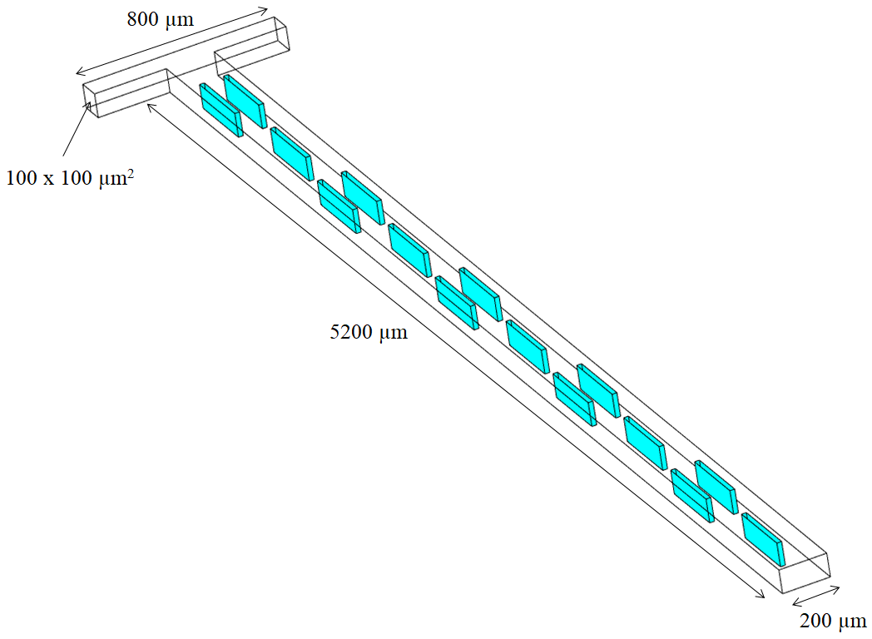

Fig. 1 3-D schematic of T-mixer with TDOs



Fig. 2 Grid of T-mixer with TDOs

Two liquid species ‘*a*' and ‘*b*', with same properties of liquid water at 20°C (density *ρ* = 998.2 kg/m3, dynamic viscosity *μ* = 0.001 Pas and diffusion coefficient *D* = 2 x 10-9 m2/s, were chosen to be mixed in the micromixer for all the simulations. The concentration in terms of the mass fraction for the boundary condition is set to one for species ‘a' and set to zero for species ‘b' at the left inlet and vice versa at the right inlet. The pressure at the outlet of the mixer is set to atmospheric pressure. The boundary conditions are provide in Table 1. Steady laminar flow model along with the species transport model is used to solve the flow mixing problem. The pressure-velocity coupling and the spatial discretization methods used for pressure, momentum, and species transport equations are tabulated in Table 2. The convergence criterion for the residuals is set to 10-6 for continuity and 10-5 for momentum and species equations.

**Table 1: Boundary conditions used in numerical simulations**

|  |  |  |  |
| --- | --- | --- | --- |
| Case | Velocity at left inlet (m/s) | Velocity at right inlet (m/s) | *Reynolds* number |
| I | 0.015 | 0.015 | 2 |
| II | 0.045 | 0.045 | 6 |
| III | 0.08 | 0.08 | 10 |
| IV | 0.25 | 0.25 | 33 |
| V | 0.5 | 0.5 | 66 |
| VI | 0.8 | 0.8 | 106 |
| VII | 1 | 1 | 133 |
| VIII | 1.1 | 1.1 | 146 |
| IX | 1.2 | 1.2 | 159 |
| X | 1.6 | 1.6 | 212 |
| XI | 2 | 2 | 265 |
| XII | 2.4 | 2.4 | 318 |
| XIII | 2.6 | 2.6 | 345 |

**Table 2: The solution methods of numerical simulation**

|  |  |
| --- | --- |
| Pressure-velocity coupling | SIMPLEC |
| Pressure | Standard |
| Momentum | Second order Upwind scheme |
| Species | Second order Upwind scheme |
| Energy | Second order Upwind scheme |

**2. 3. Grid Independence Test**

As mentioned above, commercial numerical tool, ANSYS Fluent, is used to solve the mixing phenomenon in the T-mixer with TDOs. Grid independence test has been carried out to find the required mesh size for the accurate analysis of fluid flow and mass transfer in T-micromixer (Fig. 3). Figure 3 shows the variation of axial velocity at the outlet centreline of T-micromixer with TDOs at a *Re* of 320. The maximum deviation in the axial velocity obtained for 6 and 5 micron mesh elements is 1.3 percent, whereas, for 5 and 4 micron mesh elements is only 0.8 percent. Therefore, the grid with 5 micron size element is chosen for the current study.

Fig. 3 Axial velocity profiles on the outlet centreline of T-mixer with TDOs at *Re* = 318

1. **Results and Discussion**

**3.1 Basic T-mixer**

Initially, the mixing performance of T-mixer has been evaluated in the *Re* number range of 0 to 320. At very low *Re* numbers (0 to 66), the flow in T-micromixer exhibits a completely laminar behaviour (Fig. 1a). Therefore, mixing takes place only due to diffusion between the small interfacial area between the samples at which they come into contact in the mixing channel (Fig. 1b). In the *Re* range of 100 to 160; the vortices are formed at the junction of T-mixer (Fig. 2a). However, the mixing has further decreased (Fig. 2b) as the residence time for samples has reduced. Also, the formation of vortices has resulted only in the self-rotation confining them to the same side (left/right) of their entrance in the mixing channel (Fig. 2a). On further increase of *Re*, the break-up of vortices at the junction of T-mixer occurred (Fig. 3a). The engulfment of samples taking place has significantly increased the mixing performance of T-mixer (Fig. 3b) in the *Re* range of 180 to 320.

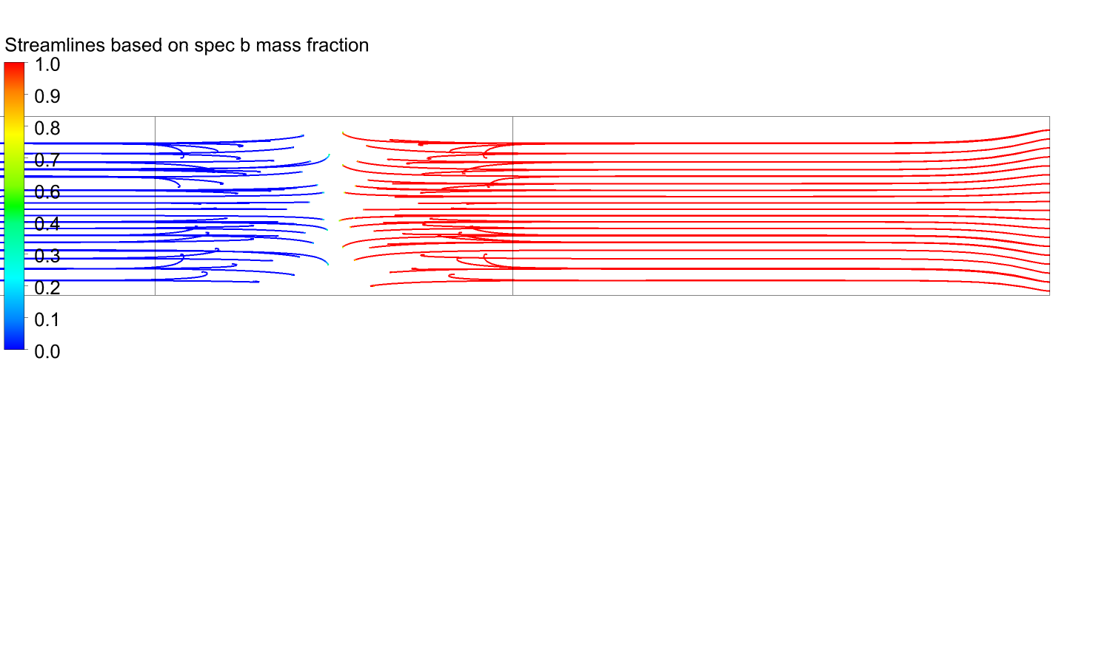 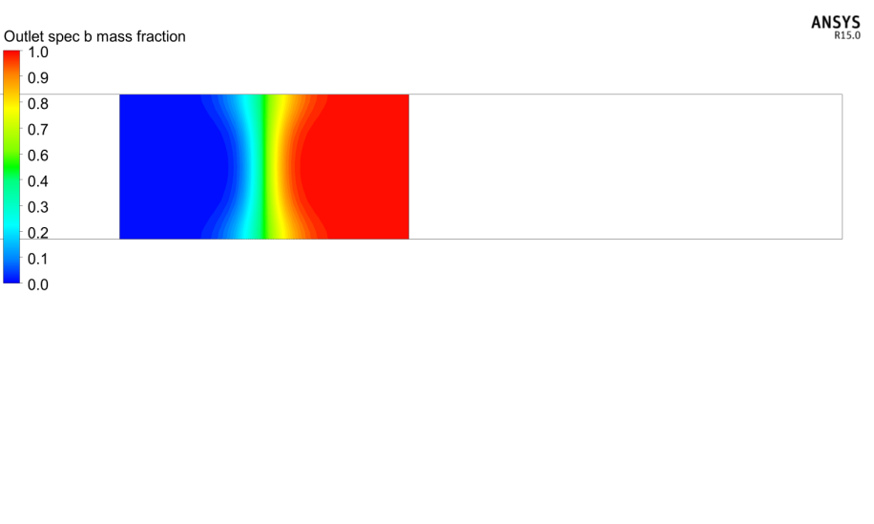

(a) (b)

Fig. 4 Front view from outlet of T-mixer at *Re* = 66 (a) streamlines and (b) mass fraction contour

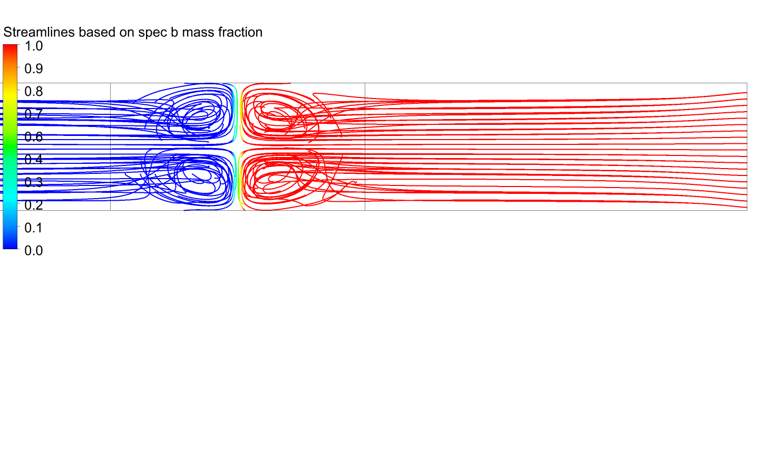 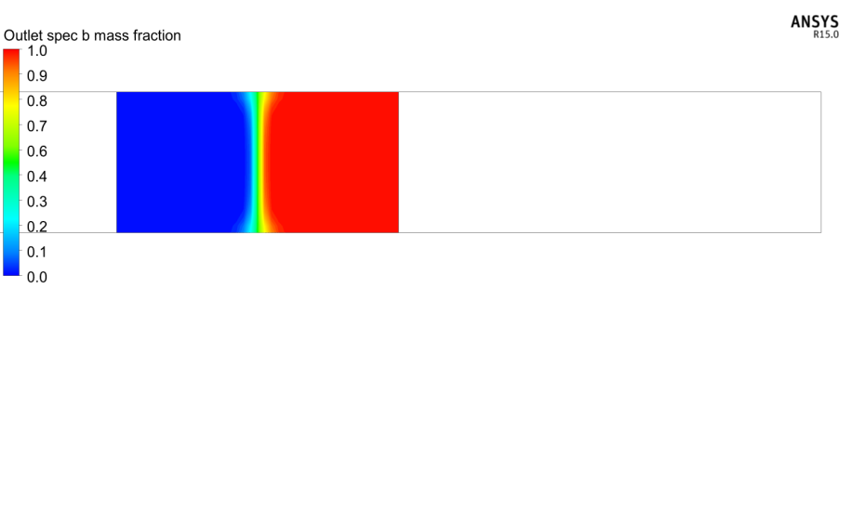

(a) (b)

Fig. 5 Front view from outlet of T-mixer at Re = 160 (a) streamlines and (b) mass fraction contour 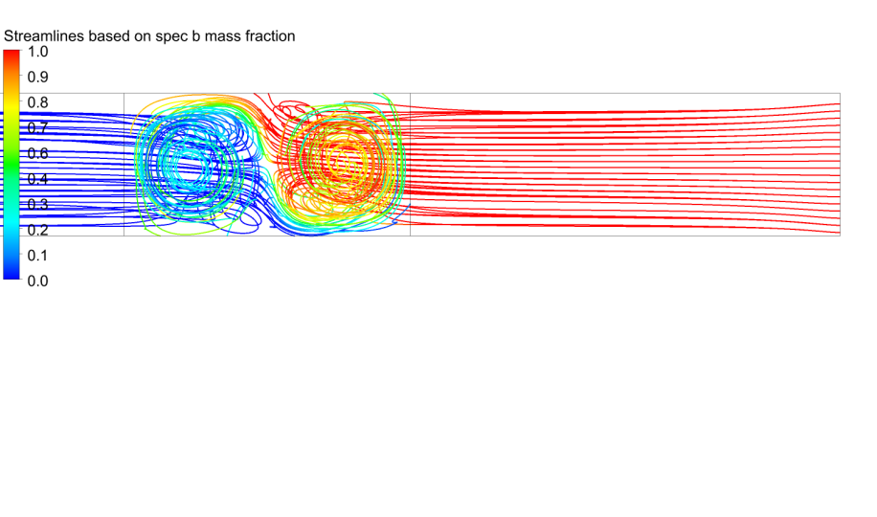 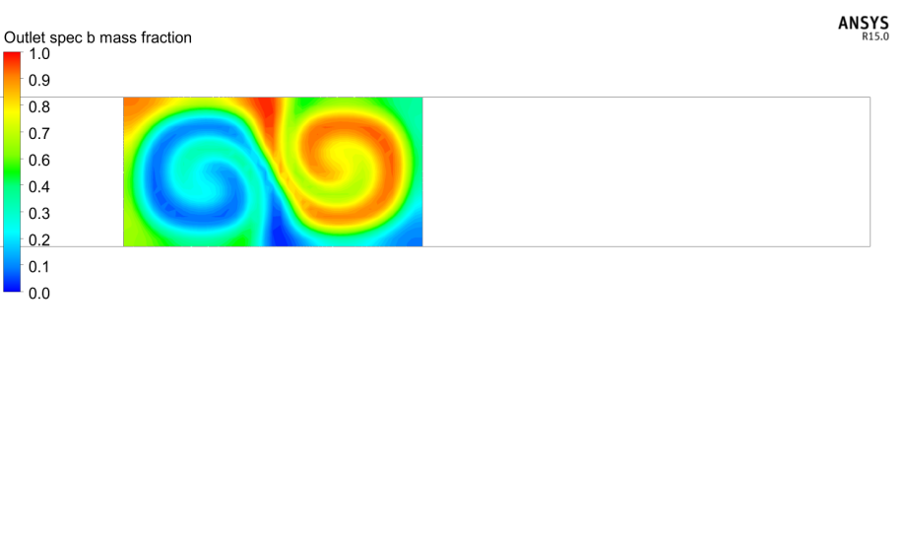

(a) (b)

Fig. 6 Front view from outlet of T-mixer at Re = 266 (a) streamlines and (b) mass fraction contour

**3.2 T-mixer with Taylor dispersion obstructions**

The mixing performance of T-mixer with obstructions of Taylor dispersion type has been evaluated in the *Re* number range of 0 to 350. The influence of TDOs in the mixing channel at low *Re* flows (0 to 150) is considerably small. However, a major influence on the mixing phenomenon has been observed particularly at high *Re* flows of 250 to 350 with the presence of TDOs in the mixing channel.

**3.2.1 Low *Re* flows**

In the *Re* range of 0 to 66, the presence of TDOs in the mixing channel has produced negligibly small effect on the mixing phenomenon of T-mixer (Fig. 7). The velocity gradients created near the surface of TDO is quickly damped by the dominant viscous forces. In the *Re* range of 100 to 150, even though there is some increase in the inertial effects, only a little improvement in the mixing quality is obtained. This is due to the fact that the vortices generated in the flow in this regime have simply made a rotational flow around the TDOs which did not favour the creation of velocity gradients in the flow. Therefore, there is no improvement in the mixing quality of T-mixer with TDOs (Fig. 8a) as compared to conventional T-mixer (Fig. 8a).

Fig. 7 Variation of mixing quality with *Re* number

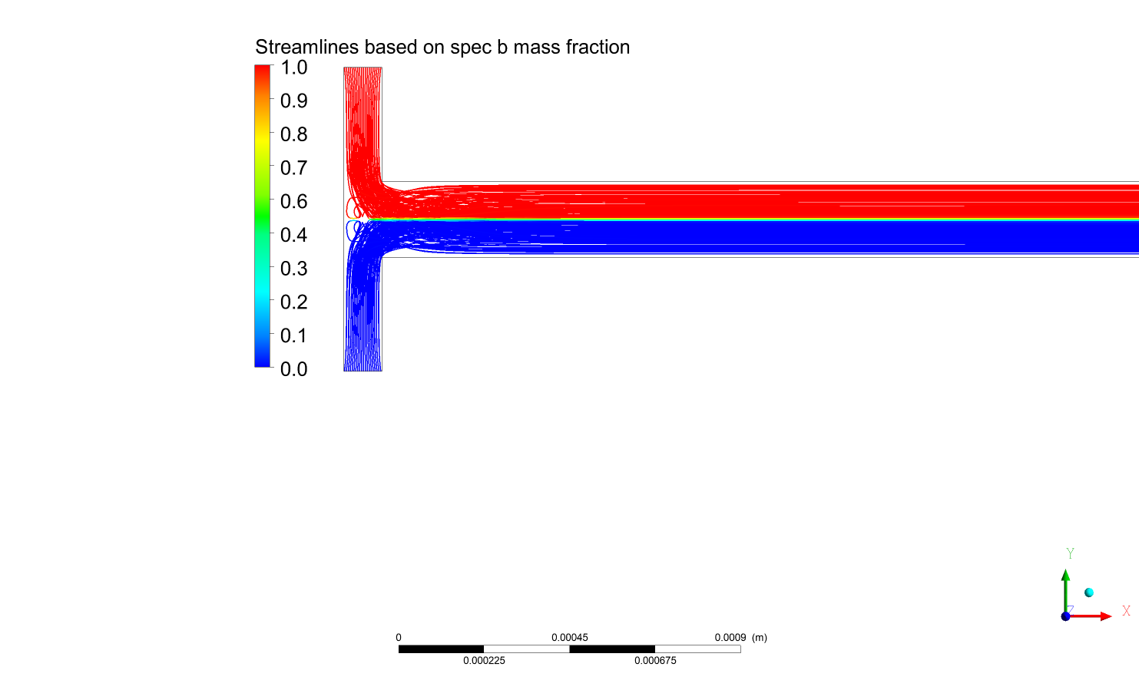 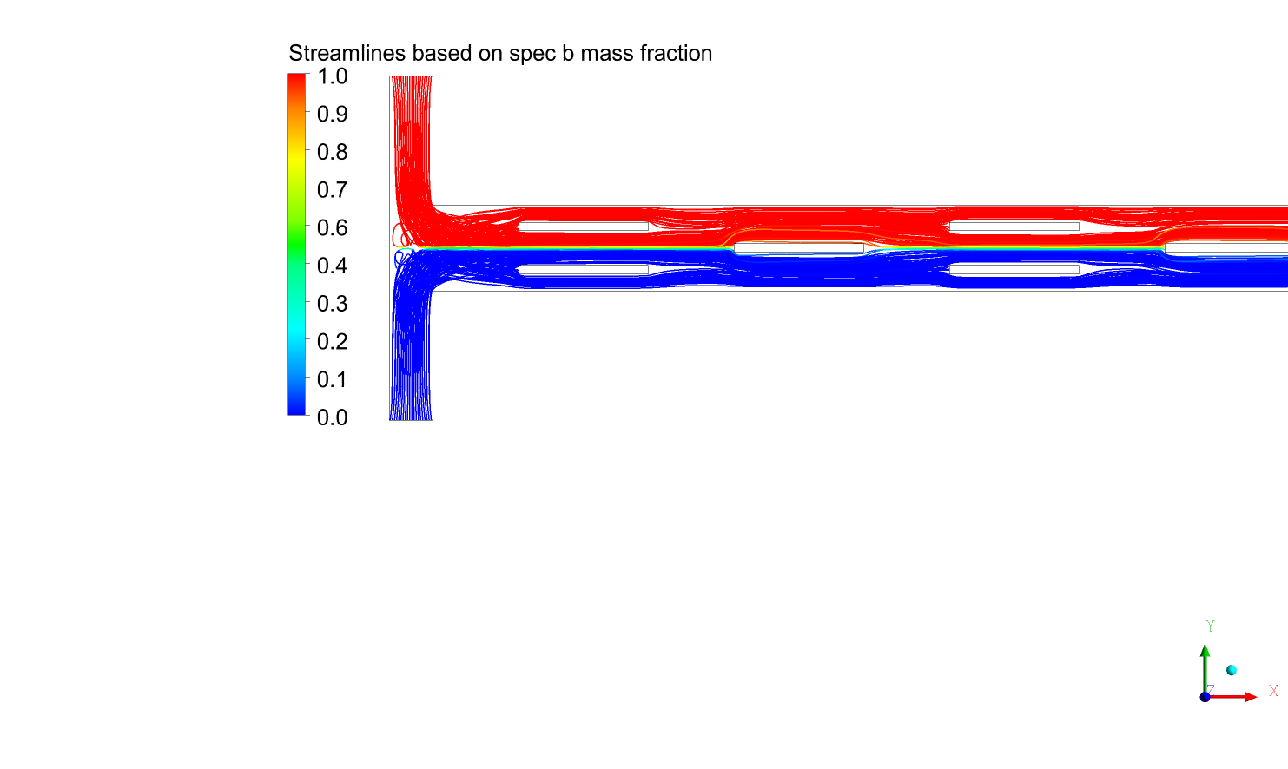

(a) (b)

Fig. 6 Streamlines from top view at *Re* = 133 (a) T-mixer and (b) T-mixer with TDOs

**3.2.2 High *Re* flows**

In the *Re* range of 150 to 220, clearly the engulfment flow is the most dominating convective effect in the T-mixer. Therefore, the presence of TDOs in the mixing channel did not show any influence on the mixing performance of T-mixer (Fig. 9). On further increase of flow rate (*Re* > 220) a significant increase in the mixing quality has been obtained with TDOs in the mixer (Fig. 10b) as compared to basic T-mixer (Fig. 10a). It is observed that with higher *Re*, the engulfment effects are reduced in the T-mixer (Fig. 11a) and the inertial effects are dominated. Hence, the effect of velocity gradients (Taylor dispersion) has a major influence on the flow (Fig. 11b) and thereby a significant enhancement is obtained in the higher *Re* flows (250 to 350).

Fig. 9 Variation of mixing quality with Re number

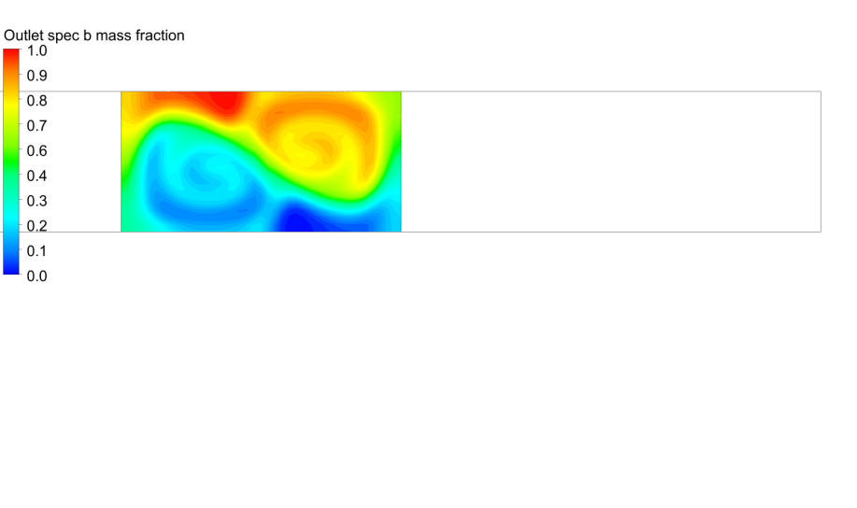 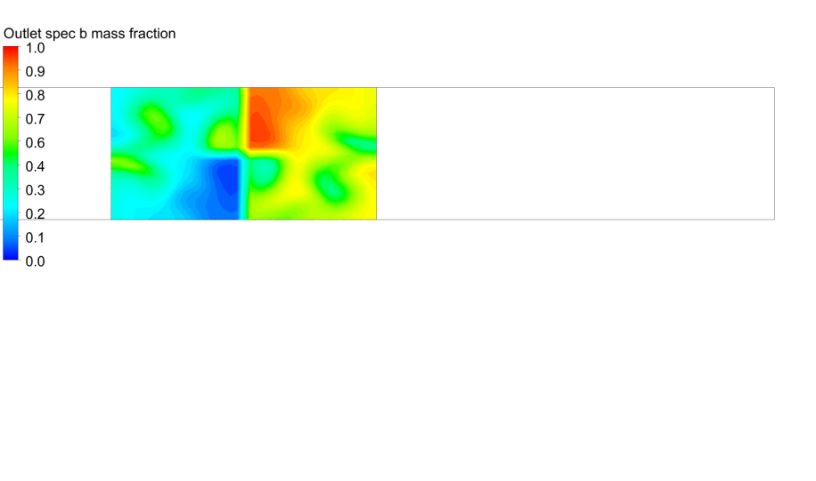

(a) (b)

Fig. 6 Outlet mass fraction contours at *Re* = 345 (a) T-mixer and (b) T-mixer with TDOs

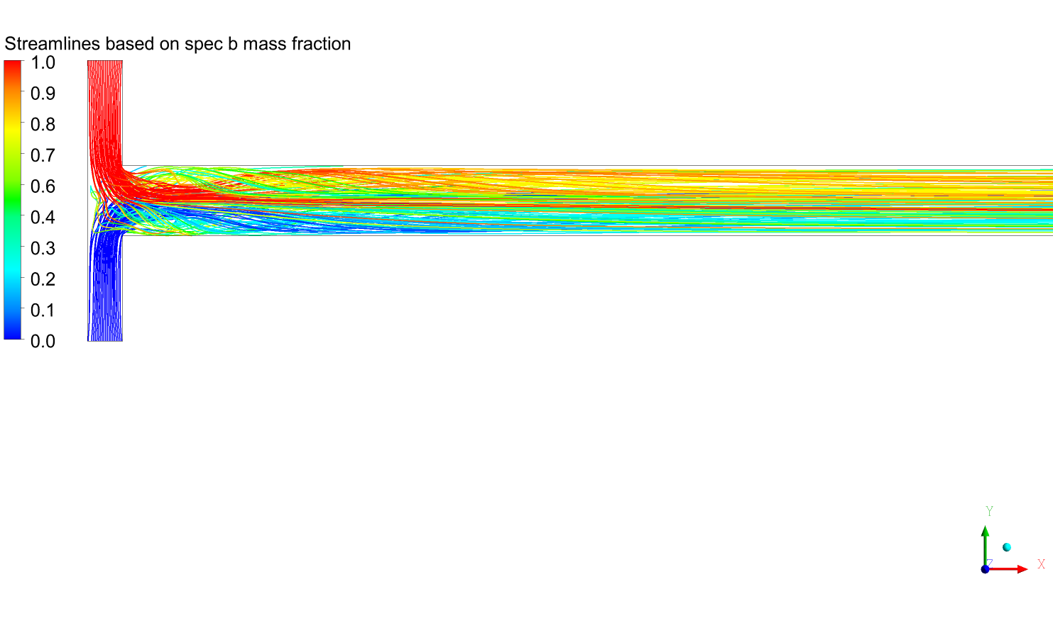

(a)

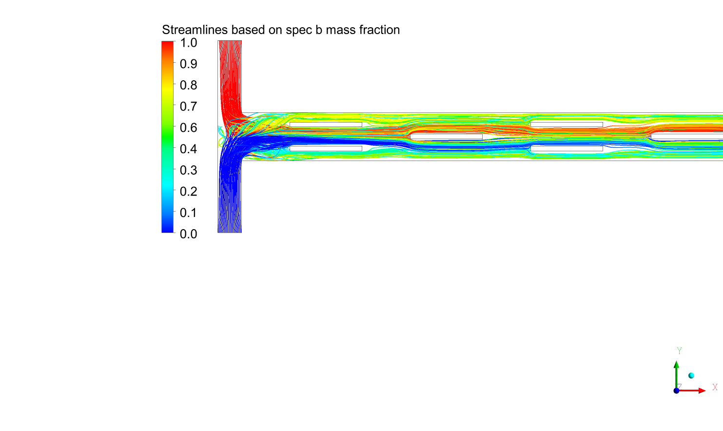

(b)

Fig. 6 Streamlines from top view at *Re* = 345 (a) T-mixer and (b) T-mixer with TDOs

**4. Conclusion**

The effect of Taylor dispersion type obstructions to create velocity gradients in the flow of T-micromixer to improve its efficiency has been investigated in the current study. It is found that at lower *Re* (0 to 66) the velocity gradients created on the surface of TDO (Taylor Dispersion Obstruction) are quickly damped by the dominating viscous effects. In the *Re* range of 100 to 150, the vortex nature of the flow in T-mixer did not favour the creation of velocity gradients with TDOs in the mixing channel. In the engulfment regime of T-mixer (160 to 220), there is negligible influence of TDOs on the mixing performance. However, in the higher *Re* (250 to 350) due to the dominant inertial effects, better velocity gradients are created in the flow and a significant increase in mixing is obtained with the presence of TDOs in the mixing channel as compare to basic T-mixer. Therefore, it is concluded that the presence of Taylor Dispersion type obstructions in T-mixer has shown a considerable influence and improved the mixing performance only at higher *Re* flows (250 to 350).

**References**

1. C. K. Chan, Y. Hu, S. Takahashi, D. L. Rousseau, W. A. Eaton and J. Hofrichter, Proc. Natl. Acad. Sci. U. S. A. 94, 1779 (1997).

2. C. Zhang, D. Xing and Y. Li, Biotechnol. Adv. 25, 483 (2007).

3. K. Y. Lu, A. M. Wo, Y. J. Lo, K. C. Chen, C. M. Lin and C. R. Yang, Biosens. Bioelectron. 22, 568 (2006).

4. S. Suga, A. Nagaki and J. Yoshida, Chem. Commun., 354 (2003).

5. S. Freitas, B. Rudolf, H. P. Merkle and B. Gander, Eur. J. Pharm. Biopharm. 61, 181 (2005).

6. T. Bayer, M. Matlosz, J. Jenck, Chem. Ing. Technol. 76, 528 (2004).

7. Bau, Haim H., Jihua Zhong, and Mingqiang Yi, Sens. Actuators, B Chem. 79, 207 (2001).

8. Yaralioglu, Goksen G., Ira O. Wygant, Theodore C. Marentis, and Butrus T. Khuri-Yakub, Anal. Chem. 76, 3694 (2004).

9. Cho, Ching-Chang, Microfluid Nanofluid. 5, 785 (2008).

10. Chung, Chen-Kuei, T. R. Shih, B. H. Wu, and C. K. Chang, Microsyst Technol. 16, 1595 (2010).

11. Buchegger, Wolfgang, Christoph Wagner, Bernhard Lendl, Martin Kraft, and Michael J. Vellekoop, Microfluid Nanofluid. 10, 889 (2011).

12. Nimafar, Mohammad, Vladimir Viktorov, and Matteo Martinelli, Chem. Eng. Sci. 76, 37 (2012).

13.Gobby, D., P. Angeli, and Asterios Gavriilidis, J Micromech. Microeng. 11, 126 (2001).

14. Deerberg, Görge, Jürgen Grän‐Heedfeld, Torsten Hennig, and Eckhard Weidner, Chemie Ingenieur Technik 77, 1501 (2005).

15. Hoffmann, Marko, Michael Schlüter, and Norbert Räbiger, Chem. Eng. Sci. 61, 2968 (2006).

16. Engler, Michael, Norbert Kockmann, Thomas Kiefer, and Peter Woias, Chem. Eng. Sci. 101, 315 (2004).

17. Bökenkamp, Dirk, Amish Desai, Xing Yang, Yu-Chong Tai, Elaine M. Marzluff, and Stephen L. Mayo, Anal. Chem. 70, 232 (1998).

18. Wong, Seck Hoe, Michael CL Ward, and Christopher W. Wharton,Sens. Actuators, B Chem. 100, 359 (2004).

19. Soleymani, A., E. Kolehmainen, and I. Turunen, Chem. Eng. J. 135, S219 (2008).