NUMERICAL ESTIMATION OF ULTIMATE SPECIFICATION OF TILT- HEXACOPTER

Vijayanandh R1a,\*, Senthil Kumar M 2b,\*, Raj Kumar G, Ramesh M, Balaji S, Thianesh U K

*a Aeronautical Engineering, Kumaraguru College of Technology, Coimbatore, Tamil Nadu, India*

\*Corresponding author Email: [vijayanandh.raja@gmail.com](mailto:vijayanandh.raja@gmail.com)

**Abstract:** Advanced multi-rotor UAVs are emerging one, in which the complex manuvering is achieved with the help of tilting mechanism. In this article deals the numerical estimation of maximum specification of tilt-hexacopter, which indented for critical applications. Maximum forward speed and rate of climb are the parameters fundamentally taken for spaeciactional study. The reference components of Tilt-Hexacopter are modelled by CATIA and the numerical simulations are carried out with the help of ANSYS Workbench 16.2, in which drag force, coefficient of drag are mainly considered as evolutional parameters. Finally Comparative analysis have been carried out for different case as well as different manuvering, in which the maximum forward speed is predicted as 40 m/s and maximum rate of climb is predicted as 30 m/s.

**Keywords:** Specification, Forward Speed, Vertical Speed,

# Unmanned Aerial Vehicle (UAV)

## Multi-rotor UAV

Nowadays unmanned aerial vehicles (UAVs) are an important part of scientific study in both military and space. As a substitute for human piloted vehicles they are advantageous to protect human life in multiple dangerous environments. The irreliabilities in tough circumstances are much higher than their counter parts. Especially, multi-rotor UAVs like tricopter, quadcopter, hexacopter are plays the vital role in complex application. While undergoes the complex applications, the multi-rotor UAVs get structural failures or else insufficient to complete the complex surveillance. In order to execute the perfect surveillance in the complex region, the multi-rotor UAVs need to undergo engineering analyses in the perspective of complex test. In this work deals the estimation of advanced multi-rotor UAV’s [Tilt-Hexacopter] specification with the help of numerical simulation

## Summary

From the survey, the major problems in the advanced multi-rotor UAVs [Tilt-Hexacopter] were analyzed, in which the prime problems are it does not provide safety to its parts, the life cycle of the components is less, and it does not have safe landing and takeoff. To overcome these problems the Tilt-Hexacopter has to undergo numerical simulation in order to estimate its ultimate specification details. The ideal choice for critical environment workers is this Tilt-Hexacopter is best suitable for any critical environment operation such as border surveillance, forest surveillance, etc. Also, from the field work it is understood that, specification study of UAVs are mandatory in order to segregate the UAVs implementation in different applications and thereby learned that advanced numerical simulation is the only way to simulate the aerodynamics behaviour of Tilt-Hexacopter while undergoing critical manuvering in the critical environment.

# Tilt-Hexacopter

## Specification

Traditionally in fixed wing UAV, lot of research has been done to incorporate vertical take-off and landing (VTOL) feature and to increase its manoeuvrability. The alternative was the rotary wing UAV which is more manoeuvrable and has the VTOL Feature. The problem associated with rotary wing UAV is that their efficiency and retreating blade stall. Hence the solution for existing problems in fixed-wing and rotary wing UAVs is an advanced UAV, which should have the capability to undergo VTOL as well as high forward speed. The concept used is in this hybrid UAV is tilt rotor mechanism, in which the proposed VTOL Tilt-Hexacopter consists of 6 motors, in which each propeller capable to provide maximum of 500 gram thrust in order to lift the 1.5 kg Tilt-Hexacopter. It have stable platform, higher efficiency and can attain higher speeds than a normal multi-rotor UAVs with the help of its tilting mechanism. A positive modification in the specification of UAVs is the best way to fulfil the upcoming complex requirements, in which high lifetime, high forward speed, long endurance and range, stable surveillance are the prime. In this paper deals the estimation of high forward speed and vertical speed of the Tilt-Hexacopter with the help of advanced numerical simulations.

## Conceptual Design

The complete 3-Dimensional diagram of the UAV is the consolidated output from its conceptual design. In order to construct a successful 3-D Tilt-Hexacopter, certain preliminary steps are need to complete, which are outer boundary of Tilt-Hexacopter, complete details of components, location of components and their complete dimensions, centre of gravity location, centre of thrust estimation. In this Tilt-Hexacopter, all the preliminary steps were completed and finalized 3-D diagram also modelled with the help of CATIA, which are shown in the figure 1 and 2. Figure 1 and 2 shows the different operational mode of Tilt-Hexacopter, in which HTOL mode is shown in the figure 2 and VTOL mode is revealed in the figure 1.

|  |  |
| --- | --- |
| without landing vtol.jpg | without landing forward.jpg |
| 1. Hexacopter in VTOL mode | 1. Tilt-Hexacopter in HTOL |

# Numerical Simulation

## Computational Fluid Dynamics (CFD) - ANSYS Workbench

CFD deals the prediction of fluid behaviour on the given object with the help of computerized set of algebraic equations. In which, fluid such as gas and liquid properties are governed by partial differential equations which represent conservation laws for the mass, momentum, and energy. The equations of fluid flow are based on fundamental physical conservation principles, which primarily deals conservation of mass and conservation of momentum. Primarily four parameters need to be estimate, which are pressure, velocity in x, y, z directions then turbulence prediction is secondary parameter estimation. Conservation of principles are tool used to estimate primary parameters directly and indirectly helped to predict the turbulence behavior. Currently numerical methods have been used as solve the fluid behavior due to complex of conservation of principle. The main stages in an Ansys software simulation are Pre-processing, in which formulate problem like geometry, equations, and boundary conditions and construct a computational mesh such as set of control volumes are completed. Solver stage comprises of the discretize the governing equations, solve the resulting algebraic equations finally post-processing executes analyze results and visualize.

## Boundary Condition

In numerical simulation, boundary conditions are capable to initiate the whole process. In this paper, pressure based solver is used because of the Tilt-Hexacopter working environment, in which Tilt-Hexacopter has comes under the low speed incompressible operation. Absolute system is selected in order to cover the whole system with the global coordinate system. Rotating propellers plays vital role in multi-rotor UAV so the effect due to propellers is much more important especially turbulence generation around the propellers is focal role in the UAV aerodynamics. In this paper k-epsilon turbulence model is used, which have the high capable to capture the turbulence, flow separation with the help of its two equations such as kinetic energy of the turbulence and dissipation rate of turbulence. Since the multi rotor UAV has limitation in the forward speed, which is comes under the low speed operation so the velocity inlet is preferable for this simulation also pressure outlet has been suggested and used. After the assignment of artificial boundary conditions, the process of physical boundary conditions have been completed in which the no slip conditions is given on the solid-fluid interaction surface on the tilt-hexacopter and free slip conditions has been to the external domain exterior part. 101325 Pa has been given as operating pressure so the value of gauge pressure value is given as 0 Pa. Least square solution methodologies is selected because of the unstructured mesh generation also higher order equation is selected in order to get high accrued results. Flow analysis over the Tilt-Hexacopter is complicated analysis, which may affect the numerical results and thereby unstable variation takes place in the output residual so relaxation factor has been reduced 20 %.

## Result

### Without Landing Gear Hexacopter - VTOL: Velocity 30m/s

|  |  |
| --- | --- |
|  | Velocity.png |
| 1. Pressure variation | 1. Planar view of Velocity variation |

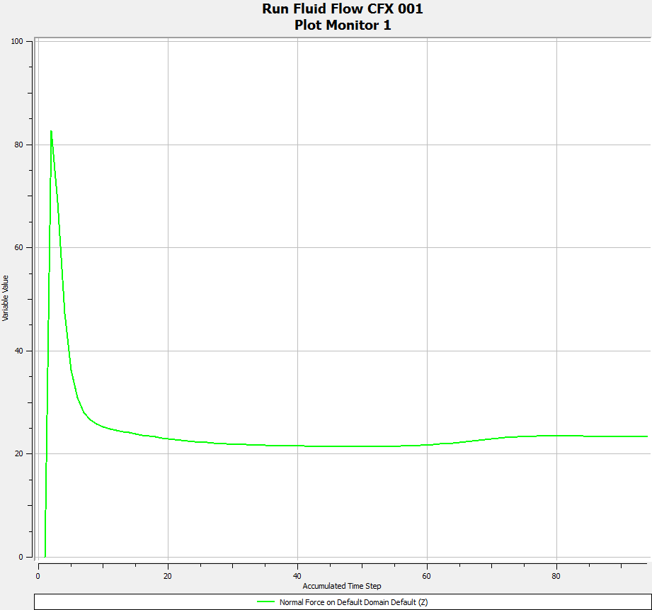

1. Drag Plot for 30 m/s

Figure 3 and 4 shows the pressure variation on the entire Tilt-Hexacopter and velocity variation in the planner view respectively. Figure 5 show the drag plot of the Tilt-Hexacopter for the fluid velocity of 30 m/s, in this case drag estimation axis is Z-axis.

### Without Landing Gear Hexacopter - VTOL: Velocity 35m/s

|  |  |
| --- | --- |
| **Pressure_Streamline_2.png** | **Velocity_1.png** |
| 1. Pressure variation | 1. Planar view of Velocity variation |

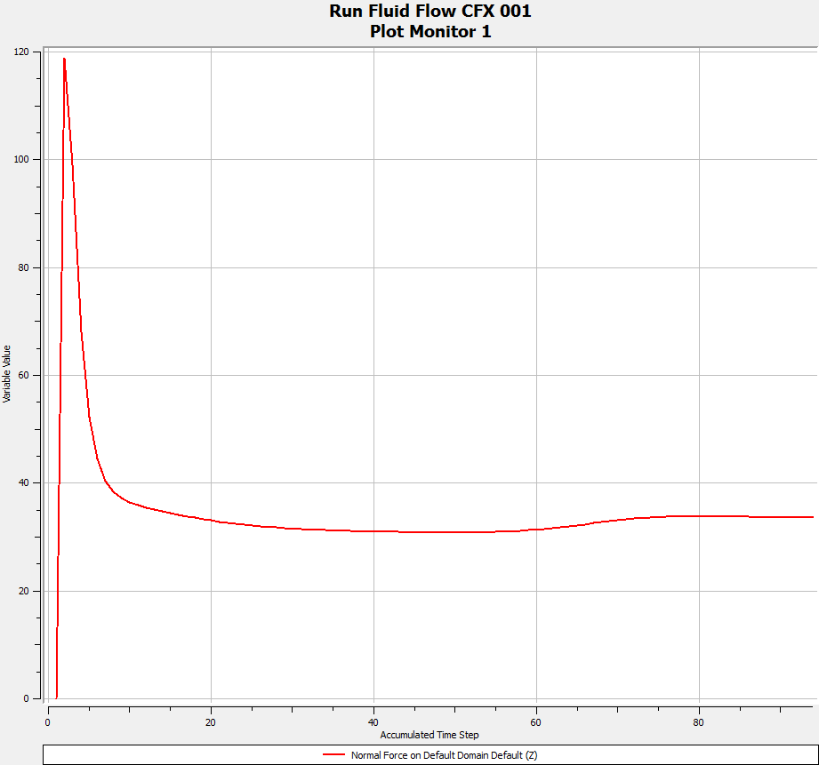

1. Drag Plot for 35 m/s

Figure 6 and 7 shows the pressure variation on the entire Tilt-Hexacopter and velocity variation in the planner view respectively. Figure 8 show the drag plot of the Tilt-Hexacopter for the fluid velocity of 35 m/s, in this case drag estimation axis is Z-axis.

### Without Landing Gear Hexacopter - HTOL: Velocity 30 m/s

|  |  |
| --- | --- |
| **pressure streamline.png** | **velocity plane 30ms.png** |
| 1. Pressure variation | 1. Velocity variation |

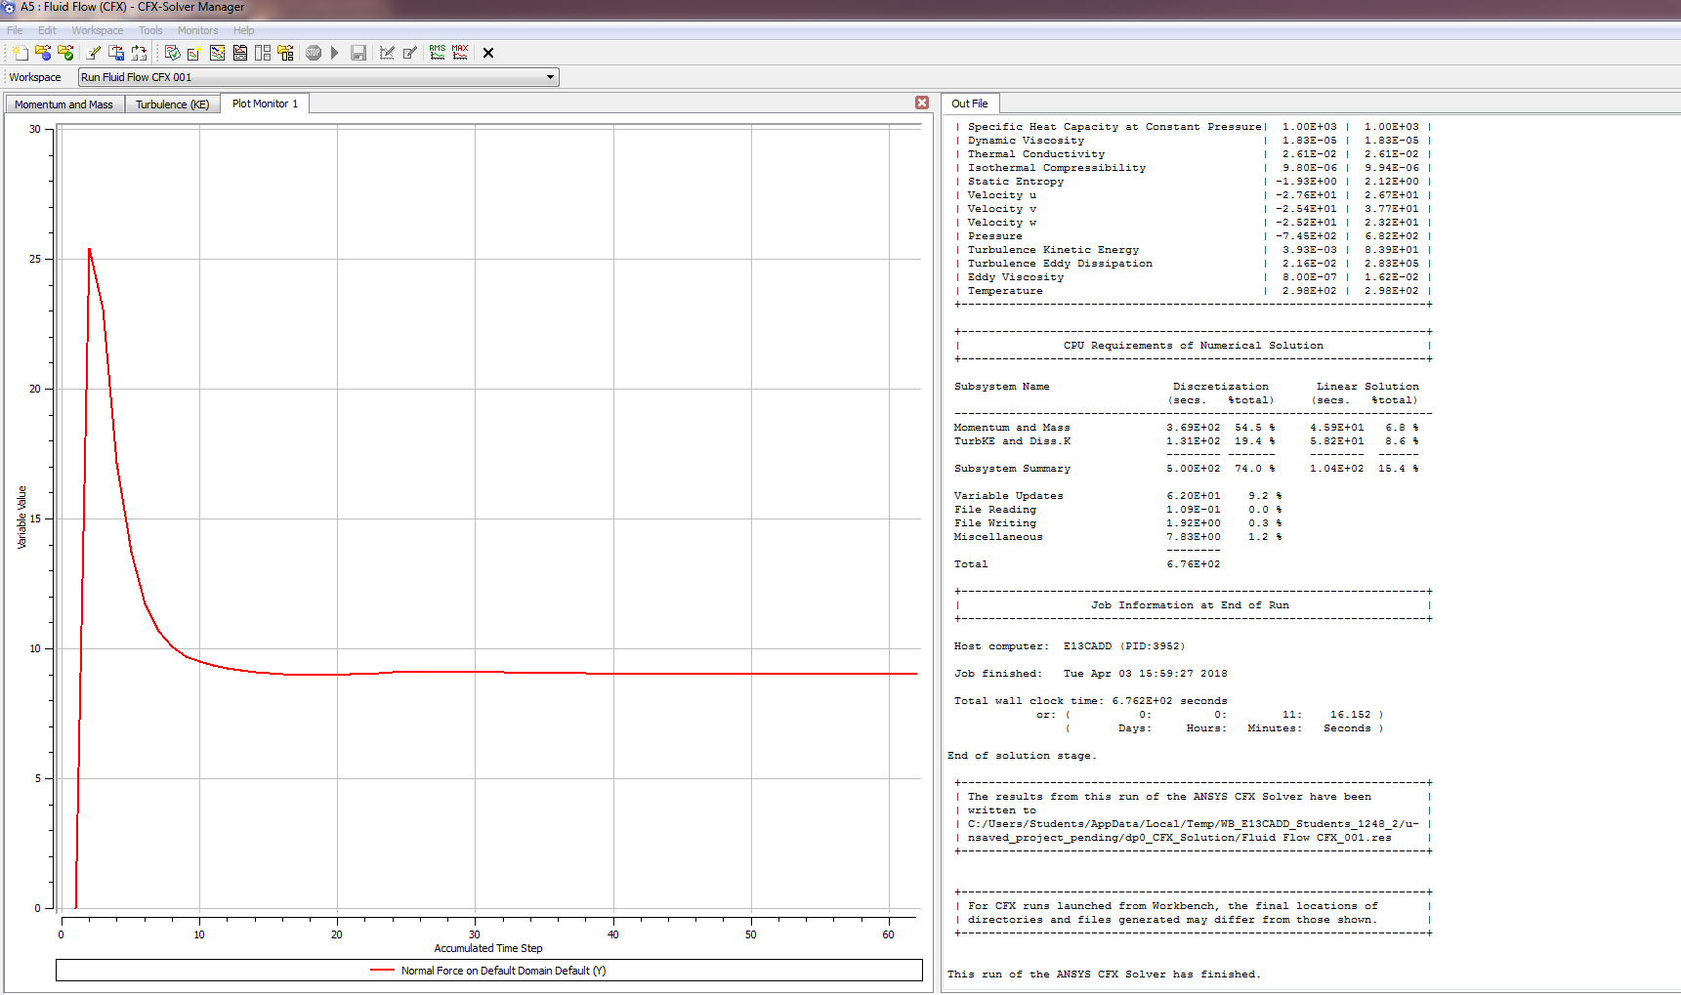

1. Drag Plot for 30 m/s

Figure 9 and 10 shows the pressure variation on the entire Tilt-Hexacopter and velocity variation in the planner view respectively. Figure 11 show the drag plot of the Tilt-Hexacopter for the fluid velocity of 30 m/s, in this case drag estimation axis is Y-axis.

### Without Landing Gear Hexacopter - HTOL: Velocity 35 m/s

|  |  |
| --- | --- |
| **pressure streamline.png** | **velocity plane.png** |
| 1. Pressure variation | 1. Velocity variation |

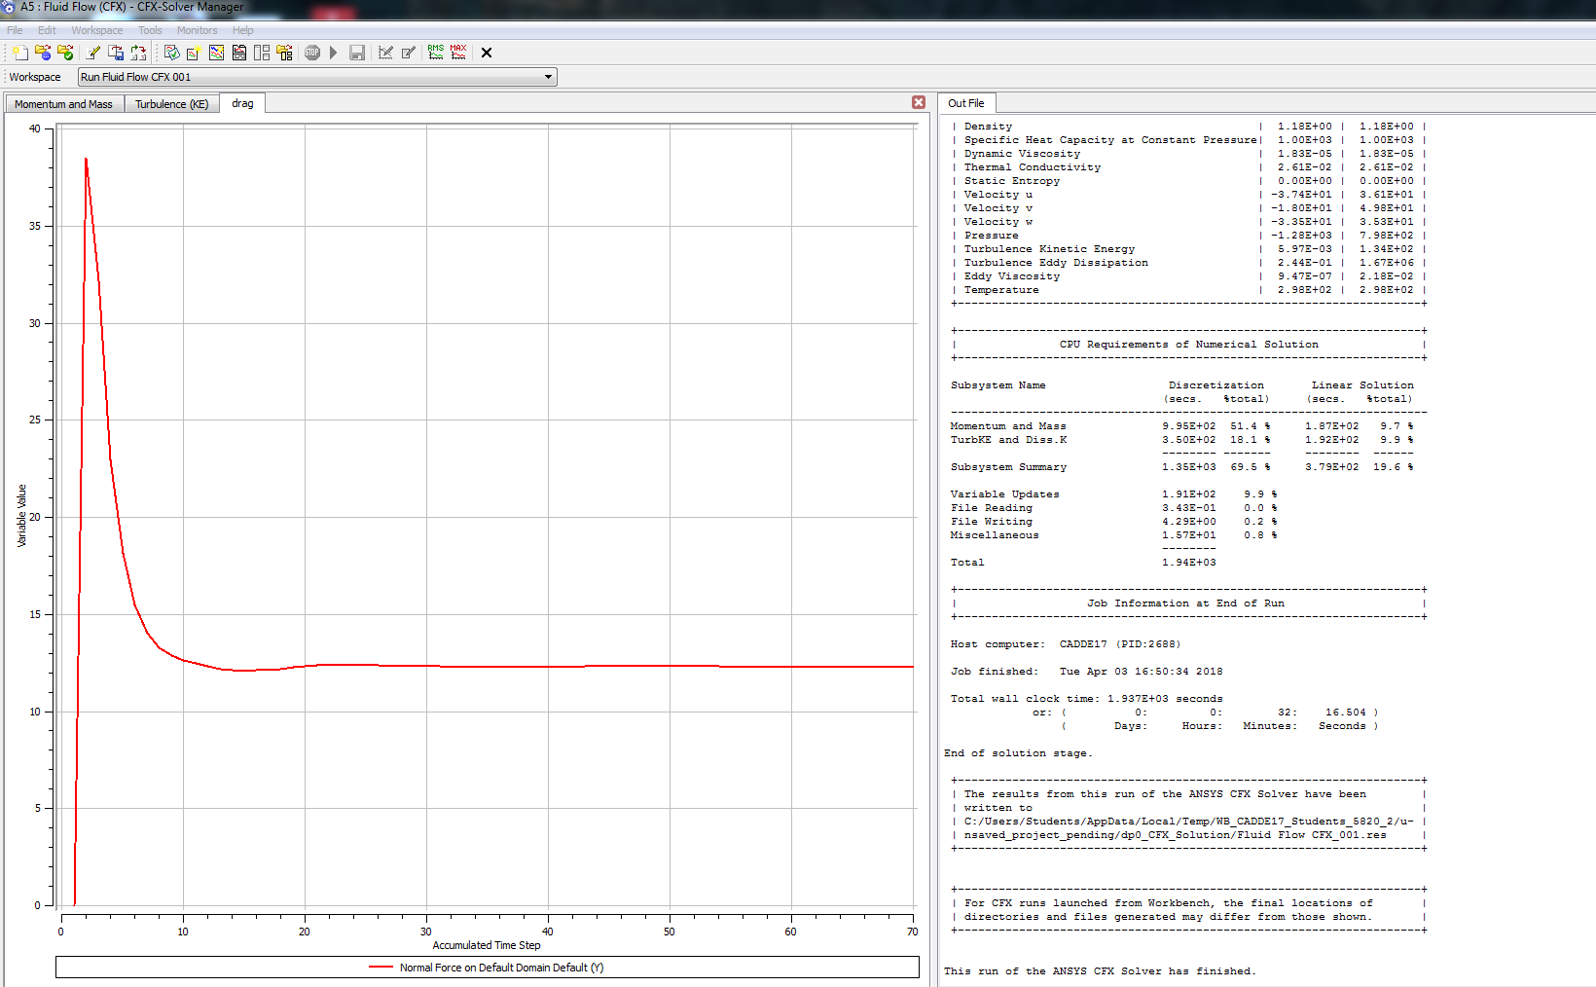

1. Drag Plot for 35 m/s

Figure 12 and 13 shows the pressure variation on the entire Tilt-Hexacopter and velocity variation in the planner view respectively. Figure 14 show the drag plot of the Tilt-Hexacopter for the fluid velocity of 35 m/s, in this case drag estimation axis is Y-axis.

### Without Landing Gear Hexacopter - HTOL: Velocity 40 m/s

|  |  |  |
| --- | --- | --- |
| **pressure streamline contour.png** | **velocity plane contour.png** | |
| 1. Pressure variation | 1. Planar view of Velocity variation |

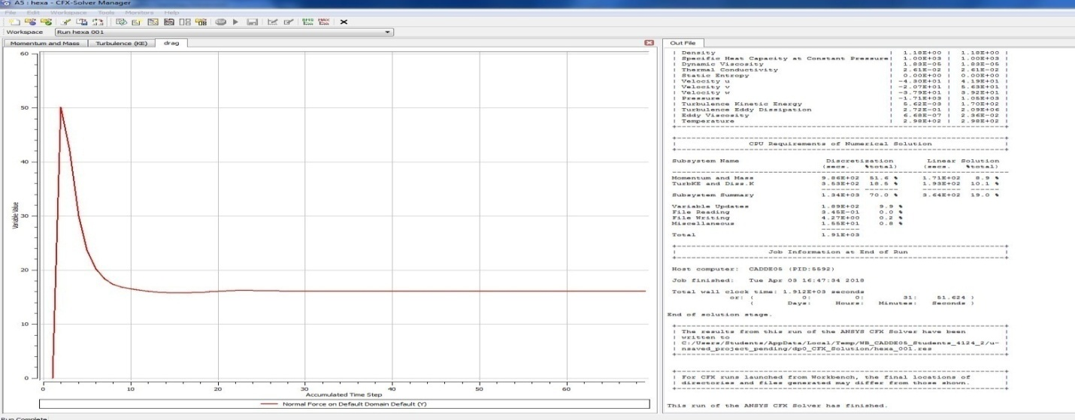

1. Drag Plot for 40 m/s

Figure 15 and 16 shows the pressure variation on the entire Tilt-Hexacopter and velocity variation in the planner view respectively. Figure 17 show the drag plot of the Tilt-Hexacopter for the fluid velocity of 40 m/s, in this case drag estimation axis is Y-axis.

### Without Landing Gear Hexacopter - HTOL: Velocity 45 m/s

|  |  |
| --- | --- |
| **pressure contour 45.png** | **velocity plane 45.png** |
| 1. Pressure distribution | 1. Planar view of Velocity variation |

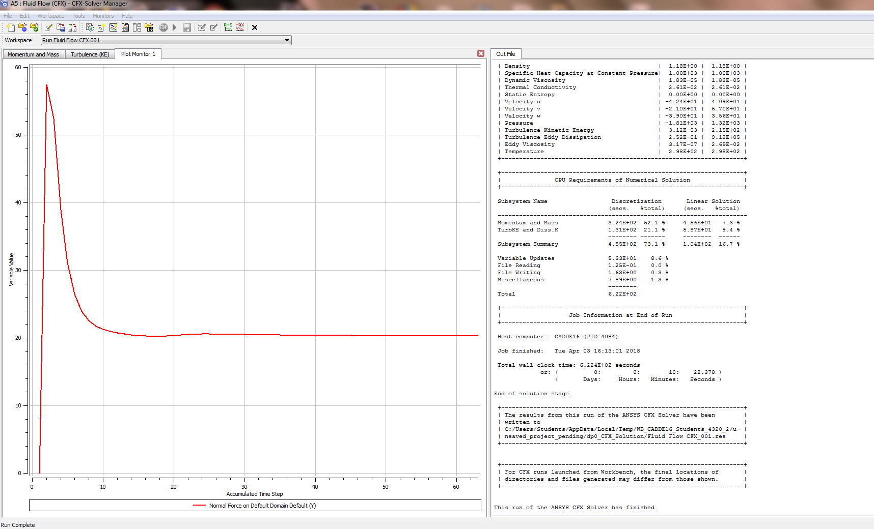

1. Drag Plot for 45 m/s

Figure 18 and 19 shows the pressure variation on the entire Tilt-Hexacopter and velocity variation in the planner view respectively. Figure 20 show the drag plot of the Tilt-Hexacopter for the fluid velocity of 45 m/s, in this case drag estimation axis is Y-axis.

## COMPARATIVE ANALYSIS of FORCES

### Overall comparison of CFX (HTOL) analysis

Table 1 contains the comparative details of the force values on the Tilt-Hexacopter for different velocities of HTOL mode. In the case of VTOL mode, the results are listed in the table 2.

1. Comparative analysis of force values of velocity

|  |  |  |  |  |
| --- | --- | --- | --- | --- |
| Axis | Without Landing Gear (N) | | | |
| Velocity (m/s) | 30 | 35 | 40 | 45 |
| X-Axis | 0.129794 | -0.152018 | -0.350575 | -0.278742 |
| Y-Axis (drag) | 9.31158 | 12.7161 | 16.6126 | 20.9441 |
| Z-Axis (lift) | 0.1374944 | 0.160803 | 0.171466 | 0.336995 |

### Overall comparison of CFX (VTOL) analysis

1. Comparative analysis of force values of velocity

|  |  |  |
| --- | --- | --- |
| Axis | Without Landing Gear (N) | |
| Velocity (m/s) | 30 | 35 |
| X-AXIS | 0.289535 | -0.31285 |
| Y-AXIS | 0.0252483 | -0.026001 |
| Z-AXIS (DRAG) | 32.761 | 46.0402 |

In HTOL operation, tilting mechanism contributes high thrust, which supported towards the drag comparison of different velocities. From the Table 1, it is understood that drag force varies 1.5 kg to 2 kg for the velocity range of 40 m/s to 45 m/s. For VTOL case, 30 m/s the drag force induced is 3.34069 kg and 4.69479 is the drag force acting on the Tilt-Hexacopter, when it undergoes at the speed of 35 m/s.

# CONCLUSION

The preliminary design calculation on the Tilt-Hexacopter was estimated for components fixing and thereby the design of the Tilt-Hexacopter finalized and modelled by CATIA V5. The numerical simulations on the Tilt-Hexacopter are carried out with the help of ANSYS Workbench 16.2, in which two types of operations have been plays a focal role HTOL and VTOL operations. From this numerical simulation, it is conclude that the maximum forward speed 40 m/s and maximum vertical speed 30 m/s are the ultimate speeds of this Tilt-Hexacopter, in which withstanding capability due to drag force impact is the only evaluating parameter considered. This paper also suggested that instead of trial and error method production of multi-rotor UAV, production of multi-rotor UAV based on the numerical simulation results is best suitable by provides the high lifetime with high probability of success.

**References**

1. Vijayanandh R et al, Design, fabrication of Tilt-Hexacopter with image processing for critical applications**”,**in International Journal of Pure and Applied Mathematics Special Issue, Volume 118 No. 9, ISSN: 1314-3395, 935-945, (2018)
2. Vijayanandh R et al, Design, Fabrication and Simulation of Hexacopter for Forest Surveillance” in ARPN Journal of Engineering and Applied Sciences, ISSN 1819-6608, Vol. 12, No. 12, page no 3879 – 3884, (2017)
3. Christos Papachristos et al., Design and experimental attitude control of an unmanned Tilt-Rotor aerial vehicle, 15th International Conference on Advanced Robotics, 2011, Electronic ISBN: 978-1-4577-1159-6, DOI: 10.1109/ICAR.2011.6088631.
4. Ertugrul Cetinsoy, Design and development of a tilt-wing UAV, Turk J Elec Eng & Comp Sci, Vol.19, No.5, 2011, doi:10.3906/elk-1007-621, pp 733-741.
5. A. Sanchez et al., Autonomous hovering of a non-cyclic tiltrotor uav: Modeling, control and implementation, in 17th IFAC World Congress, M. P. Chung, Myung Jin, Ed., vol. 17, no. 1, COEX, South Korea, 2008.
6. V. Artale et al., Mathematical Modeling of Hexacopter, Applied Mathematical Sciences, Vol. 7, no. 97, pp no 4805 - 4811, (2013).
7. Kaan T. Oner, Dynamic Model and Control of a New Quadrotor Unmanned Aerial Vehicle with Tilt-Wing Mechanism World Academy of Science, Engineering and Technology, International Journal of Aerospace and Mechanical Engineering, Vol:2, No:9, pp no 1008-1013, (2008).
8. Liu Zhong, Control techniques of tilt rotor unmanned aerial vehicle systems: A review, Chinese Journal of Aeronautics, Volume 30, Issue 1, pp135-148, (2017).
9. Hyeonsoo Yeo et al, Performance and Design Investigation of Heavy Lift Tilt-Rotor with Aerodynamic Interference Effects, Journal of Aircraft, Vol. 46, No. 4, pp no 1231 - 1239, (2009)