**LTNE effects on a binary nanofluid layer embedded by Darcy porous**

**medium**

**Urvashi Gupta 1*, Shushant Shukla2, Veena Sharma3**

*1* *Dr. S.S. Bhatnagar University Institute of Chemical Engineering and Technology, Panjab University, Chandigarh-160014, India.*

*2Energy Research Centre, Panjab University, Chandigarh-160014, India.*

*3Department of Mathematics, Himachal Pradesh University, Shimla 171005, India.*

*Corresponding author Email: [dr_urvashi_gupta@yahoo.com](mailto:dr_urvashi_gupta@yahoo.com), [urvashi@pu.ac.in](mailto:urvashi@pu.ac.in)

**Abstract**

The theory of the nanofluid layer heated and soluted from below under the effect of local thermal non-equilibrium model has been investigated using the method of superposition of basic possible modes and one term Galerkin method and applying Darcy model for the porous medium for top heavy configuration of nanoparticles A three-temperature model has been used for considering the effect of LTNE among the fluid, particle and solid matrix phases along with the Brownian motion and thermophoretic effects to account for nanoparticles. Numerical computations are carried out with software Mathematica and it is observed that the destabilizing influence of nanoparticles is balanced with the stabilizing effect of solute to a large extent. Further effect of solute is to enhance the stability where as there is no significant variation in the thermal Rayleigh number due to LTNE effects.

**Key words:** Nanofluid; Binary convection; Darcy Porous medium; Local thermal non-equilibrium.

**Introduction**

The term nanofluid was given by Choi (1995), which refers to a liquid containing dispersed particles of the size 1-100 nm. The enhance thermal conductivity behavior of nanofluids has since then been studied by many researchers. Buongiorno (2006) developed equations for mass, momentum and heat transfer in nanofluids based on conservation laws. Since then, a large number of mathematical studies on convective heat transfer in nanofluids became feasible. Tzou (2008) extended the studied and found that as a result of Brownian motion and thermophoresis of nanoparticles the critical Rayleigh number gets lower by one or two orders of magnitude. Nield and Kunznetsow (2009) investigated the Horton-Roger’s-Lapwood problem for porous medium using Darcy model. Agarwal et.al. (2011) studied the thermal instability in an anisotropic rotating porous layer saturated by nanofluid for top heavy and bottom-heavy suspension. They have investigated the onset of nanofluid convection in a porous medium when the base fluid of the nanofluid is itself a binary fluid. Bhadauria and Agarwal (2011) developed the natural convection in a nanofluid saturated rotating porous layer with thermal non-equilibrium model. A three-temperature model is been used for the effect of local thermal non-equilibrium model among the particle, fluid and solid matrix phases. Kunznetsow and Nield (2010) and Nield and Kunznetsow (2010), investigated the effect of LTNE on the onset of convection in a nanofluid saturated porous medium and in a nanofluid layer. They found that in case of some significance but it remains insignificance for dilute nanofluids.

In many situations of practical importance like in shallow artificial lakes and oceanography the effect of solute is of utmost importance. The driving density differences are caused by three diffusing components; the heat, the solute and the nanoparticles. Motivated by this in the present paper, we have studied the binary convection for nanofluids using local thermal non-equilibrium model embedded by Darcy porous medium, considering LTNE between the particle, fluid & solid matrix phases. With the introduction of LTNE model in the porous medium, four additional non dimensional parameters Nield number for particles, Nield number for solid matrix, modified thermal capacity ratio and modified thermal diffusivity ratio have come into existence while two additional non dimensional parameters viz. solute Rayleigh number and solute Lewis number are introduced due to the presence of solute in the nanofluid. The impact of these parameters on the thermal instability of the nanofluid layer is found numerically by using Mathematica software. It is found that solute Rayleigh number & Nield number for the fluid/solid interface enhance the stability of the system while concentration Rayleigh number, modified diffusivity ratio and Nield number for the fluid/particle interphase hasten the onset of thermal convection for the present top heavy distribution of nanoparticles under local thermal non-equilibrium effects.

**Problem formulation and conservation equations**

Considered a nanofluid fluid layer of thickness *d* which has been soluted and heated from below. Let  be the temperatures and  be the solute concentrations at bottom and top boundaries of the layer, respectively. The relevant conservation equations (refer: Chandrashekhar (1981), Buongiorno (2006) and Kuznetsov and Nield (2010)) embedded by Darcy porous medium are

 (1)

  (2)

 (3)

 (4)

 (5)

 (6)

 (7)

where the fluid density *ρ* is given by

 (8)

Here,  , respectively, are the fluid velocity, the particle volume fraction, the particle density, the Brownian diffusion coefficient, the thermophoretic diffusion coefficient, the viscosity of the fluid, the heat capacity of fluid, the heat capacity of nanoparticles, the thermal conductivity of medium and the solutal diffusivity. In addition to the above physical variables some other variables get introduced in our system of equations due to thermal non-equilibrium model. These additional variables and  denote, respectively, the effective thermal conductivity of the fluid, particle and solute phase,and  denote the temperature of the fluid, particle and solute phase ,is the interphase heat transfer coefficient between the fluid/particle phases and  is the interphase heat transfer coefficient between the fluid/solid phases.

Writing various non-dimensional variables as:

*,,, * (9)

where  and  is the initial volume fraction of nanoparticles which is so small that it is taken to be constant. After applying Eqs. (9) to the system of Eqs. (1)-(7), we get equations in non-dimensional form (after dropping the asterisks) as

 (10)  (11)  (12)  (13)

 (14)  (15)  (16)

along with the boundary conditions





where various non-dimensional numbers are defined as follow

; the modified diffusivity ratio, ; the interphase heat transfer parameter or Nield number, ; the modified thermal capacity ratio, ; the modified thermal diffusivity ratio, ; the thermal Rayleigh number, ; the concentration Rayleigh number, the Prandlt number,  the modified particle density increment,  the nanofluid Lewis number,  the solute Rayleigh number,  the basic density Rayleigh number,  the solute Lewis number.

**Basic solution and perturbation equations**

The basic state of the nanofluid layer is assumed to be at rest, thus we have

,,,,, (17)

Applying (17), Eqs. (10)-(16) take the forms

 (18)  (19) (20)  (21)   (22) Solving the above equations after using the boundary conditions, we get

 (23)

 (24)

Taking small perturbations in the initial state and writing

,, (25)

Applying these perturbations and neglecting the product of perturbed quantities, Eqs. (10)-(16) become

 (26)

 (27)

 (28) (29)

 (30)

 (31)

 (32)

The nine unknowns  can be reduced to six by operating on and using the identity  on Eqs. (26) - (27), we get

 (33)

where  is the Laplacian operator.

**Normal mode technique and stability analysis**

To use the method of superposition of basic possible modes, let us write

= (34)

where *lx*and *my* represent the wave numbers of the disturbance along x and y directions, respectively, is the resultant wave number and  is the growth rate parameter. Following the technique of normal modes (superposition of basic modes), the disturbance equations take the forms

 (35)  (36)  (37)

 (38)

 (39)  (40)

Trial functions in one term Galerkin weighted residuals method which satisfy boundary conditions corresponding to both free surfaces; at z=0 and z=1 are taken as . By putting this solution in equations (35)-(40), following the process of orthogonality and eliminating the constants , the eigenvalue equation is obtained which can further be written as

 (41) By putting  , in equation (41) we get

 (42) which is in confirmation with the result of Kuznetsov and Nield (2010) in the absence of solute. Further in the absence of nanoparticles as well as local thermal non-equilibrium effects i.e. substituting and  in Eq. (42); it reduces to

 (43)

which is in agreement with the classical result of Chandrashekhar (1981) apart from the effects of porosity.

**Numerical results and discussions**

Toexamine the impact of parameters like concentration of nanoparticles, solute, LTNE and thermal diffusivity ratio on the stability of the system we have studied the variation of thermal Rayleigh number with the variation in wave number by taking variation in that particular parameter and fixing all other parameters. Let us fix the values of various parameters as:

$Rn=4;Le=10;N_{A}=4;N_{HP}=10;N_{HS}=10;ϵ=0.4;ϵ_{P}=0.7;ϵ_{S}=0.4;γ_{S}=5;γ_{P}=5;Rs=100$.

Numerical computations are carried out by using Eq. (41), for stationary convection using Mathematica (11.3 version) software. From figures 1(a) and (b), it is clear that the increase in the concentration of nanoparticle hastens the onset of convection and makes the system more stable while the effect of solute is to enhance the stability of the system. This was expected for top heavy configuration of nanoparticles for the nanofluid layer soluted from below. Figures 1(c) and (d), depict the effects of Nield parameter for particles and solid matrix, respectively, on the thermal Rayleigh number. It is seen that with the increase in the Nield parameter for particles there is slight decrease in the Rayleigh number while the effect of Nield parameter for solid matrix is just the opposite i.e. it shows a slight increase in the value of the Rayleigh number with the increase in its value. Figure 1(e), shows that thermal diffusivity ratio Na hastens the onset of convection and makes the binary nanofluid layer system unstable.

Figure 2, compares the value of thermal Rayleigh number for ordinary fluid  ordinary binary fluid , binary nanofluid with LTNE and LTE effects. It is clear from the figure that the ordinary fluid is more stable as compare to the nanofluid for the present top-heavy configurations of nanoparticles. Further effect of solute is to enhance the stability where as there is no significant variation in the thermal Rayleigh number due to LTNE effects.

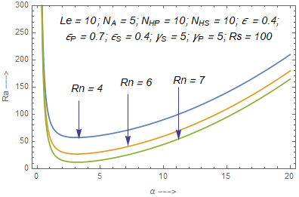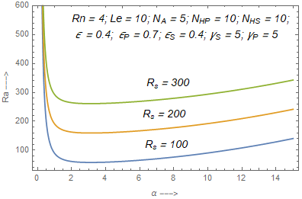

**Fig. (a) Fig. (b)**

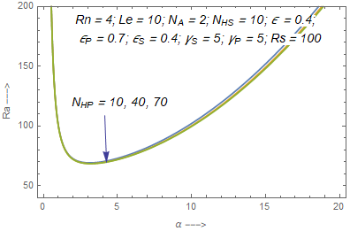 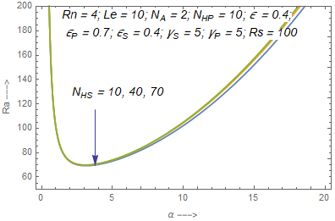

**Fig. (c) Fig. (d)**

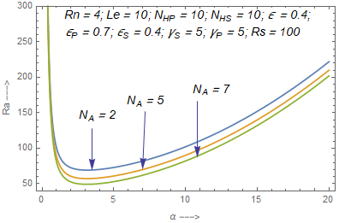

**Fig. (e)**

**Fig.1. Stability curves for different value of (a) *Rn* (b) *Rs* (c) *NA* (d) *NHs* (e) *NHp***

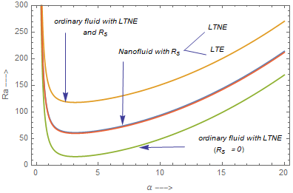

**Fig.2.Comparison of ordinary fluid, LTNE and LTE**

**Conclusions**

The theory of binary/double-diffusive convection using local thermal non-equilibrium in porous medium has been investigated using normal mode technique and Galerkin type weighted residual method and numerical computation are carried out using the software Mathematica. For the porous medium Darcy model is employed. A three-temperature model has been used for considering the effect of LTNE among the fluid, particle and solid matrix phases alongwith the Brownian motion and thermophoresis to account for nanoparticles. Due to thermal non-equilibrium, three additional parameters modified thermal capacity ratio, Nield number, modified thermal diffusivity ratio are introduced in the presence of double diffusive convection. The impact of all these parameters on the thermal Rayleigh number is found numerically. System with LTNE model is less stable as compared to LTE model in the presence of double-diffusive convection.

**References**

A.V. Kuznetsov, D.A. Nield, The onset of double-diffusive nanofluid convection in a layer of a

saturated porous medium, Transp. Porous Media 85, 941–951 **(2010)**.

A.V. Kuznetsov, D.A. Nield, Effect of local thermal non-equilibrium on the onset of convection

in a porous medium layer saturated by a nanofluid, Transp. Porous Media 83, 425–436 **(2010)**.

B.S. Bhadauria, S. Agarwal, Natural convection in a nanofluid saturated rotating porous layer: A

nonlinear study, Transp. Porous Media 87 (2), 585–602 **(2011)**.

Chandrasekhar, S., Hydrodynamic and Hydromagnetic Stability, Dover Publications, New York,

USA**(1981)*.***

D.A. Nield, A.V. Kuznetsov, Thermal instability in a porous medium layer saturated by nanofluid,

Int. J. Heat Mass Transfer 52, 5796–5801 **(2009)**.

D.A. Nield, A.V. Kuznetsov, The effect of local thermal non-equilibrium on the onset of convection

in a nanofluid, J. Heat Transf. 132, 052405 **(2010)**.

D.A. Nield, A.V. Kuznetsov, Thermal instability in a porous medium layer saturated by a nanofluid:

A revised model, Int. J. Heat Mass Transfer 68, 211–214 **(2014)**.

J. Buongiorno. Convective transport in nanofluids.ASME Journal of Heat Transfer **128** (3),

240-250 **(2006)**.

S. Agarwal, B.S. Bhadauria, P.G. Siddheshwara, Thermal instability of a nanofluid saturating a

rotating anisotropic porous medium, Spec. Top. Rev. Porous Media 2 (1), 53–64 **(2011)**.

S.Choi. Enhancing thermal conductivity of fluids with nanoparticles: In D.A. Siginer, H.P. Wang

(Eds.), Development and Applications of Non-Newtonian flows. ASME FED- 231/MD-Vol.

**66,** 99-105 **(1995)**.

Tzou, D.Y., Thermal instability of nanofluids in a natural convection, Int. J. Heat Mass Transfer,

51(11-12), pp. 2967-2979 **(2008).**